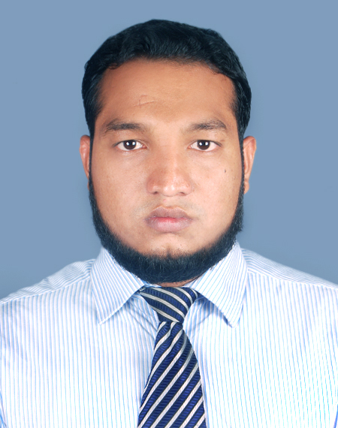

Mofassarul Hoque
“Uttaran”(5th Floor) Flat#C
73/4, Shantinagar, Dhaka-1217
Contact No: 01916906477, 01739301261
Email: shaiketdreams@gmail.com

Career Objective

Seeking an ambitious and responsible career opportunity that will utilize my education and experience where career advancement opportunities can be obtained. I would like to build up my career with National and International perspective and standard with challenging and creative job where I can put the sign of my creativity, patient and experience.
Educational Qualifications

- Bachelor Of Business Administration(B.B.A)
Institution : International Islamic University Chittagong
Year : 2012
CGPA : 3.40
Major : Finance and Banking

- Higher Secondary Certificate (H.S.C)

Institution : Nur Mohammed Rifles public school &College
Education Board : Dhaka
Group : Business study
Result : GPA (4.50) Out of 5.00
Completion year : 2008

- Secondary School Certificate (S.S.C)
Institution : Shaheen Academy School & College
Education Board : Comilla
Group : Business study
Result : GPA (4.38)
Completion year : 2006
Computer Skills

- Operating systems : Windows XP, 2000 profession,
- MS Office package : Ms Word, Ms Excel, Ms Power point,
Ms Access
- Web application : Internet browsing.
Language skills

- Good Command in English, ( Speaking, Reading, Writing)
- Good command in-Arabic, ( reading, and writing)

Extra Qualification

- Participating of certificate training program on Statistical Package for Social Science (SPSS)

Co-curricular Activities

- Experienced of relief work in distressed areas organized by Shaheen Academy School Scouts.
- Arranged and participated in many different cultural events in International Islamic University Chittagong
Personal Details

Name : Mofassarul Hoque
Father’s Name : Md. Mozammal Hoque
Mother’s Name : Shakhara Akther
Permanent Address : “Uttaran”(5th Floor) Flat#C
73/4, Shantinagar, Dhaka-1217
Date of Birth : 1st January 1991
Blood Group : B(+ve)
Martial Statues : Single
Nationality : Bangladeshi (By birth)
Religion : Islam
Reference

- Mr. Sarwar Alam  Project Director  Bangladesh Film archive,  Ministry Of Information,  121, Kazi Nazrul Islam Avenue  Shahabagh, Dhaka-1000  Ph : 9674269(O), 8953844 (R)  Cell # 01715078656 | - A.K.M Samsuddin Azad  Sr. Vice President  National Bank Ltd.  Mohakhali Branch,  Mohakhali, Dhaka.  Cell # 01716273185

