ERSHAD ULLAH
  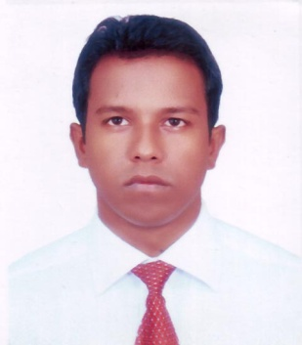
Address: Uttaran,73/4,5th floor, Flat-c,Santinugar ,Dhaka.1217
Mobile : 8801717660170
E-mail:jeweldreams@yahoo.com, jeweldreams10@gmail.com

Career Objective:
Seeking an ambitious and responsible career opportunity that will utilize my education and experience where career advancement opportunities can be obtained .i would like to build up career with national and international perspective.

Employment History:
Total Year of Experience : 2 Year 1 Months .

1. | Customer Executive (March 01, 2010 - March 30, 2011)
The local yellow pages
Company Location : ElephantRoad, Dhaka
2. | Data Analysist & Online Researchers (November 01, 2009 - February 28, 2010)
Web Emaze
Company Location : Mohammodpur, Dhaka
Department: Outsourcing Administration
3. | Data Analysist ( Feburary 01, 2009 - October 30, 2009)
Sky tech Bd
Company Location : Mirpur ,Dhaka

Academic Qualification:

Exam Title | Concentration/Major | Institute | Result | Pass Year | Duration
MBA | HRM | Stamford University | CGPA:3.125  out of 4 | 2011 | 2 years
MBS | Accounting | National University | Running | 2011 | 2 years
BBS | BBS(pass) | National University | 2nd Class, Marks : 49.28% | 2007 | 3 years
HSC | Business Studies | Feni govt. college | CGPA:3  out of 5 | 2003 | 2 years
SSC | Science | Silonia High School | 1st Div, Marks : 60.5% | 2000 | 1 years

Extra Curricular Activities:
Organized and participated many cultural and social programs in college function. i also work with different social organization. i involved with web analysis, online business & online research . i have More Web portal .i Organized my websites all activity .

Language Proficiency:
Language | Reading | Writing | Speaking
English | High | High | High
Bangla | High | High | High
Hindi | Low | Low | Medium

Computer Skill: Microsoft Word, Excel. Power Point, & Access, Internet Browsing. Web Research & Email Marketing.
Personal Details :
Father's Name | : | Md.Siddique Ullah
Mother's Name | : | Shanara Akter
Date of Birth | : | January 02, 1984
Gender | : | Male
Marital Status | : | Unmarried
Nationality | : | Bangladeshi
Religion | : | Islam(sunni)
Permanent Address | : | Uttaran,73/4,5th floor,Flat-c,Santinugar ,Dhaka.1217
Current Location | : | Dhaka

Reference (s):
 |  | Reference: 01 | Reference: 02
Name | : | Abul Kalam Azad | Mr.Md. Sarwar Alam
Organization | : | Government of the peoples Republic of Bangladesh. | Government of the peoples Republic of Bangladesh.
Designation | : | Director | Project Director.
Address | : | Defense Audit Directorate, Audit complex, Segun Bagicha, Dhaka. | Bangladesh Film archive, Ministry of information, 121, Kazi Nazrul Islam avenue, Sahabag, Dhaka-1000.
Phone (Off.) | : | 02-9351337 | 02-8953844
Phone (Res.) | :
Mobile | : | 01711986513 | 01715078656
E-Mail | : | abul.kalam65@yahoo.com | srwr9@yahoo.com
Relation | : | Relative | Relative

