PERSONAL PROFILE

Full Name | ABDULLAH AL MAMUN |  |  |  | Status |  | MARRIED |  | 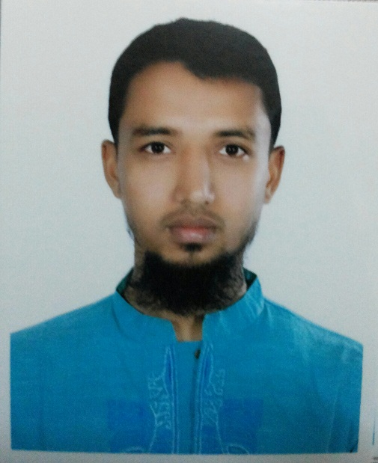
Place of Birth | COMILLA |  |  |  | Next of Kin |  | AFROZA SULTANA
Date of Birth | 18/12/1986 |  |  |  | Height |  | 1.66 M
Religion | MUSLIM |  |  |  | Weight |  | 60 KG
Father &Mother | MD.ABDUL JALIL |  |  |  | Boiler Suit Size |  | M
Address | VILL:PANCHORA, PO: CHARANAL,  PS: BURICHONG, DIST: COMILLA. |  |  |  | Size of Shoes |  | 43’’
Address |  |  |  |  | Mobile |  | +8801913027123
Passport No. | BC 0711669 | ISSUE | 20 NOV 2014 |  |  | Expire | 19 NOV 2019 | DHAKA
Seaman Book No. | C/O/5300 | ISSUE | 09 JULY 2008 |  |  | Expire | 08JULY2018 | CHITTAGONG
EDUCATIONAL QUALIFICATION |  |  |  | B.Sc(pass) IN NAUTICAL SCIENCE(NATIONAL UNIVERSITY)
CERTIFICATE OF COMPETENCY

GRADE | CERTIFICATE NO | PLACE OF ISSUE | DATE OF ISSUE | DATE OF EXPIRY
DOC CLASS -3 | BD10031174 | DG SHIPPING, DHAKA | 21/01/2015 | 20/01/2019

RECORD OF SEA SERVICE

No | Name of Company | Name of Ship | Vessel Type | GRT | Rank | Sign On  Date | Sign Off  Date
1 | FAST MERIDIAN SDN BHD. | TB.TEGUH 16501 | TUG | 176 | C/O | 04.04.2013 | 20.11.2013
2 | FAST MERIDIAN SDN BHD. | TB.TEKUN 12262 | TUG | 142 | C/O | 21.05.2012 | 18.01.2013
3 | MANSHIP,SINGAPORE | MV.TRADEWINDS | BULK | 17356 | DK.CDT | 29.04.2010 | 24.11.2010
4 | SAUDIA SHIPPING CORP. | MV.MAZIN ARAB | G.CARGO | 14280 | DK.CDT | 05.11.2009 | 19.01.2010
5 | BSC,BANGLADESH | MV.BANGLAR URMI | G.CARGO | 9840 | DK.CDT | 28.08.2008 | 13.08.2009
S. T. C. W CERTIFICATE (AMENDED 2010)

No | Type | Certificate No. | Date of Issue | Date of Expiry | Place
1 | Advance Fire Fighting | BDAFF-3025 | 21.01.2015 | 20.01.2019 | BMTI
2 | Survival Craft Rescue Boat | BDPSCRB-1584 | 21.01.2015 | 20.01.2019 | BMTI
3 | Tanker Familiarization | BDBOCT-1172 | 01.02.2015 | 31.12.2016 | MIST
4 | Medical First Aid | BDMFA-499 | 21.01.2015 | 20.01.2019 | BMTI
5 | RADAR, ROC- ARPA | BDROC NAV(O)-292 | 21.01.2015 | 20.01.2019 | BMTI
6 | GMDSS | GMDSS-1494/15 | 21.01.2015 | 20.01.2019 | BMTI
7 | SSO (Ship Security Officer) | BDSSO-2629 | 21.01.2015 | 20.01.2019 | BMTI
8 | Specialized Tanker Training Course (Chem)
9 | Specialized Tanker Training Course (Oil)
10 | Bridge Team Management (BTM)
11 | Bridge Recourse Management (BRM)
12 | Navigation Aid, Electronic Navigation System | BDNAENS-249 | 21.01.2015 | 20.01.2019 | BMTI
13 | Electronic Chart, Display Information System | BDECDIS-659 | 21.01.2015 | 20.01.2019 | BMTI
14 | Advanced oil Tanker
15 | Advanced Chemical Tanker
16 | SAT | BDSAT-7762 | 21.01.2015 | 20.01.2019 | IMTA
17 | DSD | BDSTSDSD-6232 | 21.01.2015 | 20.01.2019 | IMTA
I WARRANT THAT ALL ABOVE INFORMATION ARE TRUE & CORRECT IN ALL RESPECT.

SIGNATURE
ABDULLAH AL MAMUN

