Microservices are an architectural style that promotes the development of complex applications as a suite of small services based on business capabilities. This course will help you identify the appropriate service boundaries within the business.

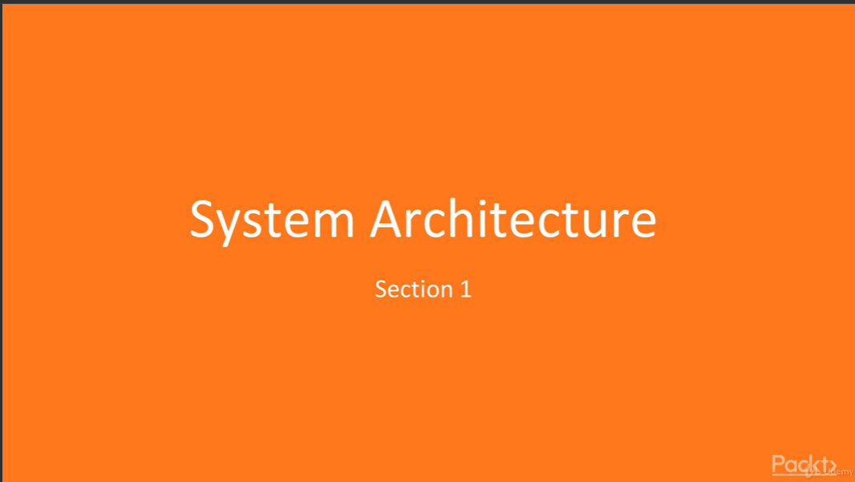

Setting up environment - Requirements:

* Dotnet core
* Visual studio code
* Docker
* MongoDb
* Postman
* Fiddler

