display

matches <- read.csv(file = "WorldCupMatches.csv", stringsAsFactors = FALSE,header=TRUE)  
players <- read.csv(file ="WorldCupPlayers.csv",stringsAsFactors = FALSE,header=TRUE)  
worldcups <- read.csv(file ="WorldCups.csv",stringsAsFactors = FALSE ,header=TRUE)  
  
  
## exploring raw data  
names(matches)

## [1] "Year" "Datetime" "Stage"   
## [4] "Stadium" "City" "Home.Team.Name"   
## [7] "Home.Team.Goals" "Away.Team.Goals" "Away.Team.Name"   
## [10] "Win.conditions" "Attendance" "Half.time.Home.Goals"  
## [13] "Half.time.Away.Goals" "Referee" "Assistant.1"   
## [16] "Assistant.2" "RoundID" "MatchID"   
## [19] "Home.Team.Initials" "Away.Team.Initials"

summary(matches)

## Year Datetime Stage Stadium   
## Min. :1930 Length:4572 Length:4572 Length:4572   
## 1st Qu.:1970 Class :character Class :character Class :character   
## Median :1990 Mode :character Mode :character Mode :character   
## Mean :1985   
## 3rd Qu.:2002   
## Max. :2014   
## NA's :3720   
## City Home.Team.Name Home.Team.Goals Away.Team.Goals  
## Length:4572 Length:4572 Min. : 0.000 Min. :0.000   
## Class :character Class :character 1st Qu.: 1.000 1st Qu.:0.000   
## Mode :character Mode :character Median : 2.000 Median :1.000   
## Mean : 1.811 Mean :1.022   
## 3rd Qu.: 3.000 3rd Qu.:2.000   
## Max. :10.000 Max. :7.000   
## NA's :3720 NA's :3720   
## Away.Team.Name Win.conditions Attendance   
## Length:4572 Length:4572 Min. : 2000   
## Class :character Class :character 1st Qu.: 30000   
## Mode :character Mode :character Median : 41580   
## Mean : 45165   
## 3rd Qu.: 61375   
## Max. :173850   
## NA's :3722   
## Half.time.Home.Goals Half.time.Away.Goals Referee   
## Min. :0.000 Min. :0.000 Length:4572   
## 1st Qu.:0.000 1st Qu.:0.000 Class :character   
## Median :0.000 Median :0.000 Mode :character   
## Mean :0.709 Mean :0.428   
## 3rd Qu.:1.000 3rd Qu.:1.000   
## Max. :6.000 Max. :5.000   
## NA's :3720 NA's :3720   
## Assistant.1 Assistant.2 RoundID   
## Length:4572 Length:4572 Min. : 201   
## Class :character Class :character 1st Qu.: 262   
## Mode :character Mode :character Median : 337   
## Mean :10661773   
## 3rd Qu.: 249722   
## Max. :97410600   
## NA's :3720   
## MatchID Home.Team.Initials Away.Team.Initials  
## Min. : 25 Length:4572 Length:4572   
## 1st Qu.: 1189 Class :character Class :character   
## Median : 2191 Mode :character Mode :character   
## Mean : 61346868   
## 3rd Qu.: 43950059   
## Max. :300186515   
## NA's :3720

head(matches)

## Year Datetime Stage Stadium City  
## 1 1930 13 Jul 1930 - 15:00 Group 1 Pocitos Montevideo   
## 2 1930 13 Jul 1930 - 15:00 Group 4 Parque Central Montevideo   
## 3 1930 14 Jul 1930 - 12:45 Group 2 Parque Central Montevideo   
## 4 1930 14 Jul 1930 - 14:50 Group 3 Pocitos Montevideo   
## 5 1930 15 Jul 1930 - 16:00 Group 1 Parque Central Montevideo   
## 6 1930 16 Jul 1930 - 14:45 Group 1 Parque Central Montevideo   
## Home.Team.Name Home.Team.Goals Away.Team.Goals Away.Team.Name  
## 1 France 4 1 Mexico  
## 2 USA 3 0 Belgium  
## 3 Yugoslavia 2 1 Brazil  
## 4 Romania 3 1 Peru  
## 5 Argentina 1 0 France  
## 6 Chile 3 0 Mexico  
## Win.conditions Attendance Half.time.Home.Goals Half.time.Away.Goals  
## 1 4444 3 0  
## 2 18346 2 0  
## 3 24059 2 0  
## 4 2549 1 0  
## 5 23409 0 0  
## 6 9249 1 0  
## Referee Assistant.1  
## 1 LOMBARDI Domingo (URU) CRISTOPHE Henry (BEL)  
## 2 MACIAS Jose (ARG) MATEUCCI Francisco (URU)  
## 3 TEJADA Anibal (URU) VALLARINO Ricardo (URU)  
## 4 WARNKEN Alberto (CHI) LANGENUS Jean (BEL)  
## 5 REGO Gilberto (BRA) SAUCEDO Ulises (BOL)  
## 6 CRISTOPHE Henry (BEL) APHESTEGUY Martin (URU)  
## Assistant.2 RoundID MatchID Home.Team.Initials  
## 1 REGO Gilberto (BRA) 201 1096 FRA  
## 2 WARNKEN Alberto (CHI) 201 1090 USA  
## 3 BALWAY Thomas (FRA) 201 1093 YUG  
## 4 MATEUCCI Francisco (URU) 201 1098 ROU  
## 5 RADULESCU Constantin (ROU) 201 1085 ARG  
## 6 LANGENUS Jean (BEL) 201 1095 CHI  
## Away.Team.Initials  
## 1 MEX  
## 2 BEL  
## 3 BRA  
## 4 PER  
## 5 FRA  
## 6 MEX

names(players)

## [1] "RoundID" "MatchID" "Team.Initials" "Coach.Name"   
## [5] "Line.up" "Shirt.Number" "Player.Name" "Position"   
## [9] "Event"

summary(players)

## RoundID MatchID Team.Initials   
## Min. : 201 Min. : 25 Length:37784   
## 1st Qu.: 263 1st Qu.: 1199 Class :character   
## Median : 337 Median : 2216 Mode :character   
## Mean :11056474 Mean : 63622330   
## 3rd Qu.: 255931 3rd Qu.: 97410003   
## Max. :97410600 Max. :300186515   
## Coach.Name Line.up Shirt.Number Player.Name   
## Length:37784 Length:37784 Min. : 0.00 Length:37784   
## Class :character Class :character 1st Qu.: 5.00 Class :character   
## Mode :character Mode :character Median :11.00 Mode :character   
## Mean :10.73   
## 3rd Qu.:17.00   
## Max. :23.00   
## Position Event   
## Length:37784 Length:37784   
## Class :character Class :character   
## Mode :character Mode :character   
##   
##   
##

head(players)

## RoundID MatchID Team.Initials Coach.Name Line.up Shirt.Number  
## 1 201 1096 FRA CAUDRON Raoul (FRA) S 0  
## 2 201 1096 MEX LUQUE Juan (MEX) S 0  
## 3 201 1096 FRA CAUDRON Raoul (FRA) S 0  
## 4 201 1096 MEX LUQUE Juan (MEX) S 0  
## 5 201 1096 FRA CAUDRON Raoul (FRA) S 0  
## 6 201 1096 MEX LUQUE Juan (MEX) S 0  
## Player.Name Position Event  
## 1 Alex THEPOT GK   
## 2 Oscar BONFIGLIO GK   
## 3 Marcel LANGILLER G40'  
## 4 Juan CARRENO G70'  
## 5 Ernest LIBERATI   
## 6 Rafael GARZA C

names(worldcups)

## [1] "Year" "Country" "Winner" "Runners.Up"   
## [5] "Third" "Fourth" "GoalsScored" "QualifiedTeams"  
## [9] "MatchesPlayed" "Attendance"

summary(worldcups)

## Year Country Winner Runners.Up   
## Min. :1930 Length:20 Length:20 Length:20   
## 1st Qu.:1957 Class :character Class :character Class :character   
## Median :1976 Mode :character Mode :character Mode :character   
## Mean :1975   
## 3rd Qu.:1995   
## Max. :2014   
## Third Fourth GoalsScored QualifiedTeams   
## Length:20 Length:20 Min. : 70.0 Min. :13.00   
## Class :character Class :character 1st Qu.: 89.0 1st Qu.:16.00   
## Mode :character Mode :character Median :120.5 Median :16.00   
## Mean :119.0 Mean :21.25   
## 3rd Qu.:145.2 3rd Qu.:26.00   
## Max. :171.0 Max. :32.00   
## MatchesPlayed Attendance   
## Min. :17.0 Length:20   
## 1st Qu.:30.5 Class :character   
## Median :38.0 Mode :character   
## Mean :41.8   
## 3rd Qu.:55.0   
## Max. :64.0

head(worldcups)

## Year Country Winner Runners.Up Third Fourth  
## 1 1930 Uruguay Uruguay Argentina USA Yugoslavia  
## 2 1934 Italy Italy Czechoslovakia Germany Austria  
## 3 1938 France Italy Hungary Brazil Sweden  
## 4 1950 Brazil Uruguay Brazil Sweden Spain  
## 5 1954 Switzerland Germany FR Hungary Austria Uruguay  
## 6 1958 Sweden Brazil Sweden France Germany FR  
## GoalsScored QualifiedTeams MatchesPlayed Attendance  
## 1 70 13 18 590.549  
## 2 70 16 17 363.000  
## 3 84 15 18 375.700  
## 4 88 13 22 1.045.246  
## 5 140 16 26 768.607  
## 6 126 16 35 819.810

library(ggplot2)  
library(DataExplorer)  
plot_str(worldcups)  
plot_histogram(worldcups)

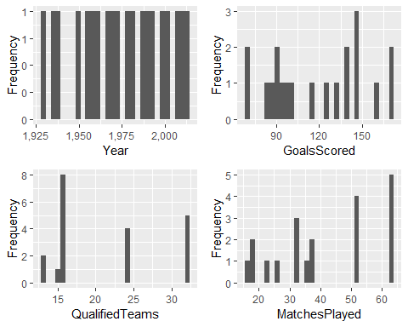

plot_bar(worldcups)

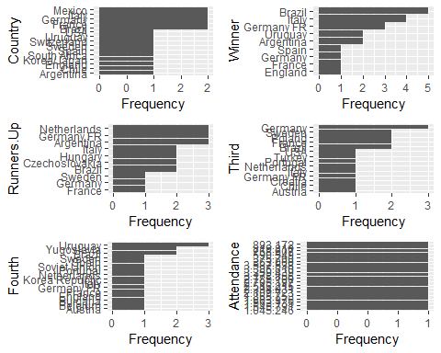

## checking for NA's and then cleaning data   
  
##sum(is.na(matches$Home.Team.Name))  
#(is.na(matches$Home.Team.Goals))  
  
#sum(is.na(matches$Away.Team.Name))  
#sum(is.na(matches$Away.Team.Goals))  
  
library(VIM)

## Loading required package: colorspace

## Loading required package: grid

## Loading required package: data.table

## VIM is ready to use.   
## Since version 4.0.0 the GUI is in its own package VIMGUI.  
##   
## Please use the package to use the new (and old) GUI.

## Suggestions and bug-reports can be submitted at: https://github.com/alexkowa/VIM/issues

##   
## Attaching package: 'VIM'

## The following object is masked from 'package:datasets':  
##   
## sleep

##library(easyGgplot2)  
matches1 <- kNN(matches, variable = c("Home.Team.Goals", "Away.Team.Goals","Attendance"), k = 5)

## Warning in gowerD(don_dist_var, imp_dist_var, weights = weightsx,  
## numericalX, : NAs introduced by coercion  
  
## Warning in gowerD(don_dist_var, imp_dist_var, weights = weightsx,  
## numericalX, : NAs introduced by coercion  
  
## Warning in gowerD(don_dist_var, imp_dist_var, weights = weightsx,  
## numericalX, : NAs introduced by coercion  
  
## Warning in gowerD(don_dist_var, imp_dist_var, weights = weightsx,  
## numericalX, : NAs introduced by coercion  
  
## Warning in gowerD(don_dist_var, imp_dist_var, weights = weightsx,  
## numericalX, : NAs introduced by coercion  
  
## Warning in gowerD(don_dist_var, imp_dist_var, weights = weightsx,  
## numericalX, : NAs introduced by coercion  
  
## Warning in gowerD(don_dist_var, imp_dist_var, weights = weightsx,  
## numericalX, : NAs introduced by coercion  
  
## Warning in gowerD(don_dist_var, imp_dist_var, weights = weightsx,  
## numericalX, : NAs introduced by coercion  
  
## Warning in gowerD(don_dist_var, imp_dist_var, weights = weightsx,  
## numericalX, : NAs introduced by coercion  
  
## Warning in gowerD(don_dist_var, imp_dist_var, weights = weightsx,  
## numericalX, : NAs introduced by coercion  
  
## Warning in gowerD(don_dist_var, imp_dist_var, weights = weightsx,  
## numericalX, : NAs introduced by coercion  
  
## Warning in gowerD(don_dist_var, imp_dist_var, weights = weightsx,  
## numericalX, : NAs introduced by coercion  
  
## Warning in gowerD(don_dist_var, imp_dist_var, weights = weightsx,  
## numericalX, : NAs introduced by coercion  
  
## Warning in gowerD(don_dist_var, imp_dist_var, weights = weightsx,  
## numericalX, : NAs introduced by coercion  
  
## Warning in gowerD(don_dist_var, imp_dist_var, weights = weightsx,  
## numericalX, : NAs introduced by coercion  
  
## Warning in gowerD(don_dist_var, imp_dist_var, weights = weightsx,  
## numericalX, : NAs introduced by coercion  
  
## Warning in gowerD(don_dist_var, imp_dist_var, weights = weightsx,  
## numericalX, : NAs introduced by coercion  
  
## Warning in gowerD(don_dist_var, imp_dist_var, weights = weightsx,  
## numericalX, : NAs introduced by coercion  
  
## Warning in gowerD(don_dist_var, imp_dist_var, weights = weightsx,  
## numericalX, : NAs introduced by coercion  
  
## Warning in gowerD(don_dist_var, imp_dist_var, weights = weightsx,  
## numericalX, : NAs introduced by coercion  
  
## Warning in gowerD(don_dist_var, imp_dist_var, weights = weightsx,  
## numericalX, : NAs introduced by coercion  
  
## Warning in gowerD(don_dist_var, imp_dist_var, weights = weightsx,  
## numericalX, : NAs introduced by coercion  
  
## Warning in gowerD(don_dist_var, imp_dist_var, weights = weightsx,  
## numericalX, : NAs introduced by coercion  
  
## Warning in gowerD(don_dist_var, imp_dist_var, weights = weightsx,  
## numericalX, : NAs introduced by coercion  
  
## Warning in gowerD(don_dist_var, imp_dist_var, weights = weightsx,  
## numericalX, : NAs introduced by coercion  
  
## Warning in gowerD(don_dist_var, imp_dist_var, weights = weightsx,  
## numericalX, : NAs introduced by coercion  
  
## Warning in gowerD(don_dist_var, imp_dist_var, weights = weightsx,  
## numericalX, : NAs introduced by coercion  
  
## Warning in gowerD(don_dist_var, imp_dist_var, weights = weightsx,  
## numericalX, : NAs introduced by coercion  
  
## Warning in gowerD(don_dist_var, imp_dist_var, weights = weightsx,  
## numericalX, : NAs introduced by coercion  
  
## Warning in gowerD(don_dist_var, imp_dist_var, weights = weightsx,  
## numericalX, : NAs introduced by coercion  
  
## Warning in gowerD(don_dist_var, imp_dist_var, weights = weightsx,  
## numericalX, : NAs introduced by coercion  
  
## Warning in gowerD(don_dist_var, imp_dist_var, weights = weightsx,  
## numericalX, : NAs introduced by coercion  
  
## Warning in gowerD(don_dist_var, imp_dist_var, weights = weightsx,  
## numericalX, : NAs introduced by coercion  
  
## Warning in gowerD(don_dist_var, imp_dist_var, weights = weightsx,  
## numericalX, : NAs introduced by coercion  
  
## Warning in gowerD(don_dist_var, imp_dist_var, weights = weightsx,  
## numericalX, : NAs introduced by coercion  
  
## Warning in gowerD(don_dist_var, imp_dist_var, weights = weightsx,  
## numericalX, : NAs introduced by coercion  
  
## Warning in gowerD(don_dist_var, imp_dist_var, weights = weightsx,  
## numericalX, : NAs introduced by coercion  
  
## Warning in gowerD(don_dist_var, imp_dist_var, weights = weightsx,  
## numericalX, : NAs introduced by coercion  
  
## Warning in gowerD(don_dist_var, imp_dist_var, weights = weightsx,  
## numericalX, : NAs introduced by coercion  
  
## Warning in gowerD(don_dist_var, imp_dist_var, weights = weightsx,  
## numericalX, : NAs introduced by coercion  
  
## Warning in gowerD(don_dist_var, imp_dist_var, weights = weightsx,  
## numericalX, : NAs introduced by coercion  
  
## Warning in gowerD(don_dist_var, imp_dist_var, weights = weightsx,  
## numericalX, : NAs introduced by coercion  
  
## Warning in gowerD(don_dist_var, imp_dist_var, weights = weightsx,  
## numericalX, : NAs introduced by coercion  
  
## Warning in gowerD(don_dist_var, imp_dist_var, weights = weightsx,  
## numericalX, : NAs introduced by coercion  
  
## Warning in gowerD(don_dist_var, imp_dist_var, weights = weightsx,  
## numericalX, : NAs introduced by coercion  
  
## Warning in gowerD(don_dist_var, imp_dist_var, weights = weightsx,  
## numericalX, : NAs introduced by coercion  
  
## Warning in gowerD(don_dist_var, imp_dist_var, weights = weightsx,  
## numericalX, : NAs introduced by coercion  
  
## Warning in gowerD(don_dist_var, imp_dist_var, weights = weightsx,  
## numericalX, : NAs introduced by coercion

summary(matches1)

## Year Datetime Stage Stadium   
## Min. :1930 Length:4572 Length:4572 Length:4572   
## 1st Qu.:1970 Class :character Class :character Class :character   
## Median :1990 Mode :character Mode :character Mode :character   
## Mean :1985   
## 3rd Qu.:2002   
## Max. :2014   
## NA's :3720   
## City Home.Team.Name Home.Team.Goals Away.Team.Goals  
## Length:4572 Length:4572 Min. : 0.000 Min. :0.000   
## Class :character Class :character 1st Qu.: 1.000 1st Qu.:4.000   
## Mode :character Mode :character Median : 1.000 Median :4.000   
## Mean : 1.151 Mean :3.445   
## 3rd Qu.: 1.000 3rd Qu.:4.000   
## Max. :10.000 Max. :7.000   
##   
## Away.Team.Name Win.conditions Attendance   
## Length:4572 Length:4572 Min. : 2000   
## Class :character Class :character 1st Qu.: 58141   
## Mode :character Mode :character Median : 58141   
## Mean : 55729   
## 3rd Qu.: 58141   
## Max. :173850   
##   
## Half.time.Home.Goals Half.time.Away.Goals Referee   
## Min. :0.000 Min. :0.000 Length:4572   
## 1st Qu.:0.000 1st Qu.:0.000 Class :character   
## Median :0.000 Median :0.000 Mode :character   
## Mean :0.709 Mean :0.428   
## 3rd Qu.:1.000 3rd Qu.:1.000   
## Max. :6.000 Max. :5.000   
## NA's :3720 NA's :3720   
## Assistant.1 Assistant.2 RoundID   
## Length:4572 Length:4572 Min. : 201   
## Class :character Class :character 1st Qu.: 262   
## Mode :character Mode :character Median : 337   
## Mean :10661773   
## 3rd Qu.: 249722   
## Max. :97410600   
## NA's :3720   
## MatchID Home.Team.Initials Away.Team.Initials  
## Min. : 25 Length:4572 Length:4572   
## 1st Qu.: 1189 Class :character Class :character   
## Median : 2191 Mode :character Mode :character   
## Mean : 61346868   
## 3rd Qu.: 43950059   
## Max. :300186515   
## NA's :3720   
## Home.Team.Goals_imp Away.Team.Goals_imp Attendance_imp   
## Mode :logical Mode :logical Mode :logical   
## FALSE:852 FALSE:852 FALSE:850   
## TRUE :3720 TRUE :3720 TRUE :3722   
##   
##   
##   
##

head(matches1)

## Year Datetime Stage Stadium City  
## 1 1930 13 Jul 1930 - 15:00 Group 1 Pocitos Montevideo   
## 2 1930 13 Jul 1930 - 15:00 Group 4 Parque Central Montevideo   
## 3 1930 14 Jul 1930 - 12:45 Group 2 Parque Central Montevideo   
## 4 1930 14 Jul 1930 - 14:50 Group 3 Pocitos Montevideo   
## 5 1930 15 Jul 1930 - 16:00 Group 1 Parque Central Montevideo   
## 6 1930 16 Jul 1930 - 14:45 Group 1 Parque Central Montevideo   
## Home.Team.Name Home.Team.Goals Away.Team.Goals Away.Team.Name  
## 1 France 4 1 Mexico  
## 2 USA 3 0 Belgium  
## 3 Yugoslavia 2 1 Brazil  
## 4 Romania 3 1 Peru  
## 5 Argentina 1 0 France  
## 6 Chile 3 0 Mexico  
## Win.conditions Attendance Half.time.Home.Goals Half.time.Away.Goals  
## 1 4444 3 0  
## 2 18346 2 0  
## 3 24059 2 0  
## 4 2549 1 0  
## 5 23409 0 0  
## 6 9249 1 0  
## Referee Assistant.1  
## 1 LOMBARDI Domingo (URU) CRISTOPHE Henry (BEL)  
## 2 MACIAS Jose (ARG) MATEUCCI Francisco (URU)  
## 3 TEJADA Anibal (URU) VALLARINO Ricardo (URU)  
## 4 WARNKEN Alberto (CHI) LANGENUS Jean (BEL)  
## 5 REGO Gilberto (BRA) SAUCEDO Ulises (BOL)  
## 6 CRISTOPHE Henry (BEL) APHESTEGUY Martin (URU)  
## Assistant.2 RoundID MatchID Home.Team.Initials  
## 1 REGO Gilberto (BRA) 201 1096 FRA  
## 2 WARNKEN Alberto (CHI) 201 1090 USA  
## 3 BALWAY Thomas (FRA) 201 1093 YUG  
## 4 MATEUCCI Francisco (URU) 201 1098 ROU  
## 5 RADULESCU Constantin (ROU) 201 1085 ARG  
## 6 LANGENUS Jean (BEL) 201 1095 CHI  
## Away.Team.Initials Home.Team.Goals_imp Away.Team.Goals_imp  
## 1 MEX FALSE FALSE  
## 2 BEL FALSE FALSE  
## 3 BRA FALSE FALSE  
## 4 PER FALSE FALSE  
## 5 FRA FALSE FALSE  
## 6 MEX FALSE FALSE  
## Attendance_imp  
## 1 FALSE  
## 2 FALSE  
## 3 FALSE  
## 4 FALSE  
## 5 FALSE  
## 6 FALSE

# display number of goals at home  
ggplot(data = matches1) +  
 geom_bar(mapping = aes(reorder(Home.Team.Goals,Home.Team.Goals, length)))+ xlab("number of goals scored at home")+ coord_flip()

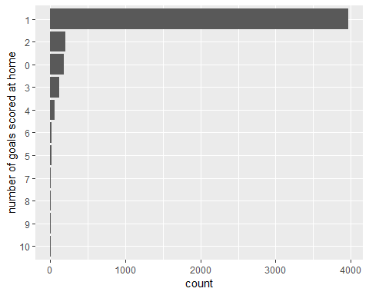

# display number of goals away  
ggplot(data = matches1) +  
 geom_bar(mapping = aes(reorder(Away.Team.Goals,Away.Team.Goals, length)))+ xlab("number of goals scored away")

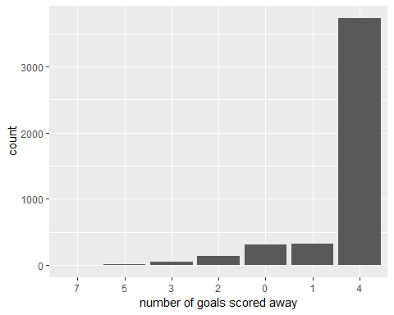

#  
  
# group stages  
ggplot(data = matches1) + geom_bar(mapping = aes(reorder(Stage,Stage, length)))+ xlab("group stages")+ coord_flip()

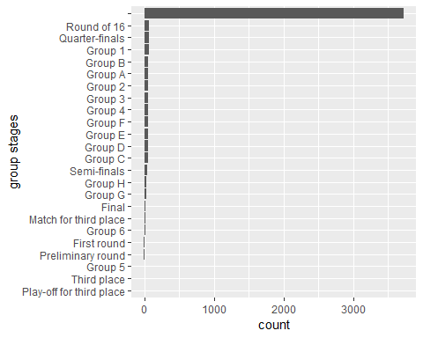

# winners  
ggplot(data = worldcups) + geom_bar(mapping = aes(reorder(Winner,Winner, length)))+ xlab("winners")+ coord_flip()

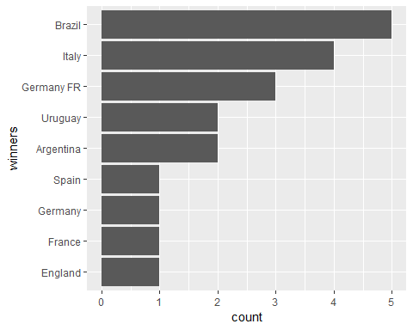

# home goals  
#home_goal <- ggplot(matches1, aes(x=Home.Team.Name, y=Home.Team.Goals)) #+ geom_bar(stat = "identity", aes(fill=Home.Team.Name))+ coord_flip()  
#print(home_goal)  
  
#away goals  
#away_goal <- ggplot(matches1, aes(x=Away.Team.Name, y=Away.Team.Goals)) #+ geom_bar(stat = "identity", aes(fill=Home.Team.Name))+ coord_flip()  
#print(away_goal)  
  
#winner vs attendance  
winner_attendance <- ggplot(worldcups, aes(x=Winner, y= Attendance )) + geom_bar(stat = "identity", aes(fill=Winner))  
print(winner_attendance)

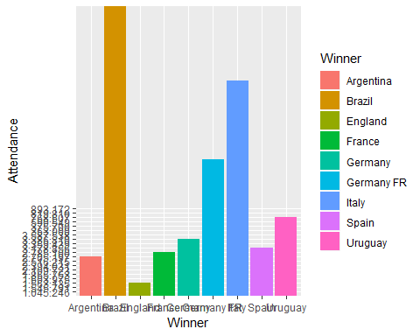

# year and attendance   
gg_bar <- ggplot(worldcups, aes(x=Year, y= Attendance )) + geom_bar(stat = "identity", aes(fill=Year))  
print(gg_bar)

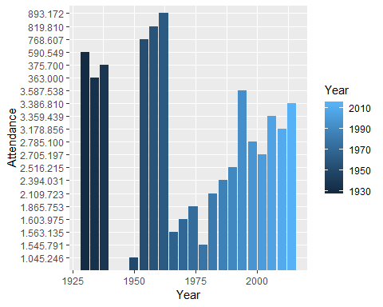

# converting to an int  
  
worldcups$Year <- as.numeric(as.character(worldcups$Year))  
  
  
 # plot of attendance vs year  
  
ggplot(worldcups, aes(Year, Attendance)) +  
 geom_point() +  
 geom_line() +  
 labs(x = "Year",   
 y = "attendeance ",   
 title = "attendance in each year")+ theme(plot.title = element_text(hjust = 0.5))

## geom_path: Each group consists of only one observation. Do you need to  
## adjust the group aesthetic?

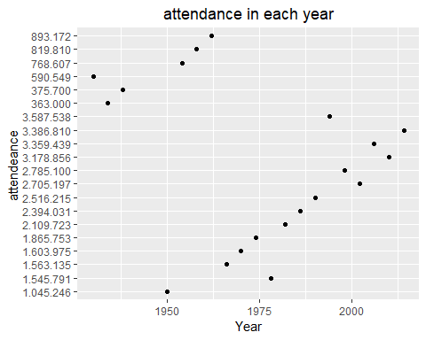

# runner up  
  
ggplot(data = worldcups) + geom_bar(mapping = aes(reorder( Runners.Up ,Runners.Up , length)))+ xlab("Runners.Up")

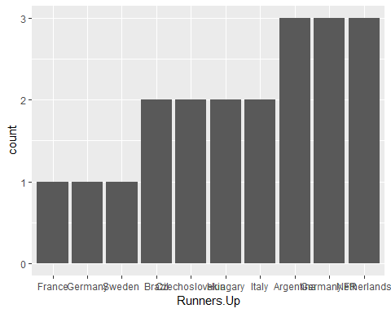

##winner vs match played  
winner_matchPlayed <- ggplot(worldcups, aes(x=Winner, y= MatchesPlayed )) + geom_bar(stat = "identity", aes(fill=Winner))  
print(winner_matchPlayed)

