*Why do we care about Greeks? Create simple strategies such as covered calls. Introduce Greeks and show how “not all covered calls are created equal.” Please explain how the Greeks tell us which options are better to use than others.*

Greeks are statistics which measure sensitivity of option prices to various factors, such as underlying price (delta, gamma), time to expiration (theta), volatility (vega), and interest rate (rho). They help a trader understand risk exposures of option positions: for example, when an option portfolio has positive delta, its value will increase if underlying price goes up, or similarly, if it has negative vega, its value will decrease if implied volatility rises. Understanding Greeks is therefore very useful for understanding and managing risk in options trading. Below is a short summary of the Greeks.

Delta

Delta measures how option price will change if underlying price increases by $1. Call option delta is from 0 to +1. Put option delta is from 0 to -1. Out of the money options have delta near zero. In the money options near +1 (calls) or -1 (puts). Delta itself changes with underlying price (this is measured by gamma). Therefore, delta is only accurate for small underlying price changes. Like all other Greeks, delta is additive. Total delta of a position with multiple options is the sum of all options’ deltas. Delta hedging makes delta zero – makes a position immune to small underlying price changes. It requires ongoing monitoring and rebalancing. Delta also changes with volatility and passing time. Lower volatility or lower time to expiration push delta closer to the extremes (0 or +1 or -1).





Gamma

Gamma measures how much delta will change if underlying price increases by $1. All options have positive gamma. All short option positions have negative gamma. Gamma is highest at the money. At the money gamma increases with passing time or decreasing volatility. Positive gamma means your profits accelerate in big moves. Negative gamma means your losses accelerate and can be very dangerous.



Theta

Theta measures how much an option’s price will change in one day. All options (with some rare exceptions) have negative theta – lose value with passing time. Theta is greatest at the money. At the money theta is greatest just before expiration. An increase in volatility increases time value and thereby theta. Short option positions have positive theta and profit from passing time.

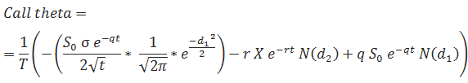

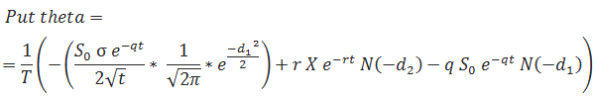

Vega

Vega measures how option price will change if implied volatility rises by one percentage point. All options have positive vega – they gain value with rising volatility. Vega is greatest at the money (but out of the money in percentage terms). The more time to expiration, the higher vega.



Rho

Rho measures how option premium will change if the risk-free interest rate increases by one percentage point. Call options on most underlying have positive rho; put options have negative rho. Rho is generally greater (in absolute terms) with more time to expiration. For many underlying assets like currencies or bonds, interest rates may also affect underlying price, and thereby option prices. This indirect effect, though often greater than the direct effect, is not measured by rho.





Greeks in a covered call strategy

An example: A covered call strategy holding 100 shares of a stock and short one call option contract (which represents 100 shares) with 0.20 delta, 0.03 gamma, -0.04 theta, and 0.08 vega has total delta of 0.80 (1 – 0.20), gamma of -0.03, theta of +0.04, and vega of -0.08 (always the opposite sign, as the stock has gamma/theta/vega of zero and you subtract the short option’s Greeks). This means the position’s total value rises if underlying stock goes up (positive delta), or as time passes (positive theta), but decreases if the short option’s implied volatility goes up (negative vega). The Greeks tell you which kinds of risks you are exposed to and what will happen to your profit or loss under different scenarios. They help you make decisions such as which strikes and/or expirations to use, how many contracts to trade (to keep the risk within your limits), or how to adjust your position when circumstances change.

Below is a hypothetical covered call and impacts of some of the Greeks.

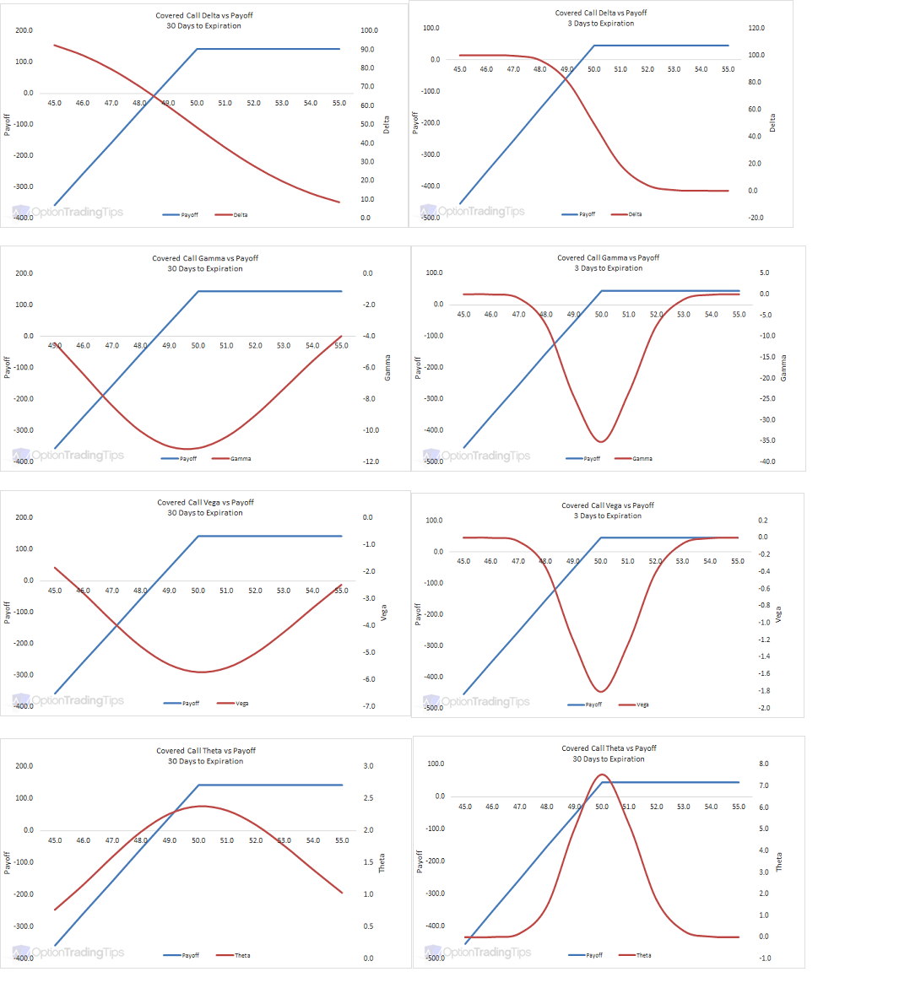

*https://www.optiontradingtips.com/strategies/covered-call.html*

*https://www.macroption.com/option-greeks/*