*In finance, the Monte Carlo method is used to simulate the various sources of uncertainty that affect the value of the instrument, portfolio or investment in question, and to then calculate a representative value given these possible values of the underlying inputs.*

*By using probability distributions, variables can have different probabilities of different outcomes occurring. Probability distributions are a much more realistic way of describing uncertainty in variables of a risk analysis. Common probability distributions include: Please provide a description to three.*

Here are some probability distributions commonly used in the financial world.

Lognormal

This distribution is commonly used to model equity prices. Lognormality of prices follows from the assumption of normally distributed returns. Bounded below, unbounded above. It has two parameters: a, location; b > 0 scale. Its probability density function is given by



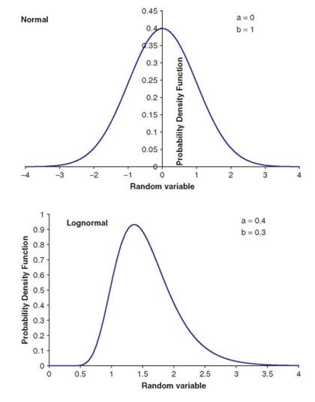

Gumbel

The Gumbel distribution is useful for modelling extreme values, representing the distribution of the maximum value out of a large number of random variables drawn from an unbounded distribution.

The general form of the PDF for the minimum Gumbel is:



where:

μ = the location parameter, β = the scale parameter.

The probability density function has only one, unchanging shape which shifts according to the location parameter, μ. As μ increases, the distribution shifts to the left; As μ decreases, it shifts to the right.

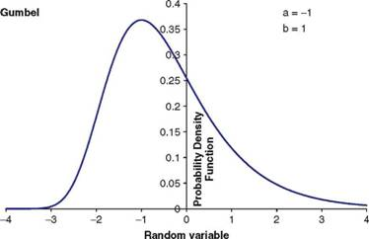

Weibull

The Weibull distribution is also useful for modelling extreme values, representing the distribution of the maximum value out of many random variables drawn from a bounded distribution. Bounded below and unbounded above. It has three parameters: a, location; b > 0, scale; c > 0, shape. Its probability density function is given by



