Let's think about auto insurance. Why do people feel their premium is wasted if they do not file a claim? If you can think about put options and potential gain should a loss occur? It would be beneficial if you could relate insurers’ pooling of losses with the concept of risk management.

**Auto Insurance vs Put options Attachment**

**Pooling of losses for risk management**

Auto insurance companies make money by charging sufficient premiums to cover the actual losses incurred and leaving a profit for the company. Pooling or sharing of losses is the essence of insurance. Pooling is the spreading of losses incurred by the few over the entire group, so that in the process average loss is substituted for actual loss. To understand this concept, let us assume there are 2 car owners owning identical cars worth $15,000 each. Let us assume there is a 10% chance of the car going into accident (the trigger event) and having extensive damages.

Expected loss = (.90*0) + (15,000*.10) = $ 1500.

Risk (Stdev) = sqrt((.90*(0-1500)^2) + (.10*(15000-1500)) = $4500

Now if the owners decide to pool their losses, there are 4 possible outcomes:

Probability(neither car in accident)=.90*.90=0.81

Probability(only first car in accident)=.10*.90=.09

Probability(second car in accident)=.90*.10=.09

Probability(both cars in accident)=.10*.10=.01

If neither car is in accident, the loss for each owner is $0. If only one car is in accident, each owner pays $7,500. If both cars are in accident, each owner pays $15,000.

Expected loss = (.81*0) + (2*.09*7500) + (,01*15000) = $1500 #expected loss remains same

Compare the risks in both cases

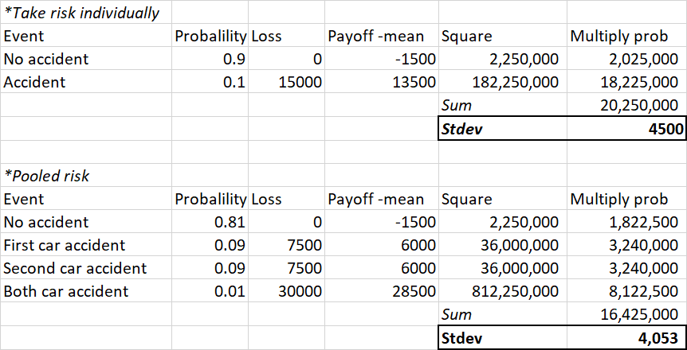

As additional individuals are added to the pool, the expected loss remains the same but the standard deviation continues to decline.

**Why do people feel premium is wasted if they do not file a claim?**

Let us assume the premium is $1500 and the asset being covered is $15,000.

There are two outcomes, accident or no accident. If no accident, you end up paying the $1500. You may consider this as wasted, However, if there is an accident, the company covers damages worth $15,000 and instead of having a 15,000 loss, it is still limited to the 1500 premium that you paid in the first place. Let’s say 2 out of 10 people are getting into car accidents. Then 8 people not getting into accidents may feel like they are paying a premium for nothing, until they get into an accident and find that their downside(losses) are limited to the premium amount ($1500). You are paying your premium to restrict your losses to $1500.

**Compare to put options**

This is very similar to the payoff from a put option where you are limiting your loss to $1500. In this case, the strike price is the amount being insured ($15,000) and the premium ($1500) is the cost of the option. As you can see in the diagram below, as the damages are higher, the Asset value moves towards 0. As it reaches 0, the maximum you profit is (15000-1500) or 13,500 (the opportunity cost is not getting insurance and paying for a new car with 15,000). But if the damage is 0, the payoff is -1500 (premium paid).

