*Although options and forwards are important in an of themselves, they are also commonly used as building blocks in the construction of new financial instruments. Please provide some examples....and explain why these would be important.*

Some strategies where options and forwards are used as building blocks to create new financial instruments:

1. Long Butterfly spread: A long butterfly spread with calls is a three-part strategy that is created by buying one call at a lower strike price, selling two calls with a higher strike price and buying one call with an even higher strike price. All calls have the same expiration date, and the strike prices are equidistant. A long butterfly spread with calls is the strategy of choice when the forecast is for stock price action near the center strike price of the spread because long butterfly spreads profit from time decay. However, unlike a short straddle or short strangle, the potential risk of a long butterfly spread is limited.

An example is given below:

Buy 1 XYZ 95 call at 6.40

Sell 2 XYZ 100 calls at 3.30

Buy 1 XYZ 105 call at 1.45

The payoff is shown below

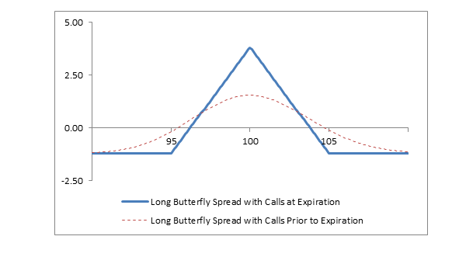

Source: https://www.fidelity.com/learning-center/investment-products/options/options-strategy-guide/long-butterfly-spread-calls

2. Forward Swaps: This is an agreement between two investors to swap assets, interest rates or almost anything else on a set date in the future. A forward swap exists in order to provide investors with the flexibility to accomplish certain investment goals, for e.g. the counter party may wish to use a swap to hedge their risk, but are only willing to accept the risks for the first year of the investment. A forward swap may consist of more than one swap. The counter parties may agree to swap interest rates beginning in 6 months, and then swap a different interest rate after one year. These type of instruments are mostly used by financial institutions to hedge interest rate risk.

3. An interest rate collar is an agreement where the seller or provider of the collar agrees to limit the borrower’s floating interest rate exposure to a specified ceiling rate and floor rate. Analytically, this represents the simultaneous purchase of a cap (which is a series of put options) with the sale of a floor (which is a series of call options). If market rates exceed the ceiling rate, then the collar provider will make payments to the buyer sufficient to bring its rate back to the ceiling. If rates fall below the floor, then the borrower makes payments to the collar provider to bring its rate back to the floor. When rates are between the floor and the ceiling the borrower pays the market rate of interest. The buyer of a collar has effectively confined his borrowing range. The idea behind a collar is to lower the up-front payment associated with a cap purchase.

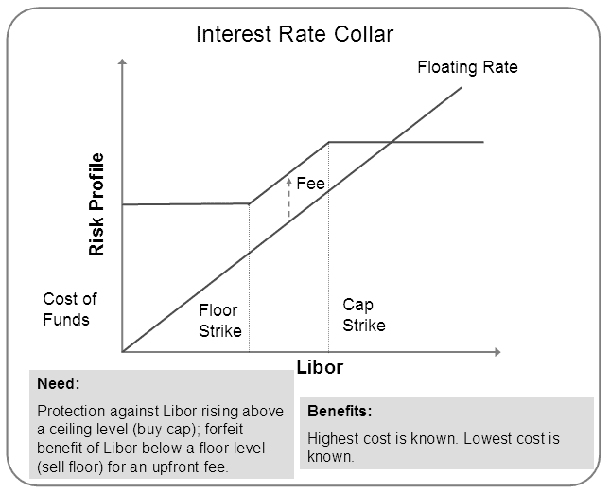

Source: https://financetrain.com/how-interest-rate-collars-work/