*Please answer the two questions below :*

*Rapid change seems to be the order of the day, as the speed and complexity of business continue to increase. Technological advances such as cloud computing, mobile devices and social media continue to take hold. Regulatory demands continue to expand. Workforce dynamics continue to evolve. These and numerous other trends spawn new risks, altering risk profiles and exposing business models to disruptive change. Because of this dynamic environment, enterprise risk management should provide the discipline to ensure a fresh look at the organization’s risk management capabilities from time to time.*

*What are the company’s top risks, how severe is their impact and how likely are they to occur?*

*Is the company prepared to respond to extreme events?*

Some of the top risks of a company are:

1. Strategic Risk: This is the risk that the company’s strategy becomes less effective in the marketplace. This could be due to technological changes, a powerful competitor entering the market, shifts in consumer demands and their way of thinking, etc. A classic example is Kodak, once the market leader in photography equipment, who did not enter the digital camera market in fear of cannibalizing its own business.

Questions to ask: Is the business highly dependent on a particular technology that has a chance of being replaced? Do people have alternatives for our product? What will happen if a new competitor enters and starts a price war? Do we have a plan if our products go out of fashion?

2. Compliance Risk: This is the risk that you are not complying with the applicable laws and regulations. This is especially valid for global food chain companies, with each domicile having its own food safety, labeling and tax and accounting rules. There are also new regulations coming in all the time and the company needs to be complaint by set deadlines.

Questions to ask: Are we expanding to markets that require adherence to significantly different regulations? What rules are we not complying to, how much fine may be the consequence? Are we complying to the employment regulations by region? Can the government shut us down or put significant new restrictions on our core business activity?

3. Operational Risk: This is the risk of an unexpected failure in the company’s day to day operations. The company needs to have standard operating procedures and the processes need to be set up to minimize people and technology failure.

Questions to ask: How often do our systems and technology fail, do we have a backup? Are we processes adequately designed to deter human error and scams? Can we have a natural disaster and what is the recovery site? What is the impact of the loss of a key employee?

4. Financial risk: This refers to the possibility of a sudden financial loss. For example: if we are earning 60% of our revenue from a single consumer, this poses significant concentration risk. For global businesses, there are currency risks involved in the form of a huge fluctuation in the exchange rates.

Questions to ask: Do we have concentration risk, what if our biggest client goes bankrupt? How sensitive is our debt to changes in interest rates? How vulnerable are we to exchange rates? What is the cash flow strategy in cases of events like COVID and many clients stop paying?

5. Reputation risk: A loss in reputation of the company in the marketplace can have significant impacts in the form of lost revenue and customers boycotting the products. There are also impacts of employees getting demoralized and the company losing its best human resources. There can be a major lawsuit against the company, or an embarrassing product recall.

Questions to ask: What can be the impact of a negative review from an influencer? Do we have PR resources to deal with crisis situations? What is the effect on the business of a mass negative review on social media?

The severity and impact of the events outlined above actually depend on the nature of the event. A company can have a risk scorecard like below to analyze the severity, likelihood and impact of such events.

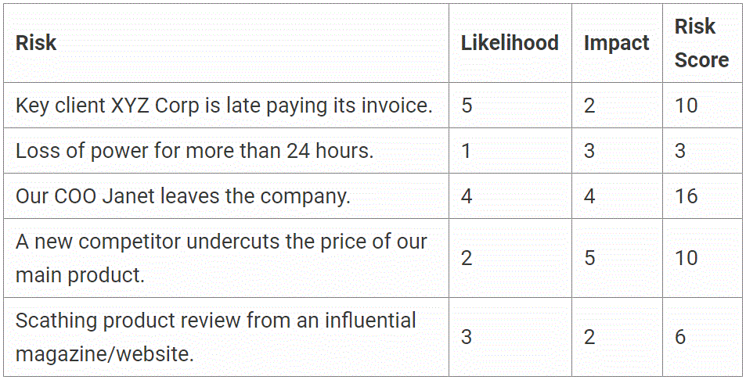

There are four main strategies to deal with risks:

Avoid it: For e.g. if the production of a certain product is completely banned in a country due to religious sentiments, it is best to avoid the product rather than trying to find loopholes to continue with production.

Reduce it: For e.g. for a major customer posing concentration risk, discounts for early payment and penalties for late payment may be designed to encourage paying early. A reserve for bad debts may be allocated to deal with credit risk.

Transfer it: An insurance contract can help transfer the associated liabilities to another party. A company may also take out liability insurance to protect itself from potential lawsuits if those are frequent in the industry.

Accept it: In the case of minor risks with less likelihood and less severity, it is best to simply accept them.

A company should have a risk plan and monitor and update it on a specific frequency to deal with all enterprise risks.

Source: https://business.tutsplus.com/tutorials/effective-risk-management-strategies--cms-22887