- Python based utility
- The tool is running in interactive mode
- Installation = “git clone” on Undercloud
- Operation Modes:

1) - Export ERRORs/WARNINGs from Overcloud logs
2) - Download all logs from Overcloud
3) - "Grep" some string for all Overcloud logs
4) - Check current:CPU,RAM and Disk on Overcloud
5) - Execute user's script
6) - Download "relevant logs" only, by given timestamp
7) - Export ERRORs/WARNINGs from Undercloud logs
8) - Overcloud - check Unhealthy dockers
9) - Extract all logs messages for given time range
10) - Extract NEW (DELTA) messages from Overcloud
11) - --- Install Python FuzzyWuzzy on Nodes ---

LogTool – Python based utility, that is coming to help us to work with OSP logs: detecting ERRORs/WARNINGS, Download logs (Not SOS Report!!!), Grep <some string> on all nodes, detecting “unhealthy dockers”, “CPU and RAM usage” e.t.c ...

This interactive tool provides a set of operation modes and may help us to investigate the “OSP issues” we've encountered in daily mode.
For example it could be:
- Manual or Automation test, that is failed.
- Night tests – something went wrong and you might want to understand why, by using OSP logs in order to find out the “root cause”



1) Motivation or why do we need it?

- The amount of OSP logs (without rotated *.gz) is terrible, for example on single Controller node we have:
[heat-admin@overcloud-controller-0 ~]$ ls -ltrhR /var/log/containers/ | grep .log | grep -v .gz | wc -l
203

- Our Setups are usually a bit complicated, for example this one is mine
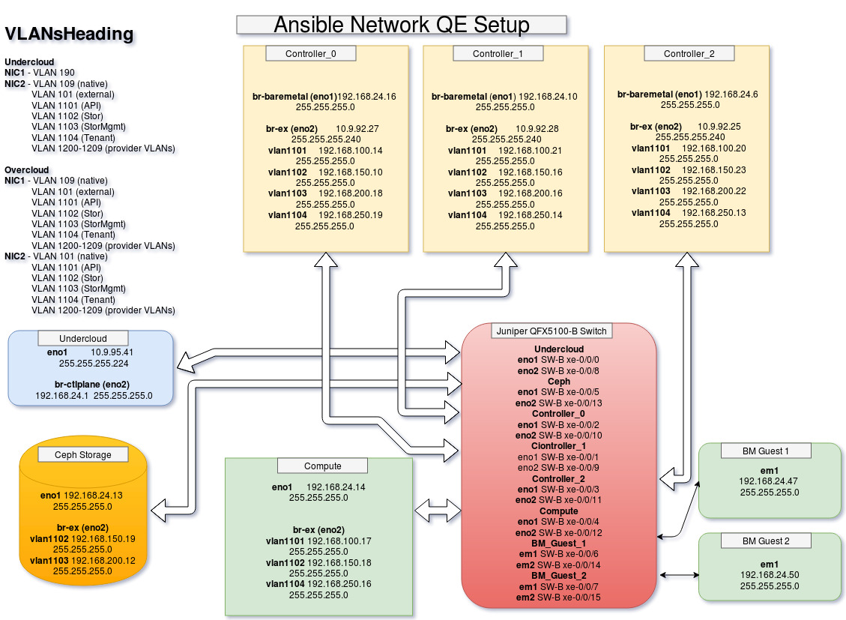
- Spending time on “donkey work” is not the best effort we can give as QEs


Donkey work definition
1) Detecting Overcloud nodes IPs
2) SSH to the nodes
3) Using all known Linux tools stuff: “vi”, “less”, “grep”, “cat”, “zcat”, “zgrep” … on so on
4) To keep in mind “relevant time range” and to compare it with investigated log messages all the time
…
…

- Sometimes, after all manual stuff is done, you just getting into conclusion that nothing “interesting” was found or you’ve just missed it somehow.



Pass through: https://github.com/zahlabut/LogTool

Demo

11) --- Install Python FuzzyWuzzy on Nodes ---

1) - Export ERRORs/WARNINGs from Overcloud logs
- Dedicated Result file is created for each Overcloud node
- Each result file is divided into 4 sections:

#################### Table of content (Section name --> Line number)####################
Extracted Errors/Warnings (raw data) --> 4
Warning, following logs failed on parsing due to non standard date format --> 2246
Statistics - Number of Errors/Warnings per log --> 2290
Statistics - Unique(Fuzzy Matching per log file --> 2298
Statistics - Unique(Fuzzy Matching for all messages in total --> 2487

3) - "Grep" some string for all Overcloud logs
Grep strings:
1499e460-4566-4084-8914-9df3f669b65c (Image)
dd03b56b-d644-4e81-b6f2-80afcdc64c74 (Server)

8) - Overcloud - check Unhealthy dockers

4) - Check current:CPU,RAM and Disk on Overcloud

6) - Download "relevant logs" only, by given timestamp
Hour ago example:
-rw-rw-r--. 1 stack stack 12M Jan 13 17:47 overcloud-controller-0.zip
-rw-rw-r--. 1 stack stack 12M Jan 13 17:47 overcloud-controller-2.zip
-rw-rw-r--. 1 stack stack 12M Jan 13 17:47 overcloud-controller-1.zip
-rw-rw-r--. 1 stack stack 8.3K Jan 13 17:47 overcloud-compute-0.zip
-rw-rw-r--. 1 stack stack 198 Jan 13 17:47 overcloud-cephstorage-0.zip

5) - Execute user's script

10) - Extract NEW (DELTA) messages from Overcloud

Limitation - Not standard log format

Usually OSP logs contains the debug level and the time stamp in each log’s line, but not all logs are keeping this convention, therefore
such logs files, will be added into the black list on run-time and will be reported in dedicated section inside the result file.

- Standard OSP log format includes time stamp and log level per logged messages, for example:
/var/log/containers/nova/nova-compute.log
2019-01-13 09:28:47.070 1 ERROR nova.compute.manager [req-930f5a88-9034-43ff-9dc3-a9a42212f875 9f5d20fe5240409c96941bc1b400d31b 9a1bffe7edb74dafba5dac89aeea7a08 - default default] [instance: e83f05e0-736e-4a5e-a546-ea1c9a4b0163] Setting instance vm_state to ERROR: Conflict: Node 5f03e7e3-5a1a-44c3-aa4e-e3e4c1856f06 can not be updated while a state transition is in progress. (HTTP 409)

- Not standard log format
/var/log/containers/rabbitmq/rabbit@overcloud-controller-2.log.1
=INFO REPORT==== 10-Jan-2019::09:57:01 ===
accepting AMQP connection <0.21900.121> (192.168.100.12:56330 -> 192.168.100.26:5672)

/var/log/containers/redis/redis.log
95:S 13 Jan 00:02:57.984 * 10000 changes in 60 seconds. Saving...
95:S 13 Jan 00:02:57.984 * Background saving started by pid 810932

/var/log/containers/ironic-inspector/dnsmasq.log
Dec 30 15:11:17 dnsmasq-dhcp[1]: read /var/lib/ironic-inspector/dhcp-hostsdir/unknown_hosts_filter
Dec 30 15:32:33 dnsmasq[1]: inotify, new or changed file /var/lib/ironic-inspector/dhcp-hostsdir/52:54:00:9e:3b:81

