Comments about Package 1 for AdminTool

A button to jump to TODAY is missing
The calendar component is awesome, but the navigation button to jump back to TODAY is needed

Week shall start on MONDAY
According to US calendars, weeks start on SUNDAY. However, one of the requirements is that the week starts on MONDAY.

In the code there is a property called dayMaxEvents
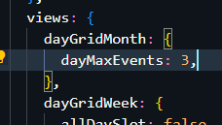
dayMaxEvents is 3
What happens if there are more than 3 events? A scroll will be activated?

Events are displayed differently on Month view and Week/Day view
Month View:
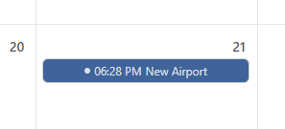

Week/Day view:
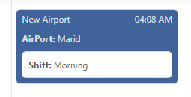
Why is this? Because of the space available?

Event should look like this
Picker: {ABC}
Vehicle: {qwert}
Assigned Airport: {POU}
City: {mnbv}
Handler: {ABC}
Assigned Airport: {POU}
City: {mnbv}

In case a smaller version is needed
Picker: {ABC} / Vehicle: {qwert}

Handler: {ABC} / Airport: {qwert}

Each day shall be divided into 2 parts, one for each shift
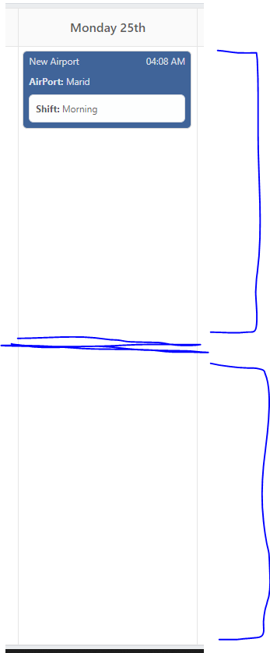
In this case, Morning Shift events would be in the upper box; Afternoon Shift events in the lower box.

Hight of week component should not be that much
The component could be smaller (in height) and grow depending on the amount of events
Right now, the component takes too much space that is not used

Modal Window for Create event needs the date
Date is an important field that is not taken into account in the modal window

Going further…

We need 2 create event buttons
- One button to add Picker/Vehicle event
- One button to add Handler/Airport event

Clicking on the event should display the information in a modal window
Similar to the modal window displayed when adding an event, the data of the event shall be displayed.
The idea is to be able to EDIT, DUPLICATE or DELETE an event.
These 3 options would appear in the modal window, so the user selects what to do.

Filter events after…
- Picker
- Handler
- Vehicle
- Airport
- City
- Shift
The idea is to show only information matching what the user selects

