[root@bop-db ~]# yum install tigervnc-server

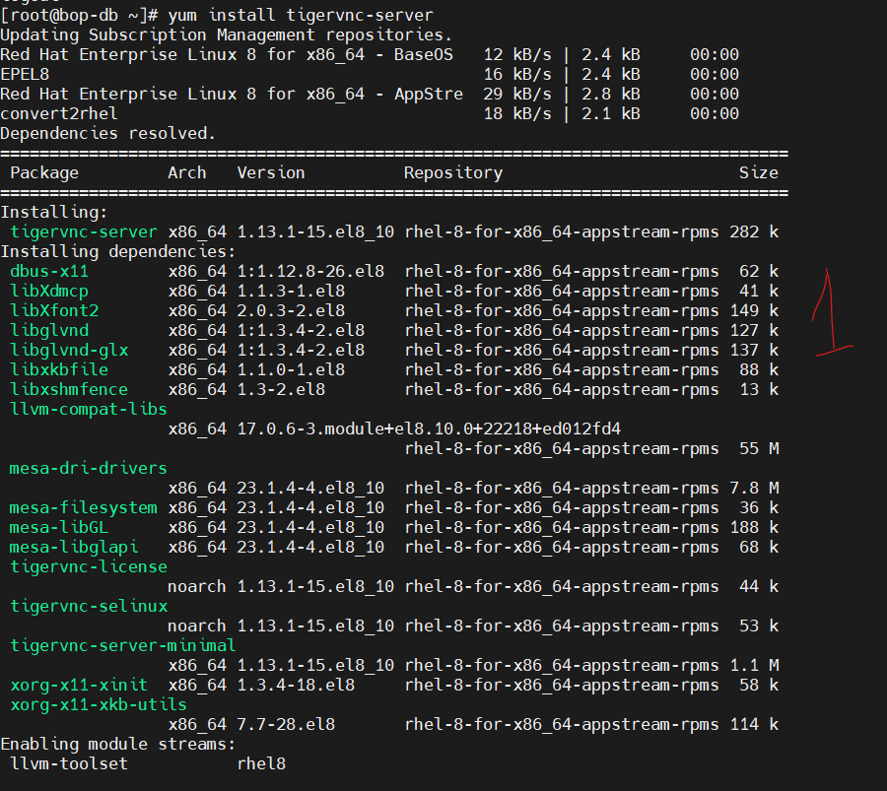

[root@bop-db ~]# dnf group install "Server with GUI"

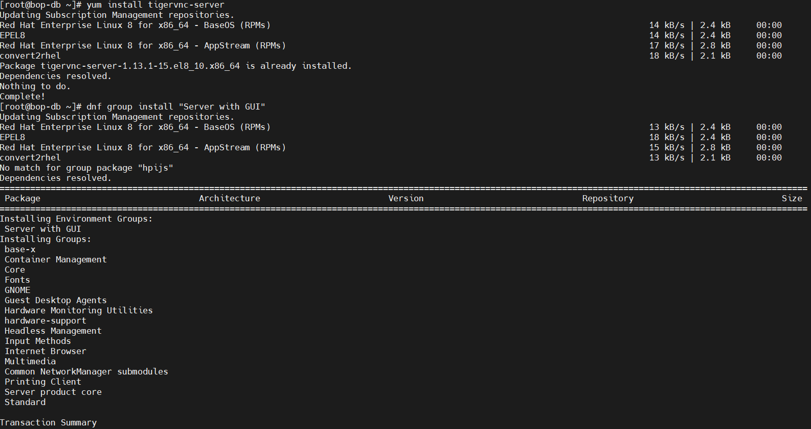

vi /etc/tigervnc/vncserver.users

here I have added oracle user

:1=oracle ( I will be accessing the GUI with oracle user)

systemctl start vncserver@:1 (from root user)

vncserver -list

