LAB 2 - AGILE PROJECT MANAGEMENT
  - Airport Lost Luggage Claim & Tracking Portal
Student Registration Number | PES1UG24CS579
Problem Statement | 30
Primary Domain | Smart Cities, Transport & Logistics
Target Actors | Passenger; Baggage Service Agent
Jira Space | Airport Lost Luggage Portal (SCRUM)

1. Objective and Scope
The Jira workspace models a traceable airport lost-luggage recovery lifecycle. The implementation is intentionally constrained to one epic and one completed sprint, as specified for this submission.

2. Epic and Product Backlog
Epic: SCRUM-5 - Airport Lost Luggage Recovery Lifecycle
Epic intent: Enable passengers and baggage service agents to report, track, investigate, recover, return, and compensate lost-luggage claims through one auditable workflow.
Key | User Story | Priority | Points | Final Status
SCRUM-1 | Submit Lost Luggage Claim | High | 3 | Done
SCRUM-2 | Match Claim with Baggage Scan Logs | High | 5 | Done
SCRUM-3 | Track Claim and Bag Timeline | High | 5 | Done
SCRUM-4 | Investigate Claim and Arrange Return | High | 5 | Done
SCRUM-6 | Process Eligible Compensation | Medium | 8 | Done
Total commitment: 5 user stories, 26 story points.

3. Epic Evidence
The epic contains the five implementation stories. All stories are linked to SCRUM-5 and show their final completion state in Jira.
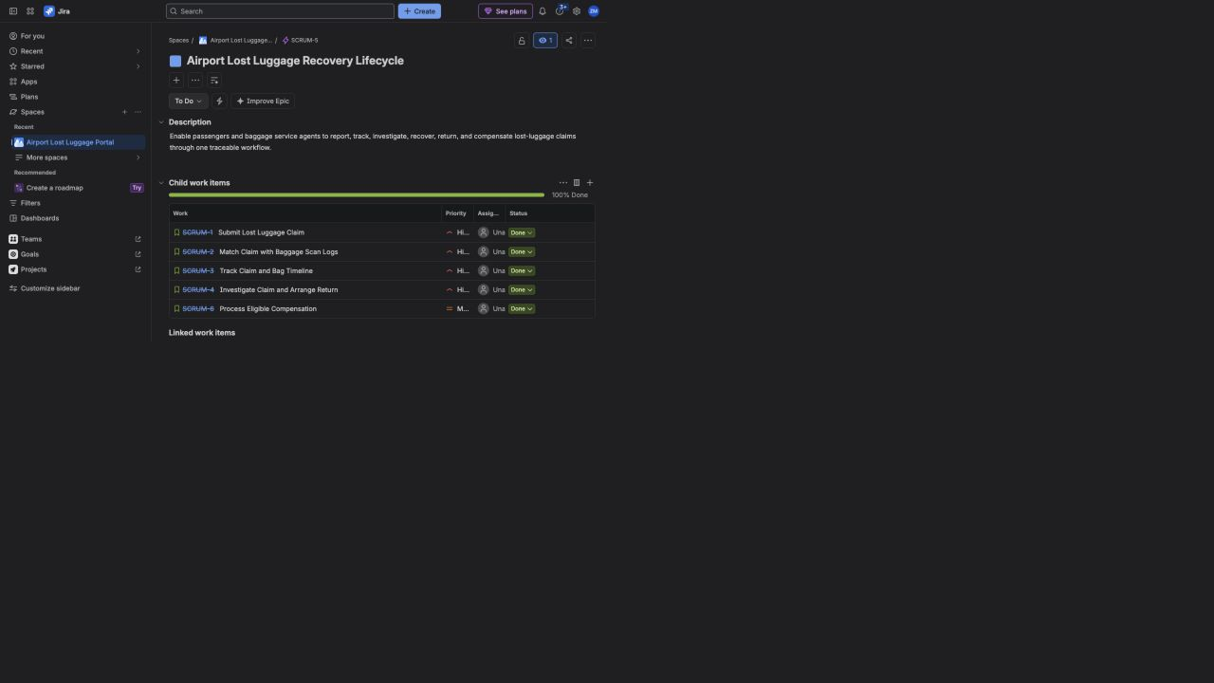
Figure 1. Jira epic and linked user stories.

4. Sprint Execution
Sprint Attribute | Configured Value
Sprint | SCRUM Sprint 1
Duration | One week: 2 September 2026 to 9 September 2026
Commitment | 26 story points
Workflow simulation | To Do -> In Progress -> Done
Completion | 5 of 5 stories completed; 26 of 26 points delivered
The active board initially placed all five committed stories in To Do. Each story was then moved through In Progress and completed in Done before the sprint was closed.

Figure 2. Active sprint board at the initial To Do state.

5. Burndown Evidence
The burndown below reconstructs the verified Jira work history for the completed one-week sprint. The report-page screenshot could not be reopened in the embedded browser, so the visual is derived from the recorded status transitions and the confirmed final state of 26 out of 26 points in Done.
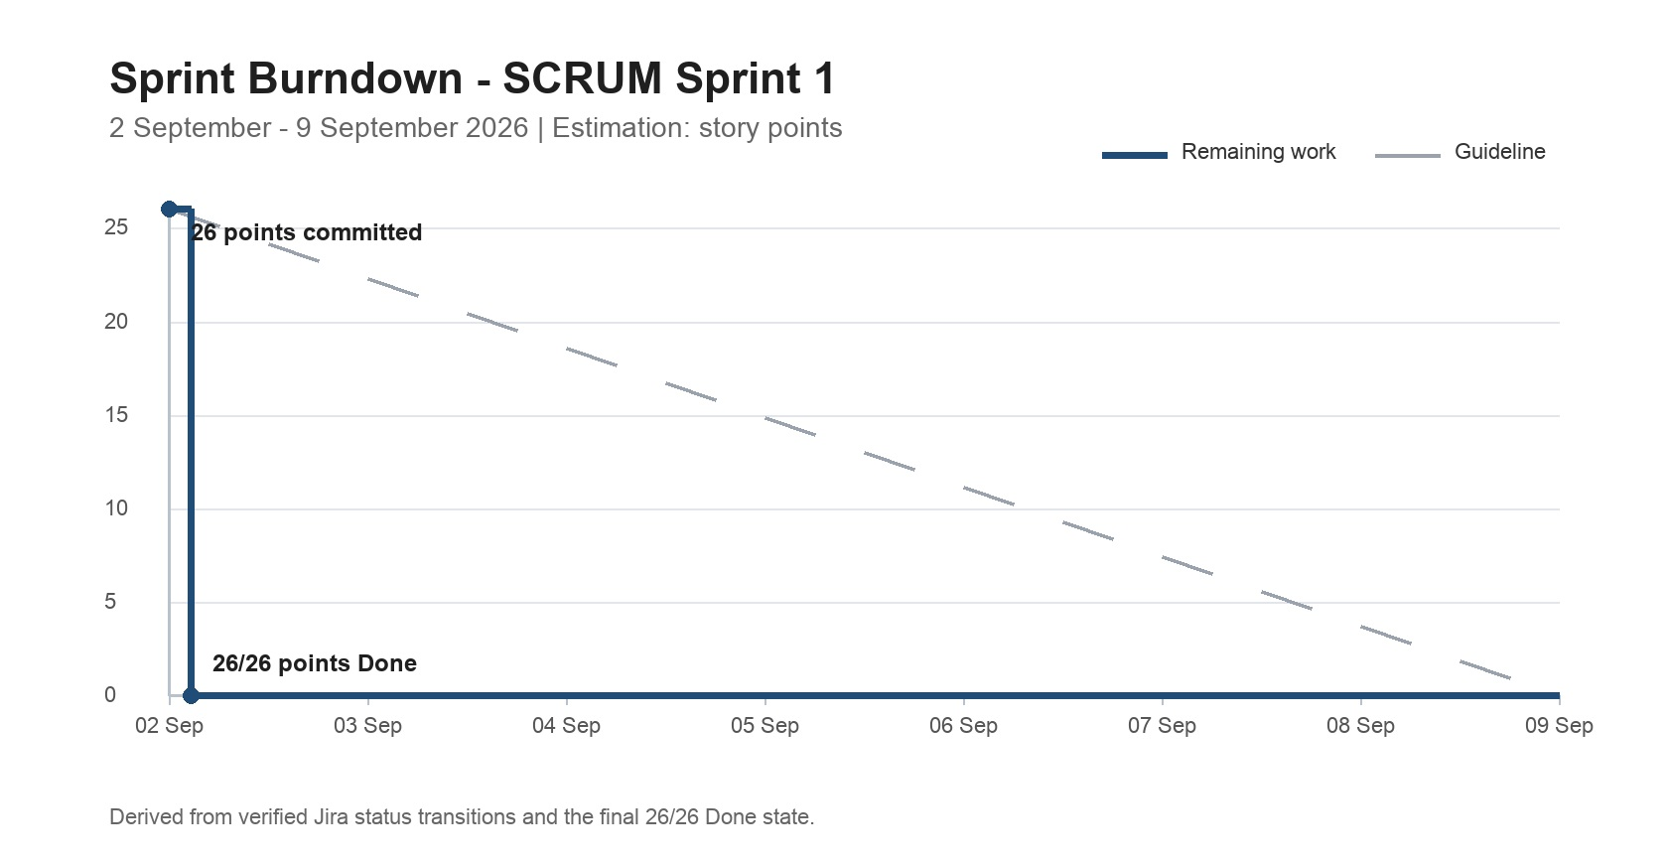
Figure 3. Derived burndown for the completed Jira sprint.

6. Reflection
1. Did the estimations reflect the actual effort?
Yes. The 3-point claim-submission story was the smallest bounded workflow, while scan matching, timeline tracking, and recovery coordination required more integration and validation. Compensation received the highest estimate because it combines eligibility rules, evidence checks, decision output, and payment-state handling.
2. Was the backlog well-prioritized?
Yes. High-priority work established the operational recovery path first: claim creation, scan matching, tracking, and agent-led return. Compensation followed at Medium priority because it depends on a mature, unresolved claim.
3. How did the simulated sprint align with expectations?
The sprint progressed logically from intake and scan matching to passenger visibility, agent recovery, and final compensation handling. The staged status changes made work-in-progress visible and preserved traceability before all five stories were completed.
4. What insights did the burndown provide?
The chart showed a single concentrated completion step because all status changes were simulated on the same day. In a real sprint, smaller stories should be closed continuously to provide steadier feedback and expose delivery risk earlier.

