Dear **Mr Soltani**,

Thanks for send code challenge for me,

I do it with visual studio 2022 and dotnet 7

I use Clean Architecture from [ASP.NET Core WebAPI Clean Architecture - Visual Studio Marketplace](https://marketplace.visualstudio.com/items?itemName=MukeshMurugan.CleanArchitectureWebApi)

I design database but I did not consider validation I want to send you quickly

Develop controller api for Family-Parent-Student and Insurance

1. Implement endpoints and manager in project CleanArchitecture.WebApi1.Infrastructure.Client
2. Include functionality to peoject CleanArchitecture.WebApi1.Application in Features with MediatR

But I don’t work with unit test

If you have any questions, please call me to answer

I use swagger 🡪 use version 1 and try it

Project run on https://localhost:4221/swagger

Family:

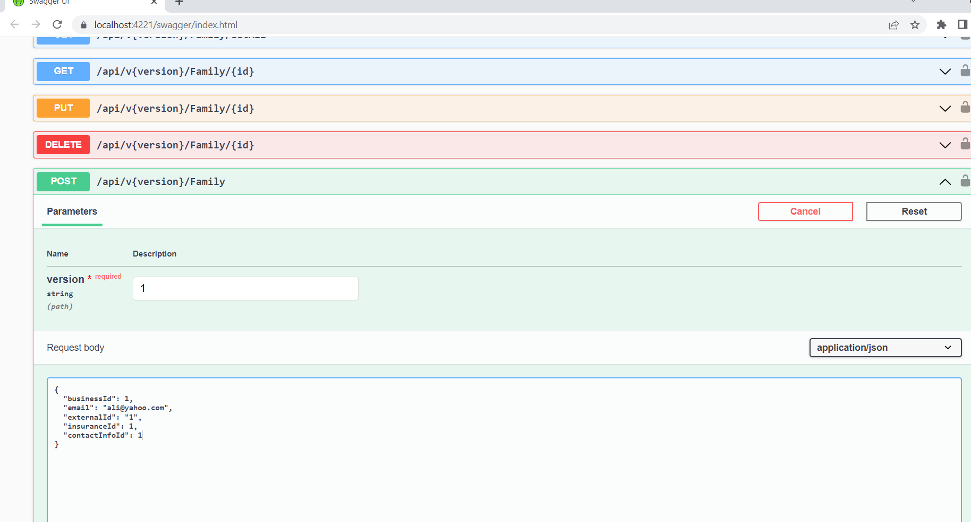

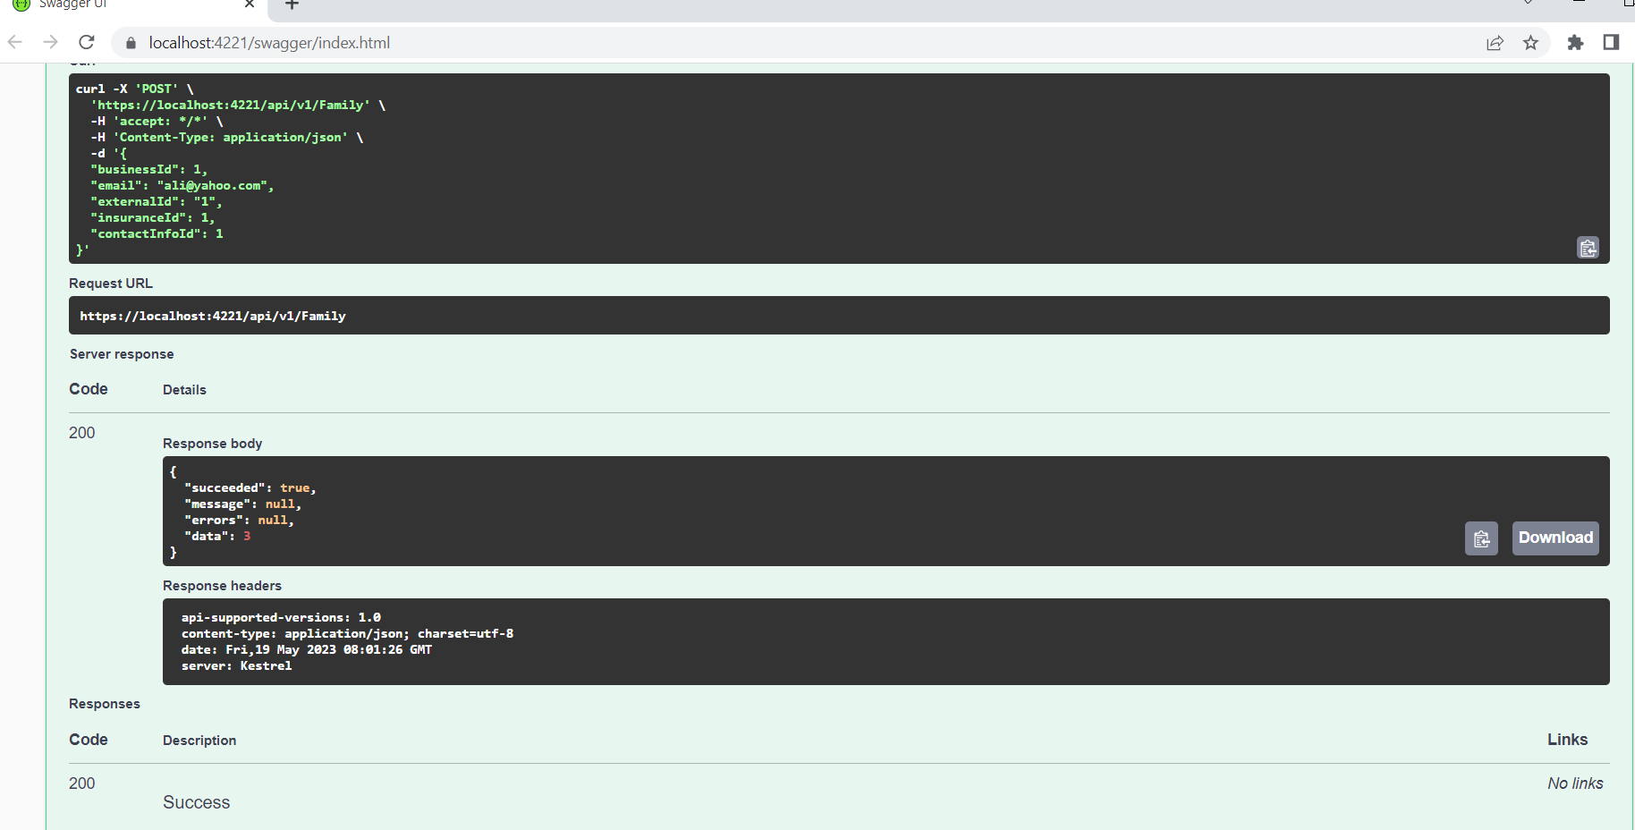

Parent:

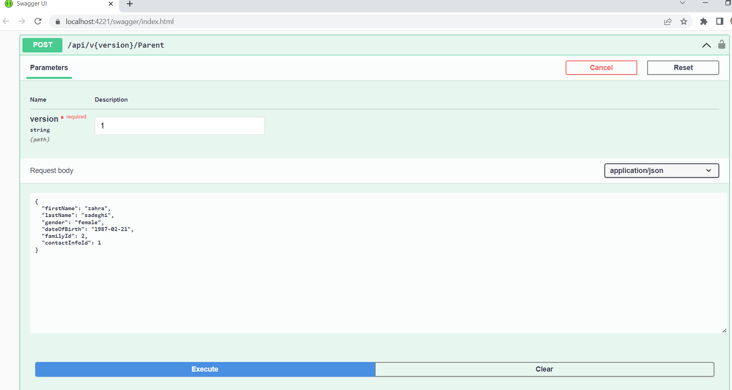

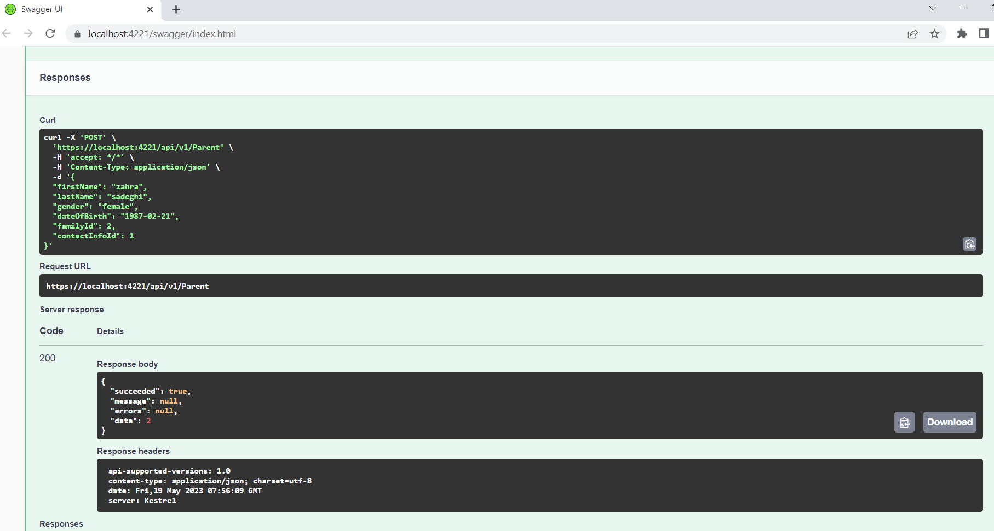

Student: 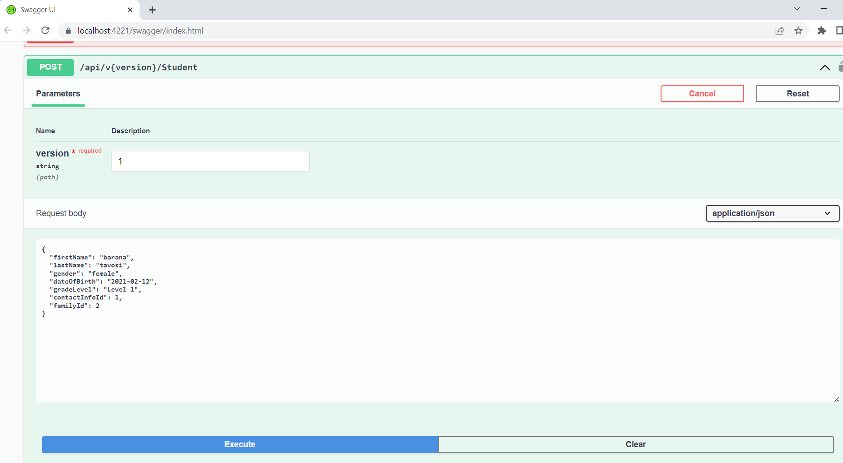

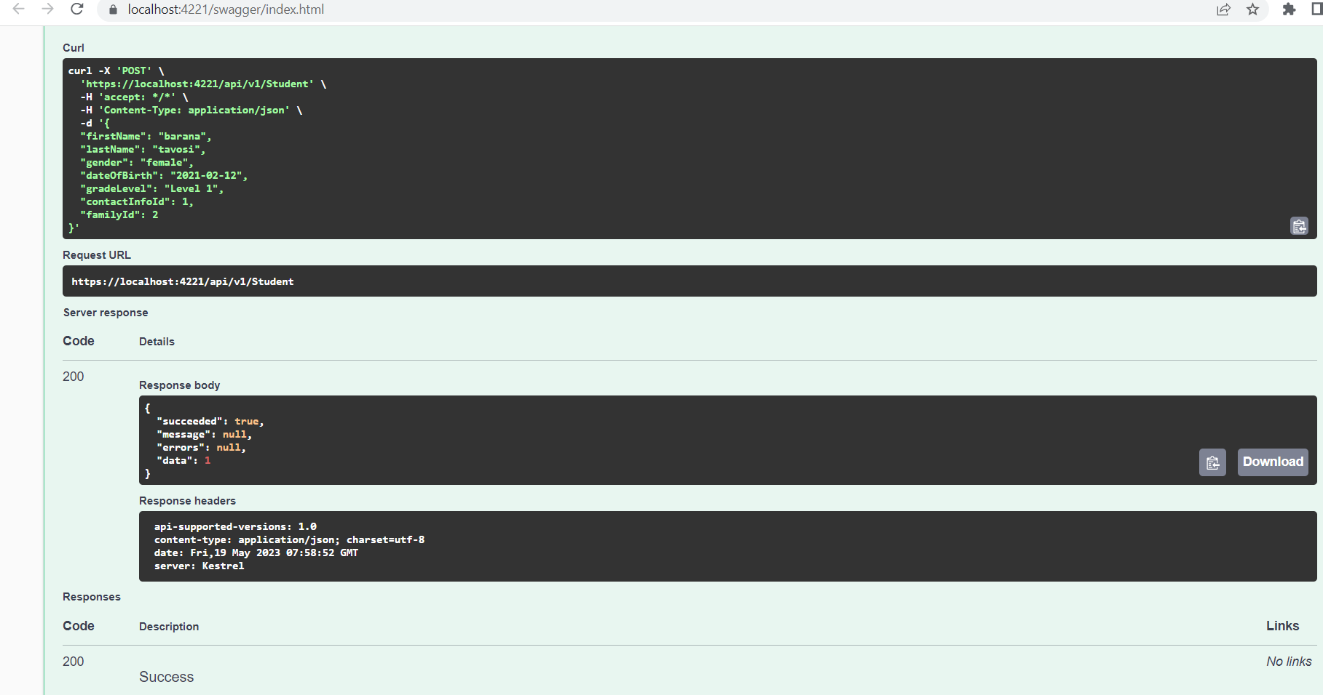

Best regards,