
FACULTY OF COMPUTER SCIENCE AND IT

PATIENT TRACKING SYSTEM

At: Shafi Specialist Hospital in Mogadishu-Somalia

By

1. Abdirahman Mohammed Yusuf ID No: CS0900258
2. Zahra Abdirahman Yasin ID No: CS0900288
3. Abdullahi AbdiAziz Mohamud ID No: CS0900268
4. AbdiShakur Omar ibrahim ID No: CS0900305

A RESEARCH PROJECT SUBMITTED IN PARTIAL FULFILMENT OF THE REQUIREMENTS FOR THE AWARD OF THE DEGREE OF BACHELOR OF COMPUTER SCIENCE AND IT OF JAZEERA UNIVERSITY

SUPERVISOR
Eng. Abdi Ishak Mohamed

September, 2022
Mogadishu - Somalia
JAZEERA UNIVERSITY (JU ORIGINAL LITERARY WORK)
DECLARATION

Name of Candidate 1 Abdirahman Mohamed Yusuf ID No: CS0900258
Name of Candidate 2 Zahra Abdirahman Yasin ID No: CS0900288
Name of Candidate 3 Abdullahi Abdiaziz Mohamud ID No: CS0900268
Name of Candidate 4 Abdishakur Omar Ibrahim ID No: CS0900305
Name of Degree: Bachelor
Title of Project Paper Research Report/ Dissertation/Thesis (“this work”): Patient Tracking System
Field of study:
We the undersigned do solemnly and sincerely declare that:
(1) We were the authors/writers of this work
(2) This Work is original;
(3) Any use of any work in which copyright exists was done by way of fair dealing and for permitted purposes and any except or extract from, or reference to or reproduction of any copyright work has been disclosed expressly and sufficiently and the title of the work and its authorship have been acknowledged in this work;
(4) We do not have any actual knowledge nor do I thought reasonably to know that the making of this work constitutes an infringement of any copyright work;
(5) We hereby assign all and every right in the copyright to this work to Jazeera University (JU), who henceforth shall be owner of the copyright in this work and that any reproduction or use in any form of by any means what so ever is prohibited without the written consent of JU having been first and obtained;
Candidate 1’s Signature: _______________
Candidate 2’s Signature: _______________
Candidate 3’s Signature: _______________
Candidate 4’s Signature: ________________

Subscribed and solemnly declared before Date: ________________________________
Supervisor’s Signature: _____________________ Date: ____________________

Dedication

We dedicate this special project to our beloved mother, dear father and brother, as well as our entire family for the support and encouragement and to all those who contributed in one way or another towards our education life and our supervisor who help this project.

APPROVAL SHEET

This is to confirm that the proposal entitled “PATIENT TRACKING SYSTEM” submitted by the above-mentioned candidates for partial fulfillment of the requirements of bachelor degree of Computer Science and IT, under the Faculty of Computer Science and IT, Jazeera University, is an original research proposal and the results embodied in this proposal have not been submitted elsewhere for the award of any degree in this University or any other similar institution.

Eng. Abdi Ishak Mohamed

(SUPERVISOR)
_____________________________________

2022
Date: ……. /………../……

Mr. Mohamed Hayir Tahlil
(RESEARCH COORDINATOR)
__________________________________

2022
Date: ………. /………../………

Eng. Jamila Hassan Mohamed
(Dean Faculty of Computer Science and IT)
__________________________________
2022

Date: ………/………... /………

CHAPTER ONE
INTRODUCTION
- INTRODUCTION

In today's world, everything is based on the use of technology, and it is very important that everyone has at least a little knowledge of it.
Patient tracking system is a system designed to monitor a patient and all his or her pain conditions making it easier for them to track their patients.
The system allows you to get all the information about the patient. It also shows you how to monitor the patient's condition. and allows the system to show you any illnesses that may have occurred to patients in the past.
An PTS will be necessary because there are a lot of difficulties in maintaining a large amount of information on paper, especially as there is usually no back-up for the information, access to information can prove difficult and time-consuming if it has to be searched for, and accuracy is needed in the recording of vital information, and chief medical personnel cannot oversee all that is written on the vast amount of paper to be used. It is, therefore, vital for a healthcare organization such as a hospital to have an automated patient tracking system.
A patient tracking system allows a health care provider to log and monitor the progress of a person through the provision of care during their stay there.

In this chapter, we will focus on the various elements of a project, including
the background of the study, the problem statement, and the significance of the study, objectives, and project organization.

  - BACKGROUND OF THE PROBLEM

Prior to implementing the first phases of a computerized patient record in the outpatient clinics of the Children's Medical Center of the University of Virginia, we performed a comprehensive assessment of current practices. Graduate students from the McIntire School of Commerce at the University of Virginia systematically reviewed work and information flow in the pediatric outpatient clinics located within the Primary Care Center. As a result of this review, a number of processes were eliminated and others were substantially re-engineered. As an outgrowth of this review process, it was concluded that a computerized patient tracking system would aid in communication between various care providers and improve patient throughput as well as overall room utilization. Approximately one year ago, we first deployed such a computerized patient tracking system.
Prior to deployment of the system, we performed an assessment of baseline practices. The purpose of this paper is to document the impact this computerized patient tracking system has had on the daily operations of our outpatient clinics.(Borowitz, n.d.)
Patient tracking system offers world class patient tracking solutions which can be used in any healthcare setting needing to manage the patient flow process. From single provider practices to large hospital groups, to multi-facility healthcare organizations, our systems are both affordable and scalable(“Tracking Solutions | Patient Tracking Software - PatientTrak - PatientTrak” n.d.).
Before the creation of patient tracking software, medical professionals and health care experts used more traditional means for patient tracking. For instance, the Los Angeles Air Force Base’s 61st Medical Squadron used management boards to maintain pharmaceutical equipment quality. They also used them to make sure that no bacteria are present in the water added to their powdered prescriptions.
While that system may have worked for them, we cannot deny that technology helps make processes more efficient. Today, IT solutions are becoming more and more popular. On the daily, app developers are creating new and innovative systems to simplify work. As such, with the help of patient management software, medical professionals and experts can improve on their performance and provide the best healthcare that they can(“Patient Tracking Software and Their Benefits - Syntactics Inc.” n.d.).
  - Nationally
In Somalia, as with the least developed countries, health and development indicators have hardly seen any improvement.
Diseases that were common in the early 1960s, after independence, Remained prevalent until today, despite some progress in social service sectors in the early 1970s. This shows that the country The health care system was unable to provide treatment satisfactorily the first and foremost challenge to the development of a sound healthcare plan is a lack of strategic information and data on the health care
system and its operations, and information on other related sectors. Most of the health service facilities record basic client information but these were never analyzed or utilized. The MOH mandated several diseases to be reported to its national surveillance office. Such information was occasionally tabulated and sent to the central office in Mogadishu by the regional MOH authorities. However, the data was haphazardly collected and had little use for effective planning and operational decisions. although in recent years it has made some progress in improving the systems in the hospitals which will be used to improve the operation of the hospital system and to facilitate operations.(National and Pillars, n.d.)
Somalia's health system has been in a severely weakened state for decades due to conflict and humanitarian crises which have led to the displacement of more than 2.6 million Somalis.(“IOM Somalia Supports New ‘Telemedicine’ Enhancement for Migrants and Host Communities - Somalia | ReliefWeb” n.d.)
  - Regionally
As antiretroviral treatment (ART) programs have been rapidly scaled up in sub-Saharan Africa, electronic data systems have been introduced to support program monitoring and evaluation imperatives . These data systems have facilitated the response to the growing demands of patient management and reporting to governments and donor groups specific for HIV care and treatment delivery, and they rely on complete and accurate charting by providers of laboratory, pharmacy and medical visits into patient charts. They were developed in parallel to national data systems due to the inadequacy of existing in-country information systems and data collection mechanisms . Typically in resource limited settings, program metrics for reporting are hand calculated on a monthly basis from paper-based registries for a given health facility which are then aggregated at the district, provincial and national-level. Donor agencies require information on not only the number of persons accessing services but also estimates of patient follow-up and retention at different points in time as well as other performance indicators . HIV care and treatment is a chronic intervention that requires, in addition to the typical program reporting requirements, proper treatment and monitoring of patients over many years. Effective delivery of HIV care and treatment over time requires timely information on the quantity and quality of care being provided by the workforce to patients. These data are vital to adequately monitor site performance and inform national planning. Researchers have used electronic patient tracking systems in epidemiologic and operations research studies of ART programs. However, only one of these studies provides results regarding the reliability of data. In order to use these data systems for epidemiologic and operations research and to ensure accurate reporting of statistics to government agencies and donors, the reliability and completeness of data systems in different settings needs to be assessed and reported. In Manica and Sofala provinces of Mozambique, an electronic patient tracking system (EPTS) assisted 18 HIV care and treatment clinics in monitoring patients’ clinical, pharmaceutical, and follow-up procedures and in reporting aggregated performance data to government and donor agencies. The EPTS was first implemented in these sites, due to the length of time the clinics had been open and the volume of patients seen, as part of a regional roll-out of the data system. The EPTS also provides a potential source of data to assess both patient and clinic-level characteristics within the Mozambique public health system. We conducted a cross-sectional study to assess the accuracy of key variables in the EPTS compared to the source data recorded in patients’ charts and evaluated the availability of data in the EPTS relevant to the study of patient attrition.(Lambdin et al. 2012)

  - PROBLEM STATEMENT

In today’s time most or all the hospitals in other field work on a dynamic system that it owns, which it uses to manage it is daily activities of all the hospitals except the patient management field which have a shortage of dynamic system Patient tracking system to solve a lot of complicated work for the nurses who had big trouble in the process of collecting the information of patients while using some papers and pens. but now this will help them go for the daily routine work safely and without any constraints. The patients are cured inside the hospital such information includes wither the patient takes the medicine or how the curing process is going on, so that it will easier so track his information also When a patient has been treated for relapse, his or her previous data may be lost. To prevent all these problems, we use this system.

  - PURPOSE OF THE PROJECT
The purpose of project is to develop a patient tracking system is
- To develop Patient Tracking System
- To manage and care about the patients record easily.
- To make a web application system for both doctors/nurses can login and can do their tasks.
- To get a partial and/or full reports with each kind.
  - PROJECT OBJECTIVES
The following were the main objectives of the study:

- To help the information collecting process of the patients.
- Reduce the risks coming while using papers.
- To make work easy for the nurses and doctors.
- To manage patients records easily.

    - RESEARCH QUESTIONS
1. How to create patient tracking system?
2. How to create different types of users such us (Doctor user and nurse user)?
3. How to collect information about the patients?
4.how to manage records of the patients?

  - PROJECT SCOPE
    - Content scope
The scope of project is to develop a Patient Tracking System and to manage it easily also the main components will be the back end and the front end of the system needed to implement by the system.

    - Time scope

The study started Feb. 2022 and finished at September 2022 but the results of the study would be used researchers or others for the future.

  - SIGNIFICANT OF THE PROJECT

The proposed system of patient tracking system is impactful for the society and it is beneficial for all the hospitals to manage and well aware to their patients, thus our contribution is to come out the patient tracking system that will facilitate all the tasks of the hospital and replacing all the manual system with the computerized system.
The main aim of this research is to develop the patient system that contains the overall components required to improve the system with both interfaces. It also presents all the full features and modules of the web and mobile application which makes ease of use.

  - REPORT ORGANIZATION
In this research, the thesis structure is organized into six chapters which is the following: Chapter 1: describe you an introduction of the research and the project, after that defines the problem statement of the study followed by research objective and it’s significant of the project, scope of the project and the thesis structure.
Chapter 2: Describes literature on Patient Tracking System according with the concepts and opinions from experts or authors. It ensures the current studies related to the system. we also discuss the relevant research associated with the problem mentioned in the study.
Chapter 3: presents research methodology and the procedures and the procedures used to develop it.
Chapter 4: is the software design phase of the research to produce a prototype that displays the architectural design
Chapter 5: presents the implementation phase of the project.
Chapter 6: provides conclusion, recommendations and future enhancements of the project.

CHAPTER TWO
LITERATURE REVIEW
2.0 INTRODUCTION

A This chapter discusses and reviews similar or related research and literature published by other author’s articles, journals, reports and previous dissertations related to the topic in question and its variables in order to give an insight into the study as well as expressing the need for this study.

  - THEORETICAL AND CONCEPTUAL DEVELOPMENT
    - General overview of Patient Tracking System.
A patient tracking system is a promising tool for managing patient flow and improving efficiency in the operating room. In this study, we measured the accuracy and precision of automatically documented timestamps compared with manual recording.(Marjamaa et al. 2006) Patient flow and feedback are critical to improving patient satisfaction and maximizing reimbursement. Focused on the healthcare enterprise, we provide patient satisfaction solutions that seamlessly integrate with EHRs improving staff efficiency and patient flow for arrival, engagement, healthcare delivery, social distancing, and online scheduling as well as post-visit through surveys and reputation management offers world class patient tracking solutions which can be used in any healthcare setting needing to manage the patient flow process. From single provider practices to large hospital groups, to multi-facility healthcare organizations, our systems are both affordable and scalable Manage the registration process effectively. Identify the average time it takes to register patients and track which resources are registering patients more efficiently As patients arrive they are entered into the system, immediately ..(“Patient Tracking Software | Patient Tracking System | Improve Patient Satisfaction - PatientTrak” n.d.)

    - Briefly Overview of patient tracking system and it is history

The Patient Tracking System was first designed to track a patient’s location and movement in the hospital. Its goal is to address the problems doctors experienced, such as lack of doctors and a large number of patients. Normally, a patient visiting a hospital does not mean that such a patient will visit just one medical professional. Sometimes the patient can need the attention of other doctors in one visit (or in an admission).
A tracking system was created for doctors to know where their patient is or with whom did, they have an appointment with. As a result, this lessened the time spent searching for a patient.(“Patient Tracking System for the Health Industry - Syntactics Inc.” n.d.)
When a patient is in an emergency situation, the system keeps track of his whereabouts until medical help arrives. Since the latitude and longitude coordinates values, in the captured GPS data frames are represented using double precision format, so the system needs 128 bits for registering each location data (i.e., latitude/longitude values). Even if the GPS system uses 64 bits instead of 128 bits format, this amount is too large and does not fit the patient location precision requirements. A simple and fast GPS data compression method is used to ensure that the GPS data takes as minimum as possible and guarantee the location accuracy(Baqer and Kamel 2013).

    - Components of the system
is a process, program, utility, or another part of a computer's operating system that helps to manage different areas of the computer. While similar to a computer program, a system component is not something an end-user directly interacts with when using a computer. There are multiple system components at work in a computer operating system, each serving a specific function. Together, they allow the operating system and computer to function correctly and efficiently.

      - Hardware
is best described as any physical component of a computer system containing circuit board, ICs, or other electronics. A perfect example of hardware is the screen on which you are viewing this page. Whether it be a monitor, tablet, or smartphone, it is hardware. Without any hardware, your computer would not exist, and software could not be used. The picture is a Logitech webcam, an example of an external hardware peripheral. This hardware device allows users to take videos or pictures, and transmit them over the Internet.(“What Is Hardware?” n.d.)
      - Software
Sometimes abbreviated as SW and S/W, software is a collection of instructions that enable the user to interact with a computer, its hardware, or perform tasks. Without software, most computers would be useless. For example, without your Internet browser software, you could not surf the Internet or read this page. Without an operating system, the browser could not run on your computer. The picture shows a Microsoft Excel box, an example of a spreadsheet software program.(“What Is Software?” n.d.)
      - Data
In general, data is any set of characters that is gathered and translated for some purpose, usually analysis. If data is not put into context, it doesn't do anything to a human or computer.(“What Is Data?” n.d.)
      - People
People resources include end users and IS specialists, hardware resources consist of machines and media, software resources include both programs and procedures, data resources include data and knowledge bases, and network resources include communications media and networks.(O’Brien 2001)
      - Procedure
These are set of instruction about how to combine the above components in order to process the information and generate the desired output. They consist of the way how to log on to the DBMS, use of different forms and manipulations throughout the project.(O’Brien 2001)

      - Database
A database is an organized collection of structured information, or data, typically stored electronically in a computer system. A database is usually controlled by a database management system (DBMS). Together, the data and the DBMS, along with the applications that are associated with them, are referred to as a database system, often shortened to just database.
Data within the most common types of databases in operation today is typically modeled in rows and columns in a series of tables to make processing and data querying efficient. The data can then be easily accessed, managed, modified, updated, controlled, and organized. Most databases use structured query language (SQL) for writing and querying data.(“What Is a Database | Oracle” n.d.)
    - Interfaces of the system
An interface establishes a physical connection between two computer systems, a conversational syntax, a format for logical messages passed between the systems, and a data-encoding structure understood by both systems.(Tribble and Korpman 1995)
      - Web Application
A web application (or web app) is application software that runs on a web server, unlike computer-based software programs that are run locally on the operating system (OS) of the device. Web applications are accessed by the user through a web browser with an active network connection. These applications are programmed using a client–server modeled structure—the user ("client") is provided services through an off-site server that is hosted by a third-party. Examples of commonly-used web applications include: web-mail, online retail sales, online banking, and online auctions.(“Web Application - Wikipedia” n.d.)
  - Shaafi Hospital CASE STUDY
Shaafi Hospitals is private modern health facilities located at the Hodon District Road between Diger and Benadir Hospital, just behind Istanbul restaurant at Mogadishu in Benadir Region. The ShaafiHospital will open its doors to April 2016.The Shaafi Hospital was set up by group Somali Medical Doctors with name of Doctors Health Care Union (DHU) led by Dr Ahmed Omar Abdi who saw the need to bridge the gap between high-cost Hospitals and the lower health care services. The current Director of the Shaafi Hospital is Dr Tahlil Abdi Afrah, other members include Dr Prof Shafici Aden Dirir Head Surgical Department, Dr Ahmed Ali Mohamed Head Medical Department and DrsNasra Ahmed Sudi Head Obs/Gyne department.
This Group of Somali Medical Doctors thus came up with this facility, which gives patients first class and quality care at affordable cost rates. It is ‘Shaafi ‘friendly because it bridges the gap between high-cost hospitals and lower health care services, at the same time offering quality and personalized services
  - COMPARE BETWEEN THE EXISTING SYSTEM
 | Existing system | New system
Manual use | The current system is partially based on manual  Patient records will be recorded as manual and we have used a lot of papers | The new system is based on computer use  No hand writing and a lot of papers will be used
Activity separation | The current system has too much departments | The new system has a specific department
Income corrupts | The current system has no automatic bill calculations  They tell you from mouth | The new system has a special part for bill and outgoing cash flow control  You can view from the system
Privacy | The current system has no privacy at all, everything is written on papers, so users’ activities are seen between all other users | The new system every user has his own activity, no one of other users can see his activities except the administrators
Security | The current system has no secure of data, and it is accessing | The new system has a login interface which he has a username and password to access it.
Reporting | The current system has no full reporting to view patient and all its information | The new system has a full functionalities of report generation as easy as. And view all its info.
Table 2-1 Comparing between old and new system
  - CHAPTER SUMMERY
Patient tracking system is system to view and manage patient information and their status.
Which helps the nurses and doctors to collect and see information of the patient easily and keep track them easily without worrying to lost the data or the case and allows them to see if the patients have any previous disease or something that makes doctors to easily make decisions The hospital. has a lot of patient that accurse to need this system and we that will help them more to track information of the patients.

CHAPTER THREE
SOFTWARE DEVELOPMENT METHODOLOGIES
  - INTRODUCTION
This chapter describes the overall software development methodology, including illustrations about operational and functional requirement of patient tracking system.
This chapter clearly explains all activities needed to be done in order to achieve the objectives of the research.
This includes the research operational framework, preliminary system study, system requirements, software requirements specifications, user requirements definition, problem analysis identification, requirement gathering techniques, use case analysis, process modeling, user case diagram, data modeling, entity relationship diagram (ERD), new proposed solution strategy, system feasibility and affordability, technical feasibility, economic feasibility, organizational feasibility, schedule feasibility, and chapter summery.

  - OPERATIONAL FRAMEWORK
Design
Observation
Analyze
Data collection
Report
Testing
Yes
No
Code

  - PRELIMINARY SYSTEM STUDY
The main important thing is to have patients to track their information and also to have who uses the system which includes doctors and nurses etc... who uses a lot of papers and pens to check the patient’s status and pass them to the doctors and also for hospital to have patients’ records.
The system is designed and developed to move the way of written papers into digital system where the nurses and doctors do their jobs with technology and the administrator can get the reports and any information of the system without talking to any patient or nurse.
  - SYSTEM REQUIREMENT
    - Hardware requirement
Hardware requirement
No | Item Name | Minimum | Maximum
1 | Ram | 4 GB | 16 GB
2 | Processor | 2.0 GHZ | 3.5 GHZ
3 | Hard Disk | 90 GB | 1000 GB
4 | Printer | Desktop printers | Thermal wristbands
Table 3-1 Hardware requirements
    - Software Requirement
Software specification requirement
No | Software Name | Description
1 | Operating system | Windows 8/10/11, Mac, Linux
2 | Apache server | XAMPP for all platforms with PHP
3 | Browser | Google Chrome, Microsoft edges, Safari, etc.
4 | Programming tool | PHP & MYSQL
5 | Interface design | Html CSS JavaScript
Table 3-2 Software specification requirement

    - User requirements
The user of the system is expected to:
a) Users must have computer or laptop or mobile and internet connection.
b) To have basic knowledge of computer/ mobile and how to uses internet.
c) To be able to understand and follow instructions that the system provides.

  - PROBLEM ANALYSIS IDENTIFICATION
The study mentioned several problems in manual system which the difficult thing is to find or get patients info and report them on a time, also lack of patients check status. patient tracking system solved all these problems and made everything 24/7, because of its online web based.
  - REQUIREMENT GATHERING TECHNIQUE
In the study we interviewed members of the hospital employee as well as the manager asked a few questions about the current system and how they see this system adding a new alternative role with many benefits. The interview question is in the appendix.
  - PROCESS MODELING
During the system requirements and design activity, system is modelled into major models These are models will be illustrated graphically that gives the reader an overview and concept of the system organization. It can be easily understood by developers and data processing professionals, and it can be used to document complex processes within a specified scope. developers and end-users can review models without a great deal of difficulty because the technique uses a structured approach that follows the normal deductive thought process. This structured approach reflects a hierarchical design whereby each process is gradually refined to reflect greater levels of detail. These detailed diagrams and supporting documentation can precisely define systems requirements. As a result, needs can be identified and discussed in a common context.
    - Unified modeling language diagrams
USE CASE DIAGRAM (HIGH LEVEL)
admin 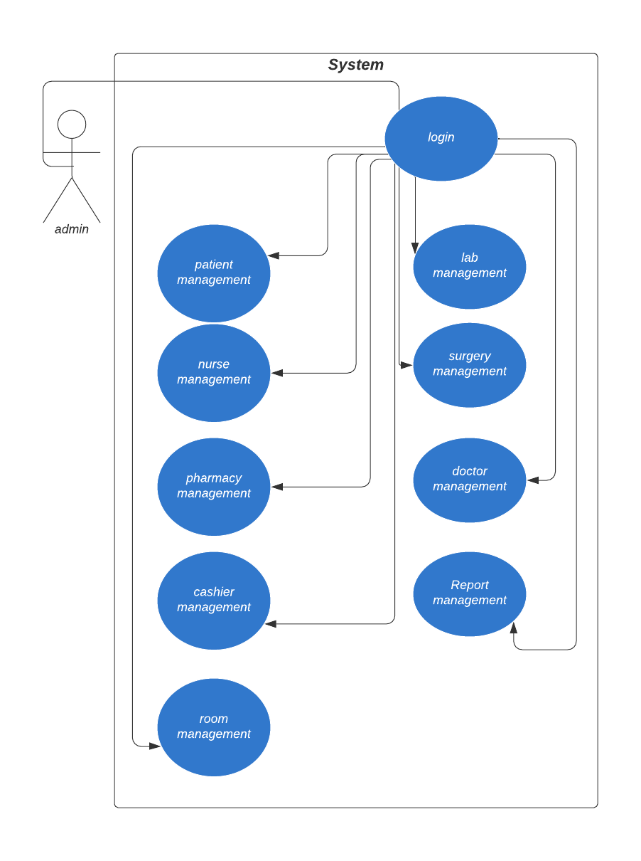
Figure 3-2 high level use case diagram

Doctor
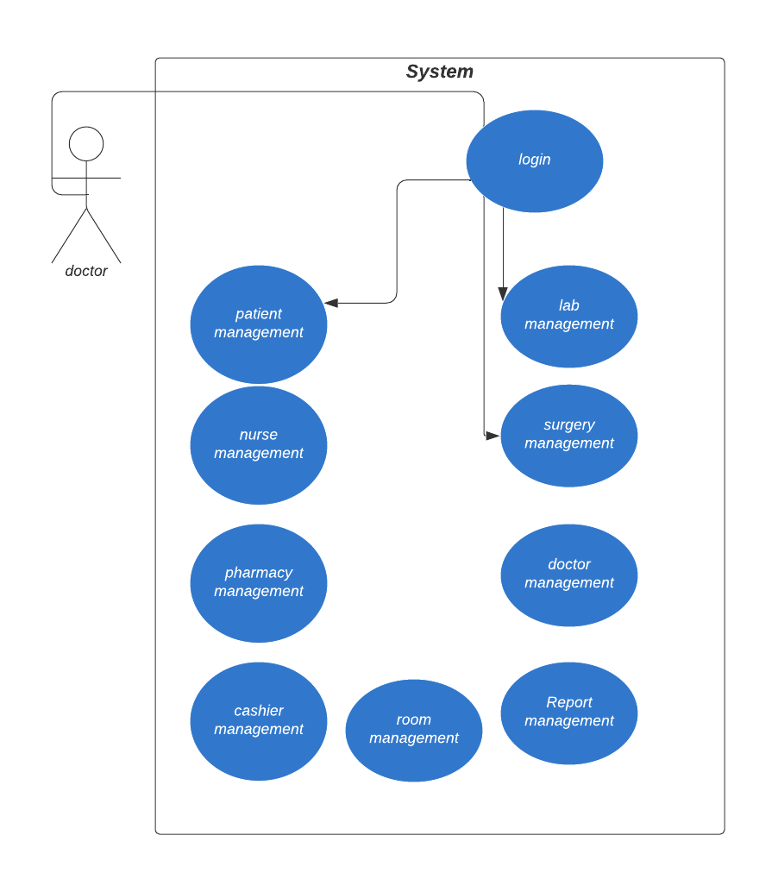Figure 3-3 high level use case diagram
Nurse
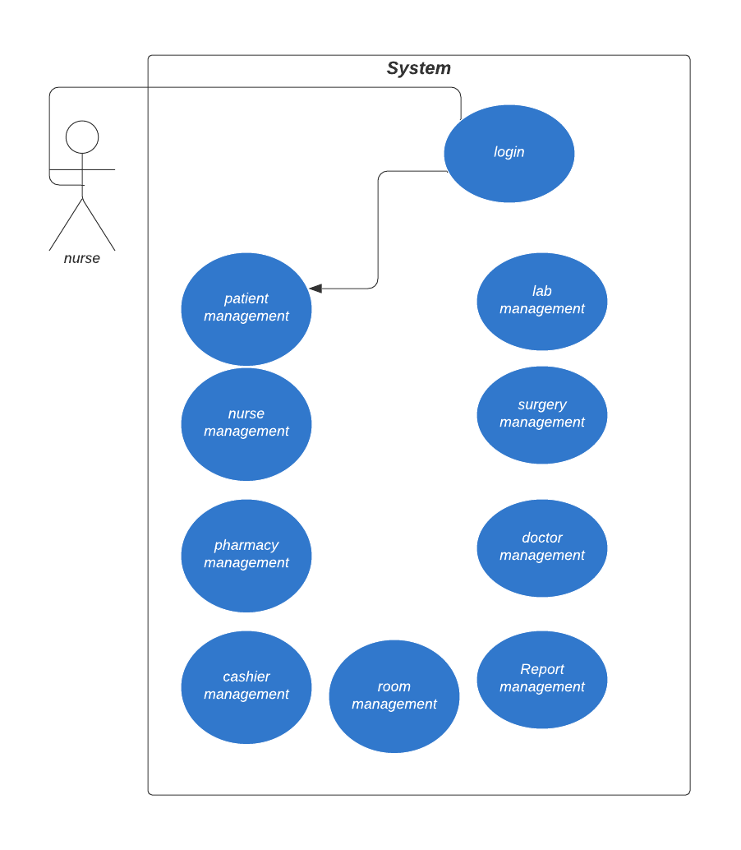
Figure 3-4 high level use case diagram

Pharmacy

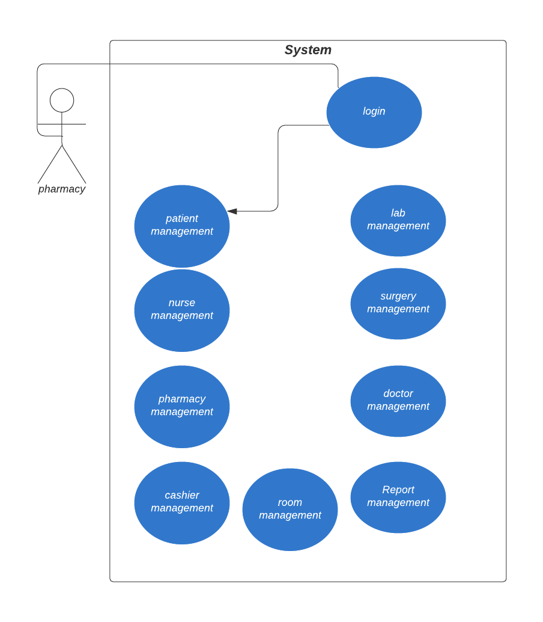

Figure 3-5 high level use case diagram

Lab
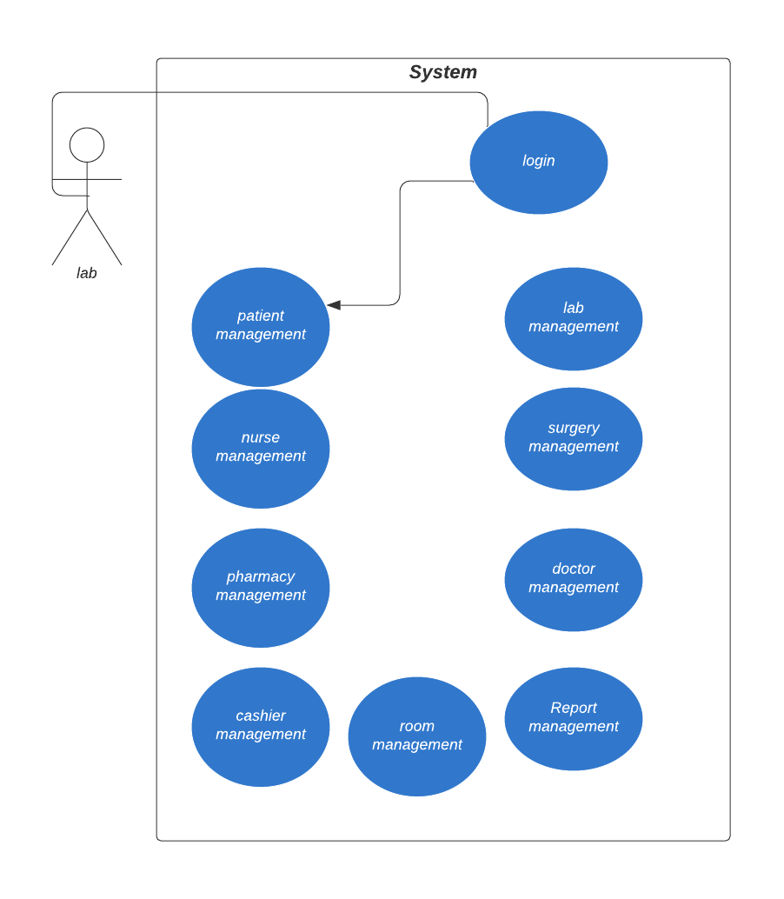
Figure 3-6 high level use case diagram

Cashier
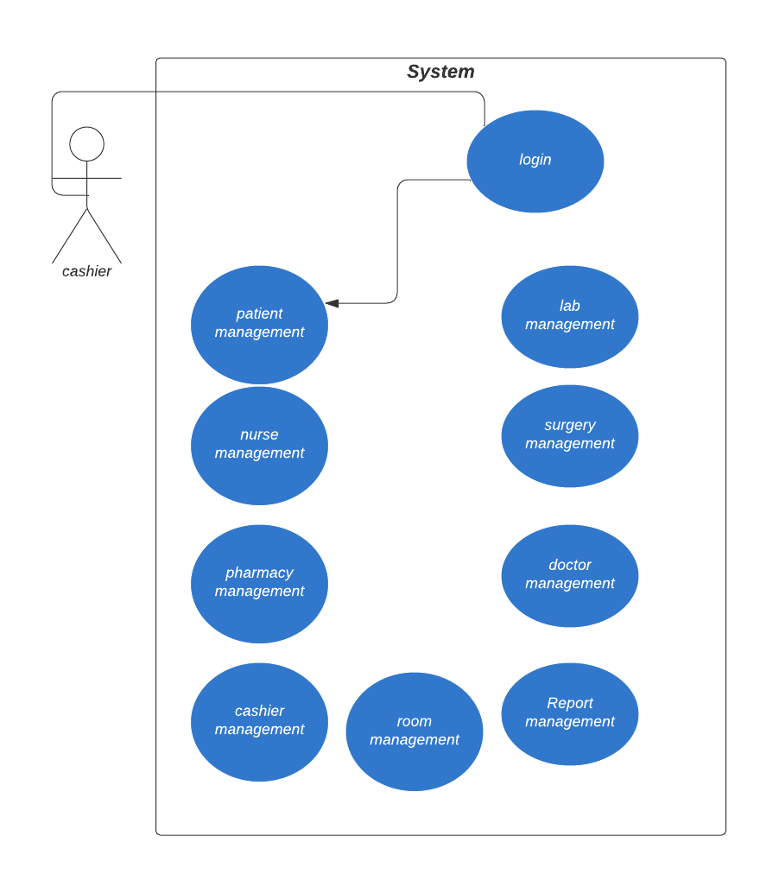

Figure 3-7 high level use case diagram
USE CASE DIAGRAM (LOW LEVEL)
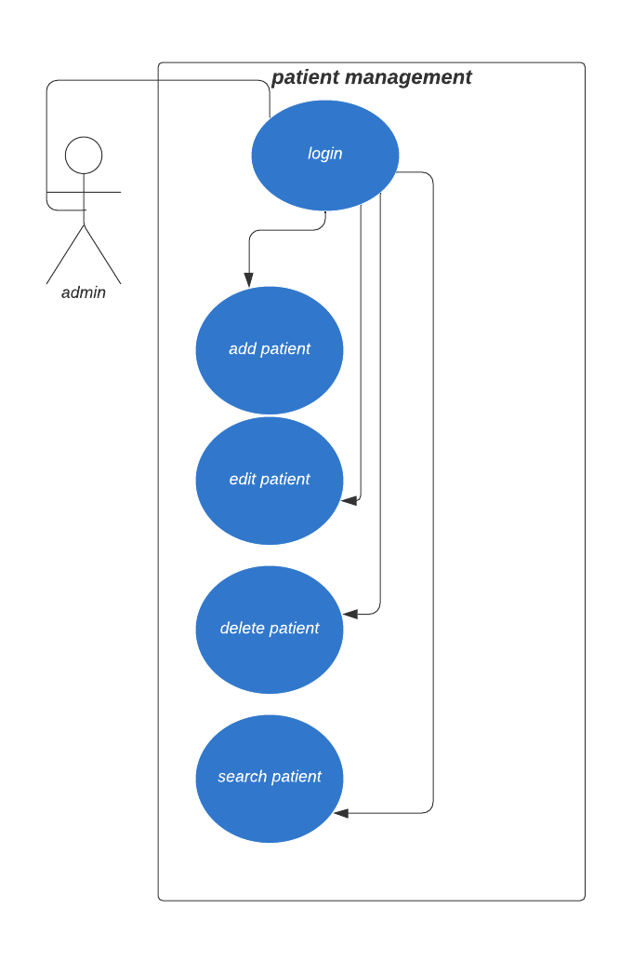
Figure 3-3 use case diagram low level (patient management)

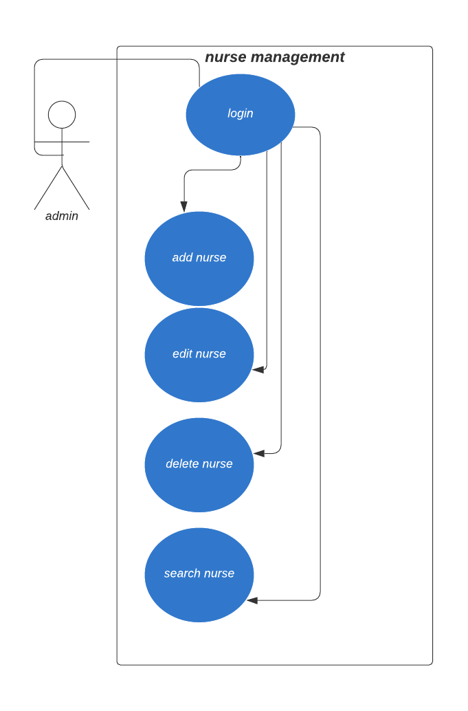
Figure 3-4 use case diagram low level (nurse management)

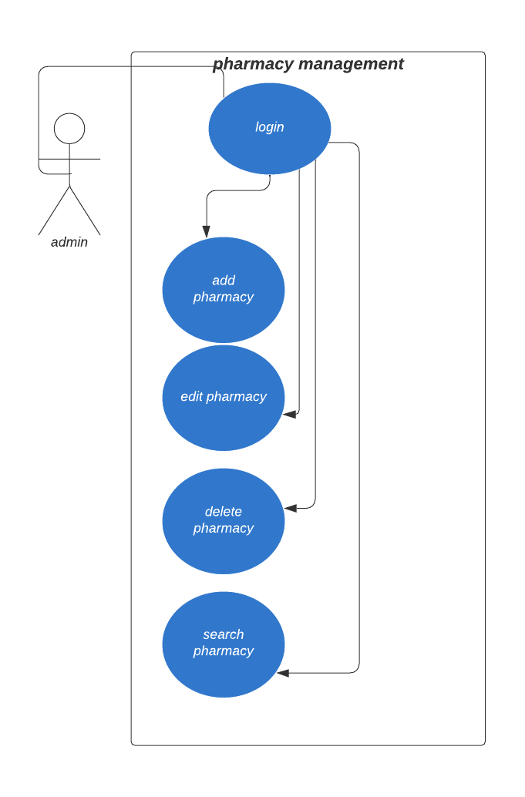
Figure 3-5 use case diagram low level (pharmacy management)

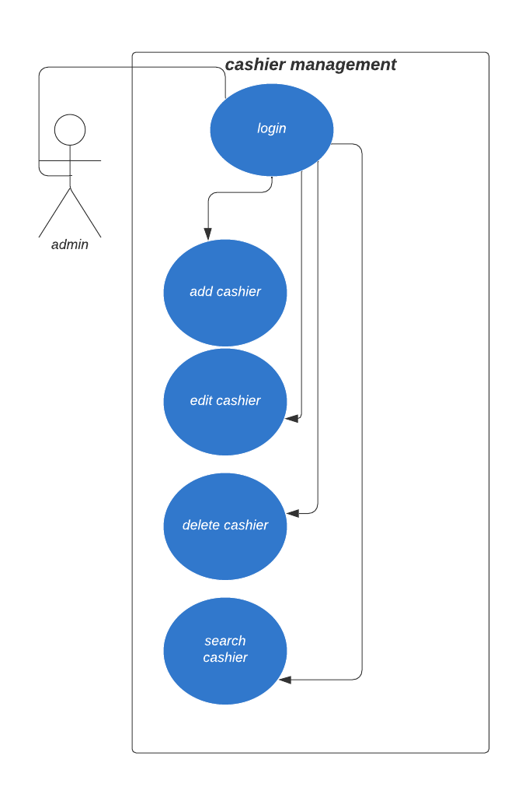

Figure 3-6 use case diagram low level (cashier management)

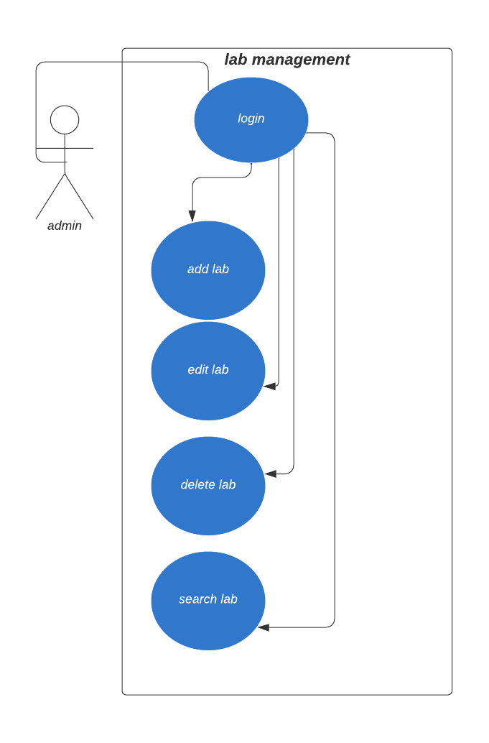
Figure 3-7 use case diagram low level (lab management)

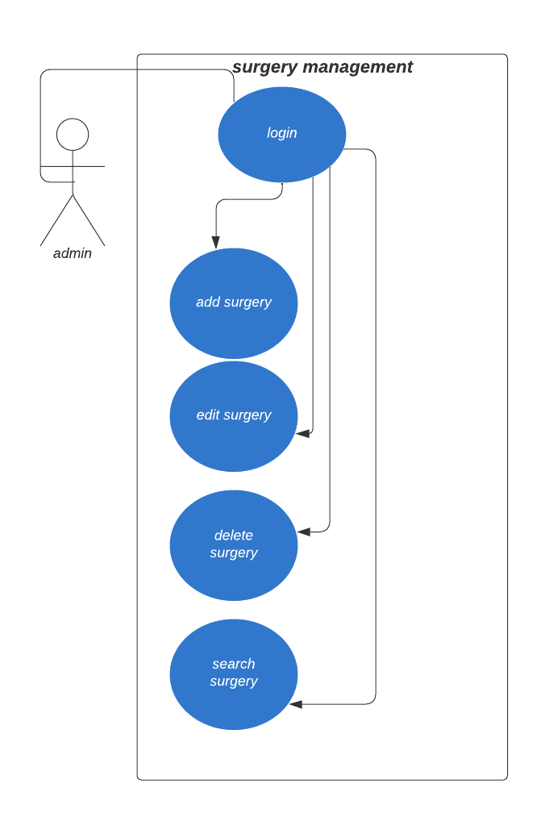
Figure 3-8 use case diagram low level (surgery management)
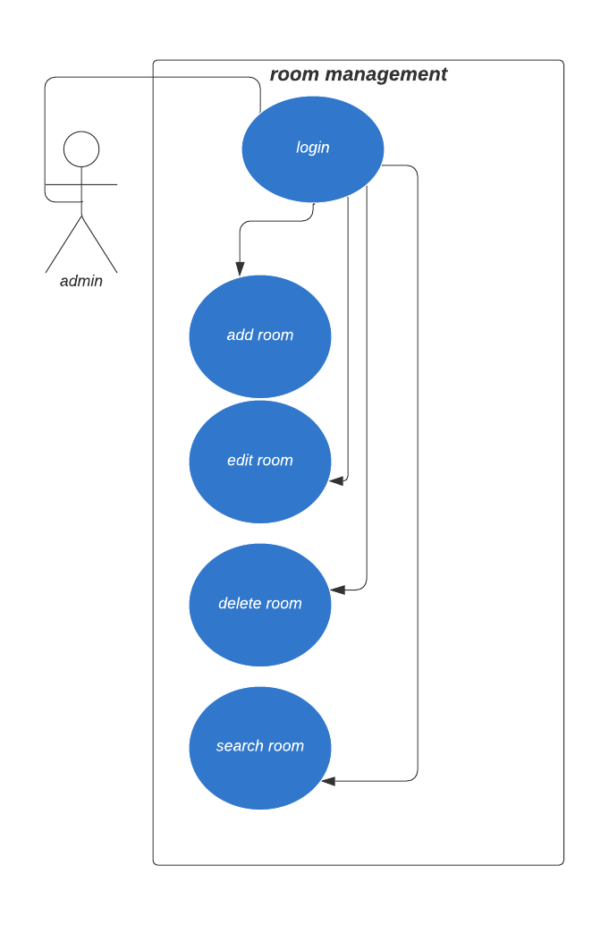
Figure 3-9 use case diagram low level (room management)

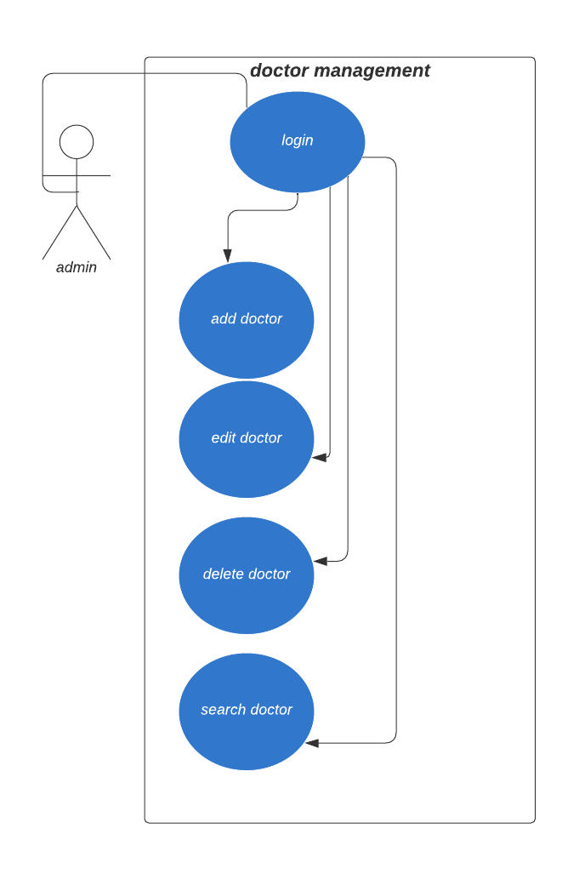
Figure 3-9 use case diagram low level (doctor management)

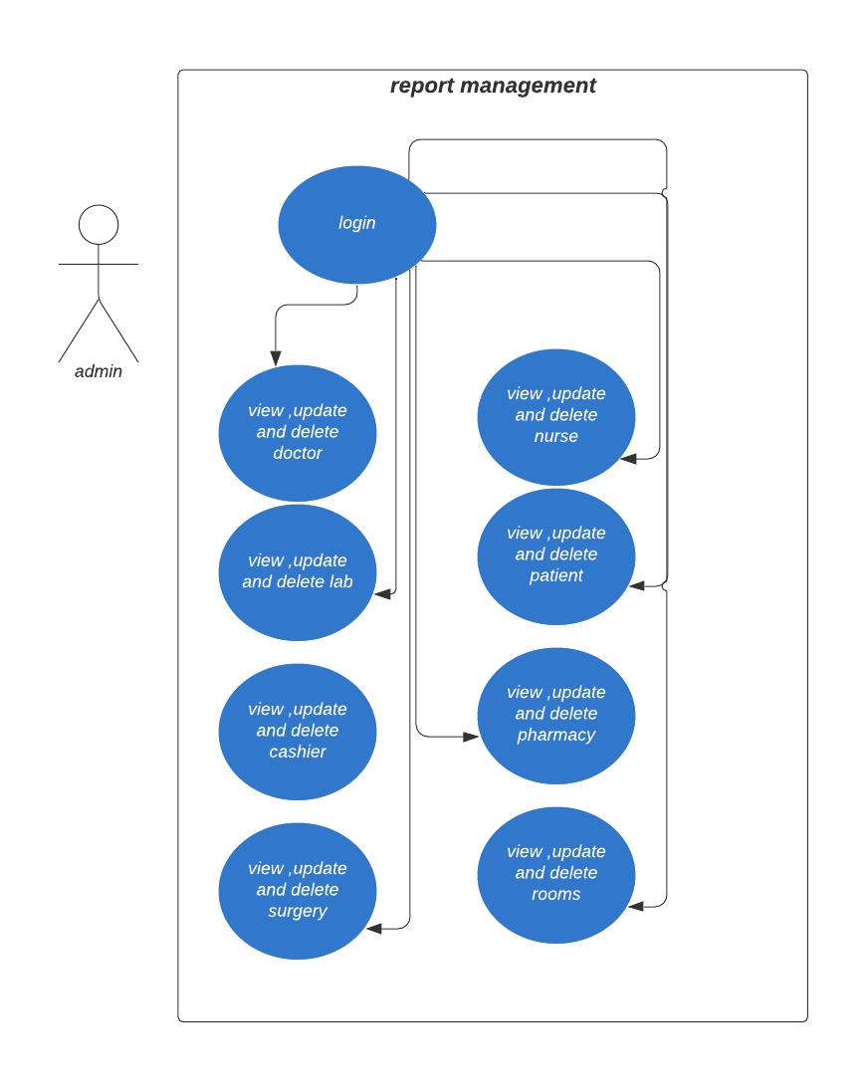

Figure 3-10 Low case use diagram (Report management)
  - DATA MODELING
    - Entity Relationship Diagrams (ER-Diagrams)
Our system uses the following symbols in ER-Diagrams
a) Entities, which are represented by rectangles
b) Relationships, which are represented by a line, show how two entities share information in the database
c) Attributes, which are represented by rectangle. A key attribute is the unique, distinguishing characteristic of the entity.

L
Entities
attributes

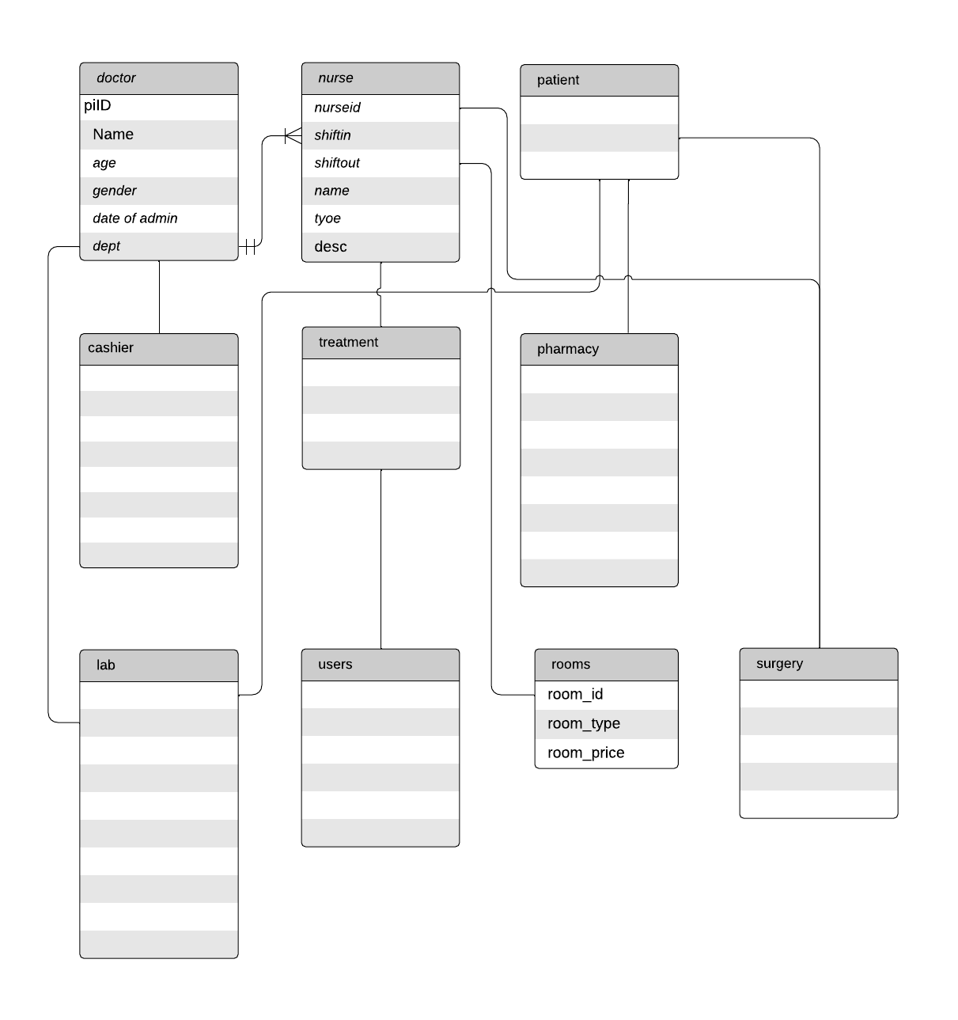
Figure 3-11 ERD Diagram
  - NEW PROPOSED SYSTEM
The new system is a responsive website app that allows Employee such as doctors to do their tasks. This system also has the information of the patient and all its status and also its manageable which means you can access into a specific category; it allows them to keep data or make reports as much as they want and it works 24/7.
  - SOLUTION STRATEGY
After the search we done to the hospitals we discovered that the they have been lost more data caused by paper and pens also takes more time to find these papers and its difficult for patient to do many trips on the hospital so we developed this system to help them make easy work and care for the patients and check their status if they good or not. we used PHP programing language as frontend and MYSQL database service as backend to solve the problem.
  - SYSTEM FEASIBILITY AND AFFORDABILITY
A feasibility study is an analysis that considers all of a project's relevant factors—including economic, technical, legal, and scheduling considerations—to ascertain the likelihood of completing the project successfully Although feasibility studies can help project managers determine the risk and return of pursuing a plan of action, several steps and best practices should be considered before moving forward.
After we collected data our system is feasible in technically, operationally and schedule
    - Technical feasibility
In this technical feasibility study- it is very important role to give consideration as mechanically what we need to achieve our goals?
The answer is "We need hardware and software materials" to develop this system according to these two things it should keep the mind. In the technical feasibility we have examined more about the system and how the system will be developed technically, so we have seen that the system initially requires both software and hardware in which takes part the system development.

      - Hardware requirement
No | Item Name | Minimum | Maximum
1 | Computer | Laptop | Laptop
2 | Ram | 4 GB | 16 GB
2 | Processor | 2.0 GHZ | 3.5 GHZ
3 | Hard Disk | 90 GB | 1000 GB
Table 3-3 Hardware requirement
      - Software requirement
No | Software Name | Description
1 | Windows | Version 10 or later
2 | PHP | Version 7 / 8 or later
3 | MYSQL | Version 5 / 8 or later
Table 3-4 Software requirement
    - Economic Feasibility
Economic analysis is to Assess the cost of this system is the most important thing which can cause your system to become more efficient and if you make a discount it will affect its performance and performance so pay carefully
No | Type | Minimum Cost | Maximum cost
1 | Hardware | $330 | $500
2 | Software | $80 | $140
3 | Costs for developers/researchers | $50 | $200
Total |  | $388 | $840
Table 3-5 Economic feasibility
    - Operational Feasibility
as people in hospitals or working have computers and telephones and are also educated people do not need any further training, they just need to be shown how the system works to understand and then work on it. Table 3-6 Operational feasibility

    - Schedule Feasibility
Time evaluation is the most important consideration in the development of project. It ensures that the project should be completed within given time constraint or schedule. It also verifies and validates whether the deadlines of project are reasonable or not. is intended for academic purpose especially undergraduate degree, it is developed for one semester.

No | Type | Time
1 | Planning And Analyzing phase | Four Weeks
2 | Design Phase | Four Weeks
3 | Coding Phase | Three Weeks
4 | Testing Phase | Three Weeks
Total |  | Twenty Weeks
Table 3-7 Schedule feasibility
  - CHAPTER SUMMERY
The chapter gives a brief overview of the research methodology used. All research activities were planned and effectively organized by using operational framework. Research designed was explained and it is qualitative research and also has discussed important points on the user requirement analysis of the system starting from introduction of the chapter, data gathering method, user requirement analysis, preliminary investigation, data gathering, DFD diagrams, UML diagrams, ERD diagrams feasibility study and then user requirement specifications.

