

CLOUD COMPUTING
NAME:
Zahra Akram.
REGISTRATION NUMBER:
FA24B1-SE-040
COURSE CODE:
SE-665
SECTION:
B
GITHUB USERNAME:
zahraakram40.
Topic:
Git, gitea, github, git Lfs, and github pagees

1. Introduction
This assignment focuses on understanding and practicing important tools and concepts used in cloud computing and software development. It includes setting up a self-hosted Git service using Gitea, connecting a local project with remote repositories, using GitHub for code hosting, managing large files with Git Large File Storage (Git LFS), and deploying a personal portfolio website through GitHub Pages.
The assignment provides practical experience in managing project files, tracking changes, transferring code between repositories, and publishing a website online. It also demonstrates how different development tools can work together to support an organized workflow.
2. Objectives
The main objectives of this assignment are:
- To set up and run Gitea using Docker Compose.
- To understand the role of PostgreSQL as a database service for Gitea.
- To create and manage repositories for storing project files.
- To understand Git remotes and connect local repositories to remote repositories.
- To push project files from a local system to Gitea and GitHub.
- To learn how Git Large File Storage (Git LFS) manages large files.
- To configure Git LFS tracking for selected files.
- To understand the basic process of uploading and managing files on GitHub.
- To deploy a personal portfolio website using GitHub Pages.
- To verify that the deployed website is accessible and displays the expected content.

Task 1: Gitea Setup
Screenshot 1: task1_gitea_running.png
shows that Gitea and PostgreSQL are running successfully through Docker Compose. The successful HTTP status confirms that the Gitea web application is responding correctly.
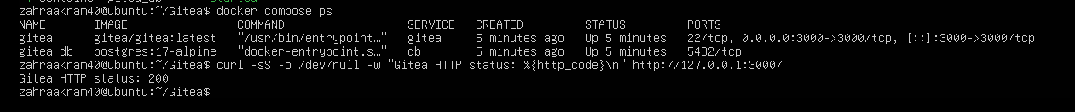
Screenshot 2: task1_gitea_push.png
shows the successful push of the assignment files to the Gitea repository. It confirms that the local Git repository is connected to Gitea and the changes have been uploaded.
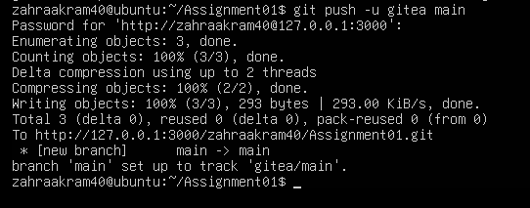
Screenshot 3: task1_gitea_repository.png
shows the assignment repository in Gitea. It confirms that the repository was created and the uploaded project files are visible.
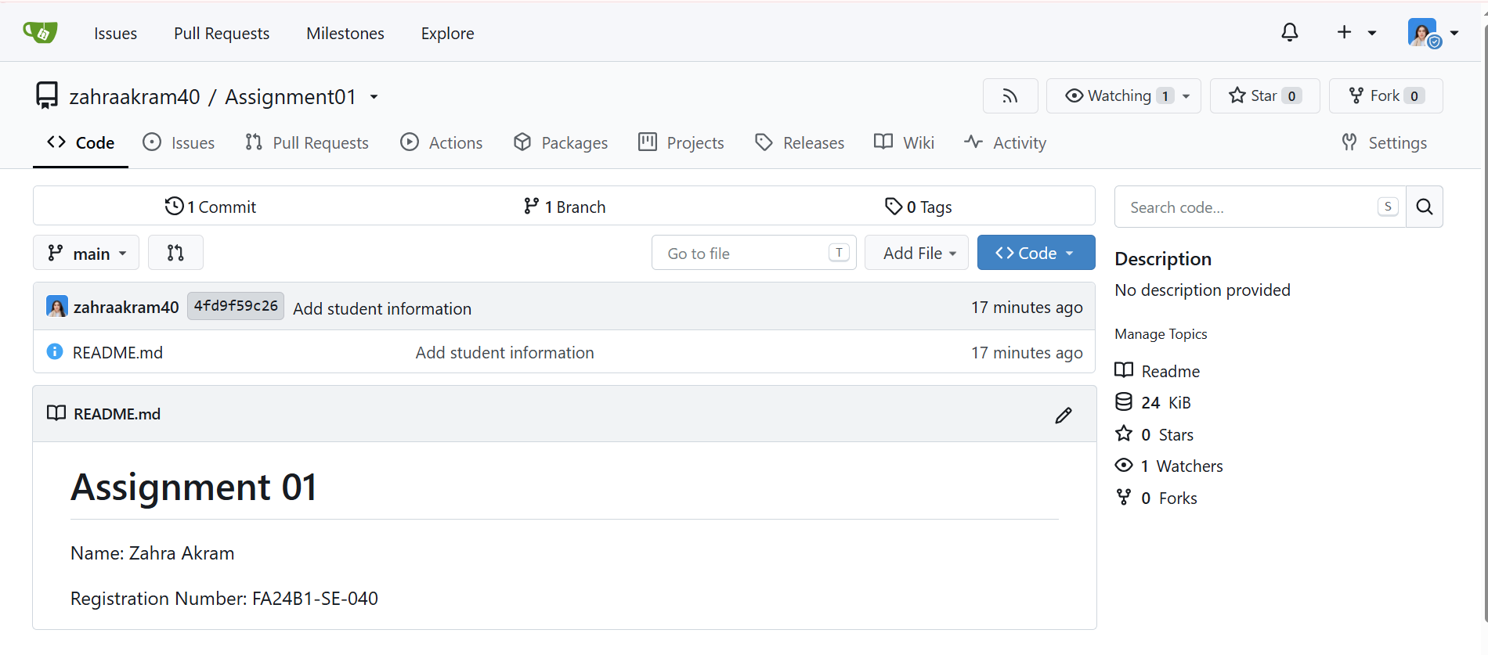
Task 2: GitHub Repository
Screenshot 4: task2_remotes.png
shows the configured Git remotes for the local repository. It verifies that the local project is connected to the required Gitea and GitHub repositories.
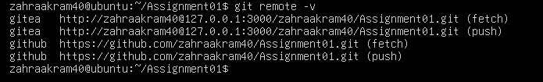
Screenshot 5: task2_github_push.png
shows the successful push of the assignment files to GitHub. It confirms that the local commits have been uploaded to the remote GitHub repository.
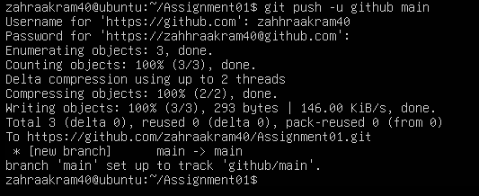
Screenshot 6: task2_github_repository.png
shows the assignment repository on GitHub. It verifies that the repository exists and the uploaded files can be viewed online.
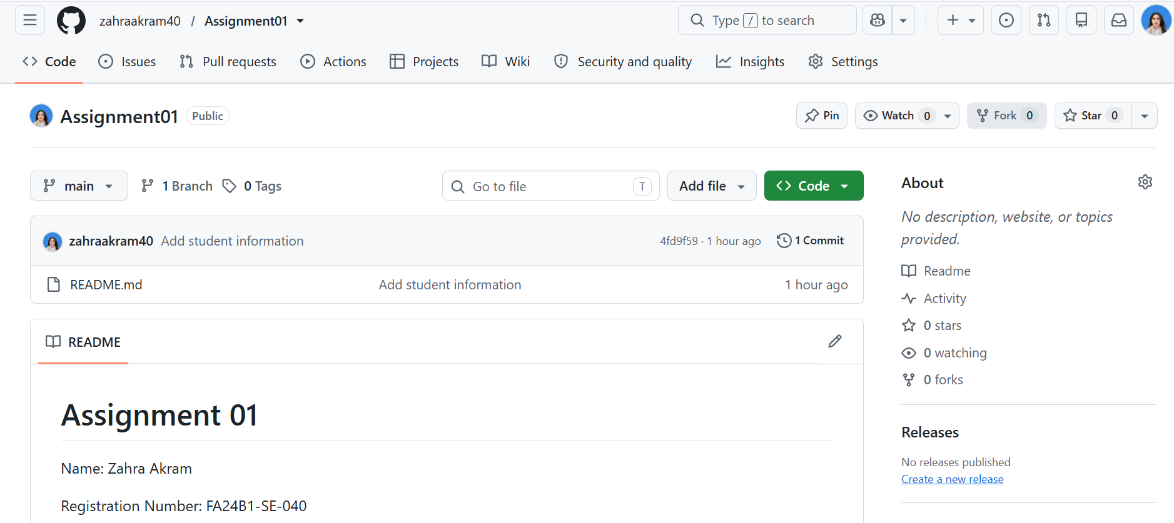
Task 3: Git Large File Storage (Git LFS)
Screenshot 7: task3_lfs_setup.png
shows the Git LFS installation and configuration. It demonstrates that Git Large File Storage has been initialized for managing large files.
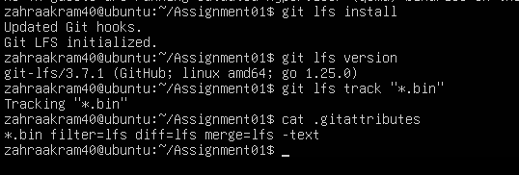
Screenshot 8: task3_lfs_files.png
shows the files selected for tracking with Git LFS. It demonstrates that the required file types or large files have been configured for LFS tracking.
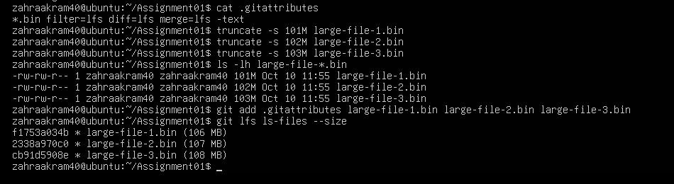
Screenshot 9: task3_lfs_push.png
shows the successful upload of the Git LFS objects and repository changes. It confirms that the tracked large files were pushed to the remote repository.
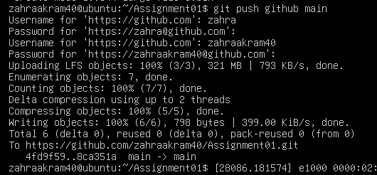
Task 4: Personal Portfolio and GitHub Pages
Screenshot 10: task4_pages_repository.png
shows the portfolio repository on GitHub. It verifies that the website files, including index.html, styles.css, and the profile picture, are present in the repository.
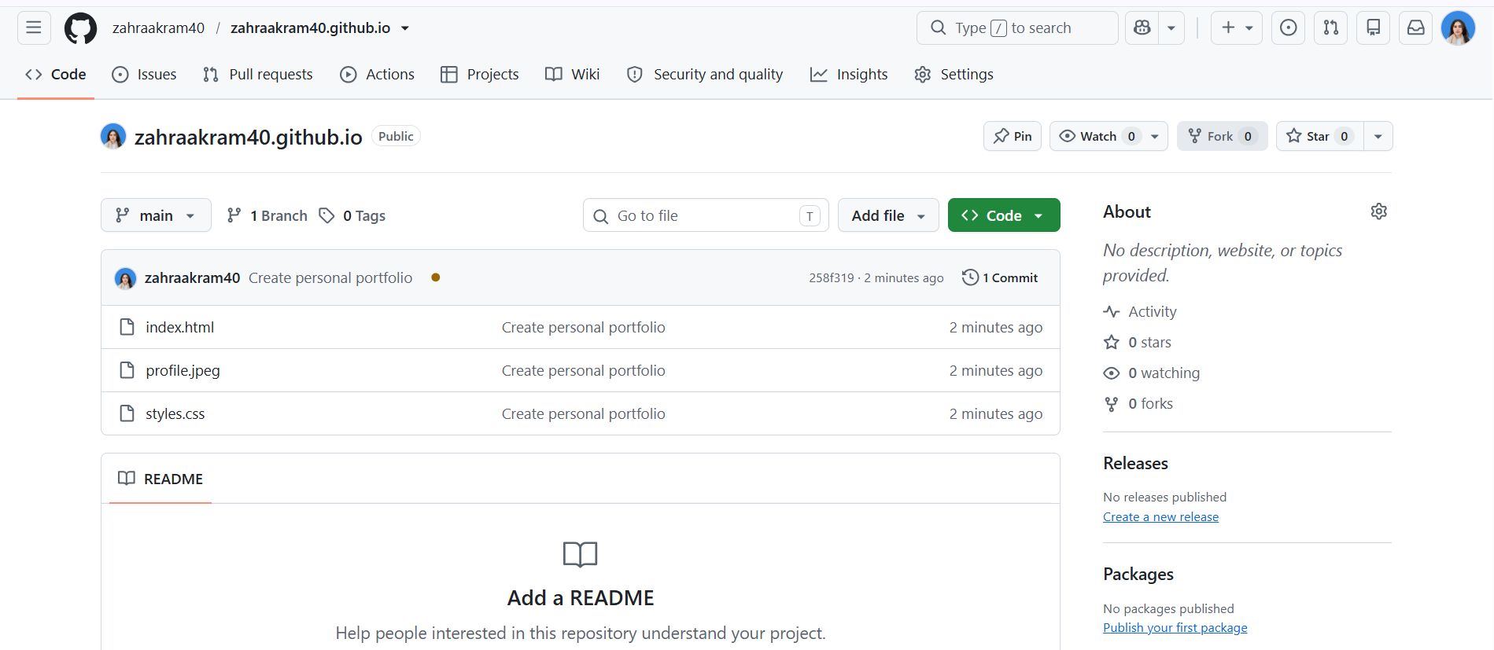
Screenshot 11: task4_pages_deployment.png
shows the GitHub Pages deployment settings. It demonstrates that the website is configured to deploy from the main branch and the root folder.
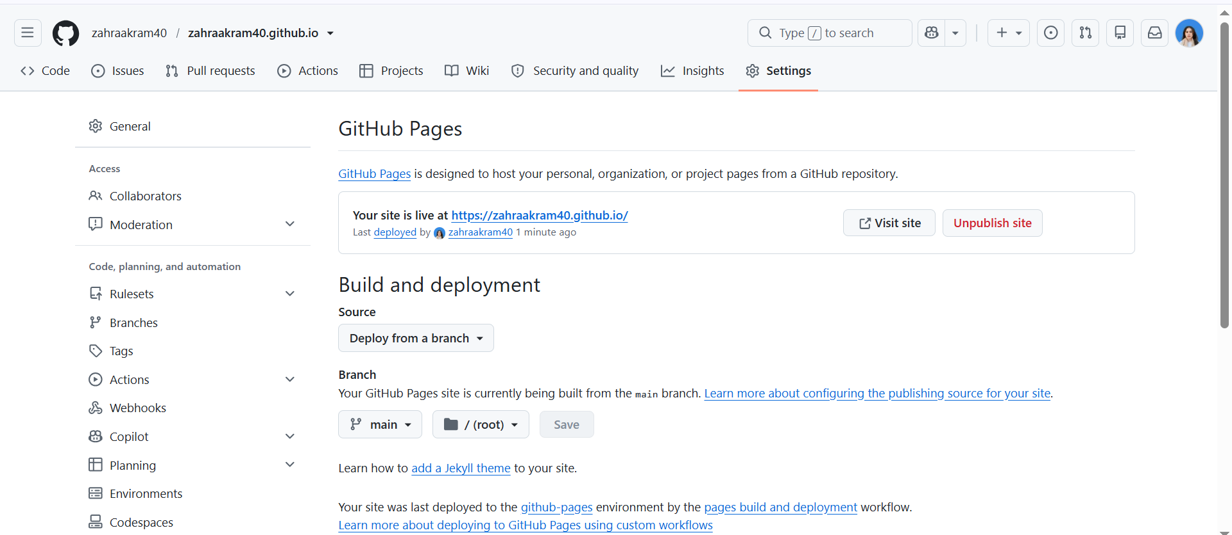
Screenshot 12: task4_portfolio_live.png
shows the published portfolio website. It displays my personal information, education, technical skills, projects, and contact details, confirming that the website is accessible online.
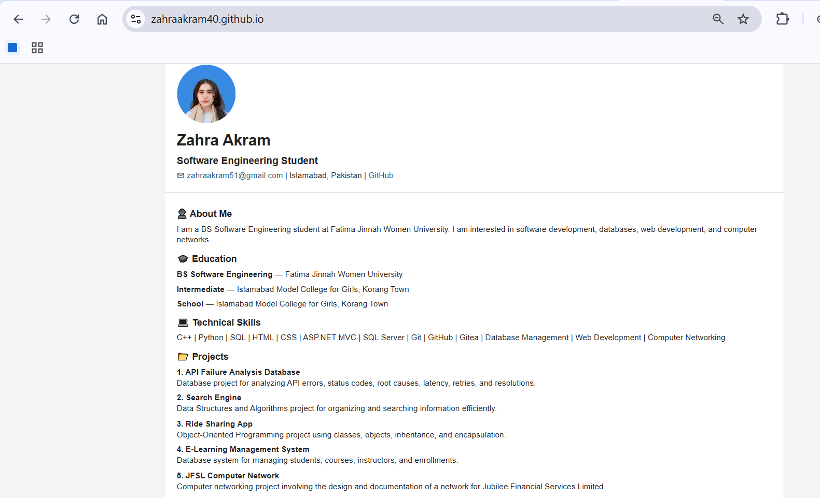
Conclusion
This assignment provided practical experience with Docker Compose, Gitea, GitHub, Git LFS, Git remotes, and GitHub Pages. It also helped me develop and publish a personal portfolio website.

