**Title Using Times New Roman Regular Font with 24 pts and maximal 14 Words**

**First Author1)[1], Second Author2), Third Author3)**

1)2)3) Study Program, Faculty, Affiliation, City, Country

1)author1@domain.com

2)author2@domain.com

3)author3@domain.com

|  |  |
| --- | --- |
| *Article history:*  **Received xx xxx 2025;**  **Revised xx xxx 2025;**  **Accepted xx xxx 2025;**  **Available online 10 Dec 2025**  *Keywords: {use 5 keywords}*  Keyword  Keyword  Keyword  Keyword  Keyword | *Abstract*  Abstracts are written in one paragraph consisting of **200 to 250 words.** The abstract is a general summary of all scientific writings. The abstract must contain key elements that will be presented briefly. The background describes the most recent research you have done or some things you would like to know. You need to put forward the research objective to find out or confirm something. The practical implications of your research results can also be noted (if any). The way you find answers or solve problems can be written in research methods. In the research results section, you can present the findings that you made in your research. Finally, you can write down the conclusions of your research, whether your research is what you expected, or if further research is needed . |

# Introduction

This template provides authors with most of the formatting specifications needed for preparing electronic versions of their papers for *Journal Binary Digital Technology (Bit-Tech)*. All standard paper components have been specified for three reasons: (1) ease of use when formatting individual papers, (2) automatic compliance to electronic requirements that facilitate the concurrent or later production of electronic products, and (3) conformity of style throughout a journal publication. Generally, a typical paper contains between 3000 and 6000 words, but there are no rigorous restrictions. Margins, column widths, line spacing, and type styles are built-in; examples of the type styles are provided throughout this document. The main sections (headings) include Introduction, Literature Review (optional), Methods, Result, Discussion, and Conclusion. Use sub-heading accordingly, the maximum depth of the subheading is Subheading 3.

Introduction section can include background information such as theories, prior work, and hypotheses. This is followed by a statement of the purpose of the research issue or problem and/or set of questions you attempt to answer in your research. It also may contain a summary of the structure of the rest of the paper.

# Related Works/Literature Review

A literature review is a critical, analytical summary and synthesis of the current knowledge of a topic. It should compare and relate different theories, findings, and so on, rather than just summarize them individually. It should also have a particular focus or theme to organize the review. The length of this section is between 500 – 700 words.

# Methods

The methods sections often come disguised with other article-specific section titles, but serve a unified purpose: to detail the methods used in an objective manner without introduction of interpretation or opinion. The methods sections should tell the reader clearly how the results were obtained. They should be specific. They should also make adequate reference to accepted methods and identify differences.

# Results

The results section and the following discussion section allow the most flexibility in terms of organization and content. In general, the pure, unbiased results should be presented first without interpretation. These results should present the raw data or the results after applying the techniques outlined in the methods section. The results are simply results; they do not draw conclusions.

The main purpose of the results section is to provide the data from the study so that other researchers can draw their own conclusions and understand fully the basis for the conclusions. A common format for the results section is to present a series of figures and to describe the figures in detail through the text. A good results section presents clear figures with efficient text. The figures should support the assertions in the paper or illustrate the new insights. Where applicable, results should be illustrated in terms of non-dimensional variables.

## Figure

All figures should be numbered with Arabic numerals (1,2,3,….). Every figure should have a caption. All photographs, schemas, graphs and diagrams are to be referred to as figures. Line drawings should be good quality scans or true electronic output. Low-quality scans are not acceptable. Figures must be embedded into the text and not supplied separately. In MS word input the figures must be properly coded. Preferred format of figures are PNG, and JPEG. Lettering and symbols should be clearly defined either in the caption or in a legend provided as part of the figure. Figures should be placed at the top or bottom of a page wherever possible, as close as possible to the first reference to them in the paper. Please ensure that all the figures are of 300 DPI resolutions as this will facilitate good output.

The figure number and caption should be typed below the illustration in 8 pt and left justified [Note: one-line captions of length less than column width (or full typesetting width or oblong) centered]. Artwork has no text along the side of it in the main body of the text. However, if two images fit next to each other, these may be placed next to each other to save space. For example, see **Figure 1**.

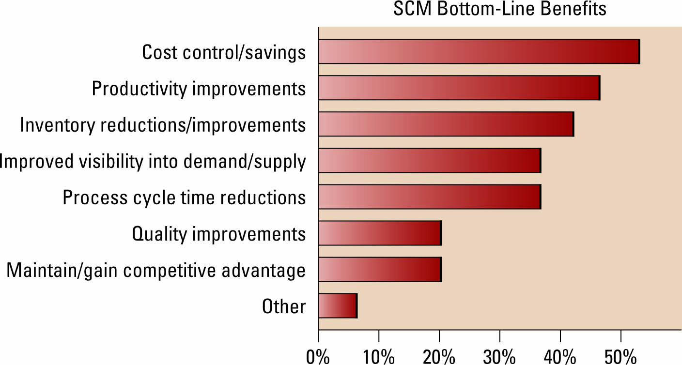

Fig. 1 Caption for figure

## Table

All tables should be numbered with Arabic numerals. Every table should have a caption. Headings should be placed above tables, center justified. Only horizontal lines should be used within a table, to distinguish the column headings from the body of the table, and immediately above and below the table. Tables must be embedded into the text and not supplied separately. **Table 1** is an example which the authors may find useful.

Table 1

Units for Magnetic Properties

|  |  |  |
| --- | --- | --- |
| **Symbol** | **Quantity** | **Conversion from Gaussian and**  **CGS EMU to SI a** |
| Φ | magnetic flux | 1 Mx → 10−8 Wb = 10−8 V·s |
| *B* | magnetic flux density,  magnetic induction | 1 G → 10−4 T = 10−4 Wb/m2 |
| *H* | magnetic field strength | 1 Oe → 103/(4π) A/m |
| *m* | magnetic moment | 1 erg/G = 1 emu  → 10−3 A·m2 = 10−3 J/T |
| *M* | magnetization | 1 erg/(G·cm3) = 1 emu/cm3  → 103 A/m |
| 4π*M* | magnetization | 1 G → 103/(4π) A/m |
| σ | specific magnetization | 1 erg/(G·g) = 1 emu/g → 1 A·m2/kg |
| *j* | magnetic dipole  moment | 1 erg/G = 1 emu  → 4π × 10−10 Wb·m |
| *J* | magnetic polarization | 1 erg/(G·cm3) = 1 emu/cm3  → 4π × 10−4 T |
| χ*,* κ | susceptibility | 1 → 4π |
| χρ | mass susceptibility | 1 cm3/g → 4π × 10−3 m3/kg |
| μ | permeability | 1 → 4π × 10−7 H/m  = 4π × 10−7 Wb/(A·m) |
| μr | relative permeability | μ → μr |
| *w, W* | energy density | 1 erg/cm3 → 10−1 J/m3 |
| *N, D* | demagnetizing factor | 1 → 1/(4π) |

Vertical lines are optional in tables. Statements that serve as captions for the entire table do not need footnote letters.

aGaussian units are the same as cg emu for magnetostatics; Mx = maxwell, G = gauss, Oe = oersted; Wb = weber, V = volt, s = second, T = tesla, m = meter, A = ampere, J = joule, kg = kilogram, H = henry.

## Equations

Equations and formulae should be typed in Mathtype or any Equation Editor, and numbered consecutively with Arabic numerals in parentheses on the right hand side of the page (if referred to explicitly in the text). They should also be separated from the surrounding text by one space.

       

Be sure that the symbols in your equation have been defined before or immediately following the equation. Use “(1),” not “**Eq. (1)**” or “**equation (1)**,” except at the beginning of a sentence: “Equation (1) is ...”

### Figure

Example of Subheading 3.

# Discussion

The discussion section is where the article interprets the results to reach its major conclusions. This is also where the author’s opinion enters the picture. the discussion is where the argument is made. Common features of the discussion section include comparison between measured and modeled data or comparison among various modeling methods, the results obtained to solve a specific engineering or scientific problem, and further explanation of new and significant findings.

# Conclusions

The conclusion contains a summary of what is learned from the results obtained, what needs to be improved in further study. Other common features of the conclusions are the benefits and applications of the research, limitation, and the recommendations based on the results obtained.

Acknowledgments (Optional)

The acknowledgments are given at the end of the research paper and should at a minimum name the sources of funding that contributed to the article. You may also recognize other people who contributed to the article or data contained in the article, but at a level of effort that does not justify their inclusion as authors. You may also state the research grant contract number if any.

References

Please use IEEE standard for Reference style. We suggest there should be at least 25 references within the manuscript. Make sure you use “*Citation & Bibliography*” feature in Microsoft Word for handling citation in manuscript. If no IEEE style in your Microsoft Word version, use “ISO 690 – Numerical Reference” style instead.

References must include all relevant information, and a DOI (Digital Object Identifier) is required for each reference. Please ensure that each reference is properly formatted with all necessary details, and the DOI is included where available. Do not combine references—each reference should be assigned a unique number. If a URL is included with the print reference, it may be added at the end of the reference.

The template will number citations consecutively within brackets [1]. The sentence punctuation follows the bracket [2]. Refer simply to the reference number, as in [3]—do not use “Ref. [3]” or “reference [3]” except at the beginning of a sentence: “Reference [3] was the first ...”. For papers published in translation journals, please give the English citation first, followed by the original foreign-language citation [6].

**Examples:**

1. G. Eason, B. Noble, and I.N. Sneddon, “On certain integrals of Lipschitz-Hankel type involving products of Bessel functions,” Phil. Trans. Roy. Soc. London, vol. A247, pp. 529-551, April 1955. doi:10.1098/rsta.1955.0004.
2. J. Clerk Maxwell, A Treatise on Electricity and Magnetism, 3rd ed., vol. 2. Oxford: Clarendon, 1892, pp. 68-73. doi:10.1093/oso/9780198508001.003.0001.
3. I.S. Jacobs and C.P. Bean, “Fine particles, thin films, and exchange anisotropy,” in Magnetism, vol. III, G.T. Rado and H. Suhl, Eds. New York: Academic, 1963, pp. 271-350. doi:10.1016/B978-0-12-558503-0.50015-3.
4. K. Elissa, “Title of paper if known,” unpublished. doi:10.1234/unpublished2024.
5. R. Nicole, “Title of paper with only first word capitalized,” *J. Name Stand. Abbrev.*, in press. doi:10.1109/ACCESS.2024.3165982.
6. Y. Yorozu, M. Hirano, K. Oka, and Y. Tagawa, “Electron spectroscopy studies on magneto-optical media and plastic substrate interface,” IEEE Transl. J. Magn. Japan, vol. 2, pp. 740-741, August 1987 [Digests 9th Annual Conf. Magnetics Japan, p. 301, 1982]. doi:10.1109/TMAG.1987.1361972.

**Notes for Authors:**

1. Please check the completeness of the writing of words/sentences, punctuation is in accordance with the template.
2. If there is writing on the image, make sure the text on the image is clear enough to read (not/too small).
3. Compress the article so that the number of pages can be as few as possible (with a minimum of 8 pages), but still maintain the appropriateness of the surrounding style format.
4. Make sure all references written in the References section are referred to in the body of the manuscript, and vice versa, all references in the body of the manuscript must be written in the References section. With a minimum of 25 References.
5. Similarity checks are rechecked by bit-tech twice (at the start of submission and after the review is complete).
6. Fill in and upload the Manuscript **Completeness Checklist and Publication Ethics** Statement together with the Article when submitting.

**Thank you.**

1. Corresponding author