Markdown:

Bold: **

Italic: _ word_

Header: #

inline link: [text](link)

Reference Link: [text]: link

inline image link: ![text](link)

blockquote : < “ text”

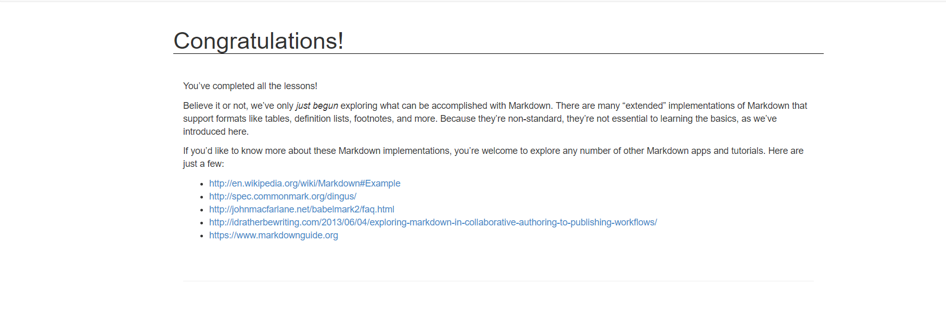

*https://www.markdowntutorial.com/conclusion/*