MSWC Paper Links (From Rus)
Friday, June 26, 2026
11:30 AM

  - Overview:
    - Belikov et al. SPIE 2026
    - Belikov et al 2015 (Original description)
  - Method
    - Thomas et al 2015 - Super Nyquist Wavefront Control
    - Sirbu et al 2017 - Multi-Star Wavefront Control
  - Description of Mode on Roman CGI:
    - Bendek et al 2021 "Enabling binary stars high-contrast imaging on Roman CGI"
  - Alpha Centauri:
    - Beichman, Sanghi 2025 (JWST Discovery)
    - Bendek et al 2025a - no MSWC
    - Bendek et al 2025b - with MSWC

MSWC Project Plan
Friday, June 26, 2026
10:02 AM

Submitted Project Plan:

Objective | Implement Multi-Star Wavefront Control into corgihowfsc + Report the on-sky performance of MSWC with Roman CGI
Tasks | - Software Setup: Install and learn how to use Roman CPP modeling software (corgisim and corgihowfsc)  - Baseline Single-Star: Establish baseline contrast performance with current wavefront control loop implementation (single-star dark hole). This task will also serve as a learning curve for using the corgihowfsc software.  - Baseline Multi-Star: Run corgihowfsc with 2 stars but using baseline single star wavefront control. This step will verify if the current corgihowfsc software capabilities for including off-axis stars as well as provide a baseline for comparing MSWF performance from Task 6-7.  - Sub-Nyquist single-star with reduced dark zone: Implement and test a smaller dark zone within the existing sub-Nyquist controllable region  - Super-Nyquist single star (SNWC): Implement and test super-Nyquist wavefront control for a single off-axis star. (we will have verified the off-axis star simulation capabilities of corgihowfsc in Task 3).  - Will need to implement the diffraction grating and square field stop  - Super-Nyquist Multi-Star (Idealized): Implement multi-star capabilities (independent, non-redundant DM modes to generate the spatially overlapping dark holes). Test with multi-star in super-Nyquist region with perfect wavefront estimation. Use 2 equivalent stars for testing.  - Full Multi-Star: Include estimation errors and run with super-Nyquist multi-star WFC.  - Simulate MSWC for Alpha Centauri: Apply the validated Roman MSWC pipeline to Alpha Centauri and simulate observations of the potential Alpha Centauri A Companion
Resources Required: | - MATLAB (to reference MSWC implementation in FALCO)  - VS Code  - Python + Virtual Environment Manager
Anticipated Outcome | (Primary) On-sky Performance (CBE) of MSWC with Roman CGI  (Secondary) A MSWC module for corgihowfsc + software documentation; test results documented in a final report
Anticipated Challenges | - Corgihowfsc software may not be compatible with off-axis stars at super-Nyquist separations. Contingency plan could include implementing this capability or focusing on simulating MSWC at the Nyquist limit (as opposed to super-Nyquist)  - Limited documentation for corgihowfsc means most of the familiarity will need to be developed by reading/working with the code directly
Deadline/Timeline | - Task 1-2: Week 4 (Jul 10)  - Task 3: Week 5-6 (Jul 24)  - Task 4: Week 6 (Jul 24)  - Task 5: Week 7 (Jul 31)  - Task 6: Week 8-9 (Aug 14)  - Task 7-8: Week 9 (Aug 14)  - Buffer + Final Documentation: Week 10 (Aug 25)
Collaboration Groups | I will potentially collaborate/reach out to the Roman CPP team that is responsible for the corgihowfsc software

Daily Notes
Wednesday, July 1, 2026
2:53 PM
  - Key (note to self):
    - outstanding question
    - answered question with the answer included after

7/2/2026 - 7/6/2026:
- Starting to dig into the code and need to have an understanding of the following to get started:
Roman architecture + instruments
Roman imaging filters
Corgi-howfsc configuration files
How are the E-fields propagated through:
The compact model
The full corgisim model
Output structure (see here) and how to interpret
- Roman architecture + instruments + imaging filters
  - In Bendek et al 2021, mention that MSWC on Roman will use the wide-field shaped pupil coronagraph (SPC), which will enable MS in Band 1 and 4. In my notes I have that we will instead likely be performing MSWC in Band 3D. Does that change the configuration then (as in what mask to add the diffraction grating to etc.)
    - 7/8 - I'm generally a bit confused because Bendek white papers say will use the following configuration which I don't have an understanding of how you mix-and-match (i.e. band 3 is spectroscopy with what looks like a bowtie shaped pupil coronagraph. I think the question is how does the "mode" connect to the "mask type"? Like what does "Wide FoV Imaging" mean if not just the configuration you need for the coronagraph? Is it the last optical element before excam? (i.e. slit spectrograph vs. lens?)
    - 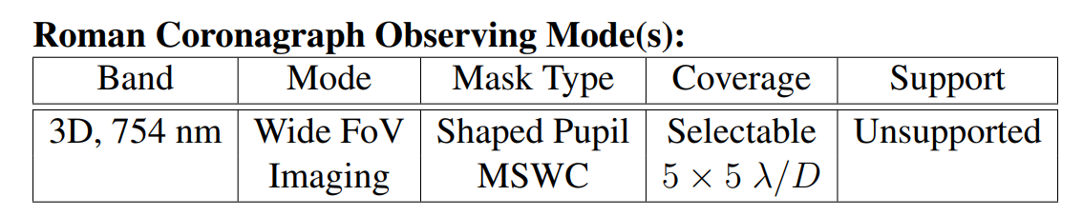
    - From Rus 1:1: WFOV Imaging in Band 3D just means we will use the WFOV coronagraph configuration (i.e. the SPAM for WFOV) and change the color filter to be Band 3d. Only need one wavelength band because alpha cen is so bright that we get more photons in just band 3d than from a 10% band
  - Again from Bendek at al. 2021, it would appear that the (simulated) hardware modifications that I will need for MSWC (and I should confirm that this is what was done in FALCO???) is a different shaped pupil mask that has a diffraction grating as well as a custom square field stop (see Figure 5 of Bendek et al 2021).
    - Correct!
- Running through the run_nulling_gitl.py and following along with the "corgi-howfsc loop" documentation:
  - The examples are run using NFOV HLC, so I'll want to make sure for my baseline results I run with the WFOV SPC instead.
  - Configuration Files:
    - There is a default_param.py file in the scripts folder, but it looks like this is only used in the corgisim examples (and I will need to check but it doesn't look like it actually applies any of the path overrides for the cfg, cstrat or hcon config files….)
    - For run_nulling_gitl.py (which is using the compact model for simulation and Jacobian calculation) it looks like the way it works is that in the top level simulation script (i.e. run_nulling_gitl.py), you specify which coronagraph mode you want to run, in this case nfov_band1
      - Then, when the script goes to initialize all of the objects you need for the loop (see, load_files in howfsc_initialization.py), it loads the specific cfg, cstrat and hcon files associated with that coronagraph mode.
      - NOTE: Okay so in that same top level script, you define your arguments and then load them using "howfsc_initialization.py/get_args. One of the optional arguments is path overrides. And then in load_files, right at the end there is a path overrides section where it would override the file paths if you specify them.
  - Should go through the "CoronagraphModel" which comes from the howfsc (i.e. the cgi-howfsc, I think?) code. This is what defines all of the planes etc. based on the cfg file and then I think this object is used for propagation of the E-field.
  - Okay also in the high level sim script, we define the estimator, in this case it is defined as the DefaultEstimator but could instead use PerfectEstimator which will use the exact Efield to make EFC instead of using the pair-wise probing.
  - Okay, so then the last thing the script does is define a GitlImage object, which is used to generate the inputs for WFSC. i.e. this can either be using the compact model (cgi-howfsc) or the full-fidelity model corgisim. Regardless, the CoronagraphModel uses the compact model and is used for Jacobian calculation?
  - Okay learning that actually run_nulling_gitl.py is not the scenario to run, should be running run_corgisim_nulling_gitl.py which is fully configuratble and also only uses compact model. The plan for tomorrow!

7/7/2026:
- Code investigation continues:
How are the E-fields propagated through:
The compact model
The full corgisim model
How are the sources added in.
Can you add in off-axis (even if just sub-nyquist) sources
Output structure (see here) and how to interpret
- Going through run_corgisim_nulling_gitl instead of run_nulling_gitl
- Things I need to understand eventually:
  - Precomputing the Jacobian? What does that mean, why do we need to re-compute the Jacobian at each iteration?
    - We are computing the Jacobian of the aberrated electric field (which we have estimated previously) and if this field is changing at each iteration (which I imagine it is…) then isn't it a given that we would need to re-compute at each iteration?
    - Okay thinking through this:
      - So a better way to think about the Jacobian is that it is a sensitivity matrix for "how sensitive is the electric field at the focal plane to DM pokes". It is a measure of our instrument sensitivity. And the way it is used is a linearization of the control problem. And also the Jacobian itself is also a linearization of the system sensitivity, so it needs to be re-calculated at every time step (particularly after large DM actuations) because it doesn't capture the nonlinearity between the DM actuators and the focal plane E-field.
  - What are the crop parameters used for? (Might be relevant for adding an off-axis star)
    - Controls the output frame dimensions. The corgi-howfsc documentation says to not modify these values, we will have to see.
  - What is the normalization strategy for? (Answer from corgi-howfsc documentation)
    - Normalization to go from photoelectrons to contrast units
    - Default is EETC (Engineering Exposure Time Calculator) to determine peakflux
    - Other options are to place an off-axis source at 7l/D to get peak flux (corgisim-off-axis) or to remove the focal plane mask to get peak flux (corgisim-on-axis)
- For the default run_corgisim_nulling_gitl:
  - Okay maybe this is a more general question: what determines (or how to determine) how many iterations are necessary a priori? Or do you need to just run according to the flowchart Fig 8 in Cady paper?
    - Is there an automated way to use this flowchart in corgi-howfsc?
    - Is there a target contrast that is feasible? (i.e. need to think through what is the fundamental limitation for the contrast, the theoretical "best" contrast we could get with the instrument if perfect WFC? And how do we calculate this?)
    - Also how is the "starting_contrast" being determined?
      - Starting_contrast as a parameter in the config file is a guess it would appear. The initial DM map sets the starting contrast
- Next Steps:
  - Understand how to read/interpret the outputs of the simulation I already ran
  - Run more baselines:
    - NFOV_band1_perfect estimation
    - WFOV_band4_defaultestimation
    - WFOV_band4_perfectestimation
    - Also probably need to increase the number of iterations?????
  - Plot the results and compare using "plot_experiment_comparison" in analysis_plots.py
  - Understand how the GitlImager works and how it relates to the optical propagation.
    - Where else is the CoronagraphModel used in the code?
    - At what step/where is the star added in and what is the limitation?
      - How is the location of the star determined? Is it hardcoded in the center? (on-axis)

7/8/2026:
- To Do (by end of week):
Run the remaining baseline cases:
NFOV_band1_defaultestimation (rerun with 10 iterations) : 2026-07-08_144336_compact_model
NFOV_band1_perfect estimation: 2026-07-08_153737_compact_model
WFOV_band4_defaultestimation
WFOV_band4_perfectestimation: 2026-07-08_161417_compact_model
Create a Jupyter Notebook to look at the output fits files etc.
Investigate how star is added to the scene and how the scene is propagated through the code
- (DE-PRIORITIZED) How does FALCO do multi-star?
  - Can I find the .fits files for the grating etc.
  - How does it handle adding in a Super-Nyquist source?
- The wavelength bands are defined in the optical_model.yaml files for each coronagraph mode
- Just thinking ahead, there will need to be (I think) 3 main modifications to the corgi-howfsc code to enable MSWC:
  - Adding in multiple stars at large (super-nyquist) separations
  - Modifying the coronagraph model to add diffraction grating on the SPC (pupil plane) and the additional field stop?
    - 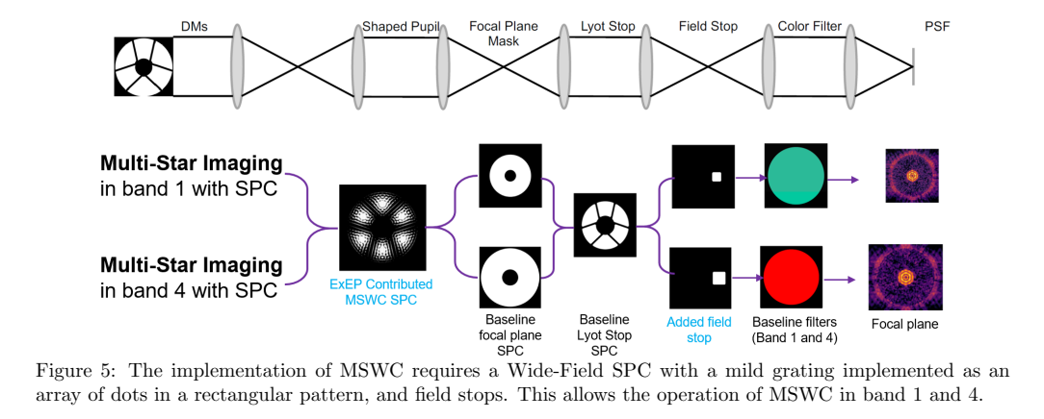
  - Adding in the actual MSWC control algorithm (separate out the DM modes for each star)
- Still Thinking ahead, the things I would like to talk to Rus/Dan/Eduardo about next time:
  - Baseline cases:
    - How to interpret the results/what to look for?
    - How to reconcile band3D with what appears to be a band 1 + 4 config for MSWC?
    - Number of iterations?? Feels like we should just be able to specify a target contrast and have a convergence criteria (ideally achieve target contrast but if the contrast converges to a worse value then it is what it is) instead of specifying number of iterations?
    - General Q: How are the narrow-field and wide-field coronagraphs designed (specifically why are the pupil plane masks different for each)
  - Adding in multiple-stars (capabilities)
  - FALCO Multi-Star implementation
- Observations about corgi-howfsc loop results:
  - How to isolate why the contrast went up (looking at NFOV band 1 case)?
    - Well, it looks like the contrast goes up on iteration 6 for every case???? And I notice this in the cady results too (see figure 10). Comparing with Figure 11, it looks like it corresponds with the same frequency of the beta bumping? So I guess need to go understand what that is and how it works. Section 6.3 in the Cady paper is maybe useful for this.
  - How does WFSC performance change with wavelength/band? (looking at WFOV band 4 vs. band 1).
    - WFOV band 4 also is taking wayyyyyyyyy longer: getting this warning a lot which I didn't get for NFOV band 1:
C:\Users\zahmed1\AppData\Local\anaconda3\envs\corgiloop\Lib\site-packages\joblib\externals\loky\process_executor.py:782: UserWarning: A worker stopped while some jobs were given to the executor. This can be caused by a too short worker timeout or by a memory leak.
warnings.warn(
C:\Users\zahmed1\AppData\Local\anaconda3\envs\corgiloop\Lib\site-packages\joblib\externals\loky\process_executor.py:782: UserWarning: A worker stopped while some jobs were given to the executor. This can be caused by a too short worker timeout or by a memory leak.
warnings.warn(
- Code questions/todo:
  - Also, should figure out how to set up MPI
  - Does corgi-howfsc actually interact with the corgisim repo at all? i.e. if I select corgisim as the active_model, does it use some compiled version that I downloaded at installation?
    - Yes, the compiled corgisim is wrapped up in cgisim-cpp. In Corgihowfsc, we interact with all of the simulation/optical propagation code via Corgisim-manager object
  - Also, in the corgisim documentation, it looks like there is something to do with mswc already?
    - In the documentation here and then I found it in the code as an "untest_cor_types" here
    - It was started to be added in but has not been tested or completed
  - How is eetc used to calculate contrast? The other two options (corgisim-off-axis and corgisim-on-axis make sense since that's what we used in my starshade work more or less)
- More general questions:
  - What is the purpose of the reference star observations? How do we choose reference stars?
    - Your reference star is brighter so WFC is faster
    - If you look at a star where you know (or expect) there are no planets and then move to target star that you suspect has planet then can do RDI for speckle subtraction (for Roman we are doing both RDI and ADI)
  - In the Cady paper, they talk about coherent contrast and incoherent contrast, how do you separately measure those?
    - Well, the coherent light can be measured by definition as the coherent intensity that you estimate via the pair-wise probing. And then the incoherent light is the unprobed intensity - coherent intensity (estimated).
    - Also, does incoherent light always set your noise floor? Since we can't do anything about it?
      - Yes but if you know the incoherent floor then you can subtract it and then just have the photon noise from the incoherent light

7/9/2026:
- Rus 1:1:
  - Next step is to see if we can get a case to start with worse initial contrast (~10^-5):
    - Should start with a flat DM to start with contrast ~10^-5
    - What determines the initial starting contrast?
  - Main things we need to figure out:
    - Band3d (I think this would just be a unique configuration file for the optical model)
    - Off-Axis Stars
    - How to run with Flat DM, run to get the iterations and see contrast get down to hopefully 10-9 and then look at the dark hole images
- To Do:
  - Finish Jupyter notebook for evaluating outputs, produce plots of the dark zone per iteration (might be good to turn this into a gif actually!)
  - See if I can create a "flat" DM initial setting and see what the starting contrast looks like for that
    - From the corgihowfsc documentation, the "dmstartmap_filenames" are different for every band but are optimized(?) to give you some good starting initial contrast
      - I mean in that case, do we really care about about starting with a flat DM? Well, I guess when we do multi-star, we wouldn't necessarily start with the same initial DM setting as for that mode for single star because we have to separate out the modes for each star?
  - Set up MPI (I think this will be a must)

7/10/2026:
- Goals for today to be on-track for internship project:
Jupyter notebook
Flat DM simulation
MPI/Multi-Processing
- Next week can:
Look at off-axis stars
- Jupyter Notebook:
  - I think it was a bit ambitious to try to make plots using all of the output variables without knowing what I'm looking for. I have a lot of the skeleton frameowkr in there but for now focused on the dark hole + probe images
  - A few things I'll want to check:
    - The raw .fits file images are in units of counts it looks likr (multiplies by peakflux * exposure time in simframes howfsc/scripts/gitlframes.py:105) so to convert back to normalized intensity is just divide by peakflux * exposure time.
      - The peak flux is reported in the debugging_history.csv
      - The exposure time is the CAM_PARAMS in the images.fits files! It's different per wavelength (the probe images have a shorter exposure than the unprobed image which looks like is 2 minutes (120 sec))
    - I masked out the center of the dark hole images according to the IWA of the coronagraph
      - I need to think about this a bit, if the IWA is where the throughput is 50%, why are things so bright? Within the IWA shouldn't things be the most suppressed?
- MPI:
  - If just using my laptop, don't need MPI (that's for multi-nodes) but should bump up the "num_imagers" parameter in default_config.yaml to 3!
- Flat DM Simulation (starting from scratch):
  - So looking into this a bit, I'm not sure exactly where the initial DM files are generated from or what they were optimized for but I believe that is what drives the initial contrast. Okay so then if we want to start with a "flat DM" the obvious (perhaps naïve) thing to do would be to just create an initial array with 0V for all 48 x 48 actuators.
    - It turns out that in the cgisim_cpp/roman_preflight_proper/examples/run_flatten.py, they initialize the DMs with a uniform 40V for a true "flat" DM. The Roman CGI DMs are electrostrictive/unipolar (electrostatic or piezoelectric) actuators that can only push the mirror in one direction relative to the subtrate. So do be able to have relative push/pull capabilities, we want to bias the actuators to some non-zero voltage in the middle of the usable range (0-100V). This is why they initialize with 40V
    - Okay but actually, DMs (because of manufacturing errors or whatever) aren't actually flat
    - But then, they also correct for manufacturing errors which gives us the initial DM maps that aren't necessarily "flat" but are pre-dark hole digging. So probably good to run a simulation with fully flat (40V) and also the initial maps. I'll start with the initial maps and see what I get
    - Talking to Rus on 7/13: I think this was correct. These are the "flat maps" that actually DO correspond with a flat DM because they correct for manufacturing defects that make it so the as-manufactured DM is not completely flat. So applying a uniform 40V across all actuators would result in a non-flat DM.

7/13/2026:
- Things to look into:
  - IWA and OWA for each coronagraph mode:
    - The dark hole IWA (I imagine) is set by the IWA of the coronagraph mode, while the OWA is set by the DM actuator spacing
    - I need to remind myself how this gets scaled between bands
      - Scales proportionally with the wavelength?
      - So this is confusing. In Cady et al 2025, Table 6 shows the properties of the WFOV coronagraph but using Band 1. Shouldn't the Inner and Outer radius of the dark hole scale with wavelength to band 4?
        - If that was the case, according to my back-of-the-envelope calcs, the IWA would be 8.26 lambda/D and the OWA would be 27.63 lambda/D
        - But, the dh_sw_mask.yaml in the WFOV_band4 model shows the IWA = 5.6 and OWA = 20.4 which is essentially the same as in band 1?????
        - This was silly of me. The Inner and Outer radius of the dark hole are given in units of lambda/D so they are normalized and thus would be the same for other bands. If we convert to mas, then it would scale linearly with wavelength
  - How to verify that multiprocessing is actually being used.
  - How to define a good beta strategy? Understand the SVD etc.
  - Profiling the code:
    - Nulling.gitl already does the profiling and writes it out to the gitl.log:
    - HOWFSC computation time: time to do a loop of the pairwise probing estimation + EFC (i.e. time to run howfsc_computation in modular_gitl.py)
    - Jac recalc time: time to do howfsc_precomputation (or precompute_jac_mpi if using mpi).
      - What is n2clist???
    - Framelist collection time for iteration
    - I just added a "total iteration time"
    - I should try upping the Jacobian workers, because I don't think this interferes at all with the imaging workers!!!!!

7/14/2026:
- Game plan:
Profile the code:
Write a script to scrape the gitl.log file for the different logged times and then make a plot that shows iteration vs. time in seconds for each step
Re-run but for band 1 NFOV
See if increasing number of Jacobian workers helps
SVD decomposition physical intuition
SVD decomposition to create beta bumping strategy
- Profiling the code:
  - Jacobian is the primary computation bottleneck for sure (reducing the Jacobian by using a smaller FOV would help??) but the strange thing is that there is a factor of ~2 (for WFOV, slightly less-ish for NFOV) between the total iteration time and the sum of the main computations.
    - My hypothesis is that this is due to saving out the outputs for every loop, I am running a NFOV case with "save_output_every_iter" set to false to compare
  - For NFOV, I am seeing that the main computation takes ~2min per iteration
  - Also, does not seem like upping the Jacobian workers from 6 to 10 did much….

7/15/2026:
- Control strategy:
I already have the baseline for WFOV Band 4 (50 iterations) using the default control strategy
Next, try running with the same control strategy as the NFOV Band 1
- Questions:
  - How does the contrast vary with wavelength, or I guess how to calculate the expected contrast floor for the different coronagraph configurations?
  - Random question: HOWFSC is correcting for wavefront aberrations introduced by the coronagraph's optics correct?
    - Yes, the EXCAM is at the focal plane so after the light has passed through the coronagraph. Jacobian is the sensitivity of the DM actuators to the focal plane E-field.
- Prep for Meeting with Rus/Dan:
  - Code Profiling:
    - WFOV Band 4 - 10 iterations nominal
    - NVFOV Band 1 - 10 iterations nominal
    - NFOV Band 1 - "saving_every_iter" turned off
    - WFOV Band 4 - 15 Jacobian workers and "saving every iter turned off"
      - Can compare the Jacobian times
  - Control Strategy:
    - Baseline vs. Band 1 Beta Bumping Schedule
  - Multiple Stars:
    - Add an off-axis star in the FOV
- Meeting notes from Rus/Dan:
  - Need to confirm but the default for the compact model is that it does not introduce any aberrations
    - Need to look in the code to see if this is true and if possible add aberrations
  - For NFOV Band 1, the spiders in the Lyot stop (I think?) introduce aberrations, which is why we then have the optimized initial DM solution to compensate.
    - According to Dan, the SPC for WFOV Band 4 should be taking care of the spiders so we shouldn't need an initial DM solution and should baseline be starting out at whatever the coronagraph contrast is (1e-8 ish). This is because the compact model doesn’t by default have any aberrations included
      - What's a bit confusing about that though is that then I would think that the initial flat DM map would be what you want to use??? Will need to ask the Roman CPP team about this.
      - Basically I need to double check/better understand what the "gitl_start_compact" DM map is correcting for if the compact model has no aberrations
  - Multi-star:
    - For corgisim it seems relatively straightforward I think
    - For the compact model, would model an off-axis star as a phase ramp in the pupil plane
      - We would need to understand how the off-axis separation translates to the angle of the phase ramp
  - Dark Hole results:
    - What is the periodic structure we are seeing in the dark hole images????

7/20/2026:
- Going through the docs/source/optical_cfg_docs.md:
  - Storing this info for later but it looks like in this would be the config file to modify for Band3d but also for modifying the size of the dark zone etc.
  - In the "dh" dark hole mask, you can just define the mask where pixels set to 1 are included in wavefront control and pixels set to 0 are excluded. I'm assuming these are pixels in the focal plane
- Trying to go through the optics modeling:
  - Okay so in CorgisimManager, it has a function called create_optics which calls the instrument.py file from corigsim to create an optics object
    - I might be wrong, but it looks like CorgisimManager is only instantiated if the backend is corgisim (backend ='corgihowfsc') and not if backend is cgi-howfsc (compact model)
  - What is the difference between a CoronagraphMode object and CorgisimManager object?
    - CorgisimManager has a function "create_optics" that calls the instrument.CorgiOptics object. This CorgiOptics object is created inside all of the "generate_..._psf functios within CorgisimManager
    - Meanwhile, a CoronagraphMode looks like it is an object that is just created to store the relevant information from the optical_model cfg file that you specify at the top level parameter default_param.yml. This object is used a bunch throughout the code, including in the GitlImager
    - So I think the real question is how does the GitlImager interface with the CorgisimManager:
      - Okay so I think the thing we directly interface with for generating images is the GitlImager object, which itself instantiates a CorgisimManager object and calls those functions only when using corgihowfsc objects. This tells me that CorgisimManager is only relevant for corgisim backend and not relevant for the compact model. And then GitlImage is a wrapper interface that allows you to use either corgisim or compact model to generate your frames etc. (i.e. composable interface)
      - Also need to double check this but I think CoronagraphModel is only necessary for the compact model???
    - For the compact model, when we need to generate an image:
      - GitlImage.get_image -> GitlImage.gitlframe_cgihowfsc -> sim_gitlframe (in "gitlframes.py") -> computes the efield using the CoronagraphMode object which has stored all of the optical model info as well as instantiated a "SingleLambda" object (see singlelambda.py). The efield is calculated using the mask propagation functions inside singlelambda.py (This is what Figure 4 in the Cady paper shows). Then this efield is converted to a frame just by computing the normalized intensity and then multiplying by peakflux and exposure times to get the frame back to units of counts.
    - For corgisim model, when we need to generate an image:
      - GitlImage.get_image -> GitlImage.gitlframe_corgisim -> CorgiManager.generate_host_star_psf -> this function first calls the "create_optics" which then creates a "CorgiOptics" object This is I think somewhat analogous to the CoronagraphMode + SingleLambda objects in terms of functionality (creates the optical model and then propagates through that). The CorgiOptics object init function sets the coronagraph model from cgisim (corgisim is a wrapper for cgisim) which itself is a wrapper for roman proper. Then the CorgiOptics generates the stellar spectrum through a bandpass and then uses Proper to generate the electric fields (which are then converted to intensity by squaring the abs magnitude). The image is then constructed into the final image array using the "construct_image_array" function in CorgiOptics. I guess the optical model propagation must be happening when the efield is generated but I'm not quite sure I see where that is happening in proper.
        - Side note: this is where the "untested" mswc coronagraph type lives, I should investigate this more because there is one for mswc_band4
- Okay so where do we stand:
  - Aberrations: I don't think I see where aberrations are added for the compact model. For corgisim, it looks like it's mainly polarization aberrations and jitter?
  - Multi-star: I haven't traced through how the "generate_off_axis" function in CorgiOptics is used…..
  - Speed-up: Need to look at this more tomorrow

7/22/2026:
- To Do:
Run a test simulation with corgisim instead of compact model to get a sense of how long it takes
- ~30min per iteration unfortunately
Off-axis star
In theory, if I add an off-axis star into the image but then am just using howfsc, the second star should be incoherent light and should still show up in the dark hole images
Small dark hole:
See notes from 7/20, I think there's an "easy" way to do this, although it is not entirely clear to me that this would be related to MSWC because it's just adjusting the "S" region in the focal plane that we want to include…..
HWOodstock Poster

7/23/2026:
- Off-axis star:
  - As a recap, here is the flow when generating an image with corgisim:
    - GitlImage object instantiated in the top level run_corgisim_nulling_gitl.py -> GitlImage.get_image (corgisim_gitl_frames.py) -> calls GitlImage.gitlframe_corgisim (corgisim_gitl_frames.py) -> CorgiManager.generate_host_star_psf (note: CorgiManager is instantiated in the constructor function for GitlImage if the backend is set to corgisim) -> this creates a "CorgiOptics" object (in corgisim/instrument.py) and then creates the scene propagated through the optical model
      - The "CorgiOptics" object "get_host_star_psf" function is a bit confusing to me, going to skip for now and assume that it will work and then can dig deeper if needed
  - Functionality for off-axis star that already exists/integration plan notes:
    - CorgisimManager.generate_off_axis_psf() already builds a scene with a point_source_info list (Vmag, magtype, position_x, position_y in mas) and calls optics.inject_point_source on a scene that ALSO includes the on-axis star.
      - Note: From what I can see, this function is currently only used for peak flux calibration (get an off-axis star's peak flux to be able to convert from counts to normalized intensity
      - This function adds noise correctly if point sources are included or not, so that is good news
      - For the noise free path though we will need to sum the host star + point source images because currently the "generate_off_axis_psf" only returns the point source image
  - Plan:
    - Corgisim_utils.py: Add 'point_sources" to _MANAGER_KEYS; add a small helper "build_point_source_info(point_sources_cfg) that converts a user-provided list of (vmag, position-x_mas, position_y_mas) into the Vmag/magtype/position_x/position_y dictionary that scene.Scene (CorgiScene) needs
    - Corgisim_manager.py: In _initialize_config, set self.point_sources = _build_point_source_info(self.corgi_overrides.get('point_sources', []))
      - Make sure this defaults to empty [] so I don't mess up regular degular operation!!!!
    - Corgisim_manager.py: in generate_host_star_psf, after sim_scene = optics.get_host_star_psf(self.base_scene), if self.point_sources is non-empty, build a companion scene.Scene and call optics.inject_point_source(…) on the same sim_scene; in the noise-free return branch, sum host-star_image.data + point_source_image.data (I think the noisy branch shouldn’t need any changes but will check).
    - Default_param.yml: in the corgi_overrides section, add a "point_sources" section (which will be processed by corgisim_utils change #1 in this list).
  - Notes:
    - As I'm setting up the point_source info for the off-axis star, I realized that in the hconf file that defines the on-axis stellar properties, there are two fields "stellar_vmag" and "stellar_vmag_target". "stellar_vmag" is the reference star for dark hole digging and stellar-vmag_target is the (ostensibly) dimmer target star. Howfsc doesn't use "stellar_vmag_target" anywhere. Which makes sense in terms of wfsc being performed using a bright reference star but then makes me realize I have a con-ops question for MSWC:
      - When doing MSWC, do you dig your dark hole directly with the target stars then??
- Notes from Meeting with Rus, Dan and Eduardo
  - How does corgisim handle off-axis sources that are outside of the FOV? From this example of a star that is at ~139 lambda/D

7/27/2026:
- Off-axis star tests stuff:
Need to fix the "noisy path" to generating the off-axis sources
Finer wavelength sampling to reduce the striations in the dark hole images as the off-axis sources moves out of the FOV
Band 3d config
Grating mask to see the diffraction orders
Understanding the aberrations
- Assumptions:
  - Using on-axis (unobstructed) source for peak flux normalization
  - Noise-less (i.e. no detector noise)
  - Monochromatic
- Other things to check:
  - What is a ballpark exposure time to use???? Does the exposure time matter except for detector noise? Would matter for counts but not contrast
  - After meeting with Rus this morning:
    - Check on aberrations. From my contrast vs binary separation plot, it looks like the aberrations are maybe only defined out to 40lam/D because there is a knee at that point
    - 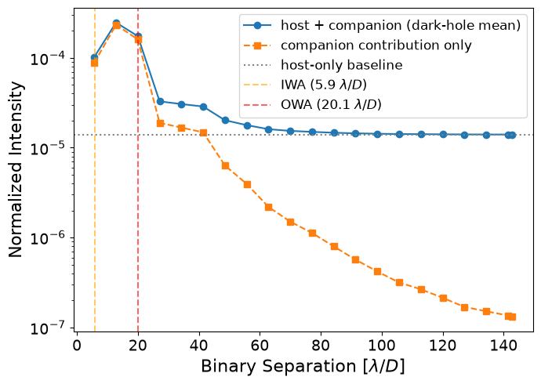

- Also just generally, let's understand what aberrations are included (i.e. why does the contrast start so high (bad))
- 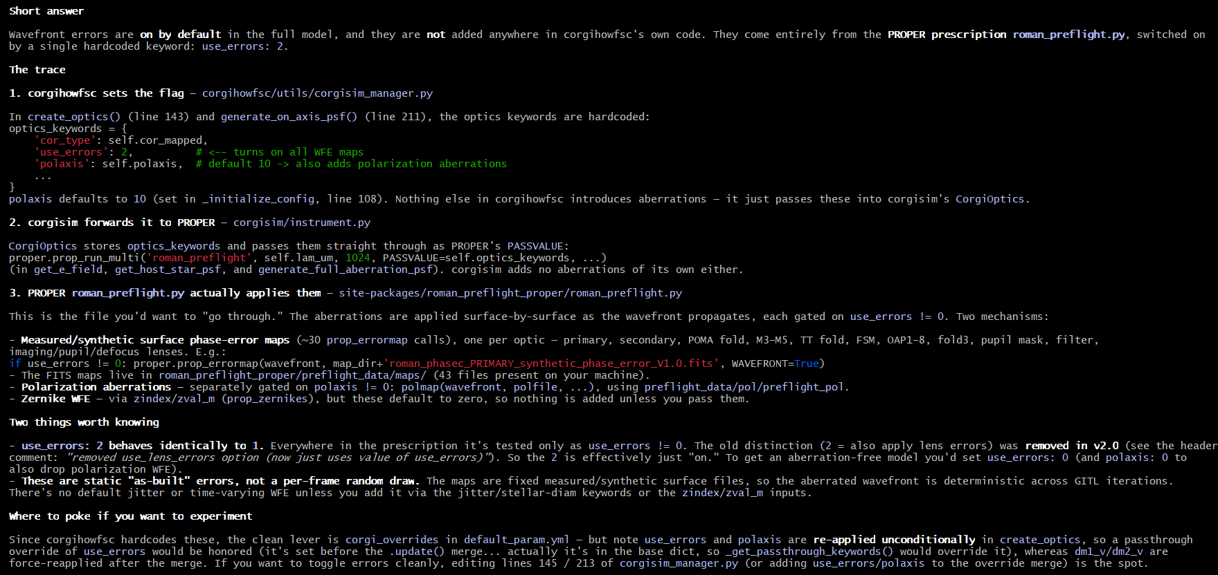
- Why is the off-axis companion showing up as 1e-2? Would expect if the two stars are the same it should be 1e0 = 1 since they are the same star in theory
  - Technically it was 2.5 mag dimmer (factor of 10) but then there is still a something un-accounted for
  - I acutally think my colorbar is just saturating
  - ANSWER: It wasn't the colorbar saturating, it was just the fact that the off-axis star was not the same magnitude as the on-axis (on-axis is the reference star which is set to 2.25 mag vs target star which is 5 mag)
    - The off-axis star was set to 5 mag. Once I correct to 2.25, it has the same normalized intensity as the on-axis (i.e. NI = 1)

7/28/2026:
- To Do:
Need to fix the "noisy path" to generating the off-axis sources
Understanding the aberrations
How does the scene change to add or remove off-axis stars that are outside of the field of view??
Grating mask to see the diffraction orders
Band 3d config
Reduced dark hole
Re-run with nlam doubled to generate gif and contrast curve (point_source_sweep)
Run single-star WFC with an off-axis source to establish baseline performance
- Noisy Path:
  - Okay as I am debugging, one thing that I constantly run into which is a bit confusing is what is "nframes":
    - We have several subbands within the chosen mode (e.g. for band4, there are three subbands)
    - We also have the unprobed, pos probed, neg probed images for each probe pair (of which there are three probe pairs I believe):
      - 3 subbands * ((3 probe pairs * 2 images for each probe (pos/neg)) + 1 unprobed per wavelength) = 21
    - We also have a set of monochromatic bands that are sampled for each subband:
  - lind (corgisim_manager.py:288, :124-133)
    - It's an index into cfg.sl_list, the list of wavelength/subband channels for the current coronagraph mode (e.g. 3 elements for band 1's a/b/c subbands, or up to 6 for band 3). _get_bandpass_recipe(lind) (corgisim_manager.py:124) uses it to pick the letter suffix:

subband_option = ['a', 'b', 'c', 'd', 'e', 'g'] # (band 3 only; else ['a','b','c'])
return self.bandpass + subband_option[lind]

- So lind=0 → '1a', lind=1 → '1b', etc. It's called "index" rather than "count" because generate_host_star_psf computes the PSF for one subband at a time — the caller loops over lind externally when it needs all subbands. We can see this pattern in corgisim_gitl_frames.py:277 (lind=j inside for j in lam_inds) and contrast_nomalization.py:158/209 (lind=sl_ind).
- This is a different axis than the "number of monochromatic wavelengths sampled", that's nlam (corgisim_manager.py:115, :142-166), which controls how many discrete wavelength samples corgisim's optics model uses within a single subband (i.e., within whichever subband lind points to). lind selects which subband; nlam controls the spectral resolution inside that subband.
- nframes (corgisim_manager.py:271-284, in the noisy branch of generate_host_star_psf/generate_on_axis_psf)
  - This refers to detector-noise realizations, not subbands or monochromatic samples. When is_noise_free=False, the code loop is:

for n in range(nframes):
sim_scene = detector.generate_detector_image(sim_scene, exptime)
frame = (self.k_gain * sim_scene.image_on_detector.data - B) / gain - master_dark
coadd += frame
return coadd / nframes

- Each iteration draws a fresh detector-noise realization (shot noise, EM gain noise, etc.) on top of the same already-computed optical PSF (for the single lind/subband requested), applies bias/dark/gain correction, and the function returns the average of nframes such noisy frames. It has nothing to do with probed vs. unprobed images or subband count, it's purely "how many independent noisy detector reads to simulate and coadd for this one PSF." If is_noise_free=True, nframes is unused entirely since there's no noise to average out.
- Also tracing nframes a bit more, it looks like it is set by some optimization inside "EETC", so it is the number of frames needed to achieve the target SNR given some camera parameters including (I guess) exposure time per frame
- So to summarize the three distinct "frame-like" axes:
  - subbands = iterate lind over range(len(cfg.sl_list)) externally, one generate_host_star_psf call per subband
  - monochromatic samples within a subband = nlam (corgisim optics internal, set via corgi_overrides)
  - nframes = repeated noisy detector reads of one already-propagated PSF, averaged together
- Also, while we are on this topic, the num_workers for multi-processing works like the following:
  - (mpi_runtime.py:294-315): For a given control iteration, rank 0 builds one FRAME task per (subband, DM-setting) combination:

frame_tasks = [
{'job_id': indj*ndm+indk, 'lind': indj, 'nframes': nframes_list[...], ...}
for indj in range(len(cfg.sl_list)) # one task per subband
for indk in range(ndm) # one task per DM/probe setting
]

- So the total task list has len(cfg.sl_list) * ndm entries — e.g. 3 subbands × (1 unprobed + several probed DM settings) = one task per (subband, probe) pair. Each task is a single, complete unit of work: a fixed lind (which subband) and a fixed nframes (how many noisy detector reads to simulate and average within that one task, on rank 0's worker).
- Imaging workers are just MPI ranks pulling from that task queue (mpi_runtime.py:424 _run_manager_task_queue, num_imager_worker/max_workers). It's a dynamic pool, not a static assignment:

while completed_task_count < len(task_list):
message = comm.recv(source=MPI.ANY_SOURCE, ...) # whichever worker finishes first
...
task = task_list[next_task_index] # gets handed the next pending task
comm.send({'message_type': task_type, 'task': task}, dest=rank)

- So aworker is not dedicated to a particular subband. Rank 0 hands out (lind, DM-setting) tasks one at a time to whichever worker rank is free next, and each worker independently runs generate_host_star_psf(..., lind=task['lind'], nframes=task['nframes']) for that single task (mpi_worker.py:116-129), then returns the averaged frame. If you have more subband/probe combinations than workers, a worker just picks up its next task as soon as it's free; if you have more workers than combinations, some workers go unused for that queue.
- To summarize the full picture: lind = which subband a task computes, ndm (DM-setting count, e.g. probed/unprobed) = the other queue dimension, nframes = noise-averaging depth inside one task on whichever worker draws it, and num_imager_worker/MPI rank count = how many tasks run concurrently. All four are independent knobs.
- Great! After hours of work, it turns out the noisy path is actually already good to go, I just wasn't looking at the images in log scale :-)

8/4/2026
Understanding the aberrations
How does the scene change to add or remove off-axis stars that are outside of the field of view??
- Off-axis stars are added as tilted wavefronts
3 simulations to run:
Lower priority: re-run 2x nlam off-axis planet sweep to get updated gif and contrast curve
Re-run planet sweep with errors turned off:
- 20260804-220808_offAxisSweep
  - Turned polaxis=0 in default.config
  - Set use_errors=0 in config_manager
  - Forgot to change DM map so used "gitl_start_compact_dm1.fits"

- 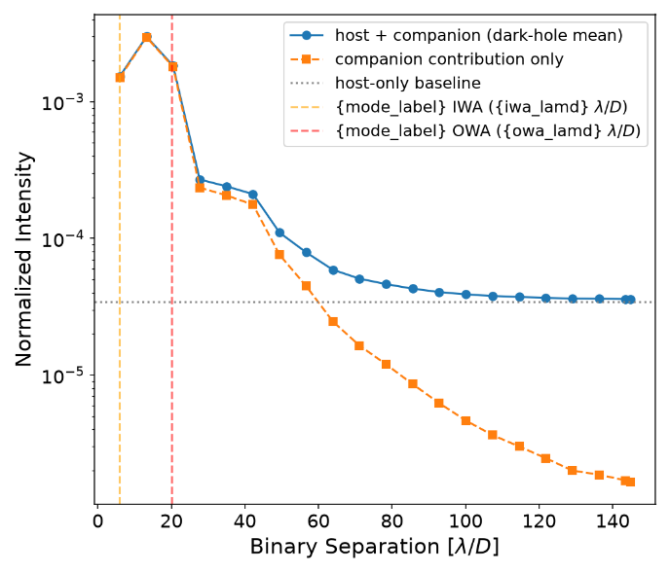
- 20260804-233913_offAxisSweep
  - Commented out polaxis (so only use_errors is turned off)
  - Set use_errors=0 in config_manager
  - Forgot to change DM map so used "gitl_start_compact_dm1.fits"

- 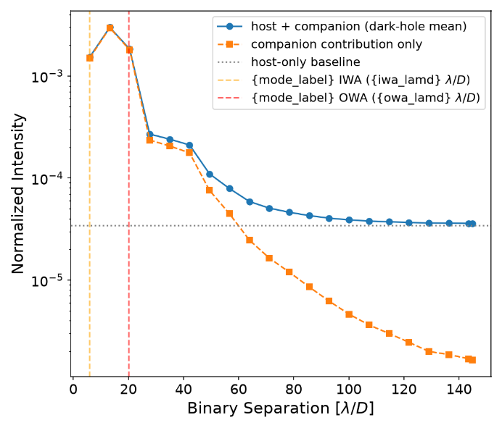

- For both of the above cases, the off-axis planet contrast is larger (brighter).
- Maybe this makes sense because without errors, the off-axis throughput is higher which is generally what we want for planet hunting.
- But Also it looks like I ran both of those two with the "gitl_start_compact_dm1.fits" DM maps which in theory have been optimized to produce 1e-8 contrast for the compact model. For the corgisim model, I guess those compact model initial DM maps resulted in the ~4e-5 contrast using run_gitl_nulling and resulted in ~1.5e-5 using my point source sweep for the host star. The difference is likely from how the contrast is being calculated (EETC in run_gitl_nulling and on-axis normalization in point_source_sweep)
- Okay so if I run with a flat DM (running now), I should see better host star contrast because the errors are still turned off so a flat DM + no optical aberrations should give me ~1e-8 contrast??? For the off-axis star I'm not quite sure how to think about this
- 20260805-074610_offAxisSweep:
  - Re-running with use_errors=0 and polaraxis commented out in default.yaml BUT with the flat DM maps ("dmabs_init_dm1/2.fits")

- 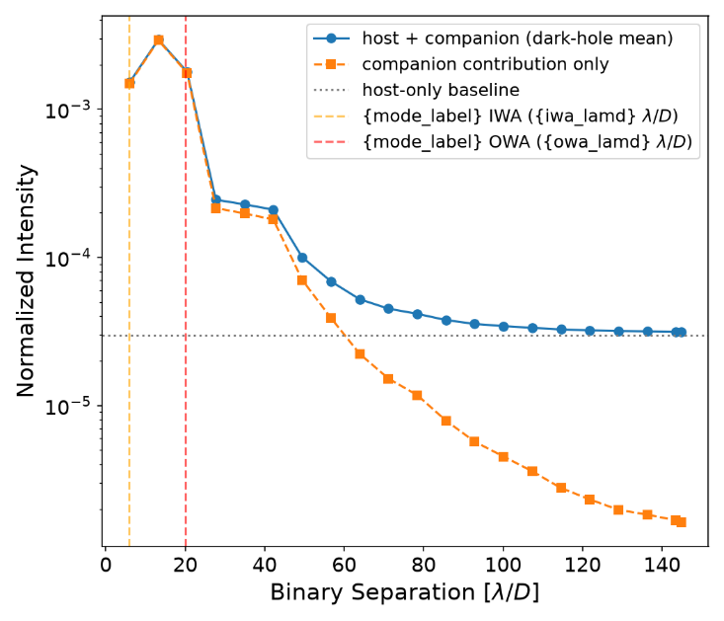
- What is strange here is that I would expect if error are turned off and I'm using the "flat maps", the host star contrast should be much lower…
- 20260805-112126_offAxisSweep: As a sanity check, I should just to make sure I can re-create the results I have here:
  - Use_error (set in corgisimManager) set to 1
  - Use the gitl_start_compact_dm1.fits DM models
  - (Left) The contrast curve from 20260724_offAxisSweep_10arcsec
  - (Right) The contrast curve from the 20260805-112126_offAxisSweep that is in theory supposed to match exactly because I am using the same settings (gitl_start_compact_dm1.fits

- 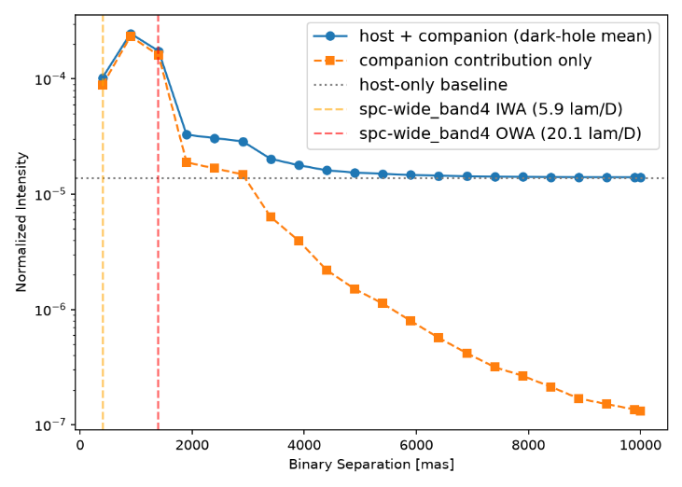
- I need to update my point_source_sweep script to output a config file so I know the details of what I ran

8/5/2026
Re-run baseline planet sweep (compact DM maps, use_errors=2)
Run baseline planet sweep with errors on but using the flat DM maps
Re-run planet sweep with mswc masks
Once I am confident in those results (maybe talk to Rus), then run wavefront control with the off-axis star there just to establish the baseline in prep for SNWC
Fix the label generation for the contrast curve, not sure why this is broekn
Potentially add the EETC normalization to compare with the OnAxisStar normalization

- Okay I see what has happened with the "baseline" curve that I've been using (The one pasted above on the left):
  - 20260724_offAxisSweep_10arcseconds is the curve I've been using but I had accidentally set the off-axis planet to be 2.5mag instead of 2.25mag here so the planet was fainter and contrast lower. You can see this in the dark frames as well, the peak of the off-axis planet is not 10^0
  - Okay then I fixed this in the "single" runs in 20260727-143237_offAxisSweep (which is the planet close in)
    - 20260727-151140_offAxisSweep: nlam=10 with planet out of the FOV
    - 20260727-160020_offAxisSweep: the full sweep but something errored so the contrast curve wasn't generated (this is what I was supposed to include in my poster)
    - 20260727-204008_offAxisSweep: nlam=5 with planet out of the FOV but fixing the panel plot for my HWO poster
    - 20260727-213329_offAxisSweep: nlam=5 with planet close in and fixing the panel plot for my HWO poster (just formatting/font sizes etc)
  - Okay then that brings us to yesterday/today:
    - 20260804-220808_offAxisSweep:
      - Correct off-axis planet magnitude (2.25), use_errors=0, polaxis=0, dm_init="gitl_start_compact_dm1.fits"
    - 20260804-233913_offAxisSweep
      - Correct off-axis planet magnitude (2.25), use_errors=0, polaxis=DEFAULT (10), dm_init="gitl_start_compact_dm1.fits"
    - 20260805-074610_offAxisSweep:
      - Correct off-axis planet magnitude (2.25), use_errors=0, polaxis=DEFAULT (10), dm_init="dmabs_init_dm1/2.fits"
    - 20260805-112126_offAxisSweep:
Correct off-axis planet magnitude (2.25), use_errors=2 (original), polaxis=DEFAULT (10), dm_init="gitl_start_compact_dm1.fits"
- Strange thing is the with use_errors=0, polaxis=0 and flat_dm_maps, I would expect host contrast to be very low. To debug, will run:
  - Run_single with off-axis planet wherever and look at what my script computes as the host star image:
    - Set use_error=0, polaxis=0, dmbabs_init_dm1/2.fits
    - 20260805-145518_offAxisSweep
    - Yup, looks like the host star average contrast is ~3e-5 which is confusing to me (don't worry I fixed the titles of the plot to only incldue 2 sig figs)

- 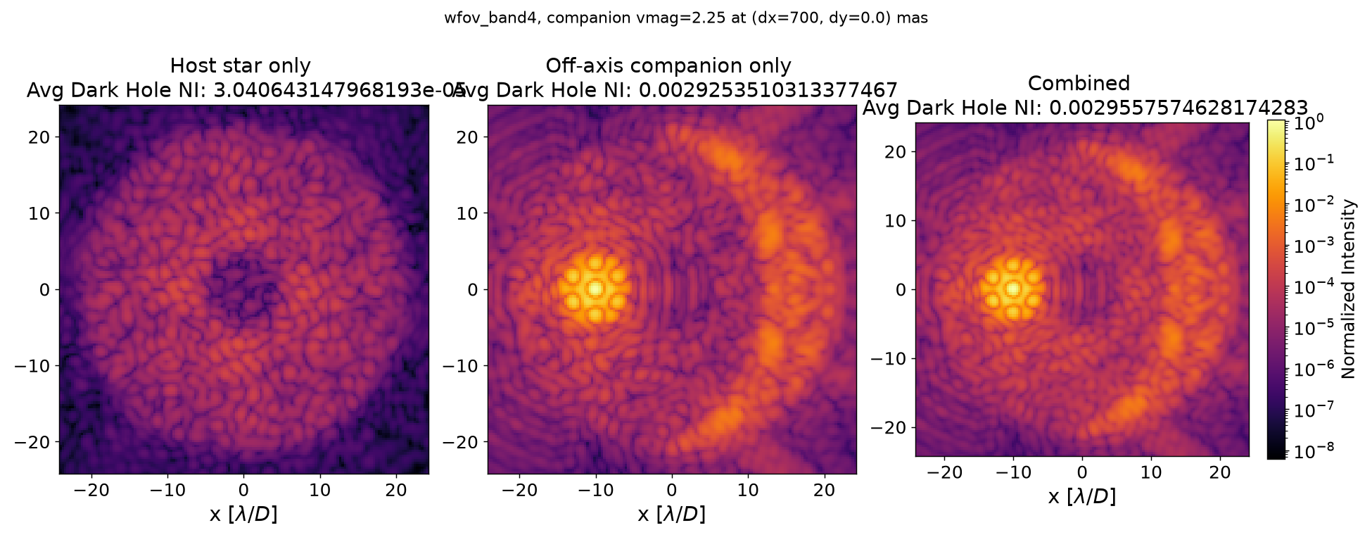

- Compare this to run like 2 iterations of corighowfsc with off-axis source turned off!! Flat DM maps, use_error=0, polaxis=0 and see what the starting contrast is…..
  - This will at least tell me if I'm calculating the contrast incorrectly
  - 2026-08-05_170334_corgisim_model:
    - Looks like it has the same starting contrast (3e-5)
    - I mean so this to me feels like it's the DM maps???????

8/6/2026
- To Do:
  - Operation track down why the on-axis contrast isn't ~1e-8/1e-9 for no WFE with the SPC mask
    - Possible culprits:
      - Use_errors=0 is not making its way into the proper runs
      - Initial DM maps aren't actually flat maps
        - I think this is likely the culprit
  - The knobs that we have that need to align:
    - Use_errors: sets the optical aberration masks
    - Polaxis: polarization aberrations
    - DM_maps:
  - Okay so let's think through the DM maps:
    - Flat DM map is supposed to just flatten the wavefront (cancel out the modeled static wavefront error)
      - Looking at the "run_flatten.py", it looks like the flat_wfe maps (which I should double check if these correspond to the same flat maps as are in the model is corgihowfsc) are generated with use_errors=1 and polaxis=10, as in they are designed to correct for the static aberrations in the entire optical system??? Also, the dm imperfections are modeled separately and those can't be turned off I think (need to confirm)
      - To run "run_flatten.py", need to copy the proper prescription into cwd (Documents in this case)
Cd ~/Documents
python -c "import roman_preflight_proper; roman_preflight_proper.copy_here()"
python .\cgisim_cpp\roman_preflight_proper\examples\run_flatten.py

- Default run_flatten.py results (with use_errors=1 and polaxis=10):
  - Mean NI before flattening: 1.801e-04
  - After flattening: 6.007e-06
  - 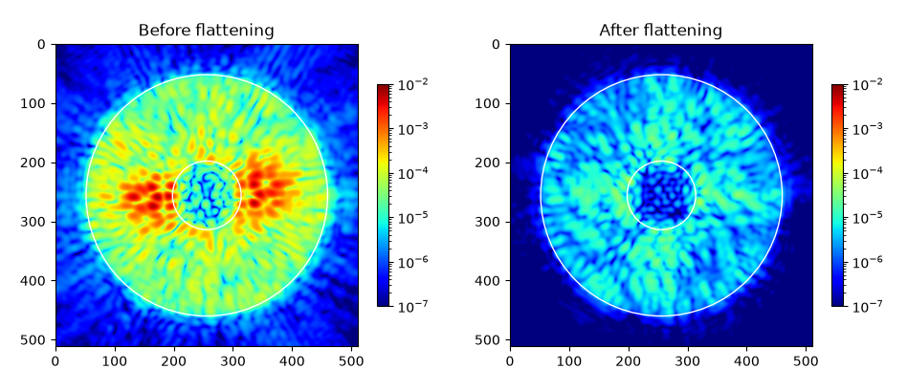

- Run_flatten.py with use_errors=0 and polaxis=0:
  - Mean NI before flattening: 1.507e-04
  - After flattening: 3.063e-05

- 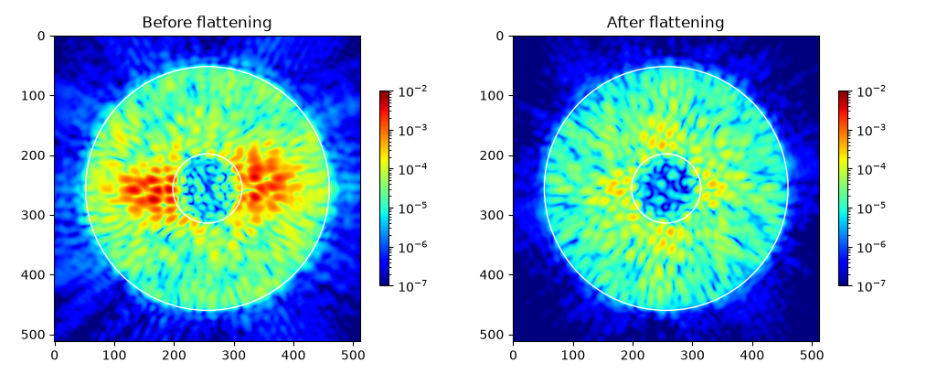

- Based on this, it looks like the "flat maps" were generated to correct all static aberrations, although I'm surprised the mean NI isn't lower?
- Talked to Rus:
  - There are many things we could dig into here but might not be the best use of time right now. For now, the flat maps mostly make sense, there are many reasons why the results are ~1e-6 instead of ~1e-8/9 (i.e. flat map isn't perfect). Keep going for now but if time can come back to this.
- Last thing before going to SNWC:
  - Confirmed that the "flat maps" I'm using in corgihowfsc are the same as the flat maps I've been testing above from proper:
    - Corgihowfsc: "dmabs_init_dm1/2.fits"
    - PROPER: "spc-wide_flat_wfe_dm1_v.fits"
- SNWC Party Time!!!!
  - Step 1: See if we can get the mswc configuration in PROPER working with the diffraction orders showing up for a super-nyquist off-axis source
    - 20260806-132754_offAxisSweep:
      - Set the "cor_type" in corgi-overrides to "spc-mswc" and confirmed that this does pass through to PROPER. However, I am not seeing the diffraction orders…..
        - First, checked that the SPM that PROPER is calling has the grating pattern: "cgisim_cpp/roman_preflight_proper/preflight_data/spc_20200623_mswc/SPM_SPC-20200623_982_rounded9_gray.fits"
        - 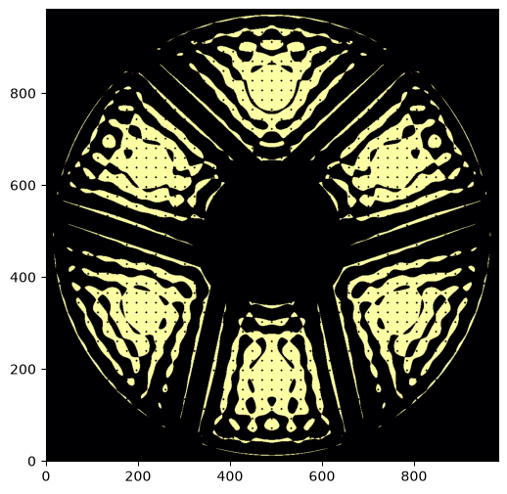

- 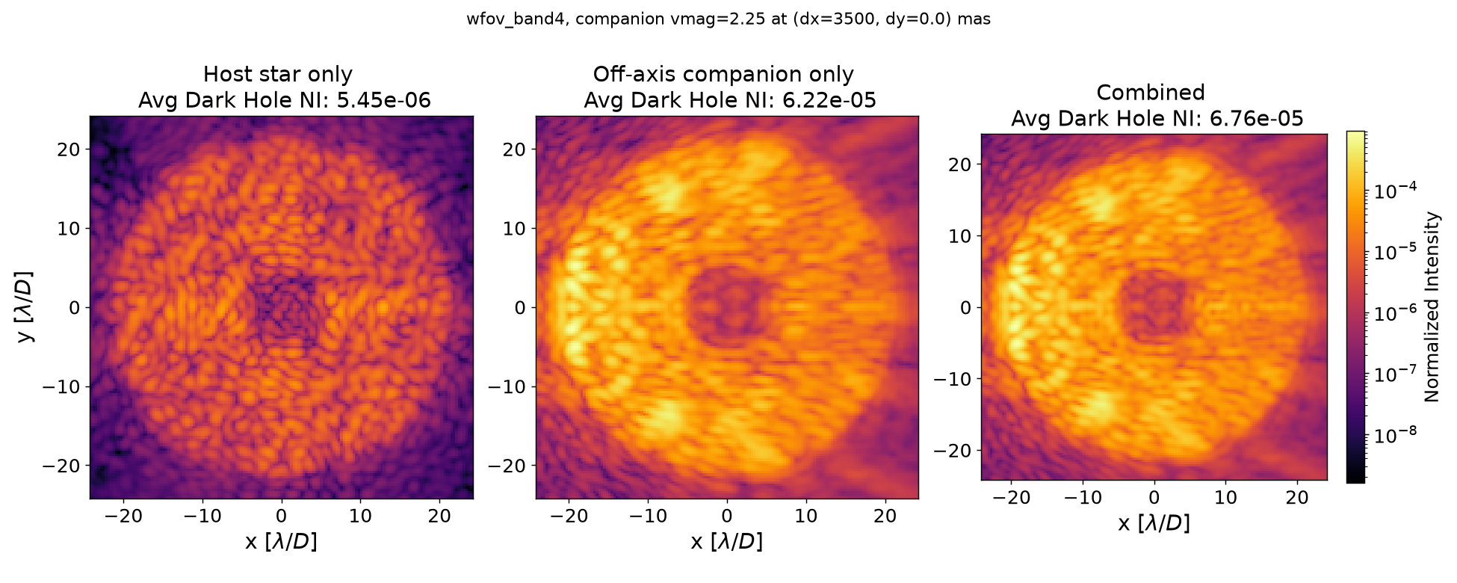

- 20260806-134307_offAxisSweep:
  - Just as a sanity check, this is the default wfov_band4 image for the same config (i.e. not using spc-mswc):
  - The results are definitely different between spc-mswc and spc-wide_band4 but (I think surprisingly) the off-axis companion image is brighter without the grating mask????
    - 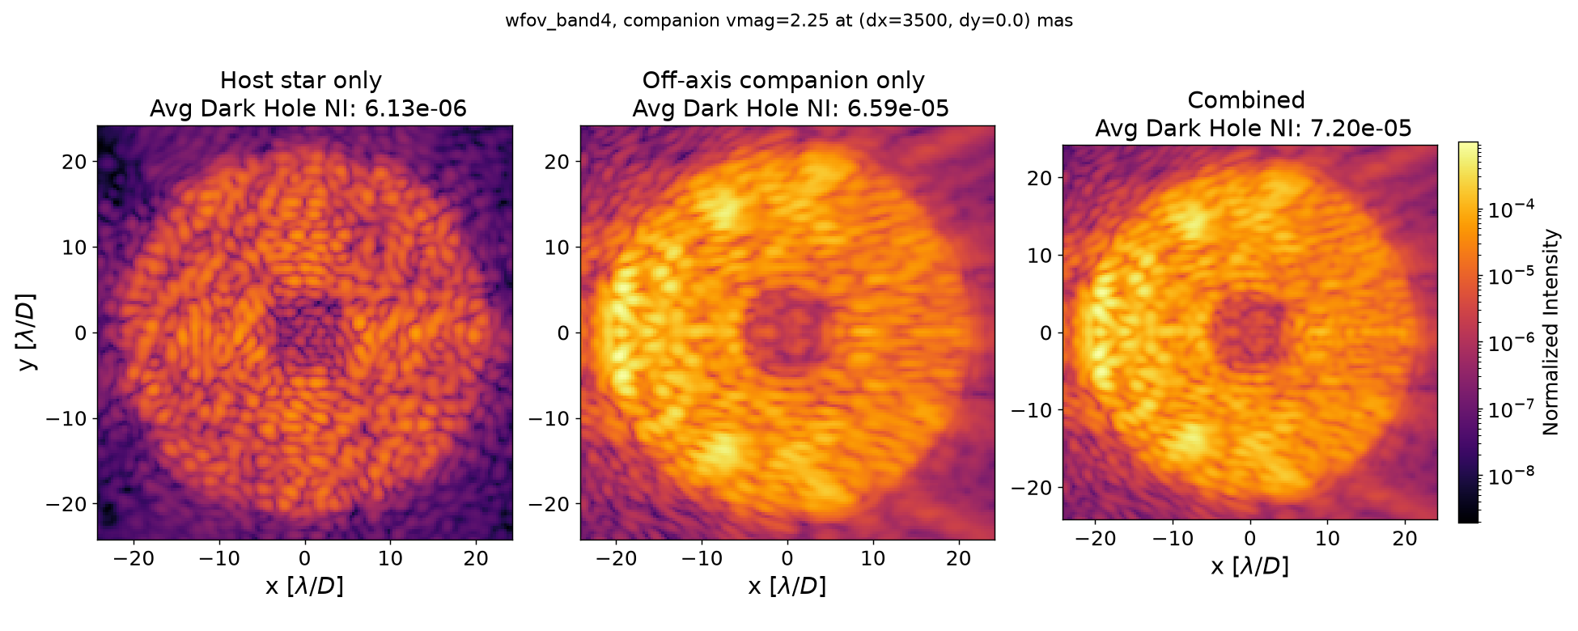
- Let's see if using the 3e-9 DM solution makes anything pop out.
  - Using the 3e-9 DM solution + moved the planet out to ~100 lambda/D
  - Spc-mswc: 20260806-144418_offAxisSweep
    - 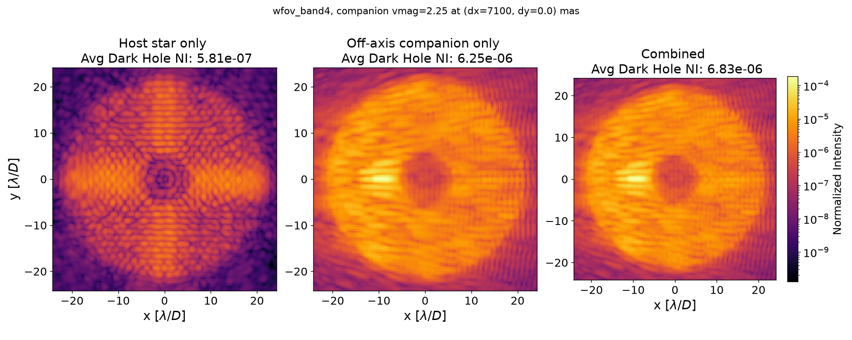

- Default spc-wide_band4: 20260806-143401_offAxisSweep
  - 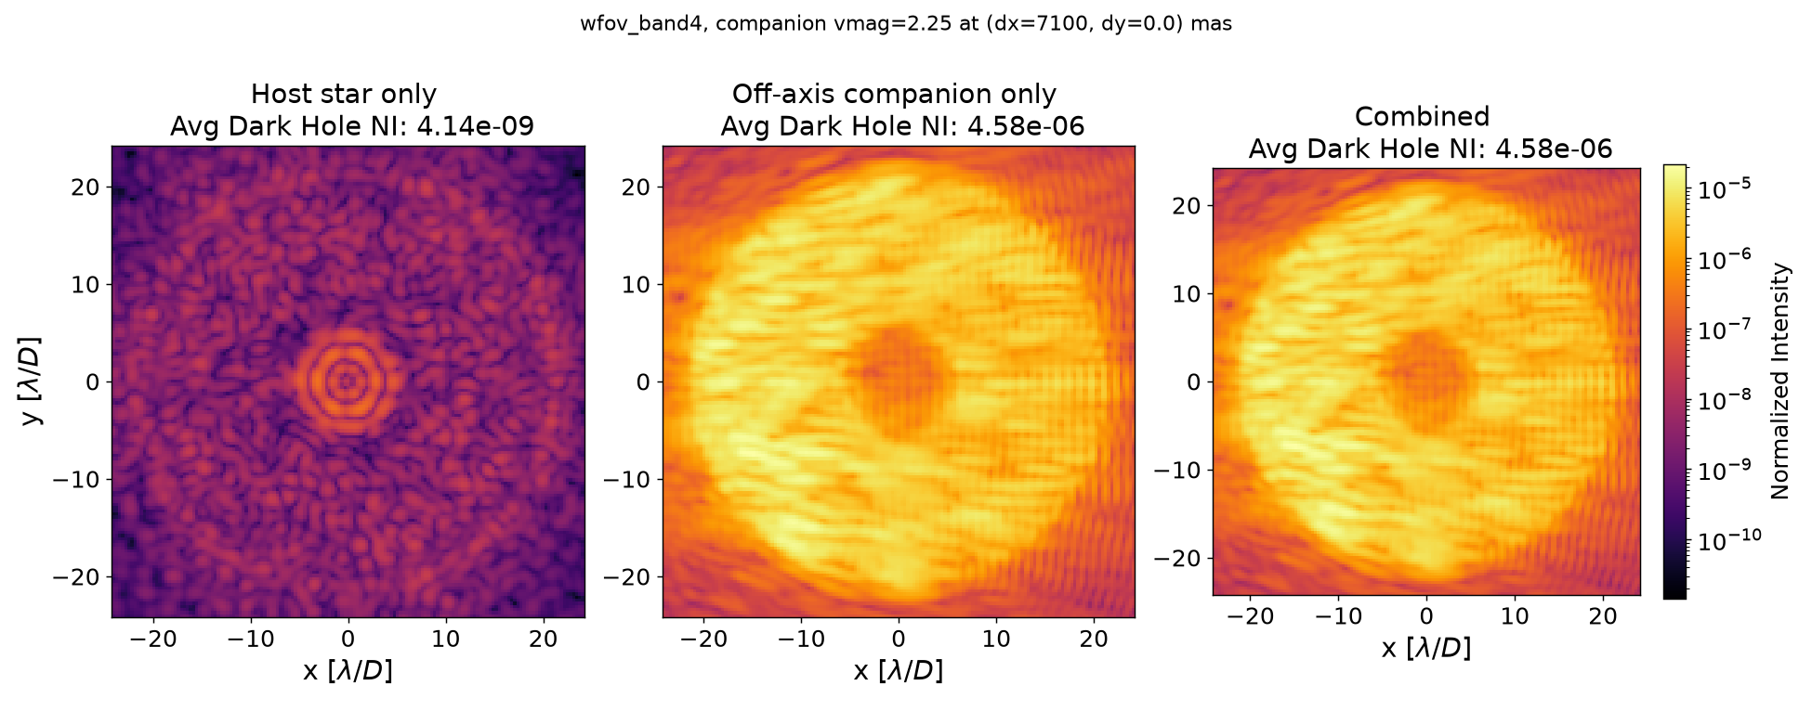
- Observations:
  - Going to the spc-mswc files decreases the host star contrast by a factor of 2?? Not sure if this is actually the case because it could be a modeling artifact stemming from the fact that spc-mswc uses completely different files for the pupil, spm, fpm, and lyot stop. I should check to see how different these really are between spc-mswc and spc-wide-band4
    - The pupil sampling for spc-mswc is slightly different (982 instead of 1000 for spc-wide-band4)
    - SPC-MSWC:
      - 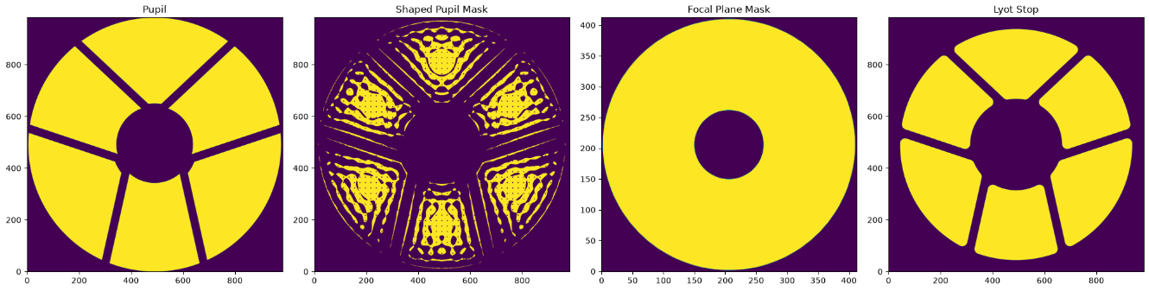
    - SPC-WIDE_Band4:
      - 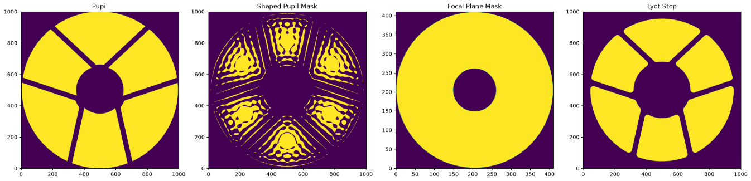
    - Why does the diffraction pattern look different between spc-mswc and spc-wide_band4? The grating??
- Meeting with Rus, Dan and Eduardo:
  - The difference in the on-axis contrast between spc-mswc and spc-wide_band4 could be because the error maps for the spm for mswc is different than the wide fov one so the DM solution that has been optimized for spc-wide-band4 will not be applicable to the same contrast for mswc
    - Apparently the mswc spm was optimized to provide the same contrast for the on-axis star as the regular spm
    - Okay I just checked and the error map is the same regardless of the actual pupil mask (all of the error maps live in cgisim_cpp/roman_preflight_proper/preflight_data/maps)
  - Should get a starting contrast with flat DM and planet at 150 lambda/D: 20260806-180438_offAxisSweep:
  - 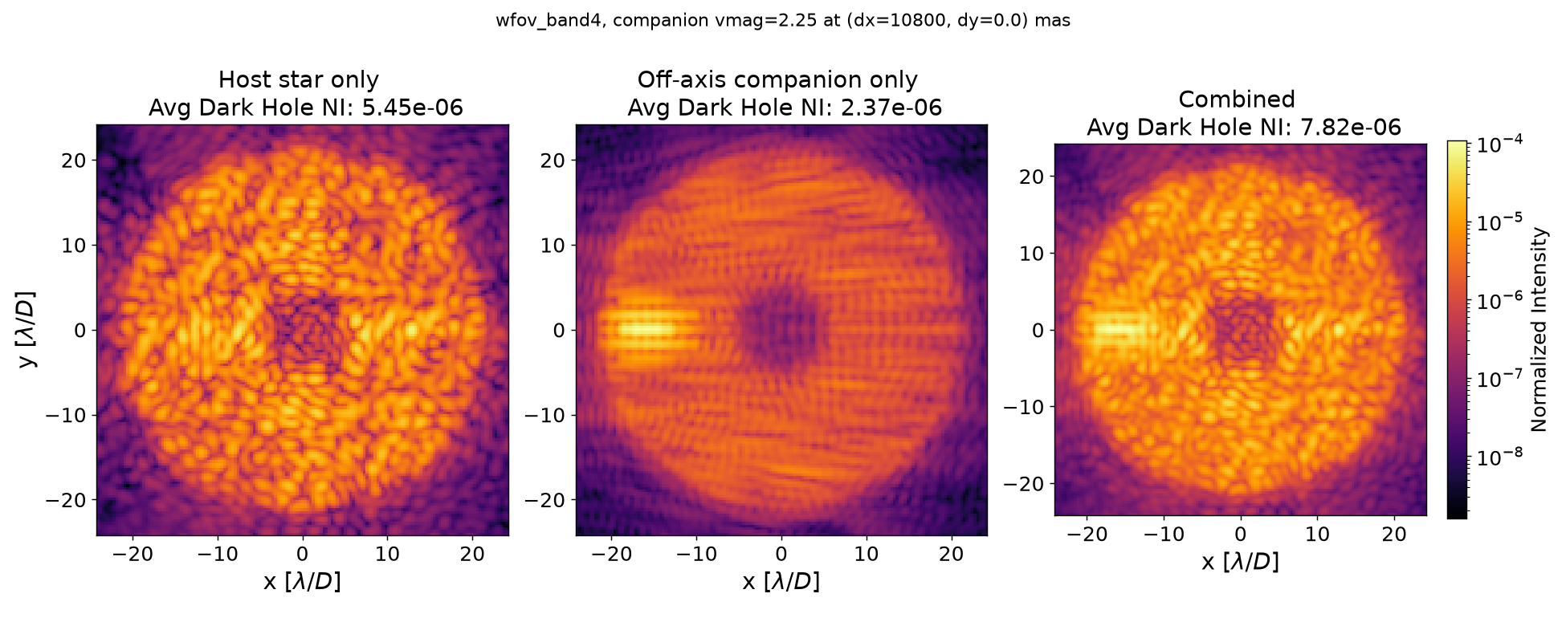
  - For SNWC:
    - Turn off the on-axis star
    - Turn on a single off-axis star at 150 lambda/D. Maybe start with a flat DM? although that's not super important
    - 5x5 dark zone that is at least 10 lambda/D away from the diffraction order
      - Not sure I fully understand where that 10 lam/D number comes from
      - It makes sense that you don't want to dig your dark hole right where the diffraction order is because if the planet is right there you will suppress its light
  - Discussed how to get around the compact model vs. corgisim issue:
    - I'm not sure I'm following why we need off-axis star capabilities in the compact model for the Jacobian calculation? If the Jacobian is just calculating the sensitivity of the focal plane E-field to DM actuations, don't we just need the compact model to include the correct spc mask?

- Does the compact model need the correct SPC mask?
- Walk through Jacobian calculation with Dan/Eduardo

8/10/2026:
- Two options for including off-axis sources in the Jacobian Calculation:
- Regardless of which option, need to:
Create a new wfov_band4_mswc mode using the correct masks.
- Question here: The compact model has a mask for every subband. PROPER just has the fixed masks, does it re-sample them in the code per wavelength?
- Ask Dan: do we have the amp/phase .fits files for the mswc spc? Looks like in the FALCO example just create a grid of dots for the grating mask?
Create a reduced dark hole mask (5 lam/D x 5 lam/D), the location will depend on if we go with Option 1 or Option 2
Also to do: Look at the mask fits files for wfov_band4, how finely are they sampled? Are they generated using PROPER?
- Also, why are the aperture struts rotated compared to corgisim?
- Also also, how were the complex valued maps generated? According to the Cady paper, all of the aberrations from phase retrieval are projected onto one mask upstream and one mask downstream from the FPM
- What determines how finely the masks are sampled? i.e. ppl for the upstream masks?
- Option 1: Compute the Jacobian for an off-axis star by treating it like an on-axis star with a dark zone 150 lam/D away:
  - To make this happen:
    - Extend every(?) mask out to 300 lambda/D (if we want off-axis star in the center, we need 150 lambda/D on each side)
      - Would just need to add padding to the existing mswc masks and then change the "crop" parameter in default_config.yml (although need to double check how this crop parameter is used….the dh_mask is 153 x 153 which is the same as the default crop value)
      - And by the way, being very explicit, 150 lam/D is the separation(ish) between the two stars, so the distance to the dark zone will be slightly different depending on where we want to put it (convention would be ~10lam/D away from the 3rd diffraction order)
    - And then there is some geometry bookkeeping to make sure the returned Jacobian is for the correct dark zone?
      - Actually no, as long as the dh_mask is correct, that is what is used to index to generate each column of the Jacobian
    - Symmetry? Does placing the off-axis star on-axis change how much leakage there in in the dark zone from the 3rd D.O.?

- Option 2: Compute the Jacobian for the off-axis star by adding it as a phase ramp
  - One thing about this would be that for a 150 lam/D phase ramp, I think we would need much finer sampling at the pupil for the ramp to be sampled correctly?? So if we are going to have to re-generate the masks anyways for this, might as well go with Option 1 since that is a bit easier?
  - It looks like there is code to account for tip/tilt at the pupil. It looks like it is used for pointing errors, so you would apply tip/tilt at the upstream pupil before the DMs and then would apply the inverse tip/tilt after the Lyot stop so that the sources lands at the correct spot in the science image
    - Could use this without the inverse tip/tilt to actually simulate an off-axis source?
    - But then the issue would be the first bullet point I have which is, do we have enough sampling resolution to carry a 150 lam/D phase ramp?

- Aside: Let's look at the wfov band 4 masks used in the compact model. (I should also go back and remind myself how the compact model propagation works):
  - All shown for subband 4a
  - Upstream Pupil: (340 x 340 px)
    - 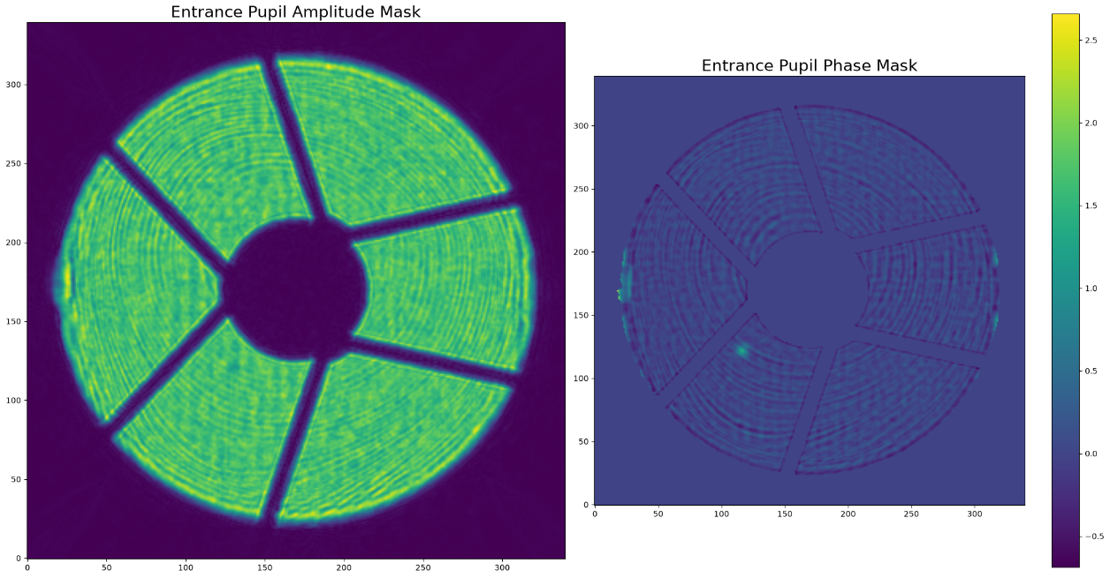
  - DM1 (48 x 48)
  - DM2 (48 x 48)
  - Shaped Pupil: (340 x 340 px)
    - 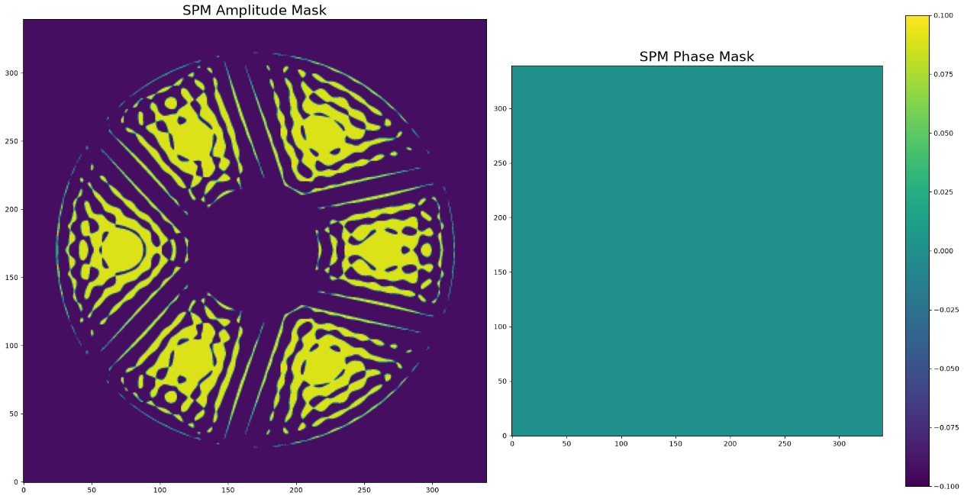
  - Focal Plane Mask: (211 x 211 px)
    - 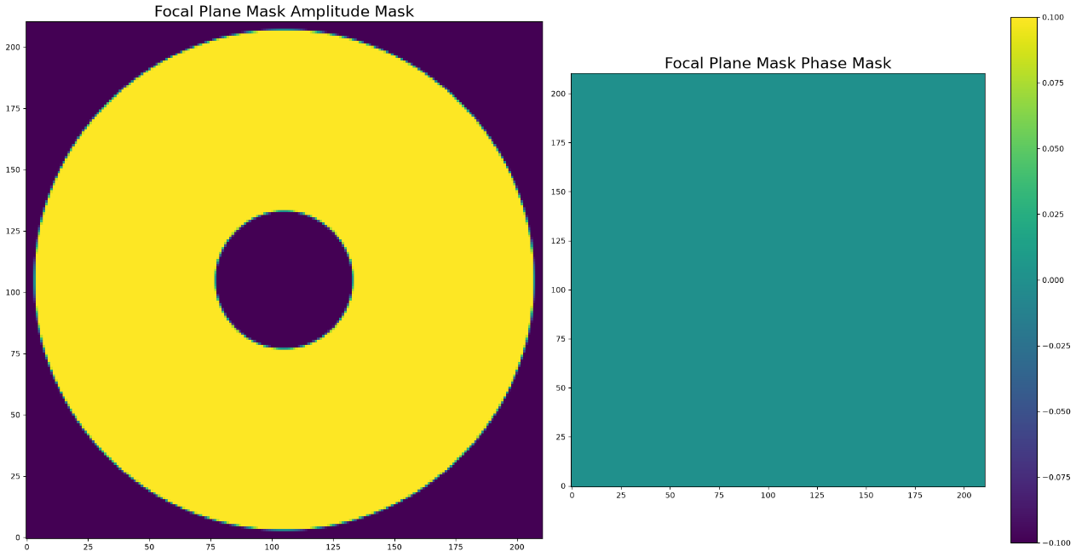
  - Lyot Stop: (340 x 340 px)
    - 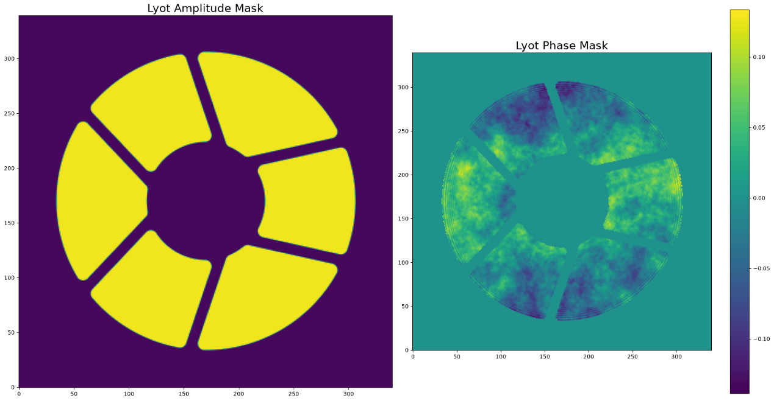

- Field Stop: (no field stop in default config) (153 x 153 px)
  - 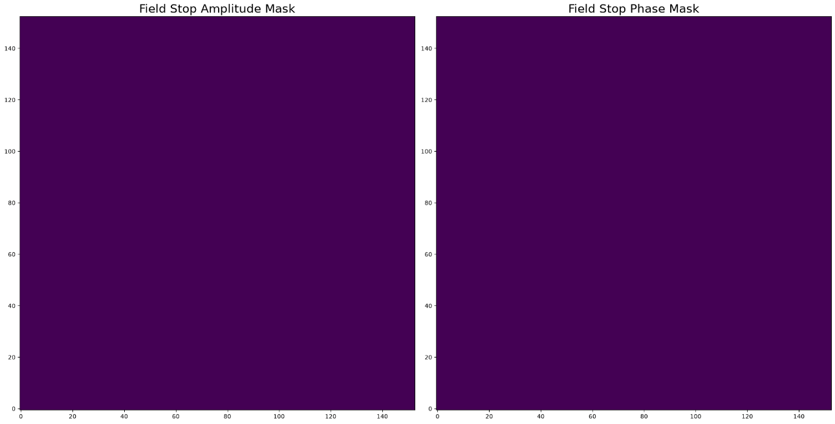
- Binary mask for dark zone: (153 x 153)
  - 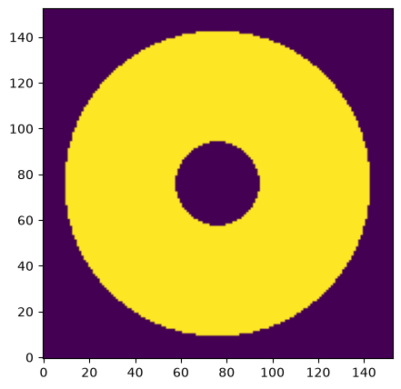
- Meeting with Dan:
  - Option 1 will only work for single-star SNWC, for MSWC we will need the phase ramp:
    - Although I'm not sure why, because isn't each Jacobian accounting for the light from a single star? So can't we do one Jacobian at a time?
  - Generating the mswc masks:
    - We don't have the correct sampling to match the rest of the masks used for spc wfov for the mswc spc mask, so will need to the take the PROPER mswc spc mask and downsample it using the code Dan will send
    - Then, we will need to pad this mask to get to 150 lam/D (which, the amount of padding is determined by how much more FOV we need in the science image plane and then back it out from there
    - Also need to include the square field stop mask and make sure it aligns with the dark zone location
  - Once we go to MSWC, will need to move to Option 2:
    - For this, will need to increase the sampling of the entrance pupil, spm, and lyot stop. This might mean that we no longer include the phase aberrations that are included in those masks currently but that's probably fine, it will just mean that our EFC has to work a bit harder because there is a mismatch between the actual optical model which is "producing" the images (in this case the full fidelity corgisim model) and the model used to generate the Jacobian which is then used to generate the correction
    - If we want to model a 150 lambda/D off-axis source, in theory 300 pix is enough? (well, that is assuming that 1 pix = 1 lam/D) Need to think through this in terms of what resolution we actually need

8/12/2026:
- To Do:
Single Star SNWC:
Fourier interpolate SPC mask to correct, matching compact model sampling
Pad the masks to allow for a 150 lambda/D source
Place the field stop in the correct location
Place the dark hole in the correct location
Make configuration for correct spc mask (copy spc wfov band 4?)
Turn off the on-axis star
Run single star SNWC

- From Dan for downsampling masks:
  - Here's an example of a trial setting up a downsamples pupil from the testbed run at OMC/HCIT:
\\exoplanetshare\labdata\FundedProjects\MSWC\MSWC_ISFM2023\hcitOMC\OMC_MSWC_malaise\falco_testbed_run202\run_falco_efc_testbed_snwc_band3d.m
- Here's an example configuration file calling the pupil resampling + clocking:
\\exoplanetshare\labdata\FundedProjects\MSWC\MSWC_ISFM2023\hcitOMC\OMC_MSWC_malaise\falco_config\falco_omc_config_snwc_band3d_circ5.m
- and the resampling function + clocking is here:
\\exoplanetshare\labdata\FundedProjects\MSWC\MSWC_ISFM2023\hcitOMC\lib_matlab_ames\resample
- For down-sampling the mask, also need to rotate it to match the compact model. The compact model pupil is rotated wrt to the camera? I think, I can't remember where I've seen this.
  - Note: I have been looking at the "Resample_test.m" which lives here: \\exoplanetshare\labdata\FundedProjects\MSWC\MSWC_ISFM2023\hcitOMC\lib_matlab_ames\resample and requires the "misc_utilities" and "Optical Propagation" folders to be on the path
- Note on down-sampling the masks. The issue I am running into is that the current masks as is are rotated wrt the camera. The PROPER mask has no knowledge (it would appear) of this rotation, and I have no way of getting the exact rotation angle from the code because it looks like they were generated at some clocking angle that was determined empirically??? (sandbox/aer/write_model_for_corgihowfsc.py)
  - Okay so it looks like the "cal" code is coralign? But I don't have the paths to the TVAC results etc. I'm going to table this part until Monday and get the rest of the stuff going because I need to get a move on and not keep getting stuck in rabbit holes (even though this one is impt)
- Okay so in theory, I just need to downsample the SPC mask and write out to a .fits file.
- Then, all of the masks need to be padded I think??
- Also, the dh_mask is only used for EFC (Jacobian calculation specifically for now) so PROPER doesn't actually need any modifications
- Questions for Dan/Eduardo on Monday:
  - Clocking for the MSWC SPM
  - Theory of MSWC -> practical implementation :
    - I'll need to add the phase ramp
    - Can we walk through EFC for mswc:
      - We have an image with contamination from multiple stars, which is incoherent with each other
      - So when we do the probing, how do we get the estimate of the coherent light from each star separately? i.e. if we naively run the probing, we get coherent light from one star, how do we get coherent light from the other star?
      - And then in terms of the Jacobian, the "G" for each star -> how is this different for each star? Because don't you just include both stars for the Jacobian calculation? Or do you only include the single star (at the correct location, hence why we need phase ramp)

- Original vs. Re-sampled Pupil.
- 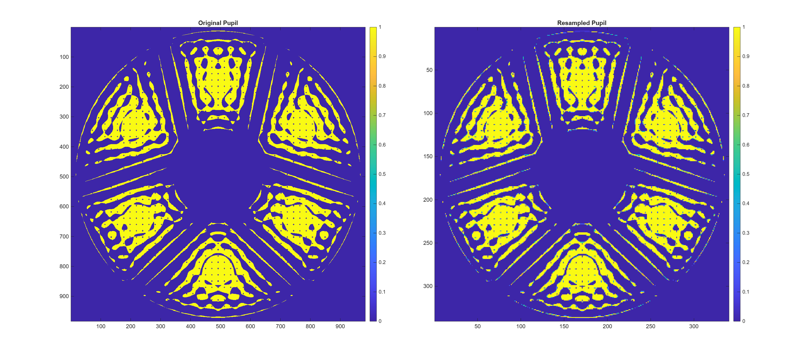

8/17/2026:
- Single-Star SNWC:
  - As a temporary step, expand the FOV to 150 lambda/D
Fourier interpolate SPC mask to correct, matching compact model sampling
- Clocking issue (clocking derived from TVAC tests (I think?) and I don't see any mention of what the clocking angle is anywhere. Possible solution is to derive the clocking angle by comparing/matching the
Pad the masks to allow for a 150 lambda/D source
- Do all of the masks get padded?
  - Pupil masks just need to be zero padded
  - Focal planes (FPM and FS) need to allow the light through so one-padded?
  - Dh_mask is what really matters
- How does this work for EXCAM cropping, do I need to just increase that crop region?
  - I think yes will need to increase the crop region
Place the field stop in the correct location
- How big is the square field stop supposed to be? (doesn't currently exist in the corgihowfsc code as far as I can see)
  - Look in AJ's flight masks paper and also Eduardo's spreadsheet
Place the dark hole in the correct location
Make configuration for correct spc mask (copy spc wfov band 4?)
Turn off the on-axis star (add an option to corgisim_overrides and then will need to hook this up to the jacobian calculation somehow too….)
Run single star SNWC
- Sub-Nyquist MSWC (Can be done independently of single-star SNWC)
  - Now need to get the phase ramp in and then also the Jacobian stacking math. Note that this applies to sub-nyquist and super-nyquist, the only reason I would do sub-nyquist is if the mswc spm clocking is a choke point, then I can use the current wfov band4 config as is and just introduce the phase ramp + jacobian stacking to still do mswc
  - Phase Ramp :
Re-use the tip/tilt functionality to introduce a phase ramp in the pupil plane
Up-sample the pupil, spm, and lyot stop. They are currently 340 pix (although I guess the sampling across the aperture is slightly less, probably 300, should check) so will need to upsample (400 samples should be enough) in order to be able to represent a 150 lam/D tilt without aliasing. Note to self: the upsampling is different than the padding!!! So in this case and go back and un-pad the arrays that I will have padded for SNWC
- According to the howfsc_optical_model.yaml, I think it is 296.1 pixels?? (I'm assuming this is what the pdp means)
- Jacobian Calculation:

- General Wiring:
Will need to hook up the jacobian calculation and multiple sensing loops etc. into the gitl_nulling function
- Super-Nyquist MSWC:
  - If I have SNWC working, then I should just be able to follow the exact sub-nyquist mswc plan above and be able to run super-nyquist mswc without any changes I believe
- Meeting with Dan and Eduardo:
  - Email AJ Riggs to see if there is a simple clocking angle I can use to rotate my mswc spm
    - Clocking, shifting, stretching, padding amount, all seem different than the PROPER masks
  - In the meantime, can use all unclocked masks
    - This would mean no aberrations but fine for demonstrating functionality
  - For multi-star EFC:
    - To get the aberrated e-field for each star, we change the location of the probes
    - This allows us to cancel out the incoherent light from the other star(s) and only get the estimate for a single star
    - Dan will send examples of the probe shape generation that is used in FALCO
    - In practice (in test bed), you need to ensure that the diffraction order stays stationary. In our model though, the diffraction order location is fixed so doesn't matter where the off-axis star is because the probe locations will be defined wrt the doffraction order
      - Need to double check, is this true? I'm still fuzzy on the relationship between the actual off-axis star and the diffraction order location
    - But so yeah, the code change here is then to so "n" sensing loops where n = number of stars. For each star, you need a set of probes which (for now) only differ in the location of the probe which gives you the aberrated field due to that star
      - Then, that aberrated field is the input to the Jacobian calculation. The mechanism of the Jacobian calculation is the same as for a single star, it's just that now it's only giving you a part of the Jacobian (i.e. for a given star and band)
      - Then, you just concatenate all of the Jacobians and you're good to go.
    - Also, once this functionality is implemented, then the way to do single star SNWC is to just set the weights for the on-axis Jacobian to zero and turn the on-axis star off. So it's a bit inefficient because you just have a part of the jacobian that is zero, but it works
  - Band 3d:
    - Eduardo brought up that he's concerned that if using Band 4 with just the three subbands, the speckle fields are going to show up as disjoint speckles instead of a continuous field and that we should sample more
    - If I'm going to modify Band 4 that much, might as well just configure Band 3d instead:
      - The only thing that needs to change is the pixel pitch for the dark zone, field stop, and focal plane mask (the physical masks themselves can stay the same)
  - Also, expanding to 150 lambda/D dark zone is annoying and a lot of work so let's just move forward with the phase ramp instead.
  - Okay so then the new game plan:
Email AJ Riggs to see if it's easy enough to modify the SPM
In the meantime, either generate the unclocked masks or fit the clocked spm
Configure Band 3d
Including create the square field stop (see Table 3 of AJ's paper on flight masks)
Add tip/tilt phase ramp for off-axis star into the compact model Jacobian calculation
Implement MSWC and SNWC wiring

8/18/2026:
- ARC Exoplanet Technologies MSWC Repo: GitHub - ARCExoplanetTechnologies/MSWC: Multi-Star Wavefront Control is a wavefront control technique that enables high-contrast imaging around binary stars. · GitHub
- Plan for today:
  - Get the MSWC model/configuration working
  - The plan was to get Band3d working but I think this might be a bigger undertaking than thought because would need to include this mode in PROPER was well as the compact model which code-wise isn't bad but I don't think it is necessarily easy to make changes to PROPER and have those changes be available to corgihowfsc (PROPER is installed a package in corgihowfsc and that installed "compiled" version gets downloaded fresh every time you run corgihowfsc is my understanding.)
  - Okay let's start with a band4a and see if we can get that working at least
    - Need to increase the sampling inside the subband
    - Also generally need to up-sample the masks to prepare for the off-axis source in the compact model.

8/20/2026:
Game Plan:
Make Band4a configuration with just the SPM best fit clocking for now?
- For now let's keep the sampling the same (so won't be able to model a 150 lam/D star) and as a future step we will increase the sampling of the masks
- Dark zone mask
Configure corgihowfsc to be able to read in/not errors with the new Band4a configuration
Phase ramp for Jacobian Calculations
Wiring for single-star SNWC
Jacobian Stacking
Multi-Star Probing Calls
Wiring for MSWC
Model Updates:
Increase sampling to allow for 150 lam/D off-axis source
Switch to Band3D with unclocked masks
Ultimate vision: Band3D with corrected masks (will likely need input from John Krist and AJ Riggs for proper and compact model updates respectively)

- Dan spoke to AJ Riggs in the CGI Working Group meeting and he said he was interested in seeing an image comparison showing any changes (he thought there shouldn’t be any difference other than downsampling & <1 deg clocking)
  - As a sanity check before I email him, should look at the wfov compact model masks versus the PROPER masks:
  - PROPER SPM vs Compact model:
  - 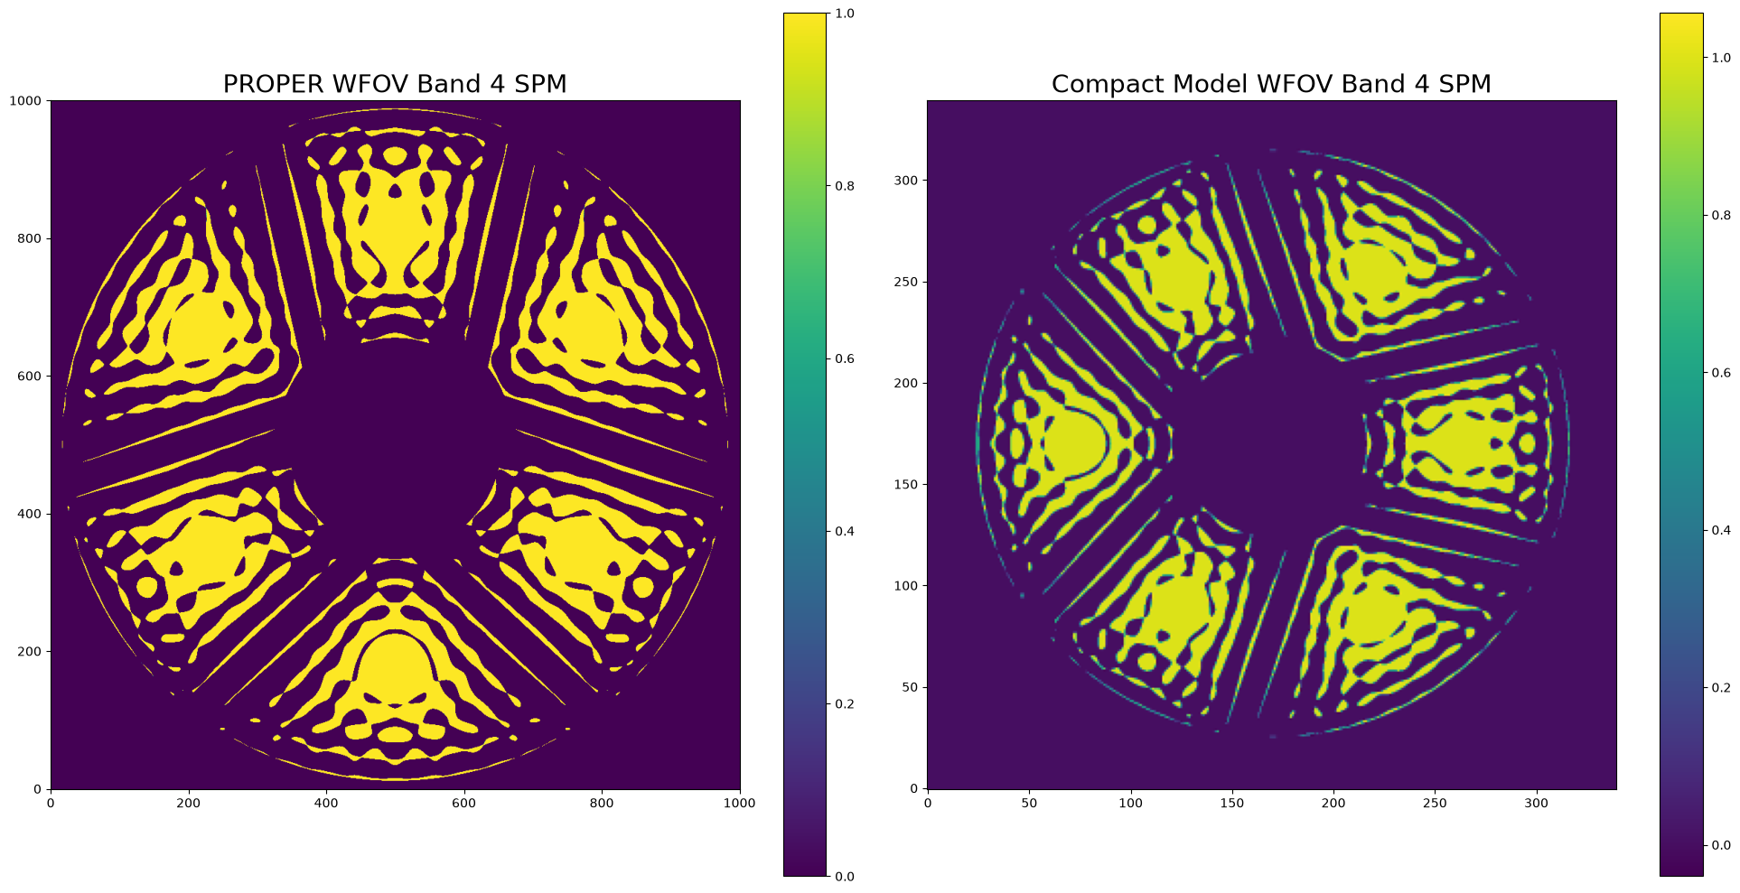

- Goals for today: configure WFOV Band4a model
- Questions:
  - In the hconf_wfov_band4.yaml, which defines the high level model parameters, what is the hardware section? (wfov_wfov_4a_seed) etc.
  - In the roman_preflight.py functions, we can use PASSKEY values which might be enough to pass in the changes to the model that we need for band4a for sure (because the only thing that PROPER currently doesn't have is the field stop)
- MSWC SPM for Compact Model:
  - This is probably just temporary until I hear back from A.J.
  - Vertical flipped mask, 90deg rotation and 20 pixel padding:
  - Checked by applying the same transformation to the regular SPM:
  - 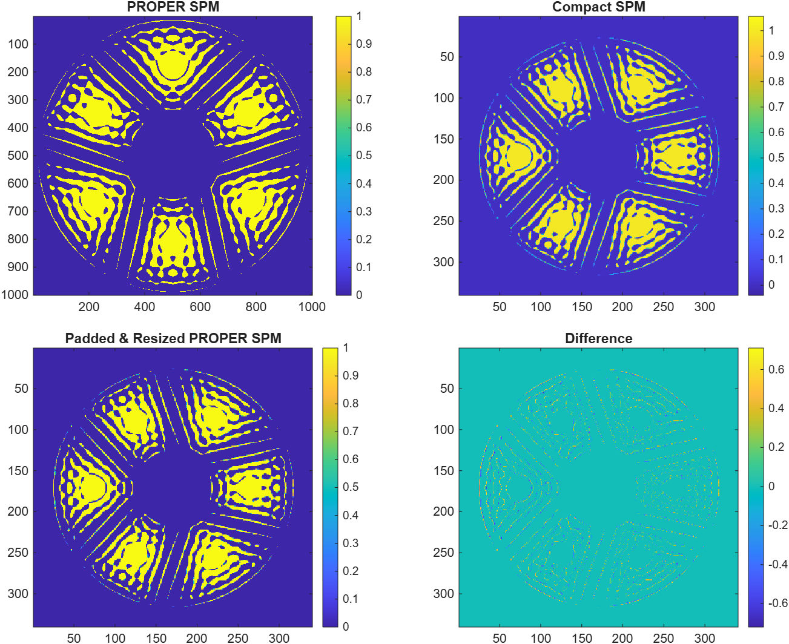

- 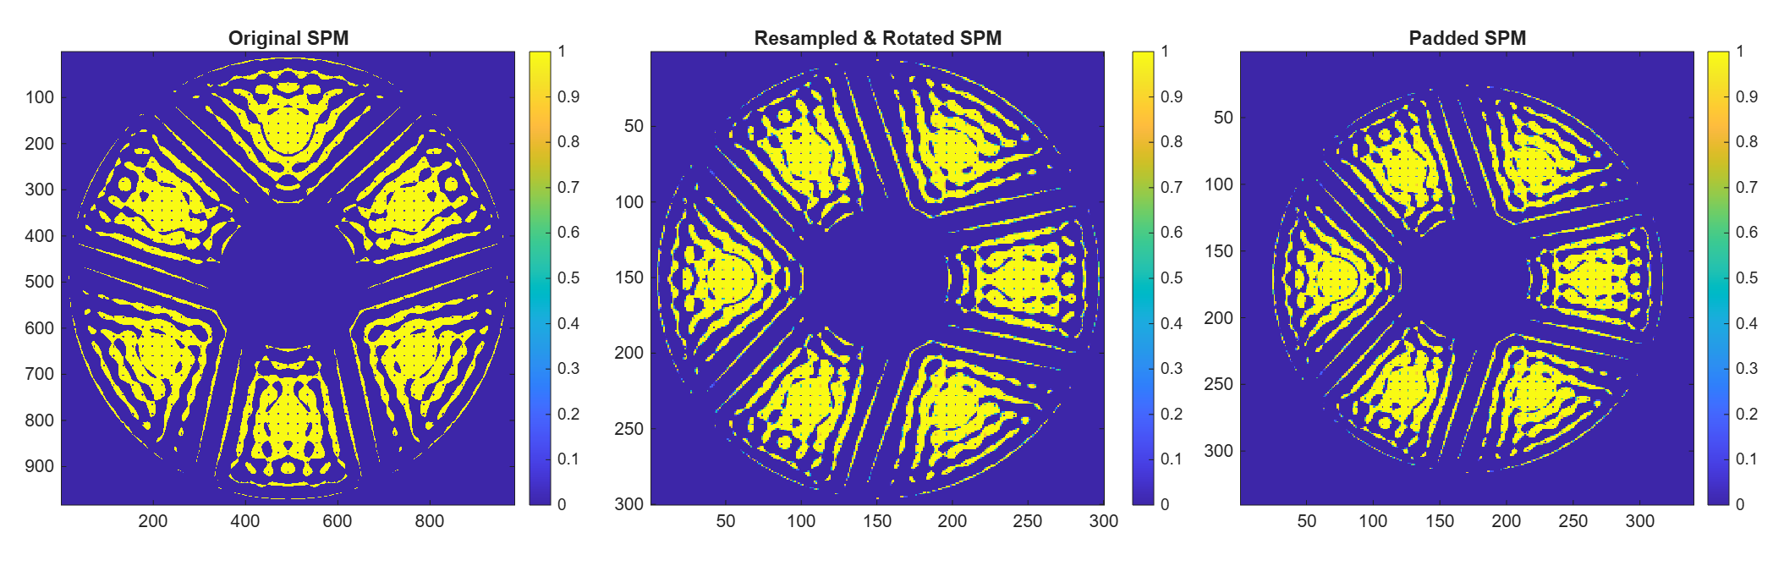

Corgi-howfsc Simulation Log
Wednesday, July 8, 2026
3:38 PM

Output Folder Name | Image Model  (compact/corgisim) | Coronagraph Mode + Band | Estimator  (Default/Perfect) | Num. Iterations | Notes
2026-07-08_144336_compact_model | Compact | NFOV band1 | Default | 10 | "Baseline" single star case
2026-07-08_153737_compact_model | Compact | NFOV band 1 | Perfect | 10 | "Baseline" single star case
2026-07-09_101938_compact_model | Compact | WFOV band 4 | Default | 10 | "Baseline" single star case in Band 4
2026-07-08_161417_compact_model | Compact | WFOV band 4 | Perfect | 10 | "Baseline" single star case in Band 4.
2026-07-10_192155_compact_model | Compact | WFOV band 4 | Default | 10 | Changed the initial DM maps to "dmabs_init_dm1/dm2.fits" to use the "flat" maps (i.e. running from scratch). This case was just a check to make sure the starting contrast changed accordingly
2026-07-10_213958_compact_model | Compact | WFOV band 4 | Default | 50 | - Same as case above but ran for full 50 iterations
2026-07-14_135523_compact_model | Compact | WFOV band 4 | Default | 10 | Increased Jacobian workers to 10 and outputting more logging for code profiling (total iteration time included)
2026-07-14-160327_compact_model | Compact | NFOV band 1 | Default | 10
2026-07-14_164539_compact_model | Compact | NFOV band 1 | Default | 3 | Turned off "output every iter" to see if that makes up the time and it would appear that it does. Strangely it does still seem like it has all of the the same outputs, I'm not sure if maybe they are dummy files or something but it doesn't look like it?
2026-07-15_101842_compact_model | Compact | WFOV band 4 | Default | 50 | - Turned off "output every iter" (although this ends up not really helping)  - Upped Jacobian workers to 15  - Used the NFOV band 1 beta-bumping schedule  - Achieved 3.1e-9 contrast!!!!

Fundamentals/Review
Wednesday, July 1, 2026
2:53 PM

Resources:
  - Fundamentals:
    - Helpful interactive page on Zernike modes from UofA: Link
    - Fourier Optics Overview (UCSB + Thorlabs): Link, Link
    - Optics (LibreTexts Physics Konijnenberg, Adam, Urbach): link'
      - 6.3 has Angular Spectrum Method for propagating Fresnel diffraction
  - Electric Field Conjugation Technique:
    - Original Paper (Give'on et al. 2007):
      - Note, this original paper combined the estimation and control algorithms somewhat
    - Pair-wise Probing (i.e. estimation focused) (Give'on et al. 2011)
    - Unified Framework Paper (Give'on et al. 2009)
    - From Rus: A good paper describing EFC from Tyler Groff: Groff et al. 2015:
      - From Rus: "Sections 1-4, 6, 7 are the key ones. Section 5 is broadband, and for MSWC, we don't need to worry as much about broadband yet (our plan is to image in band 3D on Roman, which only has a 1% band), although eventually we want to run MSWC in broad band of course. Section 8 is potentially critical down the line once you start digging deep MSWC dark zones, but we don't need to worry about it just yet."
  - SVD Review:
    - Gregory Gundersen blog: Singular Value Decomposition as Simply as Possible
    - Jeremy Kun blog: Singular Value Decomposition Part 1: Perspectives on Linear Algebra
    - Steve Brunton YouTube Series: Singular Value Decomposition

Roman CGI Architecture
Monday, July 6, 2026
12:38 PM

Roman CGI Resources
- Roman Science Support Center - Coronagraph Instrument:
  - Has links to a lot of helpful info. The main two I've referenced:
    - Roman Coronagraph Primer
    - Roman CGI Reference Info Jan 2025 Slides
- The Nancy Grace Roman Space Telescope Coronagraph Instrument (CGI) technology demonstration (2020 Kasdin et al paper)

Roman Coronagraph Architecture:
- Each of the three different modes (narrow FOV imaging, 730nm spectroscopy, and wide FOV imaging) has a different coronagraph architecture
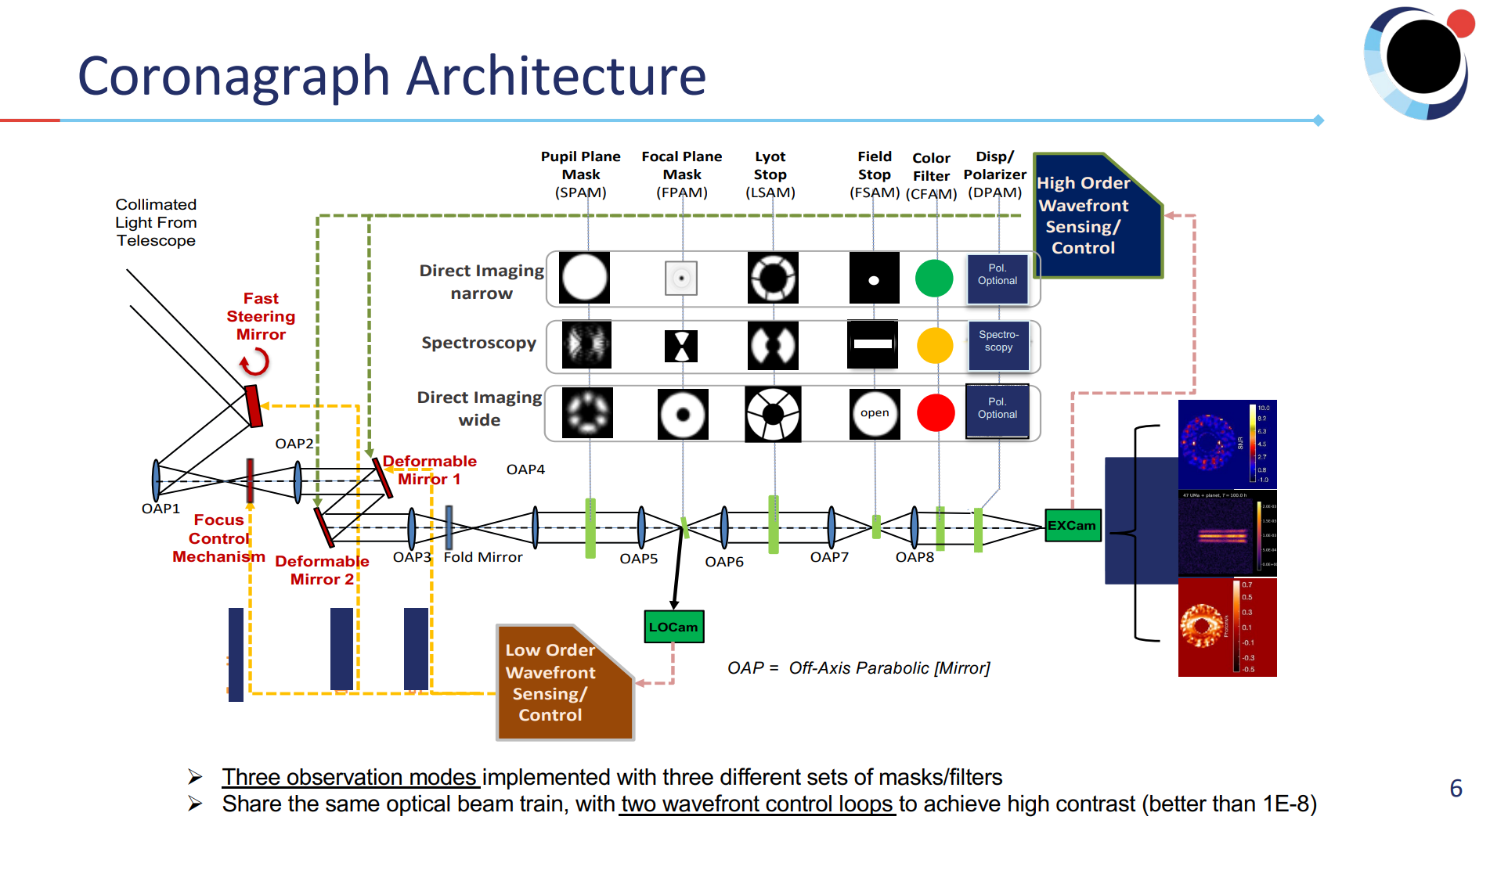

Roman Observing Modes:
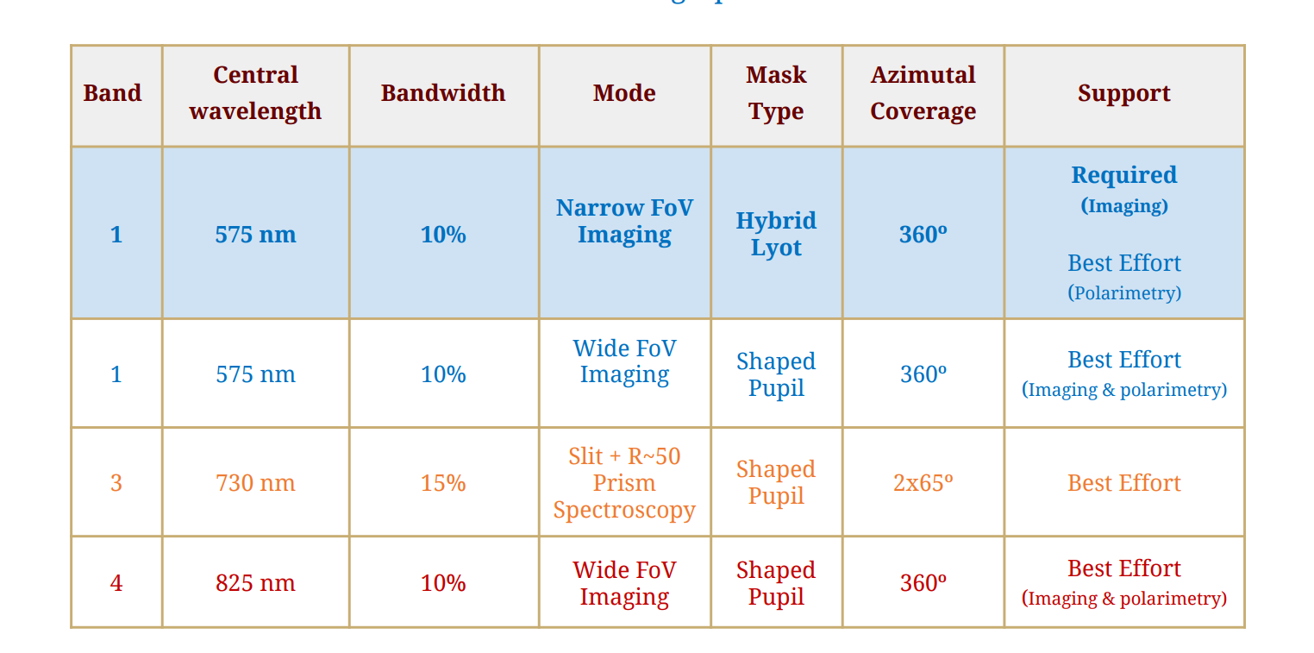

Filter Bands (From Reference Info Jan 2025 Slides)
- Note that Band 2 (660 nm spectroscopy) is the lowest priority for fabrication, implementation and on-sky testing. If resources are limited, this mode may not be exercised during the Technology Demonstration Phase.

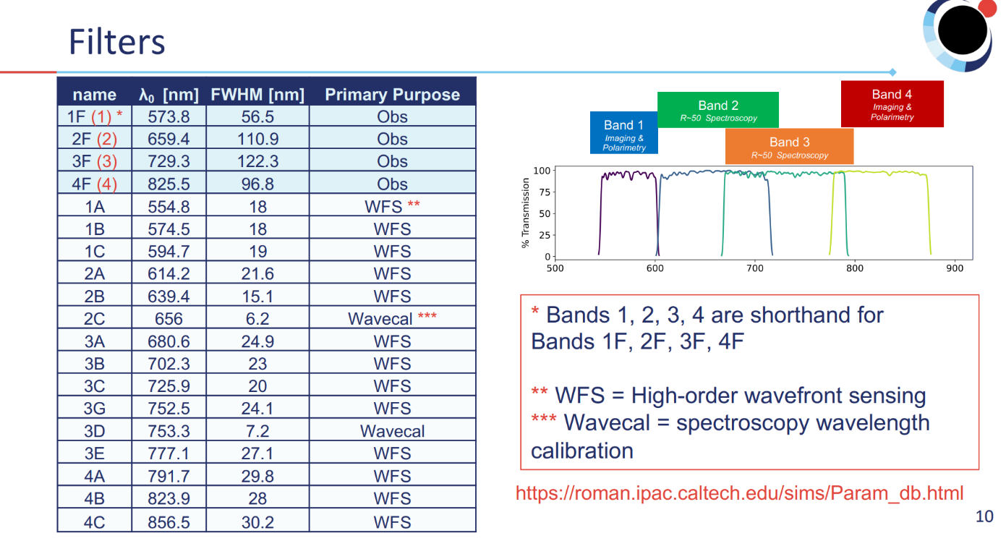

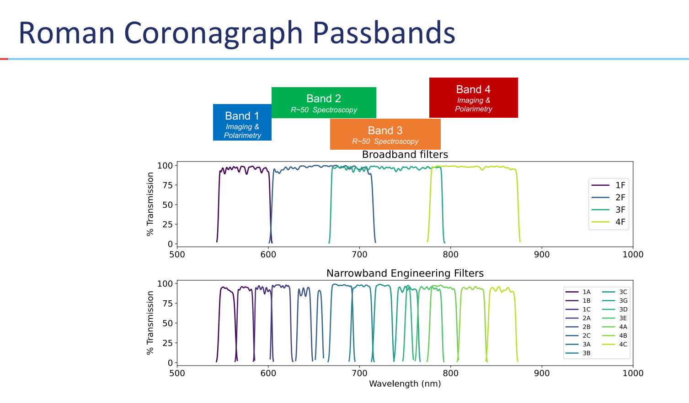

Roman CPP Software
Friday, June 26, 2026
11:46 AM

Software:
- Overview of the software architecture: Google Slides
- Imaging Simulations: corgisim
- High-order wavefront sensing and control: corgihowfsc
- For MSWC MATLAB implementation reference: FALCO

Papers:
- Cady et al. High-order wavefront sensing and control for the Roman Coronagraph Instrument (CGI): architecture and measured performance
- Krist et al. End-to-end numerical modeling of the Roman Space Telescope Coronagraph
- General Coronagraphy overview (haven't read yet but looks really good): Galicher, R and Mazoyer, J. 2023

Overview
Tuesday, June 30, 2026
12:21 PM

Repositories:
- Corgisim (Image Generation Software)
  - End-to-end simulations of Roman-CGI observations
  - Produces high-fidelity, format-compliant data for pre-launch calibration, pipeline testing, and community applications such as target planning and selection and observation planning
  - Corgisim is a wrapper for cgisim
    - CGISim: is a python wrapper around the Python Roman PROPER model; it produces Coronagraphic Instrument simulated imaged, optionally with EMCCD noise.
    - PROPER: is a library of IDL routines for simulating optical propagation in the near and far fields using Fourier-based Fresnel and angular spectrum methods. The goal is to simulate systems that require diffraction-based rather than geometrical analysis. Includes routines for creating complex apertures and obscurations, wavefront errors (defined by zernikes, power spectra, user-supplied maps), amplitude modulators (i.e. coronagraphs),. The routines automatically select which propagator (near or far-field) is best at each surface based on analytically propagating a Gaussian pilot beam.
    - 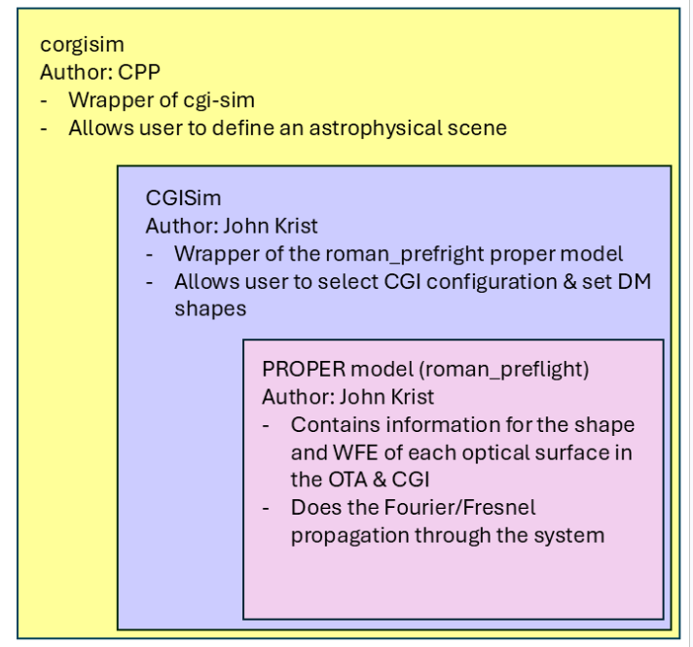
- Corgihowfsc:
  - A wrapper for performing high-order wavefront sensing and control (HOWFSC) that combines corgisim for image generation, cgi-howfsc for performing HOWFSC, cgi-eetc for exposure time calculation, and cgi-coralign for performing optical calibrations
  - 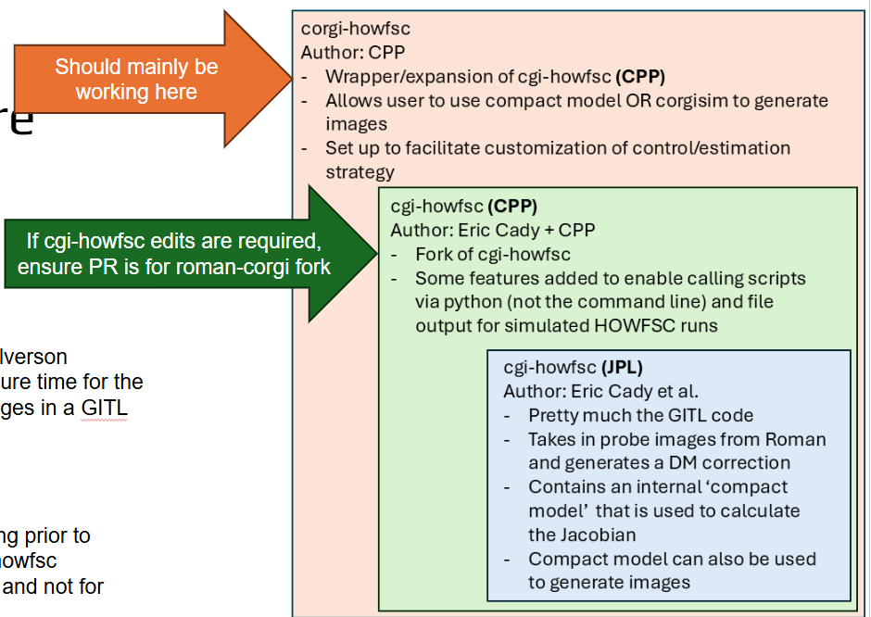

- Cgisim_cpp:
  - This repo contains the CPP (Roman Coronagraph Community Participation Program) specific CGISim Roman Preflight model to use with Corgisim
- Cgi-eetc:
  - CGI Engineering Exposure Time Calculator
  - Estimates the exposure time required to reach a user-specified signal-to-noise value in CGI for a given stellar calibration target and calibration sequence. Done by querying a lookup table of pre-computed grid of flux rate values, calculated as a function of target stellar type, brightness, and CFAM filter. (the pre-computed grid is a data cube of flux rates for stellar targets as a function of spectral type, apparent magnitude filter band and CFAM filter option.

Software Installation + Environment/Dependency Management
Tuesday, June 30, 2026
12:18 PM

6/29-6/30 - Initial Software Installation
- Corgihowfsc
  - Following the corgihowfsc installation directions, I was getting a "tos error" when trying to create the conda environment using the environment.yml file. This is because there is a commercial license limitation on the "default" channel that conda uses for installing packages etc. However, conda-forge is completely free. Here's how I got around it:
    - This is just showing that the default channel is included
      - $ conda config --show channels
channels:
- conda-forge
- defaults
- Then I added "nodefaults" channel so that in the future if a environment.yml file includes the default channel, my installation will ignore it
  - conda config --add channels nodefaults
  - conda config --show channels
channels:
- nodefaults
- conda-forge
- defaults
- But to actually remove defaults, had to navigate to this file and replaced "defaults" with "conda-forge":
  - conda config --show-sources
==> C:\Users\zahmed1\AppData\Local\anaconda3\.condarc <==
channels:
- defaults

==> C:\Users\zahmed1\AppData\Local\anaconda3\condarc.d\anaconda-auth.yml <==
channel_settings:
- frozendict.frozendict({'channel': 'https://repo.anaconda.cloud/*', 'auth': 'anaconda-auth'})
- Navigated to the .condarc file above and replaced "defaults" with "conda-forge"
- Also had to update the setup_cgi_packages.py script with the latest Proper package version (v3.3.5 instead of v3.3.4)
- General Environment/Dependency Management Things
  - Good Stack Overflow answer on the difference between venv/pyenv/poetry/conda etc.
  - Also, just as an FYI to understand the different conda channels (default vs. conda-forge, etc.):
    - Conda channels are remote locations or online repositories where packages ae stored and hosted (kind of like different "app stores")
    - The "Default" channel is the native anaconda channel that is directly managed by Anaconda, Inc.
      - Within it, there are different repos. "main" is the primary repo containing the most popular, stable, and tested data science and ML packages
    - The "conda-forge" is the largest, community-driven (i.e. free) channel. It contains thousands of up-to-date packages that are often not available in the defaults channel.
    - When you install a package, it checks your configured channels sequentially based on priority. If a package exists in multiple channels, Conda decides which one to install based on your channel_priority setting (this is what we see when we print "conda config --show channels"
- Multiprocessing vs. MPI:
  - Multiprocessing uses the same RAM for everything and just spawns works to do tasks in parallel. Use this if just using one computer
  - MPI is for multi-node processing (i.e. what I do on Sherlock)

sk-hriJettGlJOG2E4T11emxg

From <https://proxy.fast.luna.nasa.gov/ui/>

sk-hriJettGlJOG2E4T11emxg

From <https://proxy.fast.luna.nasa.gov/ui/>

LiteLLM Dashboard

Corgi-howfsc Notes
Thursday, July 2, 2026
3:28 PM

From the JATIS Paper: Link
- Cgi-howfsc can run with either the corgisim model (high fidelity, models the entire cgi system with all components) or the compact model (only models the planes with masks or DMs)
  - This applies to corgi-howfsc too

Input parameter files:
- Default_param.yaml (scripts/default_param.yaml)
  - Defines the parameters for the loop (i.e. do you want to use the compact model or full corgisim model, whether to precompute the Jacobian etc.)
  - In this loop, you can link to custom cfg, control strategy, or hcon config files to override the default mode-derived files
  - So basically, this is the highest level simulation config file.
- Cfg (Used to create CorongraphMode Object)
- Cstract (Used to create ControlStrategy Object)
  - Defines parameters for regularization etc. (Section 4 of the paper)
- Hcon (Used to create host config with stellar properties)

Howfsc Loop Flow:
- Run_corgisim_nulling_gitl.py:
  - Highest-level sim script that basically just parses the parameter files and instantiates all of the objects (coronagraph model, control strategy, imager, etc.) then passes it all off to nulling_gitl.py
- Nulling_gitl.py:
  - Nulling fitl is also a wrapper/high level that is used to call the real workhorse which is _main_howfsc_computation (via howfsc_computation in modular_gitl.py)
  - Computes the Jacobians (according to the jaq precomp argument) and exposure times,
  - generates the images and then runs howfsc_computation
  - Also does all of the logging/output file generation
- Howfsc_computation (located in modular_gitl.py)
  - Okay technically this is a wrapper for the actual howfsc computation function (_main_howfsc_computation)
  - Has a bunch of error handling
- _main_howfsc_computation :
  - Star of the show. According to the function comments, it does the following:
    - Separate image data from bad pixel map for all frames
    - Normalize each intensity frame
    - Evaluate mean total contrast over control pixels which are not masked by bad pixel map
    - Estimate complex electric fields and return fields with bad electric field maps
      - Uses classes from the "sensing" folder.
      - Either the default (i.e. pairwise probing) or perfect estimator
    - Compute control strategy parameters
    - Compute change in DM settings from electric fields
    - Compute expected mean total contrast for next iteration
    - Compute absolute DM settings, camera settings, probe scale factors
    - Compute expected time to complete next iteration

PROPER Propagation
- PROPER is only used if using corgisim "backbone"
- Entry into PROPER from corgi-howfsc:
  - Nulling_gitl.py (outside the main loop for first iteration or inside the loop for every iteration after) calls "_get_framelist" (method of gitl_worker.py) which calls _get_image_worker (method of gitl_worker.py), which finally calls the GitlImager.get_image method (the GitlImager class lived inside corgisim_gitl_frames.py)
  - FOR CORGISIM: GitlImage.get_image calls "get_host_star_psf" method of CorgiManager. This is what I modified to include point sources if the point sources are defined in default_param.yaml. Get_host_star_psf calls CorgiOptics.get_host_star_psf and CorgiOptics.inject_point_source. These two methods (the CorgiOptics object lives inside instruments.py) are what finally call "proper.prop_run_multi(roman_preflight,…)"
    - Okay and then technically this goes through a few other routing functions but eventually lands at roman_preflight.py, where the roman_preflight function does the actual optical propagation yay
    - This outputs the efield!
- Roman_preflight:
Code Line(s) | Focal or Pupil plane | Operation
753 | P | prop_begin → E-field array n=2048, pupil=1000 px
754-760 | P | ★ OFF-AXIS TILT: E *= exp(iπ(xtilt·x + ytilt·y)) ← the phase ramp if source is offset
791 | P | OTA pupil aperture (prop_multiply pupil)
794-795 | P | define_entrance (+ optional prop_zernikes WFE)
Roman OTA
799-801 | P | PRIMARY: lens + polmap(polaxis) + errormap
803-806 |  | SECONDARY: lens + errormap (+ aperture)
808-810 |  | POMA FOLD + errormap
812-825 |  | M3, M4, M5: lens + errormap each
827-829 |  | TT FOLD + errormap
831-887 |  | FSM (+ optional pupil shear 872-885, + FSM errormap 886)
CGI relay
898-901 |  | OAP1 + errormap
903-905 |  | FCM + errormap
907-910 |  | OAP2 + errormap
912-917 | P | ★ DM1 (cgi_dm, dm1_v)
919-924 | P | ★ DM2 (cgi_dm, dm2_v)
926-929 |  | OAP3 + errormap
931-933 |  | FOLD3 + errormap
935-938 |  | OAP4 + errormap
940-981 | P | ★ SHAPED PUPIL MASK (prop_multiply pupil_mask) + errormap ← acts on full tilted beam
983-986 |  | OAP5 + errormap
988 | (F) | prop_propagate → 'FPM' (TO_PLANE=True)
989-1048 | F | ★★ FOCAL PLANE MASK ← THE TRUNCATION (SPC branch 1023-1042, detailed below)
1050-1070 |  | (optional pinhole)
1072-1075 |  | OAP6 + errormap
1083-1106 | P | ★ LYOT STOP (prop_multiply lyot) ← acts on what survived the FPM
1108-1111 |  | OAP7 + errormap
1113-1135 | F | ★ FIELD STOP (SPC: MFT super-sampled, 1123-1135)
1137-1149 |  | OAP8 + errormap → CFAM baffle → filter + errormap
1153-1162 | F | IMAGING LENS (to_from_doublet) → 'IMAGE'
1206 | F | prop_end(NOABS=True) → full complex focal field (2048², ~0.49 λ/D/px, ±~500 λ/D)
1210-1221 |  | phase-term removal + flip/rot to detector frame
1232-1244 |  | prop_magnify → output_dim at final_sampling (or trim) ← final crop to the small image
1246 |  | return (field, sampling)

Meetings
Monday, July 20, 2026
11:11 AM

7/15 Code Profiling + Baseline Results
Wednesday, July 15, 2026
3:46 PM

Code Profiling:

- WFOV Band 4 - 10 iterations nominal
- 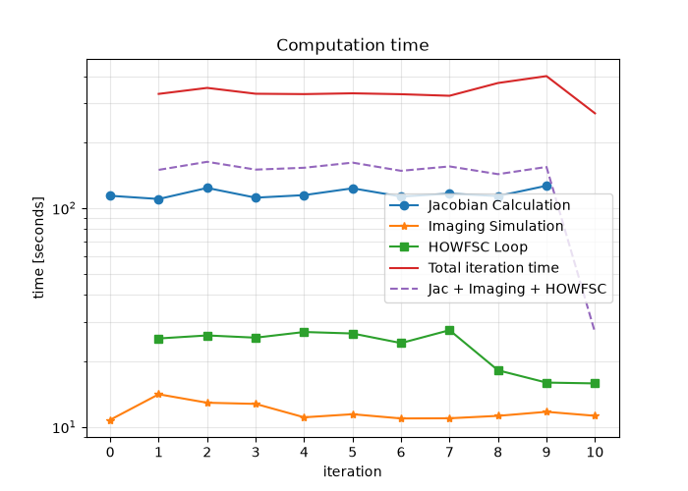
- NVFOV Band 1 - 10 iterations nominal
- 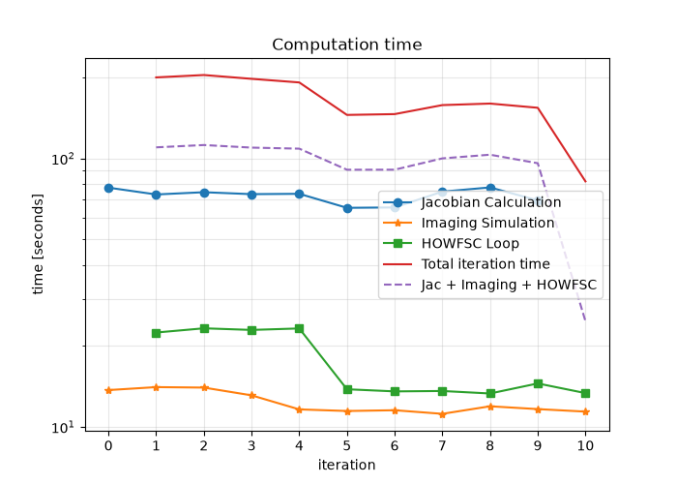

- NFOV Band 1 - "saving_every_iter" turned off
  - The total iteration time and "Jac + Imaging + HOWFSC" times become equivalent, meaning that the "saving out" process is responsible for the factor of 2 slowdown
  - This probably doesn't have any implications for actual Roman operations since they are probably not writing to disk / have much more compute but for the sake of running simulations using corgi-howfsc, this is a relatively significant slow down
- 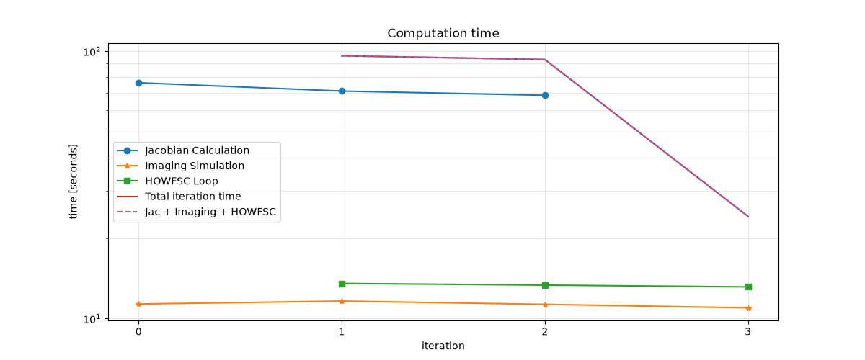

- WFOV Band 4 - 15 Jacobian workers and "output every iter" off
  - The bumps in the timing are probably on my end from running other things on my computer on the side. I guess good news is that multi-processing it working since I'm basically using all of my CPU allocation for running howfsc and the bumps in the computation time are from diverting some of that compute for other tasks???
- 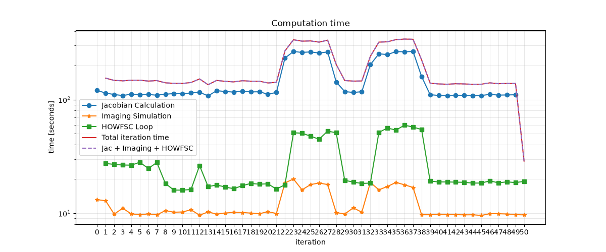

Beta Bumping Control Strategy:

- Nominal (Single Beta Bump, default in the WFOV Band 4 model):
  - Compact model
  - 50 iterations
  - Using dm_init maps
  - Final Contrast = ~2e-8
- 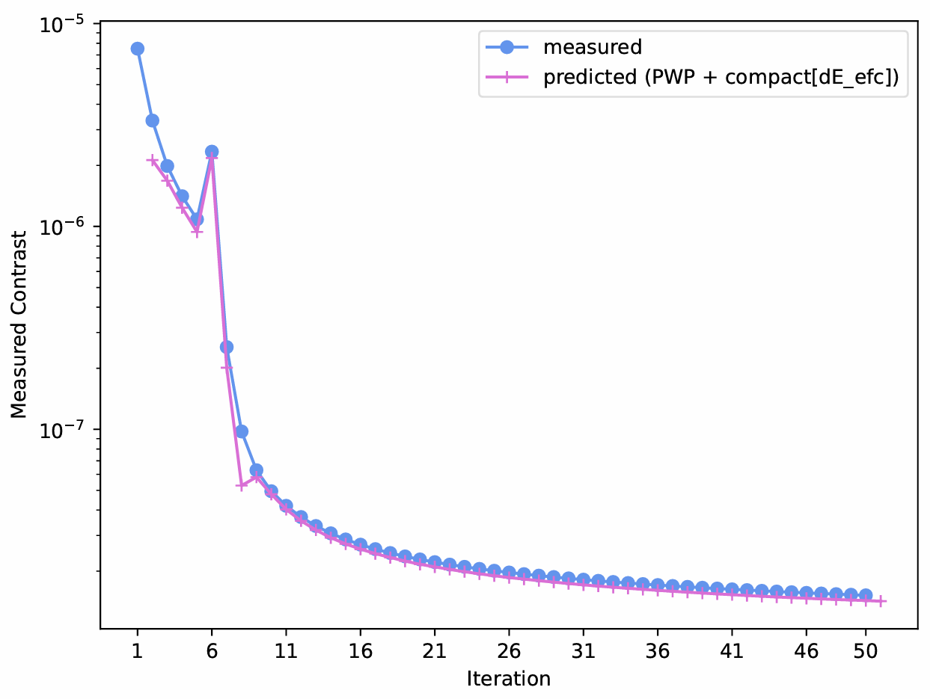

- "Naive" (Using NFOV band 1 strategy):
  - Compact model
  - 50 iterations
  - Final contrast = ~3.1e-9
  - Using dm_init maps instead of the default (see notes, this might be incorrect but the net effect could be that I am inadvertently adding aberrations)
- 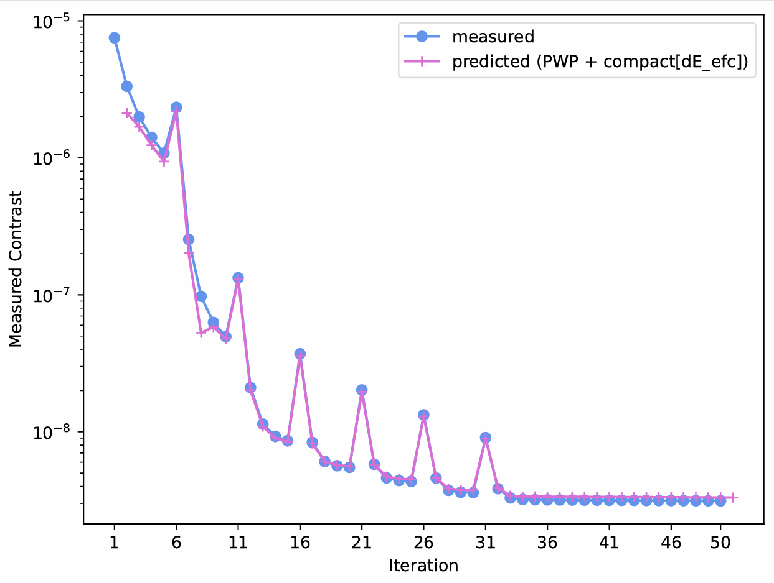

7/22 Roman Hardware Working Group Meeting
Tuesday, July 21, 2026
2:10 PM

- WFOV Band 4 Results:
  - Simulation parameters + Convergence plots
  - Dark hole animation
    - Stills of the periodic structures
  - DM Map (comparing the optimized versus the initial)
- Code Profiling (if time)
- Needs for Multi-Star:
  - Off-axis stars in corgisim and/or compact model
  - Enabling WFOV Band 3d with SPC for observing Alpha Cen
- Questions:
  - Adding Aberrations in the compact model (or what currently exists)?
  - Aberrations in corgisim?
  - Origin of the gitl_start_compact dm maps

- WFOV Band 4 Convergence Results:
  - Case 1:
    - Using "dmabs_init_dm1/2" for Initial DM Solution (instead of "gitl_start_compact")
    - Compact model
    - Default estimator
    - Same Beta Bumping schedule as defined for default NFOV Band 1 model
    - Final contrast: 3.13e-9, converges after ~35 iterations

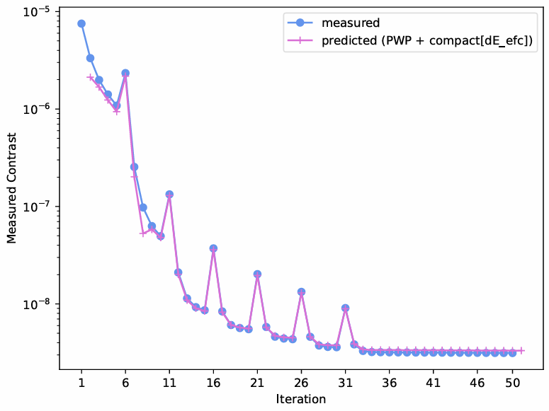

- Case 2:
  - Using "dmabs_init_dm1/2" for Initial DM Solution (instead of "gitl_start_compact")
  - Compact model
  - Default estimator
  - Default beta bumping schedule (single beta bump)
  - Final contrast: 1.5e-8, takes all 50 iterations to begin to converge

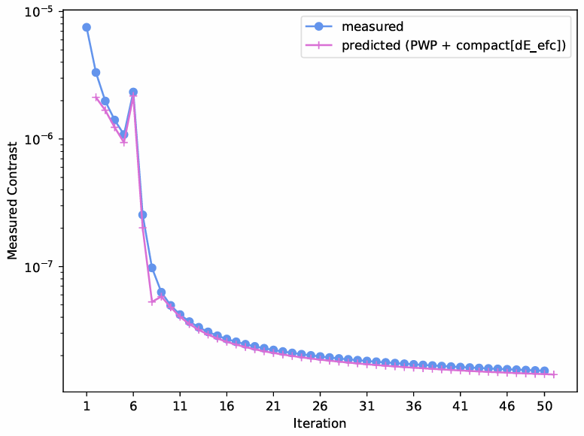
- Case 3:
  - Using "gitl_start_compact_dm1/2" for Initial DM Solution
  - Compact model
  - Default estimator
  - Default beta bumping schedule (single beta bump)
  - Final contrast: 1.9e-9 (starting contrast is 3e-9 from the DM solution)
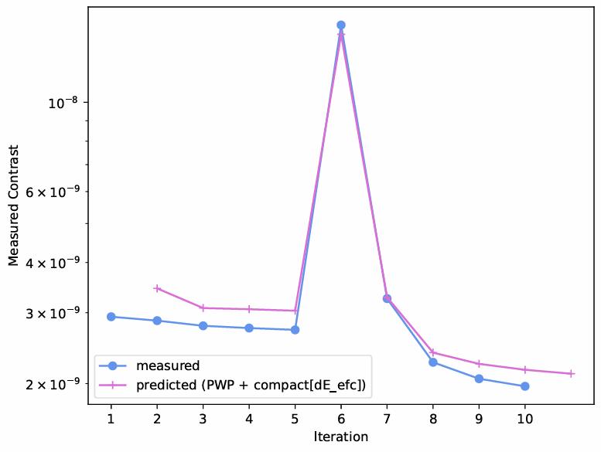

- DM Maps:
  - WFOV Band 4, "dmabs_init_dm1/2" (used for Case 1 and 2 results above)
  - 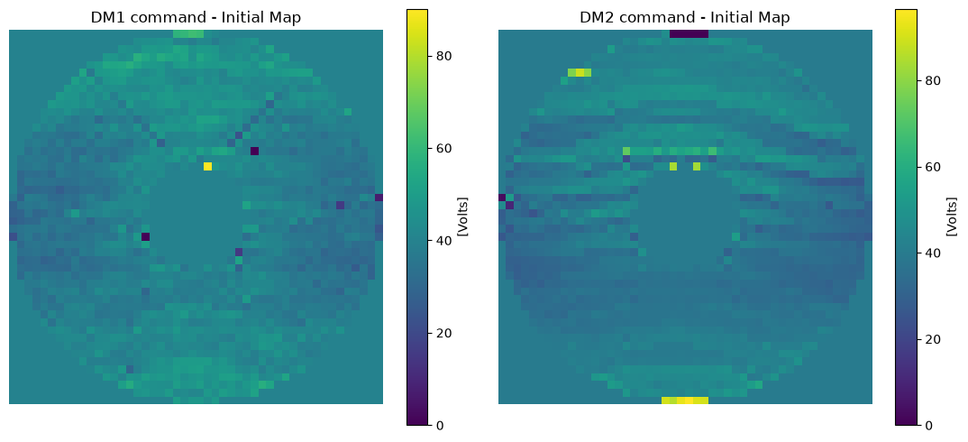
  - WFOV Band 4, 360deg "GITL Start Compact" Map (used for Case 3 results above)
  - 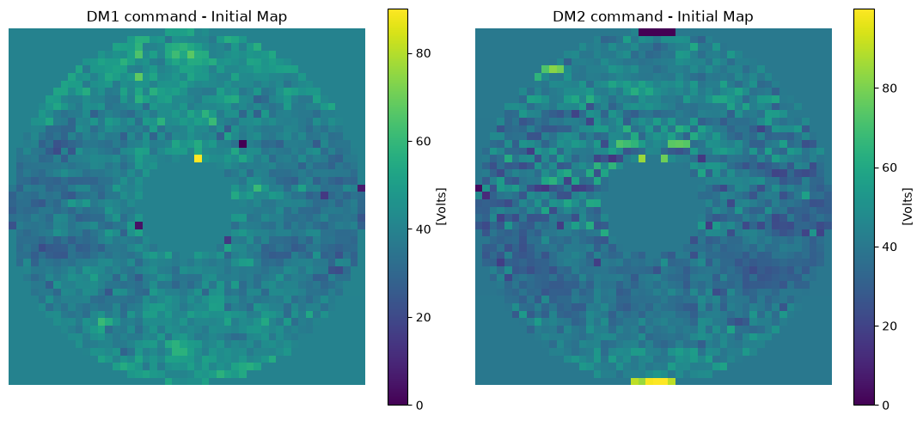
  - Origin of the gitl_start_compact maps:
    - Look similar (though not the same) to the "spc-wide_ni_3e-9_dm1_v.fits" from roman preflight proper examples
    - How were these maps generated?
  - Origin of init maps:
    - Same as the "spc-wide_flat_wfe_dm1/2" files from roman preflight proper examples, these are the flat WFE maps.
  - See "run_spc_wide.py" in roman preflight proper examples

- Code Profiling
  - Unsurprisingly, the Jacobian calculation is the dominant source of compute
  - Surprised to see that saving out the outputs slows down the simulation by a factor of 2
  - Plot shown for WFOV Band 4, 10 iterations with compact model
    - Logged values are all within the "nulling_gitl" loop
- 

8/17 Detailed MSWC Implementation Details + Status + Plan
Monday, August 17, 2026
12:29 PM

In order to enable MSWC in corgihowfsc, there are two categories of changes that need to be made:
- MSWC Machinery: Adding in the code/wiring in order to be able to run a mswc loop using corgihowfsc.
  - Examples: Jacobian stacking computation, configuration flags to use the correct model, routing to run the probing loop (with correct probes) for each star in multi-star system, off-axis star capabilities in the compact model for Jacobian computation, etc.
- Model Changes: Adding in a coronagraph model for multi-star that can be used for image generation (PROPER) and Jacobian calculation (compact model)

MSWC Machinery:
- Injecting an Off-Axis Star into Simulated Images (corgisim i.e. PROPER wrapper)
  - Status: Complete (functionality already existed, just had to be wired up through corgihowfsc config)
- Injecting an Off-Axis Star into compact model for Jacobian calculations:
  - Status: In-progress
  - Challenges:
    - Code itself is straight forward, I am re-purposing pointing error code to introduce a phase ramp for modeling an off-axis star.
    - Need to up-sampled all of the masks in order to be able to represent a 150 lambda/D separation which has some challenges (see "Compact Model Mask Modifications" in Model Changes)
- Wiring for running SNWC (single star)
  - Status: Complete
  - Need to add a configuration flag for "on-axis-star-included", which, when set to false will route through CorgiManager to not include the on-axis star in the image. Other than that, everything else can in theory stay the same until we have MSWC running
- MSWC Jacobian Stacking
  - Status: Not started, not blocked
- Multi-Star Probing Calls
  - Status: Not started, not blocked
  - For mswc, we need to do 2 "sensing" loops to estimate the coherent e-field for each star.
  - Will need a way to do the probe optimization (Dan will point you to the code in FALCO that does this)
    - Note, I found where this happens in FALCO
- Wiring for running MSWC (multi-star)
  - Status: Not started, not blocked
  - Okay so here I will need to have a lot more wiring, but I think instead of writing a separate nulling_gitl loop (which is what I was originally envisioning) but instead have a flag that just checks to see if there is an off-axis star, and if so, will have an elif statement for the jacobian computation
  - Once I add this in, I can either

Model Changes:
- Band 3D Configuration
  - Status: Temporary Solution Complete, Full Solution Blocked
  - Challenge:
    - In order to create a new model to be used with both corgisim (for simulated images) and compact model (for Jacobian), need to update the "run_proper" function to recognize a new config for band3d. Code-wise this is probably <5 lines of code. However the issue is more that the roman proper code gets copied and pulled from the installed package and is not tracked so I am hesitant to be making changes inside the PROPER code without any way to track those changes.
  - Temporary Workaround:
    - For now, going to make a "dummy" configuration called wfov_mswc_band4a just to understand what all needs to happen to wire up a new configuration into corgihowfsc etc.
    - Will include the resampled, rotated, padded MSWC SPM, a square field stop and new dark zone map
  - Eventual Solution:
    - Create Band 3d mode in corgihowfsc, PROPER, and EETC following the same process on the corgihowfsc side and with minor changes to PROPER and EETC, although will need to think about how to add these in a trackable way

- Compact Model Mask Modifications:
  - Status: Temporary Solution Complete, Full Solution Blocked
  - Challenge:
    - It seems like the masks that are used in the compact model aren't the "nominal" flight design masks from PROPER, they have been updated to incorporate the calibration and alignment results from AJ Rigg's paper and this process is currently a bit black-boxy
      - There is ambiguity in the padding, scaling, rotation, shifting of each of the masks in corgihowfsc
      - This is fine if we just want to use the masks as is in the compact model, but, for example we need to include the mswc spm into the coronagraph mode and the only mask we have PROPER mswc spm, and it is unclear how to adjust it to match the rest of the masks, particularly in terms of clocking angle
  - Temporary Workaround: There are a few (temporary) workarounds until we are able to just get the compact model versions of the mask:
    - Option 1: Use the PROPER versions of all of the masks for now. This likely just means there is a larger delta between the compact model and the PROPER model because PROPER models the full optical path and now the compact model will be modeling a slightly incorrect configuration (I am mostly worried about clocking here though). Also, if I do this, I probably wouldn't (shouldn't) include the phase error maps for the entrance pupil and lyot stop?
    - Option 2: Do a "best fit" to rotate the mswc spm to match the regular spm mask etc.
      - Note, I ended up going with this Option
- Sampling resolution:
  - Status: Not started
  - Challenge:
    - The PROPER masks are all sampled at 1000 pixels across the pupil which is why we don't have any issues with injecting a 150 lam/D off-axis source. But the compact model masks are sampled at 296 pixels across the pupil which will not work for a 150lam/D source (especially if the dark zone is on the far side of the on-axis source wrt off-axis source location
    - Not really a blocker necessarily, but will need resample all of the pupil plane masks (I think just entrance pupil, SPM, and Lyot stop????)
      - If I go from the existing compact model masks and upsample to ~600 pix/pupil, I think I can interpolate the complex field to retain the phase aberrations in entrance pupil and lyot stop
      - But I think for some reason (not sure why, just intuition) it would be better to start with the PROPER masks and down-sample to ~600 pix? But then won't have the aberrations included in the compact model

Detailed Implementation Plan for Creating a New Coronagraph Mode:
- Compact Model Files (model/wfov_mswc_band4a)
  - Wfov_band4_5x5lamD/howfsc_optical_model.yaml Updates
    - Point to the correct spm amplitude file
    - Collapse the sls to just 1 subband
    - Create the square field stop (Table 3 from Riggs et al. JATIS March 2025 has specifications, write a MATLAB script for this)
    - Create smaller dark zone solution (5x5 lambda/D at least 10 lambda/D away from diffraction order)
    - Point to the correct fs
    - Point to the correct dark_hole solution
  - Cstrat_wfov_mswc_band4a Updates:
    - Regenerate the pixelweight_ones_nlam3_nrow153 for nlam1 and add to "model/every_mask_config"
  - Naming unification:
    - Model name: wfov_mswc_band4a
    - Dark_zone solution subfolder: wfov_mswc_band4a_5x5lamD
    - Update cstrat and hconf file names to match for consistency
- New Model Wiring:
  - Loading in new model:
    - In corgihowfsc/utils/howfsc_initialization.py load_files() functions, add a new elif statement for wfov_mswc_band4a (can copy/paste the wfov_band4 block and modify as needed)
    - I think just re-name the jacfile name, need to trace what this does again
  - Passing into PROPER:
    - Add "wfov_mswc_band4a": "spc-mswc" to the CGI_TO_CORGI_MAPPING
    - Comment out the cor_type: spc-mswc in corgi_overrides in the default_params.yaml!!!!!!!!!!!!
    - The field stop will need to be passed into PROPER separately because it's currently not included in the spc-mswc (or spc-wfov in general). There is a PASSKEY for this in PROPER but will need to figure out how to go from the fs.fits to a np.array (and want it to be traceable, so maybe an corgi_override with file path?? But then will need to read it in somewhere merp
  - Default_param settings:
    - Update the sim_settings to set "mode" to wfov_mswc_band4a, and "dark_hole" to "5x5lamD"
    - Since this is band4a which is 3%, increase the nlam in defaul_param (which is different that below nlam) to 10 instead of default which is 5
- Testing:
Check that len(hconf['hardware']['sequence_list']) == nlam == 1
N2clistfiles length matched nlam
Make sure the field stop array that gets passed into PROPER matches the one in compact model
- See "current bugs" below
Run 1 iteration with new mode and see if it looks reasonable
- See "current bugs" below

Detailed Implementation Plan for Off-Axis Compact Model Propagation for Jacobian Calculation
- Add the Phase Ramp (follow the PROPER convention)
  - Confirm PROPER approach from roman_preflight:
    - Xtilt_lam = source_y_offset * lambda0_m / lambda_m
    - Ytilt_lam = source_x_offset * lambda0_m / lambda_m
    - X = np.tile((np.arange(n)-n//2)/(pupil_diam_pix/2.0), (n,1)) # columns
    - Y = np.transpose(x) # rows
    - Proper.prop_multiply(wavefront, np.exp(1j*np.pi*(xtilt_lam*x + ytilt_lam*y)))
    - Applied only at the entrance pupil (makes sense) before the pupil mask multiple and before prop_define_entrance
  - Confirm compact model hook is the same:
    - Epup.tip/tilt applied at e_start should be the same plane PROPER uses
  - Function to derive the tip/tilt magnitude formula
  - Confirm the axis mapping!!!!! (i.e. rows/columns tip/tilt x/y)
- Implementation/Wiring:
  - Configuration routing from default_param.yaml
    - More a note than to-do: cfg = CoronagraphMode(cfgfile) in run_corgisim_nulling_gitl.py line 176 is a single object passed by reference into everything downstream: GitlImage, CorgiNormalization, nulling_gitl, etc. So if I want to replace cfg with build_offaces_cfg(cfg) right after line 176, every downstream function should just use the off-axis config without issues (in theory)
    - Corgi_overrides = model_cfg.get('corgi_overrides', {}).copy() in line 194 is the only dictionary that is already set up to feed into every corgisim-related function (GitlImage, CorgiNormalization, CorgiNormalizationOnAxis).
    - Add a new manager-level key to corgi_overrides: host_star_enabled (default to True). Reuse the existing point_sources list so that 1 off-axis source + host_star_enabled=false will turn off the host star
      - Add host_star_enabled to _MANAGER_KEYS in corgisim_utiles (same as what I did for point_sources) and read it in CorgisimManager._initialize_config() next to where self.point_sources is currently (defaulting to True). This should take care of the simulated images wiring (although will need to follow through to make sure we don't actually add the on-axis star)
    - Jacobian: read the same flag after cfg is build. In run_corgisim_nulling_gitl.py, read the corgi_overrides and if there is a point source and host_star_enabled is False, call "build_offaxis_cfg
    - Image Generation: branch inside generate_host_star_psf(), if self.host_star_enabled is False, skip the optics.get_host_star_psf contribution
    - Create a "mas_to_tiptilt(position_x_mas, position_y_mas, sl, roll_angle) function in corgihowfsc/utils/cgi_prop_tools.py
    - Build_offaxis_cfg function - copy the cfg and for each sl in cfg.sl_list, rebuild only the Epup with the new tip/tilt from mas_to_tiptilt
- Testing!!!!
  - Functional tests:
    - On-axis only with mswc_band4a
      - This sets baseline for this mode and makes sure everything is working as intended with the new model
    - Sub-nyquist off-axis only with mswc_band4a
      - This will test the compact model off-axis upgrades

Current bugs:
Field stop is in the wrong location (flipped horizontally and vertically) in the

