**Instructions**

Pre course lecture practice problems (2 easy points out of the course's 100 for just attempting!) Spend no more than 20 minutes on this. You just need to attempt, there is no right answer. At the end of the semester you will get a similar problem to solve using the new skills you learn in this course. Please complete this by Thursday the 26th at noon.

1. Analysis of Flight Data – I have downloaded data from the Des Moines Airport <https://www.flightradar24.com/data/airports/dsm/statistics> that shows the number of scheduled and tracked flights the past 30 days. This files are in GitHub. Spending less than 5 minutes, I want you to examine this data and find one insight from it. You do not need to present this visually, just a sentence in the assignment link where you turn things in is fine. You can download the file from your connection to the class GitHub repo or go to it directly

at <https://github.com/profSeeger/LA558_2023/blob/main/data/DesMoinesFlightdata012023.csv>

Answer:

Scheduled flights are flights that operate on a regular basis, following a set schedule. These flights usually operate between two or more airports and have a specific departure and arrival time. Scheduled flights are typically operated by commercial airlines, such as American Airlines, Delta Air Lines, and United Airlines, and are meant to transport passengers and cargo on a regular basis.

Tracked flights, on the other hand, refer to flights that are being tracked by a system or service, such as a flight tracking website or app. These flights can be either scheduled or non-scheduled, and the tracking information typically includes the flight's current location, speed, altitude, and other details. Flight tracking can be done by using the Aircraft registration number (tail number), flight number, or the callsign.

Based on the data provided in this excelsheet, number of tracked flights are always less than or equal to the number of scheduled flights. I think it means that the scheduled flights are not always tracked by the flight system.

1. Visualizing Candy Data – Opening a variety bag of small M&M candy packs, I recorded the number of candy pieces for each color in each pack along with the type of bag. 48 observations were made and are provided in an Excel file on GitHub. Spending less than 10 minutes, analyze this data and provide a brief description of at least two observations of this dataset. Support this with a visual of your choice. Take a screenshot of this result and put the image in your GitHub account. Name the file candyObservation1.jpg The file for this is named MM_Candy_Stats.xlsx and is located in this directory of the GitHub class repo. <https://github.com/profSeeger/LA558_2023/tree/main/data>

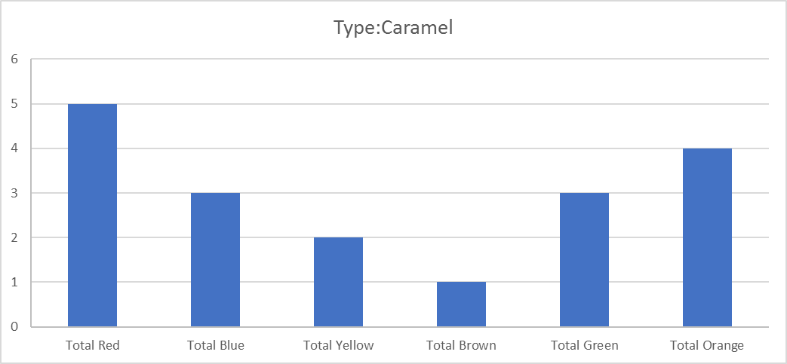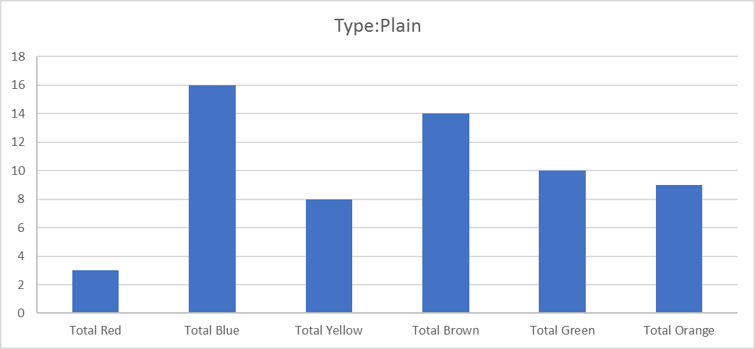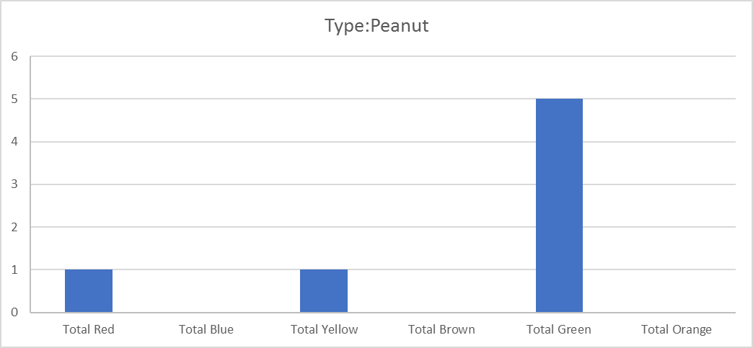

Based on these graphs which show the total number of candy pieces for each color for the whole bags of each type, blue candies, red candies, and green candies have the highest number in plain, caramel, and peanut bags respectively. In other words if you like blue candies, red candies, or green candies there is the highest probability that you can find more of them in plain, caramel, and peanut bags respectively.

Based on these graph which shows the total number of candy pieces for each color for all available bags, blue and green candies with 19 and 18 pieces respectively are the most used candies in these bags.