PT2_ODP-KLJ-FCT-120

STO KLOJEN  RUANG GPON  -7.964470° 112.615930° | STO KLOJEN  RUANG FTM  -7.964470° 112.615930°

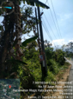 | 
LEMARI : 5 | 172.23.226.163

 | 
CARD : 01 | PORT : 14

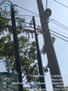 | 
LEMARI : 2 | FTM-KLJ-EA-03

 | 
OTB : 05 | SLOT : 5 PORT : 2(14)

PT2_ODP-KLJ-FCT-120

RUANG FTM  -7.964470° 112.615930° | ODC-KLJ-FCT  -7.938920°, 112.592700°

 | 
LEMARI : 2 | FTM-KLJ-OA-03

 | 
OTB : 04 | PANEL : 4

 | 
PORT : 3 CORE : 21 | ODC-KLJ-FCT

 | 
FULL TRAY | IN

 | 
PORT : | HASIL UKUR

PT2_ODP-KLJ-FCT-120

ODC-KLJ-FCT  ODC-C-288 | ODP-KLJ-FCT/120  FCT/D04/120.01

 | 
SPL | Hasil Ukur

 |  | 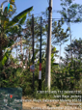
TRAY : 13 | PORT : 1 | ODP-KLJ-FCT/120

 |  | 
ODP-KLJ-FCT/120 | SPL | QR CODE

 | 
QR CODE PORT | VALIN ID

PT2_ODP-KLJ-FCT-120

ODP-KLJ-FCT/120
-7.937579°,112.591336°

 |  |  | 
PORT : 01 | PORT : 02 | PORT : 03 | PORT : 04

 |  |  | 
PORT : 05 | PORT : 06 | PORT : 07 | PORT : 08

PT2_ODP-KLJ-FCT-120

DOKUMENTASI TAMBAHAN

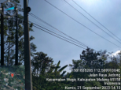 |  | 
Dokumentasi 1 | Dokumentasi 2 | Dokumentasi 3

PT2_ODP-KLJ-FCT-120

DENAH LOKASI


Keterangan: Denah Lokasi

