PT2_ODP-KLJ-FCT-120
STO KLOJEN
RUANG GPON
-7.964470° 112.615930°
172.23.226.163
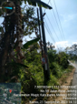
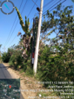
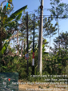
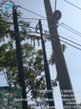
LEMARI : 5
172.23.226.163
CARD : 01
PORT : 14
STO KLOJEN
RUANG FTM
-7.964470° 112.615930°
FTM-KLJ-EA-03




LEMARI : 2
FTM-KLJ-EA-03
OTB : 05
SLOT : 5 PORT : 2(14)

PT2_ODP-KLJ-FCT-120
RUANG FTM
-7.964470° 112.615930°
FTM-KLJ-OA-03
LEMARI : 2




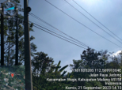
FTM-KLJ-OA-03
OTB : 04
PANEL : 4
PORT : 3 CORE : 21
ODC-KLJ-FCT
ODC-C-288
-7.938920°, 112.592700°
JL. JOYO AGUNG





ODC-KLJ-FCT
FULL TRAY
TRAY : 2
HASIL UKUR
FEEDER

PT2_ODP-KLJ-FCT-120
ODC-KLJ-FCT
ODC-C-288
-7.938920°, 112.592700°
JL. JOYO AGUNG
SPL
SPL-B.1-35





ODP-KLJ-FCT/120
FCT/D04/120.01
PERUM BRAWIJAYA RESIDEN
-7.937579°,112.591336°
ODP-KLJ-FCT/120
SEBELUM




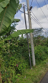
ODP-KLJ-FCT/120
DS04(10,13)
QR CODE
T3P0H26EDSRC
QR CODE PORT
VALIN ID

PT2_ODP-KLJ-FCT-120
ODP-KLJ-FCT/120
FCT/D04/120.01
PERUM BRAWIJAYA RESIDEN
-7.937579°,112.591336°
PORT : 01

PORT : 02

PORT : 03

PORT : 04

PORT : 05

PORT : 06

PORT : 07
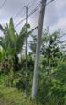
PORT : 08
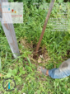

PT2_ODP-KLJ-FCT-120




PT2_ODP-KLJ-FCT-120


