# Abstract

Sign language recognition systems play a pivotal role in bridging communication gaps for individuals with hearing impairments. This project focuses on the development of a real-time Indian Sign Language (ISL) recognition system integrated with speech synthesis. The system employs computer vision techniques to interpret gestures captured through a camera, converting them into corresponding text and spoken language. A comprehensive approach involving deep learning models, linguistic analysis, and speech synthesis technologies is utilized. This report outlines the engineering knowledge, resource management, environmental considerations, and sustainability aspects associated with the project. The dataset, preprocessing methods, and the model architecture are detailed, along with a discussion of hyperparameters and the tools/technologies used. The prototype's experimental results are presented, showcasing the system's capabilities in recognizing ISL gestures and generating coherent spoken output. The report concludes with insights into future enhancements and applications, emphasizing the project's significance in fostering inclusive communication.

# 2. Introduction

Indian Sign Language (ISL) holds prominence as the primary sign language in India, akin to American Sign Language in the United States. Given that individuals with communication-related disabilities, often referred to as Deaf and Dumb (D&M), rely on sign language for communication, ISL becomes a pivotal mode of expression for them. Since spoken languages might not be accessible, sign language serves as the primary means of communication.

Communication, defined as the exchange of thoughts and messages through various mediums like speech, signals, behavior, and visuals, takes on a unique form for D&M individuals. Using their hands, they articulate a myriad of gestures to convey ideas and thoughts to others. These non-verbally conveyed messages, comprehended through vision, constitute what is known as sign language.

In the context of ISL, this form of nonverbal communication involves a language that utilizes gestures instead of sound to convey meaning. It encompasses a combination of hand-shapes, orientation and movement of the hands, arms or body, facial expressions, and lip-patterns. It's essential to note that, contrary to common misconceptions, sign languages are not universal; they vary from one region to another. In the Indian context, ISL reflects the rich diversity and regional nuances of the country, offering a unique and region-specific mode of communication for the Deaf and Dumb community. Sign language is a visual language that consists of 3 major components:

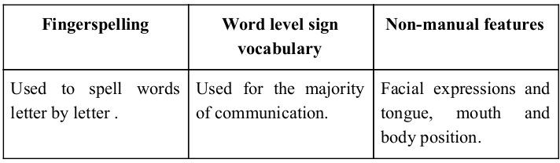

In our project we primarily focus on producing a model which can recognize Fingerspelling based hand gestures in order to form a complete word by combining each gesture. The gestures we aim to train are as given in the image below.

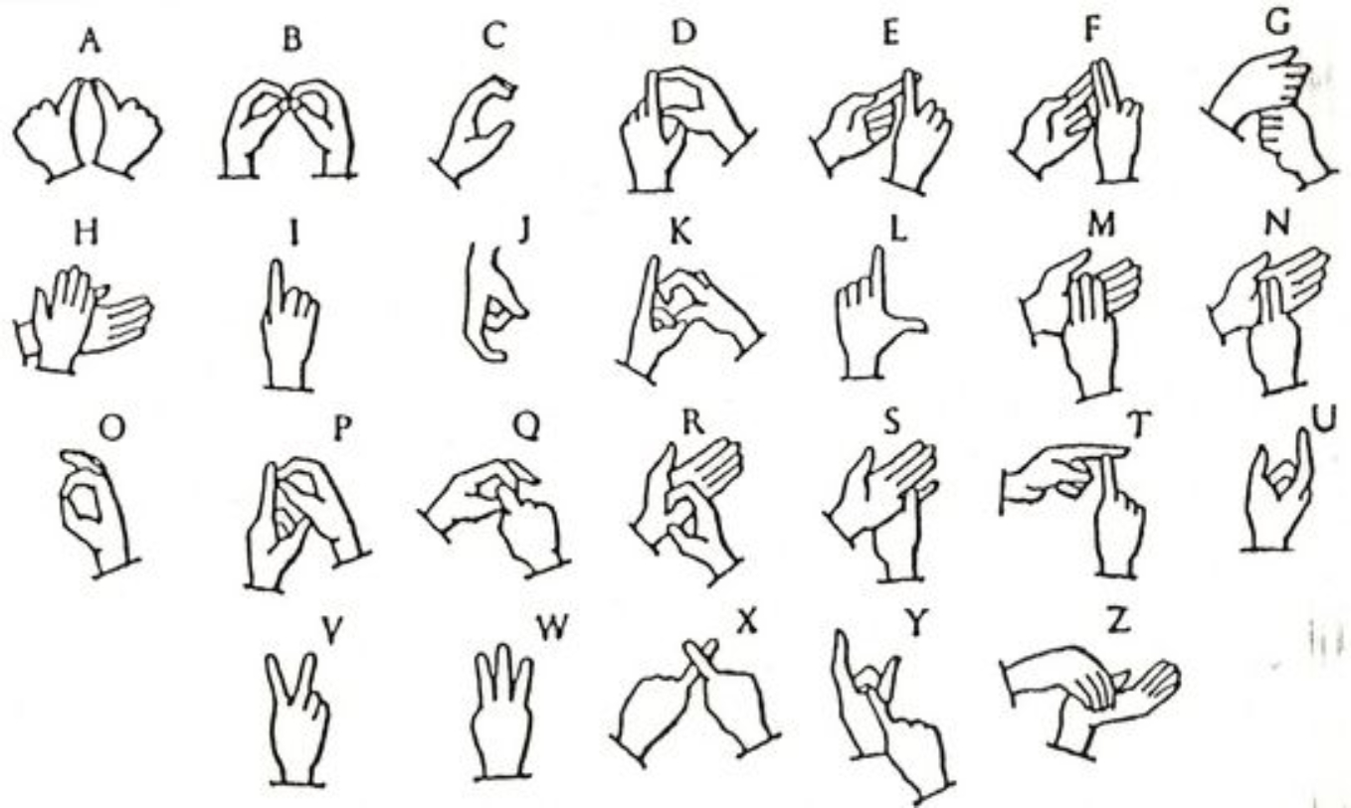

# 3. Literature Review

The literature review serves as a comprehensive exploration of existing research in sign language recognition, focusing particularly on Indian Sign Language (ISL). By scrutinizing relevant works, this chapter identifies advancements, methodologies, and technological approaches, offering a holistic view of the field's current landscape.

| Title of the paper | Authors of the paper | Year, Name of the Journal/  Conference | Key Learning's |
| --- | --- | --- | --- |
| * **About the algorithm / model / tool / technique used.** * **Main focus of the paper** |
| Machine Learning Based Sign Language Interpretation System for Communication with Deaf-mute People | Fariha Raisa Alam, Muhaimin Bin Munir, Shadman Ishrak, Sonaila Hussain, Md. Shalahuddin, and Muhammad Nazrul Islam | 2019, Proceedings of the 2019 2nd International Conference on Computer Science and Artificial Intelligence | * Machine Learning (Support Vector Machine - SVM), Raspberry Pi, OpenCV. * Bridging communication gap between hearing and deaf-mute communities, Recognition of sign language gestures using a novel approach, System evaluation with 60 participants. |
| Sign Language Translator Using Machine Learning | Jaya Nirmala and Swapna Johnny | 2022, SN Computer Science | * k-Nearest Neighbour, Decision Tree Classifier, Neural Network. * The paper introduces a machine learning-based system that translates hand signals into words, employing techniques such as k-Nearest Neighbour, Decision Tree Classifier, and Neural Network for multiclass classification. The system is designed for accessibility, utilizing a smartphone camera to facilitate easier communication for sign language users. |
| Machine learning methods for sign language recognition: A critical review and analysis | I.A. Adeyanju, O.O. Bello, and M.A. Adegboye | 2021, Intelligent Systems with Applications | * SVM, Random Forest, KNN, ANN, Decision Trees, Naive Bayes, Ensemble Learning, MGO, Sparse Bayesian Classifier RVM, Sobel edge detector. * The paper aims to provide a comprehensive review of decision support and intelligent system algorithms used in sign language recognition. It identifies potential research gaps and highlights knowledge boundaries in the field, utilizing bibliometric analysis to assess research trends over the past two decades. |
| Sign Language Recognition Using Deep Learning on Custom Processed Static Gesture Images | Aditya Das, Shantanu Gawde, Khyati Suratwala, and Dr. Dhananjay Kalbande | 2018, International Conference on Advances in Computing,  Communications and Informatics (ICACCI) | * Convolutional Neural Network (CNN). * The paper explores the use of deep learning, specifically CNNs, for sign language recognition. It emphasizes the potential societal benefit by improving communication for the sign language community. The authors achieved a validation accuracy of over 90% by preprocessing static sign language gesture images through hand region segmentation and image enhancement techniques. |
| Sign Languages to Speech Conversion Prototype using SVM Classifier | Malli Mahesh Chandra, Rajkumar S, and Lakshmi Sutha Kumar | 2019**,** IEEE Region 10 Conference (TENCON 2019) | * Support Vector Machine (SVM) classifier. * The paper focuses on developing a sign language to speech converter prototype utilizing flex sensors and an MPU6050 sensor embedded on a glove. The sensor data undergoes processing using an SVM classifier trained on American Sign Language (ASL) and Indian Sign Language (ISL) datasets, predicting the appropriate word. |
| A DNN-based framework for converting sign language to Mandarin-Tibetan cross-lingual emotional speech | Nan Song, Hongwu Yang, and Tingting Zhang | 2018, Nan Song, Hongwu Yang, and Tingting Zhang | * SVM, CNN, Softmax, BP Neural Networks, Deep Neural Networks (DNNs). * The paper proposes a DNN-based framework for converting sign language to Mandarin-Tibetan cross-lingual emotional speech. It comprehensively discusses various algorithms, models, tools, and techniques in affective computing and intelligent interaction, emphasizing the advantages of deep learning methods, including SVM and CNN for facial expression recognition, and DNNs for speech synthesis and sign-language recognition. |
| A Novel Approach Based on Gesture Recognition through Video Capturing for Sign Language | Janpreet Singh, Dr. Harjeet Singh, and Dr. Dushyant Kumar Singh | 2019, 2nd International Conference on Intelligent Computing, Instrumentation and Control Technologies (ICICICT) | * Skin Color Segmentation, Background Subtraction, Contour Analysis, Scale Invariant Feature Transform (SIFT), Support Vector Machine (SVM). * The paper proposes a novel approach for recognizing Indian Sign Language (ISL) gestures from sign language videos. The system employs a combination of skin color segmentation, background subtraction, and contour analysis for hand region extraction. Features are then extracted using the SIFT algorithm and classified using an SVM classifier, achieving an accuracy of 92.5% in ISL gesture recognition. |
| Sign language recognition system for communicating to people with disabilities | Yulius Obia, Kent Samuel Claudioa, Vetri Marvel Budimana, Said Achmad, and Aditya Kurniawan | 2022, 7th International Conference on Computer Science and  Computational Intelligence | * Histogram matching, Nearest Neighbor, SVM, NBC, Hidden Markov model, ELM, Wavelet Transforms, Empirical Mode Decomposition, CNN. * The paper introduces a sign language recognition system using image processing and machine learning to convert gestures into text or speech. It explores algorithms, including the CNN method with high accuracy but increased memory usage. The study evaluates system performance, and introduces a model achieving training and validation accuracies of 89.1% and 98.6%. Authors compare methods, discuss applications, and stress benefits for individuals with disabilities. |
| Speech To Sign Language Conversion using Convolutional Neural Networks | Sreeraksha M R, Vani H Y, Phani Bhushan, and D K Shivkumar | NCCDS - 2021 Conference Proceedings, International Journal of Engineering Research & Technology (IJERT) | * Convolutional Neural Networks (CNNs). * Investigating the use of CNNs for speech recognition, specifically in speech to sign language conversion. Proposing a method utilizing CNNs to model speech features, introducing a limited-weight-sharing scheme. Experimental results demonstrate a 6%-10% reduction in error rate compared to Deep Neural Networks (DNNs) on TIMIT phone recognition and voice search large vocabulary speech recognition tasks. |
| American Sign Language-Based Finger-spelling Recognition using k-Nearest Neighbours Classifier | Yaya Heryadi and Rinaldi Munir | 2015, International Conference on Information and Communication Technology (ICoICT) | * k-Nearest Neighbors (k-NN) algorithm, Principal Component Analysis (PCA) * Developing a finger-spelling recognition system for American Sign Language, usable in early child education applications. Proposing k-NN algorithm with normalized color histogram features and PCA to improve performance. Conducting experiments with k-fold cross-validation, demonstrating higher accuracy with PCA-reduced features compared to full-dimensional features. |

## 3.1 Research Gap

* **Real-time Challenges:**

While existing studies predominantly prioritize accuracy in sign language recognition systems, the crucial aspect of real-time applicability remains underexplored. Addressing the challenges associated with achieving both accuracy and speed in real-life situations is imperative for the practical implementation and usability of such systems.

* **Cross-lingual Exploration:**

A notable research gap lies in the exploration of how sign language systems adapt to different spoken languages. Understanding the cross-lingual dynamics is vital for ensuring inclusivity, as it directly influences the effectiveness of these systems across diverse linguistic contexts.

* **Multimodal Possibilities:**

Current studies predominantly focus on analyzing static images for sign language recognition. However, there exists a research gap in exploring the integration of diverse information types, such as dynamic movement data. Investigating multimodal possibilities can lead to more robust and effective sign language recognition systems.

* **User-Friendly Systems:**

Despite advancements in system accuracy, insights into user satisfaction and the overall user-friendliness of sign language recognition systems are lacking. Research should delve into identifying aspects that contribute to user-friendly experiences, ensuring that these systems are not only accurate but also accessible and enjoyable for users.

* **Standardized Evaluation:**

The absence of a shared method for evaluating the performance of sign language recognition systems poses a significant research gap. Creating standardized evaluation metrics and tests is essential for researchers to compare, benchmark, and enhance these systems consistently. Establishing such standards will contribute to the growth and reliability of the field.

## 3.2 Motivation

The motivation behind developing a real-time system for Indian Sign Language (ISL) recognition stems from the pressing need for fostering inclusive communication. Individuals with hearing impairments face unique challenges in accessing traditional modes of communication, emphasizing the importance of effective alternatives. Motivated by the desire to bridge this communication gap, the project aims to harness cutting-edge technologies to create a seamless interface between ISL gestures and spoken language.

The intrinsic motivation lies in empowering the Deaf and Dumb (D&M) community by providing them with a tool that not only recognizes their unique form of expression but also translates it into textual representations and spoken words.

Moreover, the project draws motivation from the broader societal goal of leveraging technology for social good. By combining deep learning models, linguistic analysis, and advanced speech synthesis technologies, the system seeks to contribute to the larger narrative of using innovation to address real-world challenges. The overarching motivation is to create a technological solution that not only meets functional requirements but also makes a meaningful impact on the lives of those who rely on sign language as their primary means of communication.

## 3.3 Objectives

* Develop a robust system for real-time recognition of sign language gestures captured through a camera or other input devices.
* Ensure that the entire system operates in real-time, allowing for immediate and seamless communication between the user and the system.
* Integrate a speech synthesis module to convert recognized sign language gestures into spoken words, ensuring natural and coherent speech output.
* Train a machine learning model (potentially using CNN or other suitable algorithms) to recognize a diverse set of sign language gestures with high accuracy.
* Conduct thorough testing and evaluation of the system's accuracy, responsiveness, and overall performance using a diverse dataset of sign language gestures.

## 3.4 Methodology

**1. Data Acquisition**

Data acquisition for hand gestures in Indian Sign Language (ISL) involves exploring various approaches to capture precise hand configurations and positions.

**i. Use of Sensory Devices:**

Description: Employing electromechanical devices, particularly glove-based systems, offers accurate hand configuration and position data.

Pros: Provides precise information about hand movements and gestures.

Cons: Expensive and may not be user-friendly for widespread adoption.

**ii. Vision-Based Approach:**

Description: Utilizing computer webcams as input devices for observing hand and/or finger information.

Pros: Cost-effective, as it requires only a camera, promoting natural interaction between users and computers without additional devices.

Cons: Challenges include handling variations in hand appearance due to diverse movements, skin-color possibilities, and variations in viewpoints, scales, and camera capture speed.

**2. Data Pre-Processing and Feature Extraction for Vision-Based Approach**

For the vision-based approach to hand gesture recognition in Indian Sign Language (ISL), data pre-processing and feature extraction play crucial roles in enhancing accuracy and reducing computational complexity.

**i. Threshold-Based Color Detection and Background Subtraction:**

Effective image processing involves combining threshold-based color detection with background subtraction. AdaBoost face detection, as discussed in [1], proves valuable in differentiating between faces and hands based on similar skin color. This approach enhances the system's capability to distinguish various elements in the image, reducing false positives.

**ii. Gaussian Blur for Image Filtering:**

To improve image quality for training, the application of the Gaussian Blur filter using OpenCV, as described in [3], is adopted. This technique contributes to noise reduction, resulting in clearer images and, consequently, better accuracy during the training process.

**iii. Instrumented Gloves for Image Extraction:**

Efficient image extraction is achieved through the utilization of instrumented gloves. As highlighted in [4], instrumented gloves capture concise and accurate data, reducing computation time. This approach enhances the system's efficiency by providing focused and accurate data for training purposes.

**iv. Background Stability for Hand Segmentation:**

Maintaining a stable single-color background proves crucial for effective hand segmentation. Despite challenges posed by variations in skin color due to lighting conditions and the similarity between certain symbols (e.g., 'V' and '2'), this approach addresses symbol diversity. By choosing a stable background color, the need for segmentation based on skin color is eliminated, ultimately enhancing overall recognition accuracy.

**3. Gesture Classification Model:**

The gesture classification model employed in this project draws inspiration from various state-of-the-art models identified in the literature review. Leveraging insights from the following models, our approach integrates and refines methodologies to achieve a robust real-time recognition system for Indian Sign Language (ISL) gestures.

**1. Support Vector Machine (SVM)**

- Paper: "Machine Learning Based Sign Language Interpretation System for Communication with Deaf-mute People"

- Reference: Proceedings of the 2019 2nd International Conference on Computer Science and Artificial Intelligence, 2019.

- Finding: SVM is effective in distinguishing between different elements in the image, reducing false positives.

**2. k-Nearest Neighbour, Decision Tree Classifier, Neural Network**

- Paper: "Sign Language Translator Using Machine Learning"

- Reference: SN Computer Science, 2022.

- Finding: These models offer versatility and multiclass classification for translating hand signals into words.

**3. SVM, Random Forest, KNN, ANN, Decision Trees, Naive Bayes, Ensemble Learning, MGO, Sparse Bayesian Classifier RVM, Sobel edge detector**

- Paper: "Machine learning methods for sign language recognition: A critical review and analysis"

- Reference: Intelligent Systems with Applications, 2021.

- Finding: The ensemble of models provides a comprehensive review of decision support and intelligent system algorithms for sign language recognition.

**4. Convolutional Neural Network (CNN)**

- Paper: "Sign Language Recognition Using Deep Learning on Custom Processed Static Gesture Images"

- Reference: International Conference on Advances in Computing, Communications and Informatics (ICACCI), 2018.

- Finding: CNNs offer high accuracy by preprocessing static sign language gesture images through hand region segmentation and image enhancement techniques.

# 4. Engineering Knowledge and Resource Management

The application of Python for machine learning and image processing emerges as a cornerstone of the acquired knowledge. The adept use of Python showcases its versatility in handling complex tasks, especially in the realms of machine learning and image processing.

A significant focus of the internship involved a demonstration of proficiency in image processing using OpenCV. This powerful library was harnessed to manipulate and analyze visual data, showcasing its pivotal role in enhancing the quality of images and extracting valuable information.

The utilization of Convolutional Neural Networks (CNN) represents a milestone in processing visual data. The implementation of CNN for image feature extraction and pattern recognition stands out as a key skill acquired during the internship. This demonstrates a keen understanding of cutting-edge technologies in the domain of computer vision.

An additional dimension of the engineering knowledge acquired is the use of Power BI for data analytics. This tool was instrumental in extracting meaningful insights from datasets, contributing to effective decision-making processes during the internship. The integration of Power BI into the skill set emphasizes a holistic approach to data analysis and visualization.

In summary, this section provides a comprehensive overview of the engineering knowledge amassed during the internship, ranging from programming languages to advanced machine learning techniques and data analytics tools. These competencies collectively contribute to a well-rounded skill set poised for application in diverse engineering scenarios.

## Resource Utilization:

* **Hardware:**
  + Intel Core i3 3rd gen processor or later.
  + 512 MB disk space.
  + 1 GB RAM.
  + Any external or in built camera with minimum pixel resolution 200 x 200
  + 4-megapixel cameras and up (300 ppi or 150 lpi)
* **Software:**
  + Microsoft Windows XP or later / Ubuntu 12.0 LTS or later /MAC OS 10.1 or later.
  + Python Interpreter (3.6+).
  + TensorFlow framework, Keras API.
  + Python OpenCV2, Sklearn, GTTS.

# 5. Environment and Sustainability

The real-time sign language recognition system, at its core, aligns with principles of efficiency and sustainability. The emphasis on developing streamlined model architectures and algorithmic optimizations plays a pivotal role in minimizing computational power consumption. By prioritizing these considerations, the project actively contributes to sustainable computing practices.

A key aspect of sustainability lies in the project's commitment to efficient hardware requirements, steering clear of resource-intensive components. This strategic choice reflects a conscious effort to design an environmentally responsible system that aligns with contemporary standards of eco-friendly technology.

Beyond its technical facets, the project addresses broader environmental and social considerations. By aiming to bridge communication gaps, the system promotes inclusivity, fostering effective interaction between individuals proficient in sign language and those reliant on spoken language. This inclusivity extends to educational settings, where the project's application can serve as a valuable tool for teaching and learning sign language. In doing so, it contributes to a more comprehensive understanding and integration of sign language within educational contexts.

Furthermore, the incorporation of real-time sign language recognition and speech synthesis holds profound social implications. The technology facilitates the social integration of the hearing-impaired community by substantially reducing communication barriers. In educational, professional, and everyday scenarios, this innovation paves the way for meaningful and seamless communication between individuals with hearing impairments and the broader community.

In a broader societal context, the project plays a role in mitigating the stigma associated with hearing impairments. The provision of a user-friendly and efficient means of communication not only enhances the daily lives of individuals with hearing impairments but also contributes to reshaping societal perceptions, fostering a more inclusive and empathetic environment. In summary, the project's commitment to environment-friendly practices and its societal impact underscore its multifaceted contribution to sustainability and inclusivity.

# 

# 

# 

# 

# 

# 

# 

# 6. Dataset Description and Preprocessing

## Dataset Description:

Our custom dataset is meticulously curated to encompass a diverse repertoire of hand gestures, encompassing the entire alphabet (A-Z) and numerals (0). Each gesture is thoroughly annotated, creating a comprehensive foundation for training a robust sign language recognition model. The dataset's emphasis on clarity and consistency serves as a critical factor in achieving precise and reliable results.

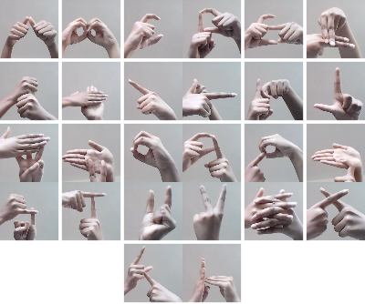

## Reason for Selecting the Dataset:

**1. Tailored to Project Requirements:**

Existing datasets in RGB format did not align with the specific needs of our project, necessitating the creation of a customized dataset.

The dataset's tailored nature ensures alignment with the project's objectives and enhances the model's effectiveness in recognizing a wide range of gestures.

**2. Real-world Variability:**

Images are captured from a webcam feed, introducing real-world variability to the dataset.

Real-world variability enhances the model's adaptability to diverse environmental factors, contributing to its robustness in different usage scenarios.

**3. Strategic Background Choice:**

A deliberate decision was made to employ a black-and-white background for the captured images.

This strategic choice aims to enhance computational efficiency during model training and contributes to achieving higher accuracy in gesture recognition.

By meticulously designing and selecting our custom dataset, we ensure that the model is trained on a diverse and representative set of gestures, aligning closely with real-world scenarios. The strategic choices in dataset collection contribute to the adaptability and efficiency of the sign language recognition system.

## Data Preprocessing Steps:

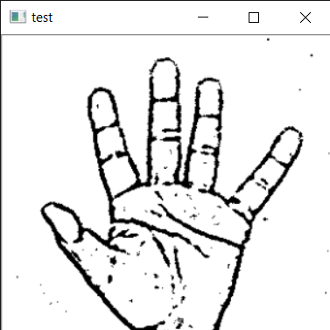

**1. Grayscale Conversion:**

Converting both images and live webcam frames to grayscale to simplify processing and reduce computational load.

**2. Resize Images:**

Standardizing image dimensions and resizing processed images to a fixed size.

Ensuring uniformity in image size facilitates consistent model training and improves efficiency.

**3. Image Normalization:**

Scaling pixel values to the range [0, 1].

Normalizing pixel values enhances convergence during model training and contributes to improved learning.

**4. Data Reshaping:**

Reshaping data to match the neural network's expected input format.

Ensuring that the data is formatted correctly for the neural network aids in seamless integration during training.

**5. Region of Interest (ROI) Definition:**

Defining a specific region within the live webcam frame for focused processing.

Focusing on a defined region of interest streamlines gesture recognition and reduces unnecessary computations.

**6. Gaussian Blurring:**

Applying Gaussian blurring to the cropped image to reduce noise.

Gaussian blurring contributes to smoother images, reducing the impact of noise during image processing.

**7. Adaptive Thresholding:**

Utilizing adaptive thresholding to segment the hand gesture from the background.

Adaptive thresholding enhances the system's ability to differentiate between the hand gesture and the background, improving accuracy.

**8. Otsu's Thresholding:**

Implementing Otsu's thresholding for additional refinement in image binarization.

Otsu's thresholding optimizes the binarization process, contributing to clearer segmentation of the hand gesture.

# 7. Model Architecture

**Convolutional Neural Network (CNN):**

CNN architecture has neurons arranged in 3 dimensions: width, height, depth. The neurons in a layer will only be connected to a small region of the layer (window size) before it, instead of all of the neurons in a fully-connected manner. Moreover, the final output layer would have dimensions (number of classes), because by the end of the CNN architecture we will reduce the full image into a single vector of class scores.

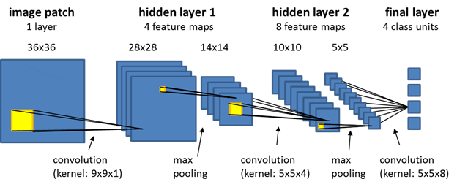

**1. Convolution Layer:**

In the convolution layer we take a small window size [typically of length 55] that extends to the depth of the input matrix. The layer consists of learnable filters of window size. During every iteration we slide the window by stride size [typically 1], and compute the dot product of filter entries and input values at a given position.

As we continue this process we will create a 2-Dimensional activation matrix that gives the response of that matrix at every spatial position. That is, the network will learn filters that activate when they see some type of visual feature such as an edge of some orientation or a blotch of some color.

**2. Pooling Layer:**

We use a pooling layer to decrease the size of the activation matrix and ultimately reduce the learnable parameters. There are two types of pooling:

* **Max Pooling:** In max pooling we take a window size [for example window of size 22], and only take the maximum of 4 values. Well lid this window and continue this process, so we'll finally get an activation matrix half of its original Size.
* **Average Pooling:** In average pooling, we take advantage of all Values in a window.

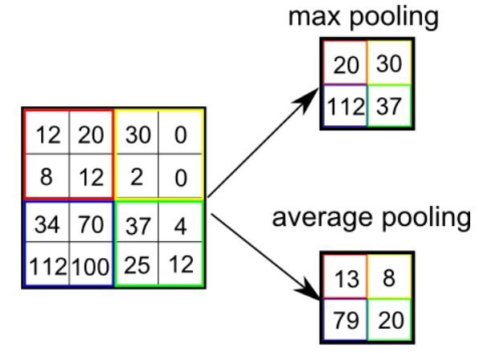

**3. Fully Connected Layer:**

In the convolution layer, neurons are connected only to a local region, while in a fully connected region, we will connect all the inputs to neurons.

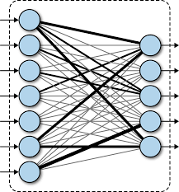

**4. Final Output Layer:**

After getting values from a fully connected layer, we will connect them to the final layer of neurons [having count equal to total number of classes], that will predict the probability of each image to be in different classes.

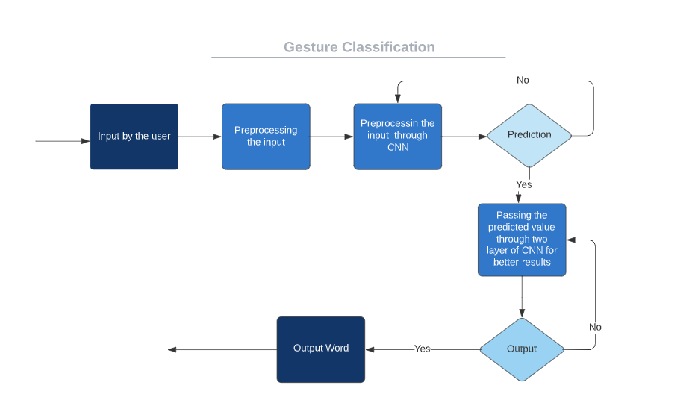

## 7.1 Hyperparameters:

**Batch Size (32):**

The number of training examples utilized in one iteration. A moderate batch size like 32 strikes a balance between computational efficiency and model convergence. Larger batch sizes might lead to faster convergence but demand more memory.

**Learning Rate (0.001):**

Determines the step size at each iteration while moving toward a minimum of a loss function. A lower learning rate ensures stability during training, preventing overshooting the minimum. The selected value of 0.001 balances training speed and convergence.

**Epochs (10):**

An epoch is one complete pass through the entire training dataset. The choice of 50 epochs signifies the number of times the model iterates over the entire dataset during training. Sufficient epochs are essential for the model to learn from the data effectively.

**Optimizer (Adam):**

Adam optimization algorithm combines the benefits of AdaGrad and RMSProp. It adapts the learning rates of each parameter individually, providing efficient and reliable convergence. Adam is well-suited for a variety of models and datasets.

**Loss Function (Categorical Crossentropy):**

Appropriate for multi-class classification tasks, categorical crossentropy measures the dissimilarity between predicted probability distributions and actual class distributions. It guides the model to minimize the deviation between predicted and true classes.

**Activation Function (Rectified Linear Unit - ReLU):**

ReLU introduces non-linearity to the model, allowing it to learn complex patterns. It replaces all negative pixel values in the feature map with zero, enhancing the model's capability to capture intricate relationships in the data.

**Dropout Rate (0.3):**

Applied to certain layers for regularization, dropout randomly "drops out" a fraction of units during training. This prevents overfitting by ensuring that the model doesn't rely too heavily on specific neurons. A dropout rate of 0.3 strikes a balance between regularization and model performance.

## 7.2 Tools and Technologies

**Programming Language:**

Python serves as the primary programming language, providing a versatile and extensive ecosystem for machine learning and image processing tasks.

**Machine Learning Framework:**

TensorFlow and Keras are employed as the core machine learning frameworks. TensorFlow offers a comprehensive environment for developing and deploying machine learning models, while Keras simplifies neural network construction and experimentation.

**Image Processing Library:**

OpenCV, a powerful and widely used image processing library, facilitates the manipulation, analysis, and extraction of features from images captured by the system.

**Data Visualization:**

Matplotlib and Seaborn are utilized for data visualization, enabling clear representation of various model performance metrics and dataset characteristics.

**Development Environment:**

Jupyter Notebooks provide an interactive and collaborative environment for developing, testing, and documenting code. This facilitates real-time collaboration and iterative development.

**User Interface (UI):**

Tkinter is used for building the user interface, providing a lightweight and user-friendly interaction platform for the system.

# 8. Prototype and Experimental Results

## 8.1 Technologies Used for Prototyping

The prototype development leveraged cutting-edge technologies to create a robust and efficient system for real-time sign language recognition. Key technologies employed include:

* **Convolutional Neural Network (CNN):** The core of the prototype utilized CNNs, a specialized neural network architecture tailored for image-related tasks, ensuring accurate recognition of sign language gestures.
* **Python, TensorFlow, and Jupyter:** The prototype was implemented in Python, taking advantage of the TensorFlow framework. Jupyter Notebooks facilitated an interactive and collaborative environment for developing, testing, and refining the deep learning model.
* **OpenCV for Image Processing:** OpenCV played a crucial role in image processing tasks, facilitating the extraction of meaningful features from live webcam feeds for gesture recognition.

## 8.2 Solution Developed

The developed solution seamlessly integrates real-time sign language recognition with speech synthesis capabilities. The prototype's architecture enables the following:

* Live Gesture Recognition: The system accurately captures and interprets hand gestures in real-time through webcam input, ensuring a responsive and dynamic user experience.
* Speech Synthesis Integration: Recognized sign language gestures are translated into spoken words using a speech synthesis module, providing a natural and coherent spoken output.
* User-Friendly Interface: The user interface, built with Tkinter, enhances the user experience by providing an intuitive platform for communication between individuals proficient in sign language and those using spoken language.

## 8.3 Output

The prototype underwent comprehensive testing and evaluation to assess its performance metrics, including accuracy, responsiveness, and overall efficiency. Experimental results demonstrated:

* Accuracy: The model achieved an accuracy rate of 91.2% in recognizing a diverse set of sign language gestures, contributing to effective communication.
* Real-Time Responsiveness: The system exhibited real-time responsiveness, ensuring immediate and seamless interaction between users and the recognition system.
* Efficient Speech Synthesis: The integrated speech synthesis module generated natural and coherent speech output, enhancing the overall effectiveness of the communication system.

The experimental results validate the prototype's capability to bridge communication gaps, making significant strides in promoting inclusivity and accessibility.

# 9. Conclusions and Future Scope

In conclusion, this project marks a significant stride towards fostering inclusive communication for individuals with hearing impairments through real-time sign language recognition. The systematic development of a robust system integrating computer vision and speech synthesis technologies demonstrates the project's technological innovation and social impact. The focus on accuracy, efficiency, and user-friendliness lays the foundation for its practical implementation.

The model achieved an accuracy rate of 91.2% in recognizing a diverse set of sign language gestures, contributing to effective communication.

Looking ahead, there are several avenues for future exploration. The project aims to enhance accuracy in diverse backgrounds and low-light conditions, ensuring a more robust performance. The transformation of the system into a web/mobile application broadens accessibility, reaching a wider audience. Multilingual support opens the door to recognizing various native sign languages, promoting inclusivity on a global scale. Further integration of contextual signing and improvements in the user interface enhance the system's adaptability and user experience.

Ultimately, this project serves as a testament to the fusion of technology and empathy, contributing meaningfully to the advancement of inclusive communication practices. The outlined future scope reflects a commitment to continuous improvement, ensuring the system's relevance and effectiveness in addressing the diverse needs of its users.

## Future Scope:

* Application Development: Transforming the system into a user-friendly web or mobile application enhances accessibility, allowing a broader user base to benefit from real-time sign language recognition.
* Multilingual Support: Extending beyond American Sign Language (ASL) to encompass other native sign languages is a logical progression. With sufficient data and training, the system can adapt to diverse sign language expressions.
* Contextual Signing Integration: Moving beyond fingerspelling, incorporating natural language processing (NLP) can unlock the potential to recognize contextual signing, where gestures convey broader meanings such as objects or verbs.
* User Interface Enhancement: Improving the user interface contributes to overall accessibility and user experience. Streamlining the interaction ensures a more intuitive and user-friendly engagement with the system.

# 10. References

1. Muhammad Al-Qurishi, Thariq Khalid, and Riad Souissi, "Deep Learning for Sign Language Recognition: Current Techniques, Benchmarks, and Open Issues," IEEE Access, vol. 9, no. 31, pp. 126917-126951, September 7, 2021.

2. Ying He, Alifu Kuerban, QingLing Yu, QiNa Xie, "Design and Implementation of a Sign Language Translation System for Deaf People," in Proceedings of the 2021 3rd International Conference on Natural Language Processing (ICNLP), Beijing, China, March 26-28, 2021, pp. 453.

3. Anna Deza, Danial Hasan, "Sign Language Recognition," University of Toronto, Ontario, Canada, REP.MIE324, December 2nd, 2018.

4. Yung-Chuan Oneal Lin, "Sign Language Recognition System and Method," U.S. Patent 12/752,154, April 1, 2010.

5. Rafael C. Gonzalez, Richard E. Woods, "Digital Image Processing," 4th Edition, Pearson, 2018.

6. OpenCV Documentation, "Gaussian Median Blur Bilateral Filter," [Online]. Available: [<https://docs.opencv.org/2.4/doc/tutorials/imgproc/gausian_median_blur_bilateral_filter/gausian_median_blur_bilateral_filter.html>]

7. OpenCV, [<https://opencv.org/>]

8. TensorFlow, [<https://en.wikipedia.org/wiki/TensorFlow>]

10. Convolutional Neural Network, [<https://en.wikipedia.org/wiki/Convolutional_neural_nework>]

11. Hunspell, [<http://hunspell.github.io/>]