**High-Resolution Image Contrast Enhancement using CUDA and Performance Comparison with Serial code**

**Operating System:** Ubuntu 20.04 LTS

1. **Implementation:**
   1. **Dependency Required:**   
      sudo apt-get install graphicsmagick-imagemagick-compat
2. **Environment & Programming Language:** CUDA in C Language
3. **Software tools:** Sublime Text, Make, MS Word (for report)

**Serial Code:**

**Compile:** make  
**Execute:** make run

**Results:**

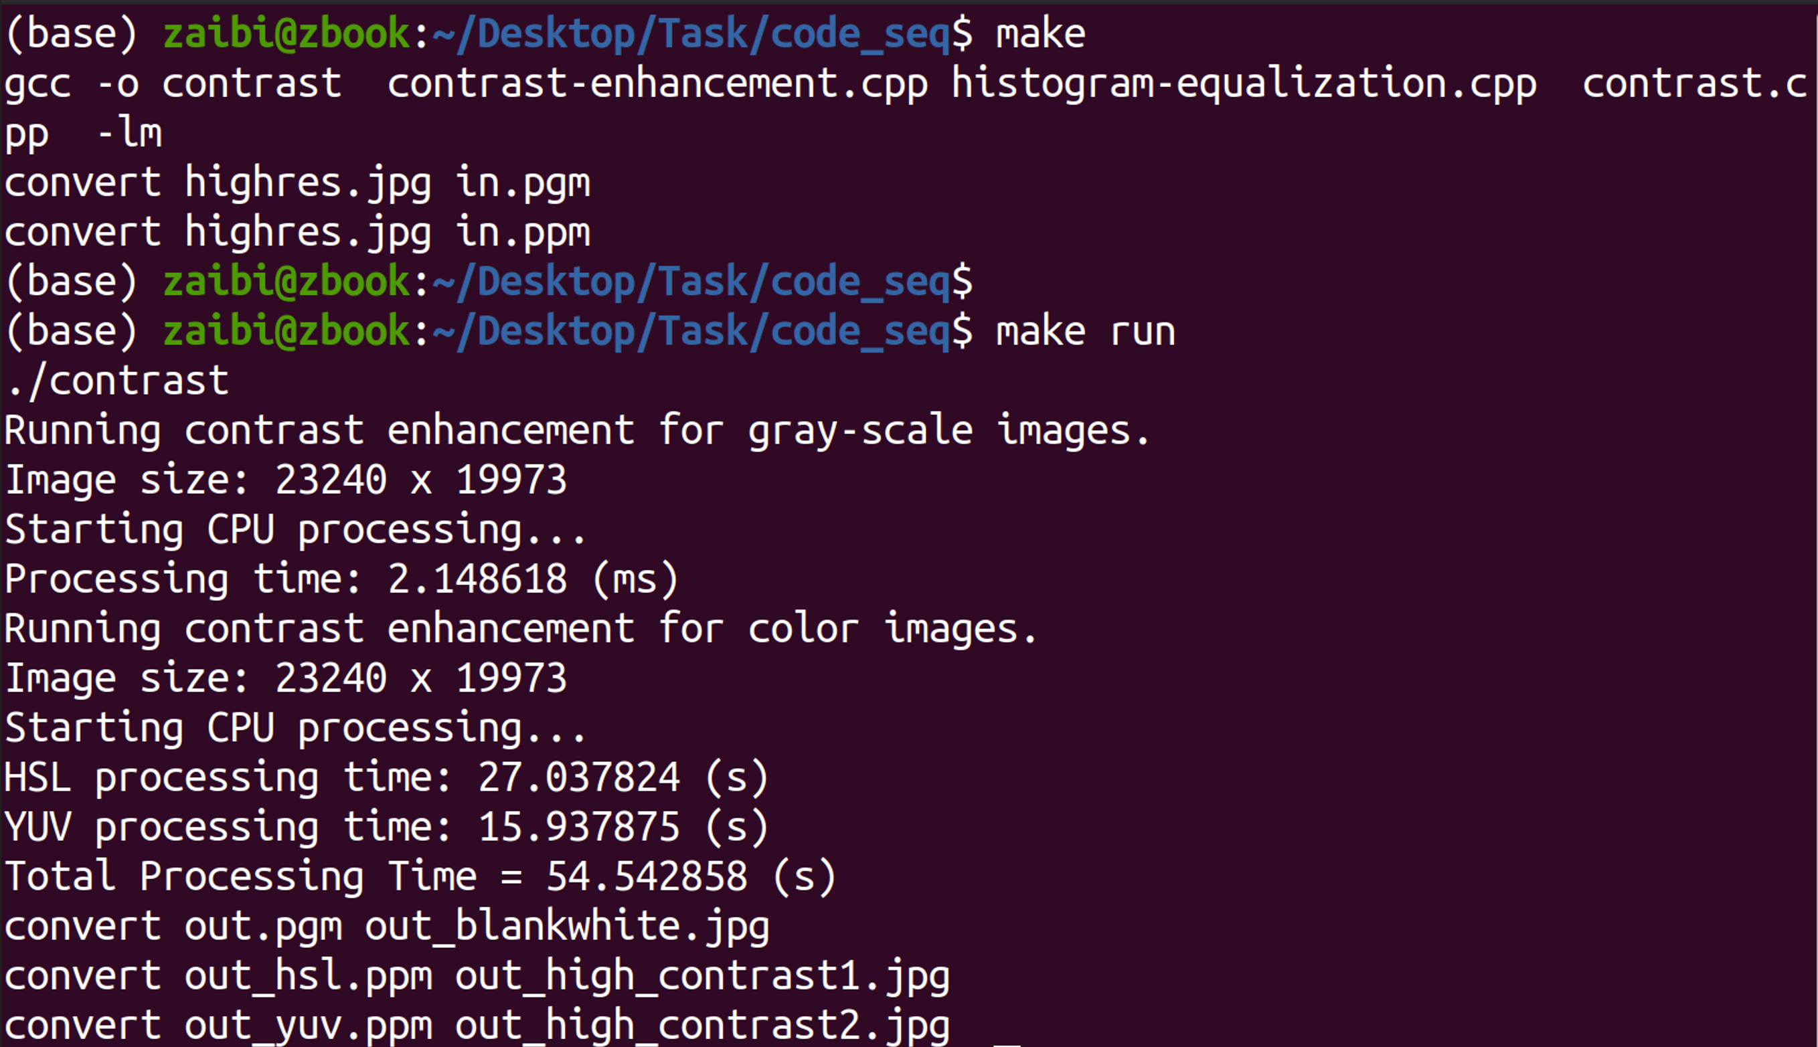

**CUDA Code:**

**Compile:** make  
**Execute:** make run

**Results:**

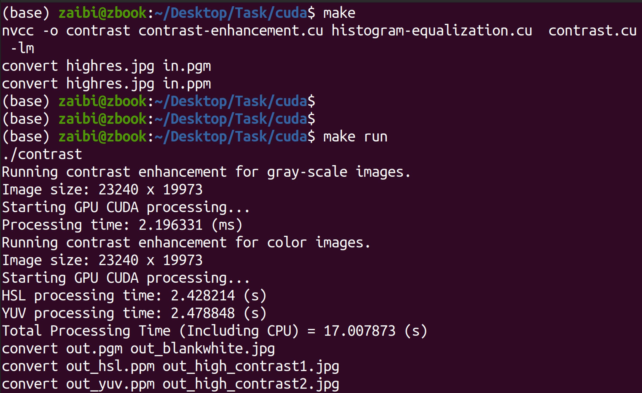

**Benchmarking Serial vs Parallel**

# **Comparison of Timings (Serial vs Parallel):**

**Image Resolution: 23240 x 19973**

|  |  |  |
| --- | --- | --- |
|  | Sequential | CUDA |
| HSL Time | 27.0378 | 2.4282 |
| YUV Time | 15.9378 | 2.4788 |
| Total Run Time | 54.5428 | 17.0078 |

**Image Resolution: 11472 x 6429**

|  |  |  |
| --- | --- | --- |
|  | Sequential | CUDA |
| HSL Time | 5.3786 | 0.4090 |
| YUV Time | 2.4999 | 0.3835 |
| Total Run Time | 9.6946 | 2.7034 |