DevOps and Cloud Computing
Final Project

MUHAMMAD JAHANZAIB PIRACHA
FA23-BAI-032

Project Report
Github URL: https://github.com/zaibjahan200/selfhealing-mlops-FA23-BAI-032

1. Got all the given project files and made modifications as required:
- Unstable app.py
- from flask import Flask, request, jsonify, render_template
- from transformers import pipeline
- import time, random, os

- app = Flask(__name__)

- classifier = pipeline(
- "sentiment-analysis",
- model="distilbert-base-uncased-finetuned-sst-2-english"
- )

- LOG_FILE = "/app/logs/predictions.log"
- os.makedirs("/app/logs", exist_ok=True)

- _request_count = 0
- _drift_injected = False

- @app.route("/", methods=["GET"])
- def index():
- return render_template("index.html")

- @app.route("/health", methods=["GET"])
- def health():
- return jsonify({
- "status": "healthy",
- "model": "distilbert-sentiment-v1",
- "model_version": "unstable-v1"
- })

- @app.route("/predict", methods=["POST"])
- def predict():
- global _request_count, _drift_injected

- _request_count += 1

- data = request.get_json()
- text = data.get("text", "")

- result = classifier(text)[0]
- confidence = result["score"]

- if _drift_injected:
- confidence = confidence * random.uniform(0.3, 0.6)

- with open(LOG_FILE, "a") as f:
- f.write(f"{time.time()},{confidence:.4f}\n")

- return jsonify({
- "label": result["label"],
- "confidence": round(confidence, 4),
- "model_version": "unstable-v1",
- "request_count": _request_count
- })

- @app.route("/api/latest-confidence", methods=["GET"])
- def latest_confidence():
- """Polled by exporter.py on EC2."""
- try:
- with open(LOG_FILE, "r") as f:
- lines = [l.strip() for l in f.readlines() if l.strip()]

- if lines:
- _, conf = lines[-1].split(",")
- return jsonify({"confidence": float(conf)})
- except Exception:
- pass

- return jsonify({"confidence": 1.0})

- @app.route("/inject-drift", methods=["POST"])
- def inject_drift():
- global _drift_injected

- _drift_injected = True
- return jsonify({"status": "drift_injected"})

- @app.route("/reset", methods=["POST"])
- def reset():
- global _drift_injected, _request_count

- _drift_injected = False
- _request_count = 0

- return jsonify({"status": "reset"})

- if __name__ == "__main__":
- app.run(host="0.0.0.0", port=5000)

- Stable-fallback app.py
- from flask import Flask, request, jsonify
- import re

- app = Flask(__name__)

- POSITIVE_WORDS = {
- "good", "great", "excellent", "happy", "love",
- "wonderful", "best", "amazing", "fantastic", "superb"
- }

- NEGATIVE_WORDS = {
- "bad", "terrible", "horrible", "hate", "worst",
- "awful", "poor", "dreadful", "disgusting"
- }

- _last_confidence = 0.95

- @app.route("/health", methods=["GET"])
- def health():
- return jsonify({
- "status": "healthy",
- "model": "rule-based-stable-v0",
- "model_version": "stable-v0-258C" # <- replace XXXX
- })

- @app.route("/predict", methods=["POST"])
- def predict():
- global _last_confidence

- data = request.get_json()
- words = set(re.findall(r"\w+", data.get("text", "").lower()))

- if len(words & NEGATIVE_WORDS) > len(words & POSITIVE_WORDS):
- label, confidence = "NEGATIVE", 0.92
- else:
- label, confidence = "POSITIVE", 0.95

- _last_confidence = confidence

- return jsonify({
- "label": label,
- "confidence": confidence,
- "model_version": "stable-v0-258C" # <- replace XXXX
- })

- @app.route("/api/latest-confidence", methods=["GET"])
- def latest_confidence():
- return jsonify({"confidence": _last_confidence})

- if __name__ == "__main__":
- app.run(host="0.0.0.0", port=5000)

- Requirements.txt

- flask==3.0.3
- transformers==4.41.2
- torch==2.3.0
- prometheus-client==0.20.0
- requests==2.32.3
- pytest==8.2.2
- selenium==4.21.0

- templates/index.html

- <!-- Required element IDs: text-input, submit-btn, result-output -->
- <!DOCTYPE html>
- <html lang="en">

- <head>
- <meta charset="UTF-8">
- <title>Sentiment Analyzer</title>
- <style>
- body {
- font-family: Arial, sans-serif;
- max-width: 600px;
- margin: 60px auto;
- }

- input[type=text] {
- width: 100%;
- padding: 10px;
- font-size: 16px;
- margin: 10px 0;
- }

- button {
- padding: 10px 24px;
- background: #1F3864;
- color: white;
- font-size: 16px;
- }

- #result-output {
- margin-top: 20px;
- font-size: 20px;
- font-weight: bold;
- }

- .positive {
- color: #0a7c0a;
- }

- .negative {
- color: #cc0000;
- }
- </style>
- </head>

- <body>

- <h1>Sentiment Analyzer</h1>

- <input type="text" id="text-input" placeholder="Enter a sentence..." />
- <button id="submit-btn" onclick="analyze()">Analyze Sentiment</button>

- <div id="result-output"></div>

- <script>
- async function analyze() {
- const text = document.getElementById('text-input').value.trim();

- const res = await fetch('/predict', {
- method: 'POST',
- headers: { 'Content-Type': 'application/json' },
- body: JSON.stringify({ text })
- });

- const data = await res.json();

- const el = document.getElementById('result-output');

- el.textContent = data.label + ' — Confidence: ' +
- (data.confidence * 100).toFixed(1) + '%';

- el.className = data.label === 'POSITIVE' ? 'positive' : 'negative';
- }
- </script>

- </body>

- </html>

- Stable-fallback branch Dockerfile

FROM python:3.11-slim

WORKDIR /app

COPY requirements.txt .

RUN pip install --no-cache-dir -r requirements.txt

COPY . .

RUN mkdir -p /app/logs

EXPOSE 5000

CMD ["python","app.py"]

- Main Branch Dockerfile
- FROM python:3.11-slim

- RUN apt-get update && apt-get install -y \
- chromium \
- chromium-driver \
- libnss3 \
- libxi6 \
- libxrender1 \
- libxrandr2 \
- libxss1 \
- libgtk-3-0 \
- libglib2.0-0 \
- fonts-liberation \
- && rm -rf /var/lib/apt/lists/*

- WORKDIR /app

- COPY requirements.txt .
- RUN pip install --no-cache-dir -r requirements.txt

- COPY . .

- ENV CHROME_BIN=/usr/bin/chromium
- ENV CHROMIUM_PATH=/usr/bin/chromium

- EXPOSE 5000

- CMD ["python", "app.py"]

Using chromium and chromium driver for selenium

- Exporter.py
- from prometheus_client import Gauge, start_http_server
- import requests
- import time

- CONFIDENCE = Gauge(
- "prediction_confidence_score",
- "Latest prediction confidence"
- )

- APP_URL = "http://16.16.226.86:32500/api/latest-confidence"

- def get_confidence():
- try:
- r = requests.get(APP_URL, timeout=5)

- if r.status_code == 200:
- return float(
- r.json().get("confidence", 1.0)
- )
- except Exception:
- pass

- return 1.0

- if __name__ == "__main__":

- start_http_server(8000)

- while True:

- value = get_confidence()

- CONFIDENCE.set(value)

- time.sleep(5)

- Jenkinsfile

pipeline {
agent any
environment {
DOCKER_USER = 'zaibjahan200'
}
stages {
stage('Fetch') {
steps { checkout scm }
}
stage('Build and Run') {
steps {
sh 'docker build -t sentiment-test .'
sh 'docker run -d --name sentiment-app -p 5000:5000 sentiment-test'
sh 'sleep 15'
}
}
stage('Unit Test') {
steps {
sh 'docker run --rm --network host sentiment-test pytest tests/test_api.py -v'
}
}
stage('UI Test') {
steps {
sh 'docker run --rm --network host sentiment-test pytest tests/test_ui.py -v'
}
}
stage('Build and Push') {
steps {
withCredentials([usernamePassword(credentialsId:'dockerhub', usernameVariable:'DHUSER', passwordVariable:'DHPASS')]) {
sh 'echo "$DHPASS" | docker login -u "$DHUSER" --password-stdin'
sh 'docker build -t $DOCKER_USER/sentiment-api:unstable .'
sh 'git stash; git checkout stable-fallback; docker build -t $DOCKER_USER/sentiment-api:stable .; git checkout main; git stash pop || true'
sh 'docker push $DOCKER_USER/sentiment-api:unstable'
sh 'docker push $DOCKER_USER/sentiment-api:stable'
}
}
}
stage('Deploy to Minikube') {
steps {
sh '''
# Check if minikube is running, start if not
if ! minikube status | grep -q "Running"; then
minikube start --driver=docker
fi

# Always apply kubectl regardless
eval $(minikube docker-env)
kubectl apply -f k8s/pvc.yaml
kubectl apply -f k8s/blue-deployment.yaml
kubectl apply -f k8s/green-deployment.yaml
kubectl apply -f k8s/service.yaml
docker rm -f sentiment-app || true
'''
}
}
}
}

- rollback.Jenkinsfile
- pipeline {

- agent any

- stages {

- stage('Switch Traffic to Stable (Green)') {

- steps {

- sh '''
- kubectl patch service sentiment-api-service \
- -p '{"spec":{"selector":{"slot":"green"}}}'
- '''

- }
- }
- }
- }

- Promethus.yml
- global:
- scrape_interval: 10s

- rule_files:
- - /etc/prometheus/alert.rules.yml

- alerting:
- alertmanagers:
- - static_configs:
- - targets:
- - alertmanager:9093

- scrape_configs:

- - job_name: sentiment-ml-exporter

- static_configs:
- - targets:
- - 16.16.226.86:8000

- alerts.rules.yml
- groups:
- - name: sentiment-alerts

- rules:
- - alert: ModelConfidenceDrift

- expr: prediction_confidence_score < 0.617

- for: 1m

- labels:
- severity: critical

- annotations:
- summary: Model confidence below threshold

- alertmanager.yml
- global:
- resolve_timeout: 1m

- route:
- receiver: jenkins-rollback-webhook

- receivers:

- - name: jenkins-rollback-webhook

- webhook_configs:

- - url: 'http://16.16.226.86:8080/generic-webhook-trigger/invoke?token=ROLLBACK_43C5A7_TOKEN'
- send_resolved: true

- http_config:

- basic_auth:

- username: jahan

- password: 119fb879805e7b086af05fab1f0a3fa7c2

- K8s/blue-deployment

apiVersion: apps/v1
kind: Deployment

metadata:
name: sentiment-blue-deployment

spec:
replicas: 2

selector:
matchLabels:
app: sentiment-api
slot: blue

template:
metadata:
labels:
app: sentiment-api
slot: blue

spec:
containers:
- name: sentiment-api

image: zaibjahan200/sentiment-api:unstable

ports:
- containerPort: 5000

volumeMounts:
- mountPath: /app/logs
name: logs

volumes:
- name: logs
persistentVolumeClaim:
claimName: sentiment-logs-pvc

- K8s/green-deployment
- apiVersion: apps/v1
- kind: Deployment

- metadata:
- name: sentiment-green-deployment

- spec:
- replicas: 2

- selector:
- matchLabels:
- app: sentiment-api
- slot: green

- template:
- metadata:
- labels:
- app: sentiment-api
- slot: green

- spec:
- containers:
- - name: sentiment-api

- image: zaibjahan200/sentiment-api:stable

- ports:
- - containerPort: 5000

- Pvc.yaml

apiVersion: v1
kind: PersistentVolumeClaim

metadata:
name: sentiment-logs-pvc

spec:
accessModes:
- ReadWriteOnce

resources:
requests:
storage: 1Gi

- Service.yaml
- apiVersion: v1
- kind: Service

- metadata:
- name: sentiment-api-service

- spec:
- selector:
- slot: blue

- type: NodePort

- ports:
- - nodePort: 32500
- port: 5000
- targetPort: 5000

- Test_api.py

import requests

BASE_URL = "http://localhost:5000"

def test_health_endpoint():
r = requests.get(f"{BASE_URL}/health", timeout=5)
assert r.status_code == 200

data = r.json()
assert data["status"] == "healthy"
assert "model_version" in data

def test_predict_returns_label_and_confidence():
r = requests.post(
f"{BASE_URL}/predict",
json={"text":"This is a great product"},
timeout=5
)

assert r.status_code == 200

data = r.json()
assert data["label"] in ["POSITIVE","NEGATIVE"]
assert 0 <= data["confidence"] <= 1
assert "model_version" in data

def test_predict_negative_text():
r = requests.post(
f"{BASE_URL}/predict",
json={"text":"This is horrible and terrible"},
timeout=5
)

data = r.json()
assert data["label"] == "NEGATIVE"
assert r.status_code == 200

def test_health_returns_model_version_unstable():
r = requests.get(f"{BASE_URL}/health", timeout=5)
assert r.status_code == 200

data = r.json()
assert data["model_version"] == "unstable-v1"

- Test_ui.py
- from selenium import webdriver
- from selenium.webdriver.common.by import By
- from selenium.webdriver.chrome.options import Options
- import time

- def test_frontend_sentiment():

- options = Options()
- options.binary_location = "/usr/bin/chromium"
- options.add_argument("--headless=new")
- options.add_argument("--no-sandbox")
- options.add_argument("--disable-dev-shm-usage")

- driver = webdriver.Chrome(options=options)

- try:
- driver.get("http://localhost:5000")

- driver.find_element(
- By.ID,
- "text-input"
- ).send_keys("This is a wonderful product")

- driver.find_element(
- By.ID,
- "submit-btn"
- ).click()

- time.sleep(3)

- result = driver.find_element(
- By.ID,
- "result-output"
- ).text

- assert result != ""

- assert (
- "POSITIVE" in result or
- "NEGATIVE" in result or
- "Confidence" in result
- )

- finally:
- driver.quit()

We pushed all these files to github in different branches main(default) and stable-fallback

Now we we will make Jenkins Job named sentiment-ci-pipeline
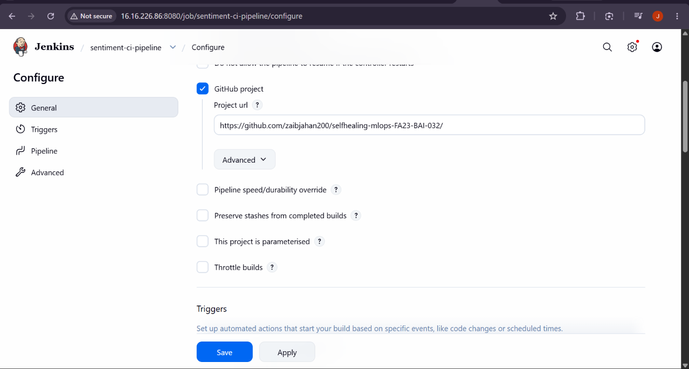
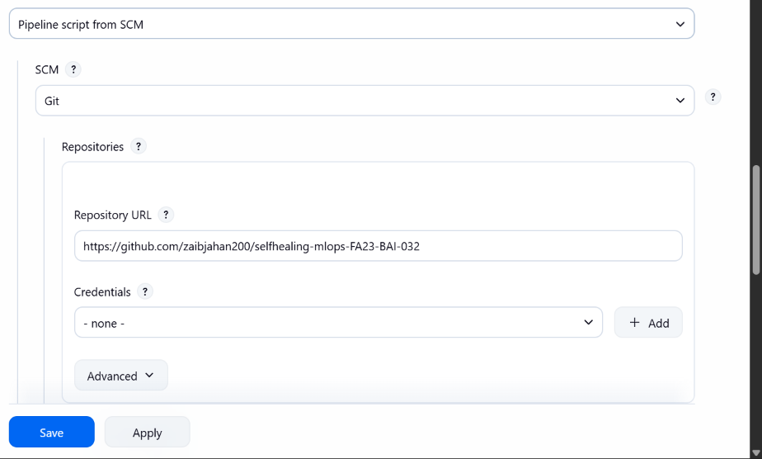
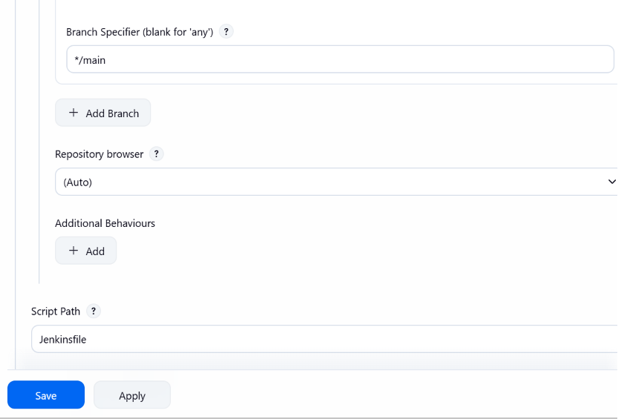

And another pipeline stable-to-fallback with generic webhook trigger installed
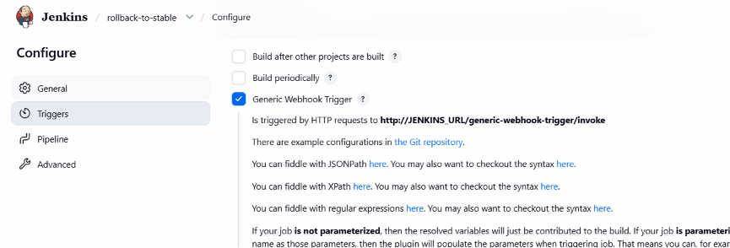
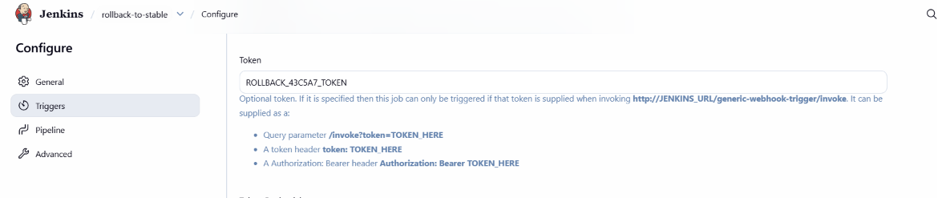
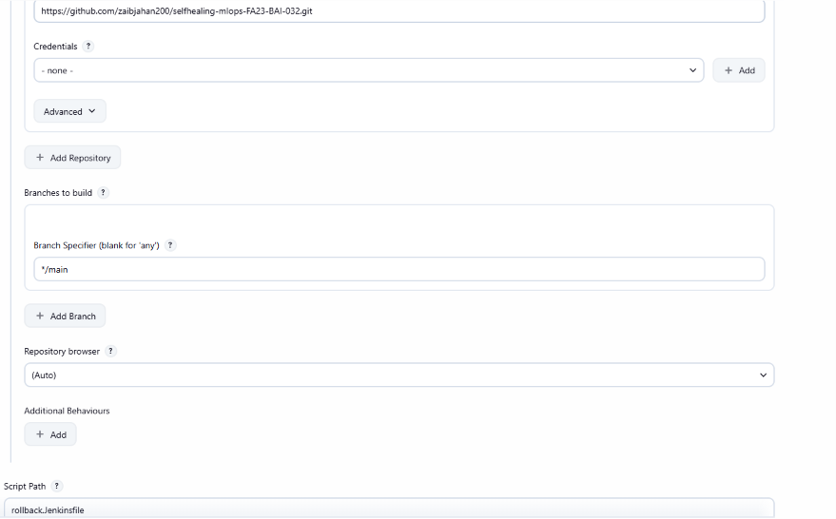
Rollback.Jenkinsfile is in main branch

To make sure that Jenkins can push images to docker we added credentials in the Jenkins and for alertmanager.yml to trigger alerts we will create a API token that it will use
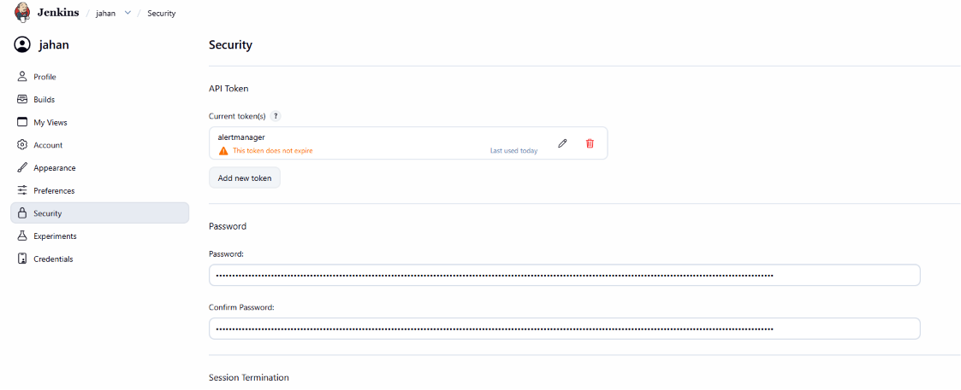
And for the checking we will make another API token
This is the token for Checking the project: 1171d19f598c84815a96d929b31d4db753
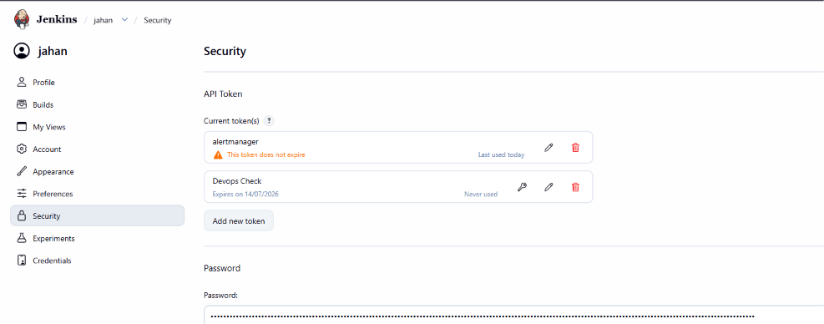

To run the promethus and alertmanager we will run them separately in docker.
We ran exporter.py using service (script at the end.)
And we cloned the repository into ec2
And Grafana was installed before. Using apt

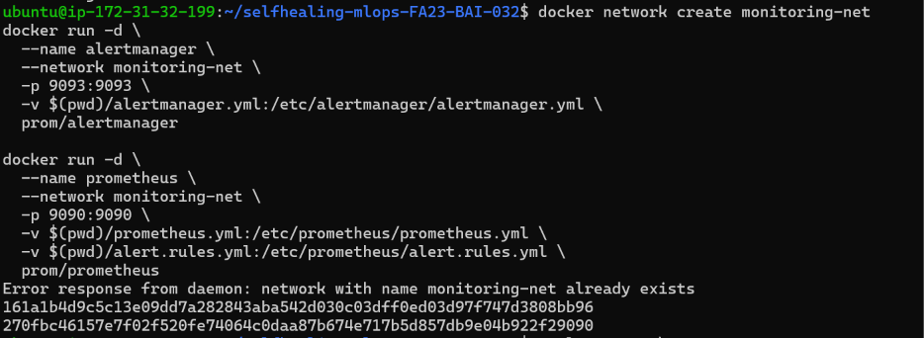

docker network create monitoring-net
docker run -d \
--name alertmanager \
--network monitoring-net \
-p 9093:9093 \
-v $(pwd)/alertmanager.yml:/etc/alertmanager/alertmanager.yml \
prom/alertmanager

docker run -d \
--name prometheus \
--network monitoring-net \
-p 9090:9090 \
-v $(pwd)/prometheus.yml:/etc/prometheus/prometheus.yml \
-v $(pwd)/alert.rules.yml:/etc/prometheus/alert.rules.yml \
prom/prometheus

Now we need to connect Grafana to promethus for making dashboard
Login and go to connection>data sources select promethus then provide the exposed url to it
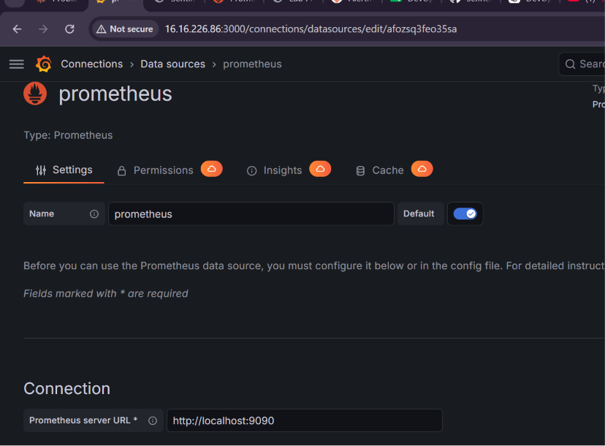
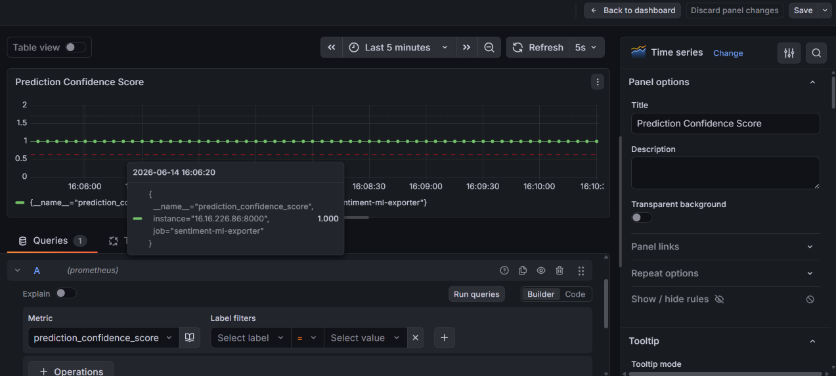
in dashboard >panel and configure set prediction confidence score as threshold

And time series as visualization

To ensure my application is exposed properly and permanently I added port forwarding as a service both for exporter.py and our application
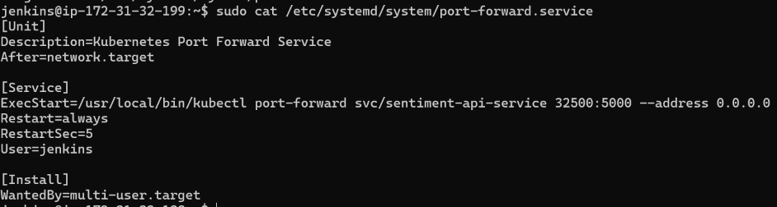

In Jenkins user and exporter in ubuntu
