Day one
Selection of components

I found the components I wanted to use and before this I saw a few videos on how to use EasyEda. I found the components and asked which battery I should use. I found that I should use the 402030 lipo 3.7v .

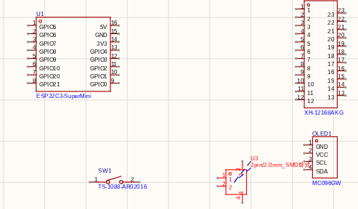
Day two
Trail and error
i wired the stuff but made some errors so i have to start over and I am very angry because it is hard and confusing and this is my first pcb so now I will start all over

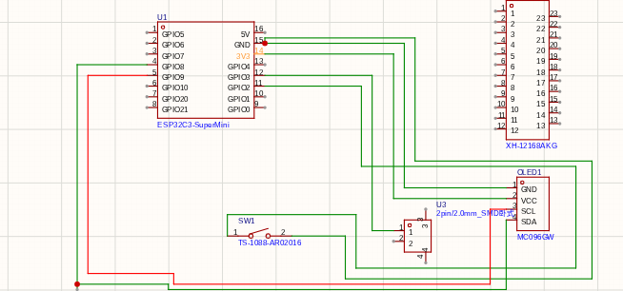

Wiring redone
I finally did all the wiring. I was also watching a video on the side so that it would be easier to turn the schematic to the PCB. I made some mistakes like I accidently connected the ground to 3v3. After that I checked all the connections.

Day three

The realization of non proper research

I found out that the small screen I wanted to use instead of that one I put a much bigger one with I don't want to use because I want to make the PCB small and portable

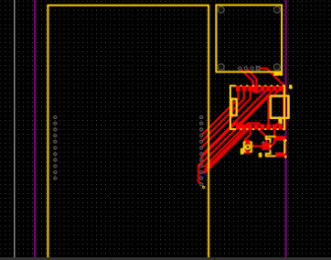\

Day four

Finishing steps
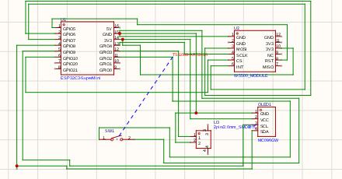

PCB done and arranged
I finished the PCB and arranged the components on the board to my liking I make sure that all the ports are facing out so that I can easily access them and I have done this in tuition and added the other screen to the PCB that is why the journal might be off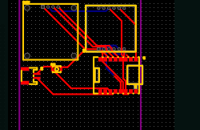

Day five
I added a Ethernet module instead of the screen

I added the connector for the ribbon cable and finished the PCB because i accidentally added a Ethernet module which I got to know when I was searching the parts price

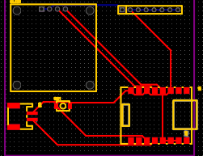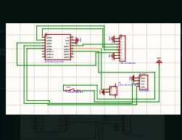

this is a electric I'd card with two screens one is an OLED to display you name the other one is to put up a photo of you face or maybe a gif video it is a cool way out electrical fellows and introduce them selfs in their own cool way

