Occupancy Grid maps is a non trivial process, as the robot has to interpret the findings of its sensors so as to make deductions regarding the state of its environment. This is facilitated by the use of a sensory model, which is a means of interpreting received sensory measurements .

We have make some assumption in this like :

1.The cell are either completely filled or completely empty , we have not assumed any partial state .

2.The occupancy probability of a cell has no role in occupancy probability of other cells.

3.If a cell is occupied it will stay occupied and if it is free it will remain free during the time our program runs.

Equation to convert Ratio to Probability is:

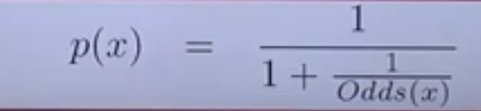

Log odds ratio is defined as

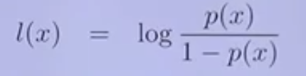

Which can be written as

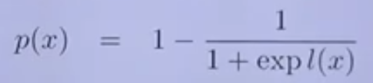

Below is just a summary of steps involved in this algortihm