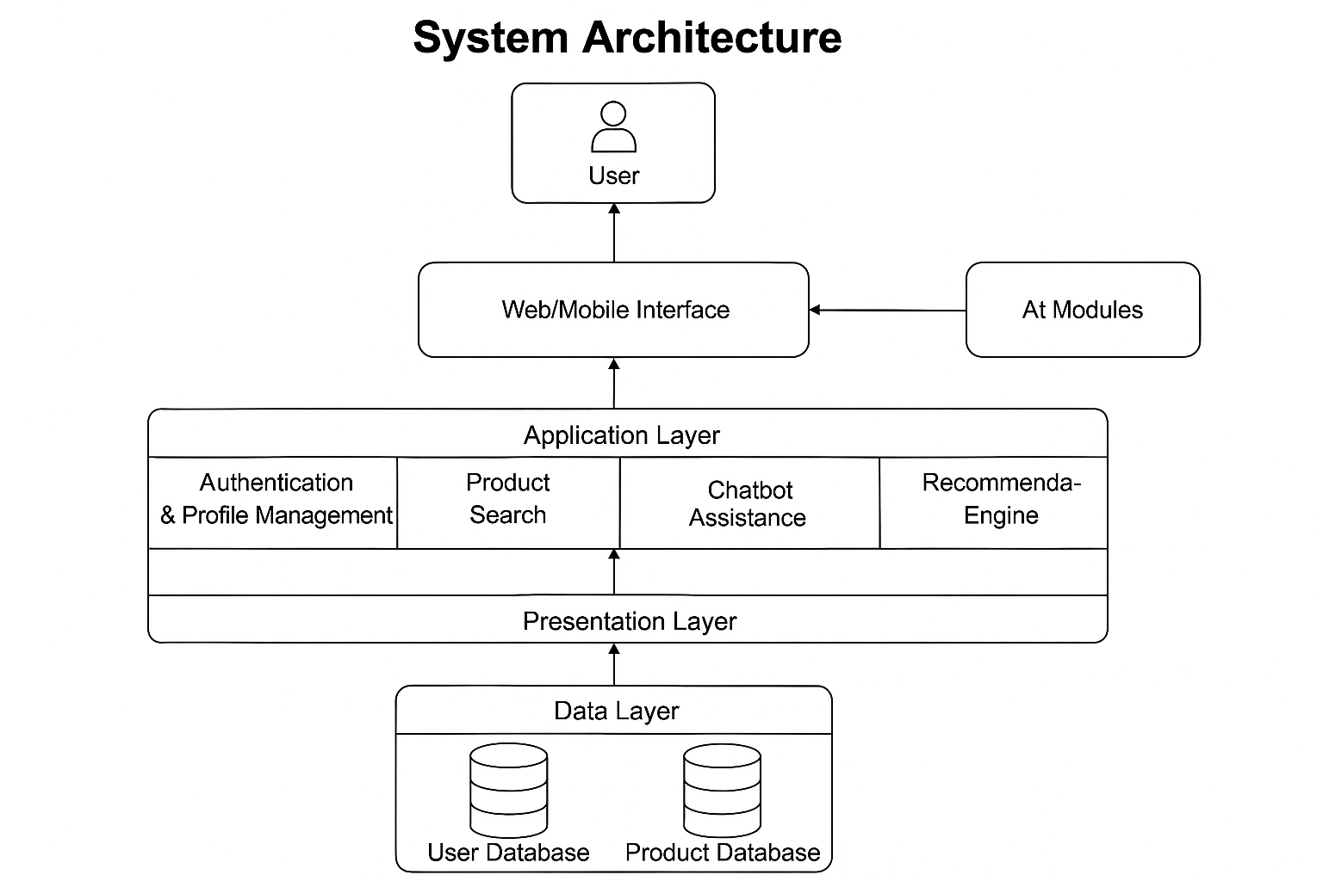The diagram illustrates a layered architecture for the AI-Powered Smart Shopping Assistant. The Presentation Layer (View) includes the Web/Mobile Interface that interacts directly with the user. The Application Layer represents the Controller, managing user requests through modules such as Authentication, Product Search, Chatbot Assistance, and the Recommendation Engine. The Data Layer represents the Model, handling all data operations through the User and Product databases. This MVC structure ensures clear separation between interface, logic, and data, enhancing maintainability and scalability.

