DOCUMENTATION

a. Background
In the modern digital landscape, efficient customer support is critical for business retention and satisfaction. The "Hosho Support System" was conceived to address the challenges of managing high volumes of customer inquiries. Traditional email support chains often lead to lost tickets, lack of accountability, and poor visibility in team performance. This project aims to centralize support operations into a single, role-based web portal that facilitates lifecycle management of support cases from ticket creation by customers to resolution by agents and strategic analysis by management.

b. Requirement Overview
The system is designed to serve six distinct user personas, each with specific functional requirements:
- Customer: Needs a self-service portal to create tickets, view history, provide attachments, and rate resolved services (CSAT).
- Support Agent: Requires a prioritized queue to manage tickets, update statuses (Open/Resolved), and communicate via threaded comments.
- Supervisor: Needs oversight capabilities to assign tickets to specific agents, balance workloads, and define automated routing rules.
- Case Manager: Focuses on high-level strategy, grouping related tickets into "Cases," defining milestones, and managing escalations.
- Quality Assurance (QA): Responsible for auditing closed tickets, reviewing audit logs, and monitoring customer feedback scores.
- Analytics Manager: Requires raw data access to forecast staffing needs and analyze trends using external tools like Power BI.

c. Solution Approach
The solution is built as a Monolithic Next.js Application using the App Router architecture. This approach was chosen to ensure a "Zero-Config" deployment experience while maintaining high performance.
- Unified Architecture: Frontend and Backend logic reside in a single repository using Next.js Server Actions, eliminating the need for a separate API server.
- Role-Based Access Control (RBAC): Security is handled via a centralized session check that redirects users to their specific dashboards (e.g., /agent/dashboard vs /customer/dashboard) upon login.
- Data-Driven Workflow: The application uses a relational database model (Prisma) to link Users, Tickets, and Cases, ensuring data integrity across the support lifecycle.
- Simulated Real-Time: Instead of complex WebSocket infrastructure, the system uses a smart "Short Polling" mechanism to provide real-time updates for queues and dashboards without server configuration overhead.

d. Solution Architecture
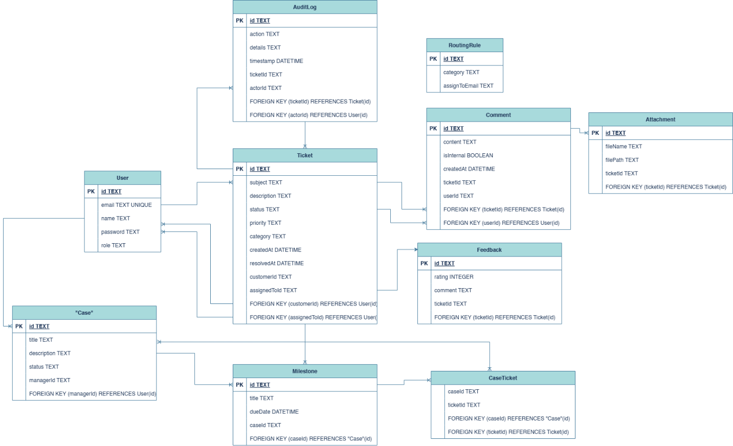
Figure: Entity Relationship Diagram
Architecture Description:
- Client Layer: Next.js React Components (Tailwind CSS + Shadcn UI).
- Server Layer: Next.js Server Actions (Node.js runtime).
- Database Layer: SQLite (managed via Prisma ORM) for relational data storage.
- Analytics Layer: Power BI Desktop connecting via CSV/Excel export for visualization.

e. Technical Details
The following technologies were selected to ensure scalability, maintainability, and ease of use:
- Framework: Next.js 15 (App Router)
  - Why: Provides server-side rendering (SSR) for fast initial loads and Server Actions for type-safe backend logic without writing manual API endpoints.
- Language: TypeScript
  - Why: Ensures code quality and prevents runtime errors by enforcing strict typing across the database and frontend components.
- Database ORM: Prisma
  - Why: Offers an intuitive schema definition and type-safe database queries. It creates a robust migration history to manage database changes over time.
- Database: SQLite
  - Why: A self-contained, server less database engine perfect for rapid prototyping.
- Styling: Tailwind CSS & Shadcn UI
  - Why: Allows for rapid development of professional, responsive interfaces without writing custom CSS files.
- External Integration: SheetJS (xlsx)
  - Why: Enables client-side generation of Excel files, allowing the Analytics Manager to export data directly to the native .xlsx format.

f. Benefits of this Solution
- Zero-Configuration: The entire app runs with a simple npm run dev command. No complex Docker containers or cloud connection strings are needed.
- Role Isolation: Strict separation of concerns ensures Customers never see internal notes, and Agents cannot access Supervisor settings.
- Real-Time Visibility: Supervisors can watch ticket queues change in real-time allowing for immediate reaction to workload spikes.
- Auditability: Every major action (reassignment, status change) is logged in an immutable AuditLog table, ensuring compliance and accountability.
- Scalable Data Model: The schema supports advanced features like "Cases" (grouping tickets) and "Milestones," ready for enterprise-level scaling.

g. Alternate Approach
While the Next.js Monolith approach was chosen for simplicity and portability, other architectures were considered:
Alternative 1: MERN Stack (MongoDB, Express, React, Node)
- Description: A traditional approach separating the Frontend (React) and Backend (Express REST API).
- Why it was rejected: It requires managing two separate servers/ports and manual type synchronization between frontend and backend.
Alternative 2: WebSocket Server (Socket.io)
- Description: Using a dedicated WebSocket server for true event-driven real-time updates.
- Why it was rejected: While faster than polling, it adds significant complexity to the deployment infrastructure. It requires a custom server instance (cannot run on serverless functions easily) and creates state management challenges that were unnecessary for this project's scale.

h. Assumptions
- Authentication: For this prototype, a simple "No-Config" authentication (email matching) is used instead of OAuth/JWT providers to facilitate easy testing by the evaluator.
- Data Volume: The SQLite database is assumed to handle the prototype load (thousands of records) efficiently. For a production release with millions of records, this would be swapped for PostgreSQL.

i. Screenshot of Apps Screens and Power BI Dashboards
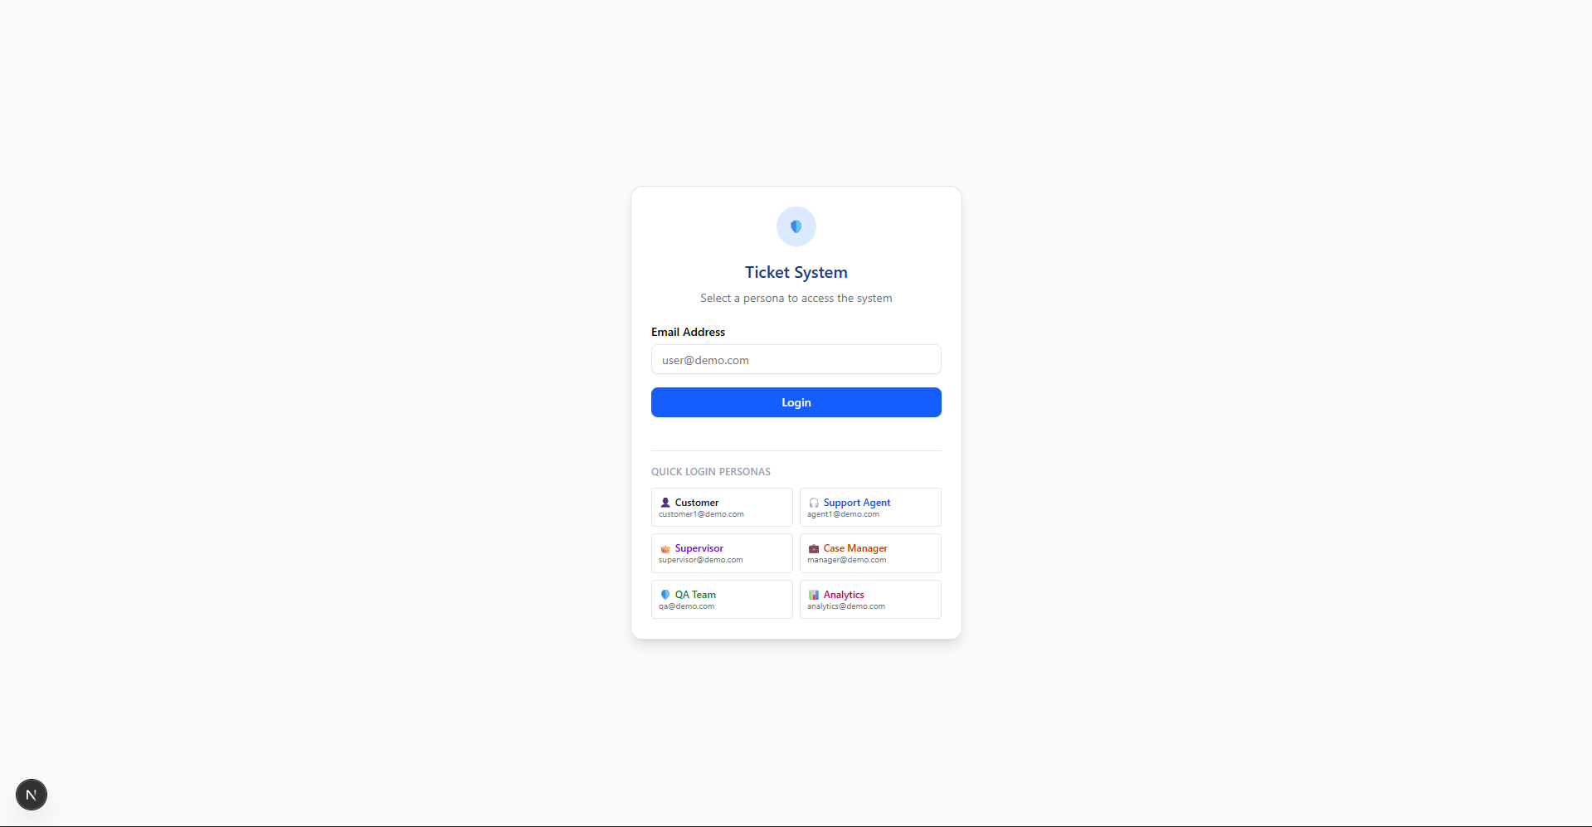Figure: Login Screen

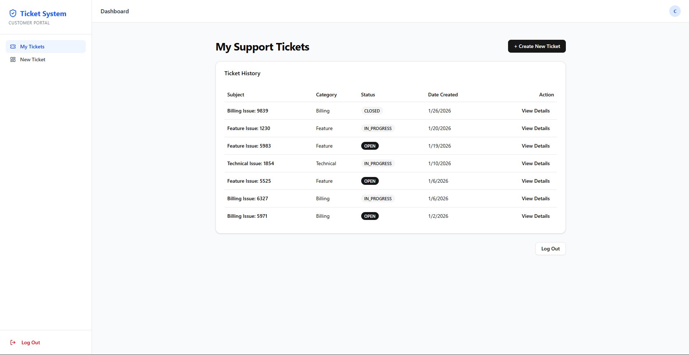Figure: Customer Dashboard

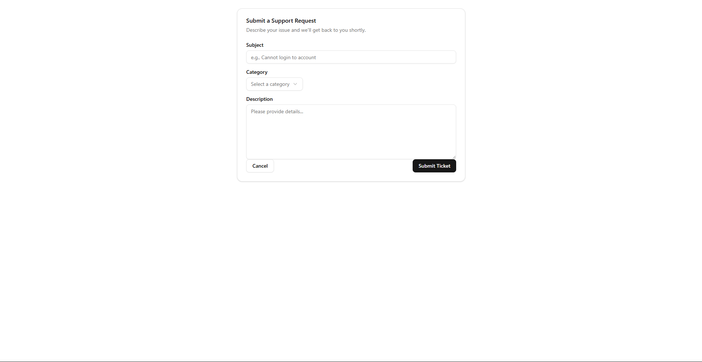Figure: Create Ticket

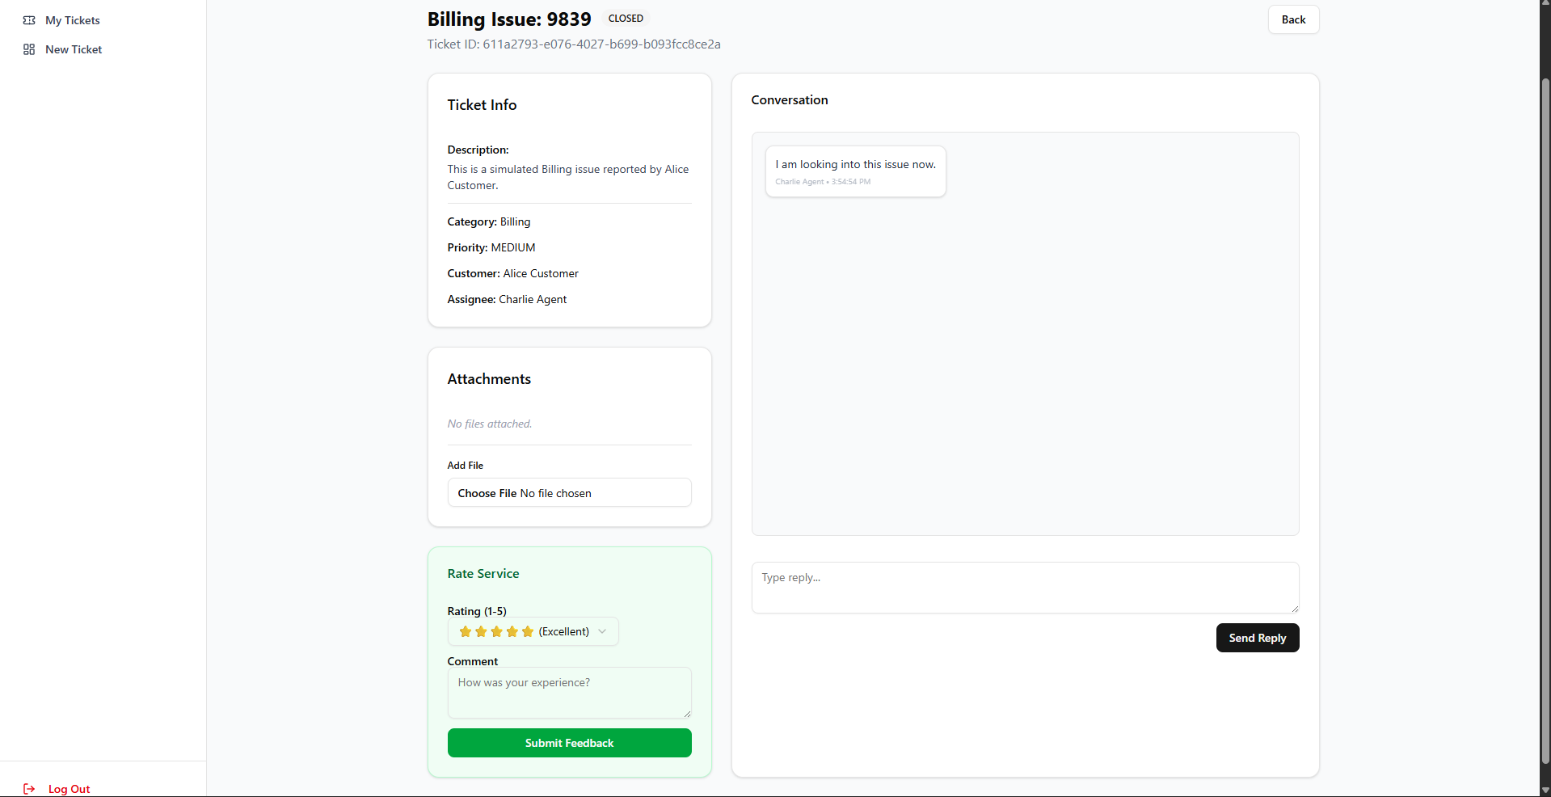Figure: Ticket View
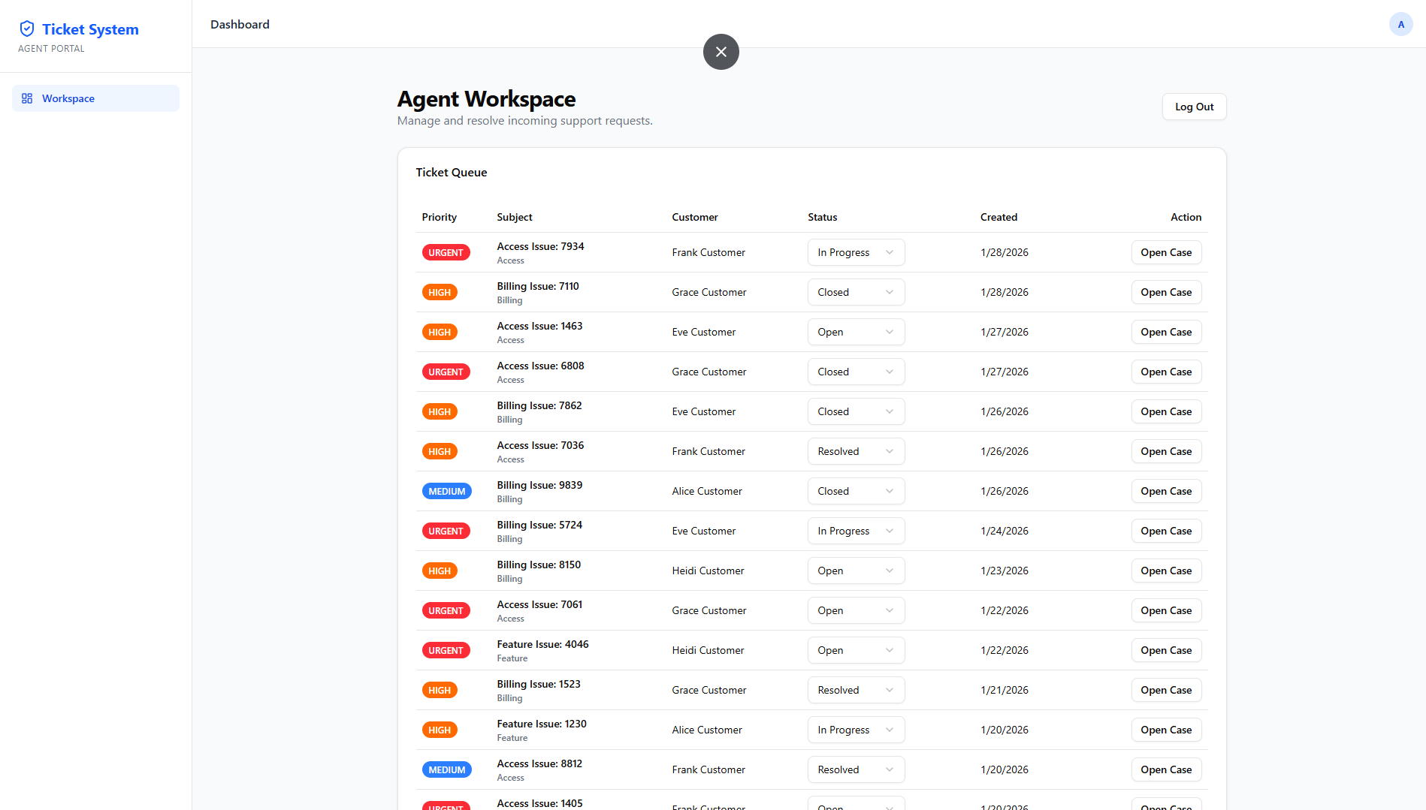Figure: Agent Dashboard

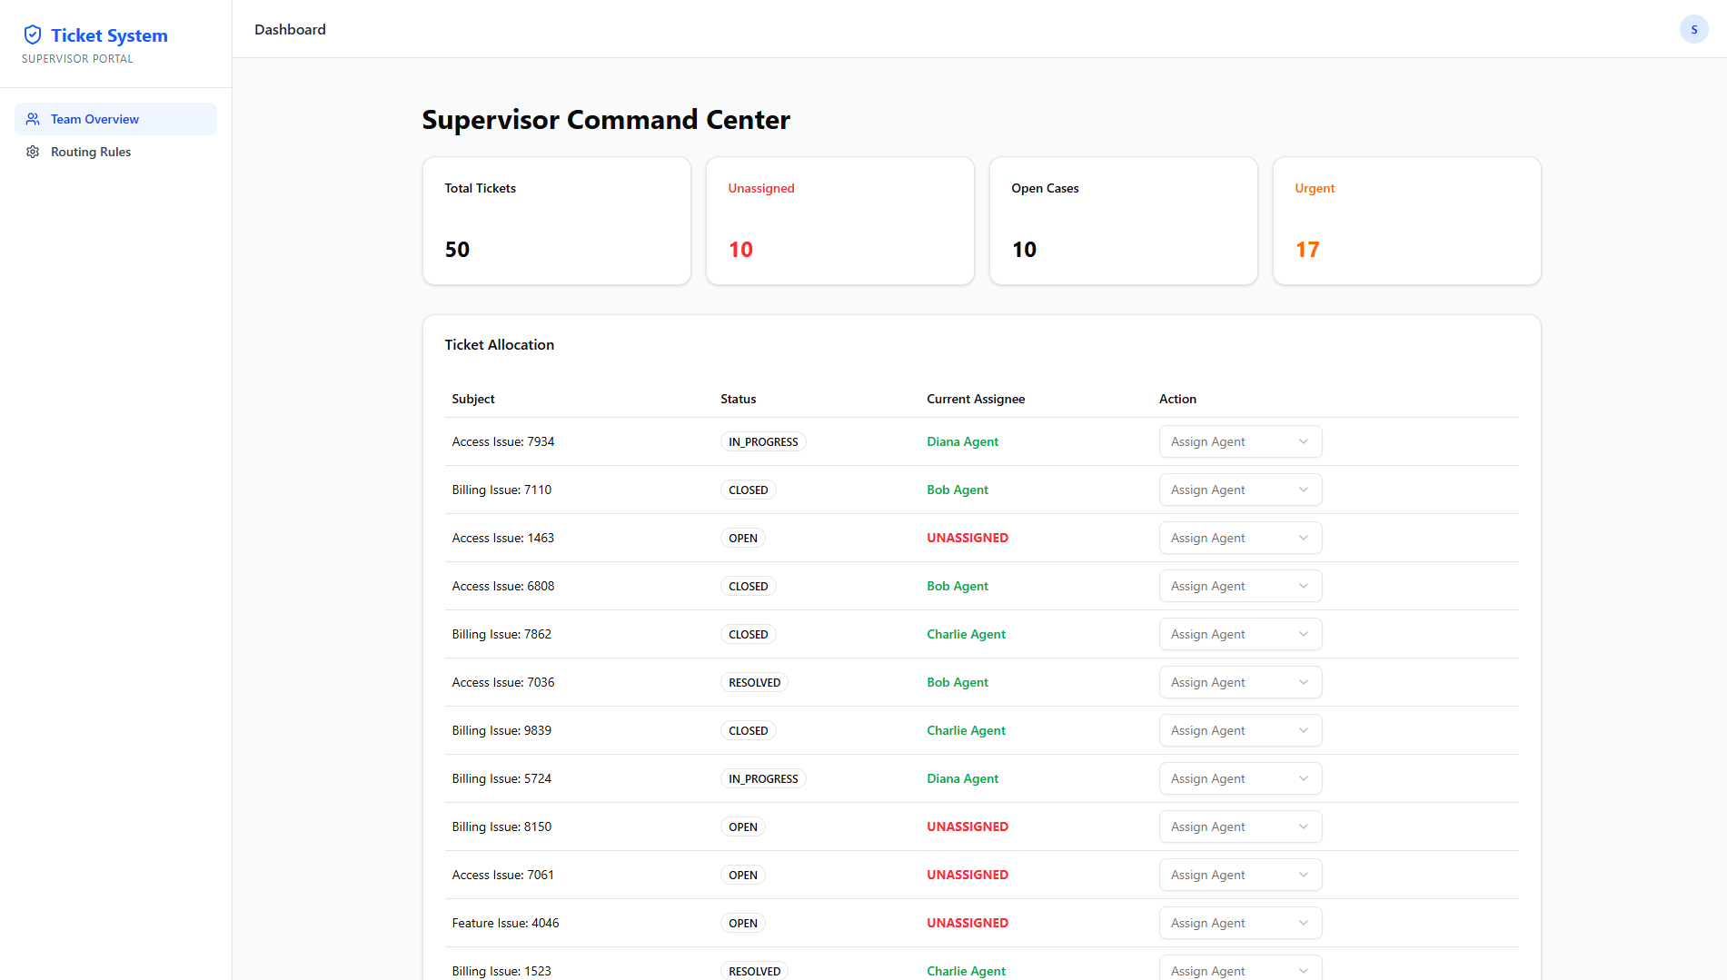Figure: Supervisor Dashboard
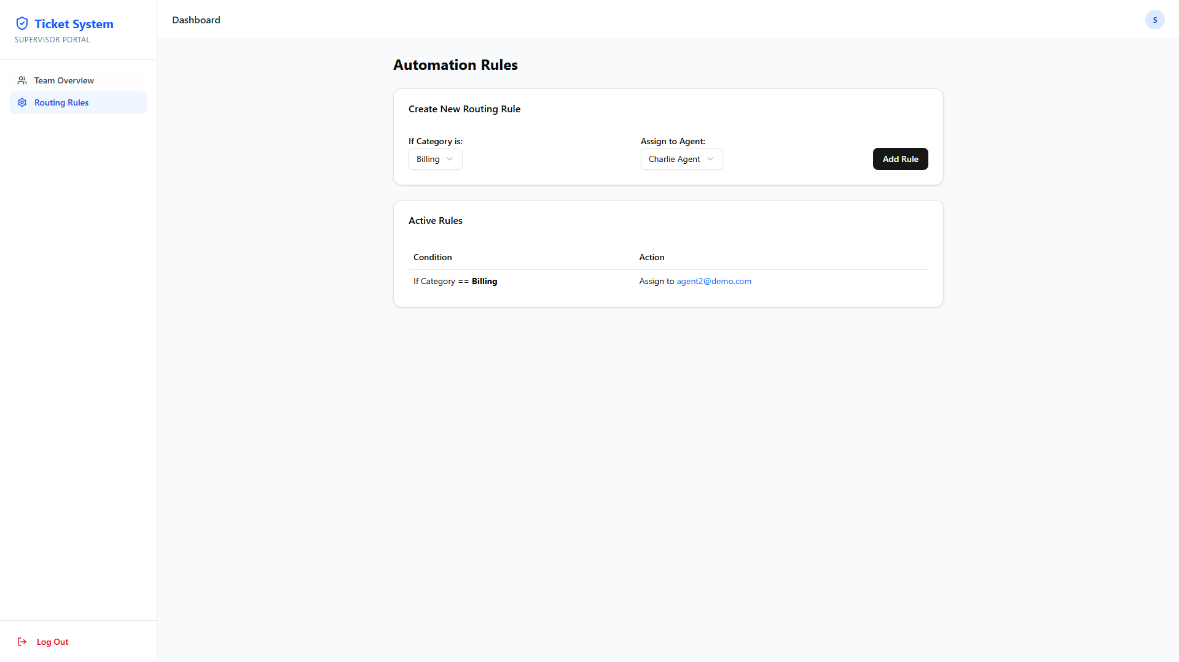Figure: Supervisor Routing Rules Dashboard
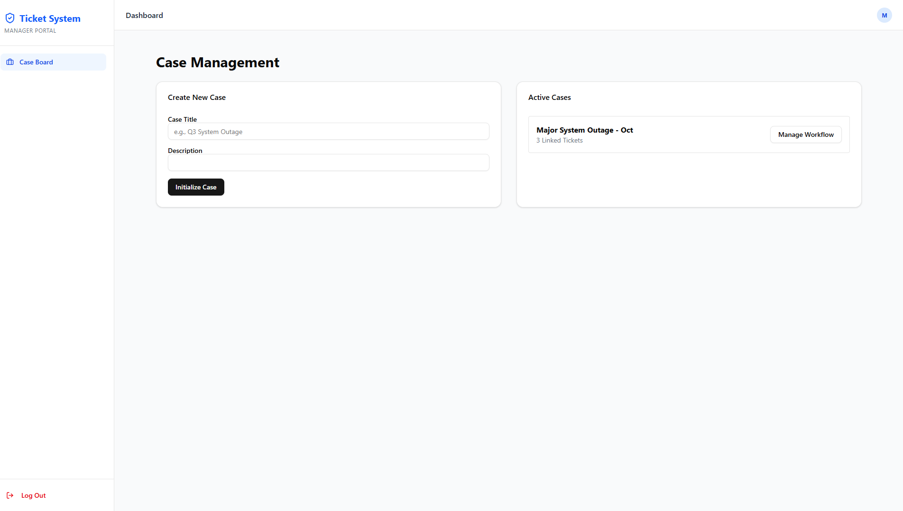Figure: Case Manager Dashboard
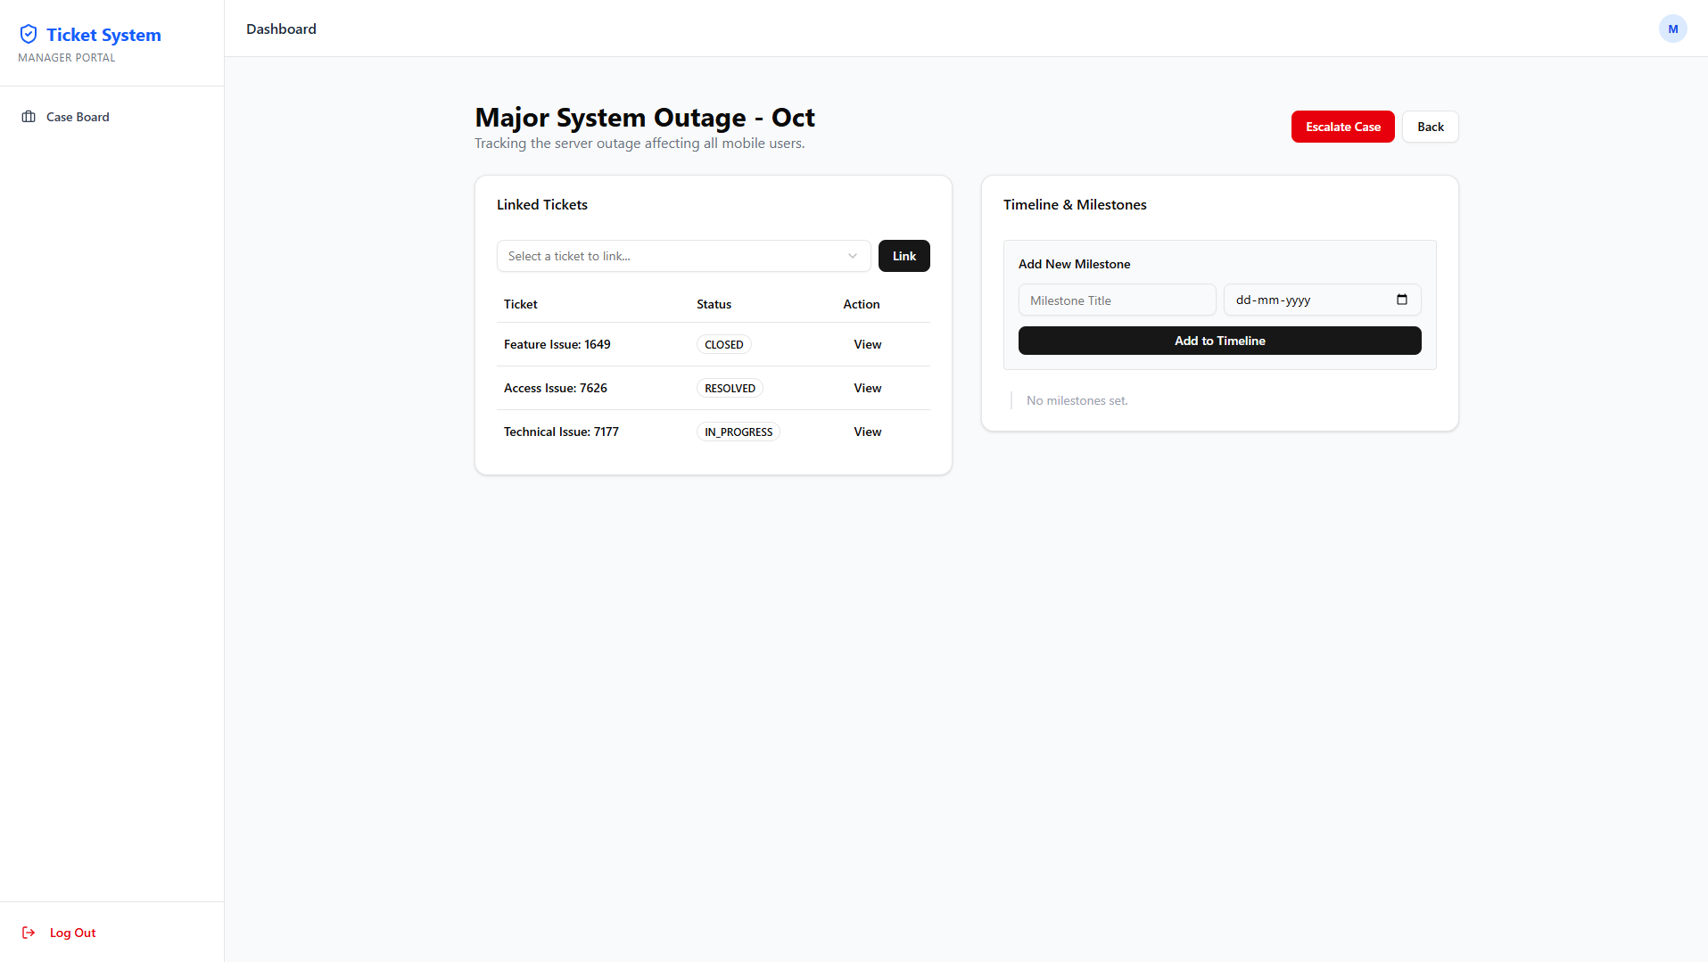Figure: Case Workflow Dashboard
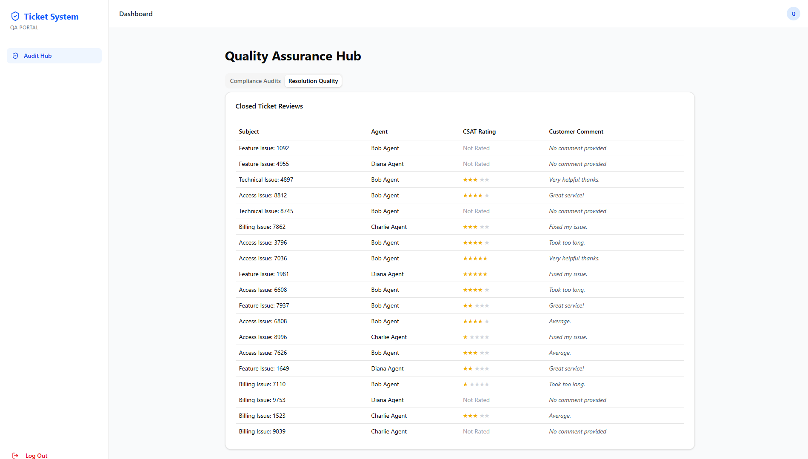
Figure: Quality Analyst Dashboard

- Power BI Dashboard: (Screenshot of your 4 charts in Power BI)
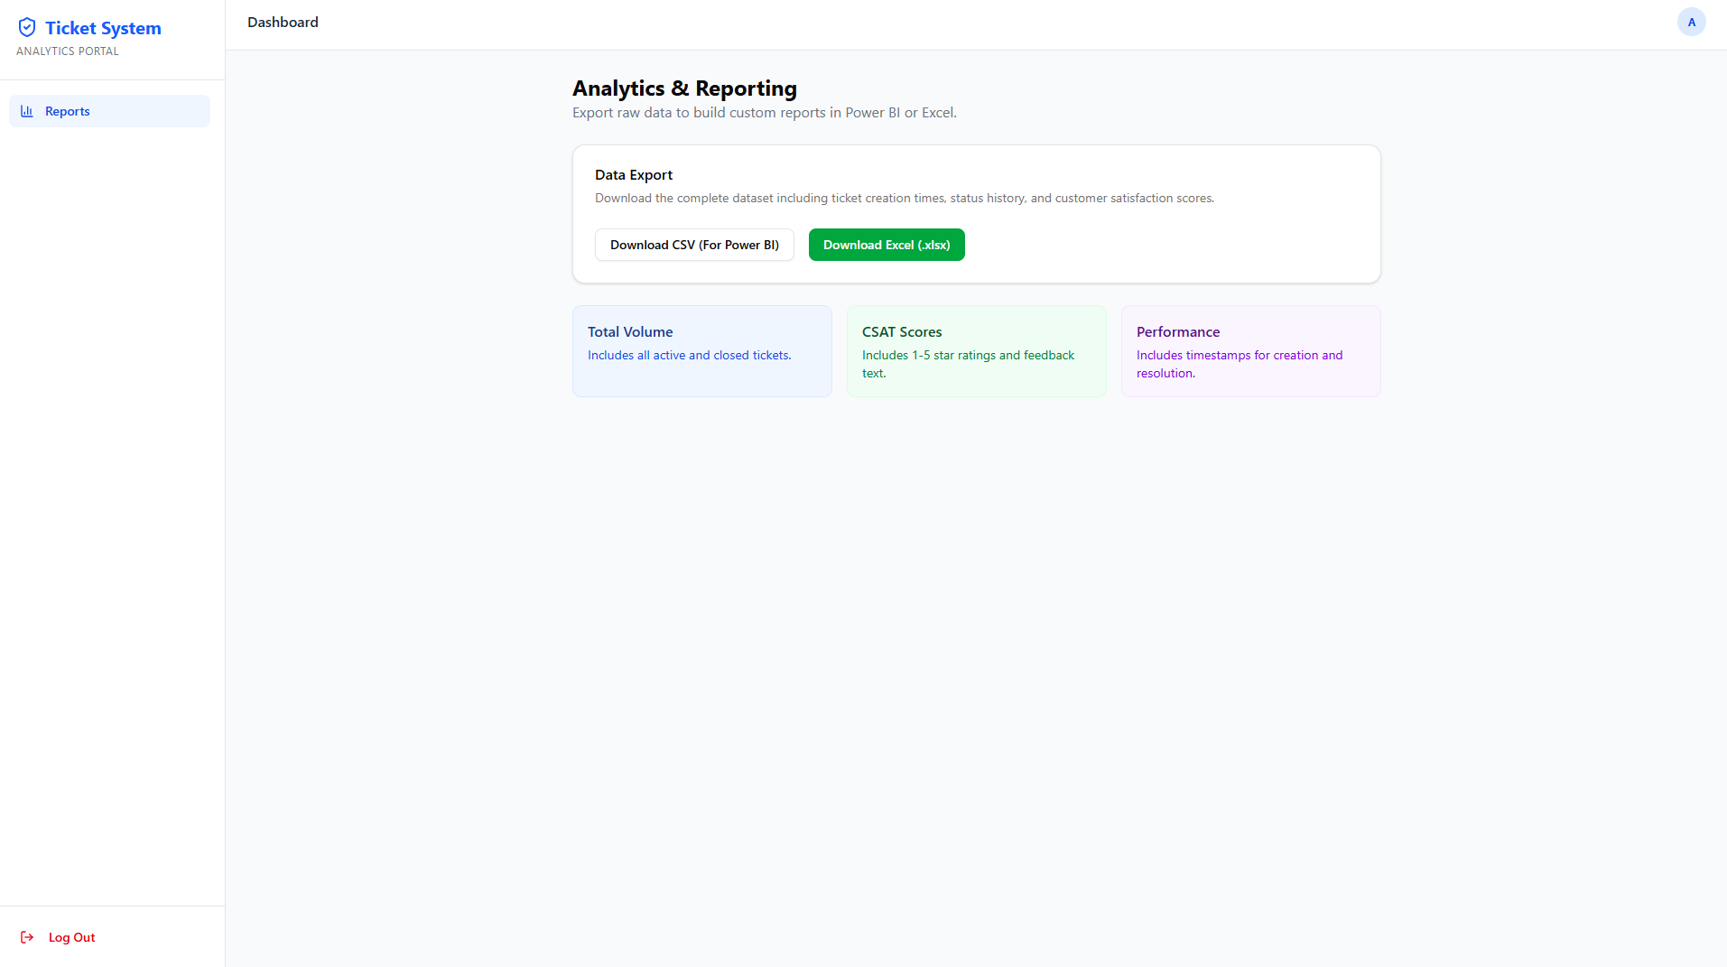
Figure: Analytical Team Dashboard

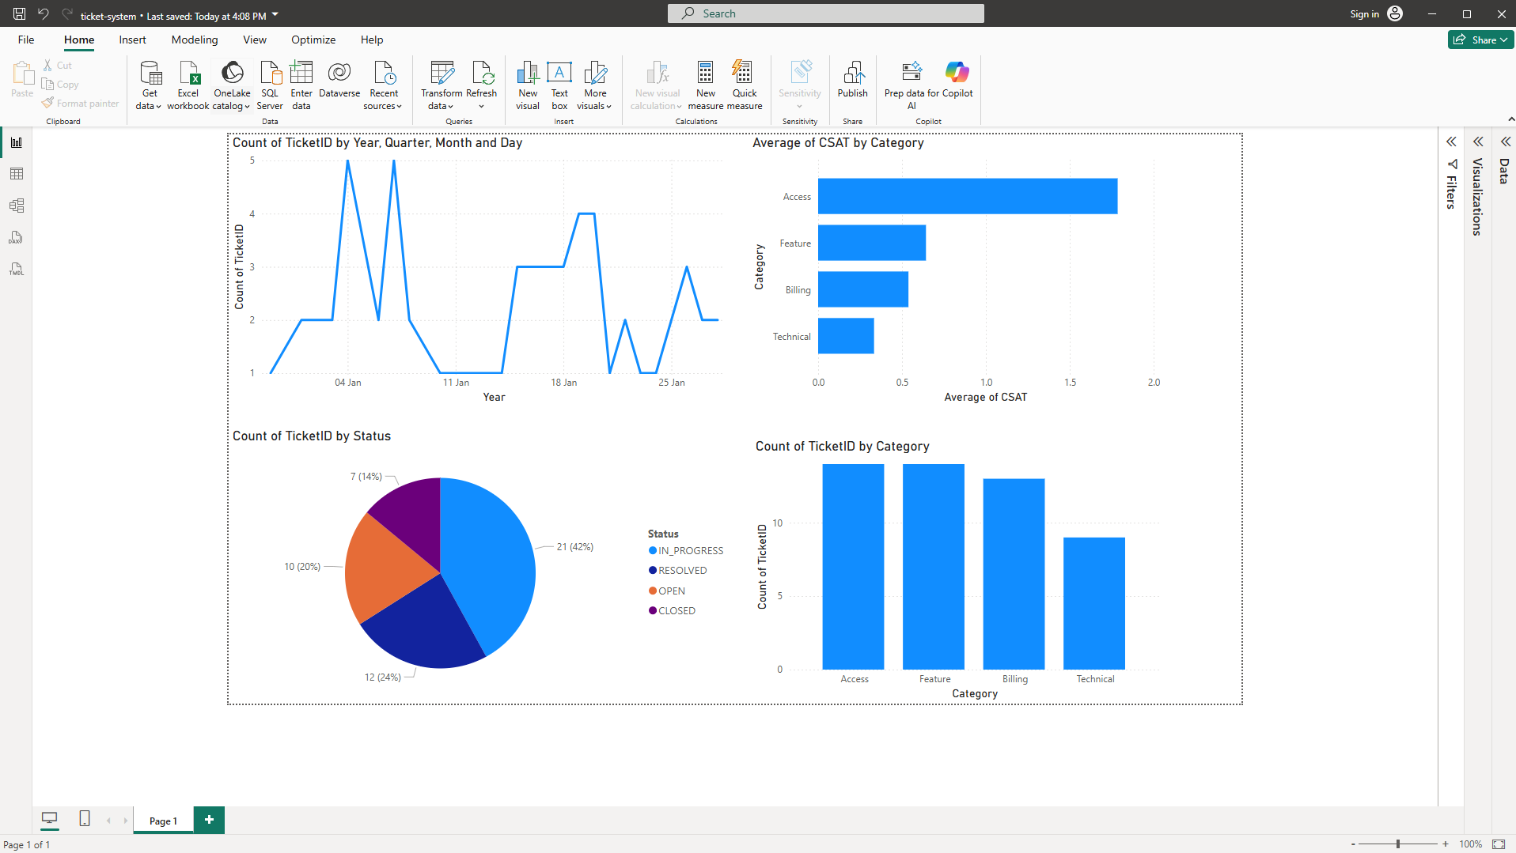
Figure: PowerBi Report View

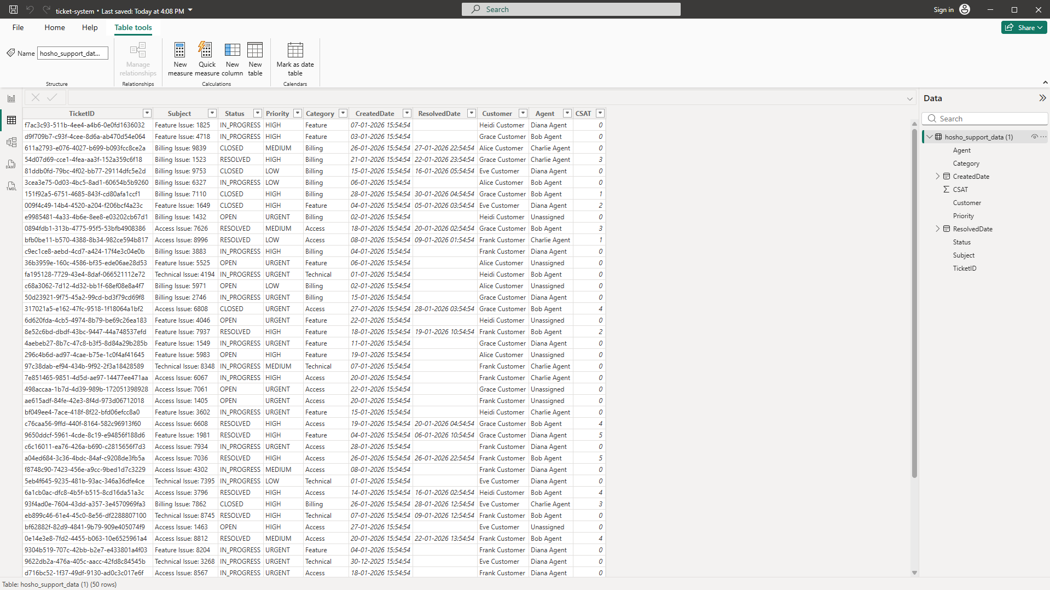
Figure: PowerBi Table View

