VR Environment Indicators and Feedback Guide
Capstone Compressor Station Model
Document No. | VR-OPS-002 | Revision | 0
System | VR Operator Preparedness  Simulator | Effective Date | 25-Mar-2026
Prepared For | Capstone Design /  Simulation Demonstration | Status | Uncontrolled Academic  Document

1. Purpose  Explain what the operator should see and hear in the VR environment during the compressor station startup procedure, including normal confirmations and step-completion logic. | 2. Scope  Applies to the capstone VR startup simulation, including step guidance, process pipe colors, compressor audio, intercooler status lights, and Emergency Stop reset behavior.

3. Indicator Categories
The VR startup sequence uses a combination of on-screen procedure guidance, color-based process feedback, equipment status lighting, and audio cues to help the operator confirm whether the step is progressing normally.
 |  |  | 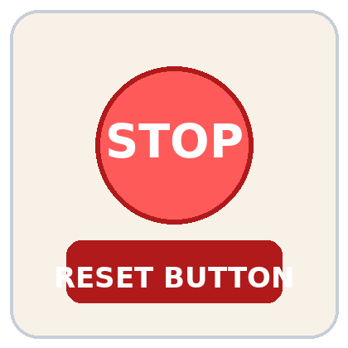 | 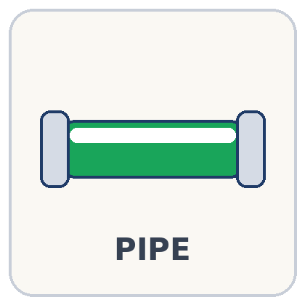
Procedure Navigation  Shows current step and unlocks the next step after completion. | Compressor  Audio  Confirms compressor start and increases with dial position. | Intercooler  Status  Flashing red and blue lights show the cooler is energized. | Emergency  Reset  Used to reset the active step after a red pipe condition. | Pipe Colours  Shows whether pipe pressure is correct for the active step.

4. Procedure Navigation and Step Progression
The startup sequence is presented as a guided, step-by-step procedure. The operator can always see the active step number and the title of the current action on the VR interface. This provides continuous context and helps the operator align their actions with the intended startup sequence.
 | • The current step number and step title remain visible throughout the active task.  • Once all required actions for that step are completed correctly, the step should highlight green.  • After the step turns green, a “Next Step” button should appear.  • The operator should use the “Next Step” button to proceed only after the green completion state is shown.

5. Pipe Color and Pressure Status Interpretation
Process pipe color in the VR environment communicates whether the simulated pressure condition is appropriate for the active step. The color meaning is step-dependent, which means green indicates that the pressure is correct for the current startup stage rather than a single fixed pressure for all steps.
Visual | State | Interpretation
 | Grey | There is no flow in that section, so simulated pressure is zero.
 | Yellow | Pressure is below the intended range for the active step.
 | Red | Pressure is above the acceptable range for the active step.
 | Green | Pressure is within the correct range for the active step.
Final startup expectation: by the final step of the startup procedure, all process pipes should appear green.

6. Audio and Equipment Feedback Cues
Compressor Audio Response   | Intercooler Visual Response  
• When the green compressor start button is pressed, sound should begin immediately.  • As the compressor dial is increased, the sound level should increase to reflect rising activity.  • A normal response is a smooth increase in audio rather than a delayed or interrupted sound profile. | • When the intercooler dial is turned on, the intercooler should begin flashing red and blue.  • Before activation, the intercooler lights should remain off.  • Once active, the flashing lights provide visual confirmation that the simulated cooler is energized.

7. Abnormal Indication and Emergency Stop Response
! | Red pipe condition during an active step: If any section of pipe becomes red at any point during a step, the operator is expected to press the Emergency Stop button. This action should reset the current step so it can be repeated correctly.
  Emergency Stop resets the active step | • If a red pipe condition appears, treat it as an incorrect or unstable state for the current step.  • Press the Emergency Stop button to reset that specific step.  • After reset, repeat the step actions and confirm that indicators return to normal before proceeding.
8. Expected Normal Simulation Behavior
Normal indication profile  • Current step and title always visible.  • Completed step changes to green.  • Next Step button appears only after correct completion.  • Compressor sound starts on command and rises with dial position.  • Intercooler lights flash red and blue when activated.  • Pipe colors move toward green as the startup sequence progresses.  • All pipes are green by the final startup step. | Operator response when something looks wrong  • Confirm the active step and compare actions against the procedure panel.  • Check whether the required valve or equipment command was completed.  • Watch for missing sound, inactive lights, or non-green completion state.  • Use Emergency Stop if a red pipe condition appears during the step.  • Repeat the step until all expected confirmations are present.

10. Revision History
Rev | Date | Prepared By | Description
0 | 24-Mar-2026 | Ahmed Elkhrashy | Initial issue for simulation guidance and training use

