Script1:

#!/bin/bash

echo This is a simple string.

echo "This is a string containing 'single quotes' so it's wrapped in double quotes."

echo "This prints the user name:" $USER

echo -e "The -e option lets us use\nformatting directives\nto split the string."

OUTPUT:

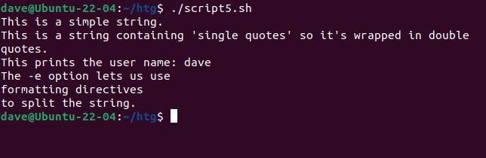

Script2:

#!/bin/bash

millennium_text="Years since the millennium:"

current_time=$( date '+%H:%M:%S' )

todays_date=$( date '+%F' )

year=$( date '+%Y' )

echo "Current time:" $current_time

echo "Today's date:" $todays_date

years_since_Y2K=$(( year - 2000 ))

echo $millennium_text $years_since_Y2K

OUTPUT:

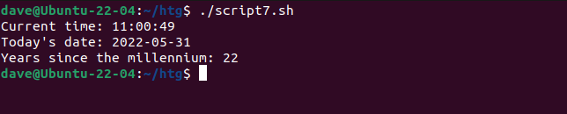

Script3:

**Handling User Input**

#!/bin/bash

echo "Enter a number and hit \"Enter\""

read user_number1;

echo "Enter another number and hit \"Enter\""

read user_number2;

printf "You entered: %d and %d\n" $user_number1 $user_number2

printf "Added together they make: %d\n" $(( user_number1 + user_number2))

OUTPUT:

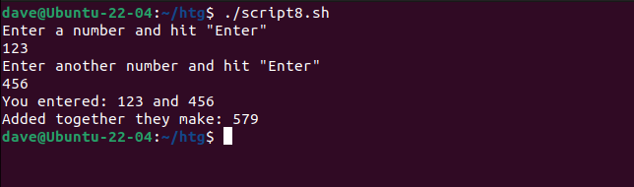

Simple Programs:

EVEN or ODD:

#!/bin/bash

# Prompt the user to enter a number

echo "Enter a number:"

read number

# Check if the number is even or odd

if [ $((number % 2)) -eq 0 ]; then

echo "$number is even."

else

echo "$number is odd."

Fi

LARGEST OF THREE NUMBERS:

#!/bin/bash

# Read three numbers from the user

echo "Enter first number: "

read num1

echo "Enter second number: "

read num2

echo "Enter third number: "

read num3

# Compare the numbers and find the largest

if [ $num1 -ge $num2 ] && [ $num1 -ge $num3 ]; then

largest=$num1

elif [ $num2 -ge $num1 ] && [ $num2 -ge $num3 ]; then

largest=$num2

else

largest=$num3

fi

# Output the largest number

echo "The largest number is: $largest"

SUM OF N NUMBERS:

#!/bin/bash

# Prompt the user to enter a number

echo "Enter a number:"

read n

# Initialize sum to 0

sum=0

# Loop from 1 to n and add each number to sum

for (( i=1; i<=n; i++ ))

do

sum=$((sum + i))

done

# Print the result

echo "The sum of the first $n natural numbers is: $sum"