EXPERIMENT-1:

**Software Requirements Specification (SRS)**

**Project:** Hospital Management System  
 **Name:** SHAIK ZAID  
 **Date:** [04/08/2025]

**Table of Contents**

1. **Introduction** *1.1 Purpose  
    1.2 Scope  
    1.3 Definitions, Acronyms, and Abbreviations  
    1.4 References  
    1.5 Overview*
2. *The* **Overall****Description** *2.1 Product Perspective  
     2.1.1 System Interfaces  
     2.1.2 Interfaces  
     2.1.3 Hardware Interfaces  
     2.1.4 Software Interfaces  
     2.1.5 Communications Interfaces  
     2.1.6 Memory Constraints  
     2.1.7 Operations  
     2.1.8 Site Adaptation Requirements  
    2.2 Product Functions  
    2.3 User Characteristics  
    2.4 Constraints  
    2.5 Assumptions and Dependencies  
    2.6 Apportioning of Requirements*
3. **Specific****Requirements** *3.1 External Interfaces  
     3.1.1 User Interfaces  
     3.1.2 Hardware Interfaces  
     3.1.3 Software Interfaces  
     3.1.4 Communications Interfaces  
    3.2 Functional Requirements  
     3.2.1 Patient Management  
      – Patient Registration and Profile Management  
      – Appointment Scheduling and Tracking  
      – Medical History and Electronic Health Records (EHR)  
     3.2.2 Clinical Management  
      – Doctor and Staff Scheduling  
      – Prescription Management  
      – Laboratory Test Management and Reporting  
     3.2.3 Billing and Insurance  
      – Billing and Invoicing  
      – Insurance Claims Processing  
     3.2.4 Administration and Reporting  
      – Inventory and Pharmacy Management  
      – Reporting and Analytics  
    3.3 Performance Requirements  
    3.4 Logical Database Requirements  
    3.5 Design Constraints*

*3.5.1 Standards Compliance  
 3.6 Software System Attributes  
  3.6.1 Reliability  
  3.6.2 Availability  
  3.6.3 Security  
  3.6.4 Maintainability  
  3.6.5 Portability  
 3.7 Organizing the Specific Requirements  
  (Requirements are organized by functional modules for clarity.)  
 3.8 Additional Comments*

1. **Change Management Process**
2. **Document Approvals**
3. **Introduction**

**1.1 Purpose**

*The purpose of this SRS document is to define the requirements for the Hospital Management System (HMS). This system is designed to support the operational, administrative, and clinical activities within a hospital environment. It is intended for use by hospital administrators, medical staff, billing personnel, and IT support teams. The document provides a detailed description of the system’s functions, interfaces, and constraints to guide developers, testers, and stakeholders.*

***1.2* Scope**

*The Hospital Management System is a comprehensive software solution aimed at improving the efficiency and accuracy of hospital operations. The system will:*

* *Manage patient registration, scheduling, and medical records.*
* *Facilitate clinical operations such as appointment management, doctor scheduling, and laboratory test tracking.*
* *Handle billing, invoicing, and insurance claims.*
* *Provide reporting and analytics for administrative and operational decision-making.*

*The HMS will integrate with existing hardware and software systems (such as diagnostic devices and legacy systems) and comply with industry standards and regulatory requirements. It is designed to be scalable for hospitals of various sizes and adaptable to different healthcare environments.*

* 1. **Definitions, Acronyms, and Abbreviations**
* ***HMS:*** *Hospital Management System*
* ***EHR:*** *Electronic Health Record*
* ***EMR:*** *Electronic Medical Record*
* ***GUI:*** *Graphical User Interface*
* ***API:*** *Application Programming Interface*
* ***ODBC:*** *Open Database Connectivity*
* ***MTBF:*** *Mean Time Between Failures*
  1. **References**
* *IEEE Std 830-1993 – IEEE Recommended Practice for Software Requirements Specifications*
* *Health Level Seven International (HL7) standards for healthcare interoperability*
* *Relevant regulatory guidelines from HIPAA (Health Insurance Portability and Accountability Act) and other local healthcare authorities*
  1. **Overview**

*This document is organized into six main sections. Section 1 provides an introduction and context for the HMS. Section 2 describes the overall system architecture and its operating environment. Section 3 details the functional and non-functional requirements, including external interfaces, system attributes, and performance criteria. Sections 4, 5, and 6 cover the change management process, document approvals, and supporting information such as appendices and reference materials.*

1. **The Overall Description**

**2.1 Product Perspective**

*The HMS is a standalone system that integrates with other hospital applications and hardware devices. It acts as a central repository and processing unit for hospital data, interfacing with:*

* *Patient monitoring systems and diagnostic devices (Hardware Interfaces)*
* *External laboratory systems and pharmacies (Software Interfaces)*
* *Communication networks for real-time data exchange (Communications Interfaces)*

**2.1.1 System Interfaces**

*The HMS will interact with:*

* *Third-party insurance systems via secure APIs.*
* *External laboratory information systems for test results.*
* *Hospital legacy systems for historical patient data migration.*

**2.1.2 Interfaces**

*The system provides a user-friendly graphical interface accessible through desktop and mobile devices. It supports web-based access for remote administration.*

**2.1.3 Hardware Interfaces**

*The HMS will interface with hospital servers, workstations, diagnostic devices, and barcode scanners for patient identification. It should support standard input/output devices and medical-grade hardware.*

**2.1.4 Software Interfaces**

*The system uses industry-standard protocols to communicate with databases (e.g., SQL Server via ODBC), external APIs for insurance and laboratory systems, and third-party reporting tools.*

**2.1.5 Communications Interfaces**

*The HMS will utilize secure network protocols (HTTPS, TLS) for data exchange, ensuring real-time communication among different hospital departments and remote access via a secured VPN.*

**2.1.6 Memory Constraints**

*The system is designed to operate on modern hardware. It must efficiently manage large volumes of patient and medical data, with expected database sizes reaching several gigabytes in large hospital settings.*

**2.1.7 Operations**

*The system supports:*

* *24/7 operational availability for critical hospital functions.*
* *Batch processing for end-of-day reporting and backups.*
* *Real-time transaction processing for patient admissions, billing, and medical records updates.*

**2.1.8 Site Adaptation Requirements**

*Customization may be required for different hospital sites, including:*

* *Localization of language and time zones.*
* *Configuration of hardware interfaces and network settings specific to each hospital location.*
* *Adaptation to site-specific workflows and regulatory requirements.*

**2.2 Product Functions**

*Key functions of the HMS include:*

* ***Patient Management:*** *Registration, scheduling, and record management.*
* ***Clinical Operations:*** *Appointment scheduling, doctor and staff management, laboratory test tracking, and EHR management.*
* ***Billing and Insurance:*** *Invoicing, payment processing, and insurance claim management.*
* ***Administration and Reporting:*** *Resource management, inventory control, and comprehensive reporting tools.*
  1. **User Characteristics**

*The intended users of the HMS include:*

* ***Hospital Administrators:*** *Require access to reports, billing summaries, and operational statistics.*
* ***Medical Staff:*** *Doctors, nurses, and technicians who need to view and update patient records, schedule appointments, and manage clinical workflows.*
* ***Billing and Insurance Personnel:*** *Use the system to manage billing, process payments, and interface with insurance providers.*
* ***IT Support:*** *Responsible for system maintenance, updates, and troubleshooting.*
  1. **Constraints**

*The HMS must comply with:*

* *Healthcare regulatory standards (e.g., HIPAA for patient data security).*
* *Integration constraints with existing hospital systems.*
* *Hardware limitations of legacy systems if integration is required.*
* *Data privacy and security protocols as mandated by regulatory bodies.*
  1. **Assumptions and Dependencies**
* *The hospital will provide the necessary hardware and network infrastructure.*
* *Users will have a basic level of computer literacy.*
* *The system assumes availability of an existing patient database for data migration.*
* *Dependencies include third-party APIs for insurance and laboratory systems and adherence to external regulatory standards.*
  1. **Apportioning of Requirements**

*Requirements have been divided into:*

* ***Critical (Phase 1):*** *Patient registration, appointment scheduling, basic EHR functionalities, billing, and reporting.*
* ***Enhanced (Future Releases):*** *Advanced analytics, mobile app support, integration with additional external systems (e.g., telemedicine modules), and comprehensive inventory management.*

1. **Specific Requirements**

**3.1 External Interfaces**

**Use case diagram:**

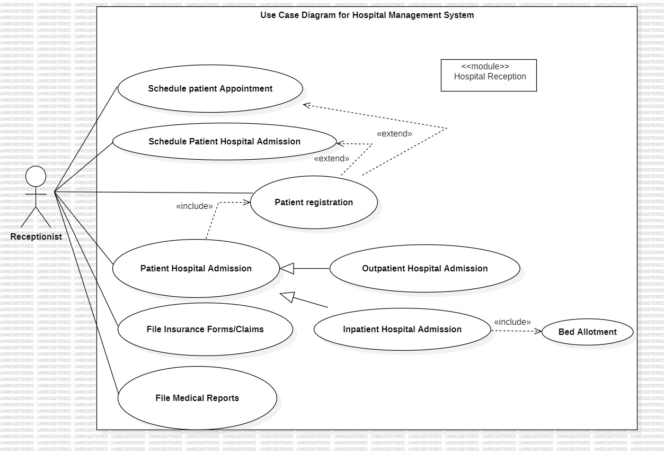

Y23CD172

**Activity Diagram:**

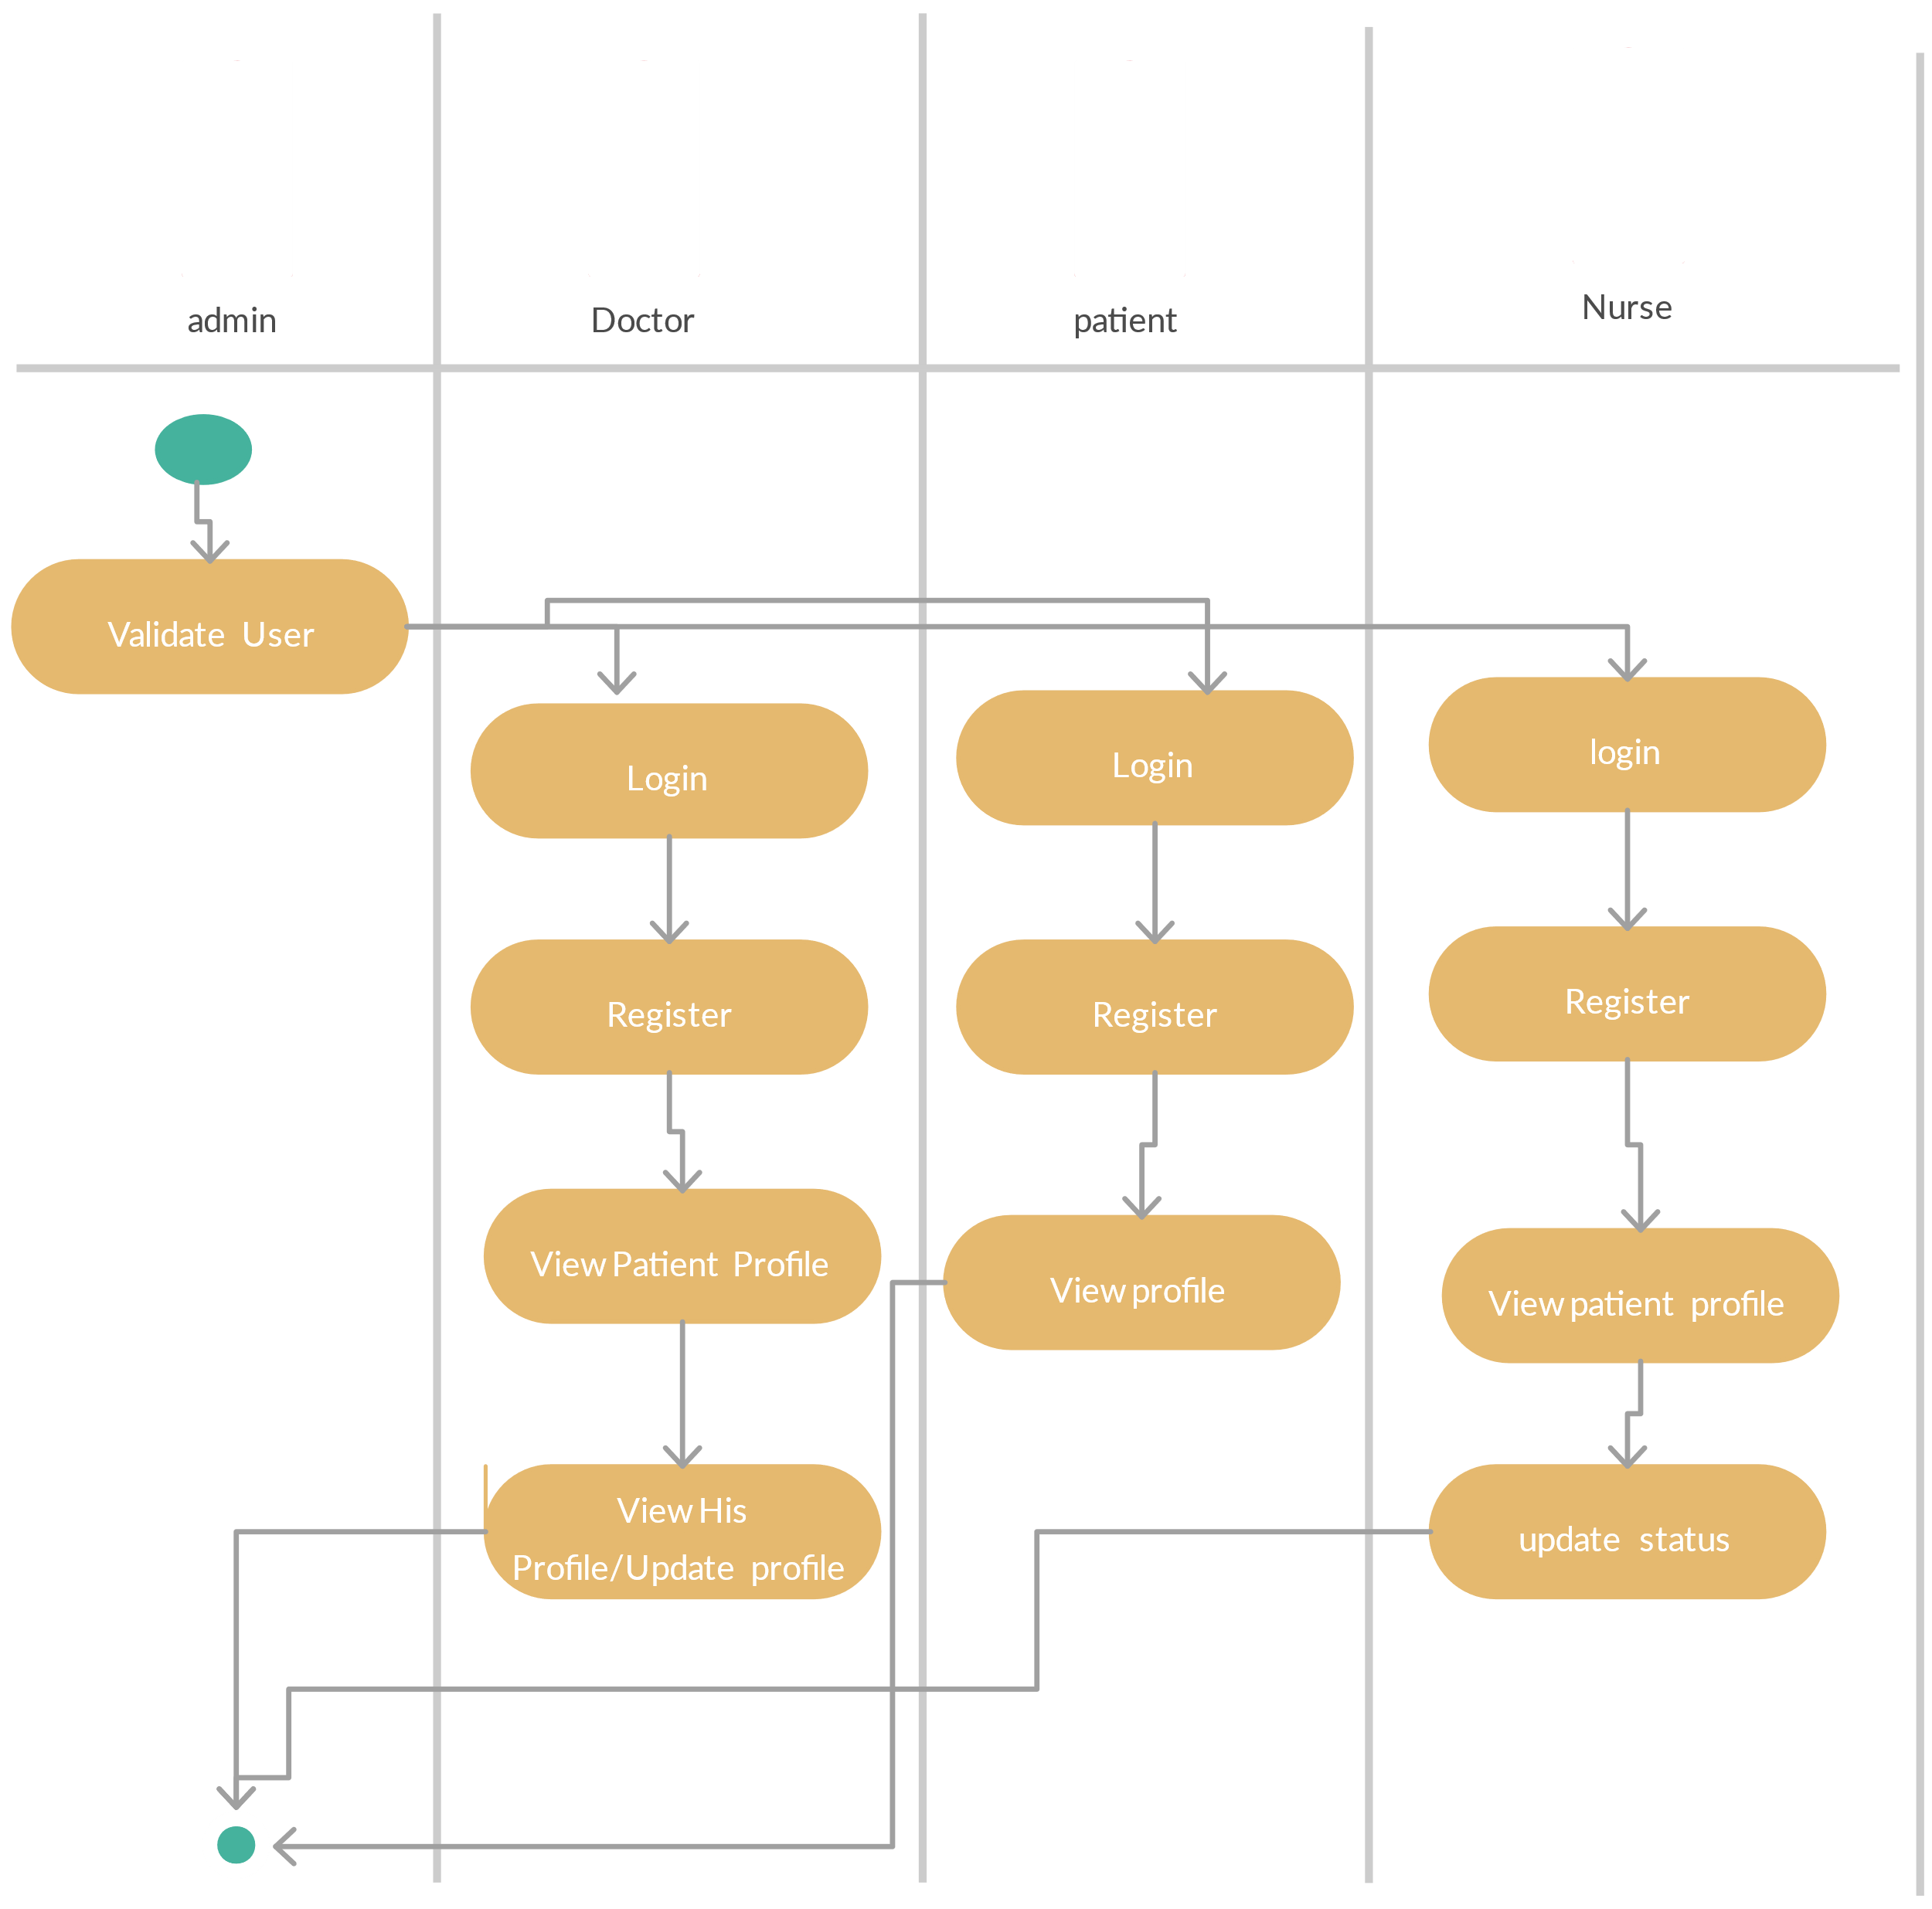

Y23CD172

**Sequence Diagram:**

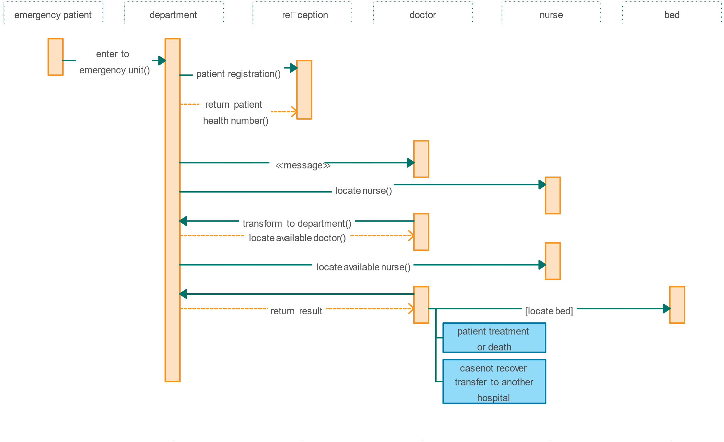

Y23CD172

**Class Diagram:**

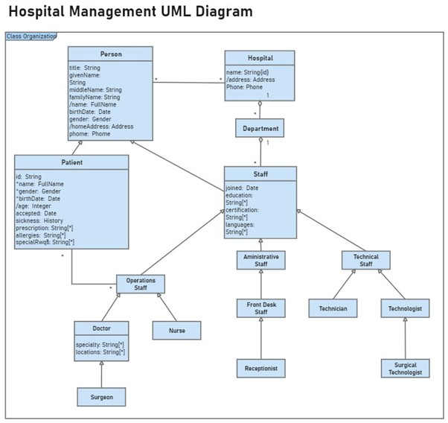

Y23CD172

**Component Diagram:**

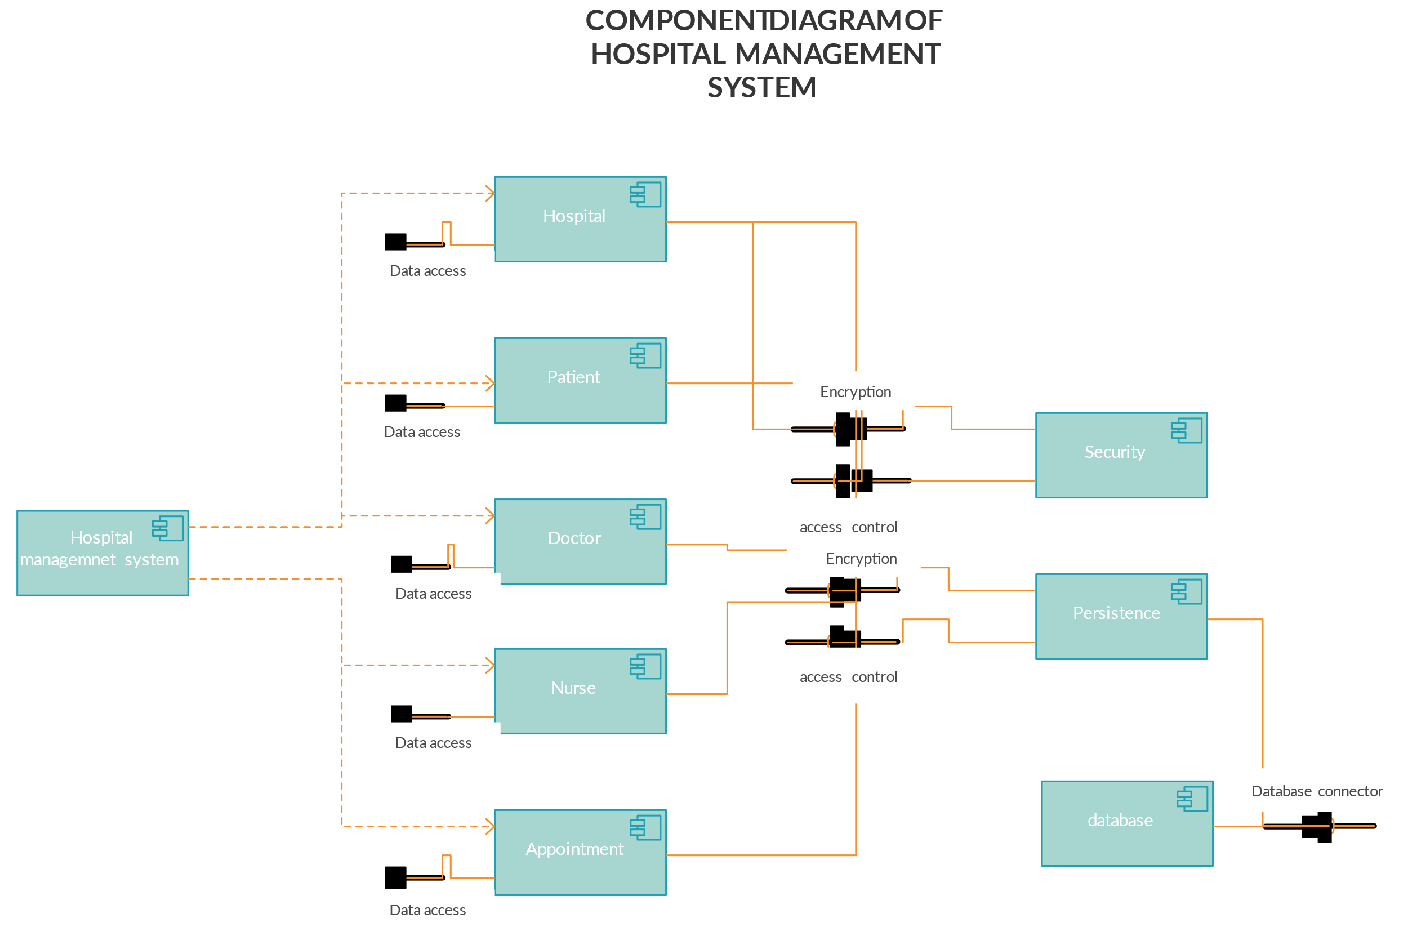

Y23CD172

**Deployement Diagram:**

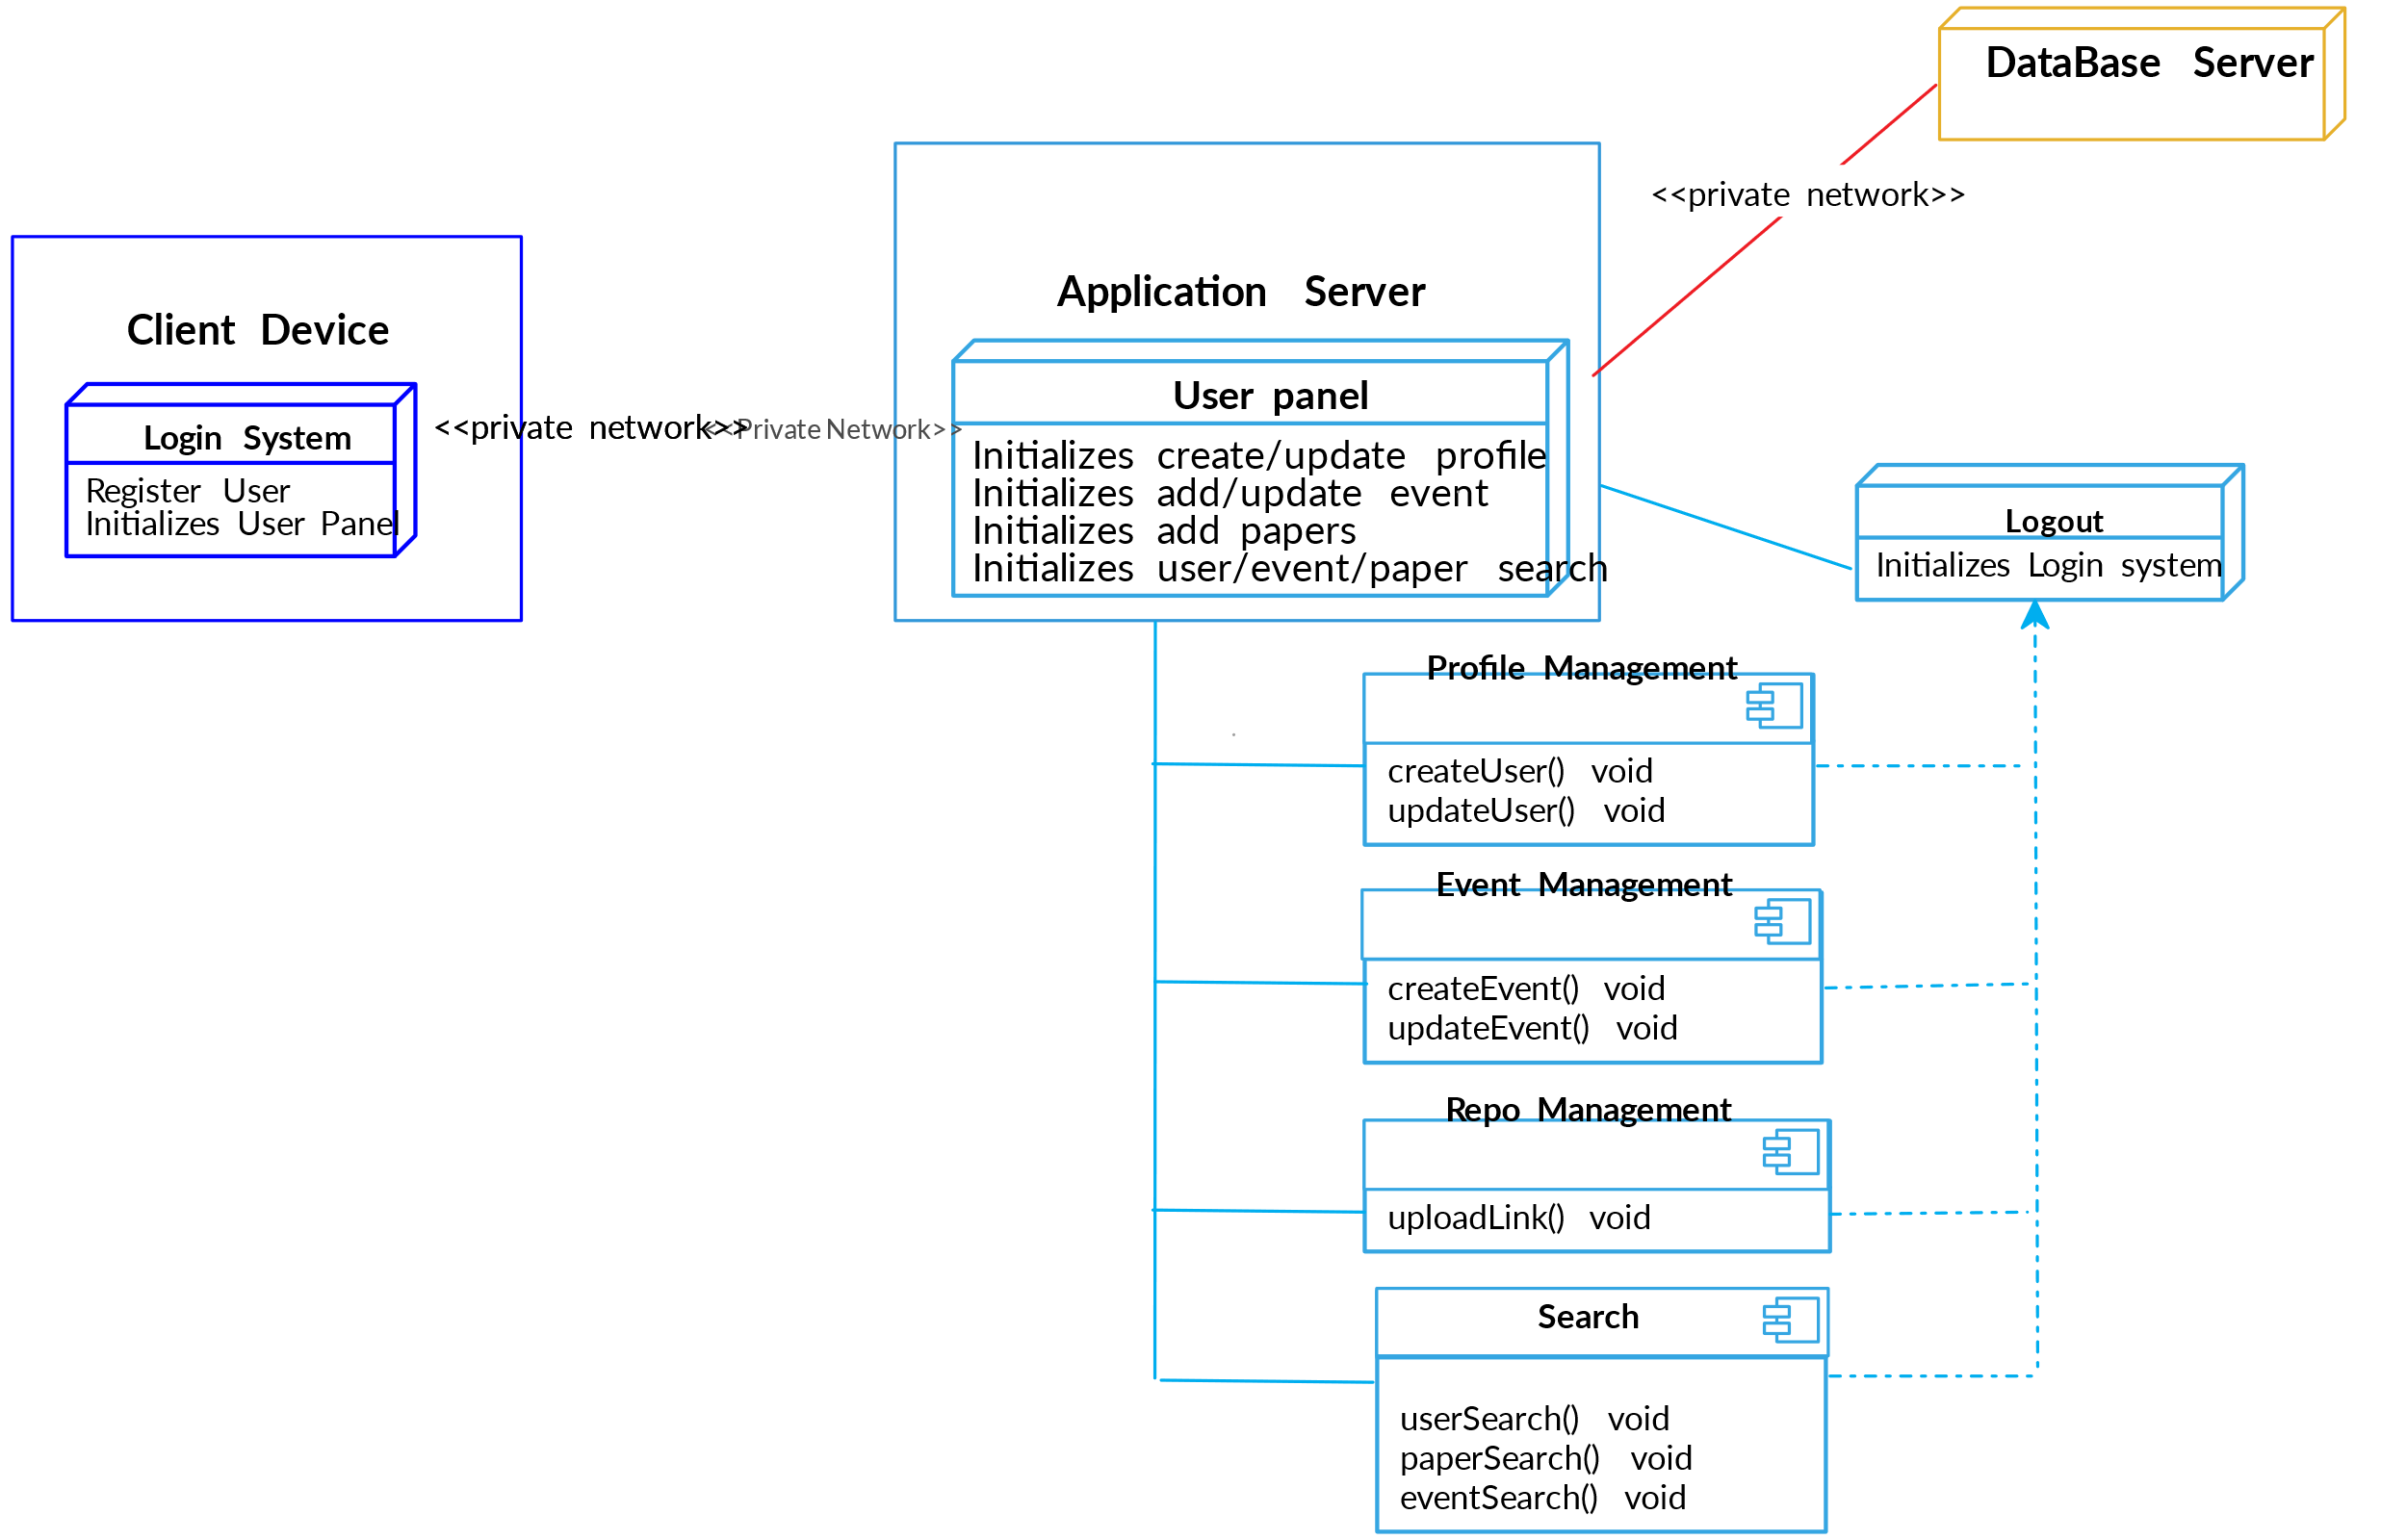

Y23CD172

**3.2 Functional Requirements**

**3.2.1 Patient Management**

* ***Patient Registration:*** *• The system shall allow for new patient registration with required fields (name, contact details, emergency contacts, etc.).  
   • It shall validate input data and prevent duplicate registrations.*
* ***Appointment Scheduling:*** *• The system shall provide an interface for booking, modifying, and canceling appointments.  
   • It shall notify patients and doctors via email/SMS upon scheduling changes.*
* ***Medical Records Management:*** *• The system shall maintain complete patient medical histories including diagnoses, treatments, and medication records.  
   • It shall allow authorized users to update records securely.*

**3.2.2 Clinical Management**

* ***Doctor and Staff Scheduling:*** *• The system shall manage staff schedules, ensuring optimal allocation of resources.  
   • It shall display real-time availability for doctors and other clinical staff.*
* ***Prescription Management:*** *• The system shall support electronic prescription generation and management, including medication details and dosage instructions.*
* ***Laboratory Test Management:*** *• The system shall facilitate test ordering, result entry, and report generation.  
   • It shall notify clinicians when test results are available.*

**3.2.3 Billing and Insurance**

* ***Billing and Invoicing:*** *• The system shall generate invoices for patient services, treatments, and procedures.  
   • It shall support multiple payment modes (cash, credit/debit, insurance).*
* ***Insurance Claims Processing:*** *• The system shall automatically prepare insurance claim forms and transmit them to the respective providers.  
   • It shall track claim status and notify billing personnel of any discrepancies.*

**3.2.4 Administration and Reporting**

* ***Inventory and Pharmacy Management:*** *• The system shall monitor inventory levels for medical supplies and medications.  
   • It shall alert administrators when stock levels fall below preset thresholds.*
* ***Reporting and Analytics:*** *• The system shall generate periodic reports (daily, weekly, monthly) covering operational metrics such as patient flow, billing summaries, and resource utilization.  
   • It shall provide dashboards for data visualization and trend analysis.*
  1. **Performance Requirements**
* *The system shall support a minimum of 100 simultaneous users without performance degradation.*
* *95% of transactions (e.g., appointment scheduling, billing processes) shall complete in under 2 seconds during peak hours.*
* *Data backup operations shall complete within designated maintenance windows to avoid disrupting hospital operations.*
  1. **Logical Database Requirements**
* *The database shall store patient records, appointment details, billing information, staff schedules, and inventory data.*
* *It shall enforce referential integrity and support complex queries for reporting.*
* *Data retention policies shall comply with regulatory requirements, with secure archiving mechanisms for historical data.*
  1. **Design Constraints**
* ***Standards Compliance:*** *• The system must comply with HL7 standards for healthcare data exchange and HIPAA for patient data privacy.  
   • The design should facilitate integration with existing hospital systems without extensive modifications.*
  1. **Software System Attributes**
     1. **Reliability**
* *The system shall achieve a Mean Time Between Failures (MTBF) of no less than 10,000 hours.*
* *Critical functions (e.g., patient registration, emergency notifications) shall have redundancy to minimize downtime.*
  + 1. **Availability**
* *The HMS shall maintain 99.9% uptime, with scheduled maintenance communicated in advance.*
* *It shall support automatic failover mechanisms in the event of server failures.*
  + 1. **Security**
* *User authentication and role-based access control shall be enforced.*
* *All sensitive data must be encrypted both at rest and in transit.*
* *The system shall log all user activity for audit purposes.*
  + 1. **Maintainability**
* *The system shall be modular in design to support ease of updates and bug fixes.*
* *Clear documentation and code comments shall be maintained to assist future developers.*
  + 1. **Portability**
* *The system shall be developed using platform-independent technologies, ensuring compatibility across various operating systems (Windows, Linux, macOS).*
  1. **Organizing the Specific Requirements**

*For clarity, requirements have been organized by major functional modules:*

* *Patient Management*
* *Clinical Management*
* *Billing and Insurance*
* *Administration and Reporting*

*This modular approach enables developers and testers to focus on individual aspects of the system while ensuring overall coherence.*

* 1. **Additional Comments**
* *The HMS should support future enhancements such as integration with telemedicine services and mobile health applications.*
* *User training and support documentation shall be provided as part of the system deployment package.*
* *Regular security audits and performance reviews will be scheduled to ensure ongoing compliance and efficiency.*

1. **Change Management Process**

*Any changes to the requirements outlined in this document must be documented, reviewed, and approved by the project stakeholders. Change requests should be submitted in writing (via email or a dedicated change management tool) and evaluated by the project management team before being incorporated into the SRS.*

1. **Document Approvals**

*The following individuals are responsible for reviewing and approving this SRS:*

| *Role* | *Name* | *Designation* | *Signature* | *Date* |
| --- | --- | --- | --- | --- |
| *Project Manager* | *Not available* | *Project Supervisor* |  | *[ / / ]* |
| *Team Lead* | *Shaik Zaid* | *Lead Developer* |  | *[ / / ]* |
| *Faculty Advisor* | *Riaz Shaik* | *Faculty Guide* |  | *[ / / ]* |

*EXPERIMENT-2:* **UseCase Diagrams**

**1.UseCase Diagram for ATM**

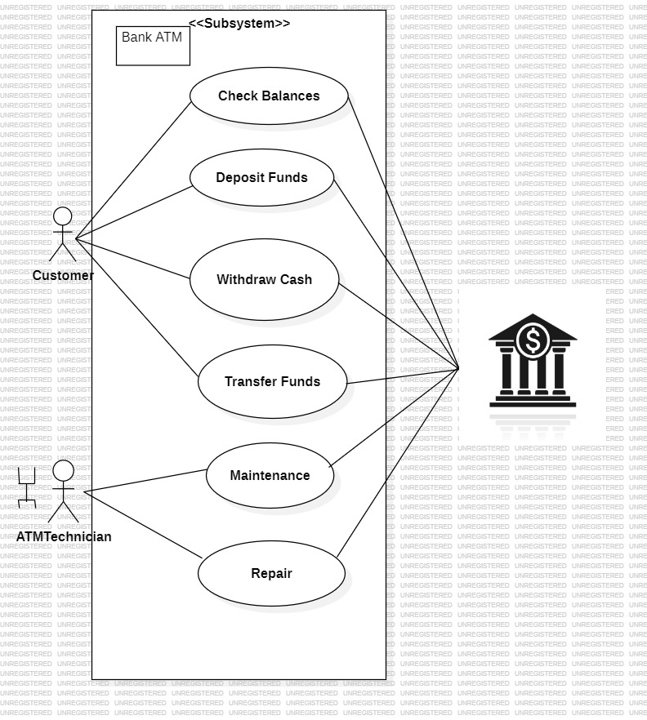

Y23CD172

***Use Case Diagram for Website:***

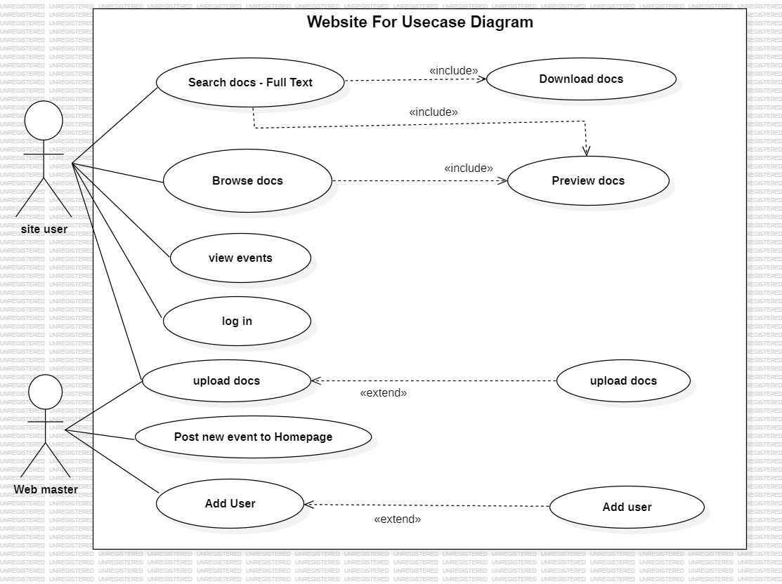

Y23CD172

***Use Case Diagram for Library Management System:***

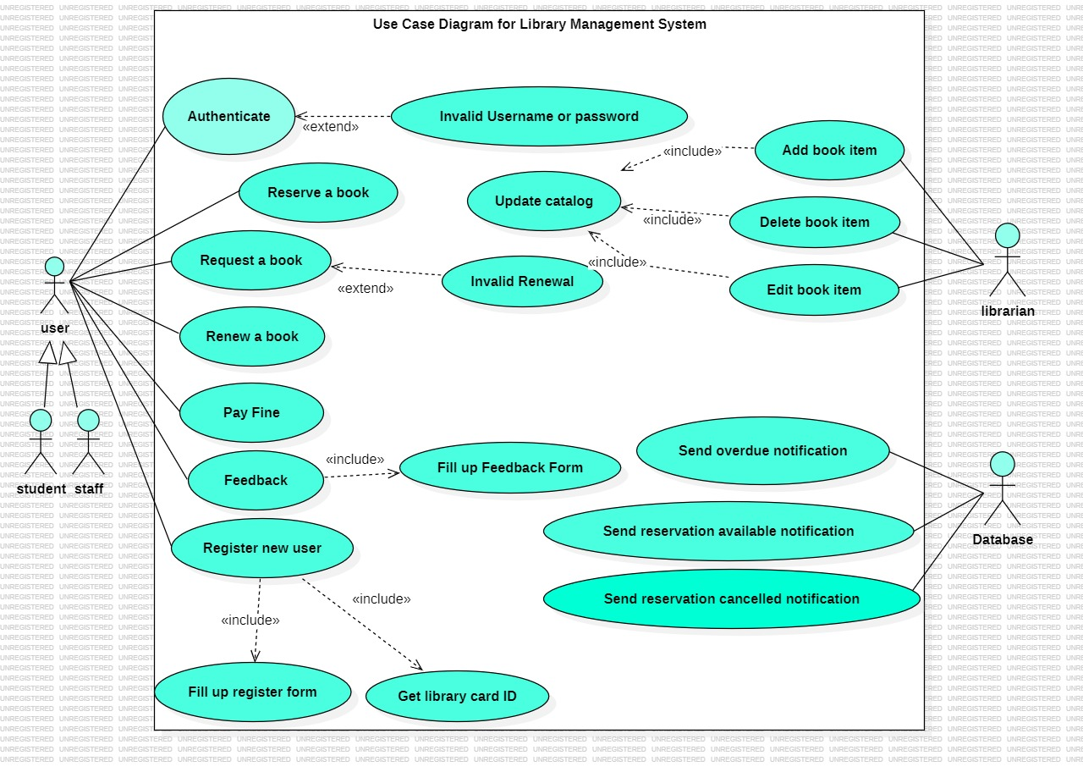

Y23CD172

***Use Case Diagram for Car Rental System:***

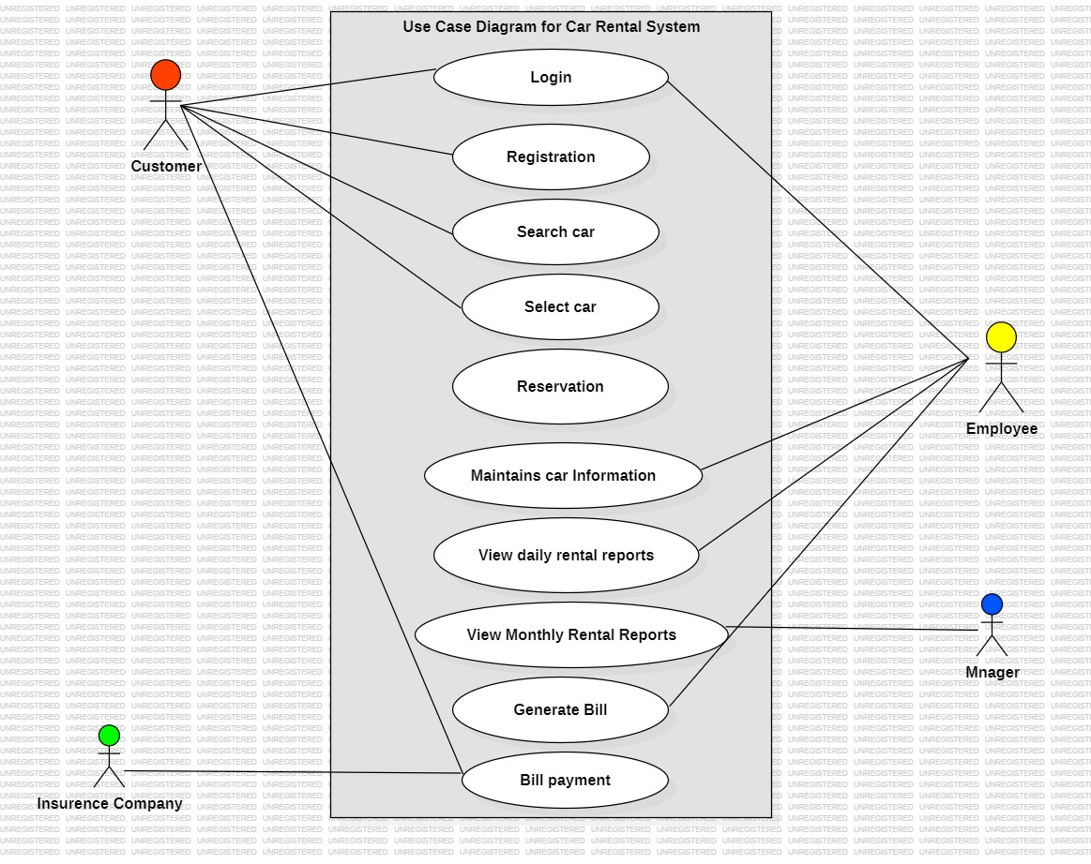

Y23CD172

***Use Case Diagram for Hospital Management System:***

**

Y23CD172

*EXPERIMENT-3:Activity Diagrams*

*Activity Diagram for UserLogin System:*

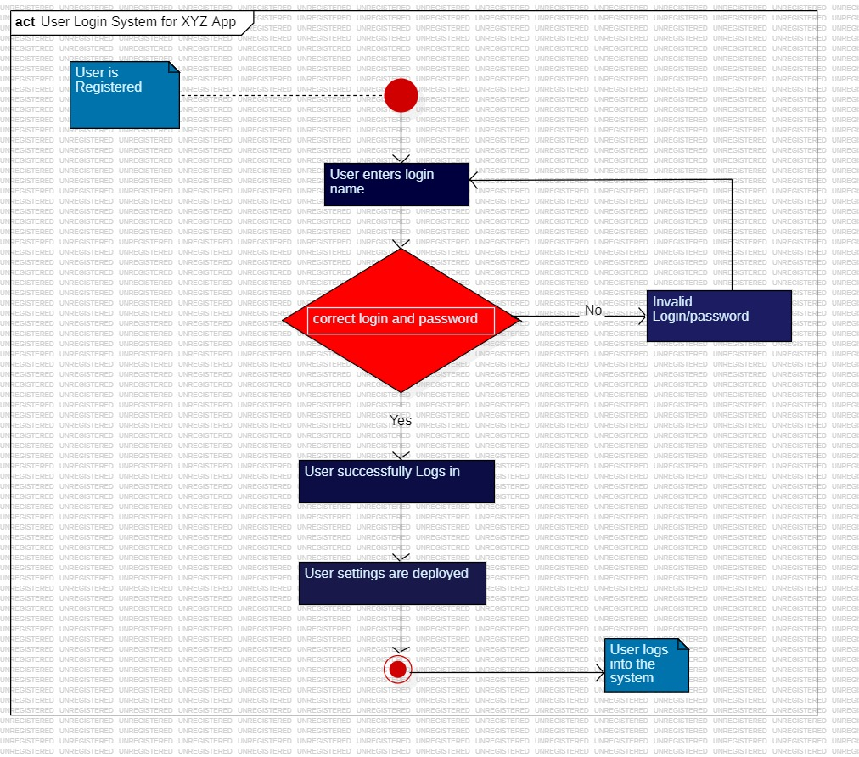

Y23CD172

ActivityDiagram for ATM system:

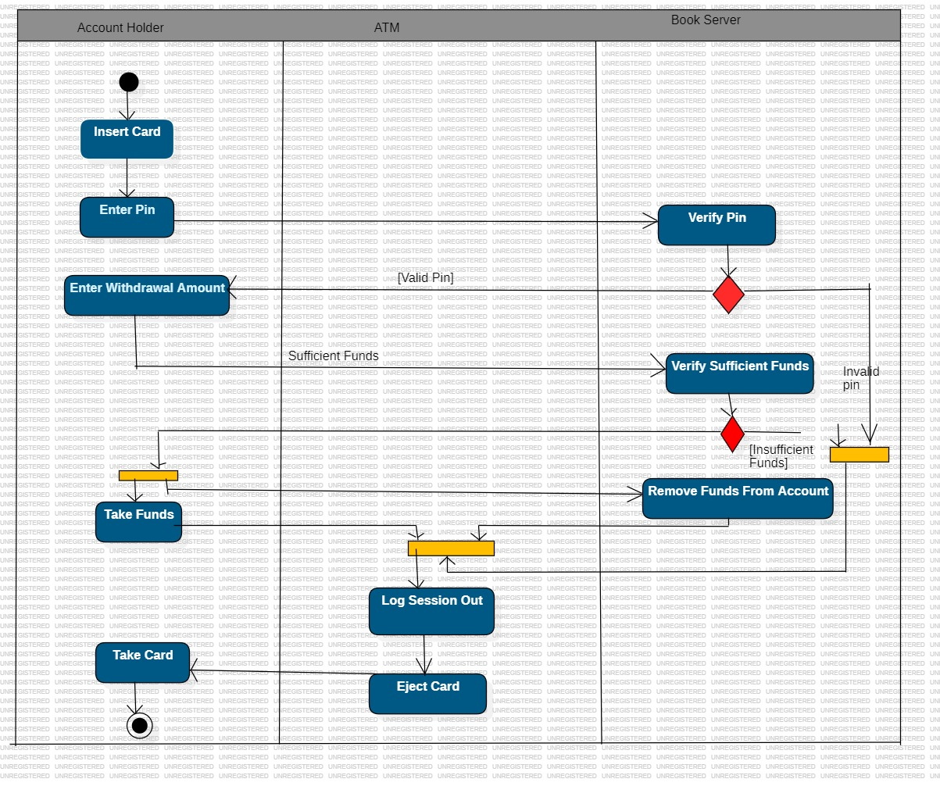

ActivityDiagram For LibraryManagement System:

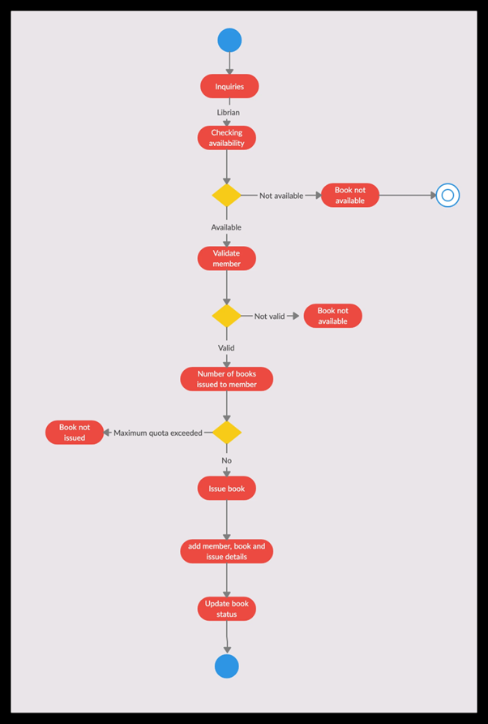

Y23CD172

EXPERIMENT-4:Class Diagrams

Class Diagram For ATM:

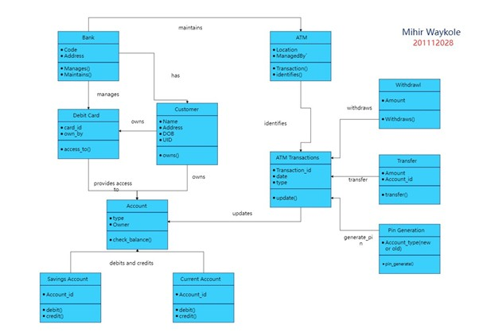

Y23CD172

Class Diagram For LibraryManagement System:

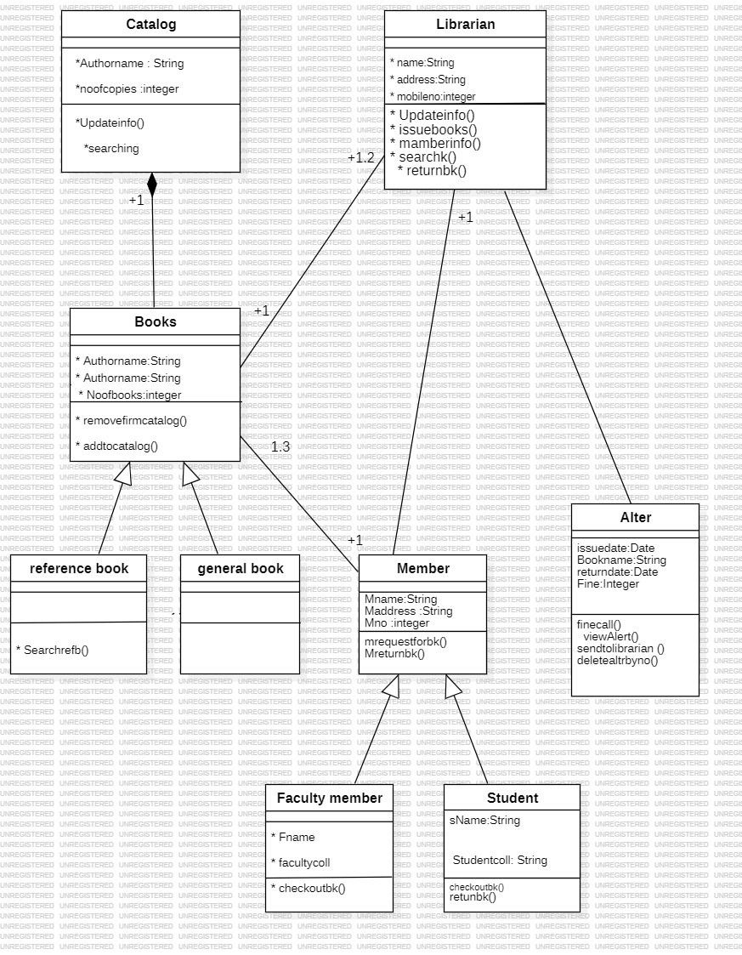

Y23CD172

Class Diagram For Online Shopping:

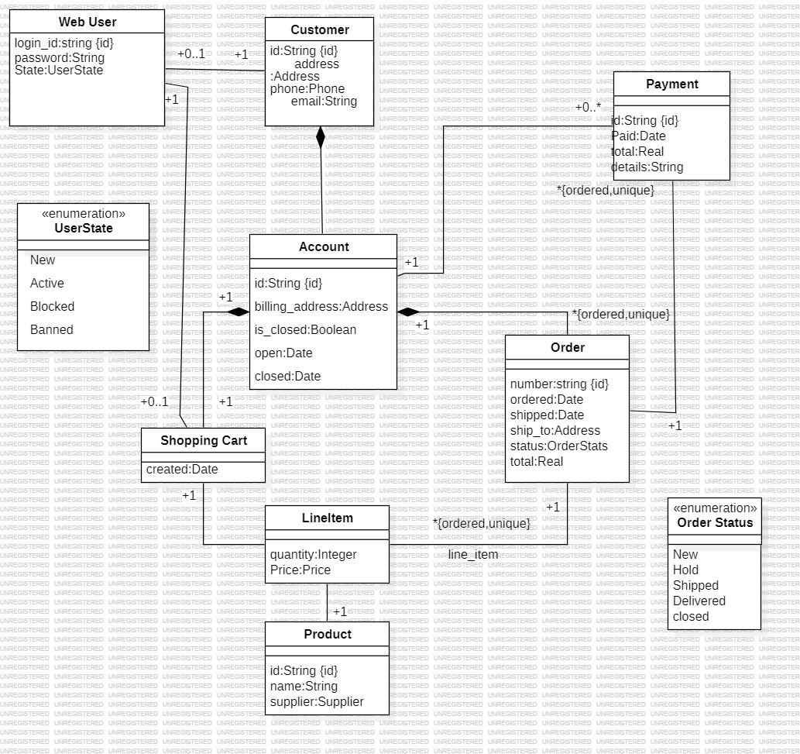

Y23CD172

Class Diagram For Hospital Management System:



Y23CD172