**Mis-no.112215113|Name-Mohd Zaid**

**1.a-** ‘-c <count>’

**1.b-** ‘-i <interval>’

**1.c-** ‘-f’

**1.d-** ‘-s <size>’

**Total packet size=32+28=60bytes**

**2.a-**

|  |  |  |  |  |
| --- | --- | --- | --- | --- |
| **S.no** | **Host** | **RTT(avg at 11:30am)** | **RTT(avg at 12:30pm)** | **RTT(avg at 1:30pm)** |
| **1.** | [www.google.com](http://www.google.com) | 12.060ms | 12.391ms | 13.643ms |
| **2.** | [www.udemy.com](http://www.udemy.com) | 13.515ms | 10.856ms | 12.244ms |
| **3.** | [www.spotify.com](http://www.spotify.com) | 12.788ms | 13.187ms | 27.831ms |
| **4.** | [www.myntra.com](http://www.myntra.com) | 17.972ms | 13.898ms | 16.666ms |
| **5.** | [www.amazon.com](http://www.amazon.com) | 10.971ms | 12.081ms | 71.322ms |
| **6.** | [www.flipkart.in](http://www.flipkart.in) | 12.966ms | 11.993ms | 143.569ms |

**Yes,** there is often a correlation between RTT and the geographical distance between the source and destination.

**2.b-** in [www.udemy.com](http://www.udemy.com) and www.amazon.com we have packet loss greater than 0%.

The reason behind may be Network issue(due to high traffic),Internet service provider issue, distance etc.

**2.c-In www.google.com**

Avg RTT(Y-axis) vs size(X-axis)

**2.d-**According to the graph, there is a slightly change in the graph , from 64 bytes to the 1024 bytes it got increasing by the slightly amount but after 1024 bytes it got decrease by the slightly amount.

**3. IP address-www.google.com**

**a-** packet loss in ping -n [www.google.com](http://www.google.com) = 15.868%

packet loss in ping -p ff00 [www.google.com](http://www.google.com) = 0.6979%

**b-** Latency Statistics for Normal Ping:

{'Minimum': 2.825, 'Maximum': 48.55, 'Mean': 9.074522727272727, 'Median': 9.59}

Latency Statistics for Pattern Ping:

{'Minimum': 2.72, 'Maximum': 49.8, 'Mean': 7.59426926926927, 'Median': 7.55}

**c-** for normal ping and pattern ping-

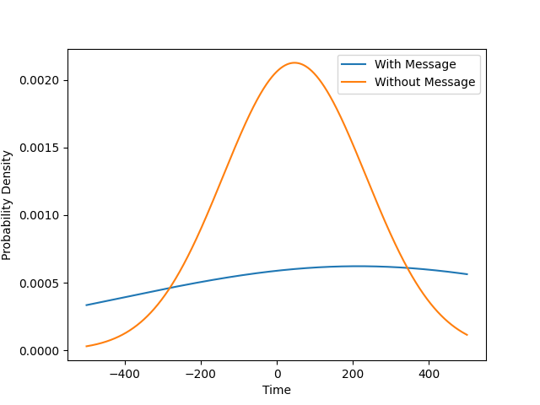

**d-** in ping -p ff00 www.google.com command packet loss and RTT is less than in ping -n www.google.com command.

**4.a-** ifconfig command output-

1. The name of active network interface-enp0s3 and lo.
2. IP address(inet)
3. Netmask
4. Broadcast address
5. MTU(Maximum transmission unit)

**4.b-**

1. View Active Network Interface
2. Enable a network interface
3. View IP address and Network interface masks
4. Assign an IP address to an interface
5. Assign to netmask to an interface

**4.c-**

1. -a: Prints the configuration for all interfaces, not just the active ones.
2. Down:To disable a network interface.

Ex-sudo ifconfig enp0s3 down.

1. Up: to reactivate a network interface.

Ex-sudo ifconfig enp0s3 up.

1. Promisc: promiscuous mode allows a network device to accept all packets.

Ex- sudo ifconfig enp0s3 promisc.

**5.a-** Netsat is used to show network status.

**5.b-** Netstat -at

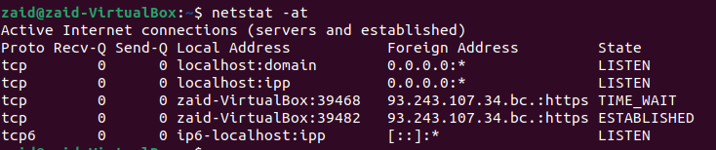

**5.c-** Destination: This column shows the destination network or host IP address.

Gateway: If there is a specific gateway (router) to reach the destination, it will be displayed in this column.

Genmask : Indicates the network mask associated with the destination IP address.

Flags: Displays flags that provide additional information about the route. Common flags include U (route is up), H (target is a host), G (use gateway), and more.

MSS: Maximum Segment Size, which is related to TCP connection parameters.

Window: The TCP window size.

Irtt: Indicates the network interface through which the packet will be sent.

Metric: A value that represents the cost or priority of a route. Lower metrics are preferred.

**5.d-** Command: netstat -i

No. of interface=2

**5.e-** Option: -su

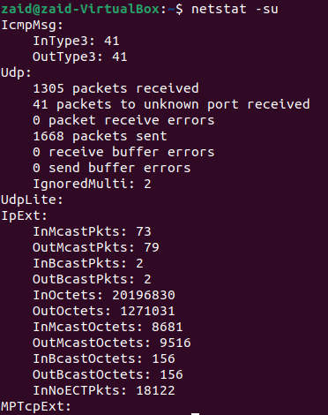

**5.f-** A loopback interface is a virtual interface that is always up and reachable as long as at least one of the IP interfaces on the switch is operational.it is use for debugging.

**6.a-** An IP tracer is helpful for figuring out the routing hops data has to go through, as well as response delays as it travels across nodes, which are what send the data toward its destination.

**6.b-**

|  |  |  |  |  |
| --- | --- | --- | --- | --- |
| **S.no** | **Host** | **Hop (6:00pm)** | **Hop(11:30pm)** | **Hop(12:30am)** |
| **1.** | [www.google.com](http://www.google.com) | **3** | **2** | **2** |
| **2.** | [www.spotify.com](http://www.spotify.com) | **2** | **3** | **3** |
| **3.** | [www.udemy.com](http://www.udemy.com) | **4** | **4** | **4** |
| **4.** | [www.myntra.com](http://www.myntra.com) | **6** | **8** | **5** |
| **5.** | [www.amazon.com](http://www.amazon.com) | **7** | **8** | **10** |
| **6.** | [www.flipkart.com](http://www.flipkart.com) | **3** | **2** | **2** |

**6.c-** The route to the same host changing at different times of the day could be attributed to several factors, and troubleshooting such issues often involves examining the underlying networking infrastructure. Here are some reason-

Dynamic routing protocols, Load Balancing, Network congestion, Routing table updates etc.

**6.d-** Traceroute is a diagnostic tool used to trace the route that packets take from a source to a destination on a network. In some cases, traceroute may not find complete paths to certain hosts. Here are several reasons why this might occur:

Firewall or security devices, Router or host configuration, load balancers, packet loss etc.

**6.e-** Yes, it is possible to find the route to hosts that fail to respond with ping. Traceroute employs alternative packet types such as UDP or ICMP Echo Request, which may bypass blocking mechanisms affecting ping. Hosts with open ports for traceroute or different routing configurations can still be discovered. Firewalls may selectively allow traceroute packets even if ICMP is blocked. Diverse host configurations contribute to varied responses between ping and traceroute.

**7.a-** Yes,

Address-it is the IP address of network interface.

HWtype- it is type of hardware such as ethernet.

HWaddress-it the MAC address associated with corresponding IP address.

Flags Mask-flags provide additional information about the entry. common flag C(resolved) and U(unresolved).

Iface-Network interface through which ARP resolution was made.

**7.b- for delete an entry in to arp table-** arp -d <IP-address>

**for add an entry in to arp table-** arp -s <IP-address> <MAC address>

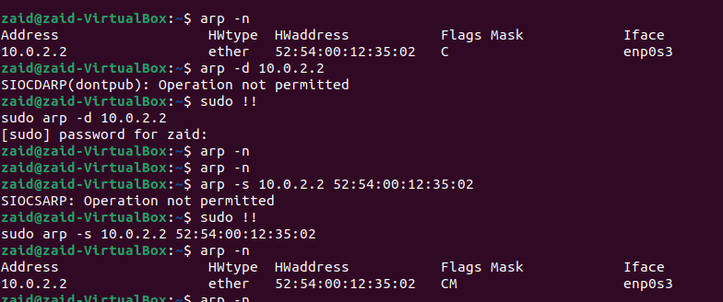

**7.c-** No, an ARP (Address Resolution Protocol) table typically contains mappings between IP addresses and corresponding MAC (Media Access Control) addresses within the same subnet.