**Hands-on 5 : ReactJS-HOL**

1. Download and build the attached react application. Unzip the react application in a folder.

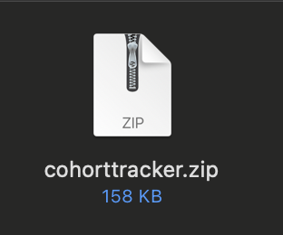

1. Open command prompt and switch to the react application folder.
2. Restore the node packages using the following commands.



1. Open the application using VS Code
2. Create a new CSS Module in a file called “CohortDetails.module.css”

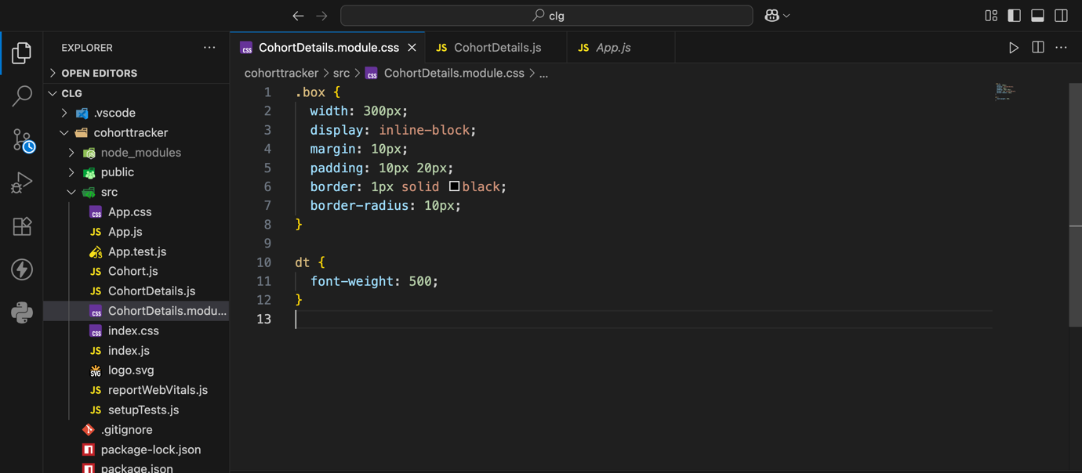

1. Open the cohort details component and import the CSS Module
2. Apply the box class to the container div.
3. Define the style for <h3> element to use “green” color font when cohort status is “ongoing” and “blue” color in all other scenarios.

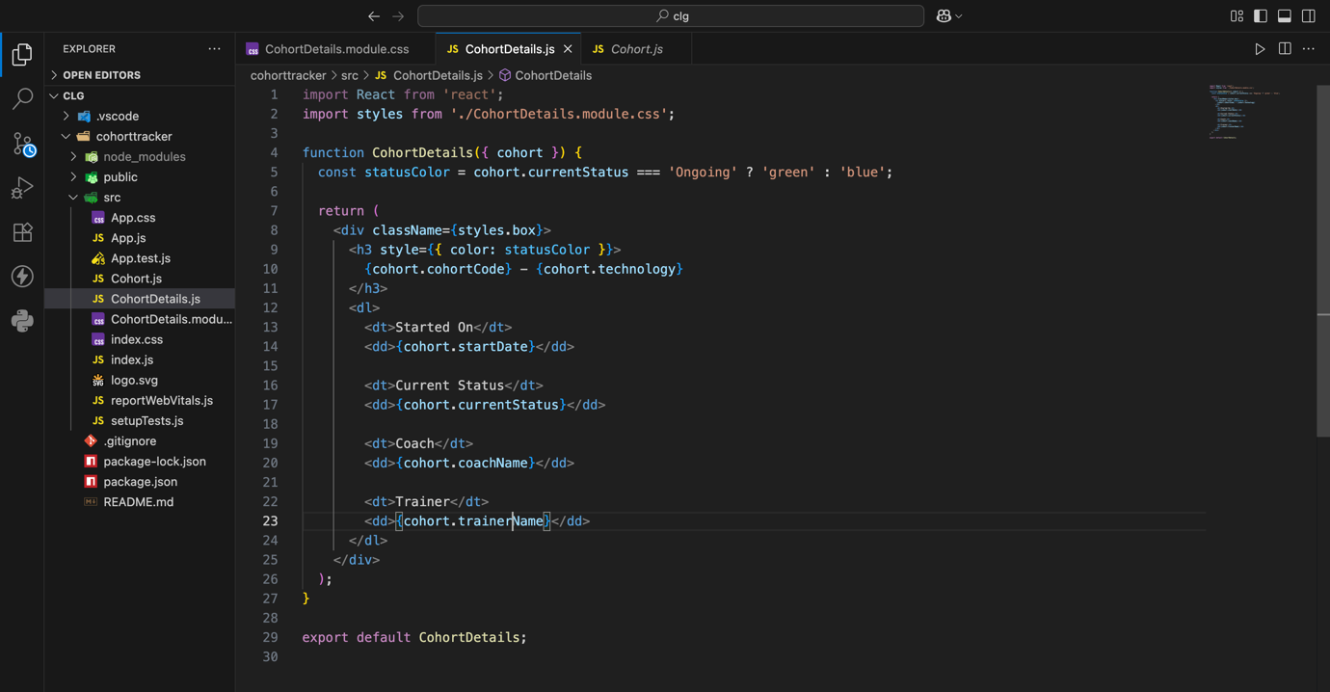

1. Final result

