Freight Rate Prediction Challenge
Machine Learning Engineer Assessment Report
Time-aware regression for freight posted-rate prediction
Development data | 48,000 labeled loads
Final validation data | 12,000 unlabeled loads
Final main model | 75% Ridge + 25% XGBoost

October 2026

1. Executive Summary
The objective was to predict freight posted rates from the provided labeled development data, validate the modeling approach using only historical information, and generate predictions for the 12,000-row final validation set. Because the final evaluation period occurs after the development period, the validation strategy was designed chronologically rather than using a random train/test split.
The final main solution combines a regularized linear model (Ridge Regression) and a nonlinear gradient-boosted tree model (XGBoost). The selected 75% Ridge / 25% XGBoost ensemble achieved an internal September-October holdout MAE of $130.43, RMSE of $637.72, and R² of 0.8254. The ensemble slightly improved all three holdout metrics relative to the individual Ridge and XGBoost models.
A separate December-compatible ensemble was trained because the fixed December input file does not contain all features available to the main model. That model uses only features present in the December file and achieved an internal holdout MAE of $147.54, RMSE of $646.66, and R² of 0.8204.
Final scorer check: The provided scorer validated all 12,000 final predictions and all 31 fixed December predictions, then generated scorer_results/candidate_december.png successfully. Final hidden validation metrics are calculated by Spotter after submission.

2. Data Overview and Exploratory Analysis
Item | Result
Development rows | 48,000
Columns | 14
Target | posted_rate
Development period | 2025-01-01 to 2025-10-31
Final validation rows | 12,000
Categorical features | pickup, delivery, equipment
Key numeric features | distance, weight, market_index, quote_signal, pickup/delivery coordinates
The target distribution is strongly right-skewed (skewness approximately 1.90), with a median posted rate of $2,030.76 and observed values ranging from $57.22 to $25,533. High-rate observations were inspected rather than removed. The largest rates were generally associated with very long distances, which supported treating them as plausible freight loads instead of obvious data errors.
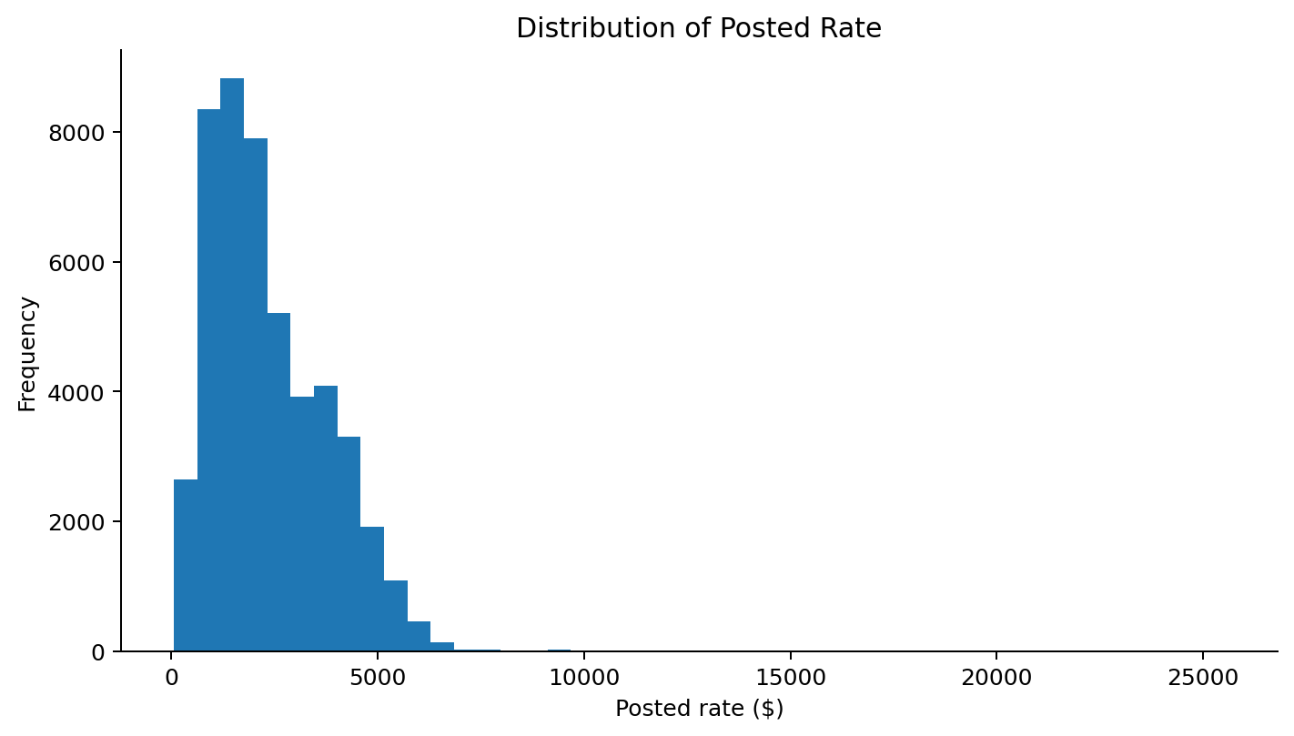
Figure 1. Distribution of the development target, posted_rate.
Distance showed the strongest simple numerical relationship with posted_rate (Pearson correlation approximately 0.91). Other variables, particularly quote_signal, showed nonlinear patterns, supporting the inclusion of a nonlinear tree model in addition to the linear baseline.

3. Data Quality and Preprocessing

3.1 Negative weight values
The development data contained 292 negative weight values. Their absolute-value distribution closely matched the valid positive-weight distribution: both had similar medians, quartiles, and the same approximate 500-47,500 lb range. The negative values were also distributed across months, equipment types, and routes rather than being concentrated in one subgroup. They were therefore treated as sign errors and converted to absolute values.

3.2 Missing values
Missingness was sparse: 300 rows (0.62%) were missing weight and 374 rows (0.78%) were missing market_index. The missing values appeared broadly distributed across months, equipment, and routes. Median imputation was therefore used inside the preprocessing pipeline. Importantly, imputation statistics were learned from the training portion only during validation to avoid leakage.

3.3 Categorical handling and unseen routes
A directional route feature was created as pickup -> delivery and retained alongside pickup and delivery. The January-August training set contained 3,999 unique routes. In the September-October holdout, only 15 routes were unseen, affecting 21 rows (0.22%). One-hot encoding used handle_unknown="ignore" so these cases could be scored safely without leakage or manual mapping.

4. Validation Strategy and Feature Engineering
A chronological split was used because the actual task is forward-looking. The main holdout was kept untouched during model tuning:
Split | Rows | Date range
Training | 38,477 | 2025-01-01 to 2025-08-31
Holdout validation | 9,523 | 2025-09-01 to 2025-10-31
Hyperparameters were selected using expanding monthly validation inside the January-August training period: Jan-May -> June, Jan-June -> July, and Jan-July -> August. This kept the final September-October holdout separate from tuning and better matched the temporal structure of the hidden evaluation period.
Feature engineering included:
- Date features: month, day of month, day of week, ISO week of year, weekend indicator, and days since 2025-01-01.
- Directional route feature: pickup -> delivery.
- Original geographic coordinates, distance, weight, market_index, and quote_signal for the main model.
- One-hot encoding for pickup, delivery, equipment, and route.
- Median numeric imputation in both models; StandardScaler was applied only to Ridge Regression.
load_id and the raw date field were excluded from the model inputs after the required derived features were created.

5. Model Development and Selection

5.1 Ridge Regression baseline
Ridge Regression was used as an interpretable regularized baseline. Alpha values were tested with expanding time-based validation. Performance improved as regularization increased and then plateaued, so alpha=100 was selected.

5.2 XGBoost model
XGBoost was tested to capture nonlinear effects and feature interactions. A small controlled search was used rather than a large grid. The retained configuration used 300 trees, max_depth=4, learning_rate=0.05, subsample=0.9, and colsample_bytree=0.9.

5.3 Ensemble selection
The two models had complementary behavior: XGBoost achieved a lower MAE, while Ridge achieved better RMSE and R². Ensemble weights were therefore tested using the same chronological cross-validation folds. A 75% Ridge / 25% XGBoost blend provided the best overall balance and was selected before the final holdout evaluation.

Model | MAE ($) | RMSE ($) | R²
Ridge Regression | 139.05 | 637.81 | 0.8253
XGBoost | 131.92 | 660.09 | 0.8129
75% Ridge + 25% XGBoost | 130.43 | 637.72 | 0.8254
Table 1. September-October holdout performance. Lower MAE/RMSE is better; higher R² is better.
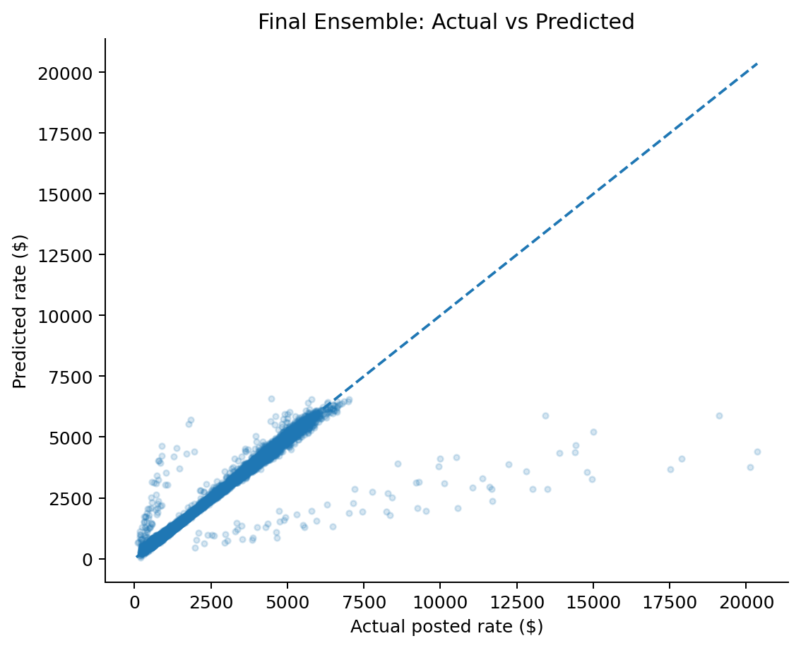
Figure 2. Final main ensemble predictions on the September-October holdout.
The remaining error is concentrated in a small number of unusually high-rate loads, which are sometimes underpredicted. This is visible in the actual-versus-predicted plot and explains why RMSE remains much larger than MAE.

6. Fixed December Prediction Model
The provided December chart input contains only pickup, delivery, distance, equipment, weight, and date. It does not contain pickup/delivery coordinates, market_index, or quote_signal, so the main model cannot be applied directly without making unsupported assumptions.
A separate reduced-feature model was therefore developed using only fields available in the December input plus engineered date and route features. Historical coverage for the fixed scenario was strong enough to support this approach: there were 32 Lexington -> Fort Wayne observations in the development data, including 21 Dry Van loads. A broader similarity filter (Dry Van, 260-460 miles, 24,500-39,500 lb) contained 2,194 historical loads.
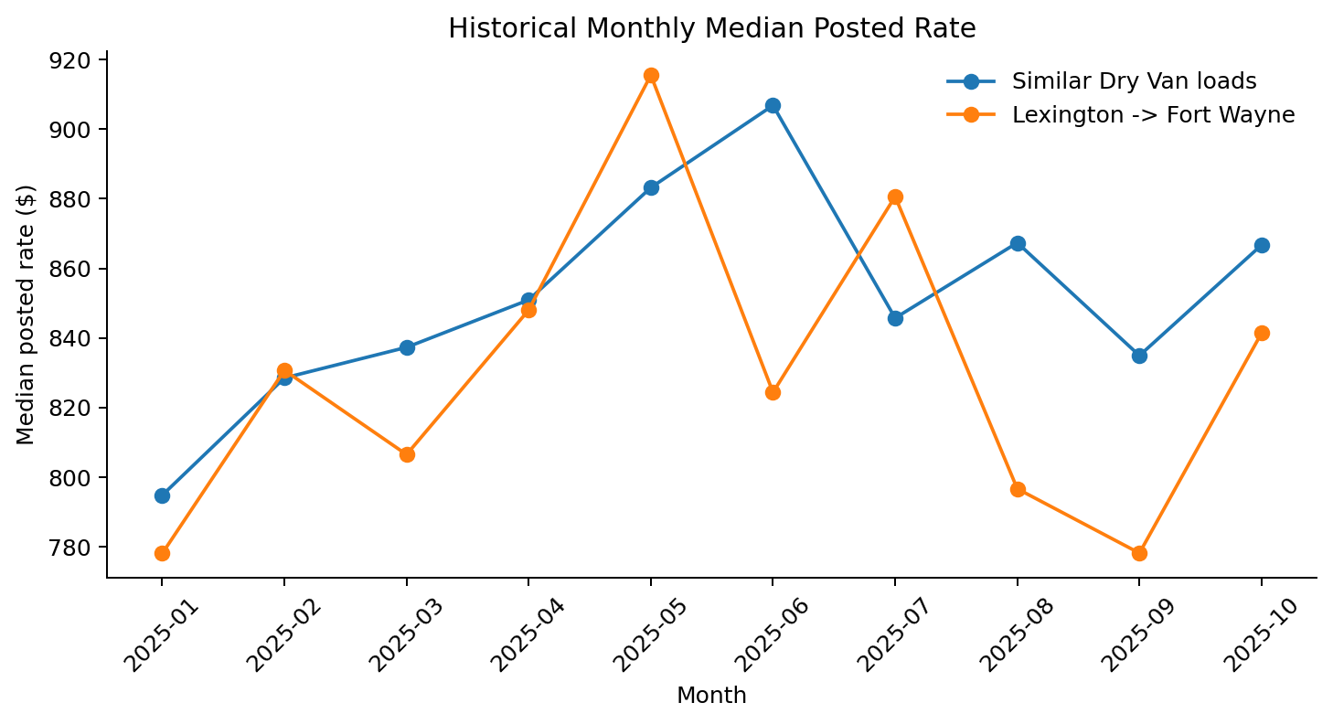
Figure 3. Historical monthly median rates for the exact route and similar Dry Van loads.
The final December-compatible model used a 50% Ridge / 50% XGBoost blend. Ridge used alpha=100; the XGBoost model used 500 trees, max_depth=3, learning_rate=0.05, subsample=0.9, and colsample_bytree=0.9. On the untouched September-October holdout using only reduced features, the model achieved MAE $147.54, RMSE $646.66, and R² 0.8204 with no non-positive predictions.
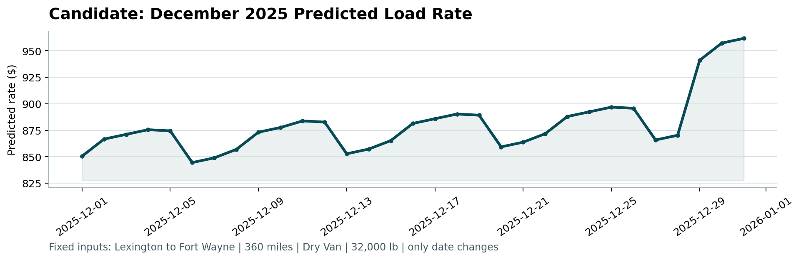
Figure 4. Fixed December 2025 prediction chart generated using the scorer-compatible 31-row input.

7. Final Training and Submission Outputs
After the validation approach, preprocessing, hyperparameters, and ensemble weights were locked, the selected models were retrained on all 48,000 labeled development rows.
Output | Method | Status
validation_predictions.csv | 75% Ridge + 25% XGBoost, full feature set | 12,000 rows; load_id,predicted_rate
December predictions | 50% Ridge + 50% XGBoost, reduced feature set | 31 rows; one per day in Dec 2025
candidate_december.png | Generated by provided scorer workflow | Created successfully
Prediction outputs were checked for missing values and non-positive values before scoring. The provided scorer confirmed that all required IDs and columns were valid, all 12,000 final predictions were present, all 31 December rows were valid, and the chart was generated successfully.

8. Limitations and Considerations
- The assessment did not specify the hidden evaluation metric. Model selection therefore considered MAE, RMSE, and R² together instead of optimizing only one metric.
- Rare, very high posted-rate loads remain harder to predict and can dominate RMSE even when typical-load MAE is low.
- The December model intentionally excludes features unavailable in december_chart_inputs.csv. This avoids fabricating market_index, quote_signal, or coordinate values, but gives the December model less information than the main model.
- The final hidden score is calculated externally after submission, so the reported metrics are internal chronological holdout estimates rather than the official score.

9. Conclusion
The solution uses a time-aware validation design, explicit data-quality handling, reproducible feature engineering, and a small set of interpretable model comparisons. The final main ensemble improved the average absolute error of either standalone model while retaining Ridge-level RMSE and R². A separate reduced-feature ensemble was used for the fixed December chart so that all predictions rely only on information actually provided for those rows.
Selected final approach: Main predictions = 75% Ridge + 25% XGBoost. Fixed December predictions = 50% reduced-feature Ridge + 50% reduced-feature XGBoost. Both outputs passed the provided scorer validation.

