**CHAPTER 1 ALERT**

1. Write a script to greet your website visitor using JS alert box.

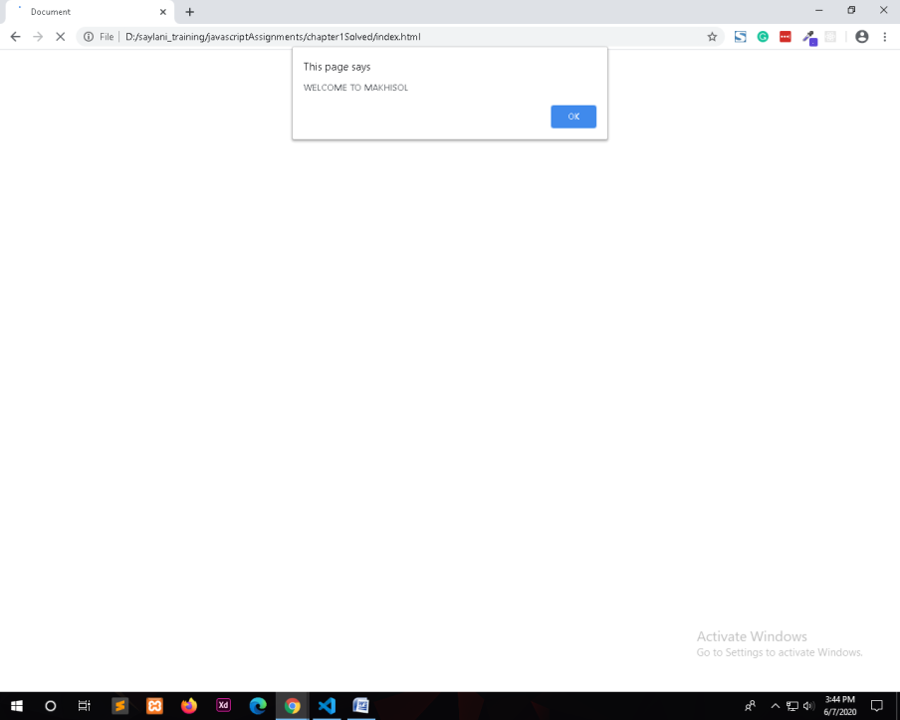

1. Write a script to display following message on your web page:

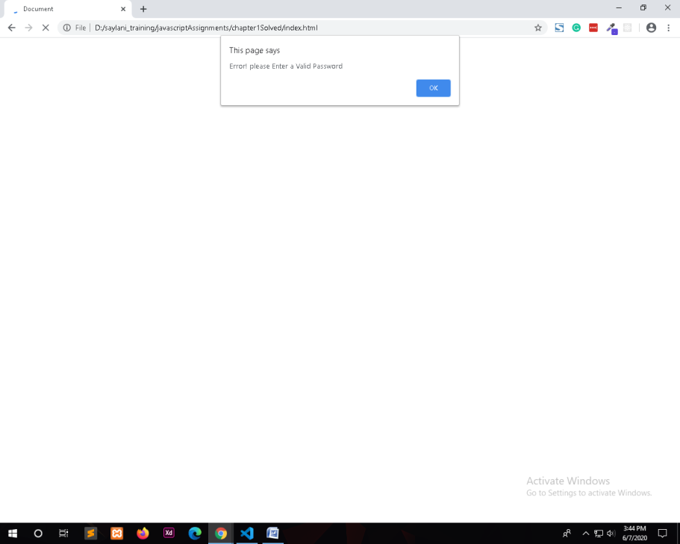

1. Write a script to display following message on your web page: (Hint : Use line break).

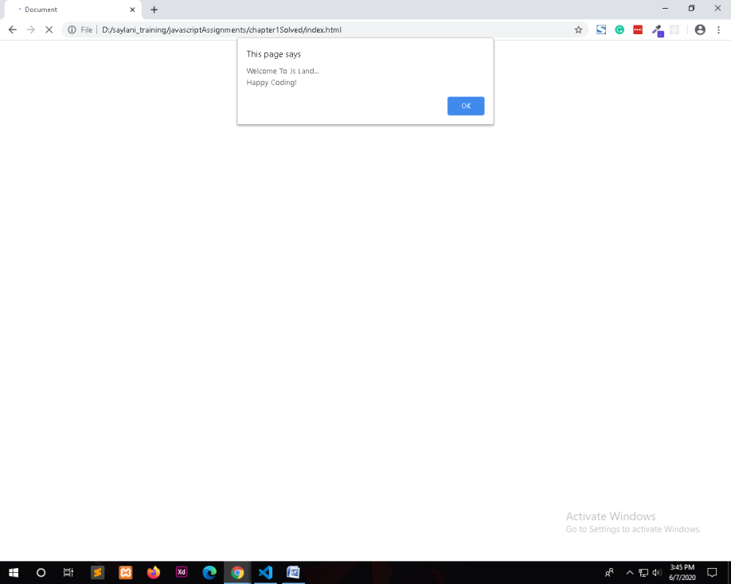

1. Write a script to display following messages in sequence.

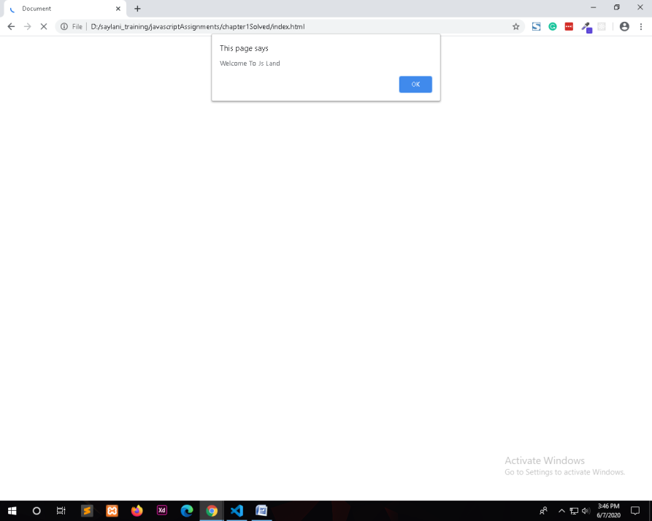

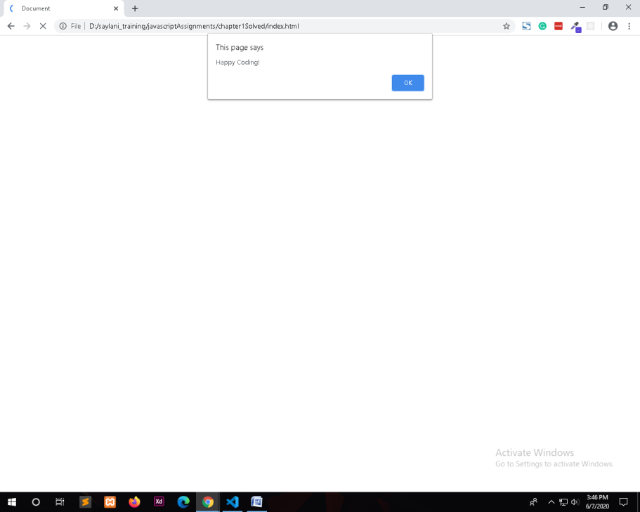

1. Generate the following message through browser’s developer console.

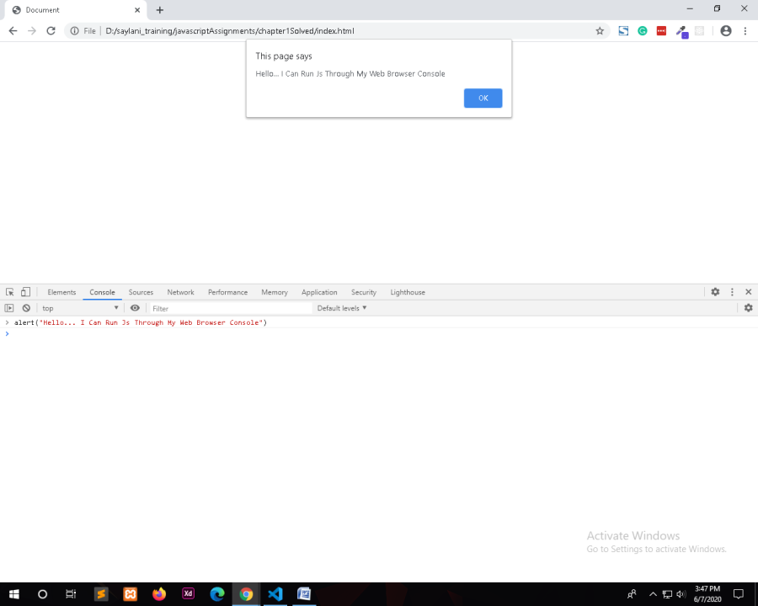

1. Make use of alerts in your new/existing HTML & CSS project.

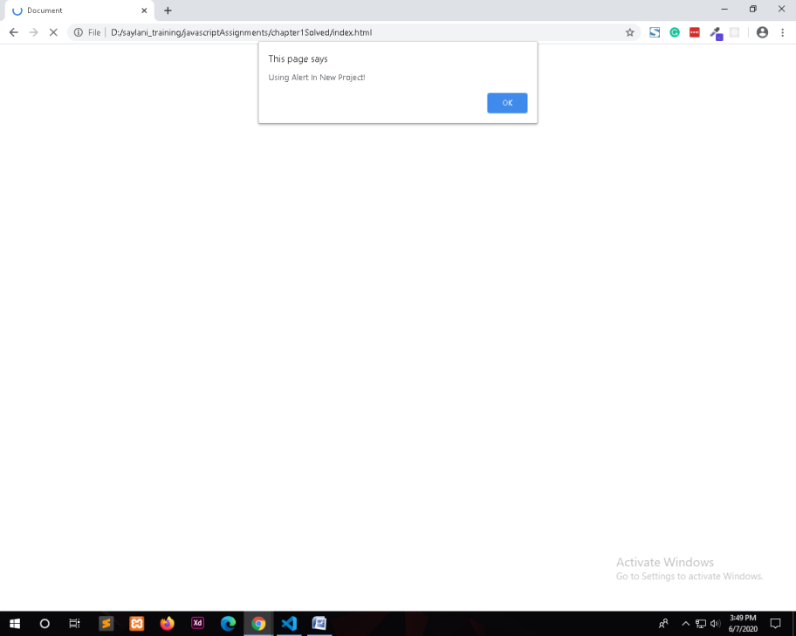

1. Practice placement of element in following sections of your project in exercise 6.
2. Head

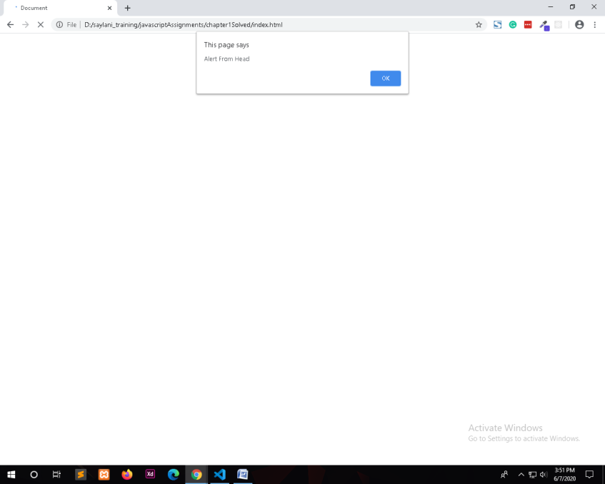

1. Body (before your page’s HTML)

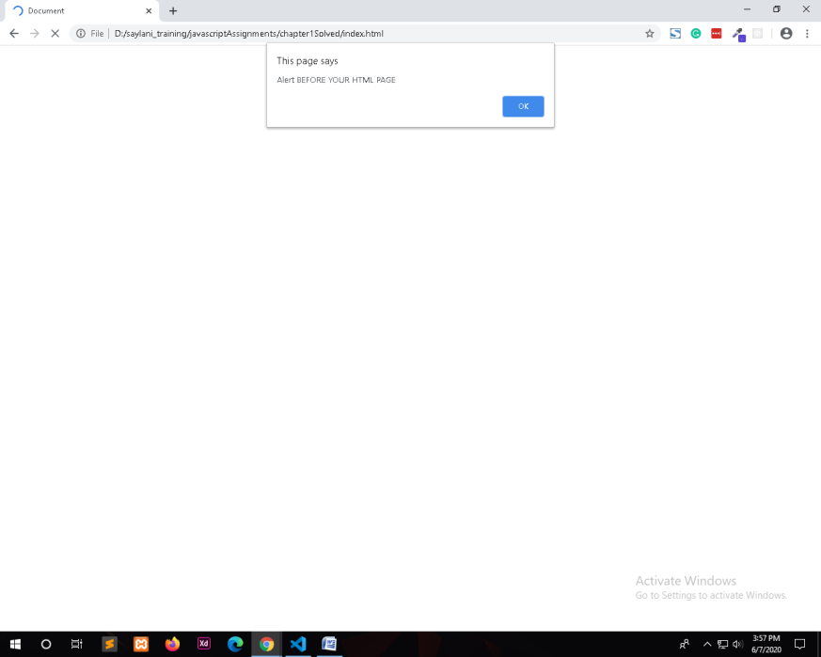

1. Body (inside your page’s HTML)

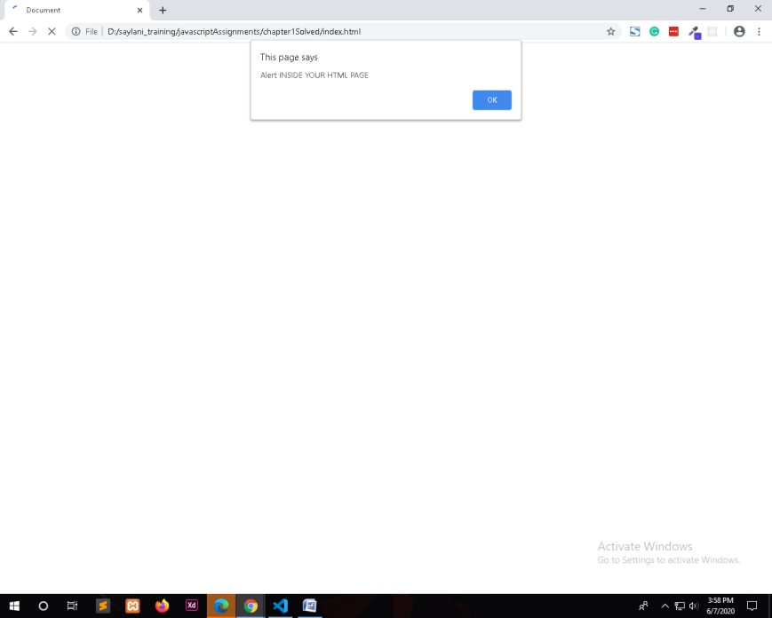

1. Body (after your page’s HTML)

