|  |  |  |
| --- | --- | --- |
| **University of Petra** | شعار جامعة البترا5 - |  |
| Faculty of Information Technology | كلية تكنولوجيا المعلومات |

ClassJo

Prepared By:

Mohammed Maher | 202210672

Omar Ismail | 202211473

Zaid Alolabe | 202110095

Supervised by:

Dr.Hossam Mustafa

Date:

2024/2025

**Abstract**

# 

ClassJo is an e-learning tool aiming at helping to organize the process of schooling and to facilitate cooperation between teachers, parents, and school management. It uses a Chabot for quick response for all the users and teachers; real-time analysis of students’ performances; and specific customizable notifications for all the interest parties. Operated on a secure cloud environment, ClassJo minimises data concerns and overload related administrative tasks that may hinder teacher students’ learning and development a lot. As the result, ClassJo is expected to make the educational process and the results more meaningful for each learner. Finally, the current abstract is also brief and aims at presenting the ClassJo as a working environment that comprises certain main key features, as well as possible advantages.

**Table of Contents**

Chapter One viii

1. Project Initiation ix

1.1 Problem Statement ix

1.2 Current System ix

1.3 Existing System ix

**1.3.1** **Seesaw** x

**1.3.2** **Remind** x

**1.3.3** **Edmo do** xi

**1.3.4** **ClassDojo** xii

1.4 Project Objectives xiii

1.5 Stakeholder List xiv

1.6 Proposed Scope xv

1.7 Scope excluded and project constraints xv

**1.7.1** **Scope excluded** xv

**1.7.2** **Project Constraints** xv

1.8 Literature Review xvi

1.9. Effects of the Project xvii

**Conclusion:** xviii

Chapter Tow xix

2.1. Planning xx

2.2. Scope Initiation xx

**2.2.1.** **WBS** xx

2.3. Gantt chart xxi

2.4. Resource Sheet xxii

**2.4.1.** **System Development Requirements** xxii

2.5. Cost Estimation and Budgeting xxiii

**2.5.1.** **System development requirements** xxiii

2.6. Risk xxiv

Chapter Three xxv

3. Requirements xxvi

3.1. Information Gathering xxvi

**3.1.1.** **Questionnaire** xxvi

3.2. Functional Requirements (FR) xxix

3.3. Non-Functional Requirements (NFR) xxix

3.4. Use Cases and Scenarios xxx

**FR1** xxx

**FR2** xxxi

**FR3** xxxii

**FR4** xxxiii

**FR5** xxxiii

**FR6** xxxiv

**FR7** xxxv

**FR8** xxxv

**FR9** xxxvi

**FR10** xxxvii

Chapter Four xxxviii

4. Project analysis and Design xxxix

4.1. Design Class Diagram xxxix

4.2. Use Case Diagram xl

4.3. Activity Diagram xli

**4.3.1.** **The Administrator to create and manage courses (FN2)** xli

**4.3.2.** **The assigned Teacher (Tether) to create and manage Tests (FN3)** xlii

**4.3.3.** **Calculate student performance based on exam and assignment results (FN4)** xliii

**4.3.4.** **The system shall include an AI-powered Chatbot to assist users (FN7)** xliv

4.4. Sequence Diagram xlv

**4.4.1.** **Users to log in** xlv

**4.4.2.** **Administrator to create and manage courses** xlvi

**4.4.3.** **The assigned Teacher (Tether) to create and manage Tests** xlvii

**4.4.4.** **Calculate student performance based on exam and assignment results** xlviii

4.5. State Chart Diagram xlix

4.6. Component Diagram l

4.7. Deployment Diagram li

4.8. I/O Screen lii

Chapter Five lvi

5. Project Implementation and Testing lvii

Chapter six lxv

Conclusion lxvi

Appendices lxvi

Project activities: lxvii

References lxxiv

**List of Figures**

Figure 1 Seesaw x

Figure **2** remind xi

Figure **3** Edmo Do xii

Figure 4 ClassDojo xii

Figure 5 Gantt chart xxi

Figure 6 Resource Sheet xxii

Figure 7 Design Class Diagram for app xxxix

Figure 8 Use Case Diagram for app xl

Figure 9 Activity Diagram functional 2 xli

Figure 10 Activity Diagram functional 3 xlii

Figure 11 Activity Diagram functional 4 xliii

Figure 12 Activity Diagram functional 7 xliv

Figure 13 sequence diagram functional 1 xlv

Figure 14 sequence diagram functional 2 xlvi

Figure 15 sequence diagram functional 3 xlvii

Figure 16 sequence diagram functional 4 xlviii

Figure 17 State Chart Diagram xlix

Figure 18 Component Diagram l

Figure 19 Deployment Diagram li

Figure 20 Design App lii

Figure 21 Design App liii

Figure 22 Design App liv

Figure 23 Design App lv

Figure 24 System Architecture lvii

Figure 25 Login lxii

Figure 26 Update lxiii

Figure 27 Add Student To Class and remove lxiii

Figure 28 Create exam and Create question lxiv

Figure 29 Appendix 1 lxvi

Figure 30 Appendix 2 lxvii

Figure 31 Appendix 3 lxviii

Figure 32 Appendix 4 lxviii

Figure 33 Appendix 5 lxviii

Figure 34 Appendix 6 lxix

Figure 35 Appendix 7 lxix

Figure 36 Appendix 8 lxix

Figure 37 Appendix 9 lxx

Figure 38 Appendix 10 lxx

Figure 39 Appendix 11 lxx

Figure 40 Appendix 12 lxxi

Figure 41 Appendix 13 lxxi

Figure 42 Appendix 14 lxxii

Figure 43 Appendix 15 lxxii

Figure 44 Appendix 16 lxxiii

Figure 45 Appendix 17 lxxiii

Figure 46 Appendix 18 lxxiii

**List of Tables**

Table 1 Stakeholder List xiii

Table 2 Scope Initiation xx

Table 3 System Dev Req xxi

Table 4 Cost Estimation xxii

Table 5 System Development Requirements xxii

Table 6 Login xxx

Table 7 create and manage courses xxxi

Table 8 Create and manage Test xxxi

Table 9 Calculate Performance xxxii

Table 10 Track Attendance xxxiii

Table 11 Notify Parents xxxiv

Table 12 Chatbot xxxiv

Table 13 Ratings performance xxxv

Table 14 Edit and Update Student xxxvi

Table 15 Generate and share reports xxxvi

Table 16 Functional Test Cases lviii

Table 17 Database Mapping (Scheme Diagram) lix

Table 18 Tables Descriptions lxi

Table 19 Project activities lxvi

# **Chapter One**

**Project Initiation**

# **Project Initiation**

This section describes the preliminary steps and activities carried out to launch the ClassJo these steps include defining project’s feasibility is evaluated and its foundation is laid, including defining objectives, scope, and stakeholders.

## **Problem Statement**

The current educational system often fails to support parents with real-time, comprehensive insights into their child's academic performance, behaviors, and overall school activities, leading to significant communication difficulties. Parents are commonly updated periodically, leaving them with limited opportunities to address issues affecting their child’s development. This delay in feedback limits their ability to respond quickly to their child's evolving needs, ultimately affecting the child’s learning experience and growth. The lack of structured, ongoing communication between teachers and parents can also reduce parental engagement and prevent timely interventions for students facing academic or behavioral challenges. Without a system in place that allows for consistent, day-to-day feedback, the opportunity for early intervention is missed, which could otherwise mitigate prospective difficulties.

Proposing a system that leverages Artificial Intelligence (AI) to analyses student data presents an opportunity to bridge these difficulties. Such a system would provide teachers with a platform to rate and document student activities and behaviors daily, offering parents and supervisors continuous insights. This approach would enable a proactive and personalized approach to addressing students’ academic and emotional needs.

## **Current System**

Currently, classroom communication and behaviour tracking are managed through a variety of traditional tools and methods, educators and parents typically rely on basic digital platforms, paper notes, and engagement. These system often lack real-time interaction, comprehensive tracking and efficient parent-teacher communication, which can result in missed opportunities for timely feedback and intervention.

## **Existing System**

This section provides an overview of the current task management systems in use, identifying their advantages and disadvantages.

### **Seesaw**

Seesaw is an instructive a learning stage that permits outlined for instructors, understudies, and families to lock in take part in a assortment of different intelligently learning instructive encounters. It is broadly utilized commonly utilized in K-12 instruction for making, the creation, sharing, and reflecting reflection on advanced portfolios.



Figure 1 Seesaw

**Feature:**

1. Student Portfolios.
2. Creative Tools.
3. Family Interaction.

**Advantages:**

1. Increased Student Engagement.
2. Encourages Reflective Learning.
3. Parental Involvement.
4. Personalized Learning.

**Shortcomings:**

1. Digital Literacy Requirements.
2. Privacy Issues.
3. Limited Free Features.

### **Remind**

Remind is an application that allows teachers to share messages with parents and students in form of a reminder, update or an announcement. It informs parents in real time the activities in their child’s school and the child’s performance.



Figure **2** remind

**Feature:**

1. Messaging.
2. Announcement sharing.
3. Scheduling.

**Advantages:**

1. Privacy and Security
2. Accessibility for Non-English Speakers

**Shortcomings:**

1. Reliance on Teacher Engagement.

### **Edmo do**

Edmo do is mostly used as learning management system (LMS), it enabled teachers to share content distribute quizzes and assignments, it also allows teachers to share grades and progress updates with parents to keep them informed about their son’s academic performance.



Figure **3** Edmo Do

**Feature:**

1. Unlimited storage.
2. Quickly create groups.
3. Assign homework.

**Advantages:**

1. Student Collaboration.
2. Comprehensive Learning Management System.

**Shortcomings:**

1. Complex User Interface.
2. Less Personalized Feedback.

### **ClassDojo**

ClassDojo is a Massive platform to help in teaching and used majorly in K-12 classrooms for making proper control over their actions from teachers, communicating with parents about the behaviour of their kids and thereby creating good relationships between Teachers, Parents and Students.



Figure 4 ClassDojo

**Feature:**

1. Behaviour tracking.
2. Real-time communication between teachers and parents.
3. Class updates.

**Advantages:**

1. User-Friendly Interface
2. Instant Feedback for Students.

**Shortcomings:**

1. Absence of Recommendations for Academic Support.

## **Project Objectives**

**Objective 1**: Develop a mechanism for timely monitoring of student academic performance, conduct and school-wide activity.

**Objective 2:** Enable daily reporting of behavioural incidents or praise by teachers

**Objective** **3:** Identify early signs of academic or behavioural difficulty to alert parents to intervene sooner.

**Objective** **4:** Establish a systematic, regular channel of communication between teachers and parents.

## **Stakeholder List**

|  |  |  |
| --- | --- | --- |
| Stakeholder | Interest | Importance |
| Project Sponsor | Provides funding and oversees project approval. | Medium |
| |  | | --- | | Project Manager |  |  | | --- | |  | | Manages timelines, scope, and resources. | High |
| Developers and product team | Those responsible for creating and maintaining the application, including software engineers ,designers, product managers , and quality assurance tester | Medium |
| Customer Support Team | Provides support for user issues and queries. | Medium |
| School Administrators | Partner entities essential for integration and policy alignment. | High |
| Teachers | Primary system users who input and access data. | High |
| Parents | |  | | --- | | End users who monitor and engage with their children’s academic progress. |  |  | | --- | |  | | High |
| Students | Direct beneficiaries whose engagement is crucial for feedback and system evolution. | Medium |

Table 1 Stakeholder List

## **Proposed Scope**

The real-time update system is a reminder system to notify parents about their child's performance, discipline, school activities, and other essential updates in real-time. The behavior documentation tool is a feature for teachers to record events, including incidents and positive achievements, providing parents with access to this information and enabling direct communication with teachers. The early detection and notification system integrates tools to identify and immediately alert parents about their children’s academic or behavioral challenges. Additionally, it serves as a structured feedback loop, a systematic feedback mechanism to facilitate continuous and effective communication between teachers and parents to resolve student-related issues. The parent-teacher interface is a dedicated communication platform to enhance interaction and collaboration between parents and teachers. The system is integrated with the school’s existing databases, allowing real-time access to and processing of student information.

## **Scope excluded and project constraints**

The following section details the specific features and functionalities that are

Intentionally excluded from the scope of the Classjo

### **Scope excluded**

Medical or Psychological Assessments: It is advised not to get involved in any circumstance, which deals with any medical or psychological concern but instead only discuss academic and conducts behaviourally related issues.

Offline Access: Offline functionalities are not recommended for the notification and the communication systems because the information has to be updated frequently

### **Project Constraints**

* **Time Constraints**

1. The project timeline is tightly constrained and must align with the academic calendar to ensure readiness for the new school year.
2. All phases (design, development, testing, and deployment) must be completed consecutively, and delays in one phase could cause cascading delays.

* **Financial Constraints**

1. The initial budget is limited, necessitating prioritization of essential features such as security and communication over optional features.
2. Funds may need to be reallocated to ensure critical components are delivered, potentially at the expense of planned secondary features.

* **Technical Limitations**

1. System Compatibility and Integration: Integrating with diverse school management systems increases complexity and resource requirements, particularly for ensuring data integrity and security.
2. Backup and Data Recovery: Robust backup and disaster recovery solutions are essential to prevent data loss and ensure swift recovery after downtimes or cyber-attacks.
3. Network Dependencies and Failure Points: Cloud-based systems relying on stable network connections may face challenges in regions with poor connectivity, incorporating offline capabilities or backup plans could mitigate accessibility issues in such areas.

## **Literature Review**

Enhancing parent-school communication via mobile applications , Effective communication between parents and schools has been recognized as a critical factor in fostering student success , with the advent of mobile application , this communication has been redefined to offer more efficient and interactive solutions, this review examines existing literature on parent-school communication , mobile application adoption in education and the role of platforms like Classjo in addressing these challenges .

* Parent-School Communication

Parent-school communications has long been a cornerstone of effective educational outcomes , Epstein 2001 highlighted the importance of parental involvement in shaping students' academic and social development traditional methods , such as parent-teacher conferences and printed newsletters often suffered from logistical limitations and low engagement rates (Hornby,2011) , modern approaches emphasize real-time , bidirectional communication allowing parents to remain actively involved in their children's educational journeys (smith, 2018).

* Mobile Application in Education

The rise of mobile technology has significantly impacted educational practices, According to Johnson et al (2016), mobile application in education offer unique advantages including accessibility customization and real-time updates, these tools

Also support various functionalities, such as instant messaging, notifications and progress tracking which align with the needs of busy parents and educators (Kumar and Singh 2019), despite these benefits challenges such as digital literacy, privacy concerns and equitable access remain pressing issues (Hargittai,2008).

* ClassDojo A case Study

ClassDojo , a popular mobile application , exemplifies the integration of technology into parent-school communication , the platform provides features like behavior tracking , classroom updates and direct messaging between parents and teacher (ClassDojo 2023) , studies have shown that ClassDojo enhances parental engagement by simplifying the process of staying informed and involved (Bergmann and Sams,2020), furthermore the application's gamified elements motivate students thereby creating a holistic educational ecosystem (sun and rogers 2021).

## **Effects of the Project**

The ClassJo project enhances school communication, streamlines administrative processes, and supports digital transformation by providing a secure, centralized platform for managing attendance, performance, tests, and courses. It fosters parent engagement, improves student performance tracking, and delivers time and cost savings, ultimately making education more accessible, efficient, and impactful.

### **Conclusion:**

While mobile applications have revolutionized parent-school communication ongoing efforts are essential to maximize their benefits and mitigate associated challenges this ensures that platforms like Classjo can continue to support inclusive effective and secure educational environments.

# **Chapter Tow**

**Project Planning**

# **Planning**

Writing a plan is significant in the management process of a project since it set objectives, scope, and resources that all the members in the team strives to achieve. It makes resource allocation convenient; time is also well utilized and costs are well controlled since the planning process comes with a cost consideration, accompanied by cost risks that may arise from cost overruns. This also involves early risk management to counter check for problematic areas and develop solutions in advance to reduce interference. Moreover, planning determines quality requirements and dimensions of performance that will provide quality outcomes based on stakeholders’ expectations. In the broad brushstroke, planning enhances the prospects of project delivery since there’s a laid down framework that enhances efficient execution and control.

## **Scope Initiation**

The project scope is divided into six main phases, each with specific tasks outlined in the Work Breakdown Structure (WBS):

### **WBS**

|  |  |
| --- | --- |
| WBS | Task Name |
| **1** | **Project Initiation** |
| 1.1 | Stakeholder Identification |
| 1.2 | Requirement Gathering |
| 1.3 | Initial Feasibility Study |
| **2** | **Project Planning** |
| 2.1 | Define Project Scope |
| 2.2 | Develop Project Schedule |
| 2.3 | Resource Allocation |
| 2.4 | Risk Identification |
| **3** | **System Design** |
| 3.1 | Create Use Case Diagrams |
| 3.2 | Design System Architecture |
| 3.3 | Design UI/UX |
| **4** | **System Development** |
| 4.1 | Backend Development |
| 4.2 | Frontend Development |
| 4.3 | Database Development |
| **5** | **Testing** |
| 5.1 | Unit Testing |
| 5.2 | Integration Testing |
| 5.3 | User Acceptance Testing (UAT) |
| **6** | **Deployment** |
| 6.1 | Deployment on Cloud Server |
| 6.2 | Launch System |

Table 2 Scope Initiation

## **Gantt chart**

The Gantt chart demonstrates the project activities (Y-axis) with the project's timetable (X-axis). It also shows the links and dependencies between the different tasks and increments.

Figure 5 Gantt chart

## **Resource Sheet**

The following table outlines the resources required for the project, including Human Resources, Software, and Hardware:

Figure 6 Resource Sheet

### **System Development Requirements**

The following table demonstrates the resources required throughout the development process of this project, including Human Resources, Software, and Hardware:

|  |  |
| --- | --- |
| Resource Type | Resources |
| Human Resources | 1. Zaid 2. Omar 3. Mohammed |
| Software | 1. Cloud Hosting (AWS Free Tier, Google Cloud Free Tier)  2. AI Chatbot API (Open Source, e.g., Rasa)  3. Project Management Tool (Trello, Jira Free Plan)  4. Version Control (GitHub, GitLab)  5. Security Tools (Open Source, e.g., OWASP ZAP) |
| Hardware | 1. Laptops/PCs (personal devices)  2. Internet Connection (personal)  3. Mobile Devices (for testing, personal) |

Table 3 System Dev Req

## **Cost Estimation and Budgeting**

The following table contains cost estimations for the different resources used in the development process of this project:

|  |  |  |  |  |
| --- | --- | --- | --- | --- |
| Human Resources | Name | Hourly Rate | Monthly Cost | Entire Project (3 Months) |
| 1 | Zaid | $25.00/hr | $500 | $12,000 |
| 2 | Omar | $50.00/hr | $8,000 | $24,000 |
| 3 | Mohammed | $25.00/hr | $4,000 | $12,000 |
| 4 | Zaid and omar | $50.00/hr | $8,000 | $24,000 |
|  | Total Human Resources |  | $24,000 | $72,000 |

Table 4 Cost Estimation

### **System development requirements**

|  |  |  |  |
| --- | --- | --- | --- |
| Name | Cost per Month | Project Duration (3 Months) | Total Cost |
| Zaid | Cloud Hosting (AWS) | $0.00 | $0.00 |
| Omar | AI Chatbot API | $25.00 | $75.00 |
| Mohammed | Microsoft Project | $10.00 | $30.00 |
| Omar and Mohammed | Security Tools | $0.00 | $0.00 |
| Name | Cost per Month | Project Duration (3 Months) | Total Cost |
| Zaid | Cloud Hosting (AWS) | $0.00 | $0.00 |
| Omar | AI Chatbot API | $25.00 | $75.00 |
| Mohammed | Microsoft Project | $10.00 | $30.00 |
| Zaid and Mohammed | Security Tools | $0.00 | $0.00 |
|  | Total Materials | $35.00 | $105.00 |

Table 5 System Development Requirements

## **Risk**

1. Technical Risks: Integration challenges with existing school systems.
2. Budget Risks: Limited funding may restrict advanced features.
3. Time Risks: Delays in development due to unforeseen issues.
4. Data Security Risks: Ensuring the security of student and parent data.
5. Lack of Experience: Team members may lack experience in certain technologies, affecting the timeline.
6. Changing Requirements: Requirements may change, impacting the project timeline and scope.

# 

# **Chapter Three**

**Project Requirements**

# **Requirements**

A questionnaire was distributed to gather the needed requirements for the system, it targets key stakeholders, including teacher's parent's students and school administrator. Knowing the answer to these questions is very important as it enables us to know how these functionalities positively affect student engagement manage communication processes to fit the app and make education more effective. By aligning the app's development with actual user feedback we aim to create a more positive, efficient and user-oriented educational environment.

## **Information Gathering**

### **Questionnaire**

Figure 1:78.8% described themselves as parents, teachers were 9.1% while administrators were 12.1%. No respondents selected a no relationship option with the school.

Figure 2: The survey further showed that out of all the respondents 47.1% prefer using mobile application when it comes to communication with the school. While 14.7% use, emails, 11.8% use phone calls, face-to-face meetings have 8.8% and WhatsApp groups also have 8.8%. A small proportion, 8.8% use all the above mentioned methods.

Figure 3: A majority, 44.1% of the respondents seldom have face ’to face interactions with school staff. Meetings are held every month by 32.4% participants, weekly by 14.7% and 8.8% participants never attend meetings.

Figure 4: Regarding the disadvantages, 48.5% of the participants pointed to the delay as a critical factor 42.4% singled out the risks of miscommunication, while 39.4% mentioned that scheduling meetings was a problem as well. About real time update, 21.2% participants voiced concern.

Figure 5: While testing the applicability of the traditional approach of communicating information, the responses as follows: somewhat effective 41.2%, very effective 29.4%, not very effective 23.5%, and ineffective 5.9%.

Figure 6: Presently, 64.7% of the respondents said that they are already in the habit of using mobile applications in communication with the school while 32.4% indicated otherwise and 2.9% mentioned that they intend to use a mobile application in this regard in the near future.

Figure 7: The most preferred application is ClassDojo, chosen by 29.4% of the users. Remind follows with 14.7%, Seesaw and Microsoft Teams each at 11.8%, Google Classroom at 8.8%, and Education now at 8.8 % also there is 8.8% of the participants who reported that they do not use any of the apps represented in this survey.

Figure 8: As for the perceived ease of use of mobile apps, 29.4% of the respondents perceive it as very easy while 38.2% somewhat perceive it as easy, 26.5% are in the middle, 11.8% found it difficult and only 8.8% very difficult.

Figure 9: There comes information on student behavior- regularly by 32.4%, occasionally by 26.5%, rarely by 26.5% while 14.7% hardly get such information updated.

Figure 10: Engagement with Monitoring Features: Regarding the interaction with the behavior monitoring features in the Apps: daily 20.6%, weekly 20.6%, occasionally 20.6%, never 17.6% and rarely 20.6%.

Figure 11: Real-Time Feedback Utility: Regarding real-time feedback features respondent said it was very useful 55.9%, somewhat 29.4% found it neutral 8.8%

Figure 12: Impact on Parental Involvement: Mobile apps make the users more involved in their child’s education by a large extent to 47.1% higher extent, somewhat more involved by 38.2%, not much involved by 11.8% and not at all involved by 2.9%.

Figure 13: When it comes to the enhancing of learners and teaching facilities via mobile applications, 41.2% of the respondents identified the factor of communication and another 41.2% said that they value real-time update on events. 35.3% of the participant said that they note the convenience of the learning resources that is facilitated by the use of the mobile applications. Better accountability was mentioned as one of the benefits that was obtained from use if mobile applications with 32.4% of the respondents supporting the benefit.

Figure 14: A majority of respondents expressed a desire for additional features in mobile communication apps 44.1% wants the application to support video conferencing.44.1% of the participants would like to have multilingual options.44.1% of the users want the application to be secure.26.5% of the participants would like the application to connect to traditional communication technologies.

Figure 15: There is interest in behavior tracking, 67.6% the respondents were interested in the app tracking behaviour.55.9% said they would like the app to track homework. Academic performance, and attendance are also crucial and these were accepted by 47.1% and 52.9% of those surveyed.

Figure 16: 55.9% said they would want to be updated either weekly or monthly.38.2% said they would be interested in being notified on critical events. Report that is appreciated by 35.3% of respondents contains an information about a daily performance.

Figure 17: Usefulness of an AI Chabot: If an AI Chabot is designed for summarizing student performance: Very useful 44.1%, somewhat useful 29.4%, neutral 17.6%, and not at all useful 8.8%.

Figure 18: Recommendation of Mobile Apps: In general, 76.5 % of the respondents would definitely recommend the use of mobile applications for parent-school communication while 17.6% at some level and 5.9% categorically rejected the idea.

## **Functional Requirements (FR)**

**FR1**: The system shall allow users to log in securely based on their roles (Administrator, Teacher, Student, and Parent).

**FR2**: The system shall allow the Administrator to create and manage courses, including assigning Teachers (Tethers) to specific courses.

**FR3**: The system shall allow the assigned Teacher (Tether) to create and manage Tests for the courses they are assigned to.

**FR4**: The system shall calculate student performance based on exam and Assignments results, assign points, and provide a rating for each student.

**FR5**: The system shall track and maintain records of student attendance for each course.

**FR6**: The system shall notify Parents with daily summaries, including attendance, performance updates, and any other relevant information.

**FR7**: The system shall include an AI-powered Chatbot to assist users with queries and provide support.

**FR8**: The system shall allow the Administrator to view and analyse all student ratings and performance reports.

**FR9**: The system shall allow the Administrator to edit and update student and teacher profiles and related data

**FR10:** The system shall generate and share detailed reports with Administrators and Teachers, summarizing student performance, attendance, and ratings

## **Non-Functional Requirements (NFR)**

**NFR1**: The system shall be efficiency.

**NFR2**: The system shall be scalability.

**NFR3**: The system shall be usability.

**NFR4**: The system shall be availability.

**NFR5**: The system shall be implementing security measures.

**NFR6**: The system shall keep user information secure.

**NFR7**: The system shall be maintainability.

**NFR8**: The system shall be Modifiability.

## **Use Cases and Scenarios**

Use cases and scenarios in software development are a must. Use cases suggest how a system can achieve its goals, while scenarios describe conditions for operating the system including its context and requirements. Both serve as a guide to design, development, and testing that will ensure the system meets users, expectations and real-world needs.

**FR1**: The system shall allow users to log in securely based on their roles (Administrator, Teacher, Student, and Parent).

|  |  |
| --- | --- |
| Use case name | allow users to log in securely based on their roles |
| Precondition | |  | | --- | | Users must have valid credentials (username and password) and a registered role. | |  | |
| Interested stakeholders | |  | | --- | | Administrators, Teachers, Students, Parents. | |  | |
| Flow Of Events | 1. User navigates to the login page. 2. User enters credentials. 3. System validates credentials and role. 4. User is granted access based on their role. |
| Alternatives | - User forgets password and uses a "Forgot Password" feature. |
| Post Conditions | |  | | --- | | User is logged in and redirected to their respective dashboard based on their role. | |  | |
| Exceptions | - Invalid credentials. - Account is locked or disabled. - Network or server issues. |

Table 6 Login

**FR2**: The system shall allow the Administrator to create and manage courses, including assigning Teachers (Tethers) to specific courses.

|  |  |
| --- | --- |
| Use case name | allow the Administrator to create and manage courses |
| Precondition | |  | | --- | | Administrator must be logged in. | |  | |
| Interested stakeholders | |  | | --- | | Teachers, Students. | |  | |  | |
| Flow Of Events | 1. Teacher navigates to the course dashboard. 2. Teacher creates a new test or edits an existing one. 3. Teacher sets test parameters (e.g., duration, questions). 4. System saves the test |
| Alternatives | - Teacher deletes a test. - Teacher schedules a test for a future date. |
| Post Conditions | |  |  |  | | --- | --- | --- | | |  | | --- | | Test is created/updated and available for students. | |  | | |  | |
| Exceptions | - Teacher is already assigned to another course at the same time. - System fails to save changes. |

Table 7 create and manage courses

**FR3**: The system shall allow the assigned Teacher (Tether) to create and manage Tests for the courses they are assigned to

|  |  |
| --- | --- |
| Use case name | allow the assigned Teacher (Tether) to create and manage Tests for the courses |
| Precondition | |  | | --- | | Teacher must be logged in and assigned to a course. | |  | |
| Interested stakeholders | |  | | --- | | Teachers, Students. | |  | |
| Flow Of Events | 1. Teacher navigates to the course dashboard. 2. Teacher creates a new test or edits an existing one. 3. Teacher sets test parameters (e.g., duration, questions). 4. System saves the test. |
| Alternatives | 1. - Teacher deletes a test. - Teacher schedules a test for a future date. |
| Post Conditions | |  | | --- | | Test is created/updated and available for students. | |  | |
| Exceptions | - System fails to save the test. - Test parameters are invalid. |

Table 8 Create and manage Test

**FR4**: The system shall calculate student performance based on exam and Assignments results, assign points, and provide a rating for each student

|  |  |
| --- | --- |
| Use case name | calculate student performance based on exam |
| Precondition | |  | | --- | | Exam and assignment results are available in the system. | |  | |
| Interested stakeholders | |  | | --- | | Teachers, Students, Parents. | |  | |
| Flow Of Events | 1. System retrieves exam and assignment results.  2. System calculates performance metrics (e.g., scores, points).  3. System assigns a rating based on predefined criteria.  4. System updates the student's profile with the rating. |
| Alternatives | |  | | --- | | 1. Manual override by Teacher to adjust ratings. | |
| Post Conditions | |  | | --- | | Student performance is calculated, and ratings are updated. | |  | |
| Exceptions | - Missing or incomplete data. - Calculation errors. |

Table 9 Calculate Performance

**FR5**: The system shall track and maintain records of student attendance for each course.

|  |  |
| --- | --- |
| Use case name | track and maintain records of student attendance |
| Precondition | |  | | --- | | Students are enrolled in courses, and attendance tracking is enabled. | |  | |
| Interested stakeholders | |  | | --- | | Teachers, Students, Parents. | |  | |
| Flow Of Events | 1. Teacher marks attendance during a class session. 2. System records attendance data. 3. System updates the student's attendance record |
| Alternatives | |  | | --- | | Automated attendance by the end of the class | |  | |
| Post Conditions | |  |  |  | | --- | --- | --- | | |  | | --- | | Attendance records are updated and stored. | |  | | |  | |
| Exceptions | - Teacher fails to mark attendance. - System fails to record data. |

Table 10 Track Attendance

**FR6**: The system shall notify Parents with daily summaries, including attendance, performance updates, and any other relevant information.

|  |  |
| --- | --- |
| Use case name | shall notify Parents with daily summaries |
| Precondition | |  | | --- | | Parents must have valid accounts and linked student profiles. | |  | |
| Interested stakeholders | |  | | --- | | Parents, Students. | |  | |
| Flow Of Events | 1. System compiles daily summaries (attendance, performance, etc.). 2. System sends notifications to Parents via email or app. |
| Alternatives | - Parents opt-out of notifications. - Notifications are sent weekly instead of daily. |
| Post Conditions | |  | | --- | | Parents receive daily summaries. | |  | |
| Exceptions | - Notification delivery fails. - Data is incomplete or unavailable. |

Table 11 Notify Parents

**FR7**: The system shall include an AI-powered Chatbot to assist users with queries and provide support.

|  |  |
| --- | --- |
| Use case name | AI-powered Chatbot to assist users |
| Precondition | |  | | --- | | Chatbot must be enabled and accessible to users. | |  | |
| Interested stakeholders | |  | | --- | | All users (Administrators, Teachers, Students, Parents). | |  | |
| Flow Of Events | 1. User interacts with the Chatbot. 2. Chatbot processes the query and provides a response or escalates to a human agent |
| Alternatives | - Chatbot provides predefined FAQs. - Chatbot redirects to a support page. |
| Post Conditions | |  | | --- | | 1. User receives assistance or resolution. | |  | |
| Exceptions | - Chatbot fails to understand the query. - Technical issues with the Chatbot. |

Table 12 Chatbot

**FR8**: The system shall allow the Administrator to view and analyze all student ratings and performance reports.

|  |  |
| --- | --- |
| Use case name | AI-powered Chatbot to assist users |
| Precondition | |  | | --- | | Administrator must be logged in. | |  | |
| Interested stakeholders | |  | | --- | | Administrators. | |  | |
| Flow Of Events | 1. Administrator navigates to the reports section. 2. Administrator selects a student or group of students. 3. System displays ratings and performance reports. |
| Alternatives | |  | | --- | | - Administrator exports reports for offline analysis. | |  | |
| Post Conditions | |  |  |  | | --- | --- | --- | | |  | | --- | | Administrator views and analyzes reports. | |  | | |  | |
| Exceptions | - Reports are unavailable or incomplete. - System fails to generate reports. |

Table 13 Ratings performance

**FR9**: The system shall allow the Administrator to edit and update student and teacher profiles and related data.

|  |  |
| --- | --- |
| Use case name | allow the Administrator to edit and update student and teacher |
| Precondition | |  | | --- | | Administrator must be logged in. | |  | |
| Interested stakeholders | |  |  |  | | --- | --- | --- | | |  | | --- | | Administrators, Teachers, Students. | |  |   . | |  | |
| Flow Of Events | 1. Administrator navigates to the profile management section. 2. Administrator selects a profile to edit. 3. Administrator updates the profile data. 4. System saves the changes. |
| Alternatives | |  |  |  | | --- | --- | --- | | |  | | --- | | - Administrator deletes a profile. | |  | | |  | |
| Post Conditions | |  |  |  |  |  | | --- | --- | --- | --- | --- | | |  |  |  | | --- | --- | --- | | |  | | --- | | Profile data is updated and saved. | |  | | |  | | |  | |
| Exceptions | - Invalid data entered. - System fails to save changes. |

Table 14 Edit and Update Student

**FR10**: The system shall generate and share detailed reports with Administrators and Teachers, summarizing student performance, attendance, and ratings.

|  |  |
| --- | --- |
| Use case name | provide Teachers with the ability to review and update student ratings |
| Precondition | |  | | --- | | Student data (performance, attendance, ratings) is available. | |  | |
| Interested stakeholders | |  |  |  | | --- | --- | --- | | |  | | --- | | Administrators, Teachers. | |  | | |  | |  | |  | |
| Flow Of Events | 1. System compiles data into a report. 2. System shares the report with Administrators and Teachers via email or dashboard. |
| Alternatives | |  |  |  |  |  | | --- | --- | --- | --- | --- | | |  |  |  | | --- | --- | --- | | |  | | --- | | - Reports are generated on-demand. | |  | | |  | | |  | |
| Post Conditions | |  | | --- | | Reports are generated and shared. | |  | |
| Exceptions | - Data is incomplete or unavailable. - Report generation fails. |

Table 15 Generate and share reports

# **Chapter Four**

**Project Analysis and Design**

# **Project analysis and Design**

This section provides details about the analysis and design of the CalssJo Application, which is derived from the user requirements. We use various UML diagrams such as class diagrams, use case, activity, sequence, state chart, component, and deployment diagrams to present the structure and behaviour of the system.

## **Design Class Diagram**

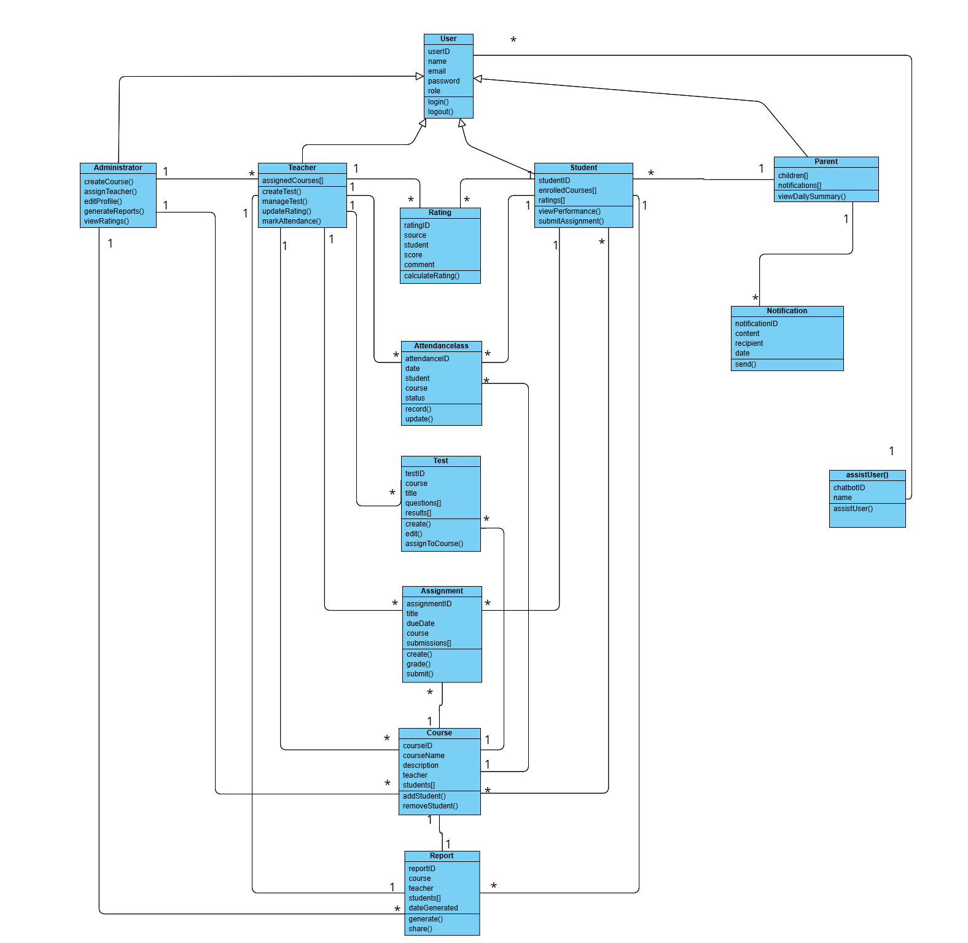

Figure 7 Design Class Diagram for app

## **Use Case Diagram**

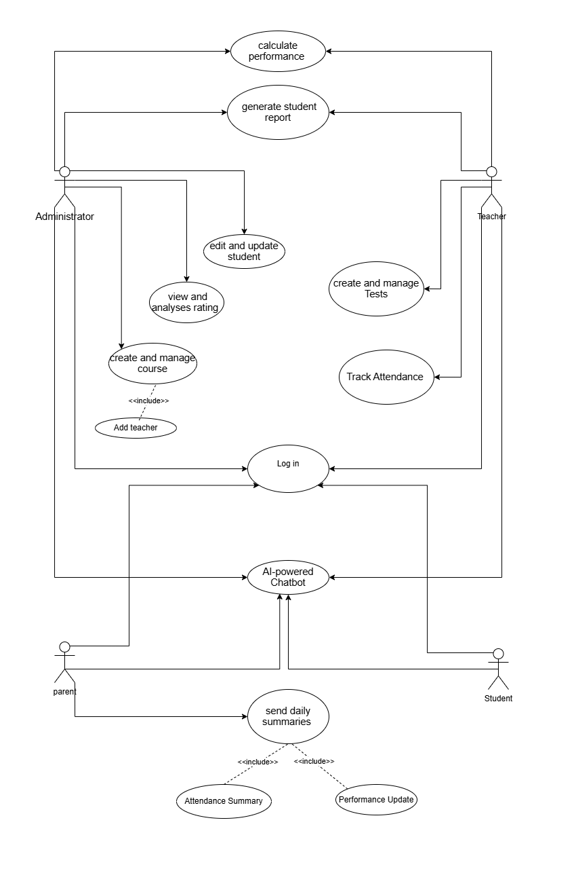

Figure 8 Use Case Diagram for app

## **Activity Diagram**

In this section we describe Activity diagrams to demonstrate user actions done in the system

### **The Administrator to create and manage courses (FN2)**

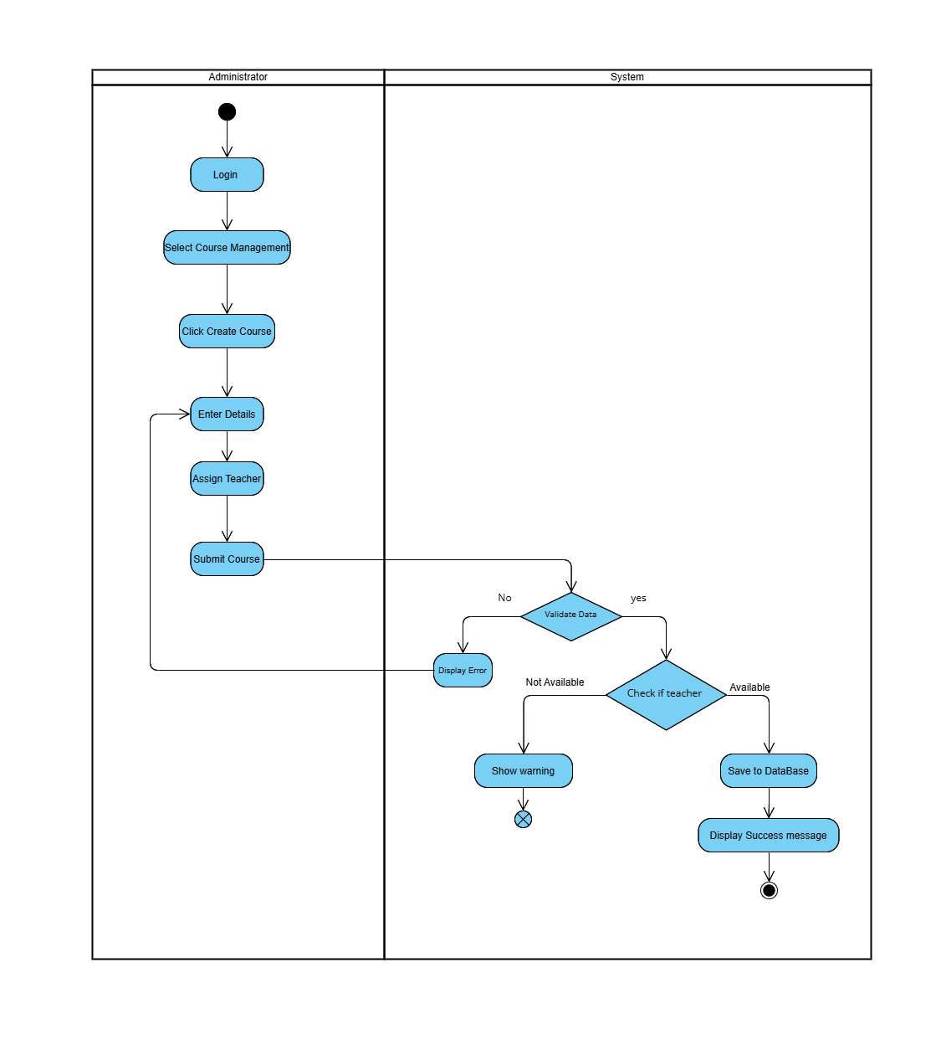

Figure 9 Activity Diagram functional 2

### **The assigned Teacher (Tether) to create and manage Tests (FN3)**

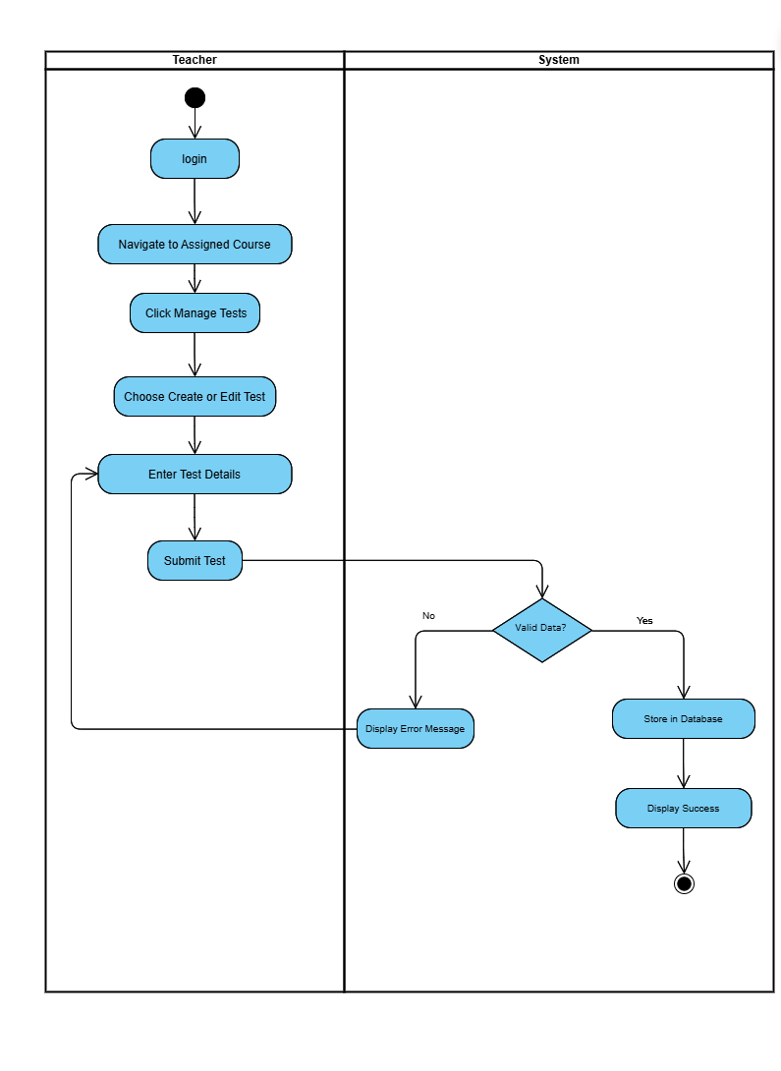

Figure 10 Activity Diagram functional 3

### **Calculate student performance based on exam and assignment results (FN4)**

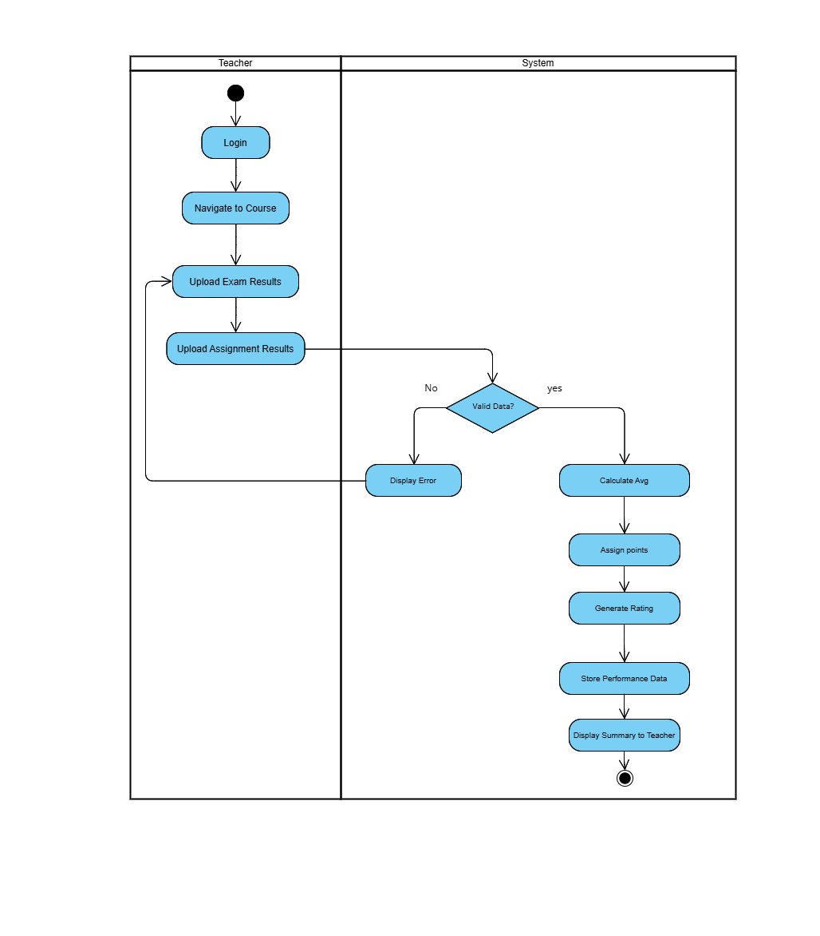

Figure 11 Activity Diagram functional 4

### **The system shall include an AI-powered Chatbot to assist users (FN7)**

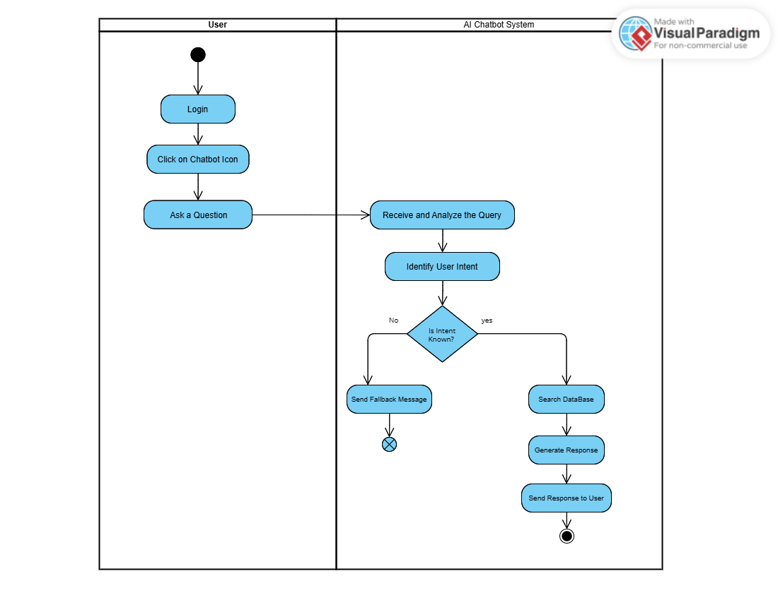

Figure 12 Activity Diagram functional 7

## **Sequence Diagram**

In this section we describe sequence diagrams to demonstrate user actions done in the system

### **Users to log in**

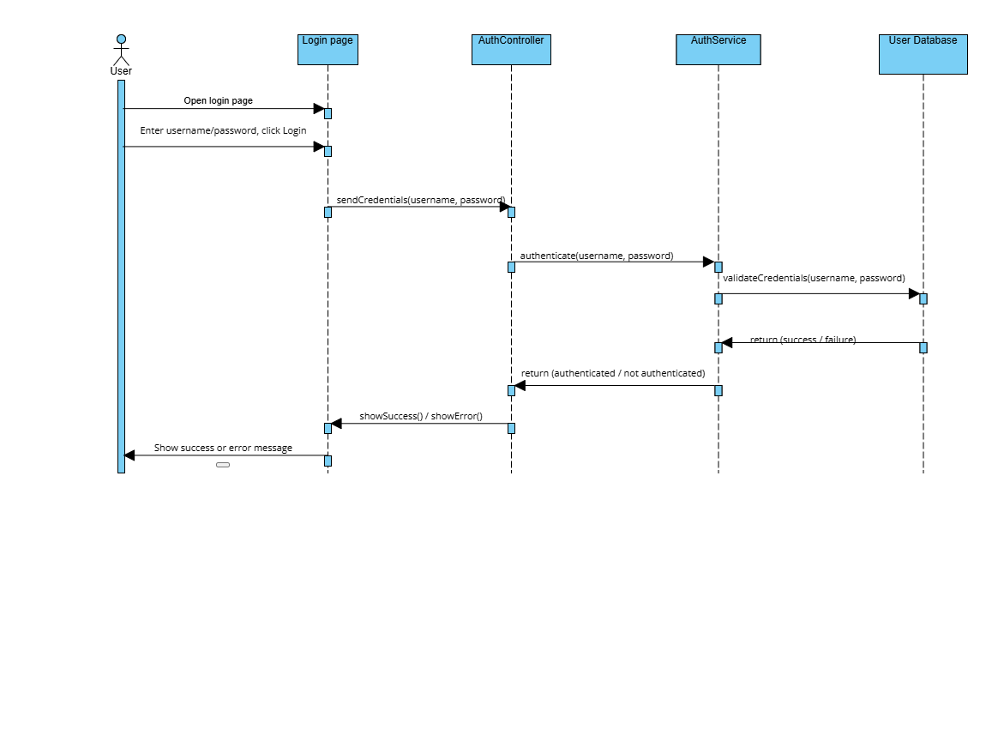

Figure 13 sequence diagram functional 1

### **Administrator to create and manage courses**

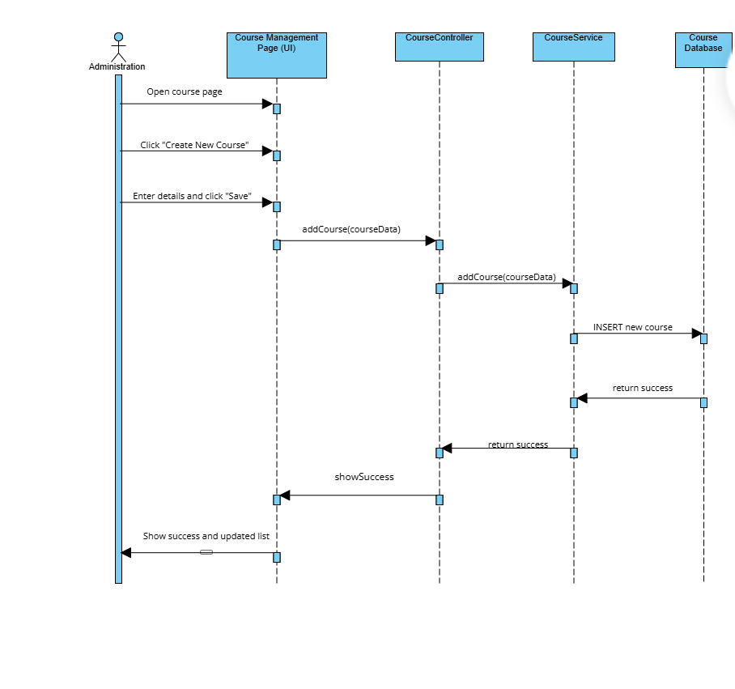

Figure 14 sequence diagram functional 2

### **The assigned Teacher (Tether) to create and manage Tests**

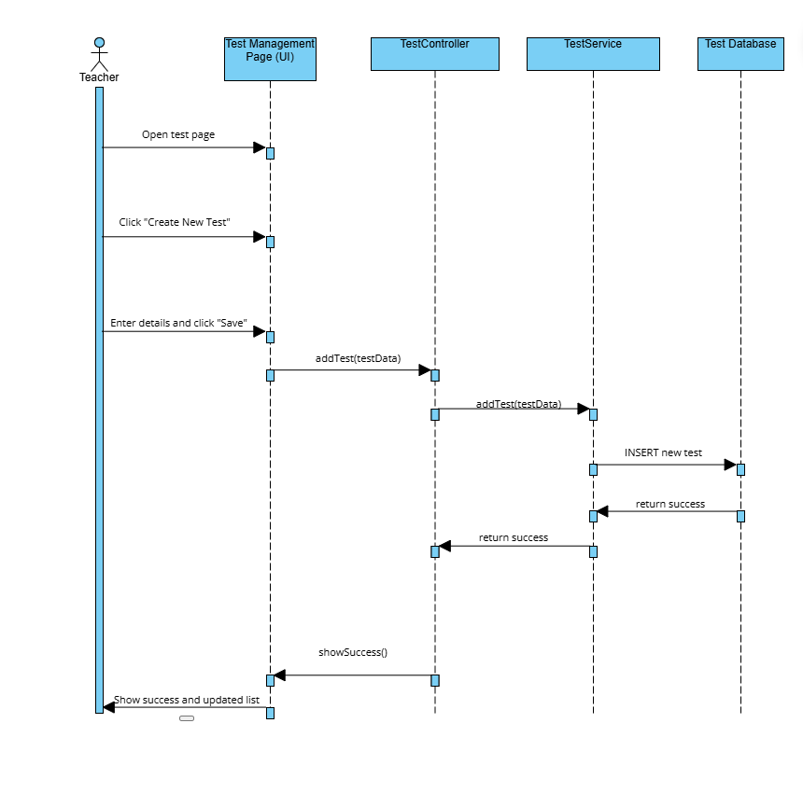

Figure 15 sequence diagram functional 3

### **Calculate student performance based on exam and assignment results**

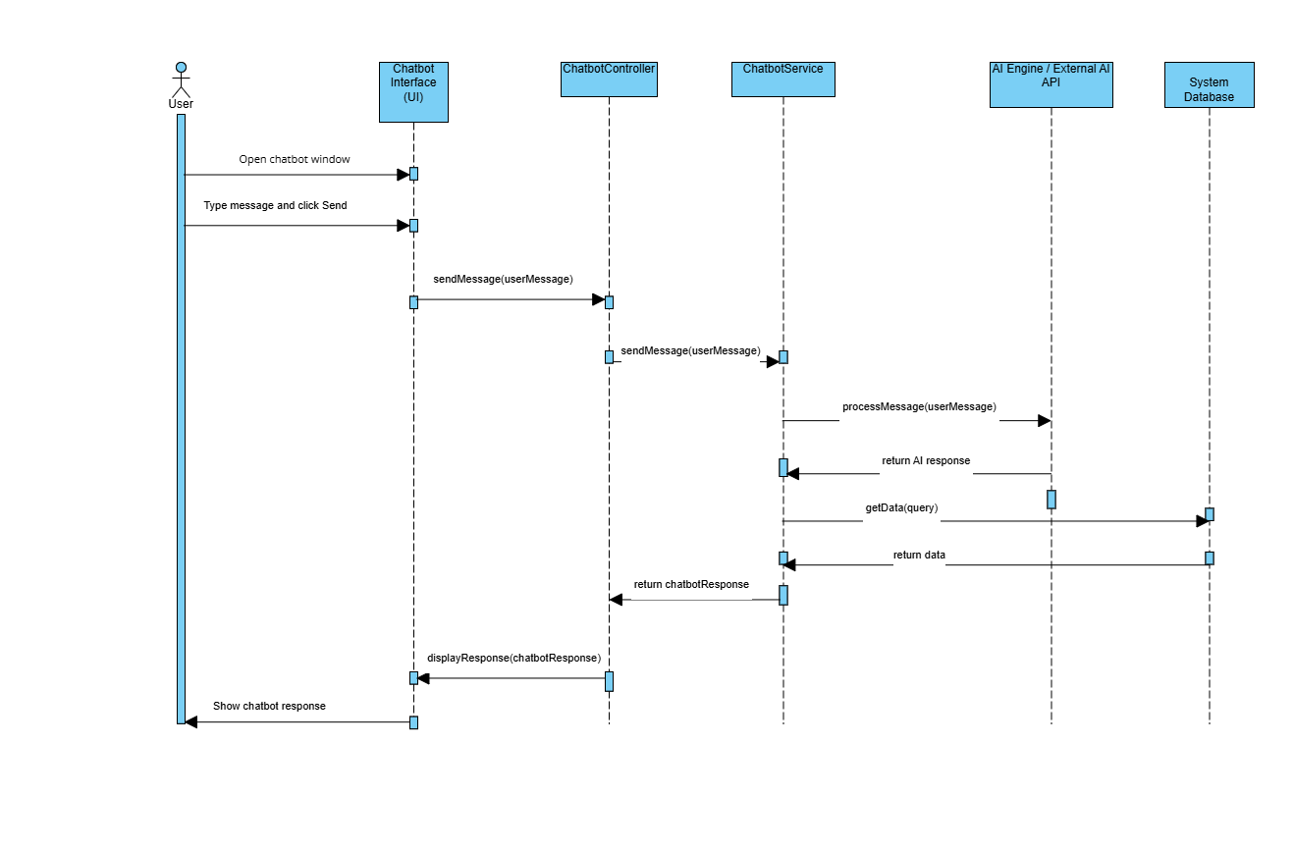

Figure 16 sequence diagram functional 4

## **State Chart Diagram**

In this section presents state chart diagrams showing some used states and transitions as the users perform actions in the system

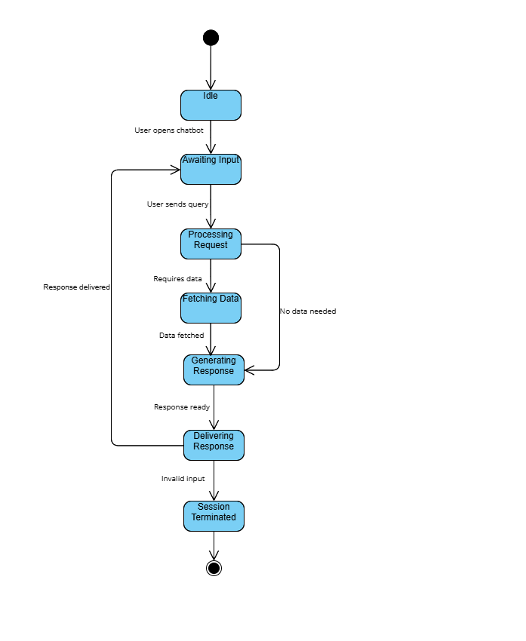

Figure 17 State Chart Diagram

## **Component Diagram**

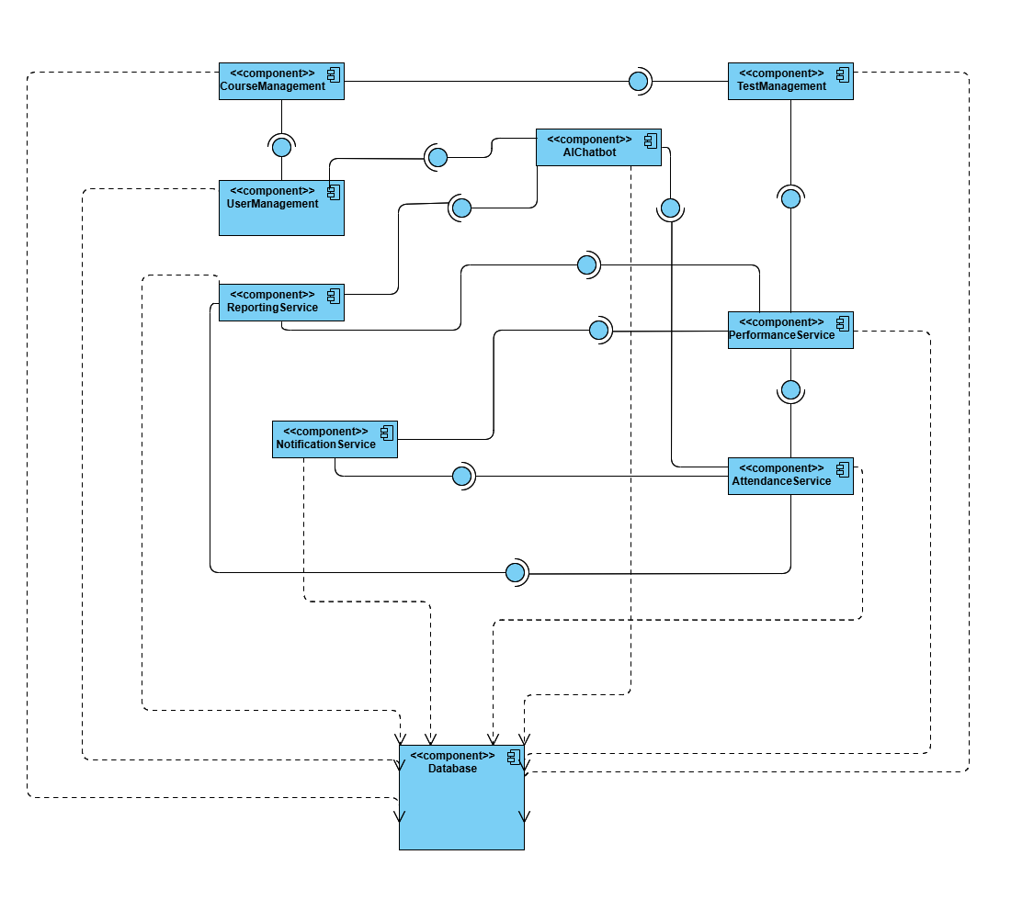

Figure 18 Component Diagram

## **Deployment Diagram**

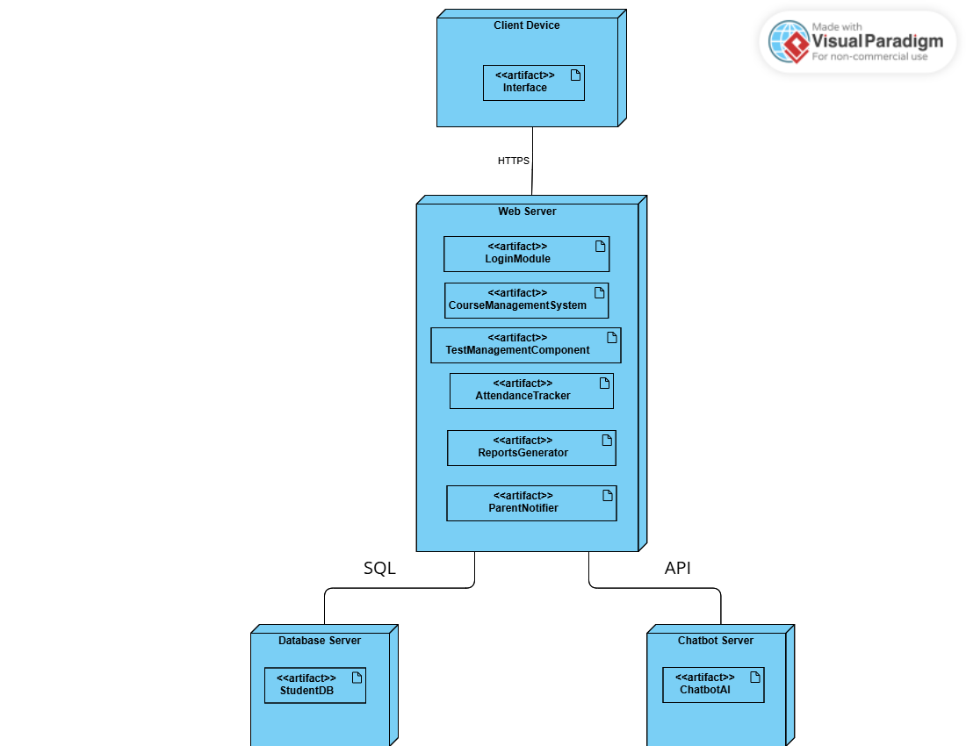

Figure 19 Deployment Diagram

## **I/O Screen**

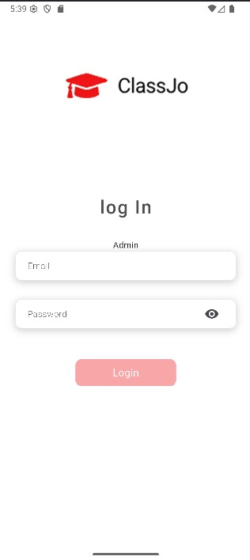

Figure 20 Design App

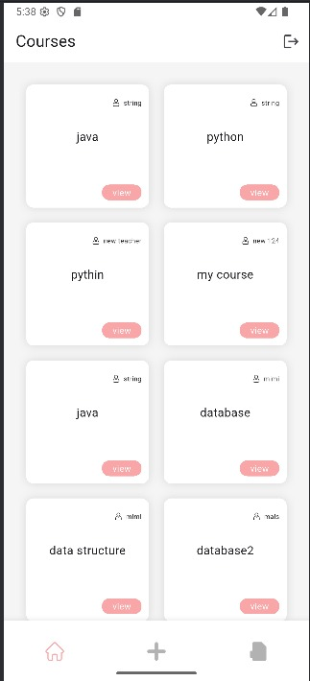

Figure 21 Design App

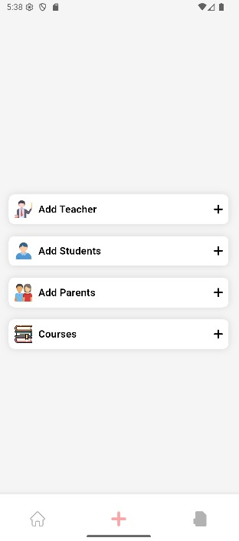

Figure 22 Design App

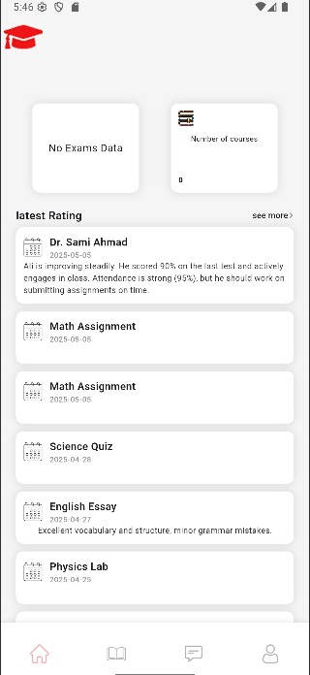

Figure 23 Design App

# Chapter Five

**Project Implementation and Testing**

## **Project Implementation and Testing**

This section outlines the implementation and testing details of the ClassJo application. In particular, we present the system architecture and describe the technologies utilized throughout the development process. Further, we will detail our work in terms of database schema design, along with relevant coding snippets from our implementation. Additionally, we will outline the challenges experienced during the implementation process and display the testing approach of key functions. Consequently, this detailed description focuses on the theoretical and practical aspects concerning the ClassJO application.

* 1. **System Architecture**

In Figure 24 shows the ClassJo app system architecture and describes the position of the Flutter Mobile App as the frontend that serves API calls to the Backend (C#). The server implements business logic, implements the MySQL Database to ensure data safety, and interfaces OneSignal to send notifications to the app users.

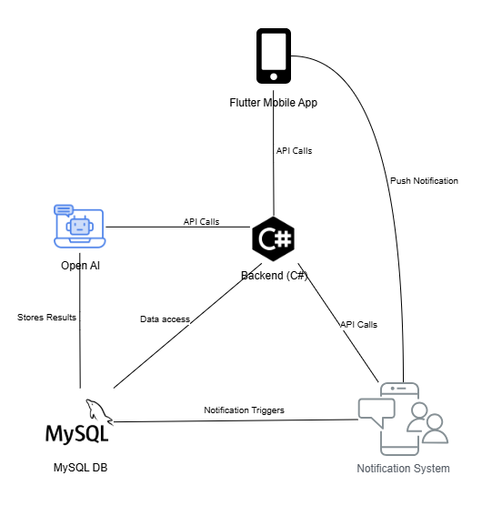

Figure 24 System Architecture

* 1. **Description of Technologies Used**

**Frontend**: Flutter allow us to maintain a uniform interface across devices, which is quite essential in today’s scenario. It takes care of the responsive design so that the UI components can be consistent across different screen resolutions, and it also enables cross-platform capabilities so that the same code can work on iOS and Android therefore minimizing the development time.

**Backend**: C# acts as the server-side programming language which provides a robust mechanism to users for logins and registrations by allowing user authentication as well as handles user requests by interacting with the respective database.

**Database**: MySQL offers strong capabilities in user management such as the safe storage of user credentials and preferences, storage of user tasks, schedules, and notification settings, and above all, the opportunity to scale successfully to cater for the ever increasing number of users.

**Notification System**: OneSignal is used to craft tailor made notifications by dispatching scheduled reminders and updates with regards to the users’ interests as well as automatic alerts that alter reminders to help the users work smoothly and productively

* 1. **Challenges Faced**

The development of the ClassJo application was characterized by various difficulties. Technologies integration appeared to be one of the main difficulties, for example, the integration of Flutter and C# or setting up OneSignal for the notifications. The second was the seamless experience, there was a need to keep the database and the predetermined UI constantly.

* 1. **Functional Test Cases**

In Table 16 shows testing for a few functional requirements to compare the expected results with the actual results

|  |  |  |  |  |  |
| --- | --- | --- | --- | --- | --- |
| **Test Case ID** | Requirement | Input | Expected Output | Actual Output | Result |
| **TC-01** | User Login | Administrator, Username and Password | Redirect to Admin Dashboard | |  | | --- | | Redirect to Admin Dashboard |  |  | | --- | |  | | Pass |
| **TC-02** | User Login | Empty Username, Password: 123456 | Error: "Enter Username" | Error: "Enter Username" | Pass |
| **TC-03** | User Login | Username: admin, Empty Password | Error: "Enter Password" | Error: "Enter Password" | Pass |
| **TC-04** | Manage Course | Create New Course: "Math 101", Assign Teacher: "Mr. A" | Course Created and Teacher Assigned | Course Created and Teacher Assigned | Pass |
| **TC-05** | Manage Course | Create Course with Empty Name | Error: "Enter Course Name" | Error: "Enter Course Name" | Pass |
| **TC-06** | Manage Tests | Teacher creates Test for Course "Math 101" | Test Created Successfully | Test Created Successfully | Pass |
| **TC-07** | Calculate Student performance | Input: Exam 85%, Assignment 90% | Performance Calculated, Points & Rating Displayed | Performance Calculated, Points & Rating Displayed | Pass |
| **TC-08** | Track Attendance | |  | | --- | | Mark Student ID: 123 as "Present" for Course "Math 101" |  |  | | --- | |  | | Attendance Recorded | Attendance Recorded | Pass |
| **TC-09** | Notify Parents | Frequency: Daily | Notification Sent Daily to Parent Email | Notification Sent Daily to Parent Email | Pass |
| **TC-10** | AI-powered | User asks: "How to reset my password?" | Chatbot provides guidance on password reset | Chatbot provides guidance on password reset | Pass |
| **TC-11** | Edit Profiles | Admin edits Teacher Profile, changes email | Teacher Profile Updated | Teacher Profile Updated | Pass |

Table 16 Functional Test Cases

* 1. **Database Mapping (Scheme Diagram)**

In Figure 17 shows the database architecture, tables, table's structure, and the relationships between these tables.

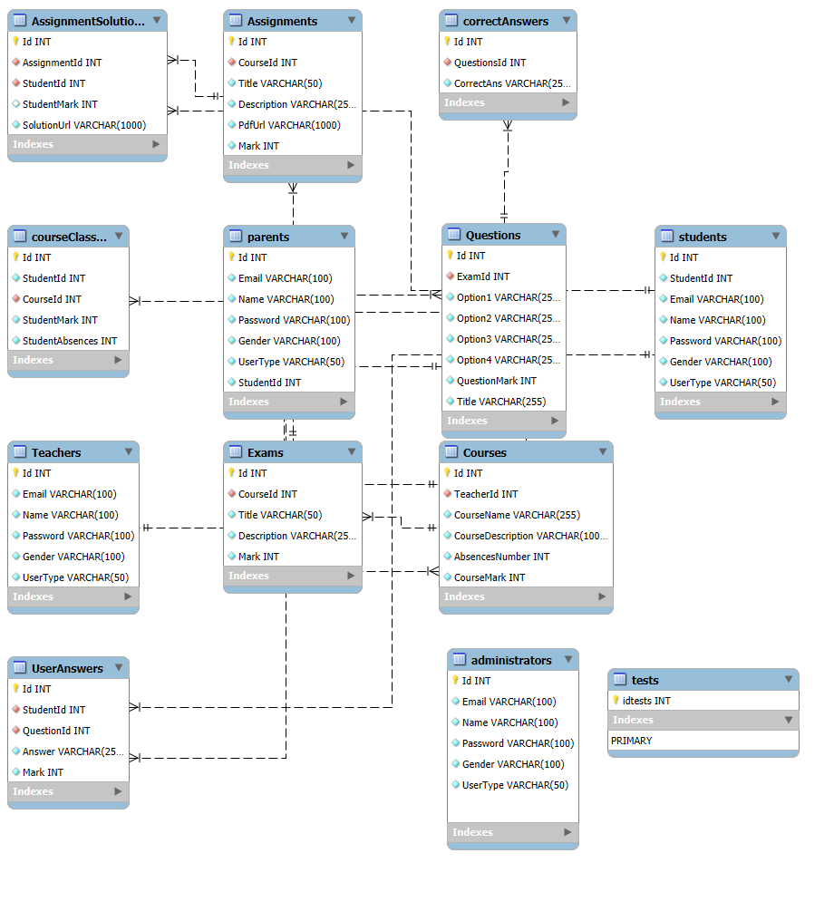

Table 17 Database Mapping (Scheme Diagram)

* 1. **Tables Descriptions**

In this section information will be given about the tables in our database.

|  |  |
| --- | --- |
| Table Name | Description |
| Assignments | Contains information about tasks assigned to students, including title, detailed description, and total mark. Each assignment is linked to the Assignment Solutions' table for student submissions. |
| AssignmentSolutions | Records individual student submissions for assignments. Includes the solution URL, the mark awarded, and links to the corresponding assignment and student. |
| correctAnswers | Holds the correct answers for each question in an exam. Used to evaluate student responses in the 'UserAnswers' table. |
| parents | Stores login credentials and personal data for parents. Parents can monitor student performance and attendance. |
| questions | Houses multiple choice questions linked to exams. Each record includes the question text, four possible answers, the mark value, and the related exam. |
| students | Maintains student login information and demographics. Acts as a central entity for course enrolments, submissions, and exams. |
| courseClassStudent | Joins students with their enrolled courses. Tracks the student's final mark and number of absences for a specific course. |
| Teachers | Contains login and profile data for teachers. Teachers manage courses, create exams, and monitor student progress. |
| Exams | Defines tests linked to a course. Each exam includes a title, description, and total mark. Associated with questions. |
| Courses | Stores course metadata, including name, description, and maximum absences allowed. Each course is assigned to a teacher. |
| UserAnswers | Captures student answers to individual exam questions. Used to compare student responses to correct answers and assign marks. |
| administrators | Stores login credentials and basic profile data for system administrators who manage the overall platform. |
| tests | A placeholder table with unclear purpose, likely used for testing or temporary development. |

Table 18 Tables Descriptions

* 1. **Major Function**

1. **Log in**

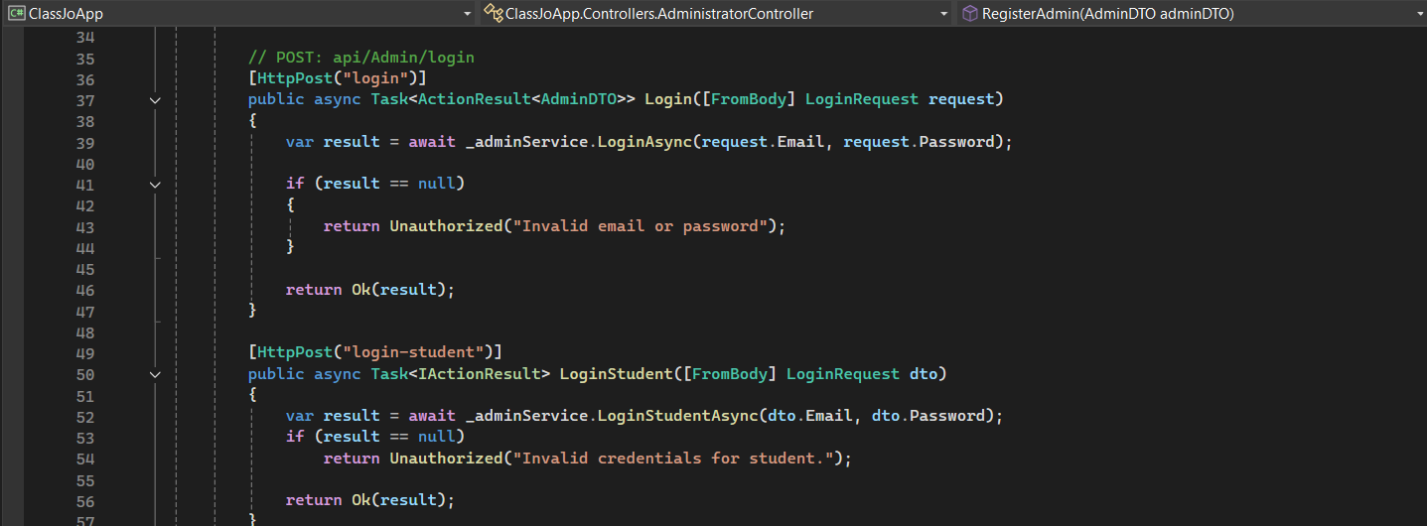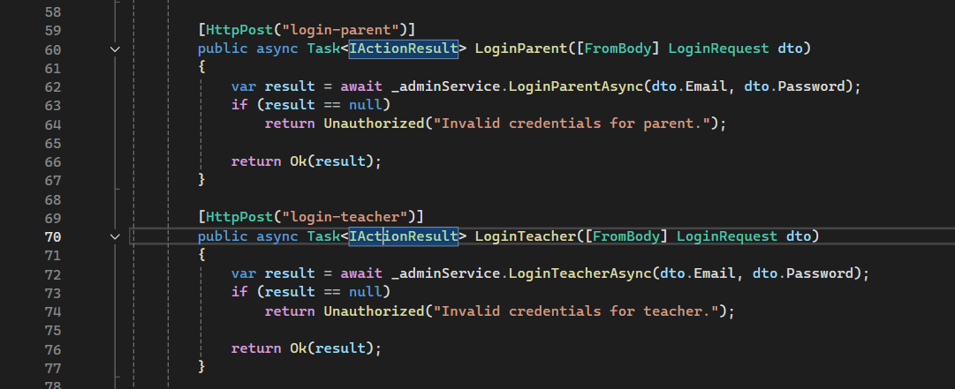

Figure 25 Login

1. **Update**

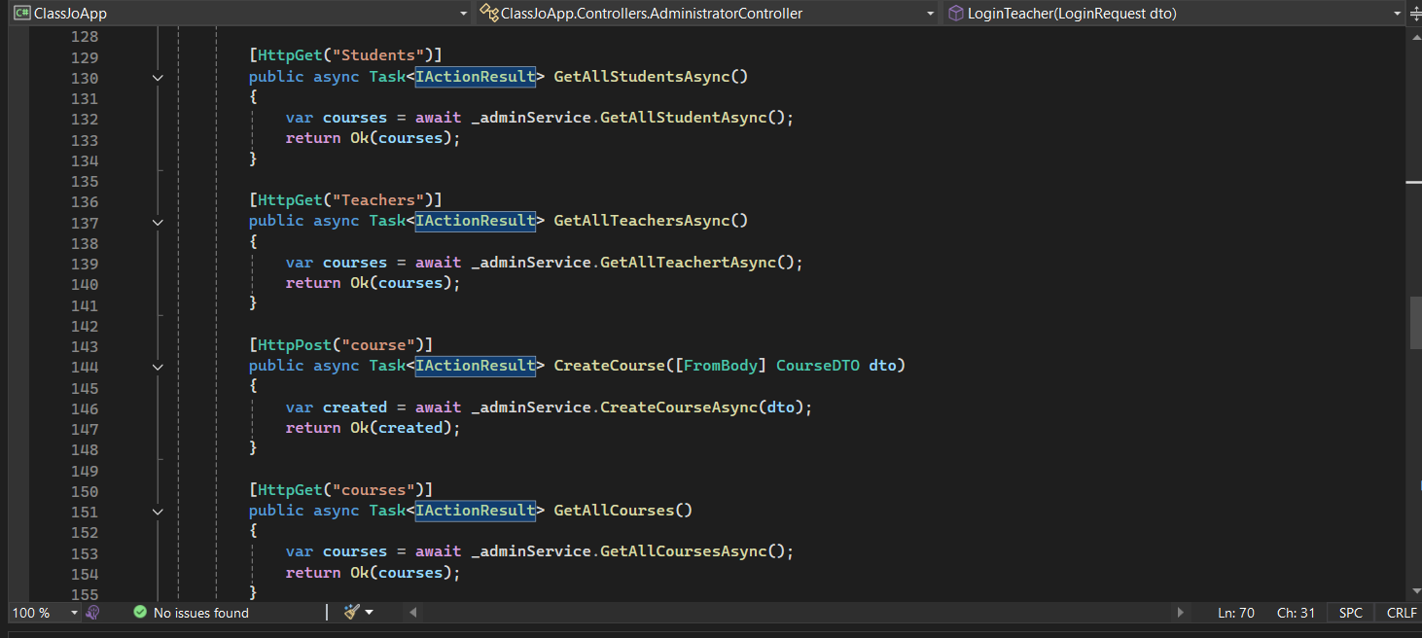

Figure 26 Update

1. **Add Student To Class and remove**

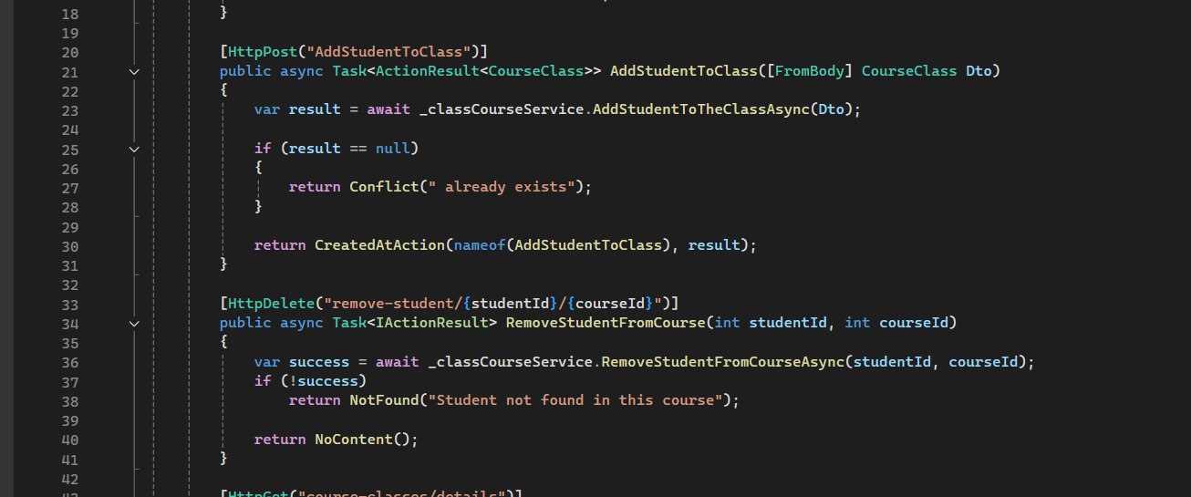

Figure 27 Add Student To Class and remove

1. **Create exam and Create question**

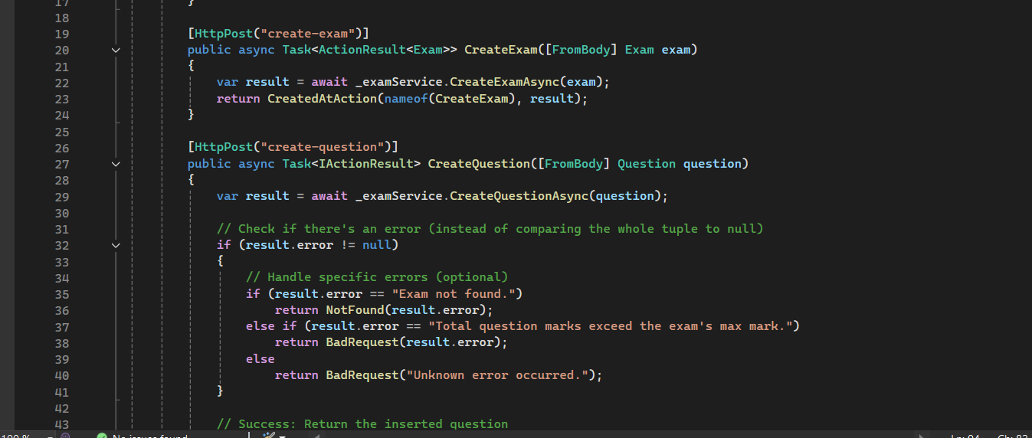

Figure 28 Create exam and Create question

# Chapter six

**Conclusion**

# **Conclusion**

ClassJo provides a smart, AI-powered platform that enhances collaboration between teachers, parents, and school management. By offering real-time insights and streamlined communication, it addresses key gaps in today’s educational systems. With a clear roadmap for future improvements, ClassJo is well-positioned to drive innovation and improve student outcomes across diverse learning environments.

## **Appendices**

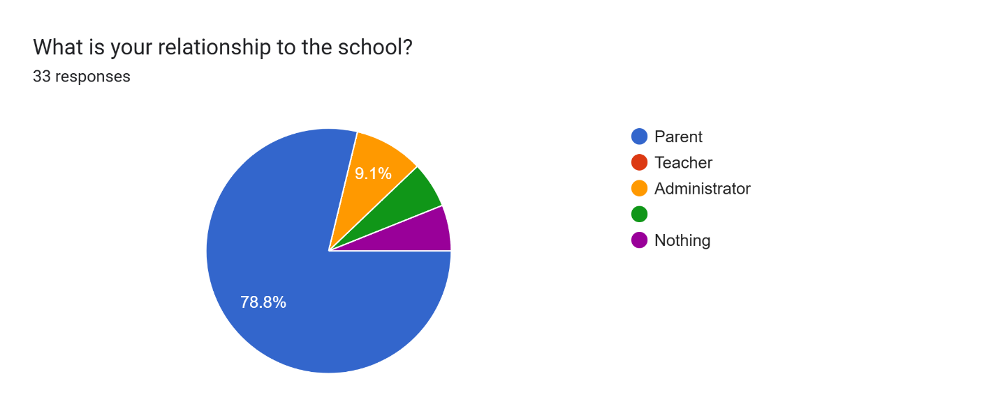

Figure 29 Appendix 1

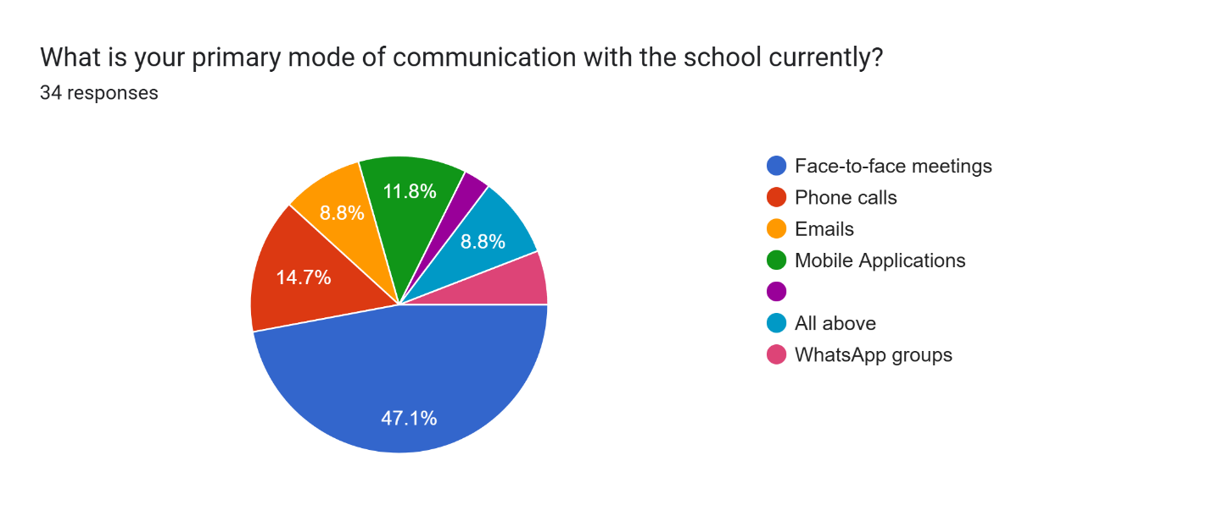

Figure 30 Appendix 2

## **Project activities:**

|  |  |  |  |
| --- | --- | --- | --- |
| Communication Mode | Staff Assigned | Budget Allocation | Time Allocation (Hours-Week) |
| Face-to-face meetings | 3 staff members | 500 | 15 |
| Phone calls | 2 staff members | 300 | 10 |
| Email | 1 staff members | 200 | 5 |
| Mobile application | 1 IT specialist | 400 | 7 |
| All above | 4 staff members | 600 | 20 |
| WhatsApp groups | 2 staff members | 250 | 8 |

Table 19 Project activities

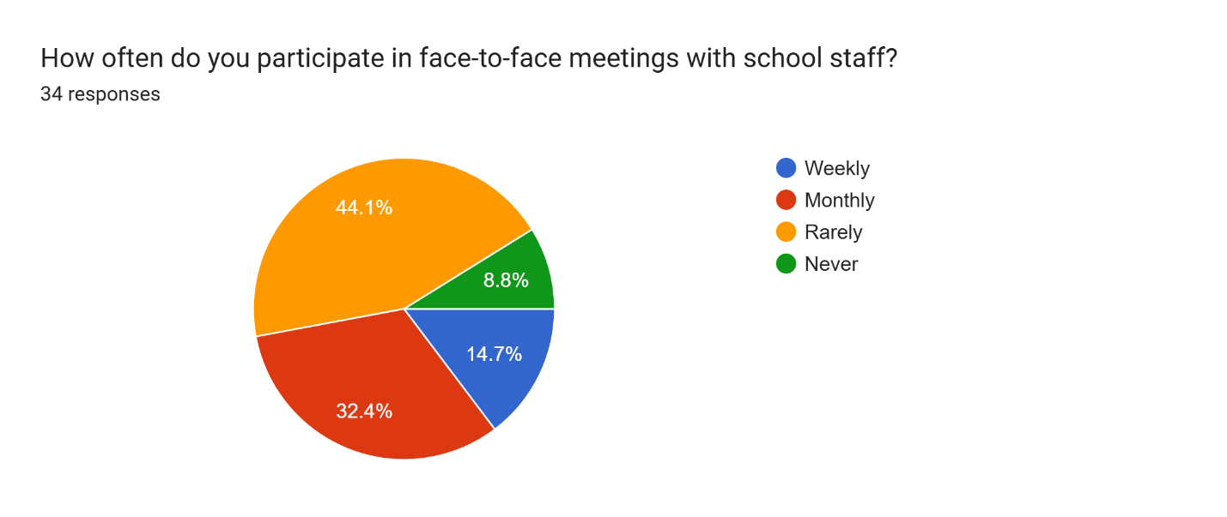

Figure 31 Appendix 3

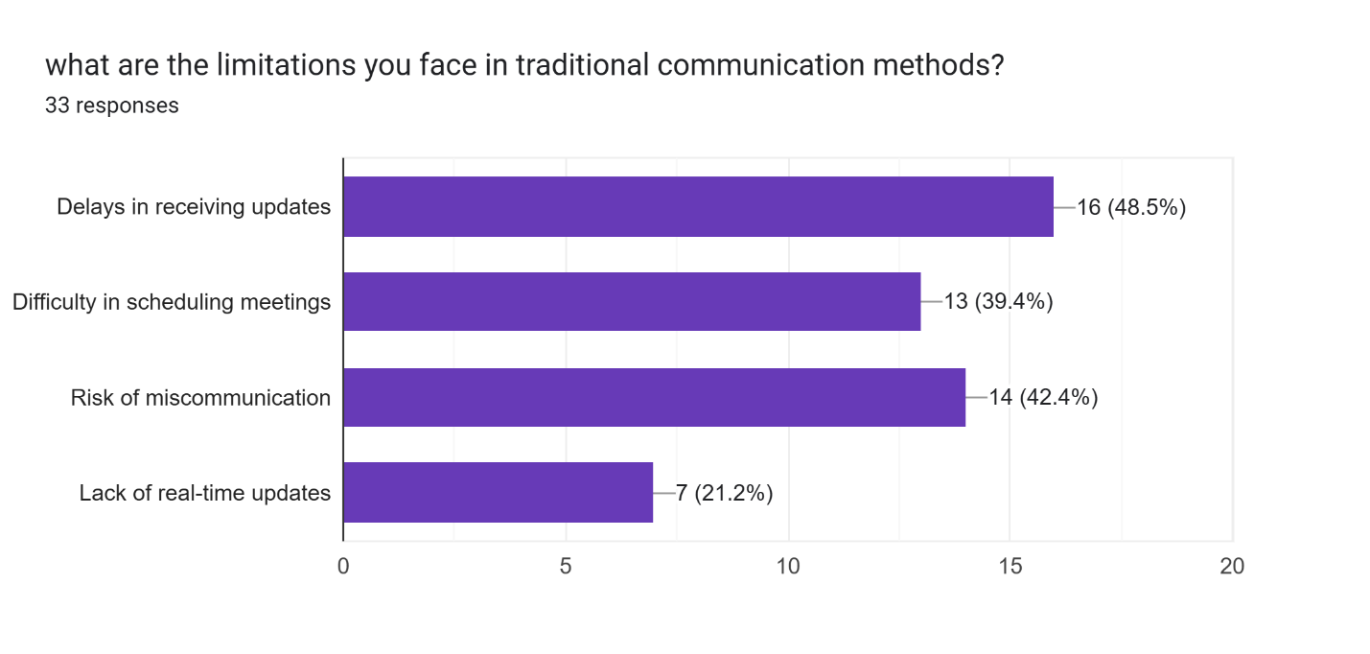

Figure 32 Appendix 4

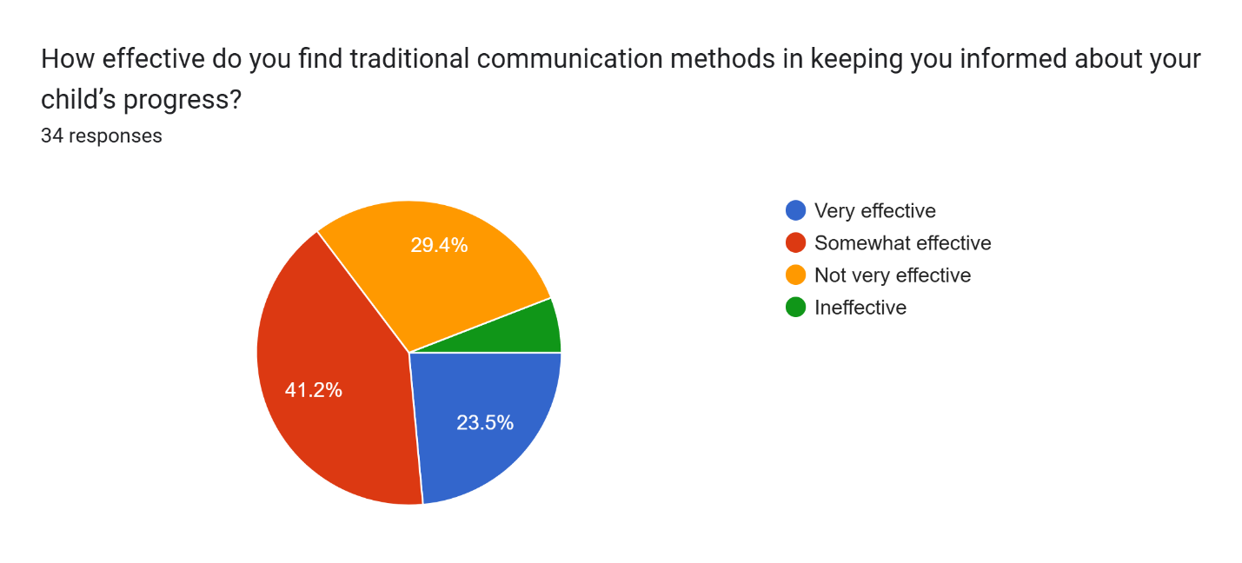

Figure 33 Appendix 5

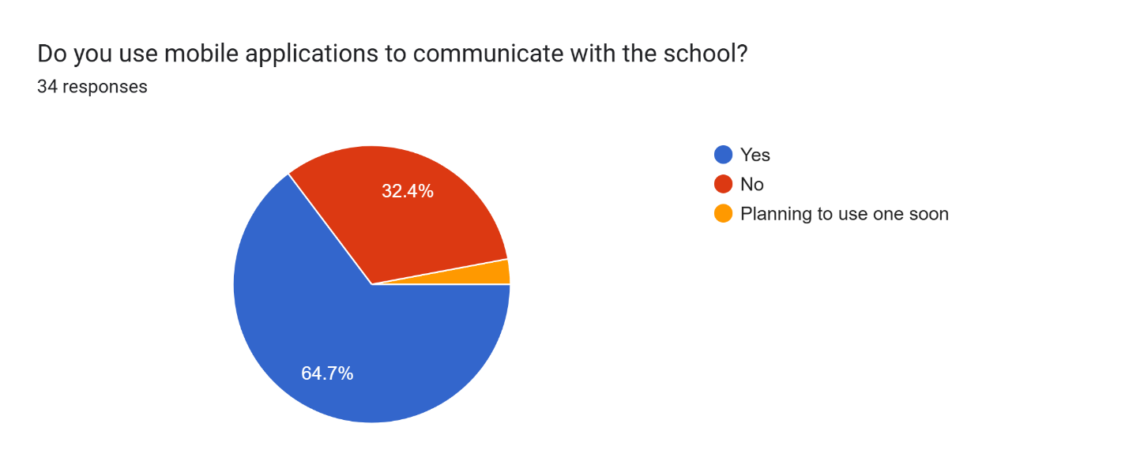

Figure 34 Appendix 6

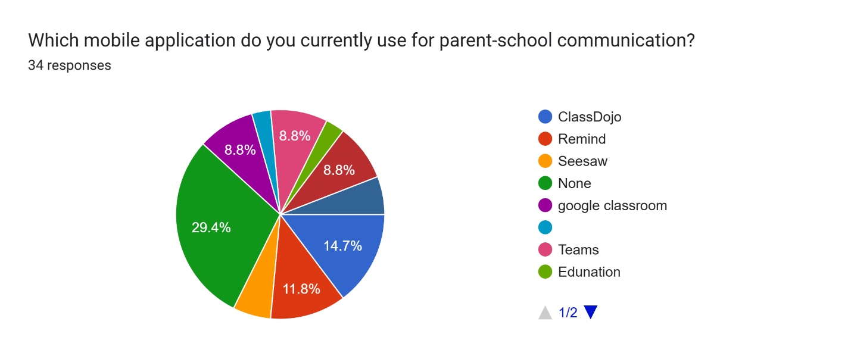

Figure 35 Appendix 7

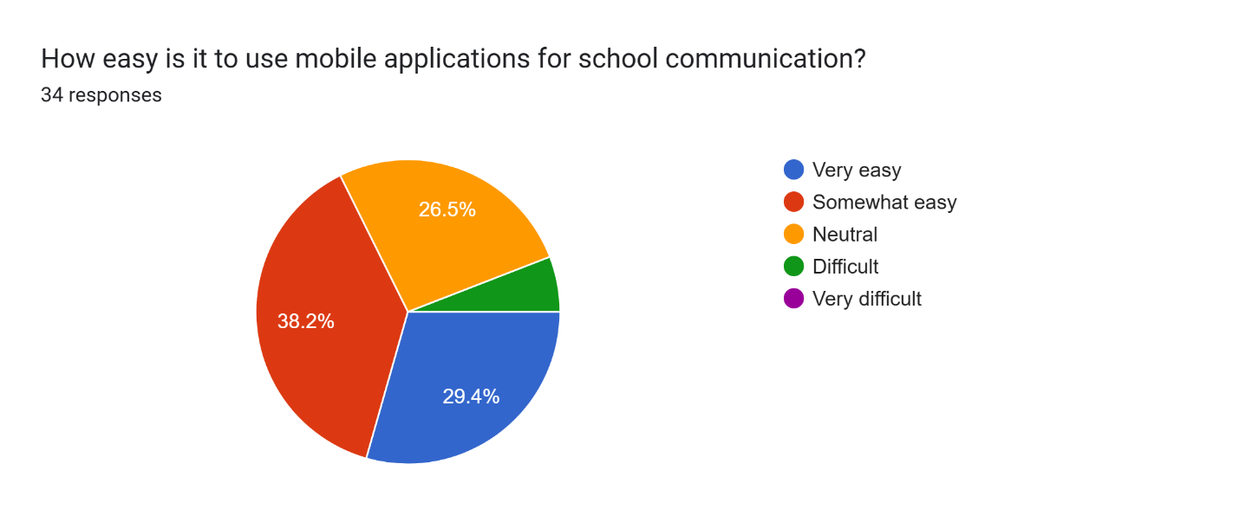

Figure 36 Appendix 8

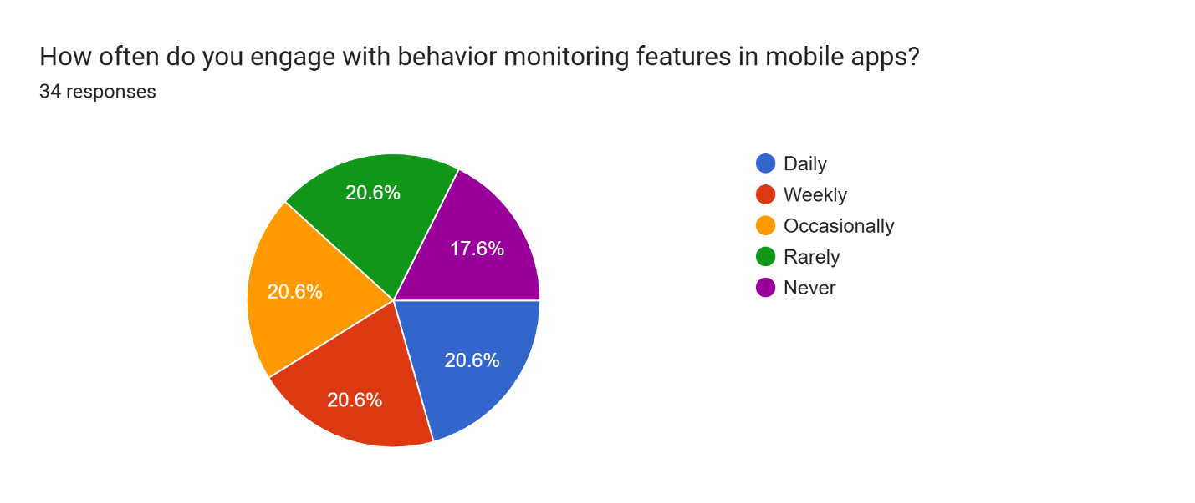

Figure 37 Appendix 9

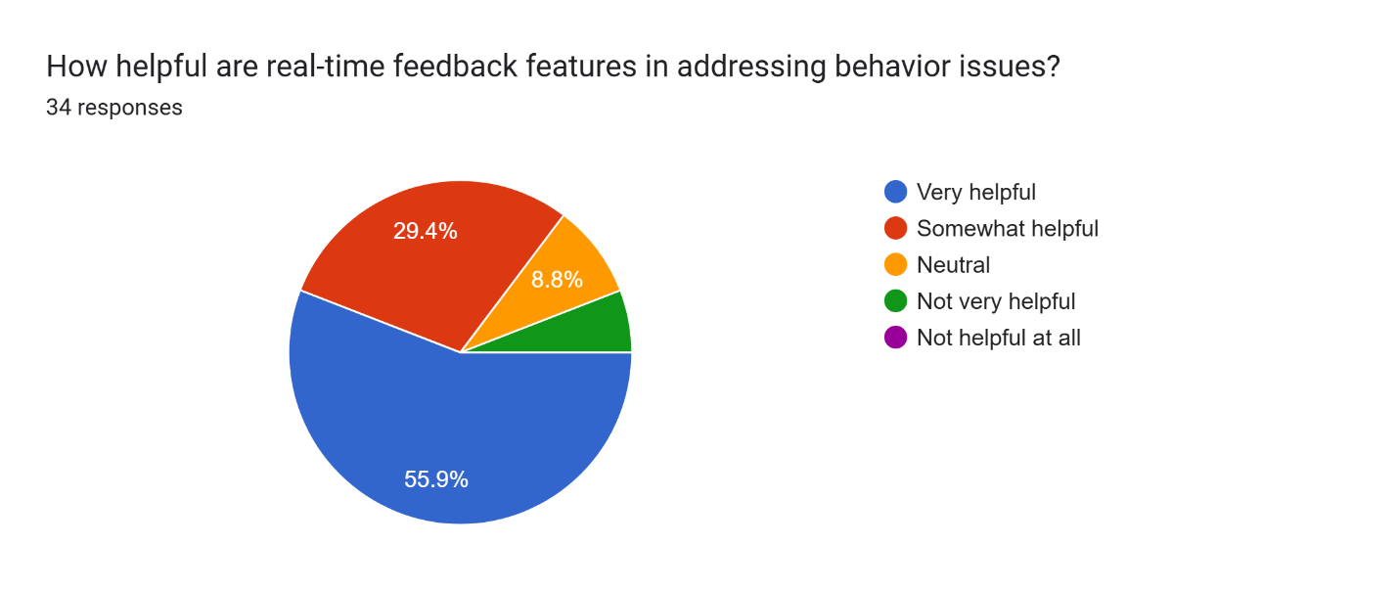

Figure 38 Appendix 10

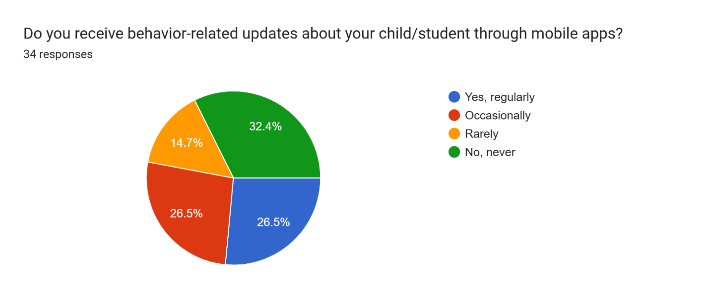

Figure 39 Appendix 11

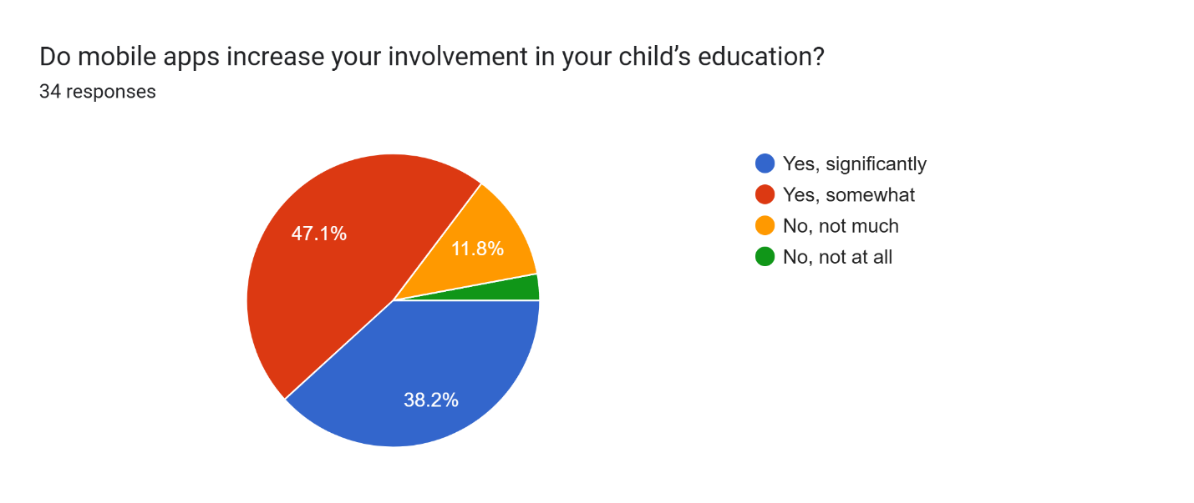

Figure 40 Appendix 12

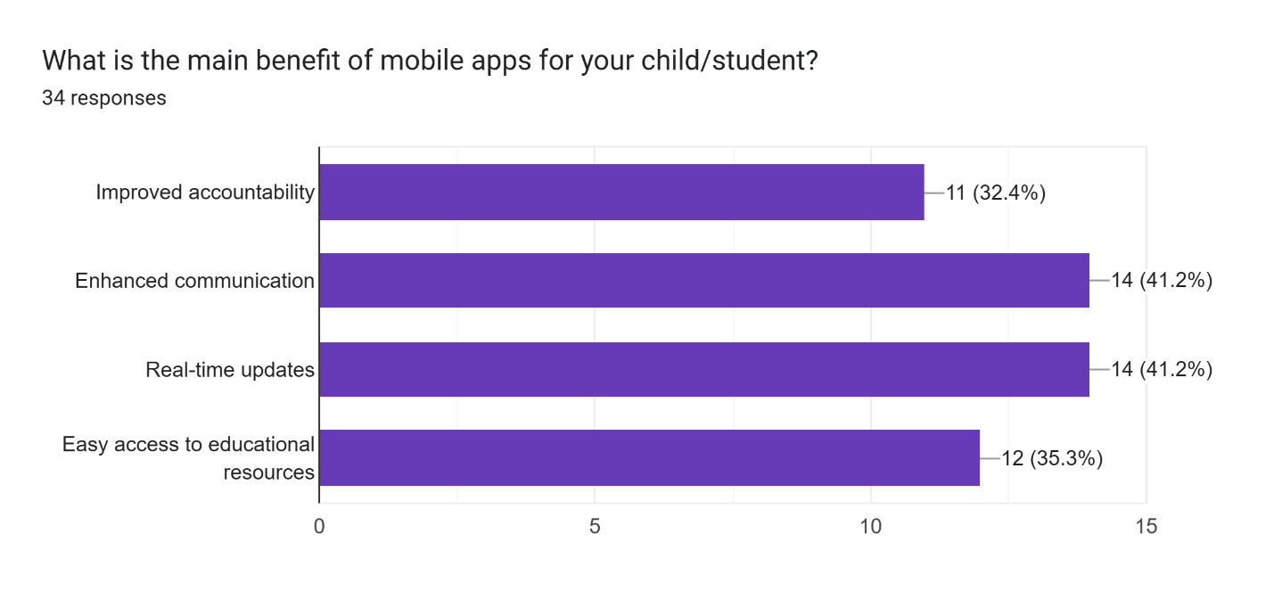

Figure 41 Appendix 13

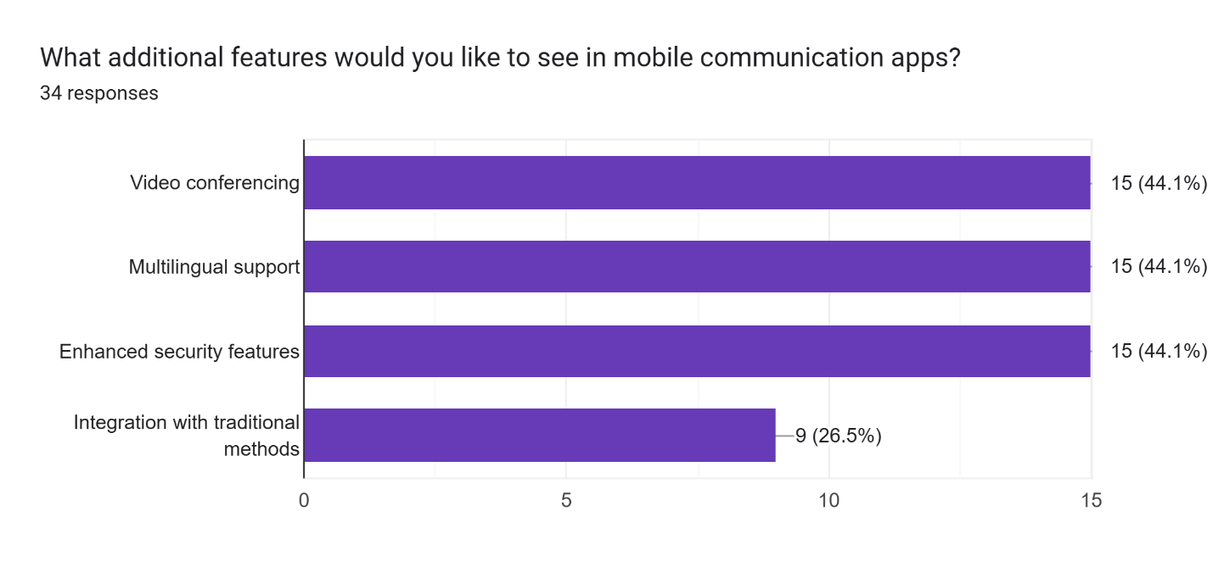

Figure 42 Appendix 14

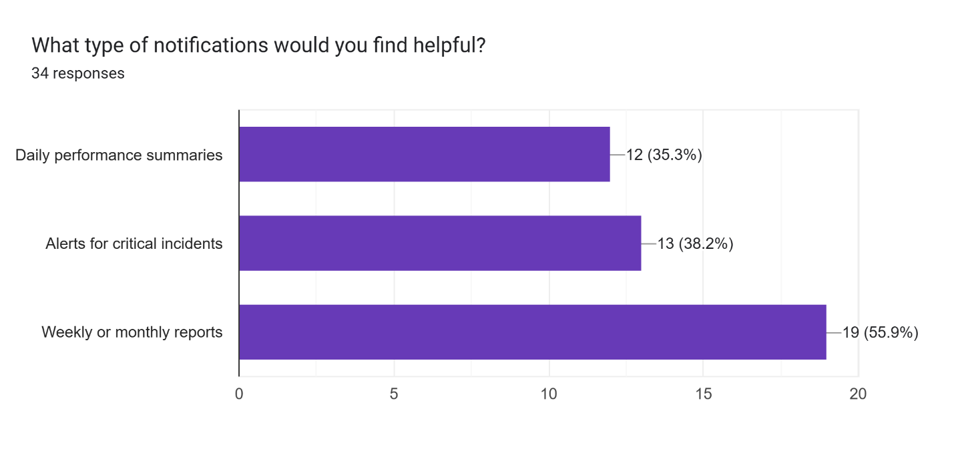

Figure 43 Appendix 15

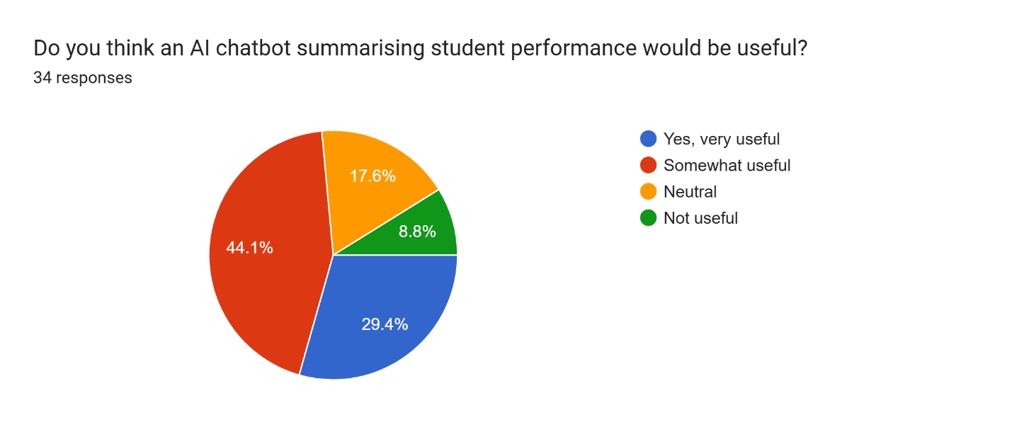

Figure 44 Appendix 16

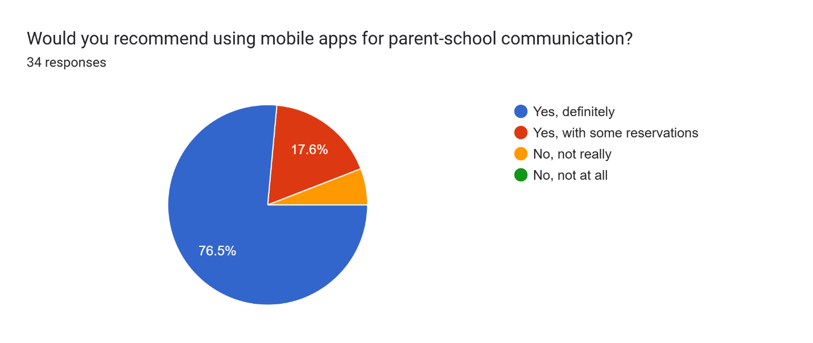

Figure 45 Appendix 17

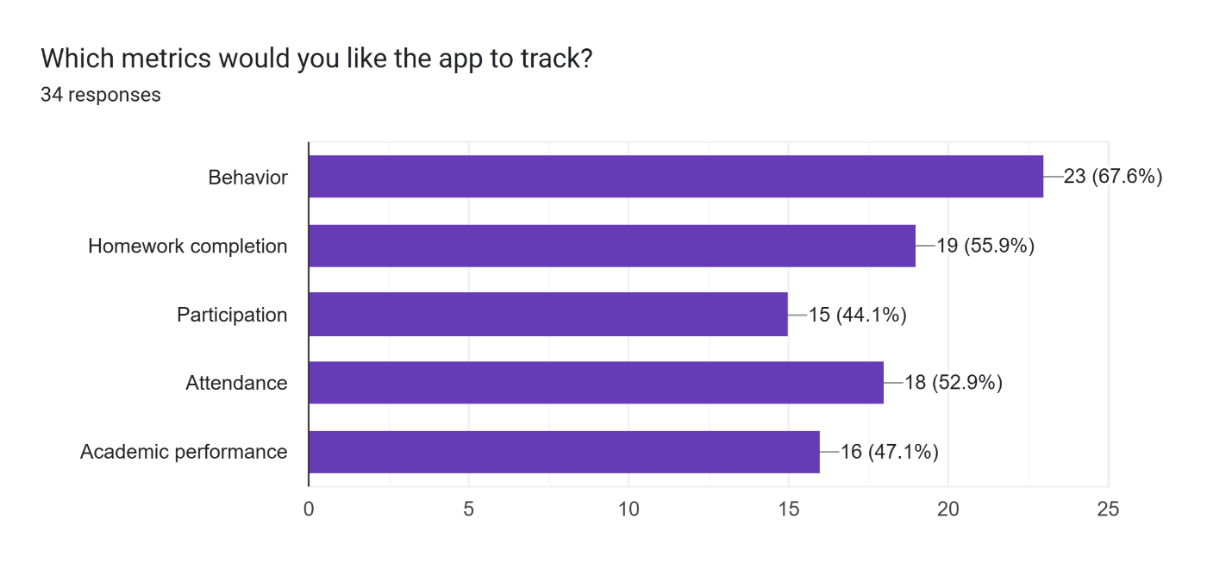

Figure 46 Appendix 18

## **References**

Bergmann, J. and Sams, A., 2020. Title of Work. Place of publication: Publisher.

ClassDojo, 2023. Features overview. [online] Available at: [https://www.classdojo.com](https://www.classdojo.com/) [Accessed 28 December 2023].

Epstein, J., 2001. School, Family, and Community Partnerships: Preparing Educators and Improving Schools. Boulder, CO: Westview Press.

Hargittai, E., 2008. Digital Literacy and the Digital Divide. Place of publication: Publisher.

Hornby, G., 2011. Improving Parental Involvement. New York: Continuum.

Johnson, L., Becker, S.A., Estrada, V. and Freeman, A., 2016. The NMC Horizon Report: 2016 Higher Education Edition. Austin, Texas: The New Media Consortium.

Kumar, A. and Singh, M., 2019. Enhancing the Impact of Technology in Education. Place of publication: Publisher.

Smith, J., 2018. Real-time Parent-School Communication. Place of publication: Publisher.

Sun, P. and Rogers, C., 2021. Gamification in Education: Motivating Students through Technology. Place of publication: Publisher.