**Test 2 CSC 3304 Machine Learning**

**Question 1**

1. Linear regression is a basic method of predictive analysis, and is widely used. These estimates of regression are used to describe the relation between a dependent variable and one or more independent variables. For example, predicting the revenue of a business for the following years.
2. Simple linear regression has one dependent and one independent variable while multiple linear regression has one dependent and one or more independent variables. For example, when calculating rent for rooms, in single linear regression model, we predict the rent based on the number of days rented. While in multiple regression model, we predict the rent based on the number of days and the size of the room.
3. Boosting is a machine learning algorithm that can convert a weak learning algortithm into a strong learning algorithm. Boosting is important in machine learning because it improves the accuracy of the outcome and reduce the error rate in the outcome. In solving face detection problems, AdaBoost can be used by applying many weak classifiers at a different scale on detecting the face. These classifiers will identify the eyes of the face. One weak classifier is not enough. Therefore, many classifiers are used to compute the weighted average of the weak classifiers, creating a better and more accurate outcome.
4. Example of the problem: Predicting the rate of cancer cases in Malaysia

Process of machine learning algorithm:

Multiple linear regression method. The dependent variable will be the cancer rate and the independent variables will be the states, gender, age and many more.

Choosing the best algorithm:

By looking at the datasets on the rate of cancer in Malaysia, it can be seen that the data has a relationship with other data which opens the path for executing a simple or multiple linear regression model for prediction. Other than that, regression models are the basic and most common method for prediction purposes in machine learning.

Evaluate performance of algorithm:

By comparing the predicted cancer rates with the actual cancer rates for a particular year, the accuracy of the results can be calculated from the comparison. If the accuracy percentage is high, the performance of the experiment is a success.

If the algorithm does not show good results, what is the next step:

The next step would be trying to execute a single linear regression model based on the relationship between cancer rates and states. This method is chosen because the probability of a more accurate outcome would possible if the variables are reduced and become simpler.

**Question 2**

|  |  |  |  |
| --- | --- | --- | --- |
| **x** | **y** | **x^2** | **xy** |
| 609 | 241 | 370881 | 146769 |
| 629 | 222 | 395641 | 139638 |
| 620 | 233 | 384400 | 144460 |
| 564 | 207 | 318096 | 116748 |
| 645 | 247 | 416025 | 159315 |
| 493 | 189 | 243049 | 93177 |
| 606 | 226 | 367236 | 136956 |
| 660 | 240 | 435600 | 158400 |
| 630 | 215 | 396900 | 135450 |
| 672 | 231 | 451584 | 155232 |
| **6128** | **2251** | **3779412** | **1386145** |

1. m = (1386145 – (6128 * 2251)) / ((10 * 3779412) – (6128^2))

= -51.3287

b = 2251 – ((-51.3287 * 6128) / 10)

= 33705.2274

|  |  |  |  |  |
| --- | --- | --- | --- | --- |
| **x** | **y** | **y = -51.3287x + 33705.2274** | **error** | **Error^2** |
| 609 | 241 | 2446.0491 | 2205.0491 | 4862241.5334 |
| 629 | 222 | 1419.4751 | 1197.4751 | 1433946.6151 |
| 620 | 233 | 1881.4334 | 1648.4334 | 2717332.6742 |
| 564 | 207 | 4755.8406 | 4548.8406 | 20691950.8042 |
| 645 | 247 | 598.2159 | 351.2159 | 123352.6084 |
| 493 | 189 | 8400.1783 | 8211.1783 | 67423449.0744 |
| 606 | 226 | 2600.0352 | 2374.0352 | 5636043.1308 |
| 660 | 240 | -171.7146 | -411.7146 | 169508.9119 |
| 630 | 215 | 1368.1464 | 1153.1464 | 13229746.6198 |
| 672 | 231 | -787.659 | -1018.659 | 1037666.1583 |
| **6128** | **2251** | **22510.0004** | **20259.0004** | **117325238.1** |

1. 117325238.1

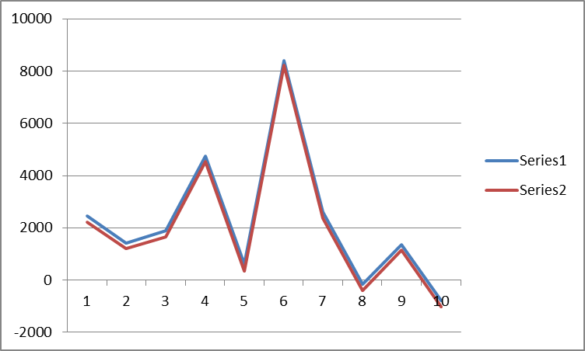

**Question 3**

Positively labelled data: (3, 3), (3, -3), (-3, -3), (-3, 3)

Negatively labelled data: (1,1), (1, -1), (2, 1), (1, -2)

1. (10, 10), (7, 1), (1, 1), (1, 7)

(1,1), (1, -1), (2, 1), (1, -2)

S1 = (1, 1) S2 = (1, 1)

3a1 + 3a2 = -1

3a1 + 3a2 = +1

a2 = -1 – 3a1

3a1 + 3(-1 – 3a1) = +1

3a1 – 3 – 9a1 = +1

-6a1 – 3 = +1

a1 = - 2/3

a2 = -1 – 3(-2/3)

a2 = 1