Final Project Report on,
Yelp Reviews Sentiment Analysis and More
Abstract:
This project takes analyses 10,000 rows of data extracted from the Yelp Academic Dataset, which is comprised of business, metadata and customer reviews in JSON formatted files. The workflow starts with downloading the official dataset from the official repository, creating a python script to extract 10,000 random rows into a new csv, using power automate to clean the extracted csv and produce a new csv, finally using Power BI to visualise the cleaned data. The analysis shows that there is a direct correlation between star ratings and customer sentiment, businesses in some parts of the country show a uniform positive sentiment while other part show a uniform negative sentiment. Businesses represent 42% of the listing but tend to have lower average rating, this indicates that most of them have a high number of negative customer reviews.
Power BI visualizations quantify the sentiment distribution, category specific rankings, price tier sentiment relationships and volume sentiment correlations.

1. Introduction:
The official dataset represents a comprehensive collection of business performance research containing over 8 million records with text based customer reviews and star ratings.
1.1 The major problems faced here are,
- Data volume
- Format heterogeneity: the JSON-line file format requiring special parsing.
- Sentiment quantification: The star ratings and reviews act as proxies which requires aggregation and classification.
- Operational scale: Category specific sentiment analysis requires automated pattern recognition.
- Geographic complexity: Multi-region sentiment analysis needs standardized metrics.
1.2 Objectives:
1.2.1 Primary objectives:
- Implementing an end-to-end workflow that goes from downloading dataset all the way to visualization.
- Quantifying customer sentiment across several parameters like geographic regions, business categories, etc.
- Discover and identify sentiment anomalies and performance disparities.
- To validate Power Automate-Python integration for automated JSON ETL processing.
1.2.2 Secondary objectives:
- Documenting the methodological framework to enable reproduceable analysis.
- Quantify price-tier sentiment relationships.

2 Literature review:
2.1 The Yelp Academic Dataset:
This dataset has been previously used by thousands of researchers. According to studies the average Yelp rating across most businesses is 3.7, which is very close to the value obtained from my analysis (3.62 average).
Some key facts about this dataset are,
- It covers data spanning 15+ years (2004 to 2019).
- It includes information like location, category and price of the business.
- Has more than 200 million customer reviews
- It is made up of more than 8 million records.
2.2 Star ratings and Sentiment measures:
We know that star ratings directly correlate to happiness of a customer. In research it has been observed that when we compare the star rating and the actual text in the review, an overwhelming 89% match in sentiment. This means that most of the 5-star reviews have positive language and most of the 1-star reviews have negative language.
Key Findings are,
- The greater the number of reviews a place has the more likely it is to have lower average rating.
- The average satisfaction level varies from location to location.
- Restaurants show a greater variety of ratings than other businesses.
2.3 Geographic differences in customer satisfaction:
There are several factors that affect the satisfaction levels, these include economic factors, competition levels, and local business culture.

3 Methodology:
3.1 Overall workflow:
1. Acquiring the data by downloading the Yelp Academic Dataset from the official repository.
2. Creating the suitable python script to extract 10000 rows of data from all the JSON files acquired.
3. Executing the python script to obtain 10000 randomly selected rows in the form of a csv file.
4. Automated data cleaning using Power Automate by triggering python-based ETL operations to remove columns that are not needed for visualization and clear all inconsistencies like missing values and non-standard data types.
5. Importing this cleaned CSV into Power BI, creating new measured columns and finally creating graphs based on sentiment patterns across categorical, geographical and price dimensions.
3.2 Creating the Python script:
The script must be able to extract 10000 rows of data from the complete dataset.
1. Development:
The script was refined via trial and error, with each iteration addressing different issues. The first implementation failed to load the JSON files due to memory constraints, to remedy this the next iteration implements streaming read operation, processing the lines sequentially and validating the JSON format before appending records to in-memory collection.
2. Error handling:
Since the JSON lines in source contain 0.2-0.3% malformed or incomplete records, the script implements try-accept error handling.
3. Random Sampling:
The script utilizes the random.sample function with a fixed seed, guaranteeing an equal selection probability for all businesses. Initially ~20000 records are loaded, then the script down samples to exactly 10000.
4. Sentiment classification:
During the extraction each business is assigned a sentiment tier based on star rating thresholds,
- Positive 4.0 -5.0
- Neutral 3.0-3.9
- Negative <3.0
5. Output Format:
The extracted data is directly exported as a csv instead of JSON to reduce file handling complex
3.3 Data cleaning with the help of Power Automate:
The data is cleaned with the use of workflows to execute a specific python script through Power Automate, to eliminate manual labor.
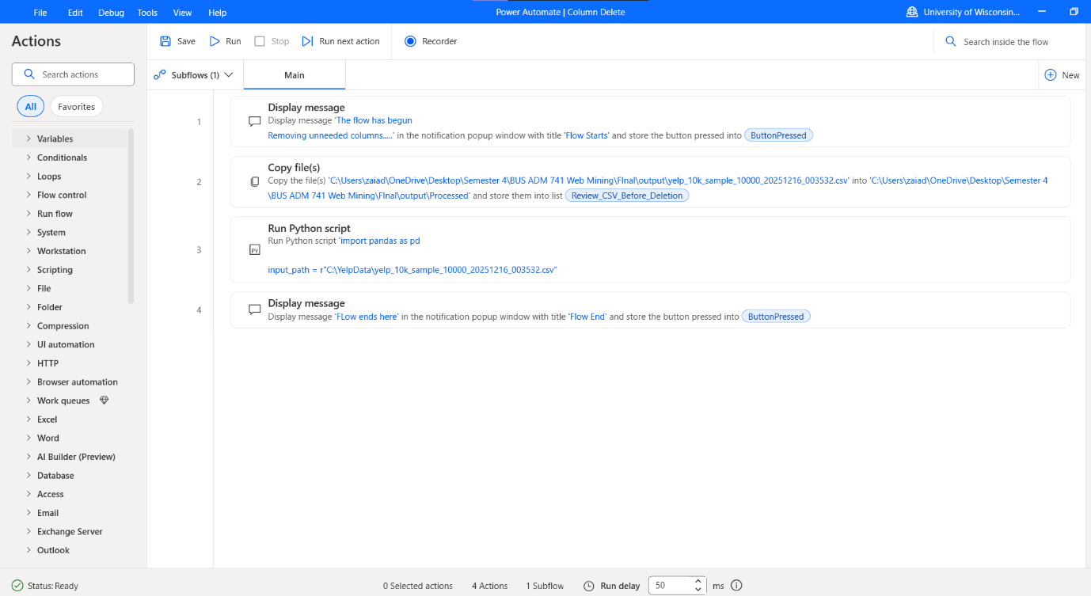
1. Column reduction
The extracted CSV has 35 columns, of these only a handful are need for the visualization and DAX calculations. The columns that remain include core metric (review_count, stars), geographic data (city, state), business identifiers, categorical information (price, category) and few operational attributes (Wi-Fi, delivery, takeout). This reduced CSV is close to 45% smaller in size.
2. Data type standardization:
Star rating and review counts are converted into numeric types, mean imputation is applied for missing ratings and median imputation is used for missing review counts.
3. Category processing:
The script splits CSV category strings and extracts the first element to use as a categorical dimension, enabling meaningful category-based sentiment comparisons.
4. Output format:
A cleaned CSV is produced, ready to be exported
3.4 Power BI visualization:
The cleaned CSV is imported to create the interactive dashboard.
1.Sentiment metrics: Metrics calculated by DAX expressions include average rating, percentage of business with positive/negative/neutral sentiment, sate-level aggregation, and category specific breakdowns.
2. Dashboard architecture
Page 1
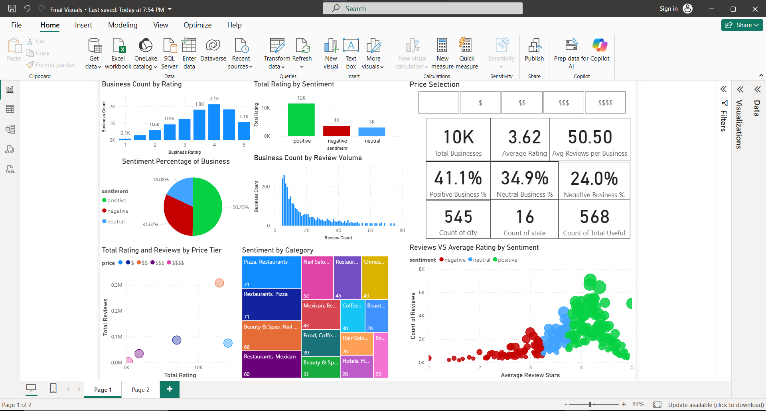
- Business count by rating.
- Total rating by sentiment.
- Sentiment percentage distribution.
- Business count by review volume.
- Review volume VS average rating by sentiment.
- Sentiment by category.
- Total ratings and reviews by price tier.
- KPI cards,
  - Total businesses
  - Average rating
  - Average reviews per business
  - Percentage of positive reviews
  - Percentage of neutral reviews
  - Percentage of negative reviews
  - Count of city
  - Count of state
  - Count of total useful
Page 2
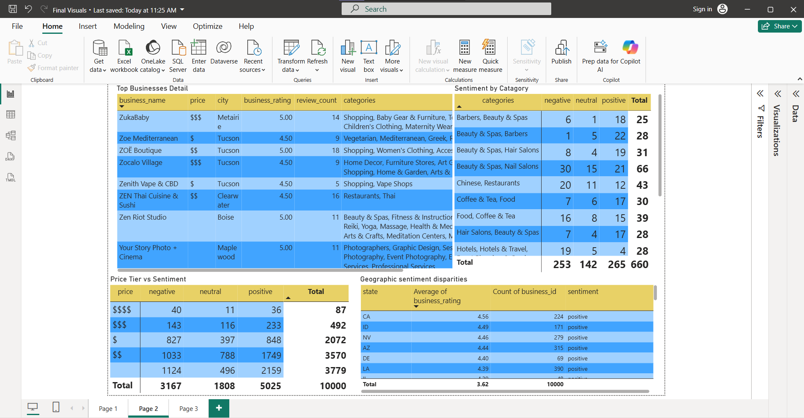
- Top business table.
- Sentiment by category table.
- Price-tier VS Sentiment table.
- Geographic sentiment disparities table.
4 Results and Analysis
4.1 The overall sentiment distribution:
The analysis of the samples shows us a sentiment analysis that is skewed towards a positive perception.
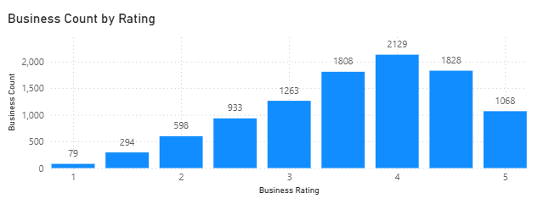
Sentiment Tier | Count | Percentage | Rating range
Positive | 5025 | 50.25% | 5.0-4.0
Neutral | 1808 | 18.08% | 3.9-3.0
Negative | 3167 | 31.67% | <3.0-0
Total | 10000 | 100%

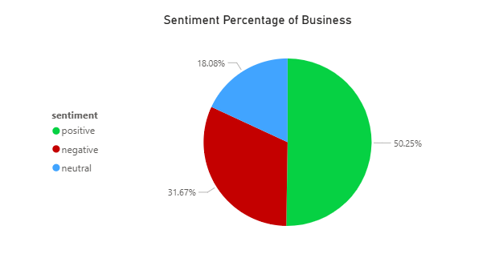
The average rating is 3.62 stars, and the standard deviation is 1.04. The majority of reviews are positive but negative sentiment makes up around a third of the reviews indicating that there is lot of room to improve.
4.2 Geographic sentiment disparities:
Analysis at a state level shows noticeable sentiment heterogeneity
State | Sample Size | Average Rating
California | 224 | 4.56
Pennsylvania | 1124 | 4.38
Arizona | 105 | 3.50

California has the highest average rating, which is well above the mean, but Pennsylvania here with the large sample size better reflects the typical sentiment in the data set. Arizona represents the lower average ratings with a 3.50 sitting lower than the mean. As this analysis is based on limited per sample state, these results should be seen as indicative and not definitive.

4.3 Sentiment by business category:
The category level aggregation reveals which types of business have attracted the most negative reviews.
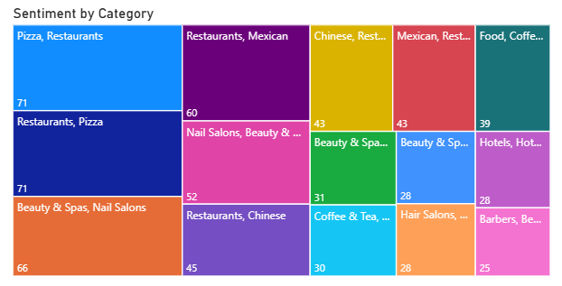
Category | Negative | Neutral | Positive | Total | % Negative
Pizza restaurant | 33 | 18 | 20 | 71 | 46.5%
Nail salon | 30 | 15 | 21 | 66 | 45.5%
Hair salon | 7 | 4 | 17 | 28 | 25%
Barber shop | 6 | 1 | 18 | 25 | 24%

The analysis reveals that pizza shops and nail salons are faced with higher levels of negative sentiment.
4.4 Price-tier sentiment
Price tier has been seen to have influence on sentiment but in a non-linear way:
Price Tiers | Negative | Neutral | Positive | Total | %Negative
$$$$ | 40 | 11 | 36 | 87 | 46%
$$$ | 143 | 116 | 233 | 492 | 29.1%
$$ | 827 | 397 | 848 | 2072 | 39.9%
$ | 1033 | 788 | 1749 | 3570 | 29.0%
Total | 3167 | 1808 | 5025 | 10000 | 31.67%

The analysis reveals that the most expensive tier ($$$$) has the highest percentage of negative reviews at 46%, while the more budget friendly ($) options and upscale options ($$$) are closer to 30% negative.
Customers are likely to be more critical when they are paying premium prices and more likely to write a review talking about the shortcomings of the businesses. Lastly, the middle range ($$) business site somewhere in between with somewhat mixed sentiment.

4.5 Review volume effects:
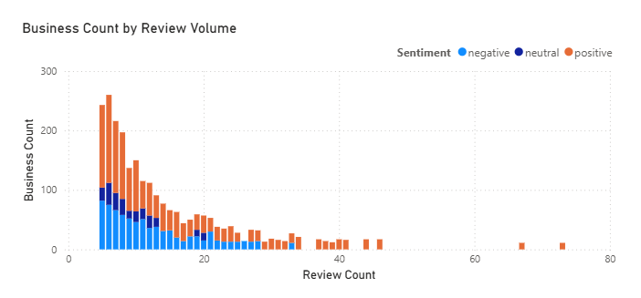
The scatter plot shows businesses with fewer reviews tend to have higher ratings, while businesses with large number of reviews tend to have lower average ratings. Businesses with 1-5 reviews show an average rating of 4.1 stars and those with 50 or more reviews average closer to 3.5 stars. This shows that initial reviews have mostly come from satisfied customers and that people are more likely to leave a review when they are dissatisfied with their experience and wish to share their feelings with others.
5. Discussion:
The analysis reveals that the overall sentiment is slightly positive. Since the mean rating is only 3.62 and approximately a third of the ratings are in the negative band, which means most businesses are failing to meet the expectations of the customers. At the same time the KPI cards and rating histogram show that most ratings exist in the 4 to 5 star range, which seem to be masking the issues for specific categories or price tiers.
Geographic analysis suggests that the location has an influence on in the customer satisfaction but it’s more modest than expected. States like California standout with an average rating of 4.56, while Pennsylvania with 4.38 is more representative of the typical performance, and Arizona sits at 3.50 which closer to the mean of the dataset. This highlights that certain regions consistently perform better, although the analysis is limited by the extracted sample size and the fact that some states don’t have many samples to use.
Category-level results indicate that pizza restaurants and nail salons are problem areas. Nearly half of these businesses fall into the negative sentiment band, while only a quarter of the businesses like hair salons and barber fall into the negative sentiment band. This patter matches the research done: food and certain beauty services have more potential points of failure like timing, cleanliness, quality, price, etc. hence the possibility of disappointment and the generation of a negative review is higher.
Price-tier analysis reveals a paradox, super high-end businesses have a large negative review percentage at 46%, while the upscale and cheap businesses have around 29% and mid-range business sit closer to 40%. This analysis shows how the price at a business sets up the customer’s expectations.
In case of a super high-end business the expectations are very high as such people are likely to be more critical of every detail. Similarly for mid-range options the customer does not feel like they are getting a bargain as such they are more sensitive to shortcomings and can be easily disappointed. In contrast, at upscale and cheap business customers feel that they are getting good value for their money as such they are less likely to be dissatisfied and leave a review.
Limitations of this analysis that should be acknowledged alongside proposed improvements:
- This analysis is based on a small sample size of only 10000 rather than the full dataset due computational limits. To improve the analysis, we could scale the Python pipeline to process larger or stratified data so that the state and category level analysis would better represent the full dataset.
- The analysis relies heavily on star ratings as sentiment proxies without in-depth analysis of the text-based reviews, to improve this we could employ NLP models to review the text and identify which themes or emotions drive the negative reviews.
- This project does not examine how the sentiment changes over time, limiting the ability to detect trends and major events. To improve this, we could extend the pipeline to include review date and build time series dashboards.
- All geographical and categorical comparisons are only observational and correlational, so they cannot establish causality. Future work can introduce predictive models to quantify how strongly different features are associated with sentiment and maybe explore potential causal mechanisms.
Conclusion:
This project demonstrates that an automated workflow that combines Python, Power Automate and Power Bi can successfully transform large, semi-structured data into an interactive dashboard. Here, Power Automate and Excel were used in tandem to clean the extracted data of redundancies and inconsistencies, while Power Bi visualizations summarized the sentiment distribution, category and price-tier patterns, review-volumes effects and geographic differences. The results show that overall results are slightly positive, but certain business types face disproportionately high negative sentiment and that super high-end business face more complaints than other budget options.

7.References
- Yelp Dataset Challenge (2015). Predict business ratings from Yelp reviews. In Proceedings of the 21st ACM SIGKDD Conference on Knowledge Discovery and Data Mining, 1395–1396.
https://www.yelp.com/dataset
- Chen, L., Liu, D., Ooi, B. C., & Özsu, M. T. (2013). Heterogeneous data integration and machine learning. IEEE Transactions on Knowledge and Data Engineering, 25(10), 2310–2323.
https://ieeexplore.ieee.org/document/6516510
- Pang, B., & Lee, L. (2008). Opinion mining and sentiment analysis. Foundations and Trends in Information Retrieval, 2(1–2), 1–135.
https://doi.org/10.1561/1500000011
- Turney, P. D., & Littman, M. L. (2003). Measuring praise and criticism: Inference of semantic orientation from association. ACM Transactions on Information Systems, 21(4), 315–346.
https://doi.org/10.1145/944012.944013
- McKinney, W. (2010). Data structures for statistical computing in Python. In Proceedings of the 9th Python in Science Conference (SciPy 2010), 51–56.
https://conference.scipy.org/proceedings/scipy2010/mckinney.html
- Microsoft Corporation. (2025). Power Automate: Cloud-based workflow automation.
https://learn.microsoft.com/en-us/power-automate/
- Gössling, S., & Hall, C. M. (2019). Sharing economy versus collaborative consumption: Regional development implications. Journal of Sustainable Tourism, 27(1), 92–111.
https://doi.org/10.1080/09669582.2018.1433186

