**1. Customer Segmentation Insights:**

Based on the clustering and analysis, describe the identified segments and their characteristics. For example:

* **High Income, High Spending (Segment A)**:
  + These customers are the mall's most valuable. Target this segment with exclusive rewards, loyalty programs, or premium offerings.
* **Low Income, High Spending (Segment B)**:
  + This segment shows high engagement despite lower income. You could offer promotions or installment-based payment options to keep them engaged and boost their spending.
* **High Income, Low Spending (Segment C)**:
  + These customers have untapped potential. Consider strategies to increase their spending, such as personalized offers or curated shopping experiences.
* **Low Income, Low Spending (Segment D)**:
  + Engage this segment with budget-friendly options, promotions, or community events to build customer loyalty and increase foot traffic.

**Visualizations to Include:**

* **Income vs. Spending Score Scatter Plot**:

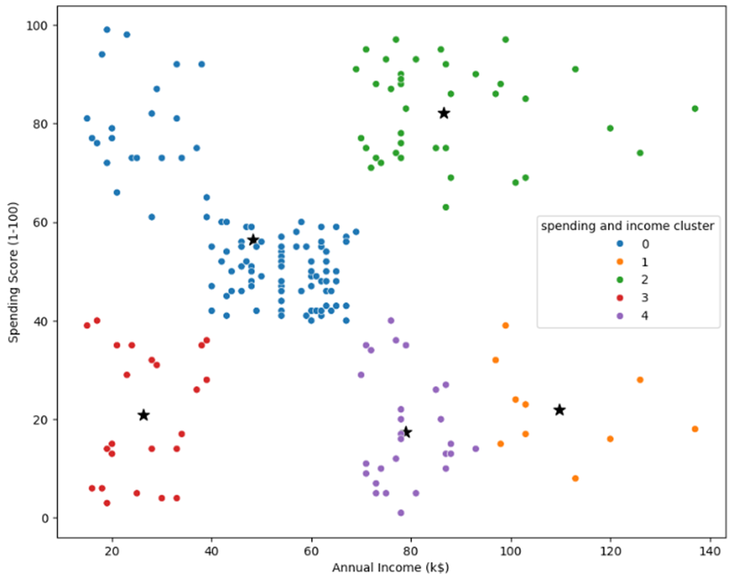

**2. Demographic Insights:**

* **Gender Balance**: Female dominates in customer numbers, this could be leveraged in gender-specific marketing campaigns or product offerings.

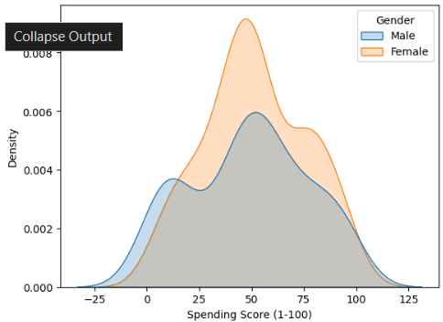

* **Age-Based Trends**: Age group between 25 to 45 spend more. We can do special events, or digital promotions targeting this specific age groups.

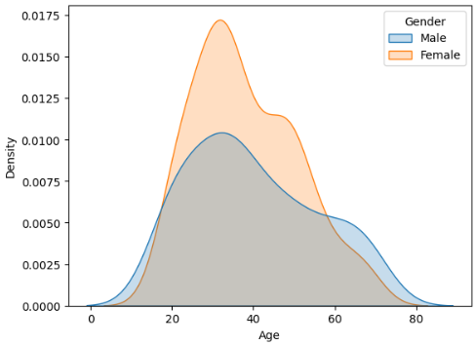

**3. Marketing Recommendations:**

* **Personalized Marketing**: Use customer segments to personalize marketing efforts. For example:
  + Send targeted offers via email or SMS to **high-spending segments** with premium products.
  + Engage **low-spending segments** with discounts or loyalty programs to encourage repeat visits.
* **Event-Based Promotions**: Organize exclusive events or VIP shopping experiences for **high-income clusters**, such as a loyalty club night.

**4. Sales Strategy Adjustments:**

* **Product Placement**: Place premium products in areas frequented by **high-income clusters**, while ensuring budget-friendly options are available for **low-income customers**.
* **Special Discounts or Payment Plans**: Offer easy payment plans or installment schemes for customers in the **Low-Income, High-Spending** group to maximize engagement.

**5. Mall Layout and Customer Experience:**

* **Enhance Customer Experience**: Based on the findings, consider adjusting mall layout, service levels, or promotions to match customer demographics and spending habits.
* **Loyalty Program**: Develop a loyalty program that rewards high-spending customers and incentivizes low-spending customers to spend more.

**6. Further Data Collection Suggestions:**

* Suggest collecting additional customer data (e.g., **shopping preferences, transaction history, or visit frequency**) to refine segmentation and enhance future analysis.
* Consider analyzing **seasonal trends** or **event-driven footfall**, which can impact customer behavior and spending.

**Conclusion:**

* The importance of customer segmentation in driving targeted marketing, enhancing customer loyalty, and improving profitability.
* Suggest conducting continuous data analysis over time to refine segmentation models and update marketing strategies as customer preferences evolve.