STEPS TO CREATE SERVLET USING ECLIPSE IDE

- Download and install Tomcat software (exe file, present eclipse version compatible)
- Open a terminal and start eclipse
- $ eclipse

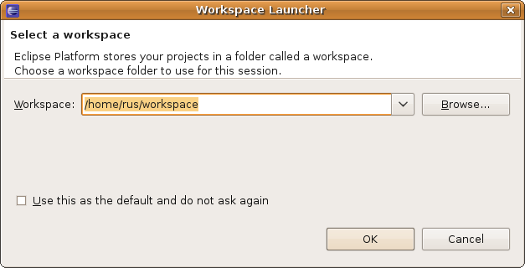

Create Dynamic Web Project
Select from the menu File --> New --> Dynamic Web Project.
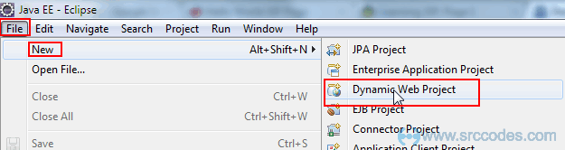

Enter "HelloWorldServlet" as the project name. Keep rest of the settings as it is as shown in the following screenshot.

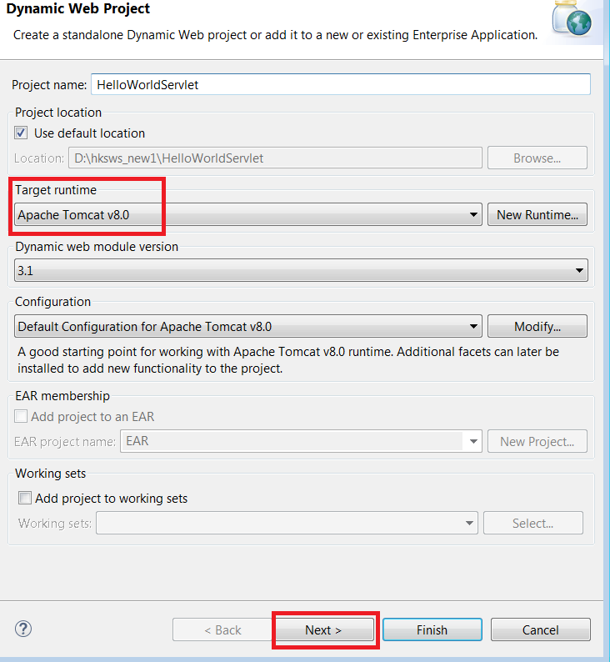
Click "Finish" button.

2. Create Servlet Class
Select from the menu File --> New --> Servlet.
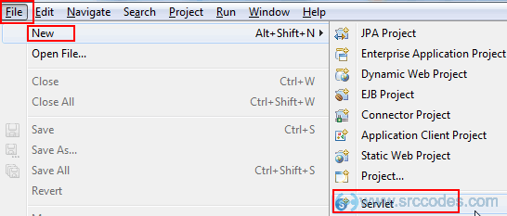
Write "HelloWorld" in the 'Class Name' field. Click 'Next' button.
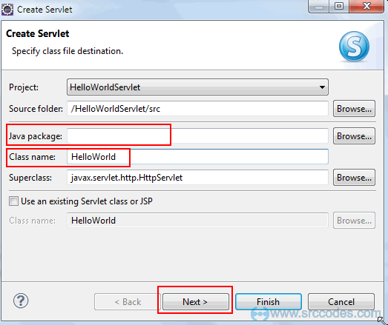
We can specify deployment descriptor (web.xml) specific information in the following screen. Just keep every thing as it is for the time being. Click "Next" button.
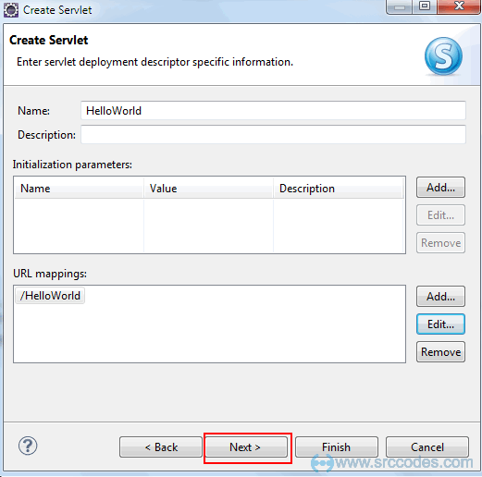
Click 'Finish' button.
Eclipse will generate a Servlet class based on the configuration / input we provided in the previous steps and open the same in the Java Editor as shown below

4. Write Custom Code
File: HelloWorld.java
Note :
Notice the highlighted line number 13 in the above code. "/HelloWorld" is the servlet url that we need to specify in the browser url to access the same. This is annotation based approach to define servlet mapping. We can do the same inweb.xml file as well. For simplicity we are moving forward with the

5. Run Your Servlet Code
Right click on the project 'HelloWorldServlet' and select from context menu 'Run As' --> 'Run on Server'.
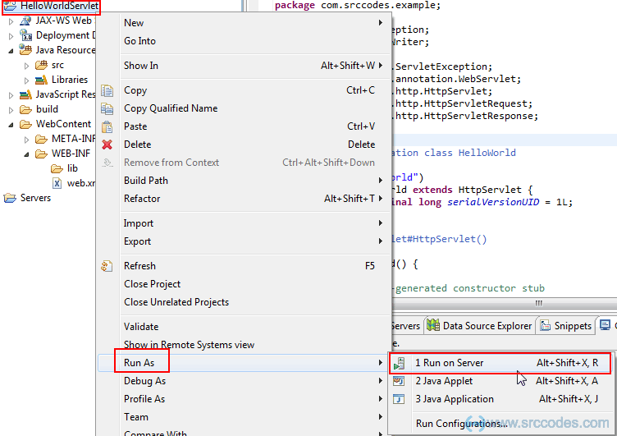

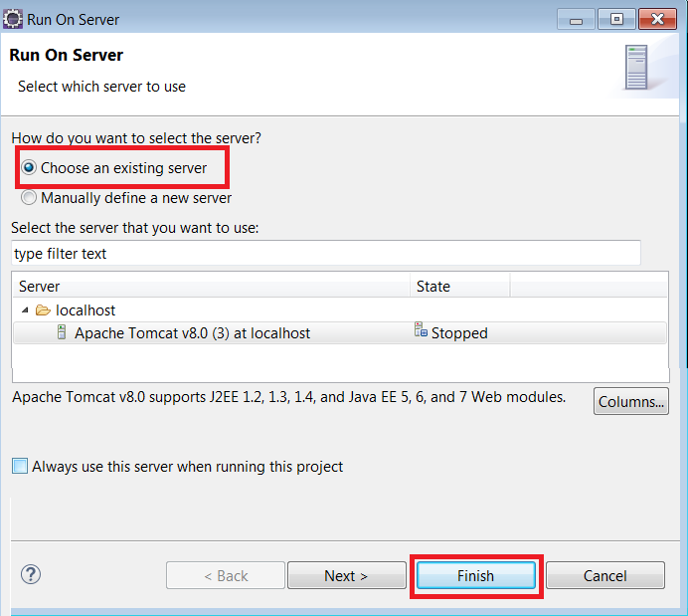
Click "Finish" button. HelloWorldServlet web application will be deployed in the tomcat web server.
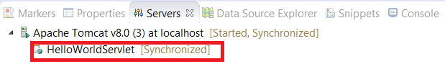
6. Browser Output
Eclipse will open a browser and your server side code will print 'Hello World!' in the browser.
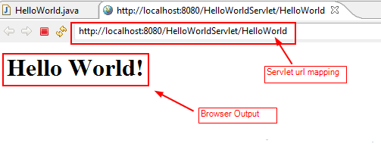

Select the existing tomcat server. If not available then manually define a new web server.
Go to Console window (see Down side window pane)
→ Select Server→ Right Click→New→Server
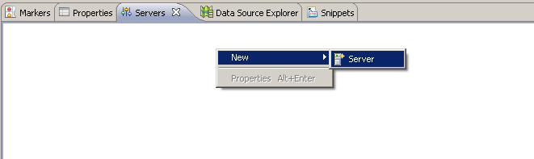

Select Apache → Tomcat v5.5 Server (present tomcat software downloaded by you)

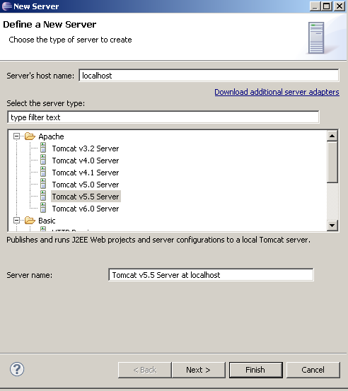

Select Tomcat installation directory→Finish

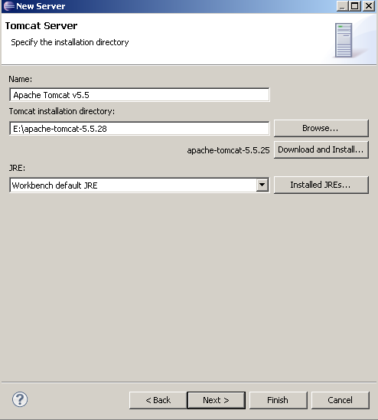

Now Tomcat Server is available through eclipse
Right Click →Start the Server: The Server Started, Synchronized appear on the screen

