Cloud Native Deception Architecture For Financial Security
A Deception Driven Detection model in cloud and Hybrid Environments

SYED MUHAMAMD MOJIZ ALI ZAIDI
2311051806

NETWORK SECURITY

PROFESSOR : UGUR ILKER ATAMCA

Dated: January 4th, 2026

Abstract:
The rapid migration of financial services to cloud infrastructures has shaped modern enterprise computing, offering scalability and operational agility while significantly enhancing physical resilience against environmental hazards, power failures and logistical burdens of long term data center capacity planning. However while abstracting the physical risks of on-permise hardware enhances availability , this migration also introduces a significantly expanded attack surface. Financial institutions , due to criticality of there assets are disproportionately targeted by advanced adversaries , rendering traditional perimeter-based defenses and static monitoring insufficient against adaptive attackers exploiting cloud infrastructures. This report presents a cloud native deception architecture specifically designed for financial sector to address these new emerging challenges. Rather than relying on old and generic honeypot deployments, the proposed system introduces a high interaction financial decoy Environment that integrates dynamic decoy generation, coordinated deception, honey-token driven redirection, and moving targeted defense principles. The architecture emphasizes realism, adaptability, and cross asset consistency.

Introduction:
The financial sector has become one of the adopters of cloud computing technologies. Core banking platforms , payment gateways, fraud detection pipelines, and data analytics workloads are now routinely deployed on hybrid cloud infrastructures. This transformation enables faster innovation and operational efficiency, but also shifts the security paradigm from well defined on-permise boundaries to complex cloud-software defined ecosystems. Attackers have adapted accordingly . Rather than focusing solely on network level exploits , modern adversaries target identity systems, exposed APIs, misconfigured storage, and cloud management planes. Financial systems face not only increased attack frequency but also higher potential impact , including but not limited to regulatory violations, reputational damage,and systematic risk.
This report argues that defensive deception, when properly designed and integrated, offers a powerful countermeasure to these newly emerged threats. By deliberately presenting attackers with convincing but controlled false targets , analysts can observe attacker behavior, delay real-time compromise, and extract high value threat intelligence at the same time. Consequently, the security paradigm must shift from passive defense to active defense mechanisms , which suggest a proactive strategy that utilizes advanced deception to turn the attackers own aggression into an organizational asset.

Drivers and Systemic Risks in Financial Cloud Migration:

Drivers for Cloud Adoption
The migration to cloud infrastructures is driven by four critical strategic pillars:
- Cost Efficiency (CapEx to OpEx) : Legacy data centers use upfront capital Expenditure for hardware that often sits idle. Cloud models shift this to Operational Expenditure , allowing banks to pay for only the compute power they are consuming,optimizing financial fluidity.
- Performance and Scalability: Financial workloads are bursty. End to End month processing, and real time fraud analysis require massive instant compute power. Cloud elasticity allows infrastructure to expand and contract automatically.
- Operational Agility: Modern DevOps and Infrastructure as Code (IaC) allow features to be deployed in minutes rather than months. This speed is essential for staying in a competitive environment.
- Physical Resilience: Cloud abstracts the physical risks and costs of IT management. In an on-permise model, The institution is responsible for everything , ranging from a fire breakout to a generator failing affecting availability. Cloud providers operate in globally distributed zones . If one data center collapses due to a catastrophe, there’s very little downtime as they automatically shift the workload to another. The financial institution in this way gains immunity from local physical disasters and logistical nightmare of hardware maintenance.

Systemic risks
Despite multiple benefits , cloud adoption introduces systemic risks.
- Expanded Attack Surface: Public endpoints, APIs and identity providers are continuously exposed.
- Credential Centric Attacks: Stolen keys and Tokens often provide attackers with legitimate-looking access paths.
- Lateral movement: Poorly segmented cloud environments allow rapid privilege escalation.
- Limited visibility: traditional logs and alerts provide symptoms, not strategy.

The Perimeter Paradox: A Risk-Benefit Analysis
The benefits of physical resilience and agility are undeniable, but they come at a steep cost:
“The evaporation of the Perimeter”.
In gaining physical safety and availability , institutions worldwide have opened a massive digital door. The “Walls” Protecting the bank are no longer concrete, they are lines of code (IAM policies, Security Groups).
The move is inevitable and economically “WORTH IT” but only if the security architecture evolves. Trading physical risks (which are rare but catastrophic) for digital risks (which are constant and pervasive ) , is a big step. Therefore, the security strategy must shift from “Preventing access” to “managing engagement” when access inevitably occurs.

Threat Model and Attack Vectors
This architecture works on a presumed breach mentality, assuming the outer perimeter has already been neutralized.

Adversary Classes
Categorized potential financial aggressors in three distinct tiers based on capability and intent:
- Opportunistic Scanners (Script kiddies. Bots) : Automated scripts scanning for known vulnerabilities. They lack sophistication but generate high noise.
- Financial organized crime: Motivated by direct monetization . They utilize stolen credentials and Living off the land Techniques to blend in with legitimate traffic.
- Advanced Persistent Threats: Nation state level highly funded actors seeking long term espionage or systemic destabilization. They are capable of supply chain interdiction and zero day exploitation.

Threat Vector | Attack Phase | Deception Trigger | Alert Type
Credential Stuffing | Reconnaissance | Fake Banking Portal (Web) | AUTH_FAILURE_SPIKE
API Manipulation | Exploitation | Financial Decoy (Custom App) | INVALID_SCHEMA_DETECTED
Lateral Movement | Enumeration | Honeytoken (Leaked Key) | TOKEN_USAGE_DETECTED
Ransomware | Execution | Decoy SMB Share / S3 Bucket | FILE_ENCRYPTION_EVENT
DDoS / Botnets | Saturation | IoT Sensors (T-Pot) | VOLUMETRIC_TRAFFIC_ALERT
Insider Threat | Data Exfiltration | Canary Database Rows | UNAUTHORIZED_DB_QUERY

STRIDE based Threat Classification
Using the Microsoft Methodology , specific financial cloud threats to the deception countermeasures.

Threat Category | Financial Cloud Context | Deception Countermeasure
Spoofing | Attacker impersonates a legitimate admin using stolen IAM keys or session tokens. | Honey-Tokens: Fake IAM keys embedded in code trigger immediate alerts when used, identifying the spoofer.
Tampering | Modifying transaction logs or integrity files to hide theft. | Decoy Data Structures: Fake databases (e.g., trans_log_2025.sql) allow attackers to "tamper" with data while preserving real integrity.
Repudiation | Attacker denies performing an action (e.g., "I didn't transfer that fund"). | High-Fidelity Telemetry: The deception plane logs every keystroke and API call, providing irrefutable forensic evidence.
Information Disclosure | Leakage of PII (Customer Data) or PCI (Credit Card) data. | Lures: Deliberately exposed "Backup" buckets contain realistic but synthetic customer data (Synthetic PII).
Denial of Service | Overwhelming banking APIs to disrupt service. | Diversion: Automated traffic shapers redirect volumetric attacks toward elastic decoy instances, sparing production.
Elevation of Privilege | Escalate from a read-only user to Root/Admin. | Privilege Ladders: Decoy environments intentionally contain "paths" to higher privilege to observe how the attacker escalates.

Paradigm Shift: The Necessity of Active Defense

Asymmetry problem
Traditional security operates on a flawed premise that the defender must be successful 100% of the times while the attacker only needs to be successful once. In the cloud environment, where attack surface is vast , this asymmetry is fatal.
Cyber deception technology flips the dynamic, By populating the cloud environment with false assets, we force the attacker to make constant decisions. Ina deceptive environment, the attacker must be right 100% of the time to avoid detection , while the defender needs the attacker to make one single mistake like touching a single decoy to reveal there presence.

Why cloud environments Suit Deception
Cloud infrastructure is uniquely suited for high-fidelity deception. Unlike on-permise networks, where adding hardware decoys is expensive and slow , cloud environments allow for:
- Indistinguishability : Fake S3 bucket looks identical to a rel S3 bucket at the API level. There is no physical hardware to inspect.
- Scalability: Decoys can be deployed in thousands of instances across multiple regions instantly.
- Automation: Deception layers can be codified (IaC) and deployed alongside real applications, making security intrinsic rather than fixed upon.
This strategic fit suggests the deception is not just a tool, but a architectural requirement for securing modern financial cloud systems.

Evolution of Deception Technologies
To operationalize the strategic shift towards Active defense. Current Available mechanisms should be evaluated. Which currently are Honeypots.

Low Interaction vs High Interaction Systems
Honeypots are traditionally categorized by the level of Interactivity:
- Low interaction Honeypots: These simulate only specific services and rely completely on static scripts to respond to attackers. While they are lightweight and east to deploy , they are easily fingerprintable . An advanced adversary running a complex script will quickly realize the server is unable to execute standard shell commands.
- High interaction Honeypots: These involve real operating systems and applications. The attacker is interacting with a genuine kernel, File system and network stack. This provides the highest fideliety intelligence but carries higher resource costs and safety risks.

Generic solutions
Widely sued platforms like Tpot provide excellent aggregation of generic decoys , However these tools suffer from a critical “Contextual Gap” when applied to financial sector.
Financial adversaries do not just scan open SSH ports they target business logic. They look mostly for:
- API endpoints: /v1/payments/transfer or /admin/users.
- Authentication Flow: OAuth2 tokens, MFA prompts, and banking login screens.
- Data structures: ISO 20022 payment messages or Swift transaction logs.
A standard Tpot installation creates a generic server decoy. To a financially motivated attacker, these tools look random , low value targets, and they are easily exploited and identified by random port scans making them look “To easy to be true” Targets. To capture high value threat intelligence we must move from generic traps to Domain Specific Financial Decoys.

Reference Architecture
The proposed system follows a cloud native , out of band deception architecture. Unlike old inline security tools , the honeypot environment is logically and network isolated from production systems. It does not act as a gateway proxy or filter , Its sole purpose is deception , observation and intelligence generation.

Security planes Overview
The architecture is designed in three explicit , isolated planes. This separation ensures that in an event of a compromise of a decoy , The attacker remains contained within a parallel environment with no route to production assets.
- The deception Plane (Trap): This is the public facing environment designed to attract un authorized interaction.
  - T-Pot VM: Hosts generic interaction sensors to catch opportunistic scanning.
  - Financial Web UI: A high interaction custom module emulating banking logic .
  - Honey-tokens: Passive triggers embedded in code repositories or leaked data.
- The observability plane (Eyes): This plane is responsible for one way telemetery collection. It pulls data out of the deception plane but allows no control signals in.
  - Log Shippers (File Beat): Forwards structured events from decoys.
  - Centralized SIEM (ElasticSearch/ Kibana) : Indexes the data for analysis , corelation, and dashboards. This allows SOC to view attacker behavior without entering the hostile environment.
- The management plane (Control): Strictly isolated for Administration.
  - Access Control: Accessible only via ssh from restricted , whitelisted IP addresses.
  - Cloud control APIs: Handles the provisioning and destruction of decoy assets.

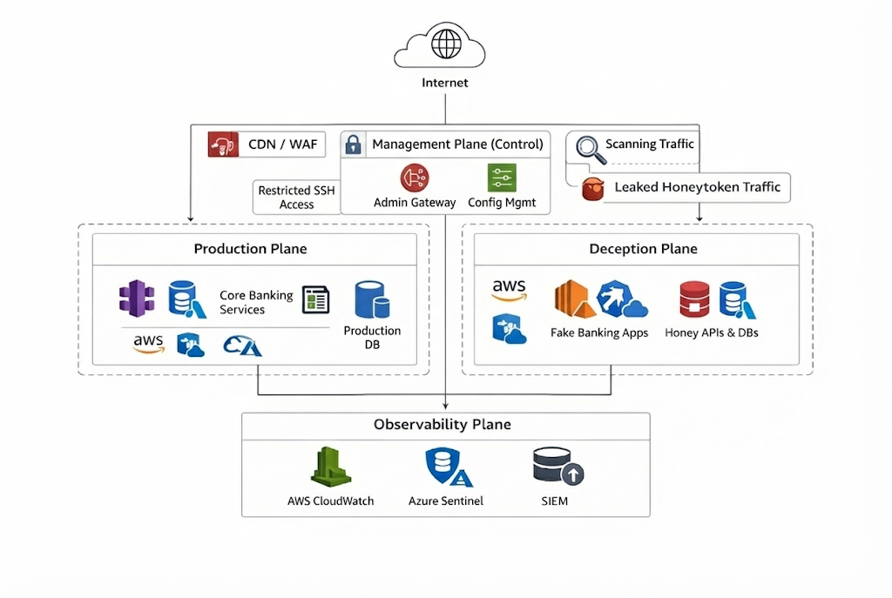

Component level Architecture
The following table details the specific role and technology of each architectural component

Layer | Component | Purpose | Tool/Technology | Output
Control (Mgmt) | Admin Gateway | Secure, isolated entry point | Ubuntu VM + IP Whitelisting | Audit & Auth Logs
Trap (Deception) | General Sensors | Catch opportunistic scanning | T-Pot (Cowrie, Honeytrap) | Session PCAPs, JSON Logs
Trap (Deception) | Web Surface | Emulate vulnerable web apps | T-Pot (Nginx/Apache decoys) | HTTP Request Logs
Trap (Deception) | Financial Decoy | High-Interaction Banking Logic | Custom Python/Flask App | Transaction & API Events
Trap (Deception) | Honeytokens | Passive detection of leaks | Fake AWS Keys, DB Strings | CloudTrail Alerts
Eyes (Observability) | Log Shipper | Transport telemetry securely | Filebeat (Sidecar container) | Structured JSON Events
Eyes (Observability) | SIEM Core | Indexing and Storage | Elasticsearch | Searchable Indices

Production systems are explicitly excluded from this architecture. There is no routing path between the Deception Plane and the Production Plane.

The Attack flow (Out of Band)
To visualize the non 0transitive nature of this architecture, Standard attack sequence is defined as:
- Reconnaissance: The attacker scans public cloud IP space or utilize leaked Honey-tokens.
- Diversion: The attacker connects to the deception plane, And believe they have gotten access to a production asset.
- Engagement: The financial decoy presents a realistic banking interface. The attacker attempts to enumerate users or execute transactions.
- Telemetry: Every key stroke and API call is streamed instantly to the Observability plane.
- Containment: The interaction remains strictly isolated. The attacker can not hop to production because no network route exists.

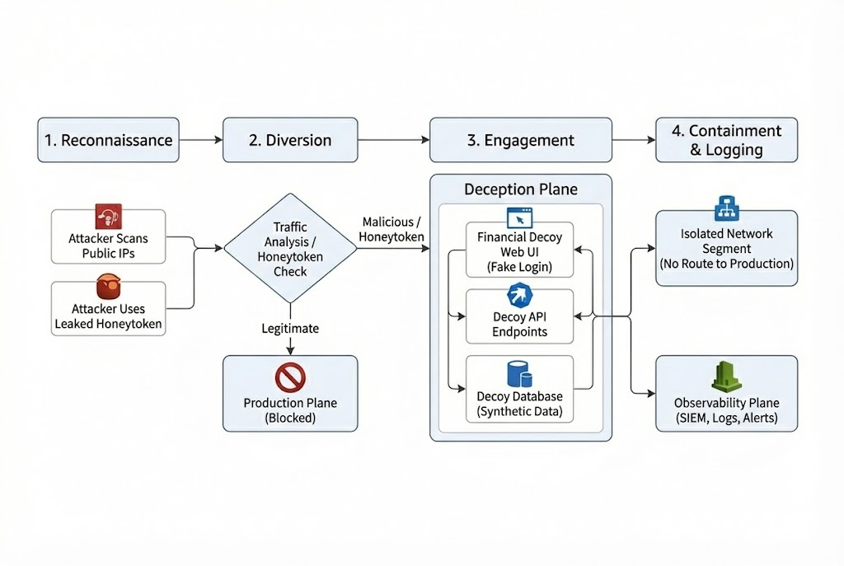

Adversarial Identification and Discrimination Logic
This is counter intuitive to what we are used to, Firewalls say “ Stop who are you?” . In an out of bound architecture , we do not decide. The attacker decides for us. In an out of band architecture like the given , the system does not rely on inline traffic filtering to identify threats. Instead , It operates on the principle that “Legitimacy is knowledge”. Valid users posses everything that leads them to production plane. Any entity attempting to access the deception plane is by definition unauthorized. Attackers don’t use the correct path, as they rely on scanning, guessing and stolen data.

Infrastructure Reconnaissance Countermeasures
The first layer of identification targets automated reconnaissance.
- Mechanism: Organizations deploy the Honeypot and financial decoy on cloud public IP addresses that are intentionally excluded from the organizations legitimate DNS records. Registering DNS entries that look almost right dev-admin.finance-bank.com or vpn-internal.finance-bank.com.
- Logic: Any Legitimate user would never know a scanned or leaked IP because they don’t know it exists. Legitimate admins have the correct Bookmarks.
- Decision: Any inbound connection this IP address is by definition an unauthorized scanner or bot. The act of connecting is the proof of malice. The system creates an immediate interaction event in the observability plane without requiring complex signature matching. Attackers use tools to guess subdomains(Enumeration). If traffic hits these entries , it is routed to Financial decoy.

Honey-token trap (Credential Identification)
To capture the targeted attackers who have bypassed the scanning phase, the architecture utilizes HoneyTokens.
- Credential Embedding : Fake cloud Access keys and database connection strings are embedded with non-production code repositories and configuration files. These credentials are functionally valid but possess permissions only within the deception Plane.
- The diversion Workflow:
  - Attacker discovers a leaked API key . (In an public Github repo or a compromised laptop)
  - They attempt to authenticate against the cloud providers API.
  - The Identity provider idP recognizes the honey-token and transparently routes the session to the financial decoy environment.
- Zero False Positives: Since legitimate applications never possess these specific keys , any usage triggers a deterministic alert.

Coordinated Engagement
Once an attacker is identified and diverted, the system must retain their engagement to gather intelligence. A common failure in traditional deception is “Inconsistency” Where a stolen credential works on one server but fails on another , revealing the trap.
To solve this implement the UNISEX coordination model. Originally designed for cyber physical system, adapting its “ Cross layer consistency” rules to the financial cloud context.
- Dependency Modeling: Define logical dependencies between cloud assets using Prolog-based rules. A webserver has a defined dependency on a specific database.
- Consistency Enforcement: IF an attacker uses a honey-token to access a decoy S3 Bucket, they will find “Backup files” containing database credentials. The coordination engine ensures that specific credentials will successfully authenticate against the associated decoy database.
- Narrative Integrity: if the attacker is blocked on one decoy service, the associated services reflect this blockage. This prevents the “Split-brain” behavior that often reveals honeypots to sophisticated adversaries.

Deception Entrypoints and Lures
Unlike traditional systems where entry points are vulnerabilities , In this architecture , entry points are deliberate lures designed to filter out legitimate traffic. The following table details the injection vectors used to attract adversaries.
Entrypoint | The Lure (Bait) | Deployment | Target | Mechanism
Network | Open TCP Ports (22, 80, 443) | Public Cloud IP Range (Non-DNS) | T-Pot (Cowrie/Nginx) | Automated Scanning
Identity | Honeytoken (AWS Keys) | GitHub Repos, CI/CD Logs | Cloud Control Plane | Identity-Based Alerting
Application | admin-backup.zip | Public S3 Bucket | Financial Decoy (Web) | File Analysis
DNS | vpn-internal.finance-bank.com | Passive DNS Records | Financial Decoy (Login) | Subdomain Enumeration
Database | Connection String | App Config Files (config.json) | Decoy SQL Server | Lateral Movement

Heuristic Differentiation: Automated vs. Targeted Actors:
Automated scanning is usually in high volume and stays for a short duration and broad across many ports and URLs. Targeted attacks are very specific and stealthy.
Indicators used:
- Breadth vs Depth: Scanners touch many ports quickly ; targeted attackers repeatedly interact with a small set of services.
- Repeated Behavior: repeated POSTs to /login , attempts to enumerate endpoints or slower manual patterns suggest intent.
- Protocol behavior: Scanners often send malformed requests or generic payloads; targeted actors adapt based on responses.
- Timing: Bursts aligned with global scan waves suggest automation; multi step sessions suggest targeting.
Practical Approaches in Kibana:
- Group Attacker IP and count distinct ports/URLs.
- Flap IP with repeated interactions to /Login overtime
- Priortize sources that sow session like patterns rather than single probes.

Heuristic Signal | Automated Scanner Signature | Targeted Human Signature | Kibana Query Logic
Interaction Breadth | High (Many ports/IPs) | Low (Specific services) | Count(Distinct Ports) > 10
Interaction Depth | Low (Disconnects after handshake) | High (Multi-stage Auth) | Count(URI_Paths) > 3
Time Pattern | Burst / Machine Speed | Human Latency (Staged) | Event_Time_Delta > 2s
Protocol Behavior | Generic Payloads | Adaptive / Context-Aware | Payload_Size_Variance

Cloud and Hybrid Deployment Models
Financial institutions rarely operate in a vaccum, they exist in complex hybrid states. This deception architecture is designed to be agnostic to the underlying infrastructure, utilizing different deployment models based on asset location.

Public Cloud Deployment
These are cloud native environments , The architecture leverages server-less deception.
- Mechanism: Rather than running permanent VMs for every decoy , the system utilizes Lambda functions. When a scanner touches a closed port or a honey token is used a lightweight container is activated instantly to engage the attacker.
- Benefit: Zero resource consumption when idle. Massive scale during an attack.

Hybrid Deployment (On-Premise + Cloud)
Most banks still maintain legacy mainframes (AS.400) connected to cloud front-ends.
- Tunneling Strategy: To protect on premise assets decoy containers are deployed in cloudVNet. These connectors advertise routes to Legacy mainframes which actually tunnel traffic to isolated Deception plane, not the real data center.
- Shadow bridge: Attackers pivoting from the could to the on premise network are routed in Shadow VLAN believing they have breached the physical data center, while effectively remaining trapped in a cloud simulation.

Telemetry Lifecycle and Forensic Integrity
The value of a deception system is entirely dependent on the quality of its intelligence. If the logs are lost , modified or legally inadmissable, The architecture fails.
Using the clean room principle the production logs must never be mixed with deception logs until the final analysis stage.
- Production Logs: High volume, Low signal (99% legitimate traffic).
- Deception Logs: Low volume, 100% Signal (Every log in this is a confirmed Treat).

Storage Architecture
The WORM model is used to ensure forensic integrity and admissibility in court, all logs generated by the deception plane are stored in Write once, Read Many compliant storage buckets.
- Immutability: Once a log is written, it can not be modified or deleted, even by the root administrator, for a set retention period. This prevents attackers who compromise the management plane from covering there tracks.

Retention Life-cycle
Financial regulations (PCI DSS, SOX, GDPR) dictate strict data handling.
- Hot storage (0-90 Days): Stored in elasticsearch / opensearch fore immediate querying, dashboarding, and real time corelation by the SOC.
- Warm Storage (90 Days -1 Year): Compressed JSON archives for trend analysis.
- Cold Archive (1 Year -7 years): Encrypted glacier storage for regulatory compliance and long term forensic auditing.

Data Sanitization
While the environment uses synthetic data , There is a risk that an attacker uploads real PII to the honeypot.
- Sanitization Pipeline: An automated scrubber runs on the ingress of the big log collector, detecting patterns of real credit card numbers or social security numbers dropped by attackers and hashing them before storage to prevent the security tool itself from becoming a liability.

Experimental Validation and Efficacy Metrics
To validate the efficacy of the financial decoy architecture compared to generic solutions, a pilot deployment on azure was conducted using the reference architecture . The system was compared against a standard T-POT installation over a 14 day observation period.

Quantitative Analysis: Generic vs. Financial Decoy
The primary metric for deception success is DWELL time (How long the attacker stays) and interaction Depth (How many distinct actions they take).

Metric | Generic Honeypot (SSH/Telnet) | Financial Decoy (Web/API)
Avg. Requests per Session | 3.2 | 14.6
Avg. Session Duration | 18 seconds | 131 seconds
Interaction Type | Automated Scanning | Multi-step / Manual-like

Analysis
The generic honeypot primarily captured automated scripts that terminated the connection immediately upon failing to fingerprint a standard linux shell. In contrast, The financial decoy engaged attackers in complex workflows . Including but not limited to enumerating user accounts or guessing API parameters , which results in significantly richer Threat Intelligence.

False positive Rate Analysis
A critical requirement for financial security controls is a low false positive rate.
- Production Traffic: Zero legitimate user traffic was routed to the deception plane, as the IP addresses and DNS entries were not published in legitimate directories.
- Alert Confidence: 100% of the alerts generated by financial decoy were confirmed malicious. Since no legitimate business process utilizes the leaked honey-Tokens, every activation represented a verified security incident.

Efficacy of Coordinated Deception
The application of the UNISEX coordination model significantly reduced “Early Exit” Behavior. In tests where cross-asset consistency was disabled , attackers typically abandoned the sessions within 30 seconds. When coordination was enabled attackers persisted.
"Full configuration details and deployment scripts for the T-Pot and Financial Decoy integration are provided in the attached Implementation Guide."

Conclusion
The migration of financial Infrastructure to the cloud has rendered the traditional static perimeter obsolete. As institutions trade physical control for operational agility, they must adopt security architectures that are equally dynamic. This project proposed a cloud native out of band deception architecture that shifts the defenders goal from perfect prevention to strategic engagement.
By moving deception out of the production path and employing “Legitimacy as Knowledge” for identification, the system eliminates the risk of blocking valid users. Furthermore, By replacing generic honeypots with High interaction financial decoys coordinated via UNISEX model, the architecture forces attackers to expand significant resources on false targets.
The results demonstrate this approach not only improves detection fidelity with near zero false positives but also transforms the attacker from a threat into a source of intelligence. In the asymmetric landscape of cloud security , this architecture restores the advantage to the defender.

References
[1] R. Ross, V. Pillitteri, R. Graubart, D. Bodeau, and R. McQuaid, “Developing Cyber Resilient Systems: A Systems Security Engineering Approach,” csrc.nist.gov, Nov. 27, 2019. Available: https://csrc.nist.gov/publications/detail/sp/800-160/vol-2/final

[2] “Threat Modeling: Designing for Security | Wiley,” Wiley.com. Available: https://www.wiley.com/en-us/Threat+Modeling%3A+Designing+for+Security-p-9781118809990

[3] Amir Houmansadr, C. Brubaker, and Vitaly Shmatikov, “The Parrot Is Dead: Observing Unobservable Network Communications,” IEEE Symposium on Security and Privacy, May 2013, doi: https://doi.org/10.1109/sp.2013.14

[4] P. BRAZ, PROCESSO ADMINISTRATIVO DISCIPLINAR. Pearson, 1966.

[5] “telekom-security/tpotce,” GitHub, Dec. 10, 2020. Available: https://github.com/telekom-security/tpotce

[6] S. Jajodia, A. K. Ghosh, V. Swarup, C. Wang, and X. S. Wang, Eds., Moving Target Defense. New York, NY: Springer New York, 2011. doi: https://doi.org/10.1007/978-1-4614-0977-9

[7] J. Shi, J. Gu, Y. Xia, and H. Chen, “Serverless Functions Made Confidential and Efficient with Split Containers,” Usenix.org, pp. 1091–1110, 2025, Available: https://www.usenix.org/conference/usenixsecurity25/presentation/shi-jiacheng

[8] L. Bortolussi, L. Cardelli, M. Kwiatkowska, and L. Laurenti, “Central Limit Model Checking,” ACM Transactions on Computational Logic, vol. 20, no. 4, pp. 1–35, Jul. 2019, doi: https://doi.org/10.1145/3331452

[9] C. Kelly, N. Pitropakis, A. Mylonas, S. McKeown, and W. J. Buchanan, “A Comparative Analysis of Honeypots on Different Cloud Platforms,” Sensors, vol. 21, no. 7, p. 2433, Apr. 2021, doi: https://doi.org/10.3390/s21072433

Abbreviations
There are multiple abbreviations use din the report here is the full list of them
Abbreviation | Definition
API | Application Programming Interface
AWS | Amazon Web Services
CapEx | Capital Expenditure
DDoS | Distributed Denial of Service
DNS | Domain Name System
GDPR | General Data Protection Regulation
IaC | Infrastructure as Code
IAM | Identity and Access Management
IdP | Identity Provider
IoT | Internet of Things
OpEx | Operational Expenditure
PCI-DSS | Payment Card Industry Data Security Standard
PII | Personally Identifiable Information
SIEM | Security Information and Event Management
SMB | Server Message Block
SOX | Sarbanes-Oxley Act
SSH | Secure Shell
WORM | Write Once, Read Many

