**Steps**

1. For images like CLSA, where there is a problem that patients' IDs are as folder names and the DCM files are named the same e.g. dxa_lateral in this case, use the file ***sorting_and_combining_and_naming.py*** by placing it as follows.

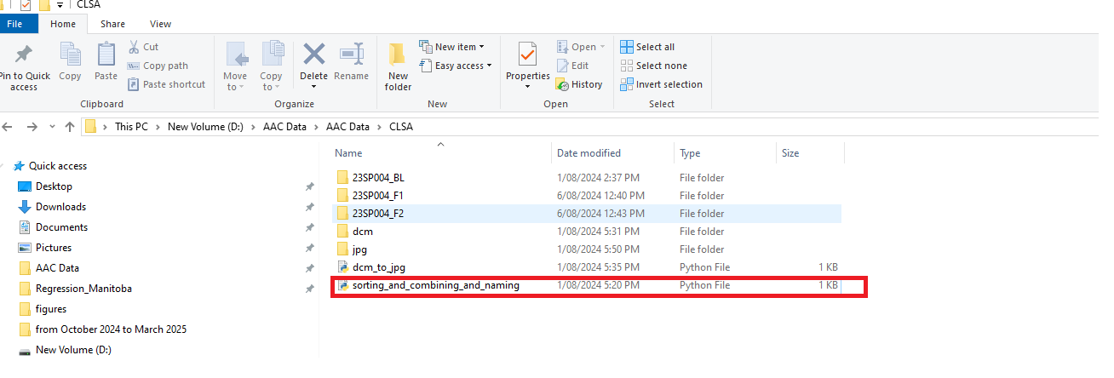

1. Open the terminal in Linux or PowerShell in Windows and use the following command:

***python sorting_and_combining_and_naming.py --src_folder_path ./23SP004_F2 --dst_folder_path ./ 23SP004_F2 _dcm***



1. Next to convert DCM files to jpg use the following command:

***python dcm_to_jpg.py --src_folder_path ./dcm2 --dst_folder_path ./23SP004_F2_jpgs --min_value 0 --max_value 4096***

Note: It is important to manually check few images of the DICOM files for the maximum and minimum value range for the pixels. If for example, you find a value of 3998 as a maximum value and a minimum value of 0, then you need to select min value =0, and max value =4096 (multiple of 2). DO NOT select as 3998 or 4000.

1. Copy the jpg files to *‘./VerteNet/dataPath/data/test’*.
2. Paste the trained model file at the location *‘./VerteNet/weights_spinal/model_last.pth*.’
3. Run the following command:

***python main.py --phase test --dxa_dataset clsa***

1. You will get a folder with following format:
   1. *clsa_detailed_outputs*
      1. *images_with_landmarks_and_IVGs*
      2. *images_with_landmarks_only*
      3. *images_with_offset_vectors*
      4. *landmarks*
      5. *original_images*
2. Go *to ‘./VerteNet/dataPath/outputs’* and run the following command:

***python Algorithm_Aorta_Clip_Detection.py --src_folder_path VerteNet_predictions/clsa_f2_5000_detailed_outputs --dst_folder_path clsa --factors_range_min 0.9 --factors_range_max 1.2 --dpi 150***

A new folder will be generated with following structure:

1. *clsa*
   * 1. *imgs*
     2. *landmarks*
     3. *outputs*
     4. *splines*

*The ‘splines’ folder contains the resultant files with the format ‘Aorta_Clip_Flag_flagstatus_filename.jpg*