Individual Report

Introduction to Database
- Name: | - Syed Khurram Abbas Zaidi
Student ID: | - G1423141
Course: | BSc (Hons) Computing
Module:  Assessment:  My Github | Introduction to Database  ▪ Individual Report (1500 words)  https://github.com/zaidis4/CPU4-103-INTRODUCTION-TO-DATABASE.git
Date: | 09/11/2026

- Introduction
This project is about building a database for Crownfield Eye Hospital, a fictional eye hospital. The hospital needs to keep track of patients, clinicians, appointments, diagnoses, medicines and follow-up care. When information is kept in paper files or spreadsheets, the same details can appear many times. This makes records harder to update and check. My aim was to organise the information into connected tables in MySQL so that it is easier to find, update and manage.
The report explains my design, normalisation, SQL queries and security tests. I used MySQL Workbench to build the database, run queries and check the results. The step-by-step normalisation tables are in Appendix A.

- Understanding and designing the data
The original hospital table has repeated patient and clinician details. For example, Amina Yusuf appears twice because she attended two appointments. The first appointment also lists two medicines in one field. If her postcode changed, staff might update one row but forget the other. This is called an update anomaly. It is also difficult to add a clinician without an appointment or delete an appointment without losing other details.
I designed and created 11 core tables: patient, clinician, specialty, clinic, appointment, diagnosis, appointment_diagnosis, prescription, medicine, prescription_item and follow_up. Each table has a clear purpose. The patient table stores a patient once; the appointment table records each visit. Primary keys (PK) identify records, while foreign keys (FK) link records. For example, appointment.patient_id is an FK that points to patient.patient_id. A link table, appointment_diagnosis, connects appointments and diagnoses when one appointment can have more than one diagnosis.
I created the ER diagram myself using dbdiagram.io. It uses the same terms as our weekly lessons: entities, attributes, primary keys, foreign keys, one-to-many relationships and link tables.
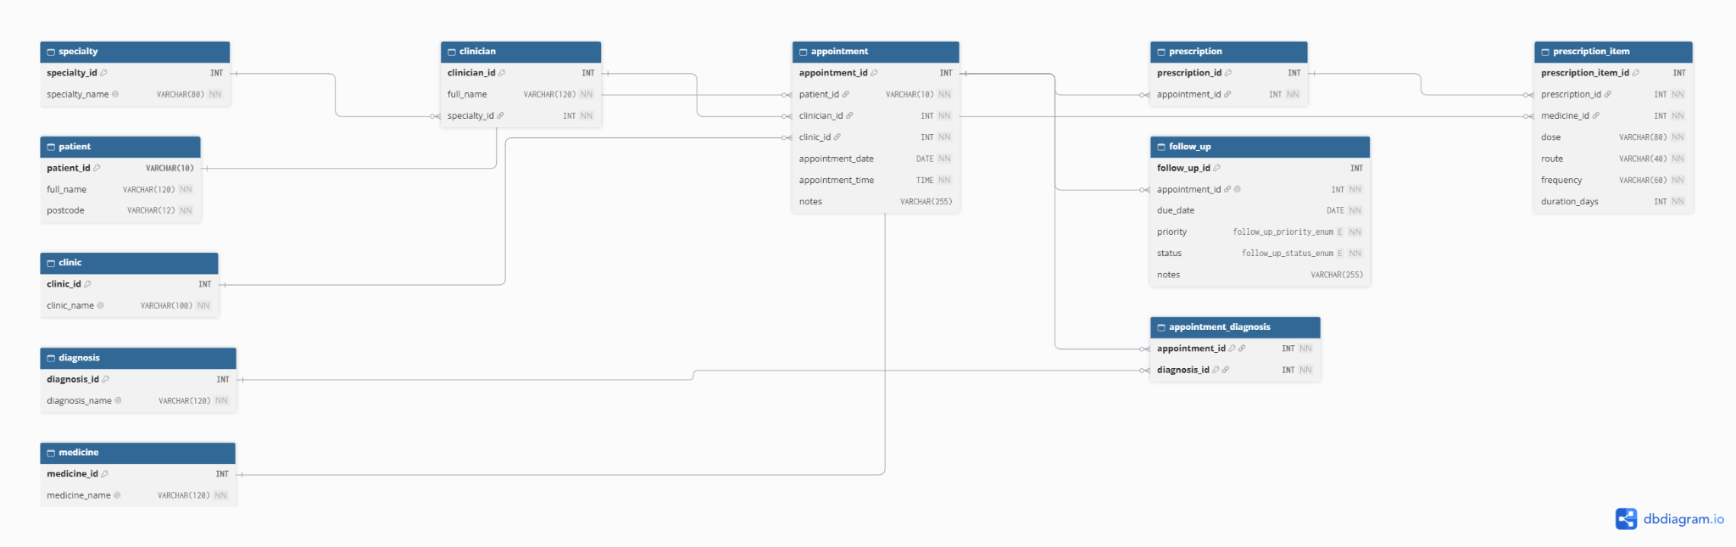
Figure 1. Crow’s Foot ER diagram showing the 11 related tables.

- Normalisation: UNF to 3NF
Normalisation means splitting information into suitable tables so we do not repeat the same facts unnecessarily. I started with the unnormalised data (UNF), made the values atomic in 1NF, removed partial dependencies in 2NF and removed transitive dependencies in 3NF. Appendix A shows the original five records and the tables at each stage.
In 1NF, the medicines field is split so each medicine has its own row. In 2NF, patient and appointment details are separated from medicine entries. In 3NF, clinician, specialty, clinic, diagnosis and medicine names are kept in their own tables. This makes updates safer. For example, changing a specialty name in the specialty table updates the description in one place instead of in every appointment.
My Individual Contribution
I completed the ER diagram and database design myself. I identified the entities and relationships, created the tables in MySQL, and tested the SQL queries, stored procedure, trigger, user permissions, encryption example and transactions. I also prepared the SQL files for my individual GitHub repository. This was my own practical contribution to the project.

- Implementation and testing
I built and tested the crownfield_eye database in MySQL. The core design has 11 tables, and my earlier test data included 12 fictional patients and 20 appointments. The tables use suitable types such as VARCHAR, INT, DATE and TIME. Primary keys identify each row, and foreign keys help prevent references to missing patients or clinicians. I also used a separate appointment_audit table for trigger testing.
I checked the design by running queries across related tables. The INNER JOIN returned 20 appointment records with patient and clinician names. This showed that the relationships were working for the test data.

- Six SQL features
  - Group BY and HAVING
I used COUNT with GROUP BY and HAVING to find patients who had more than one appointment. This is useful when the hospital wants to see repeat visits. GROUP BY puts the records into groups, and HAVING filters the totals.

  - INNER JOIN
I joined appointment, patient and clinician to show who attended which clinician they saw and when the visit took place. The query returned 20 appointments. This saves us from putting the same names into every appointment record.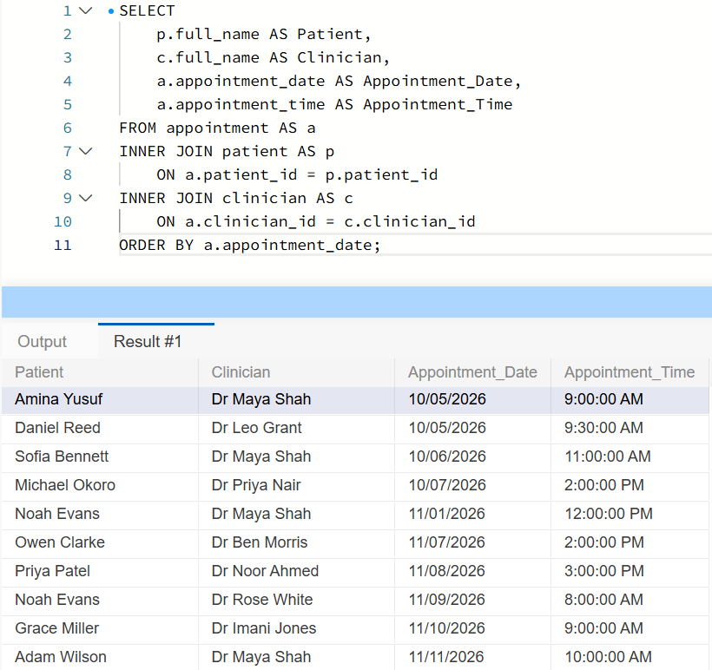
Figure 2. INNER JOIN results from MySQL Workbench.

  - LEFT JOIN
I used a LEFT JOIN to find appointments with no matching follow-up record. Five appointments, numbered 16 to 20, were returned. This could help staff check whether a follow-up needs to be arranged.
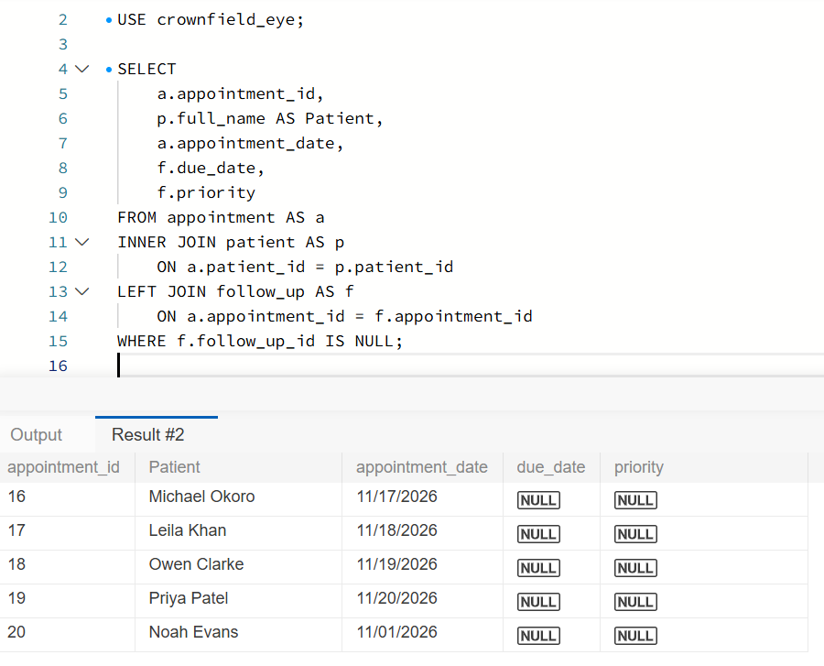
Figure 3. Five appointments without follow-up records.

  - Subquery
The subquery calculated the average number of appointments among patients who had attended at least once. The main query then found patients above that average. Seven patients were returned, including Amina Yusuf with three appointments.
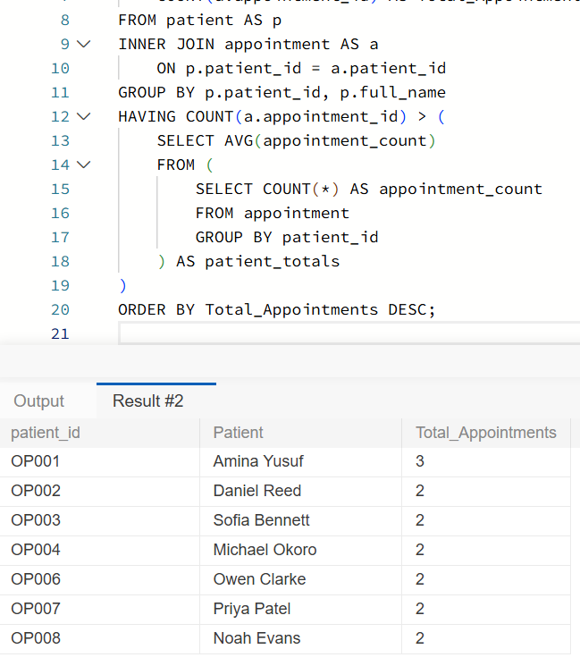
Figure 4. Subquery results.
  - Stored procedure
I created GetPatientAppointments so a patient ID can be entered instead of writing the full query each time. When I entered OP001, the procedure returned three appointments for Amina Yusuf. This makes the query reusable.
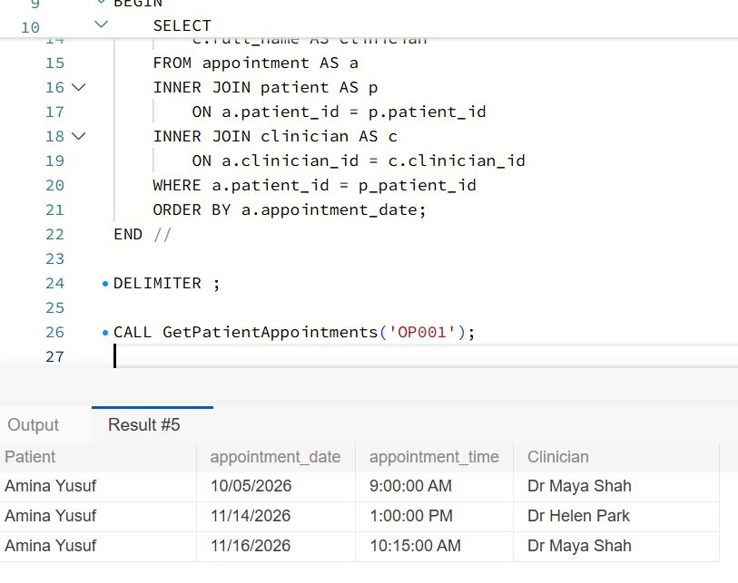
Figure 5. Stored procedure result for OP001.
  - Trigger
My AFTER UPDATE trigger records changes to appointment dates in appointment_audit. I changed appointment 1 from 5 October 2026 to 1 December 2026 and then changed it back. The audit table recorded both changes. This is helpful when the hospital needs to see when dates were changed.
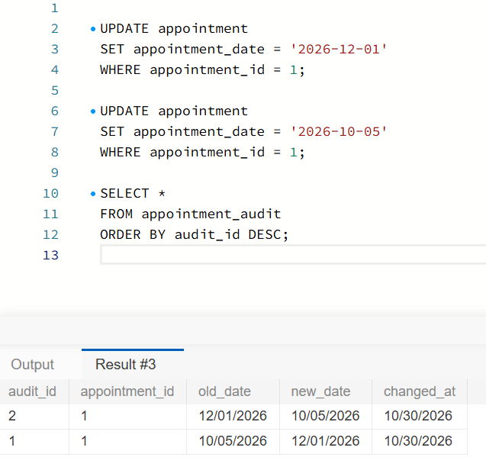
Figure 6. Two audit entries created by the trigger.
- Security and Transactions
I created four database roles. The administrator can manage the database. The doctor can read tables and update some clinical records. The receptionist can manage patient and appointment details. The patient role can only open a limited appointment view. These roles help control what different users are allowed to do.
I tested the patient role using a separate account. It could open the appointment view, but it could not open the patient table. MySQL showed Error 1142, which means permission was denied. This is good evidence that the table restriction worked. However, the view still shows appointment rows for different patients. It hides some columns, but it does not make sure a patient sees only their own appointments. A real hospital system would need an extra check for that.
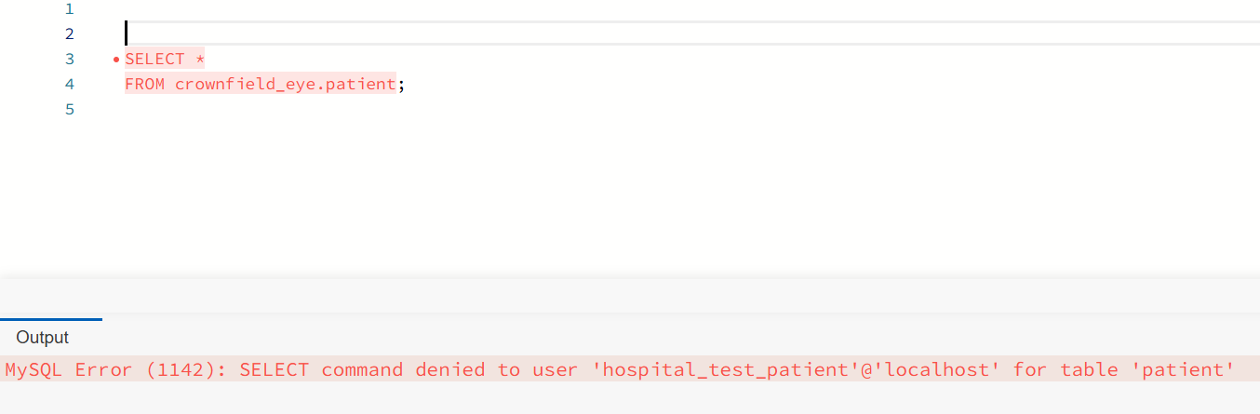
Figure 7. Patient account denied access to the patient table.
I tested encryption using the fictional words “Fictional Patient Note”. MySQL changed the words into encrypted data. When I used the same key to decrypt it, the original words appeared again. This shows that encryption and decryption worked in my test. It does not show that real patient records were saved in encrypted form. My separate GitHub security script includes a stored-note example, but that example still needs testing. I also tested transactions: ROLLBACK cancelled a test insert, while COMMIT saved another insert.
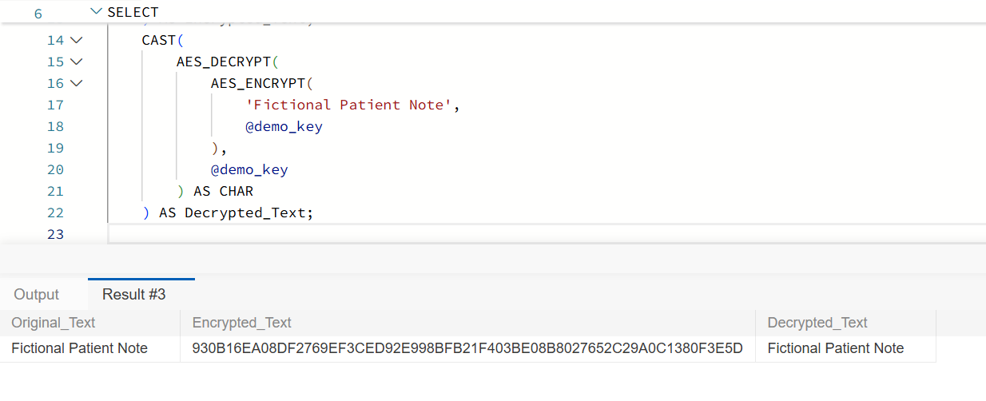
Figure 8. AES encryption and decryption demonstration.

- Evaluation and Reflection
I designed the ER diagram and built the database independently. I worked through UNF, 1NF, 2NF and 3NF, then wrote and tested SQL queries, a stored procedure and an audit trigger. I also created the four database roles, tested restricted access, and demonstrated encryption and transactions. I organised the SQL files for GitHub and prepared the report and presentation. This practical work helped me understand how the topics from our weekly lessons fit together.
The best part of this project was seeing my database tables and SQL queries work together. I also learned that it is important to test permissions using a restricted account. My tests show useful progress, but the database is still a classroom example. Before real use, the patient view must show only the correct patient’s records, doctors should have more limited access, and stored medical details would need proper encryption and safe key storage. I would also test more invalid data and errors.
Security check in simple words: the view controls which columns can be seen; it does not automatically control which patient rows can be seen. The encryption screenshot shows a working example, not encrypted patient records. These are improvements I would make next.
- References
Bath Spa University (2025) CPU4:103 Database Development: Assessment Brief. Module materials.
Oracle (n.d.) MySQL Reference Manual. Available at: https://dev.mysql.com/doc/refman/8.4/en/ [Accessed: 5 November 202].

Appendix A: Normalisation tables and explanation
One appointment, four simple steps:
Stage | What happens to Amina’s first appointment?
UNF | Two medicines are together in one cell.
1NF | Latanoprost and Timolol become separate rows.
2NF | Patient and appointment details are stored once; a link table lists both medicines.
3NF | Clinician, specialty, clinic and medicine details are stored in their own tables, connected by IDs.

A1: UNF – Original Unnormalised Data
UNF means the information is still on one big table. The same patient can appear many times, and some cells contain more than one value. For example, Amina has two medicines in the same cell: Latanoprost | Timolol. This makes searching and updating harder.
Patient ID | Patient |  | Clinician |  | Clinic | Date / Time |  | Medicines |  | Follow up
OP001 | Amina Yusuf |  | Dr Maya Shah |  | City Road | 05 Oct 09:00 |  | Latanoprost | Timolol |  | 6 weeks | High
OP002 | Daniel Reed |  | Dr Leo Grant |  | City Road | 05 Oct 09:30 |  | Aflibercept |  | 4 weeks | Urgent
OP001 | Amina Yusuf |  | Dr Maya Shah |  | Bedford | 16 Nov 10:15 |  | Latanoprost |  | 12 weeks | Routine
OP003 | Sofia Bennett |  | Dr Maya Shah |  | City Road | 06 Oct 11:00 |  | None |  | 26 weeks | Routine
OP004 | Michael Okoro |  | Dr Priya Nair |  | Croydon | 07 Oct 14:00 |  | Sodium chloride drops |  | 8 weeks | Routine
Patient ID |  | Postcode |  | Specialty |  |  | Diagnosis |  | Notes
OP001 |  | NE1 4AB |  | Glaucoma |  |  | Ocular hypertension |  | Review IOP
OP002 |  | N16 7QP |  | Retina |  |  | Diabetic macular oedema |  | OCT before review
OP001 |  | NE1 4AB |  | Glaucoma |  |  | Ocular hypertension |  | Visual field test
OP003 |  | E8 2LD |  | Glaucoma |  |  | Glaucoma suspect |  | Monitor
OP004 |  | SE6 3RT |  | Cornea |  |  | Keratoconus |  | Corneal topography

The table above shows the main problem. The original dataset also contains postcode, specialty, diagnosis and notes. The extra columns below complete the five original records in the same order.
A2: 1NF – one value in each field
STEP 1: Make sure each cell contains only one value. Amina’s first appointment has two medicines, so it becomes two rows. I also separate “6 weeks | High” into 6 weeks and High. The same appointment reference is repeated because it is still one appointment with two medicines.
appointment_ref | patient_id | full_name | appointment_date | medicine_name | follow_up_weeks | priority
A1 | OP001 | Amina Yusuf | 2026-10-05 | Latanoprost | 6 | High
A1 | OP001 | Amina Yusuf | 2026-10-05 | Timolol | 6 | High
A2 | OP002 | Daniel Reed | 2026-10-05 | Aflibercept | 4 | Urgent
A3 | OP001 | Amina Yusuf | 2026-11-16 | Latanoprost | 12 | Routine
A4 | OP003 | Sofia Bennett | 2026-10-06 | — no medicine — | 26 | Routine
A5 | OP004 | Michael Okoro | 2026-10-07 | Sodium chloride drops | 8 | Routine

“Latanoprost | Timolol” is no longer stored as one value. This is 1NF, but patient and appointment information is still repeated on the two A1 medicine rows.

A3: 2NF – remove partial dependencies
STEP 2: Put facts into the table they belong to. The patient name and postcode belong in Patient. The appointment date and clinician belong in Appointment. Medicines for an appointment belong in a small link table. In the combined 1NF example, the working key is (appointment_ref, medicine_name): appointment details depend only on appointment_ref, not the whole key. Splitting the tables removes this partial dependency.
Patient (2NF working table)

patient_id (PK) | full_name | postcode
OP001 | Amina Yusuf | NE1 4AB
OP002 | Daniel Reed | N16 7QP
OP003 | Sofia Bennett | E8 2LD
OP004 | Michael Okoro | SE6 3RT

Appointment (2NF working table)

appointment_ref (PK) | patient_id (FK) | clinician_name | specialty_name | clinic_name | appointment_date | appointment_time
A1 | OP001 | Dr Maya Shah | Glaucoma | City Road | 2026-10-05 | 09:00
A2 | OP002 | Dr Leo Grant | Retina | City Road | 2026-10-05 | 09:30
A3 | OP001 | Dr Maya Shah | Glaucoma | Bedford | 2026-11-16 | 10:15
A4 | OP003 | Dr Maya Shah | Glaucoma | City Road | 2026-10-06 | 11:00
A5 | OP004 | Dr Priya Nair | Cornea | Croydon | 2026-10-07 | 14:00

AppointmentMedicine (2NF working table)

appointment_ref (PK/FK) | medicine_name (PK)
A1 | Latanoprost
A1 | Timolol
A2 | Aflibercept
A3 | Latanoprost
A5 | Sodium chloride drops

Now A1 is written only once in the Appointment table. The link table has two rows for A1 because two medicines were given. If an appointment date changes, I update it once, not in every medicine row. This is the main idea of 2NF.

A4: 3NF – remove transitive dependencies

STEP 3: Remove details that belong to another table. For example, a clinician has a specialty. I store specialty_name in Specialty, and clinician stores specialty_id instead. I do the same for clinics, diagnoses and medicines. The appointment table keeps IDs that connect these tables. This is 3NF: each non-key detail belongs to its own key, not another non-key field.
Final table | Important fields (using MySQL names) | Why it exists
patient | patient_id (PK), full_name, postcode | Patient details stored once
specialty | specialty_id (PK), specialty_name | Specialty description stored once
clinician | clinician_id (PK), full_name, specialty_id (FK) | Clinician linked to specialty
clinic | clinic_id (PK), clinic_name | Clinic name stored once
appointment | appointment_id (PK), patient_id (FK), clinician_id (FK), clinic_id (FK), appointment_date, appointment_time, notes | One row per appointment
diagnosis | diagnosis_id (PK), diagnosis_name | Diagnosis names stored once
appointment_diagnosis | appointment_id (PK/FK), diagnosis_id (PK/FK) | Link table for diagnoses
medicine | medicine_id (PK), medicine_name | Medicine names stored once
prescription | prescription_id (PK), appointment_id (FK) | Prescription linked to visit
prescription_item | prescription_item_id (PK), prescription_id (FK), medicine_id (FK), dose, route, frequency, duration_days | One medicine item per row
follow_up | follow_up_id (PK), appointment_id (FK), due_date, priority, status, notes | Follow-up plan linked to visit

Example final 3NF records
Table | Example records
patient | OP001 | Amina Yusuf | NE1 4AB
specialty | 1 | Glaucoma
clinician | 1 | Dr Maya Shah | specialty_id = 1
clinic | 1 | City Road
appointment | 1 | OP001 | clinician_id = 1 | clinic_id = 1 | 2026-10-05 | 09:00
medicine | 1 | Latanoprost; 2 | Timolol
prescription | 1 | appointment_id = 1
prescription_item | 1 | prescription_id = 1 | medicine_id = 1; 2 | prescription_id = 1 | medicine_id = 2
diagnosis | 1 | Ocular hypertension
appointment_diagnosis | appointment_id = 1 | diagnosis_id = 1
follow_up | 1 | appointment_id = 1 | priority = High | due_date to be confirmed

A5: difference between 2NF and 3NF

2NF | 3NF
Removes partial dependencies from a composite key. | Removes transitive dependencies between non-key fields.
Example: move appointment_date out of a combined appointment–medicine table. | Example: move specialty_name out of the clinician/appointment data and store it in specialty.
Stops appointment details repeating for each medicine. | Stops specialty, clinic and medicine descriptions repeating in many rows.

1NF = one value in each cell.
2NF = put information in the right table, so it depends on the whole key.
3NF = move details about other things into their own tables

Appendix: AI Usage Statement
I acknowledge the use of the following AI tools in the preparation of this assignment:
- ChatGPT (https://openai.com) – used to generate an initial outline and provide guidance on structuring ideas.
- Grammarly (https://www.grammarly.com) – used to check grammar, punctuation, and writing style.
I confirm that no content generated by AI technologies has been presented as my own work. All analysis, discussion, and conclusions included in this assignment are my original work and reflect my understanding of the subject matter. The AI tools were used solely as support to enhance planning, organization, and clarity, and I have critically evaluated and revised any suggestions to ensure they align with my own ideas and academic standards.

