Documentation of the Company Management System Zaid Jehad Tabatebi 2110012
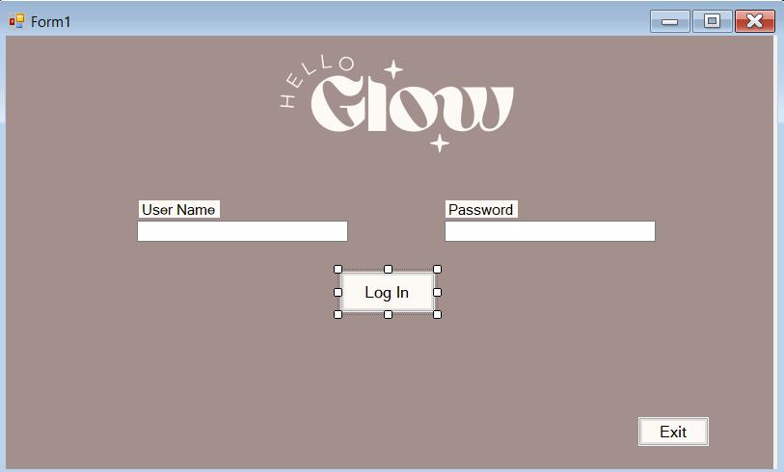

Private Sub Button1_Click(sender As Object, e As EventArgs) Handles Button1.Click

' Check if the name is valid
If IsValidName(TextBox1.Text) Then

MessageBox.Show("Login successful!", "Success", MessageBoxButtons.OK, MessageBoxIcon.Information)

Dim form2 As New Form2()

form2.Show()
Me.Hide()
ResetForm()
Else

MessageBox.Show("Invalid name. Please enter a name with letters only.", "Error",
MessageBoxButtons.OK, MessageBoxIcon.Error)

TextBox1.Clear()

TextBox1.Focus()
End If

Private Function IsValidName(ByVal name As String) As Boolean

- Regex to match only letters (both uppercase and lowercase) Dim regex As New Regex("^[A-Za-z]+$")

- Check if the name matches the regex
Return regex.IsMatch(name)
End Function

Private Sub ResetForm()
TextBox1.Clear()
TextBox1.Focus()

Button1.Enabled = False
End Sub

Private Sub Button2_Click(sender As Object, e As EventArgs) Handles Button2.Click
Me.Close()

End Sub
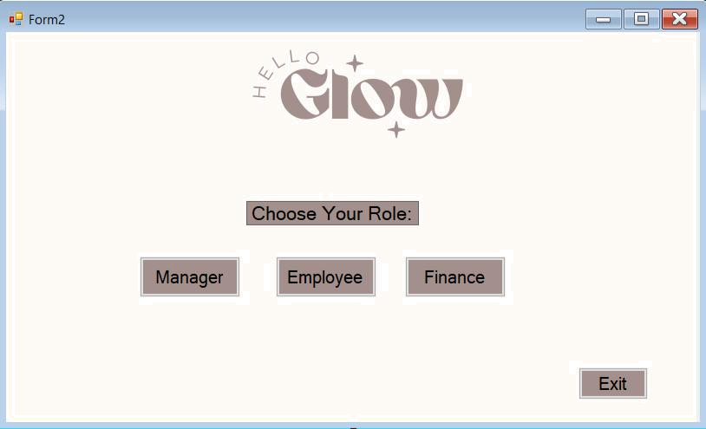

Private Sub Button1_Click(sender As Object, e As EventArgs) Handles Button1.Click

Dim form7 As New Form7()
form7.Show()
Me.Hide()
End Sub

Private Sub Button2_Click(sender As Object, e As EventArgs) Handles Button2.Click
Dim form8 As New Form8()

form8.Show()
Me.Hide()
End Sub

private Sub Button3_Click(sender As Object, e As EventArgs) Handles Button3.Click Dim form9 As New Form9()

form9.Show()

Me.Hide()
End Sub

Private Sub Button4_Click(sender As Object, e As EventArgs) Handles Button4.Click Me.Close()

End Sub
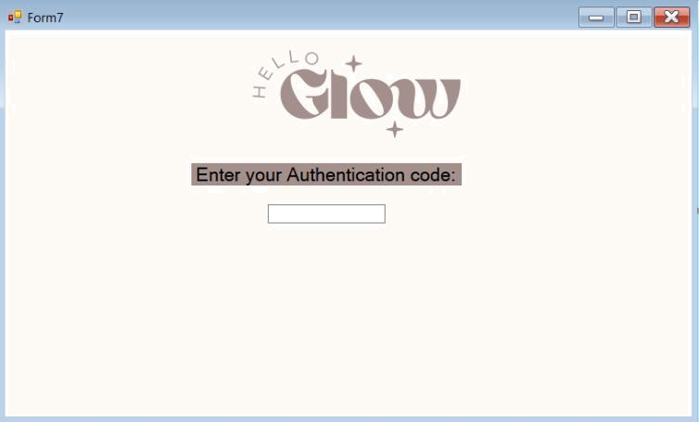

Private Sub TextBox1_TextChanged(sender As Object, e As EventArgs) Handles TextBox1.TextChanged

If TextBox1.Text = "12345**" Then

Dim form3 As New Form3()
form3.Show()
Me.Hide()

End If
End Sub
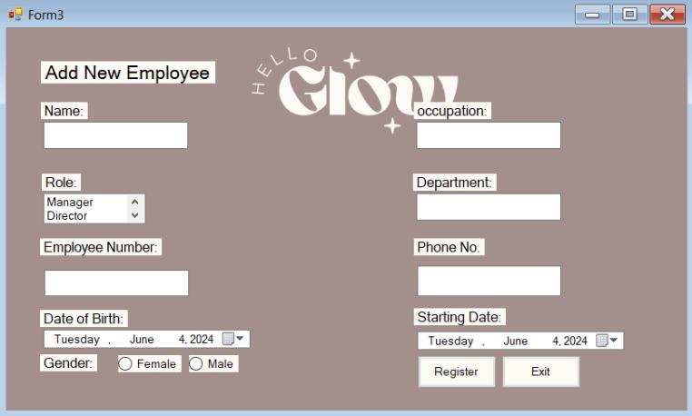

Private Sub Button2_Click(sender As Object, e As EventArgs) Handles Button2.Click
Dim form1 As New Form1()
form1.Show()

Me.Hide()
End Sub
Private Sub Button1_Click(sender As Object, e As EventArgs) Handles Button1.Click

- Get text from multiple TextBoxes Dim text1 As String = TextBox1.Text Dim text2 As String = TextBox6.Text Dim text3 As String = TextBox2.Text

Dim text4 As Date = DateTimePicker2.Text Dim text5 As Date = DateTimePicker1.Text

Dim form4 As New Form4()
form4.SetLabelValues(text1, text2, text3, text4, text5)

form4.Show()
End Sub
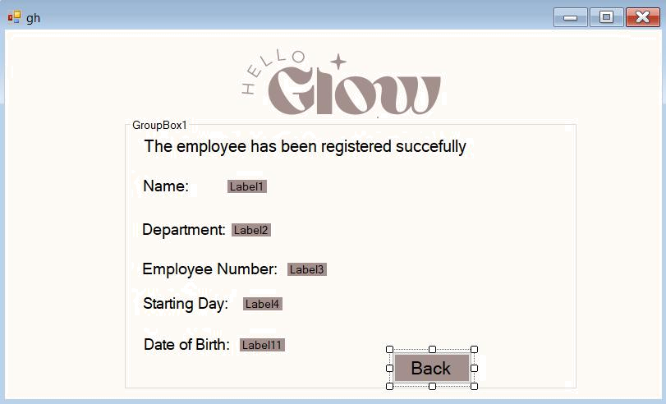

Public Sub SetLabelValues(text1 As String, text2 As String, text3 As String, text4 As Date, text5 As Date) Label1.Text = text1

Label2.Text = text2

Label3.Text = text3
Label4.Text = text4
Label11.Text = text5

End Sub

Private Sub Button1_Click(sender As Object, e As EventArgs) Handles Button1.Click

Dim form3 As New Form3()
form3.Show()
Me.Hide()
End Sub
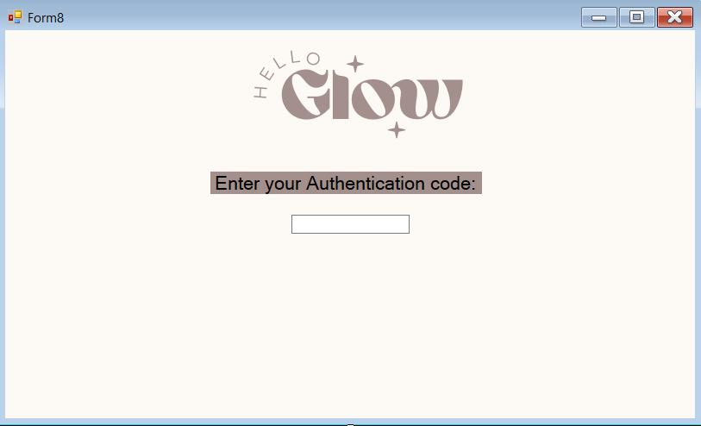

Private Sub TextBox1_TextChanged(sender As Object, e As EventArgs) Handles TextBox1.TextChanged

If TextBox1.Text = "1234**" Then
Dim form5 As New Form5()
form5.Show()
Me.Hide()

ElseIf TextBox1.Text = "12345**" Then
Dim form5 As New Form5()
form5.Show()
Me.Hide()

End If
End Sub
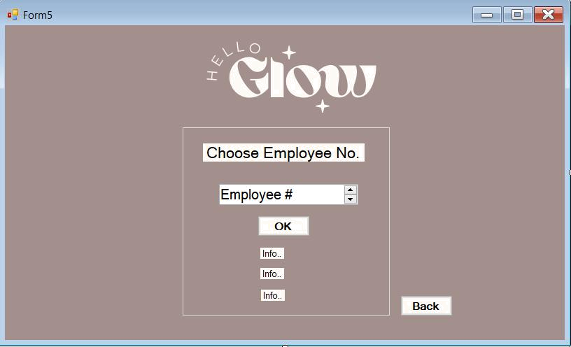

Private Sub Button1_Click(sender As Object, e As EventArgs) Handles Button1.Click
If DomainUpDown1.Text = "2020001" Then

Label1.Text = "Zaid Jehad"
Label3.Text = "Manager, IT"
Label4.Text = "IT Department"
ElseIf DomainUpDown1.Text = "2110169" Then

Label1.Text = ""
Label3.Text = "Mohammad"
Label4.Text = "English Department"
ElseIf DomainUpDown1.Text = "2020028" Then

Label1.Text = "Yousef"
Label3.Text = "Supervisor"
Label4.Text = "English Department"
ElseIf DomainUpDown1.Text = "2110100" Then

Label1.Text = "Ali"
Label3.Text = "Employee"
Label4.Text = "Finance Department"
ElseIf DomainUpDown1.Text = "2110302" Then

Label1.Text = "Naser"
Label3.Text = "Employee"
Label4.Text = "HR Department"
ElseIf DomainUpDown1.Text = "2120222" Then

Label1.Text = "Fahad"
Label3.Text = "Supervisor"
Label4.Text = "Marketing Department"
ElseIf DomainUpDown1.Text = "2020099" Then

Label1.Text = "Khalid"
Label3.Text = "Employee"
Label4.Text = "Marketing Department"
Else

MessageBox.Show("You need to choose Employee!", "Error", MessageBoxButtons.OK,

MessageBoxIcon.Error)
End If End Sub

Private Sub Button2_Click_1(sender As Object, e As EventArgs) Handles Button2.Click Dim form2 As New Form2()

form2.Show()
Me.Hide()
End Sub ‘’’’’

Private Sub Button3_Click(sender As Object, e As EventArgs)
Dim form6 As New Form6()
form6.Show()
Me.Hide()
End Sub
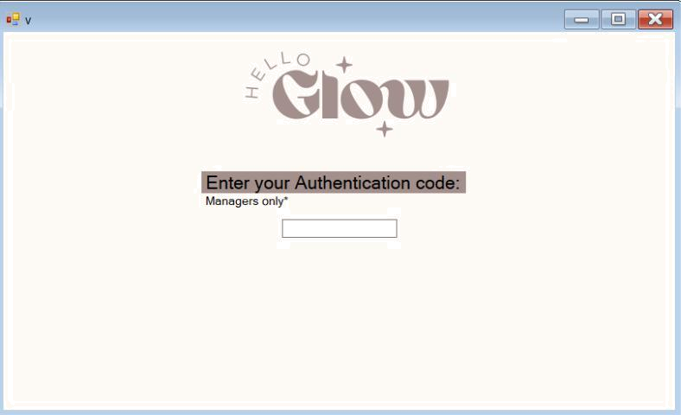

Private Sub TextBox1_TextChanged(sender As Object, e As EventArgs) Handles TextBox1.TextChanged
If TextBox1.Text = "12345**" Then
Dim form6 As New Form6()

form6.Show()
Me.Hide()

End If
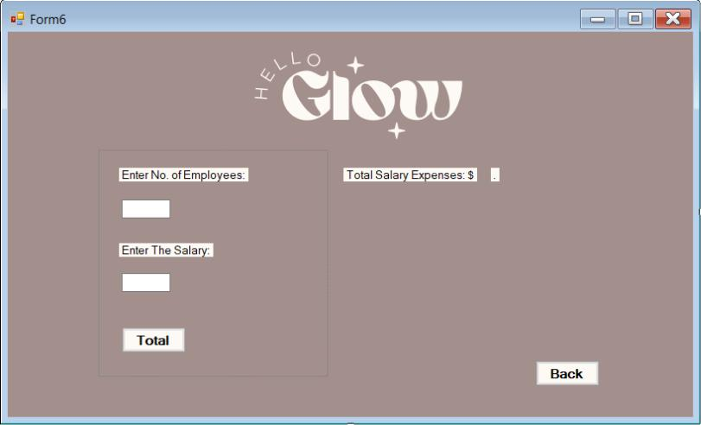

End SubPrivate Sub Button1_Click_1(sender As Object, e As EventArgs) Handles Button1.Click

Dim numEmployees As Integer = TextBox1.Text
Dim salaryPerEmployee As Decimal = TextBox2.Text
Dim totalSalaries As Decimal = 0

- Use a For loop to calculate total salary expenses For i As Integer = 1 To numEmployees

totalSalaries += salaryPerEmployee Next

- Display the total salary expenses
Label4.Text = totalSalaries.ToString("F2")
End Sub

Private Sub Button2_Click(sender As Object, e As EventArgs) Handles Button2.Click
Dim form2 As New Form2()

form2.Show()
Me.Hide()
End Sub

