

Project Title: Gym Booking and Subscription Management System
Instructor: Dr. Ahmad Hussein Ababneh
Course: System Analysis and Design (401355)

Student Name: Zaid Jehad Tabatebi & Dnaia Ghunaim
Student ID: (2110012) (2320048)

Mobile number:(0799073192) - ( 0799723535)

System Request – Gym Booking and Subscription Management System

- Project Sponsor
The virtual gym management (as part of this course project) is sponsoring the development of this system to modernize gym operations and automate all booking, membership, and payment processes.

- Business Need
The current manual system based on paper records and Excel sheets is inefficient, time-consuming, and prone to human error. The gym needs a digital solution that can streamline member management, session scheduling, trainer assignments, and payment tracking.

- Business Requirements

The proposed system must support the following features:
- Register and manage gym members
- Create and manage subscription plans (monthly, yearly, etc.)
- Schedule fitness sessions (e.g., Zumba, Cardio, Yoga)
- Assign trainers to sessions
- Allow members to book sessions
- Track attendance for each session
- Process and manage payments
- Generate reports for management

- Business Value
The new system will:
- Save time by automating daily operations
- Eliminate manual paperwork and reduce errors
- Improve customer satisfaction and communication
- Provide real-time access to session and member data
- Support better decision-making through reports

- Special Issues or Constraints

- The system should be simple and user-friendly for staff and members
- Security and privacy of member data must be ensured
- The system must be completed within the semester deadline

Project Initiation – Gym Booking and Subscription Management System

- Introduction
The project initiation phase formally begins the development of the Gym Booking and Subscription Management System. This phase focuses on identifying the problem, setting the objectives, defining the scope, and recognizing the involved stakeholders. It serves as the foundation for all future planning and implementation.
- Problem Statement
The gym currently relies on manual methods (e.g., paper forms and Excel sheets) to manage members, subscriptions, bookings, and trainer schedules. This leads to inefficiencies, lost records, scheduling conflicts, and a poor experience for both staff and customers.

- Project Objectives
The system aims to:
- Digitize the registration and subscription process
- Allow real-time session booking by members
- Automate trainer scheduling
- Track attendance and generate member activity logs
- Process and record payments
- Improve overall operational efficiency and user satisfaction

- Scope of the System
The system will include:
- Member registration and management
- Subscription plans and validity tracking
- Fitness session creation and booking
- Trainer assignments and scheduling
- Payment tracking and history
- Reports generation (attendance, finance, member status
Out of Scope:
- No mobile application
- No online payment integration
- No biometric entry system
(These can be considered future extensions)

- Stakeholders
- Project Owner: Virtual Gym (simulated case)
- System Analyst & Developer: Zaid Jehad
- End Users: Gym administrators, trainers, members
- Supervisor: Dr. Ahmad Hussein Ababneh

- Success Criteria
The project will be considered successful if:
- All core modules are implemented and functional
- The system supports key business processes
- The database is complete with real data entries and relationships
- The report and presentation are submitted on time
- At least 10 SQL queries are performed successfully

Project Management Plan – Gym Booking and Subscription Management System

- Time Allocation Plan (Estimated)

Phase | Estimated % | Estimated Hours | Description
Planning | 20% | 4 hours | Includes preparing the system request, writing the project initiation, and scheduling tasks.
Analysis | 30% | 6 hours | Includes identifying system requirements, building DFDs, and defining entities and processes.
Design | 25% | 5 hours | Involves designing the database (ERD), defining business rules, and creating user interface layouts.
Implementation | 25% | 5 hours | Includes building the database, inserting test data, writing SQL queries, and testing functionality.

Total Estimated Time: 20 hours

- Actual Time Spent

Phase | Actual Hours | Notes
Planning | 3 hours | Faster than expected because the project vision was clear.
Analysis | 6 hours | On track; DFDs and process identification took time as expected.
Design | 6 hours | Took slightly longer due to database design adjustments.
Implementation | 5 hours | As expected; database and SQL queries were completed smoothly.

Total Actual Time: 20 hours

- Observations

- The project timeline was followed closely.
- The design phase required more time than estimated due to reworking the ERD and key relationships.
- Working solo made the planning phase faster and more efficient.
- Proper planning ensured the implementation phase stayed within the estimated time.

Data Flow Diagrams (DFDs)

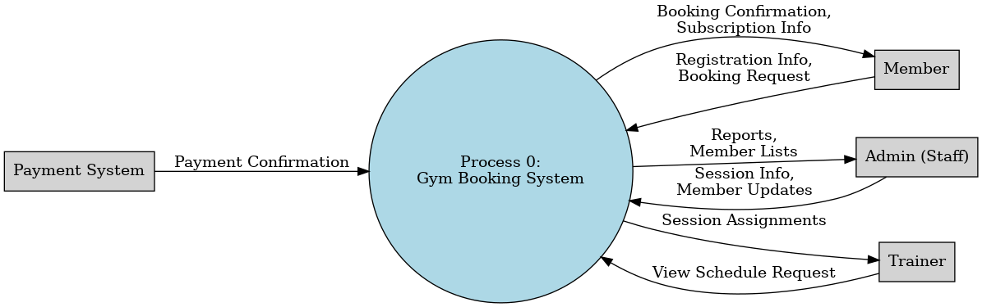

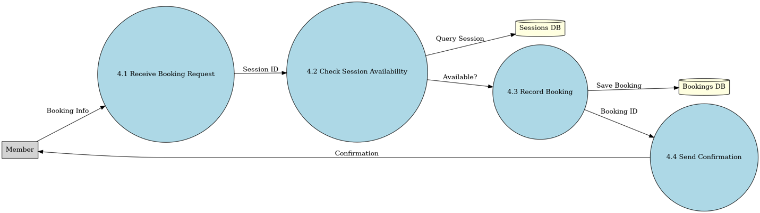
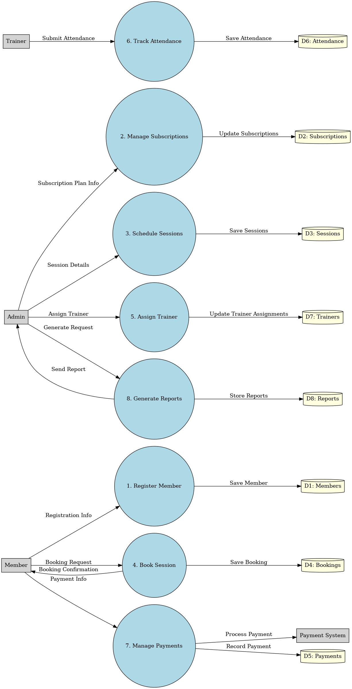

UML Diagrams

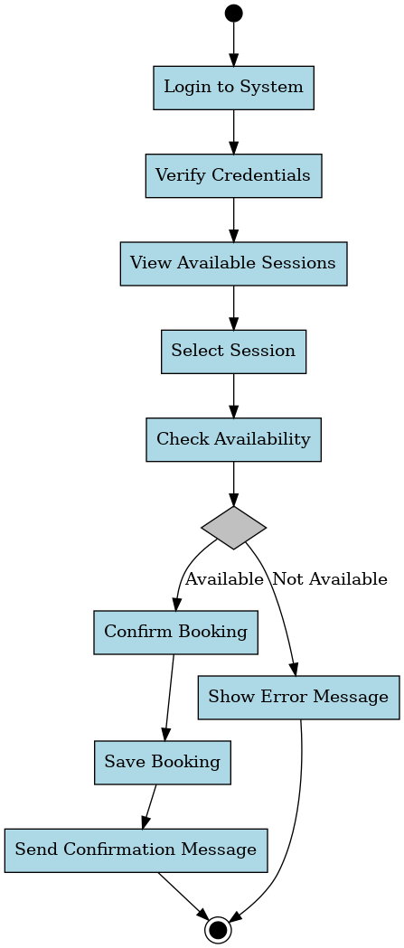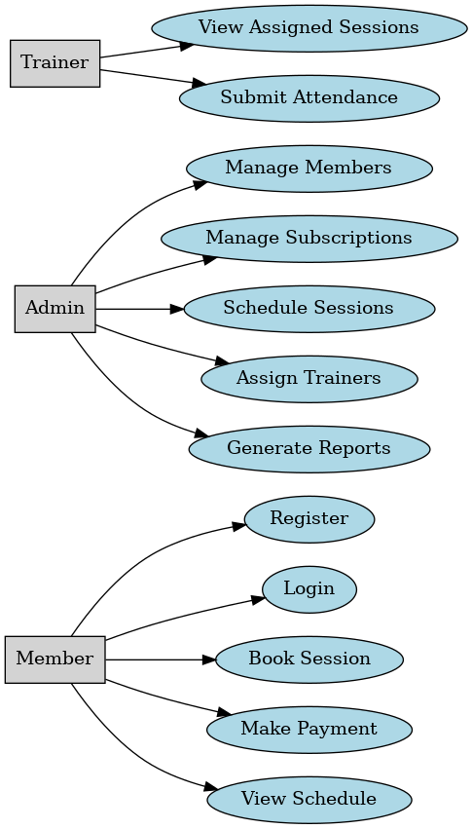

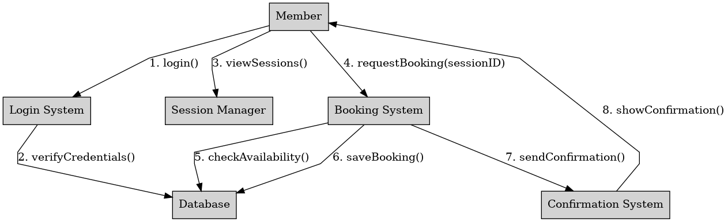

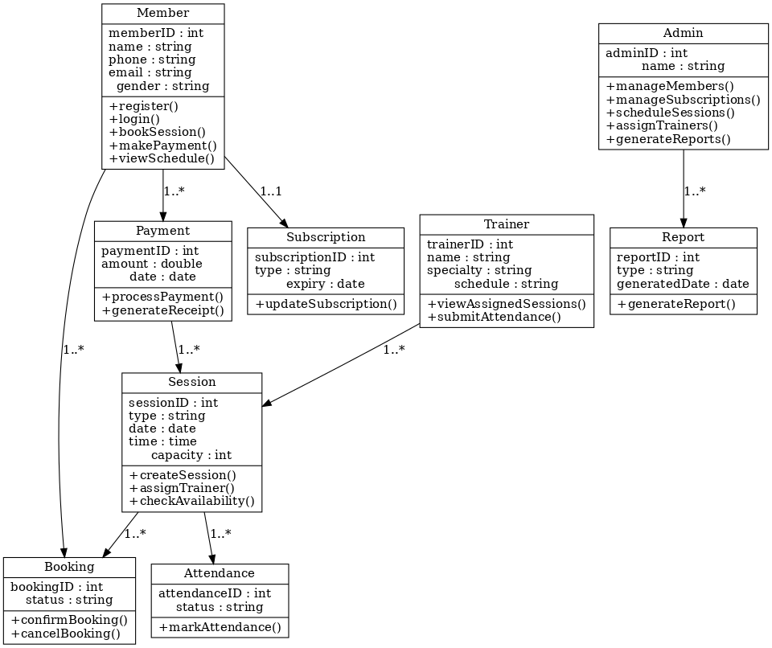

Entity Relationship Diagram (ERD)

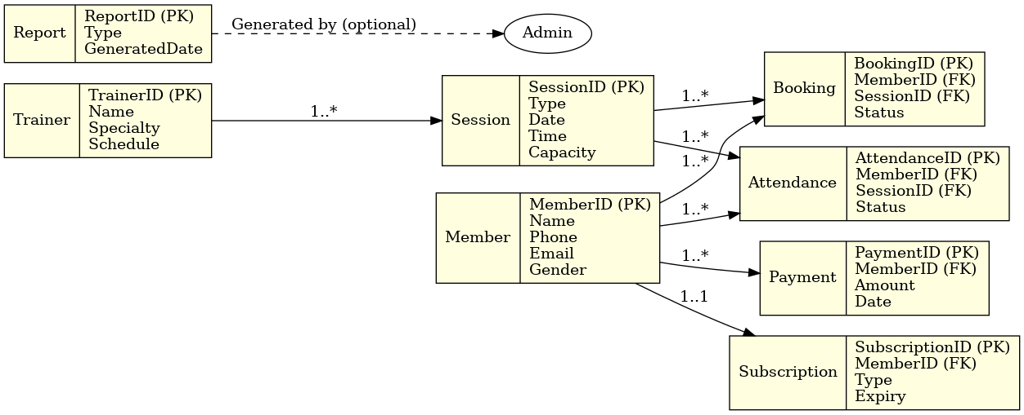

Business Rules and Primary Key Justification

Business Rules
# | Relationship | Business Rule
1 | User – Books – Session | A user can book multiple sessions, and each session can be booked by multiple users (Many-to-Many through a Booking table).
2 | Session – Assigned to – Trainer | Each session is conducted by one trainer. A trainer can conduct many sessions (One-to-Many).
3 | Trainer – Belongs to – Gym | Every trainer is assigned to one gym only. A gym can have many trainers (One-to-Many).
4 | User – Makes – Payment | A user can make multiple payments. Each payment is associated with one user only (One-to-Many).
5 | Payment – For – Session | Each payment is linked to a specific session. A session can have multiple payments (One-to-Many).

Primary Key Justification

Table | Primary Key | Justification
User | user_id | To uniquely identify each user in the system.
Trainer | trainer_id | Ensures each trainer has a unique identity for tracking session assignments.
Session | session_id | Required to differentiate between sessions for scheduling and booking.
Booking | booking_id (or composite: user_id + session_id) | Used to prevent duplicate bookings and clearly connect users with their sessions.
Payment | payment_id | Ensures every transaction has a unique reference for tracking.
Gym | gym_id | Distinguishes each gym entity in case of multi-gym systems.

Database Implementation

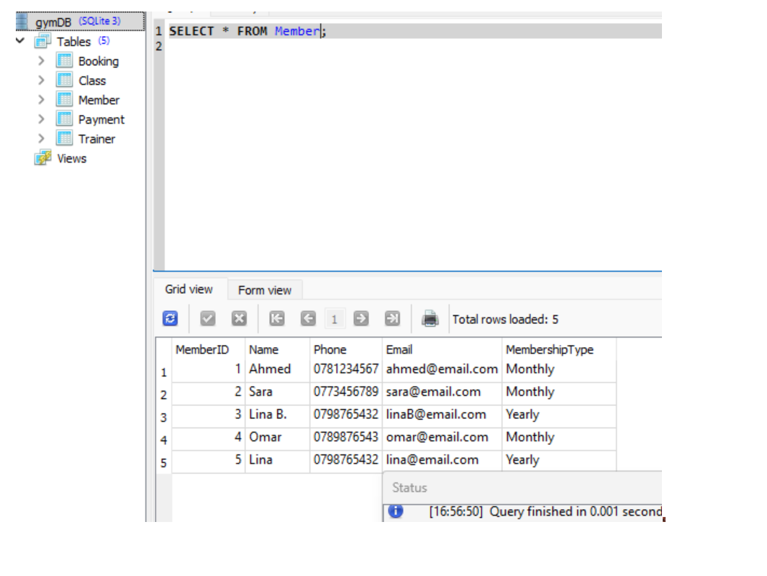
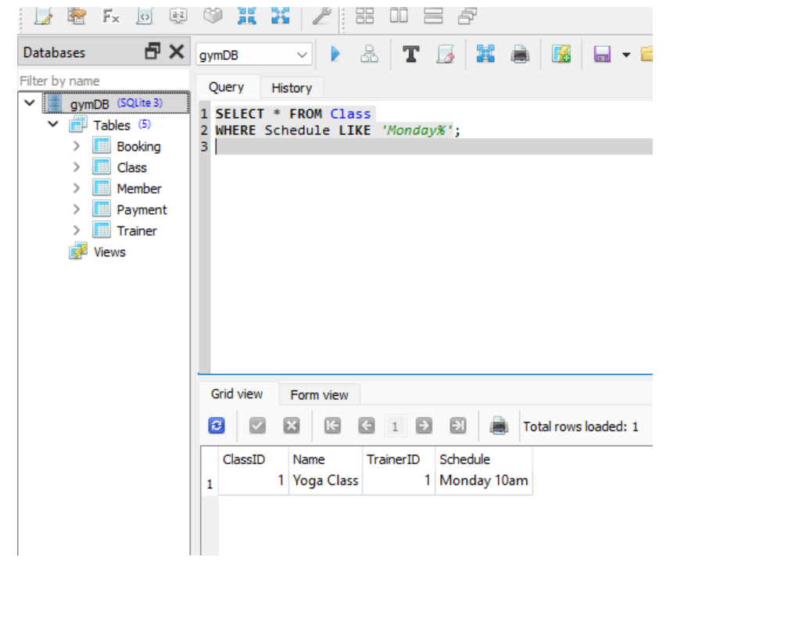

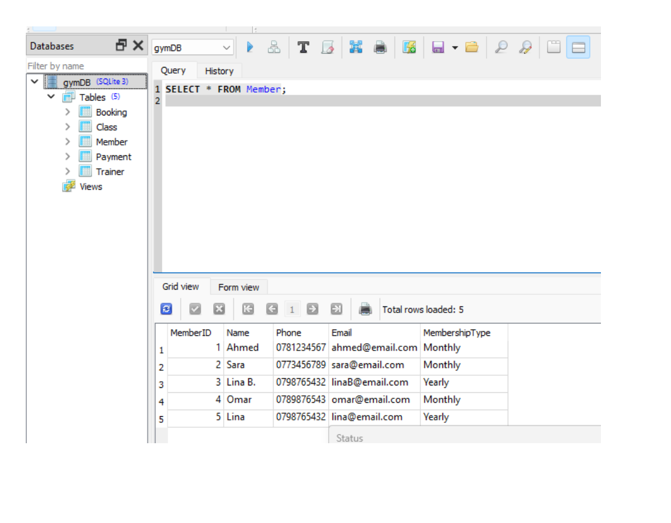
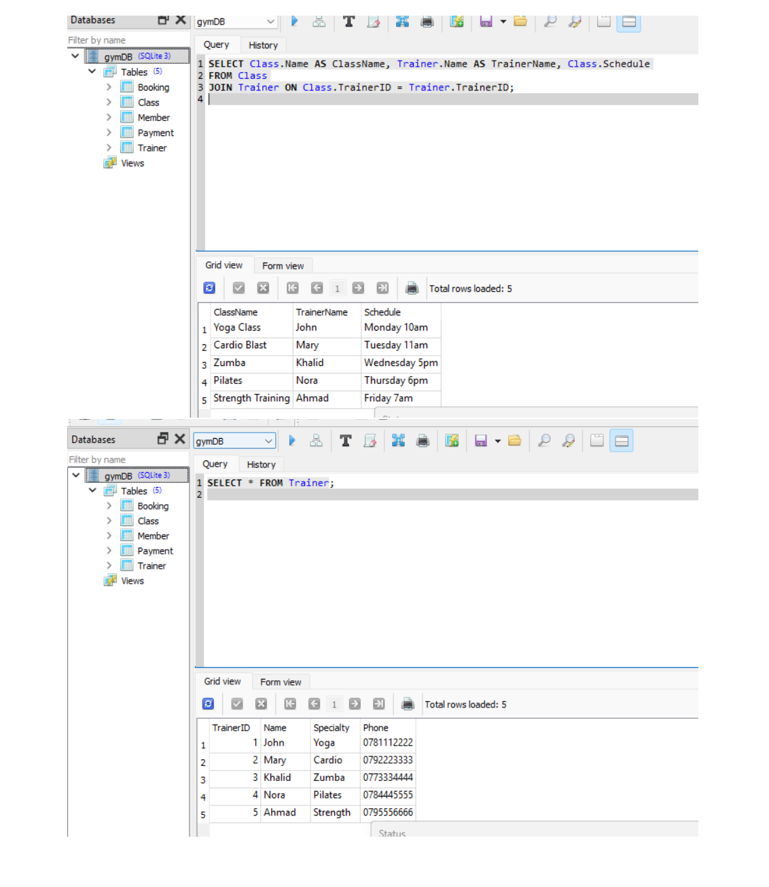

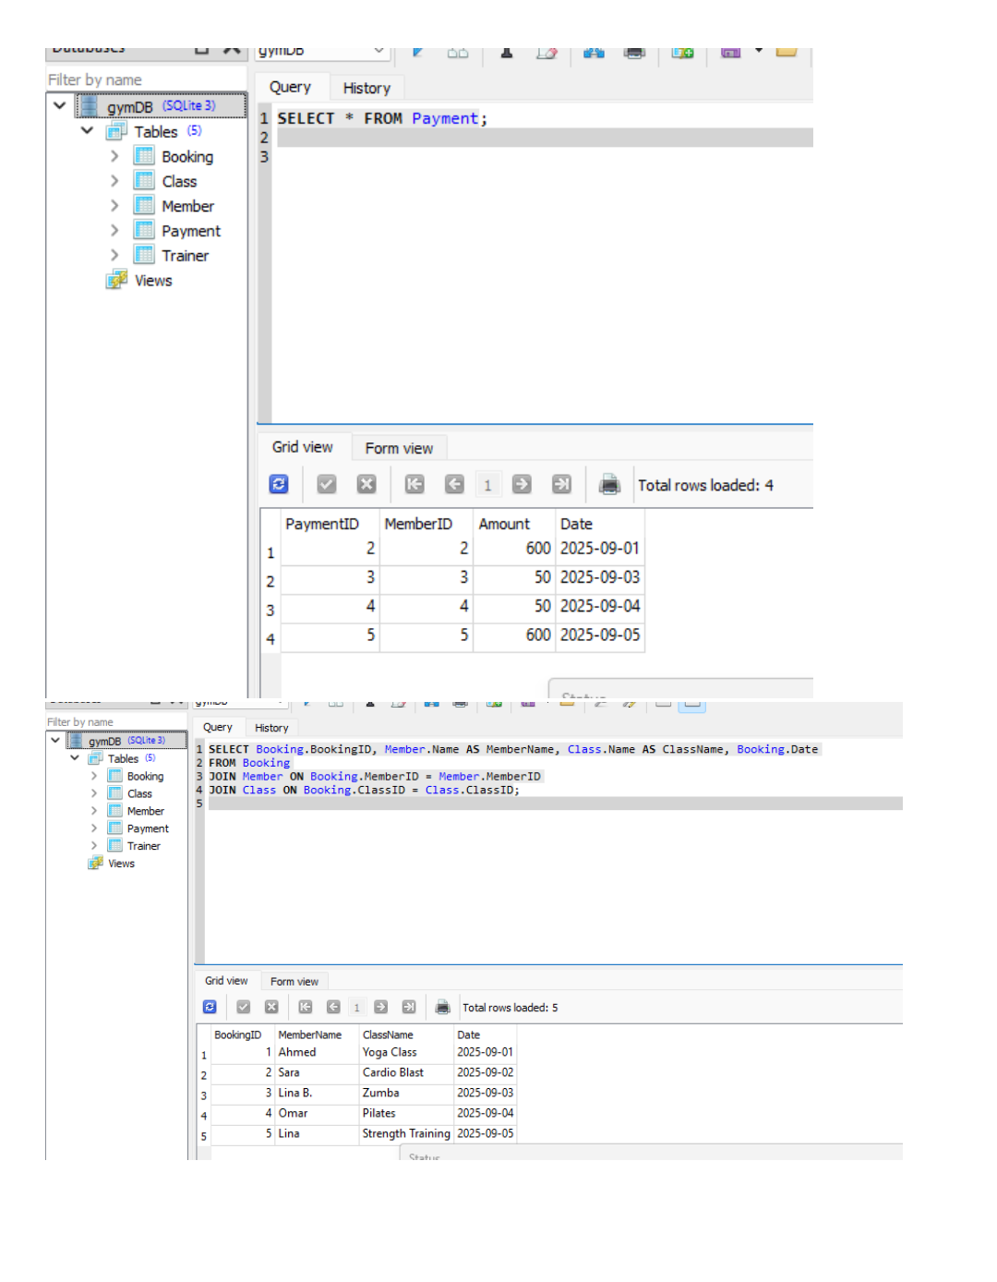

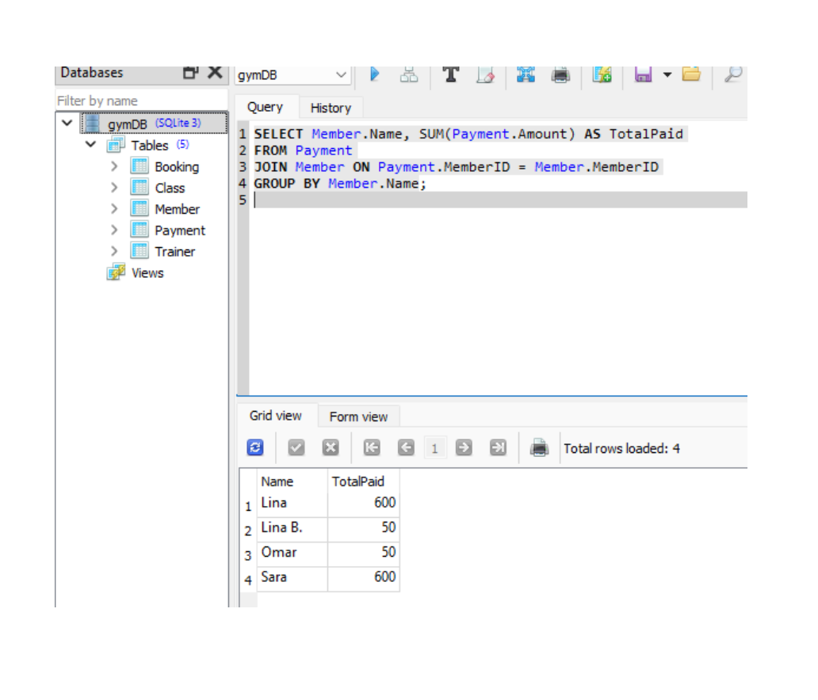

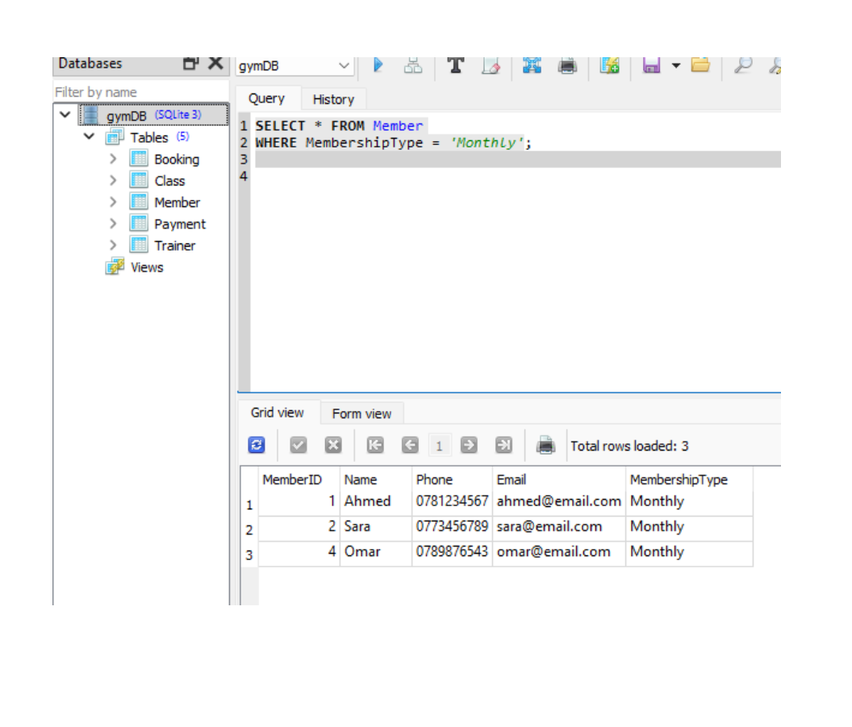
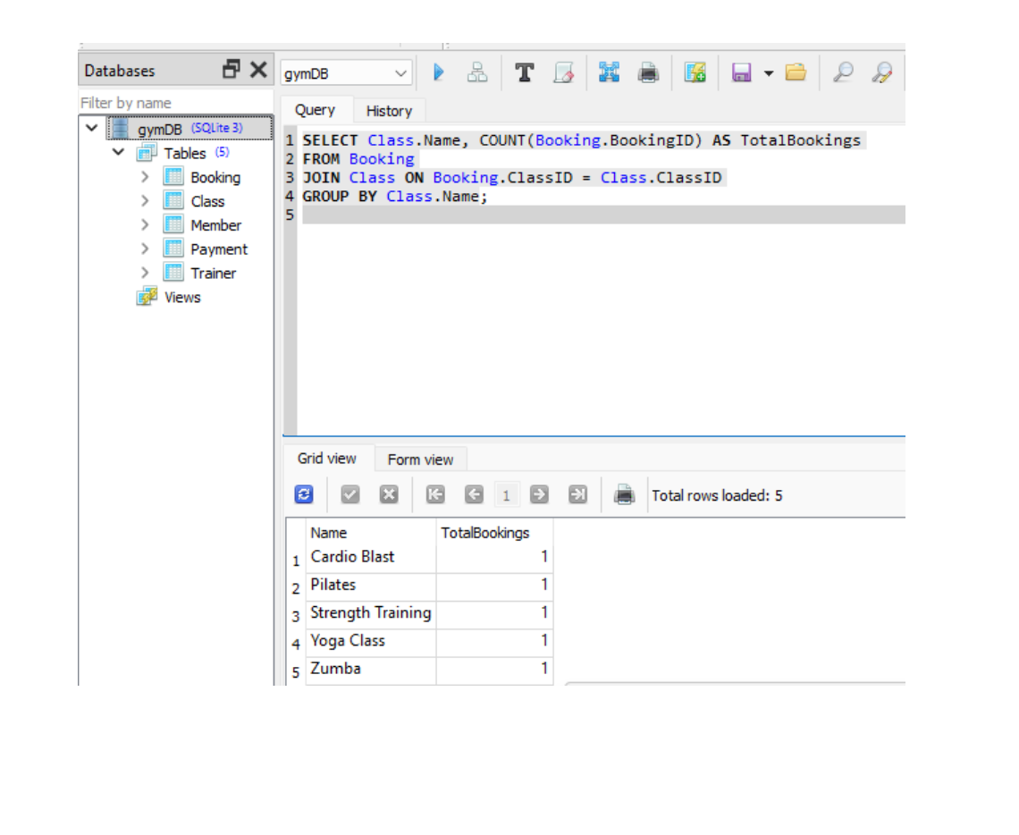

Architecture Design – Gym Booking and Subscription Management System

- Software Architecture

- System Type: Centralized Client–Server Model.

- Database: Stored on the server and accessed by clients through a desktop or web application.

- Software Components:

  - Database Management System (DBMS): SQLite (suitable for academic projects) or MySQL/PostgreSQL for production.

  - Backend: Implemented in Python/Java/PHP; handles bookings, member management, payments, and business logic.

  - Frontend (User Interface): Desktop or web application using HTML/CSS/JavaScript or GUI frameworks such as JavaFX/PyQt.

  - Operating System: Windows 10/11 or Linux Ubuntu.

  - Supporting Tools: DB Browser for SQLite / phpMyAdmin for database management, and Draw.io / Lucidchart for diagrams.

- Hardware Architecture

Client Side (Members, Trainers, Admins):

- Device: Laptop or desktop computer.
- Processor: Intel i3/i5 or equivalent.
- RAM: Minimum 4 GB.
- Storage: 20 GB available.
- Network: Standard internet connection (Wi-Fi).

Server Side (Database + Application):

- Processor: Intel i5/i7 or higher.
- RAM: Minimum 8 GB.
- Storage: 100 GB SSD.
- Network: Stable internet connection with ≥ 10 Mbps.
- Operating System: Windows Server or Linux Ubuntu.

- System Architecture Description

- Member/Trainer/Admin (Clients): Send and receive requests (login, booking, payments).

- Application Layer (Frontend + Backend): Processes user actions and manages system logic.

- Database Layer (SQLite/MySQL): Stores and retrieves data for members, trainers, sessions, bookings, payments, subscriptions, attendance, and reports.

Justification

- Why Client–Server Model?
Simple and easy to implement.
Supports multiple users simultaneously.
Ensures centralized and secure data management.
- Why SQLite/MySQL?
SQLite is lightweight and ideal for academic projects.
MySQL/PostgreSQL provide scalability for real-world production.

- Hardware Specifications:
Selected to balance practicality, performance, and cost-efficiency.

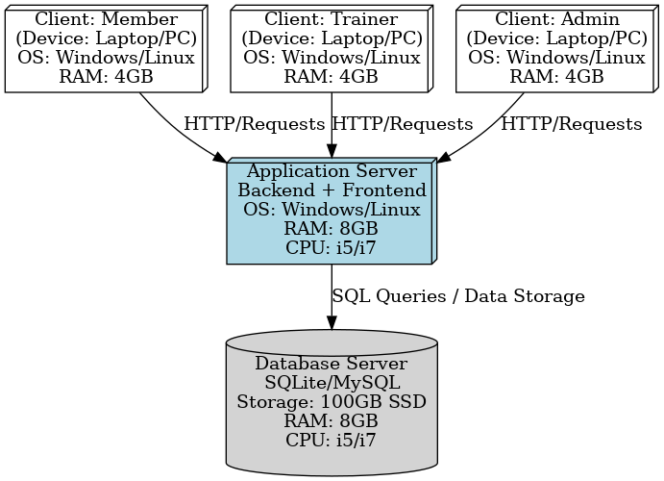
Conclusion

The Gym Booking and Subscription Management System has successfully met its intended objectives by automating the core operations of a fitness center, including member registration, subscription management, session booking, trainer assignments, payments, and reporting. By replacing manual processes with a structured digital solution, the system has eliminated inefficiencies, reduced human errors, and improved overall data accuracy.
The use of DFDs, UML diagrams, ERD, and database implementation with SQL queries demonstrated a comprehensive application of System Analysis and Design principles. The system architecture ensured both practicality and scalability, while the design choices allowed for a user-friendly experience for members, trainers, and administrators.
Overall, the project provides a strong foundation for future enhancements such as mobile application integration, online payments, and biometric access. It not only fulfills the academic requirements of the course but also presents a real-world applicable solution for modern gyms.

