Documentation Report for Titanic Dataset Analysis using Apache Spark on Google Colab
Hisham AlQanneh – 2110017
Zaid Tabatebi -2110012
Table of Contents:
- Introduction
- Environment Setup
- Data Loading
- Data Cleaning and Preparation
- Exploratory Data Analysis (EDA)
- Visualizations
- Conclusion

Introduction
This project aims to analyze the Titanic dataset to extract insights using Apache Spark for data manipulation and visualization. The goal is to leverage Spark's capabilities to handle large datasets efficiently and to visualize the data for better understanding.
Environment Setup
The environment setup includes installing necessary libraries and initiating a Spark session in Google Colab.

Libraries Used
- PySpark: The Python API for Apache Spark, used for large-scale data processing.
- Py4J: A Java library integrated with PySpark to enable Python programs to dynamically interface with JVM objects.
- Pandas: A data manipulation library for Python, used here for converting Spark DataFrames to Pandas DataFrames for visualization.
- Matplotlib: A plotting library for Python, used for creating static, animated, and interactive visualizations.
- Seaborn: A Python data visualization library based on Matplotlib, providing a high-level interface for drawing attractive statistical graphics.
- NumPy: A fundamental package for scientific computing in Python, used for numerical operations.
Starting a Spark session:
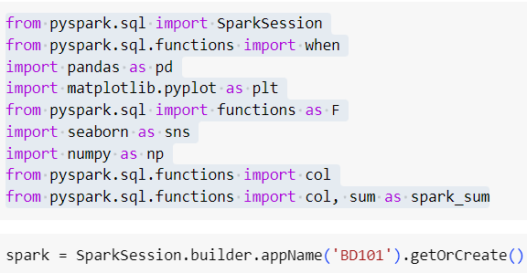

Data Loading
The Titanic dataset is loaded into a Spark DataFrame.
Schema:
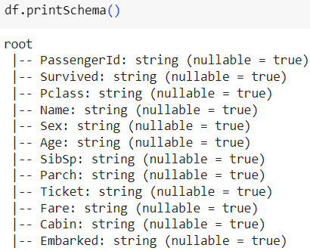
Header:
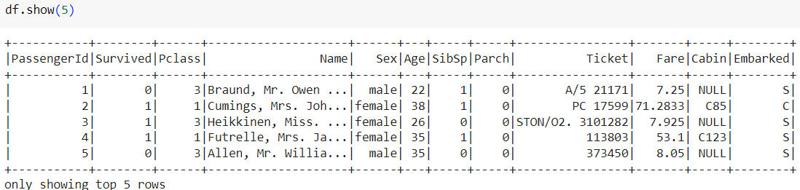
Count:
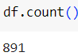

Data Cleaning and Preparation
This section covers the data cleaning steps, including handling missing values and feature engineering.
Dropping columns:
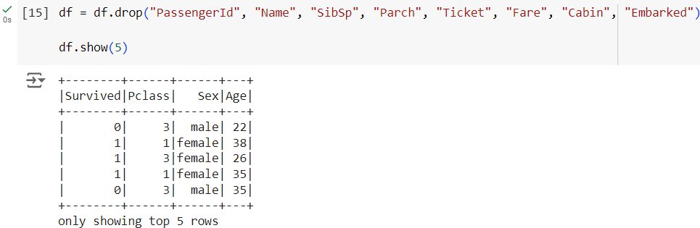
Checking for Null values:
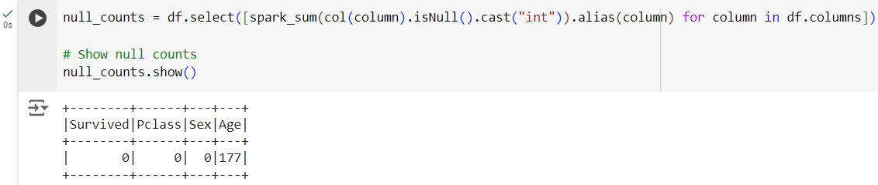
Replacing Null values with (unknown):
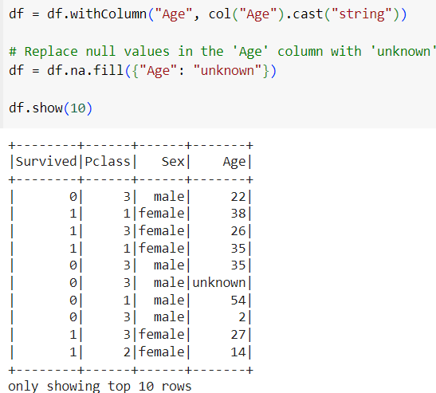
Enriching with a new column called (AgeGroup):
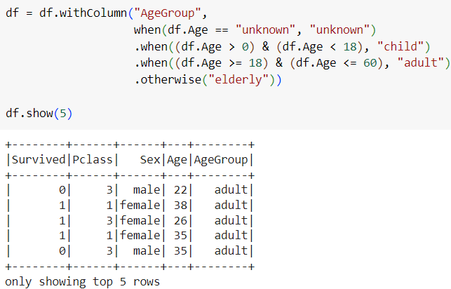

Exploratory Data Analysis (EDA)
In this section, summary statistics and correlations are computed to understand the data better.
Unique values for (Pclass):
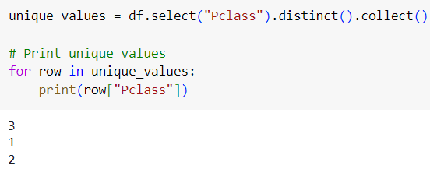
Count by gender:
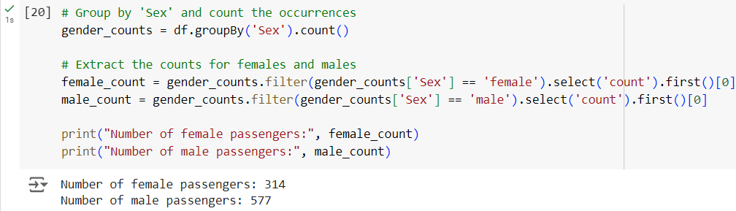
Count of survival by gender:
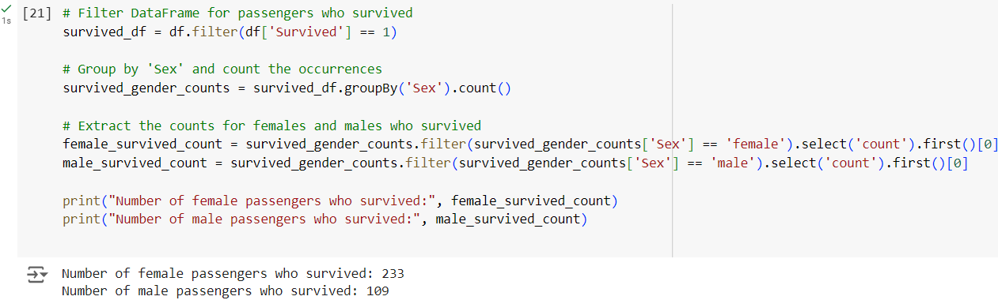

Visualizations
The visualizations are created using matplotlib and seaborn to gain insights from the data.
Survival rate for each passenger class:
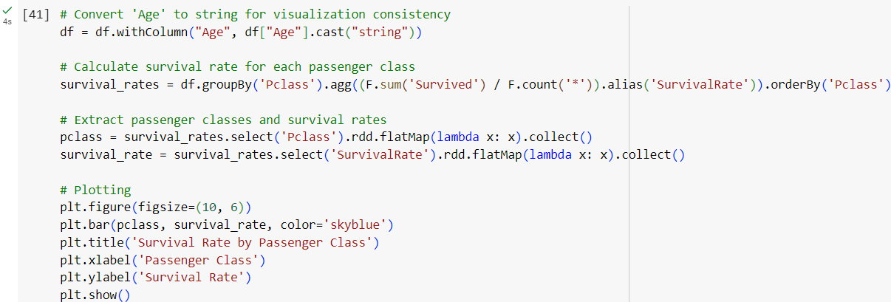
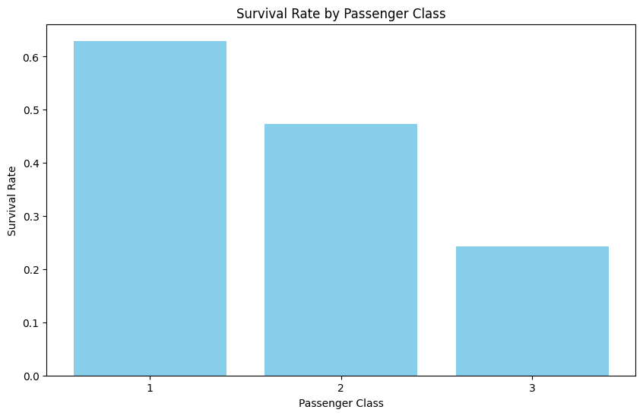

Survival rate by gender:
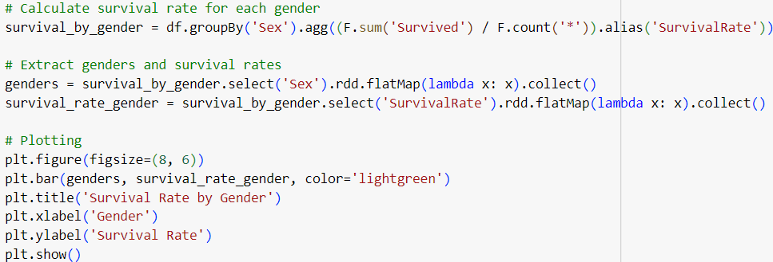

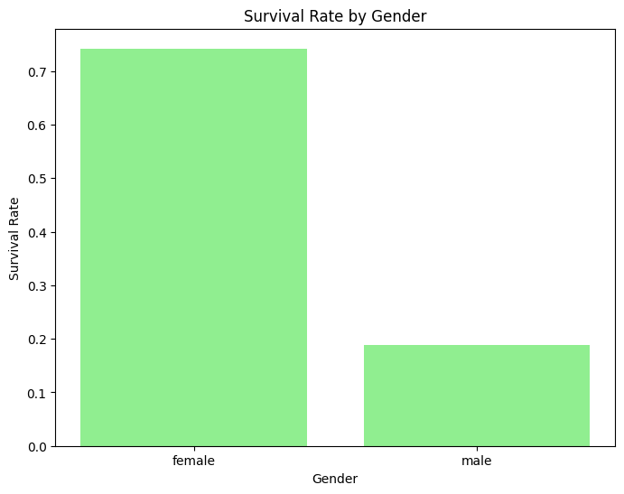

Survival counts for each gender:
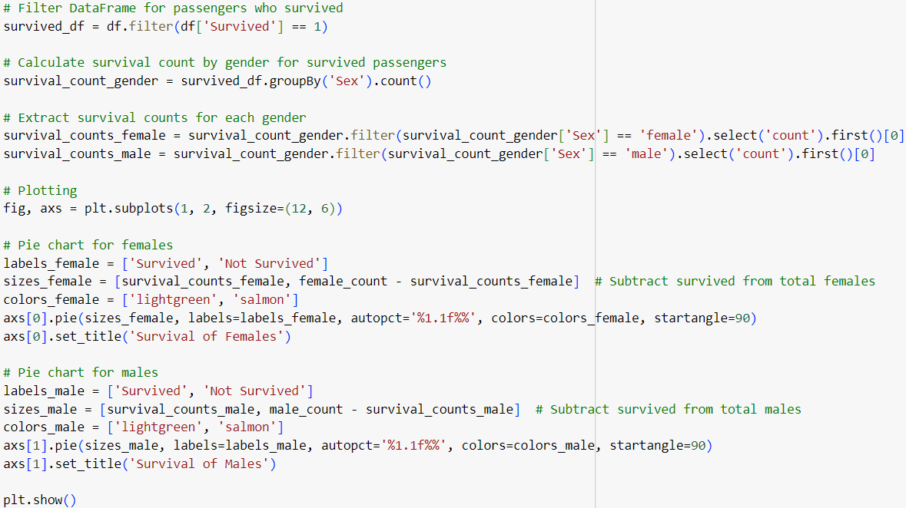
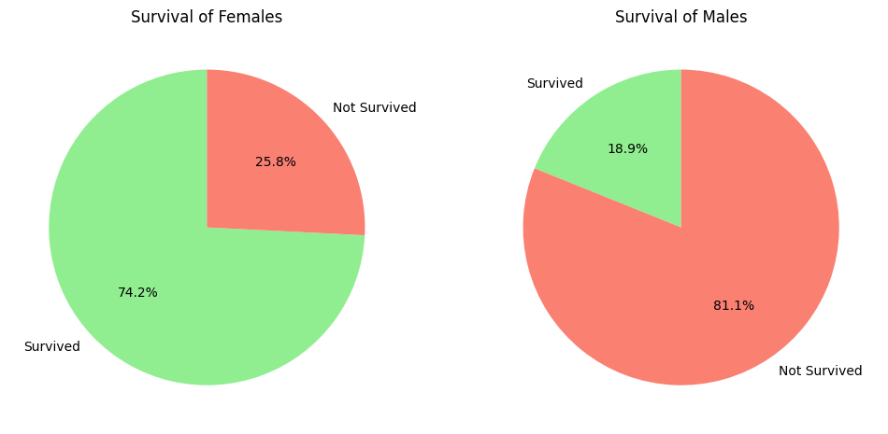

Count of ages:
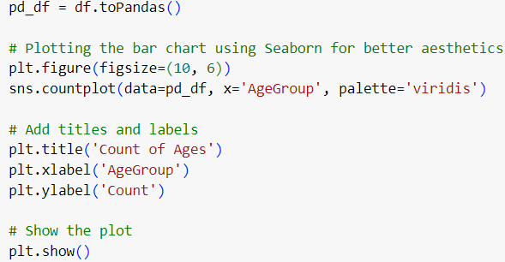
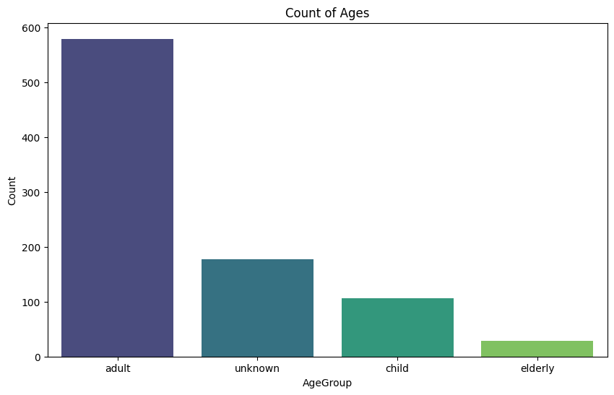

Survival rate for each age group:
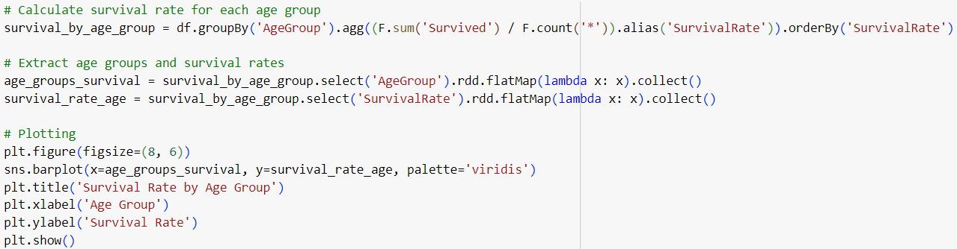
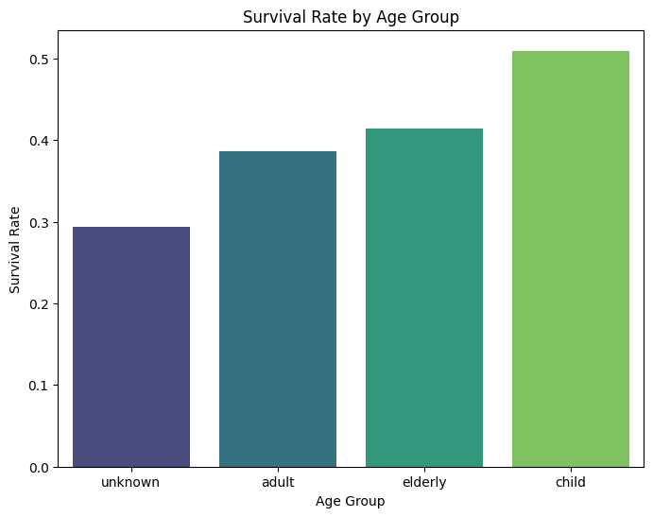

Survival rate for each gender and passenger class:
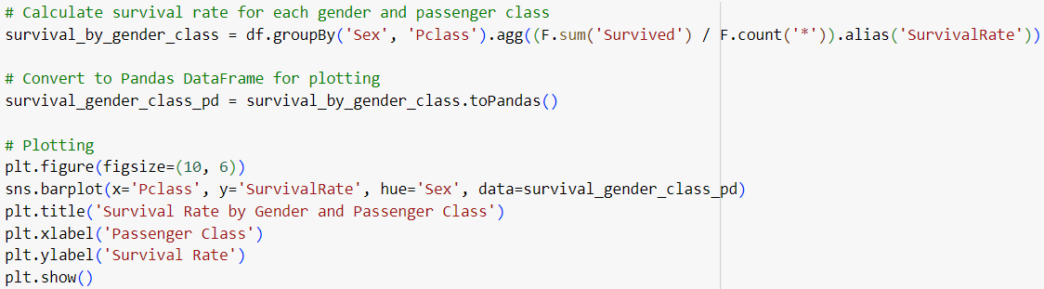
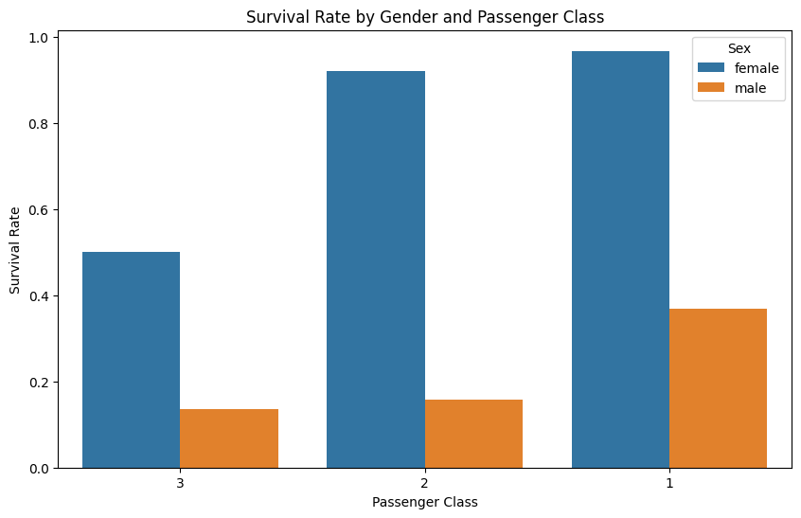
Conclusion
This section summarizes the key findings from the analysis and visualizations. The analysis highlights the demographic features that significantly impacted survival rates, such as gender and family size. Using Spark for data processing proved efficient for handling and analyzing the dataset.

Notebook link: https://colab.research.google.com/drive/1D0zxMZSQYlCrY-bMLmxhrccV9HBsFvYd?usp=sharing

