Room-mates Spending Tracking and Payment Settlement

1. Harsh Kumar Singh 20BCS095
2. Gujjarlapudi Joshi Prakash 20BCS091
3. Halbar Sai Kumar 20BCS092

BRANCH : CSE YEAR : 2020 – 2024

Submitted to

**Prof. Pritee Khanna**



PDPM INDIAN INSTITUTE OF INFORMATION TECHNOLOGY, DESIGN AND

MANUFACTURING JABALPUR, INDIA

November 16th , 2021



Room-mates Spending Tracking and Payment Settlement

**INTRODUCTION**

R-STAPS also called Room-mates Spending Tracking and Payment Settlement, is a web application which organizes all your expenses in one place so that everyone can see who they own and how much. Whether you are sharing a vacation, splitting the rent with roommates or paying someone back for lunch, R-STAPS will make it easier for you.

**FOCUS**

Most people want to be fair to each other, but sometimes they forget, or can’t decide on what fair is. In addition to helping people honour their debts, we provide mediation advice about fairness issues through our “fairness calculators.” These calculators turn our crowdsourced data into a neutral fairness opinion about your personal situation.



**FEATURES**

1] Kill the rent

Set up rent shares once with flat-mates and pay it easily. R-STAPS make it easier for you to divide you rent among you friends and roommates.

2] Share the fun

Settle-up balances for any group activities from trips to movies to dinner and lunches.

3] Keep track of your money

R-STAPS keep your every data in its database, so no worries about keeping the record of your transactions we are here.

**OVERALL DISCRIPTION**

User should be able to retrieve his transactions information, they can send money to anyone as long as the receiver is also using R-STRAPS. They can also view the list in which they had been requested to pay and to whom and by how much.

* Settle up – Helps you to pay any amount to anyone.
* Rent pay – Helps you to easily pay you rent along with your roommates.
* Others – Helps you to pay in any group transactions.
* Pending – Helps you to see the pay requests sent to you.

USER FUNCTIONS

* Can pay money to anyone.
* Can receive money from anyone.
* Can view their transaction and R-STAPS balance.
* Can view other details about their account as per their requirement.

ADMINISTRATIVE

* Can add/delete a user account.
* Can make changes in the data stored in the database.

OPERATING ENVIROMENT

* Operating system: Windows
* Database: SQL database
* Platform: PHP

**EXTERNAL INTERFACE REQUIREMENT**

USER INTERFACES

* Front-end – HTML/CSS
* Back-end software – SQL

HARDWARE INTERFACES

* Windows.
* A browser which supports HTML and CSS.

SOFTWARE INTERFACES

* Operating system – We have chosen Windows operating system for its best support and user-friendliness.
* Database – To save the user records, and other transactions we have chosen SQL database.

COMMUNICATION INTERFACES

This application supports all types of web browsers. We are using simple electronic

Forms for our transactions, and paying purpose etc.

**SYSTEM FEATURES**

DESCRIPTION and PRIORITY  
 The R-STAPS application maintains the information about your transactions, and helps you to pay when you and your comrades are equally participating in distributing your paying amounts.

CLIENT/SERVER SYSTEM

The term clint/server refers primarily to an architecture or logical division of responsibilities, the client is the application(front-end), and the server is the DBMS (back-end).

**NONFUNCTIONAL REQUIREMENTS**

PERFORMANCE REQUIREMENTS

The steps required to perform the implementation of R-STRAPS database are listed below.

1. E-R DIAGRAM

The E-R Diagram constitutes a technique for representing the logical structure of a database in pictorial manner. This analysis is then used to organize data as a relation, normalizing and finally obtaining a relation database.

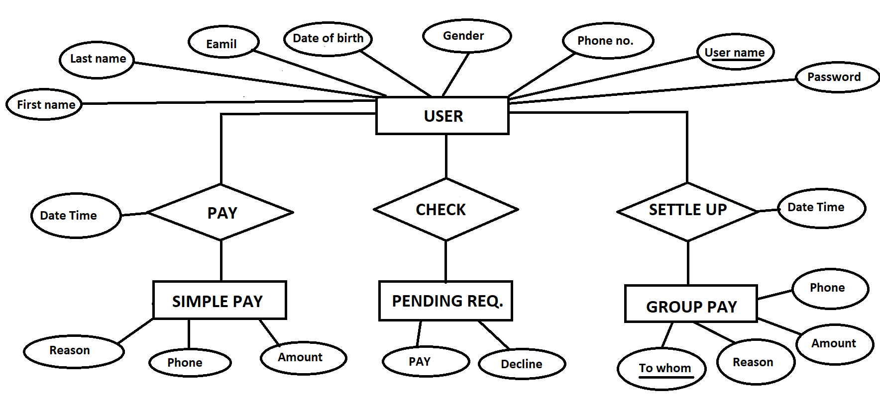

1. USER INTERFACE

