**RFID Based Attendance System**

**Introduction**

Main concept behind Radio Frequency Identification (RFID) based attendance system is to take the attendance of students or employees in any college or university or company. RFid card has to be shown in front of the RFid reader, then the attendance of the respective person is noted down by the controller and transmitted through the Xbee. At the receiving end a Xbee is configured as receiver and it reads the serially transmitted data from the transmitter.

Most educational institutions' administrators are concerned about student security. The conventional method allowing access to students inside a college/educational campus is by showing photo i-cards to security guard is very time consuming and insecure, hence inefficient. Radio Frequency Identification (RFID) based security system is one of the solutions to address this problem. This system can be used to allow access for student in school, college, and university. It also can be used to take attendance for workers in working places. Its ability to uniquely identify each person based on their RFID tag type of ID card make the process of allowing security access easier, faster and secure as compared to conventional method. Students or workers only need to place their ID card on the reader and they will be allowed to enter the campus. And if any invalid card is shown then the buzzer is turned on.

**Abstract**

The security system is basically an embedded one. Embedded stands for hardware controlled by software. Here, the software using a Microcontroller (Arduino ATMEGA 328), controls all the hardware components. The microcontroller plays an important role in the system. The main objective of the system is to uniquely identify and to make security for a person. This requires a unique product, which has the capability of distinguishing different person. This is possible by the new emerging technology RFID (Radio Frequency Identification). The main parts of an RFID system are RFID tag (with unique ID number) and RFID reader (for reading the RFID tag). In this system, RFID tag and RFID reader used are operating at 125 KHz. The microcontroller internal memory is used for storing the details. This report provides a clear picture of hardware and software used in the system. It also provides an overall view with detailed discussion of the operation of the system.

**Block Diagram:**

**Transmitter-**

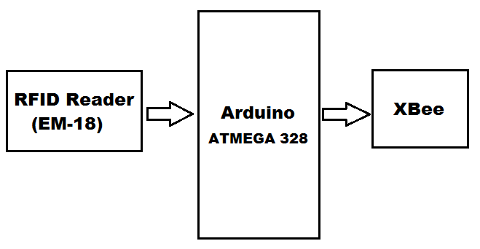

**Receiver-**

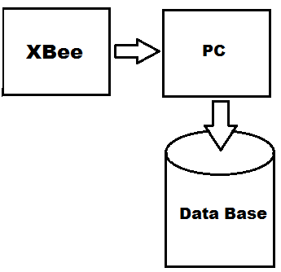

1. **RFID Reader:**

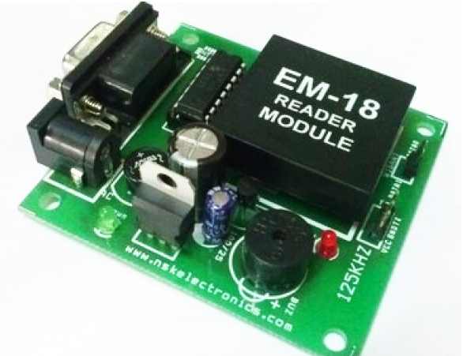

This is a low frequency (125Khz) RFID reader with serial output with at range of 8-12cm. It is a compact units with built in antenna and can be directly connected to the PC using RS232 protocol.

Many types of RFID exist, but at the highest level, we can divide RFID devices into two classes: active and passive. Active tags require a power source they’re either connected to a powered infrastructure or use energy stored in an integrated battery. In the latter case, a tag’s lifetime is limited by the stored energy, balanced against the number of read operations the device must undergo. One example of an active tag is the transponder attached to an aircraft that identifies its national origin. Another example is a LoJack device attached to a car, which incorporates cellular technology and a GPS to locate the car if stolen. However, batteries make the cost, size, and life-time of active tags impractical for the retail trade. Passive RFID is of interest because the tags don’t require batteries or maintenance. The tags also have an indefinite operational life and are small enough to fit into a practical adhesive label. A passive tag consists of three parts: an antenna, a semiconductor chip attached to the antenna, and some form of encapsulation. The tag reader is responsible for powering and communicating with a tag. The tag antenna captures energy and transfers the tag’s ID (the tag’s chip coordinates this process). The encapsulation maintains the tag’s integrity and protects the antenna and chip from environmental conditions or reagents. The encapsulation could be a small glass vial or a laminar plastic substrate with adhesive on one side to enable easy attachment to goods. Two fundamentally different RFID design approaches exist for transferring power from the reader to the tag: magnetic induction and electromagnetic (EM) wave capture. These two designs take advantage of the EM properties associated with an RF antenna—the near field and the far field. Both can transfer enough power to a remote tag to sustain its operation—typically between 10 W and 1 mW, depending on the tag type. (For comparison, the nominal power an Intel X Scale processor consumes is approximately 500 mW, and an Intel Pentium 4 consumes up to 50 W.) Through various modulation techniques, near- and far-field-based signals can also transmit and receive data.

1. **Arduino:**

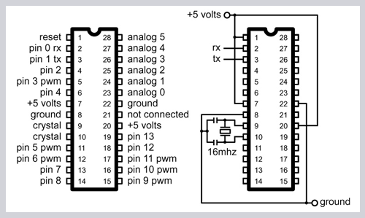

The high-performance Atmel 8-bit AVR RISC-based microcontroller combines 32KB ISP flash memory with read-while-write capabilities, 1KB EEPROM, 2KB SRAM, 23 general purpose I/O lines, 32 general purpose working registers, three flexible timer/counters with compare modes, internal and external interrupts,serial programmable USART, a byte-oriented 2-wire serial interface, SPI serial port, 6-channel 10-bit A/D converter (8-channels in TQFP and QFN/MLF packages), programmable watchdog timer with internal oscillator, and five software selectable power saving modes. The device operates between 1.8-5.5 volts.

By executing powerful instructions in a single clock cycle, the device achieves throughputs approaching 1 MIPS per MHz, balancing power consumption and processing speed.

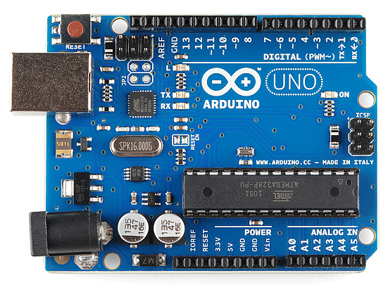

1. Xbee -

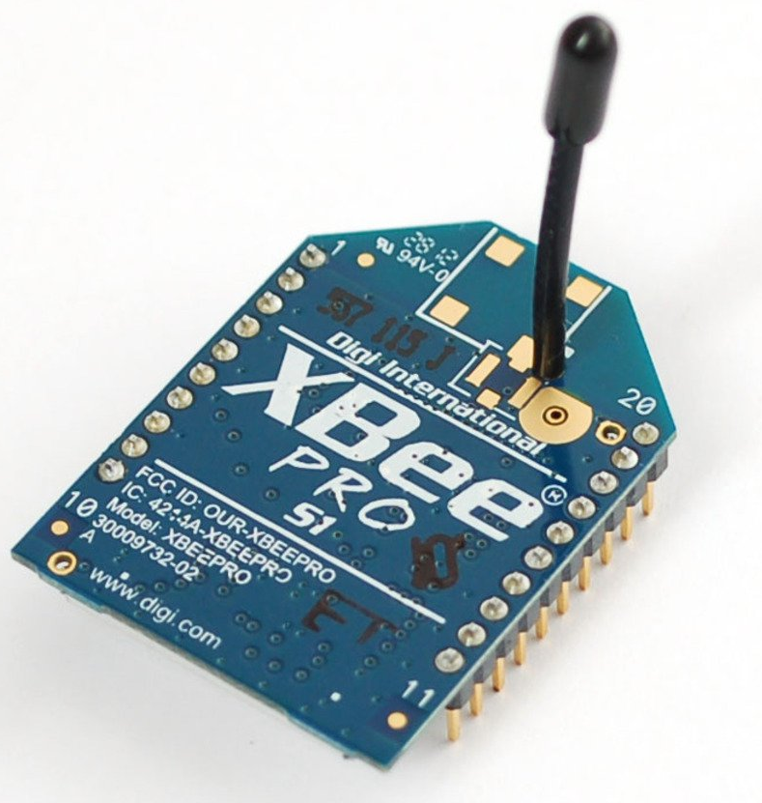

XBee is a wireless communication module that [Digi](http://www.digi.com/products/wireless/zigbee-mesh/) built to the 802.15.4/ZigBee standard. The ZigBee wireless standard can form self-healing mesh networks.

"XBee and XBee-PRO 802.15.4 OEM RF modules are embedded solutions providing wireless end-point connectivity to devices. These modules use the IEEE 802.15.4 networking protocol for fast point-to-multipoint or peer-to-peer networking. They are designed for high-throughput applications requiring low latency and predictable communication timing. XBee modules are ideal for low-power, low-cost applications. XBee-PRO modules are power-amplified versions of XBee modules for extended-range applications."

The XBee and XBee-PRO RF Modules were engineered to meet IEEE 802.15.4 standards and support the unique needs of low-cost, low-power wireless sensor networks. The modules require minimal power and provide reliable delivery of data between devices. The modules operate within the ISM 2.4 GHz frequency band and are pin-for-pin compatible with each other.

Design Notes: • Minimum connections: VCC, GND, DOUT & DIN • Minimum connections for updating firmware: VCC, GND, DIN, DOUT, RTS & DTR • Signal Direction is specified with respect to the module • Module includes a 50k Ω pull-up resistor attached to RESET • Several of the input pull-ups can be configured using the PR command • Unused pins should be left disconnected.

Planned Work Flow:

Xbee serially transmits this data to the COM port of your Computer.

A Windows Form Application is built to read the COM Port and save that data in Data Base using SQL Commands.

Before storing the Data in data base, the data (RFID Number) is checked in the database and relative actions takes place based on Authorization and Authentication.

Each time a card is placed on the reader, attendance is recorded with Current Time, Current Location (Example Class1, Lab1 etc.), RFID number of the holder and respective lecture going on.

Student’s attendance will not be counted if he places the tag in the absence of teacher or before teacher has entered the claa room.

Languages Used:

1. **Embedded C** for programming Arduino.
2. **C#** for Windows Application (.exe file).
3. **SQL** (Structured Query Language) to store data in database.

IDE (Integrated Development Environment) used:

1. Arduino IDE 1.8.
2. Visual Studio 2015.

Major Hardware Components:

1. Arduino (Atmega 328)
2. Xbee
3. EM-18 125KHz
4. RFID Tags etc.